Telecommunication Standardization  Bureau | 

Geneva, 31 May 2010

Ref: | Addendum 1 to  TSB Collective letter 4/SG3RG-LAC
Tel:  Fax:  E-mail: | +41 22 730 5887  +41 22 730 5853  tsbsg3@itu.int | – To the members of the Study Group 3 Regional Group for Latin America  and the Caribbean (SG3RG-LAC)

Subject: | Meeting of the Study Group 3 Regional Group for Latin America and the Caribbean (SG3RG-LAC) and associated BDT Seminar  Santo Domingo, Dominican Republic, 6-9 July 2010

Dear Sir/Madam,
1 Further to TSB Collective Letter 4/SG3RG-LAC of 28 April 2010, please find attached in Annex 1 practical information on the event, as well as the venue of the meeting and a list of hotels near the venue with which Indotel has negotiated preferential rates.
2 You are kindly requested to make your hotel reservation directly with the hotel of your choice, as indicated in point 2 of Annex 1. In order to facilitate the booking, you may use the form attached as Annex 2.
3 Should you require any additional clarification, please do not hesitate to contact either of the following persons:
In ITU:  Ms. Maite COMAS  ITU-T Study Group 3  Tel: +41 22 730 5901  Fax: +41 22 730 5853  Email: tsbsg3@itu.int | In Indotel:  Mr. Sócrates MARTÍNEZ  International Relations Office  Tel: +1 829 473 8525  Fax: +1 829 473 8544  Email: smartinez@indotel.gob.do
Yours faithfully,

Malcolm Johnson
Director of the Telecommunication
Standardization Bureau
Annexes: 2
ANNEX 1
(to Addendum 1 to TSB Collective letter 4/SG3RG-LAC)

Practical information

- Venue of the meeting
The seminar and meeting will take place at the Hotel Santo Domingo, at the following address:
Avenida Independencia, Esquina Abraham Lincoln
Santo Domingo
República Dominicana
Tel: +1 809 221 3618
Fax: +1 809 533 8898
Web site http://www.hotelsantodomingo.com.do
- Hotels
Hotel Santo Domingo (venue of the meeting)
 | Single | Double | Observations
Deluxe room | USD 107.10 | USD 119.70 | Includes tax, breakfast and Internet
On executive floor | USD 126.00 | USD 138.60 | Includes tax, breakfast and Internet
To make the reservation, please contact Ms. Wendy ASTACIO (after the first contact, you will receive a form to fill in and return on which you will have to write your credit card number in order to formalize the reservation) |  | Tel: +1 809 221 3618  Cell: +1 809 747 1610  Email: w.astacio@hsd.com.do
Hotel BQ Santo Domingo
Av. Sarasota No. 53
Bella Vista
Santo Domingo
Tel: +1 809 535 9722 / 535 0800 ext. 2746
Email: info@bqsantodomingo.com
Web: www.bqsantodomingo.com
 | Single | Double | Observations
Standard Room | USD 94.50 | USD 107.10 | Includes tax, breakfast and Internet
Superior | USD 107.10 | USD 119.70 | Includes tax, breakfast and Internet
Superior Suite | USD 138.60 | USD 144.90 | Includes tax, breakfast and Internet
This hotel is located at approximately 30 to 40 minutes by taxi from the venue of the meeting. When you make the reservation, please make sure you quote “INDOTEL/ITU event”. |  | Contact: Carolina LUNA  Tel: +1 809 535 0800 ext. 2720  Celular: +1 829 279 3732  Fax: +1 809 534 6251  Email: cluna@bqsantodomingo.com
Hotel Intercontinental V Centenario Santo Domingo
Av. G. Washington, 218
Santo Domingo
Tel: +1 809 221 0000
Fax: +1 809 221 2020
Web: http://www.intercontinental.com/santodomingo
Email santodomingo@interconti.com
 | Single | Observations
Standard Room | USD 126.00 | Includes tax and breakfast
Deluxe Room | USD 157.20 | Includes tax and breakfast
Club Room | USD 200.34 | Includes tax and breakfast
Contact: Andry CALDERÓN
Gerente de Ventas Comerciales
Tel: +1 809 221 1567
Fax: +1 809 686 3576
Hotel Holiday Inn Santo Domingo
Av. Abraham Lincoln, 856
Santo Domingo
Tel: +1 809 621 0000
Fax: +1 809 985 1000
Web: www.holidayinn.com
 | Single | Observations
Standard Room | USD 137.34 | Includes tax, NO breakfast
Deluxe Room | USD 162.54 | Includes tax, NO breakfast
Club Room | USD 212.94 | Includes tax, NO breakfast
Contact: Andry CALDERÓN
Gerente de Ventas Comerciales
Tel: +1 809 221 1567
Fax: +1 809 686 3576
Hotel Hilton Santo Domingo
Av. George Washington, No. 500
Santo Domingo
Tel: +1 809 685 0000
Fax: +1 809 685 0202
Web: www.hiltoncaribbean.com/santodomingo
 | Single | Observations
Standard Room | USD 163.00 | Includes tax and breakfast
- Visa and departure tax
Depending on your nationality, you will either require a visa to enter the Dominical Republic, or simply a tourist card.
Citizens of the following countries require visas: Afghanistan, Angola, Saudi Arabia, Burundi, Chad, China, Colombia, Congo, Cuba, Egypt, Ethiopia, Philippines, Ghana, Guinea, Haiti, India, Indonesia, Iran, Iraq, Jordan, Kenya, Kuwait, Lao, Lebanon, Liberia, Mali, Namibia, Nepal, Niger, Nigeria, New Zealand, Pakistan, Panama, People’s Republic of Congo, People’s Republic of Korea, Rwanda, Senegal, Sierra Leone, Syria, Somalia, South Africa, Sudan, Thailand, Taiwan, Tanzania, Togo, Turkey, Uganda.
It is advisable to contact the Dominican Republic’s consular representation in your country of residence before departure in order to ensure whether you need a visa.
For the remaining countries, a simple tourist card is necessary. This card can be purchased at the customs control upon arrival at the airport in Santo Domingo. The cost is USD 10,00.
Additionally, all travelers departing the Dominican Republic will be required to pay a tax of USD 20,00, regardless of their nationality or of their reason to visit the Dominican republic. Some airlines (Iberia or Air Europe) include this tax in the price of their tickets.
Please ensure that you have these USD 30,00 with you in US currency. Otherwise, you will have to exchange money at the airport and the rate is not favourable.
- Transportation airport-hotel and between the various hotels and the venue of the meeting
Information on transportation between airport and hotel and between the various hotels and the venue of the meeting will be sent out in due course by email to the distribution list of the group.
- Taxis
You may hire a private taxi at all airports and main hotels. It is recommended that visitors agree on the fare before starting the trip, as not all taxis have meters.
- Local time
Local time is UTC/GMT -4. There is no summer time.
- Climate
The climate in the Dominican Republic is seaside semitropical, with average yearly temperature of 80°F (26.5°C). During the period when the event will take place, the temperature in Santo Domingo fluctuates between 78° and 91°F (26° and 33°C).
- Medical requirements and vaccinations
No particular vaccination is obligatory to travel to the Dominican Republic. The most usual health complications are those derived from long unprotected exposure to the sun, sunstroke, bowel disorders and ear problems. It is recommended to drink bottled water during your stay in the Dominican Republic. It is also advisable to buy a valid health insurance to cover your stay, as well as to take the usual basic medicines (aspirine, antidiarrheal, various creams, plasters, etc.).
- Internet connectivity in the meeting venue
A wireless Internet connection will be available in the meeting romos during the event.
- Currency and Exchange rate
The Dominican peso (DOP) is the currency of the Dominican Republic. The acronym of the currency is DOP, sometimes also written RD$.
The Dominican peso is divided into 100 cents and it is the only currency accepted in shops. The average current exchange rate is:
USD 1 = DOP 36.50
Legal tender notes are 2000, 1000, 500, 200, 100 and 50, while coins are 25, 10, 5 and 1 pesos.
Banks and currency exchange bureau are authorized to change foreign currency. The currencies that can be exchanged most easily are US dollars, Canadian dollars and Euro. It is recommended to keep the receipt of the exchange operation in order to be able to change the remaining pesos back to your currency upon departure.
- Shopping hours
Shopping centres are usually open from 0900h or 1000h until 1900h or 2100h. Smaller shops often open around 0900h and close around 1800h or 1900h. Some of these smaller shops may take one or two hour breaks at lunchtime. In any case, most shops will be open to the public between 1000h and 1200h and between 1600h and 1800h. On Saturdays, many shops close at 1300h. All large supermarkets and shopping centres in Santo Domingo, except Supermercados Bravo, open on Sundays until 2000h. All other shops are closed on Sundays, except for grocery stores that remain open 24/7.
- Electricity and sockets
Electrical voltaje in Santo Domingo is 110 Volts/60Hz.
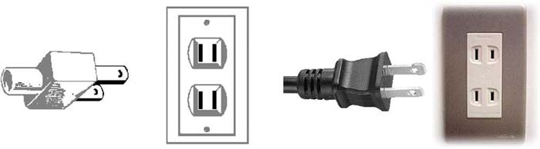
- Languages
Spanish is the oficial language of the Dominican Republic.
- Tips
It is customary to leave tips in restaurants, hotels and services. Restaurants usually charge a 10% tax on the bill and it is customary to leave an additional tip of up to 10%. Tips are generally given to taxi drivers, bell boys, waiters, doormen, etc.
- About the Dominican Republic
The Dominican Republic is a multicolour mosaic of Spanish, French, Haitian and African influences framed in extremely rich history. Christopher Columbus described this exuberant land as “a paradise-like island with high wooded mountains and large valleys and rivers”. This statement is as true today as it was in 1492. In addition to warm sun, sea and sand, the Dominican Republic offers an exciting and exclusive cultural experience that captivates the senses.
It is a tourist destination like none other – a festival for the senses with blinding scenery, exotic cuisine and a remarkable variety of art and entertainment options. The rhythmical emotion of the Merengue, intriguing relics of centuries past, first class tobacco and world class baseball are all waiting for you. The Dominican Republic is a place full of surprises that will prove enjoyable for even the most experienced of travelers.
Santo Domingo is the capital of the Dominican Republic.
Source: Official web site of the Ministry of Tourism of the Dominican Republic: www.godominicanrepublic.com

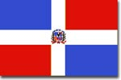  Flag of the Dominican Republic | 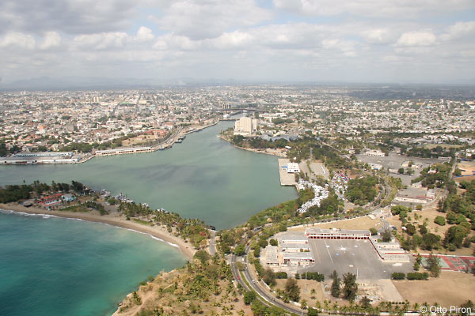  Santo Domingo  Fuente: http://www.el-bohio.com/aerial_tour/photos/aerial_tour02.jpg

ANNEX 2
(to Addendum 1 to TSB Collective letter 4/SG3RG-LAC)
 | Hotel reservation form  Formulario de reservación de hotel  BDT Seminar and SG3RG-LAC Meeting  Santo Domingo, 6-9 July 2010  Seminario BDT y reunión del SG3RG-LAC  Santo Domingo, 6-9 de julio de 2010 | 
This form is to be returned once completed to the hotel of your choice:
Sírvase rellenar este impreso y devolverlo al hotel de su elección:
---EVENTO INDOTEL / UIT---
Name of the hotel:
Nombre del hotel:
Type and number of rooms required:
Tipo y número de habitaciones:
Dates and number of nights:
Fechas y número de noches:
Personal information/Información personal:
Name of participant:
Nombre del participante :
Organisation/Company:
Organización/Empresa:
Country:
País:
Flight number, time and date of arrival:
Número de vuelo, hora y fecha de llegada:
Flight number, time and date of departure:
Número de vuelo, hora y fecha de partida:
Payment/Pago
Name as it appears on credit card:
Nombre tal y como aparece en la tarjeta de pago:
Type of credit card:
Tipo de tarjeta de pago:
Credit card number:
Número de tarjeta de pago:
Valid until:
Válida hasta:
Date and signature/Fecha y firma:
_______________

