Telecommunication Standardization  Bureau | 

Geneva, 2 February 2010

Ref: | TSB Collective letter 6/SG3RG-AO
Tel:  Fax:  E-mail: | +41 22 730 5887  +41 22 730 5853  tsbsg3@itu.int | – To the members of the Study Group 3 Regional Group for Asia and Oceania (SG3RG-AO)

Subject: | Meeting of the Study Group 3 Regional Group for Asia and Oceania (SG3RG-AO) (former TAS Group) and the associated BDT Workshop, 26-28 April 2010, Beijing, China (People’s Republic of)

Dear Sir/Madam,
1 I am pleased to inform you that the Study Group 3 Regional Group for Asia and Oceania (SG3RG-AO) is to meet in Beijing, China, on 27 and 28 April 2010, at the kind invitation of the Ministry of Industry and Information Technology of China. The meeting will take place at the Beijing North Star Continental Grand Hotel, and will be preceded by a seminar focusing on tariff issues and country case studies.
2 The Seminar, organized with the cooperation of the Telecommunication Development Bureau (BDT), will start at 0930 hours on 26 April 2010. The meeting of the SG3RG-AO will start at 1430 hours on the 27 April 2010 and will be restricted to delegates and representatives of administrations and recognized operating agencies of the region, in conformity with §2.3.2 of Section 2 of Resolution 1 of the WTSA-08. The registration of delegates will take place in the morning of Monday, 26 April at the meeting venue as from 0830 hours.
3 In agreement with the Chairman of the SG3RG-AO, the seminar and the meeting will be conducted in English without interpretation.
4 The draft agenda of the SG3RG-AO meeting, as prepared by the Chairman of this group, may be found in Annex 1 hereto.
5 As it will be seen from the agenda, the purpose of the meeting will be to analyze the results of the cost study realized in the AO region and to study how this cost study can be reflected in the accounting rates negotiation. The SG3RG-AO should also give consideration to the new study items identified during its last meeting. In preparation for the meeting hereby convened, reference should be made to Report SG3RG-AO – R 1 (Hanoi, March 2009). Administrations and recognized operating agencies are invited to submit contributions and also to respond to TSB Collective letters 4 and 5/SG3RG-AO, both dated 14 December 2009 concerning the inquiry on the results of the cost study for inward IDD services in direct and transit relations, and the Questionnaire on the movement of accounting rates (both questionnaires are available on line at http://www.itu.int/ITU-T/othergroups/tas/index.asp).
6 You will shortly be receiving a letter of invitation from BDT for the Regional Seminar to be held just before the SG3RG-AO meeting.
7 Would you please read carefully Annex 2 to this collective letter which contains practical information kindly provided by the host organization.
In particular, I would point out that you should announce your participation using Annex 5 (with a copy to the TSB) by 1 April 2010.
In addition, Annex 3 should be sent directly to the hotel of your choice, with copy to the host organization no later than 1 April 2010.
For those participants who require a Visa, Annex 4 should be sent to the host organization no later than 1 April 2010.
8 Pursuant to the provisions of Recommendation A.1 of the WTSA (Johannesburg, 2008) contributions to the work of the SG3RG-AO shall be submitted to the Director of the Telecommunication Standardization Bureau (TSB).
9 Contributions which cannot reach TSB by 21 April 2010, must be sent directly to the host organization at the address given hereunder, with a copy to TSB.
With a view to settling any questions which might arise concerning contributions, the name, the fax and telephone numbers and e-mail address of the person to be contacted should be indicated on contributions. Accordingly, please give those details on the cover page of all documents.
The contact persons to send a copy of the hotel reservation, assistance requests regarding visa obtention and contributions after 21 April 2010 are:
Mr LI Zhi
China Academy of Telecommunication Research of MIIT (CATR of MIIT)
Tel: +86-10-62301515
Fax: +86-10-62305019
E-mail: lizhi@catr.cn
Mr YU Zhicheng
China Academy of Telecommunication Research of MIIT (CATR of MIIT)
Tel: +86-10-62304137
Fax: +86-10-62304011
E-mail: yuzhicheng@catr.cn
It is important to note that participants should enquire in advance whether they need a visa for China and apply to the Consulate or Embassy of China in their respective country.
10 We are pleased to inform you that ITU will provide a limited number of partial fellowships (i.e., accommodation and a daily allowance to cover meals and incidental expenses) to facilitate participation from Least Developed or Low Income Developing Countries. An application must be authorized by the relevant Administration of the ITU Member State and be limited to only one person per country. If you wish to apply for a fellowship, please inform the TSB Secretariat no later than 26 March 2010, by E-Mail to tsbsg3@itu.int or by FAX at +41 22 730 5853.

Yours faithfully,

Malcolm Johnson
Director of the Telecommunication
Standardization Bureau

Annexes: 5
ANNEX 1
(to TSB Collective letter 6/SG3RG-AO)

Draft agenda

- Opening of the meeting
- Approval of the agenda
- Available documents
- Review of SG3RG-AO and ITU activities
- Results of the SG3RG-AO questionnaires
- SG3RG-AO cost model enhancements (LRIC)
- Traffic declarations and settlement procedures
- Accounting rates issues:
  - Mobile termination charge
  - Shortening of the settlement period and establishment of a dispute resolution procedure
  - Discussion on network externalities
  - Settlement of mobile data communication including SMS, MMS, Video/Music
  - Fraud and risk management
  - NGN Charging
- IP Telephony
- IP traffic recording
- International Internet Connectivity
- Effect of migration of traditional traffic to the hubbing
- Review of International Telecommunication Regulations
- Future work programme
- Other business
- Next meeting

ANNEX 2
(to TSB Collective letter 6/SG3RG-AO)

General Information
- Venue

Beijing North Star Continental Grand Hotel

Add: No.8 Beichen Dong Road
Chaoyang District
Beijing P. R. China 100101
Tel: (8610)84985588，84980105
E-mail: bcgh@bcghotel.com
Web: http://www.bcghotel.com/English/jiudian/index.asp
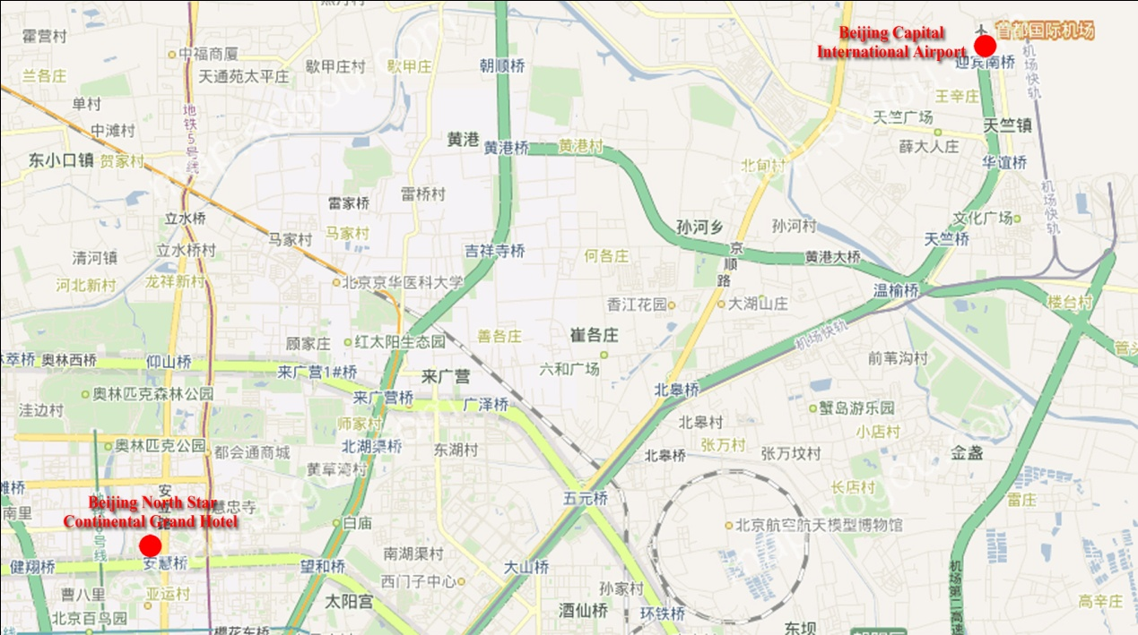

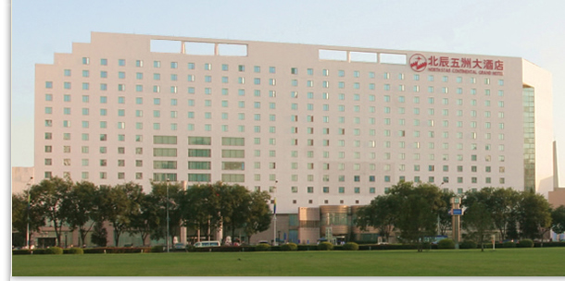

- Transportation from Airport
Beijing North Star Continental Grand Hotel is located in the northern part of the city, approximately one hour drive from airport.
Please visit the following website for detailed information of Beijing Capital International Airport (BCIA): http://en.bcia.com.cn/.

1 Transportation information

Upon Arrival
Please pick up some useful information (City Maps, Tourist Information booklet, Subway Directions, etc.) at Information Center at the airport.

Taxi
A taxi service is available all the day at the airport. The fare is about RMB100, including the Express Way charge.

Airport Shuttle
Beijing North Star Continental Grand Hotel is located near Anhui Qiao Station of the Airport Shuttle. Please take the Airport Shuttle running from BCIA to Zhongguancun outside Terminals 2 or 3, and get off at Anhui Qiao Station. The hotel is not far from the station, you may take taxi or bus to the hotel. (Fare of taxi is about RMB13.)

Airport Shuttle service is available at all Terminals (1, 2, and 3). The ticket is RMB16/person for single trip.

Airport Express
Airport Express (ABC, Airport Beijing City) service is available at both Terminals 2 and 3. Each ticket costs RMB25/person for single trip.
Please take the Airport Express (ABC) to Sanyuan Qiao Station, and transfer to subway Line 10, heading to Ba Gou, and transfer to subway Line 8 at Bei Tucheng, then get off at the Olympic Centre. Now you are at the central zone of the 2008 Beijing Olympic Games. It will take you 10 to 15 minutes to walk to the hotel.
*This would be an easily-get-lost journey from the airport to the hotel, however, if you are willing to adventure the Beijing subway system and experience the 2008 Beijing Olympic Games, you may try this way. The fare of subways in Beijing is RMB2Yuan/person for single trip.

2 Hotels
Two hotels are recommended by the host organization, i.e.Beijing North Star Continental Grand Hotel and Crowne Plaza Park View Wuzhou. The two hotels are next to each other.

Brief Introduction of Beijing North Star Continental Grand Hotel (Recommended accommodation):
Beijing North Star Continental Grand Hotel is a large four (4) star hotel with 538 elegant and comfortable rooms. The guest rooms are equipped with the latest, advanced technology which demonstrates the international quality and hospitality.

For more information, please visit: http://www.bcghotel.com/English/jiudian/index.asp.

Room Rates of Beijing North Star Continental Grand Hotel:
Room Type | Single | Double
Standard Room | USD110 | USD125
Deluxe Room | USD120 | USD135
Executive Room | USD130 | USD145
Executive Suite | USD190 | USD200

Brief Introduction of Crowne Plaza Park View Wuzhou:
Crowne Plaza Park View Wuzhou Beijing is a luxury hotel located in the northern part of Beijing next to the Beijing International Convention Centre and within walking distance to the Olympic Green and much celebrated Bird’s Nest Stadium.

For more information, please visit: http://www.ichotelsgroup.com/h/d/cp/1/en/hotel/PEGPV.
(See registration and hotel booking forms in Annexes 3 and 5)
- Hotel rooms will be assigned on a first-come-first-serve basis, thus early reservation is recommended.
- In order to guarantee your reservation, your credit card information is necessary for a deposit equivalent to one night. Total amount of the hotel fee will be charged directly by the hotel when checking out.
- Any changes or cancellations regarding room reservation should be informed by e-mail or faxed to the hotel.
- Travel Information

1 Visa
Any foreign visitors wishing to enter the People’s Republic of China must have a valid passport and a valid visa. For more information, please visit the Ministry of Foreign Affairs of PRC at http://www.fmprc.gov.cn/eng/default.htm.

2 Currency & Exchange
The Chinese currency unit is the Yuan. Bank notes are 100, 50, 20, 10, 5, 1 bills and coin denominations are 1(Yuan), 5(0.5 Yuan), 1(0.1 Yuan). Money can be exchanged at Beijing Capital International Airport, banks, and hotels.
Approximate exchange rate at 18 January 2010:
USD 1 = RMB 6.8272

For exchange rates information, please visit http://www.boc.cn/sourcedb/whpj/enindex.html.

3 Weather
The Weather in late April is usually warm. The average temperature is 15°C (59°F). For more detailed climate information, please visit the web site of China Meteorological Administration at http://www.cma.gov.cn/en/.

4 Electricity

The standard supply is 220 volts with AC/60 cycles. Outlets for 220 volts are available at the hotels.

5 Emergency Calls

Police: 110
Fire Department: 119
Medical Emergencies: 120 or 999

6 Business Hours
Government offices are open from Monday to Friday between the 08:00 and 17:00.
Banks open from 09:00 to 17:00 on weekdays and weekends.
Major department stores are usually open from 10:00 to 21:00, including weekends.

7 Automated Teller Machines (ATM) for Foreign Travellers
Travellers who carry internationally recognized credit cards can get a cash advance in RMB at Automated Teller Machines (ATMs) installed at airports, major hotels, department stores, and some buildings on the street.

8 Tipping
Tipping is not a traditional Chinese custom. A 10% service charge is added to your bill at all tourist hotels and 10% at some famous restaurants.

9 Tourism Information
Please visit the following Websites for more information of Beijing tourism:
http://english.visitbeijing.com.cn/.

10 Local Time

GMT + 8 hours

11 Computer Networking
Each meeting room will be equipped with wireless access (Wireless LAN, supporting IEEE802.11b, 2.4GHz band) to the Internet. Those who wish to use the wireless access must be equipped with the necessary hardware and correctly configured PC.

12 Let the Pic Talk
If you have difficulty in communicating with the taxi driver, try to show him this picture which means “Please drive me to Beijing North Star Continental Grand Hotel.”
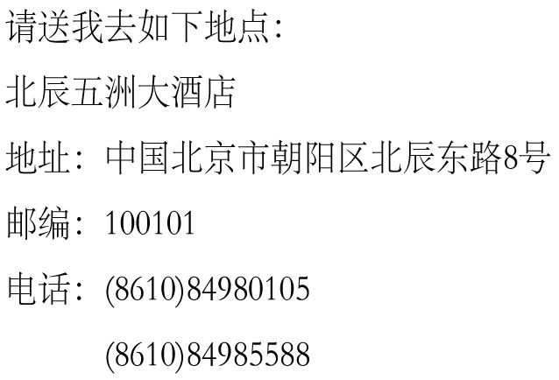

ANNEX 3
(to TSB Collective letter 6/SG3RG-AO)

 | Meeting of the Study Group 3 Regional Group for Asia and Oceania (SG3RG-AO) and associated BDT Seminar  26-28 April 2010, Beijing, P.R.China | 

HOTEL RESERVATION FORM

This form should be sent to the hotel of your choice, with copy to the national coordinator in China, to ensure booking of hotel
by fax at: +86-10-84972651

For information about the hotels – see Annex 2

Family name
First name
Country
Organisation
Address Tel:
Fax:

E-mail:

Name of Hotel
single/double room(s) at the meeting preferential rate
from April 2010 to April 2010

Credit Card No Expiry Date

Date Signature

ANNEX 4
(to TSB Collective letter 6/SG3RG-AO)
Meeting of the Study Group 3 Regional Group for Asia and Oceania (SG3RG-AO) and associated BDT Seminar
26-28 April 2010, Beijing, P.R.China

Visa Support Form (Deadline 1 April 2010)

Please use CAPITAL letters.

Surname & first name(s):
Sex:
Organization:
Position:
Address:
Telephone:
Fax:
Nationality:
Passport number:
Date of issue:
Date of expiry:
Country & city where you will obtain visa to P.R.China:
Date of birth:
Place of birth:
Date of arrival:
Date of departure:

XEROCOPY OR SCANNED COPY OF YOUR NATIONAL PASSPORT IS TO BE ENCLOSED
Please fax or e-mail this form duly completed by 1 April 2010 at the latest, to:
Mr LI Zhi  China Academy of Telecommunication Research of MIIT (CATR of MIIT)  Tel: +86-10-62301515  Fax: +86-10-62305019  E-mail: lizhi@catr.cn | Mr YU Zhicheng  China Academy of Telecommunication Research of MIIT (CATR of MIIT)  Tel: +86-10-62304137  Fax: +86-10-62304011  E-mail: yuzhicheng@catr.cn

ANNEX 5
(to TSB Collective letter 6/SG3RG-AO)

Meeting of the Study Group 3 Regional Group for Asia and Oceania (SG3RG-AO) and associated BDT Seminar
26-28 April 2010, Beijing, P.R.China

REGISTRATION FORM
Please complete a separate form for each delegate and return by 1 April 2010 to:
Mr LI Zhi  China Academy of Telecommunication Research of MIIT (CATR of MIIT)  Tel: +86-10-62301515  Fax: +86-10-62305019  E-mail: lizhi@catr.cn | Mr YU Zhicheng  China Academy of Telecommunication Research of MIIT (CATR of MIIT)  Tel: +86-10-62304137  Fax: +86-10-62304011  E-mail: yuzhicheng@catr.cn

With a copy to TSB - Fax: +41 22 730 5853 (Email: tsbsg3@itu.int)
I participate in the following (please tick as appropriate): | Seminar |  | SG3RG-AO  Meeting
 | Mr |  | Mrs |  | Miss |  | Ms

Family Name

First Name

Accompanied by – please specify name

Country

Name of Administration of Member State*

Name of Sector Member/Associate/Other

Complete address of administration or organization: | Tel:  Fax:  Email:

Private address during the meeting: | Tel:  Fax:  Email:

Date: | Signature:
________________

