Бюро стандартизации
электросвязи
Женева, 7 октября 2010 года
Осн.: | Дополнительный документ 1  к Коллективному письму 5/9 БСЭ
Тел.:  Факс:  Эл. почта: | +41 22 730 6071  +41 22 730 5853  tsbsg9@itu.int | − Администрациям Государств – Членов Союза, Членам Сектора МСЭ-Т и Ассоциированным членам МСЭ-Т, принимающим участие в работе  9-й Исследовательской комиссии

Предмет: | Собрание Рабочих групп 1/9 и 2/9  Лоренсвиль, Джорджия (США), 19 ноября 2010 года
Уважаемая госпожа,
уважаемый господин,
1 В соответствии с тем, что сообщалось в Коллективном письме 5/9 от 25 августа 2010 года, направляем прилагаемую дополнительную информацию, касающуюся собрания Рабочих групп 1/9 и 2/9, которое должно состояться в Лоренсвиле, Джорджия (США), 19 ноября 2010 года и которому будут предшествовать собрания Объединенной группы Докладчиков (15−18 ноября 2010 г.).
2 Информация практического характера, представленная принимающей организацией, содержится в Приложении 1.
С уважением,
Малколм Джонсон
Директор Бюро
стандартизации электросвязи
Приложение: 1
ANNEX 1
(to Addendum 1 to TSB Collective letter 5/9)
Practical information
(Lawrenceville, Georgia, USA, 15−19 November 2010)
- Venue
Cisco Systems, Inc.
5030 Sugarloaf Parkway
Lawrenceville, GA 30044
Tel.: +1 770 236 7000
- Transportation to the Cisco Systems Lawrenceville campus and hotels nearby:
Hartsfield-Jackson International Airport is located in south Atlanta, inside the I-285 interstate perimeter highway.
Vehicles are available at the airport rental car center for your trip to the Cisco Systems Lawrenceville campus and nearby hotels. For access to the rental car center, follow the Ground Transportation signs in the airport. Public transportation is not available for the trip to the campus. Refer to the map (Appendix 1) for driving directions to the Cisco Systems Lawrenceville campus and nearby hotels.
Rental cars are reasonable in Atlanta and directions are very easy.
Northeast of Atlanta Taxi fares:
Airport to Cisco at 5030 Sugarloaf Parkway, Lawrenceville, GA 30042 is approximately $75.00 one-way.
Taxi Fee Structure – Atlanta Business District
Flat Rate Zone from/to the Airport
Downtown $ 30
Buckhead $ 40
Midtown $ 32
*$2 charge for each additional person.
The hotels in the area have shuttle services to Cisco Systems Lawrenceville campus at your ask. Taxis are readily available also.
3. Passports and Visas
All foreign visitors entering the United States (US) must have a valid passport. Visitors from countries whose citizens require a visa should at the earliest time and well in advance of travel apply for a visa at a US Embassy or consulate. The following provides information relating to entry into the U.S.
US ENTRY FOR NONIMMIGRANTS
The US State department issued a detailed update of the current Visa Policy. Click on the link below for complete information.
US State Dept. Visa Policy Update
For assistance with your visa, visit the following websites:
International Visitors Office site: http://www.nationalacademies.org/visas
Official information on the visa application process: http://travel.state.gov/visa
4. Climate
Monthly Average values of the temperature and precipitation in Atlanta are given in the table.
 | November
Average Max Temperature | 63°F/17°C
Average Minimum Temperature | 44°F/7°C
Average Precipitation | 4.1”/10.4cm
5. Electrical Appliances
Throughout the U.S. electrical appliances operate from 120V, 60Hz. power supplies with plugs as shown below. It is suggested guests bring their own power converters and wall plug adapters to allow use of international appliances. Hotels typically provide irons, ironing boards and hair dryers in the hotel rooms, so there is no need to bring these items with you.
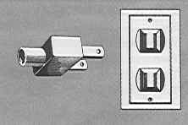
6. Contact Point
Any questions about the meeting arrangements, please contact:
Mr. Gale Lightfoot; email lightfg@cisco.com or telephone +1 770 236 7886
Appendix 1
Map showing route to Cisco Systems Lawrenceville campus and vicinity from Atlanta’s Hartsfield-Jackson International Airport
(Hotels near Cisco Systems indicated on map)

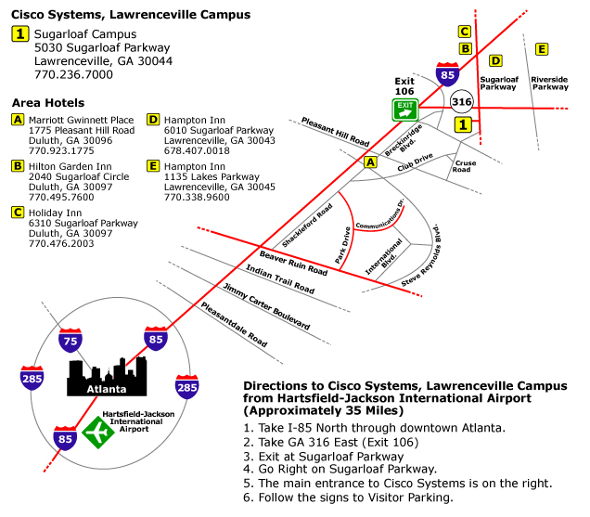

Appendix 2
Hotels
[Distance (kilometers/miles) one-way from hotel to Cisco Systems in brackets]
Lawrenceville, GA: Many of the hotels in the Lawrenceville area are not-full service hotels. They typically offer breakfast and limited room service.
Marriott Gwinnet Place
1775 Pleasant Hill Road
Duluth, GA 30096
+1 770.923.1775
[9.7 km/6 miles ]
http://www.marriott.com/hotels/travel/atlgp-atlanta-marriott-gwinnett-place/

Hilton Garden Inn
2040 Sugarloaf Circle
Duluth, GA 30097
+1.770495.7600
[6.4 km/4 miles]
http://hiltongardeninn.hilton.com/en/gi/hotels/index.jhtml?ctyhocn=ATLGSGI

Holiday Inn
6310 Sugarloaf Parkway
Duluth, GA 30097
+1.770.476.2003
[4.8 km/3 miles]
http://www.holidayinn.com/hotels/us/en/duluth/atldu/hoteldetail?siclientid=1952&pcCrdtd=true

Hampton Inn
6010 Sugarloaf Parkway
Lawrenceville, GA 30043
+1.678.407.0018
[4.8 km/3 miles]
http://hamptoninn.hilton.com/en/hp/hotels/index.jhtml?ctyhocn=ATLDMHX

Hampton Inn
1135 Lakes Parkway
Lawrenceville, GA 30045
+1.770.338.9600
[4.8 km/3 miles]
http://hamptoninn.hilton.com/en/hp/hotels/index.jhtml?ctyhocn=ATLLVHX

