Telecommunication Standardization  Bureau | 

Geneva, 7 October 2010

Ref: | Addendum 1 to  TSB Collective letter 5/9
Tel:  Fax:  E-mail: | +41 22 730 6071  +41 22 730 5853  tsbsg9@itu.int | To Administrations of Member States of the Union, to ITU-T Sector Members and to ITU-T Associates participating in the work of Study Group 9

Subject: | Meeting of Working Parties 1/9 and 2/9  Lawrenceville, Georgia, (USA)  19 November 2010

Dear Sir/Madam,
1 As stated in Collective letter 5/9 of 25 August 2010, please find herewith additional information related to the Working Parties 1/9 and 2/9 meeting, to be held in Lawrenceville, Georgia, on
19 November 2010 preceded by Joint Rapporteur Group Meetings (15-18 November 2010).
2 Practical information as provided by the host organization is given in Annex 1.
Yours faithfully,

Malcolm Johnson
Director of the Telecommunication
Standardization Bureau

Annex: 1

ANNEX 1
(to Addendum 1 to TSB Collective letter 5/9)
Practical information
(Lawrenceville, Georgia, USA, 15-19 November 2010)
- Venue
Cisco Systems, Inc.
5030 Sugarloaf Parkway
Lawrenceville, GA 30044
Tel.: +1 770 236 7000
- Transportation to the Cisco Systems Lawrenceville campus and hotels nearby:
Hartsfield-Jackson International Airport is located in south Atlanta, inside the I-285 interstate perimeter highway.
Vehicles are available at the airport rental car center for your trip to the Cisco Systems Lawrenceville campus and nearby hotels. For access to the rental car center, follow the Ground Transportation signs in the airport. Public transportation is not available for the trip to the campus. Refer to the map (Appendix 1) for driving directions to the Cisco Systems Lawrenceville campus and nearby hotels.
Rental cars are reasonable in Atlanta and directions are very easy.
Northeast of Atlanta Taxi fares:
Airport to Cisco at 5030 Sugarloaf Parkway, Lawrenceville, GA 30042 is approximately $75.00 one-way.
Taxi Fee Structure – Atlanta Business District
Flat Rate Zone from/to the Airport
Downtown $ 30
Buckhead $ 40
Midtown $ 32
*$2 charge for each additional person.
The hotels in the area have shuttle services to Cisco Systems Lawrenceville campus at your ask. Taxis are readily available also.
3. Passports and Visas
All foreign visitors entering the United States (US) must have a valid passport. Visitors from countries whose citizens require a visa should at the earliest time and well in advance of travel apply for a visa at a US Embassy or consulate. The following provides information relating to entry into the U.S.
US ENTRY FOR NONIMMIGRANTS
The US State department issued a detailed update of the current Visa Policy. Click on the link below for complete information.
US State Dept. Visa Policy Update
For assistance with your visa, visit the following websites:
International Visitors Office site: http://www.nationalacademies.org/visas
Official information on the visa application process: http://travel.state.gov/visa
4. Climate
Monthly Average values of the temperature and precipitation in Atlanta are given in the table.
 | November
Average Max Temperature | 63°F/17°C
Average Minimum Temperature | 44°F/7°C
Average Precipitation | 4.1”/10.4cm
5. Electrical Appliances
Throughout the U.S. electrical appliances operate from 120V, 60Hz. power supplies with plugs as shown below. It is suggested guests bring their own power converters and wall plug adapters to allow use of international appliances. Hotels typically provide irons, ironing boards and hair dryers in the hotel rooms, so there is no need to bring these items with you.
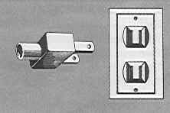
6. Contact Point
Any questions about the meeting arrangements, please contact:
Mr. Gale Lightfoot; email lightfg@cisco.com or telephone +1 770 236 7886

Appendix 1

Map showing route to Cisco Systems Lawrenceville campus and vicinity
from Atlanta’s Hartsfield-Jackson International Airport.
(Hotels near Cisco Systems indicated on map)

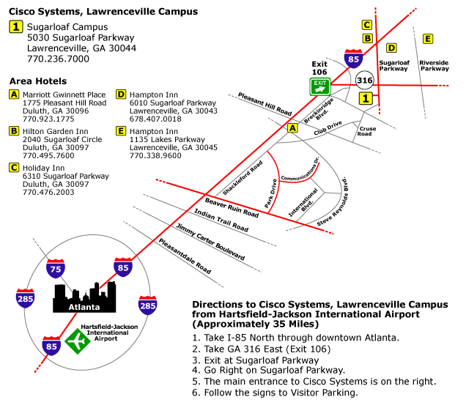

Appendix 2
Hotels
[Distance (kilometers/miles) one-way from hotel to Cisco Systems in brackets]
Lawrenceville, GA: Many of the hotels in the Lawrenceville area are not-full service hotels. They typically offer breakfast and limited room service.
Marriott Gwinnet Place
1775 Pleasant Hill Road
Duluth, GA 30096
+1 770.923.1775
[9.7 km/6 miles ]
http://www.marriott.com/hotels/travel/atlgp-atlanta-marriott-gwinnett-place/

Hilton Garden Inn
2040 Sugarloaf Circle
Duluth, GA 30097
+1.770495.7600
[6.4 km/4 miles]
http://hiltongardeninn.hilton.com/en/gi/hotels/index.jhtml?ctyhocn=ATLGSGI

Holiday Inn
6310 Sugarloaf Parkway
Duluth, GA 30097
+1.770.476.2003
[4.8 km/3 miles]
http://www.holidayinn.com/hotels/us/en/duluth/atldu/hoteldetail?siclientid=1952&pcCrdtd=true

Hampton Inn
6010 Sugarloaf Parkway
Lawrenceville, GA 30043
+1.678.407.0018
[4.8 km/3 miles]
http://hamptoninn.hilton.com/en/hp/hotels/index.jhtml?ctyhocn=ATLDMHX

Hampton Inn
1135 Lakes Parkway
Lawrenceville, GA 30045
+1.770.338.9600
[4.8 km/3 miles]
http://hamptoninn.hilton.com/en/hp/hotels/index.jhtml?ctyhocn=ATLLVHX

