电信标准化局 | 

2010年1月19日，日内瓦

文号： | 电信标准化局第3/9号集体函
电话：  传真：  电子  邮件： | +41 22 730 6071  +41 22 730 5853  tsbsg9@itu.int | 致国际电联各成员国主管部门、  ITU-T部门成员和参加第9研究组  工作的ITU-T部门准成员

事由： | 第2/9工作组的会议  2010年3月19日，上海（中国）

尊敬的先生/女士：
1 根据第9研究组上一次会议（2009年10月26-30日）的决定，我谨通知您，第2/9工作组（终端及应用）将应中国中兴公司（ZTE）的盛情邀请，于2010年3月19日在中国上海召开会议。
第一天的会议将于9:00开始。与会者的注册工作将自8:30起开始进行。有关会议厅安排的具体信息将在会场的电视屏幕上显示。
2 会议将仅以英文进行。
3 会议为无纸会议。
4 由第2/9工作组主席王东先生起草的工作组全会议程草案见本函附件1。
5 由第2/9工作组主席王东先生起草的联合报告人组和第2/9工作组会议工作计划草案见本函附件2。
6 第2/9工作组本次会议的主要目的是根据联合报告人组此前会议的结果，酌情考虑启动有关建议书草案的批准程序。
7 东道组织（中兴公司）提供的实用信息见附件3。
8 根据A.1建议书（2008年，约翰内斯堡）的规定，有关第2/9工作组的文稿应提交电信标准化局（TSB）。电信标准化局在会议召开日的至少十个日历日以前收到的文稿将发布在第9研究组的网站上。因此，此类文稿必须在2010年3月8日之前寄达电信标准化局。按照现行规定，对于在会议开始日至少两个月之前收到的文稿，可以应要求予以翻译。
欢迎与会者以第9研究组主页上提供的网上提交表格或电子邮件的方式向以下地址提交文稿：tsbsg9@itu.int。详尽指南见ITU-T网站。
我们大力提倡您使用已制作出的一套模版，它们既能够使ITU-T文件的格式保持一致，又可以方便文件制作、提高效率。这些模版可以在ITU-T各研究组网页中的“代表资源”（Delegate Resources）（http://www.itu.int/ITU-T/studygroups/templates/index.html）处找到。
为了解决与文稿有关的问题，请在文稿上注明联系人的姓名、传真和电话号码以及电子邮件地址。因此，务请在所有文件的首页注明这些细节。
提交在第2/9工作组会议前举行的联合报告人组会议的文稿应发布在ITU-T的非正式网站上：
● 第4/9号课题文稿网址: http://ifa.itu.int/t/2009/sg9/exchange/q4/
● 第5/9号课题文稿网址: http://ifa.itu.int/t/2009/sg9/exchange/q5/
● 第8/9号课题文稿网址: http://ifa.itu.int/t/2009/sg9/exchange/q8/
● 第9/9号课题文稿网址: http://ifa.itu.int/t/2009/sg9/exchange/q9/
● 第10/9号课题文稿网址: http://ifa.itu.int/t/2009/sg9/exchange/q10/
9 为了便于电信标准化局进行文件制作和会议组织方面的必要安排，我希望您能通过信函、传真（号码：+41 22 730 5853）或电子邮件（tsbreg@itu.int）的方式尽早、但不迟于2010年2月19日将代表贵主管部门、部门成员、部门准成员、区域性组织和/或国际组织或其它实体出席会议的人员名单发至我处，同时，希望各主管部门注明其代表团团长（如果有副团长，亦盼一并注明）的姓名。
10 请注意，ITU-T会议的与会者应通过ITU-T网址进行网上注册：http://www.itu.int/ITU-T/studygroups/com09/index.asp。
11 我们谨在此提醒您，一些国家的公民需要获得签证才能入境中国并在此逗留。请在会议召开前及早向驻贵国的中国使馆或领事馆查询有关办理签证的信息。如需在办理签证方面提供协助，请填妥附件4中的表（“邀请函申请表”）并发至：
Liu Qiong 刘琼女士
电话:+755-2677-5537
电子邮件: liu.qiong@zte.com.cn

顺致敬意！

电信标准化局主任
马尔科姆•琼森

附件：4件
ANNEX 1
(to TSB Collective letter 3/9)

Draft Agenda for the Plenary sessions of Working Party 2/9
(Shanghai, China, 19 March 2010)
1. Welcome and approval of agenda
2. Approval of Rapporteur Group meetings Report
3. Intellectual Property Rights inquiry
4. “Consent” on draft Recommendations proposed for approval in accordance with
Recommendation A.8
5. Approval of outgoing Liaison Statements
6. Future Work Programme
7. Future Interim activities
8. Others
9. Closing

ANNEX 2
(to TSB Collective letter 3/9)
Draft work programme for the meetings of the Joint Rapporteur Group and
of Working Party 2/9
(Shanghai, China, 19 March 2010)
 | 15 March  Monday |  |  |  | 16 March  Tuesday |  |  |  | 17 March  Wednesday |  |  |  | 18 March  Thursday |  |  |  | 19 March  Friday
 | A.M. |  | P.M. |  | A.M. |  | P.M. |  | A.M. |  | P.M. |  | A.M. |  | P.M. |  | A.M. | P.M.
WP 2 |  |  |  |  |  |  |  |  |  |  |  |  |  |  |  |  | X | X
Joint Rapporteur Group |  |  | X¹ | X¹
Q 4/9 | X | X |  |  | X | X | X | X | X | X | X | X | X | X
Qs 5, 8, 9 & 10/9 | X | X |  |  | X | X | X | X |  |  | X | X |  |  | X | X

¹ Joint meeting of Qs 4,8,9, &10/9 and Qs 13 &21/16 subject to confirmation.

- SG 9 management team meeting will be held in the afternoon of 18 March 2010.

ANNEX 3
(to TSB Collective letter 3/9)
Practical Information

1 Meetings and Dates:

15 – 18 March 2010 – Joint Rapporteur group meetings

19 March 2010 – Plenary sessions of Working Party 2/9
2 Location:
Shanghai, China

2.1 Venue:
Parkyard Hotel Shanghai
Address: 699 Bibo Road, Zhangjiang Hi-Tech Park
Shanghai 201203
China
Tel: +86 21 6162 1168
Fax: +86 21 6162 1170
Website: http://www.parkyard.com/en/hotel_index.aspx?CurrentHotelID=6

A map of the hotel is provided below.

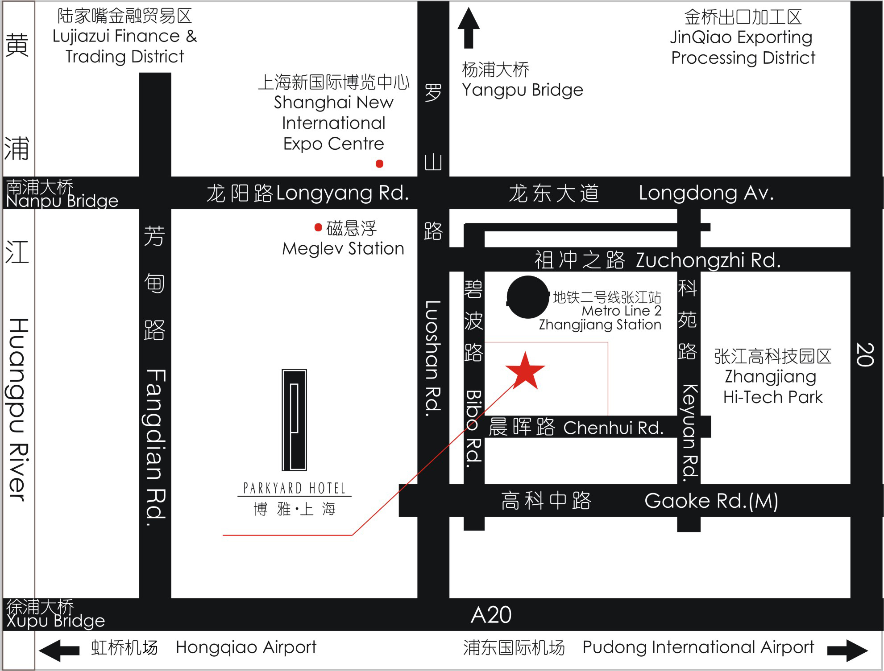

3 Transportation from airport(s):
There are two international airports in Shanghai:
- SHANGHAI PUDONG International Airport
- SHANGHAI HONGQIAO International Airport
Information about both airports can be found on the website:
http://www.shanghaiairport.com/en/index.jsp

Most long-haul flights connect to PUDONG Airport. It is about 21 KM (or 30 minutes by car) from PUDONG Airport to the Parkyard Hotel Shanghai and 25 KM (or 40 minutes by car) from Shanghai HONGQIAO Airport. Taxis are always available. The fare will be approximately ￥120RMB.
The alternative way from PUDONG Airport to the hotel is to take the Maglev train. Shanghai Maglev Train station is located at Terminal 1 of PUDONG Airport. Take the Maglev Train to the Longyang Road station with the ticket of RMB40 (there are only two stops, do not worry about missing your stop). Then interchange Metro Line No.2 and get off at Zhangjiang Hi-tech Park Station. The hotel located at the south of the station with 3 minutes walk distance.
4 Hotel Room Rate:
Business Room King/ Twin: ￥850 RMB per night
(One daily buffet breakfast, internet, 15% surcharge and tax are included)
Cut-off Date: February 28, 2010
Please make your reservations before the cut-off date to ensure the reduced group rate. Rates may be significantly higher after the cut-off date.
Check-in/Check-out Time:
Check in – 12:00 a.m.
Check out – 2:00 p.m.
Reservations:
Please fill in the ROOM RESERVATION FORM in Appendix A and send the completed form via fax or email to the hotel.
To ensure that your confirmation is sent promptly, please type your information into the form. Handwritten faxes can be difficult to read and may prevent the agent from sending a confirmation.
Cancellation:
Any cancellation within 24 hours or NO SHOW, one night room rate will be charged from your credit card.
Please Note:
Please contact the Parkyard Hotel Shanghai directly to make any changes.
5 Visa Requirements:
If you require an invitation letter to obtain your Chinese visa, please fill in the INVITATION LETTER REQUEST FORM (Annex 4) and email it with the subject of “Invitation letter request for ITU-T SG9 WP2 Meeting” to the host. The invitation letter will be dispatched within one week after receipt of the the email request.

6 Information about Shanghai City:

You will find more information about Shanghai City on the website: http://www.chinahighlights.com/shanghai/

7 Internet:
Each meeting room is equipped with wireless access to the Internet.

8 Mobile Network:
GSM and CDMA coverage in China. GSM coverage: There is GSM 900/1800 coverage in Shanghai.

9 Electricity: 220V

See picture below for outlet type.


10 Currency:
Local currency is RMB ¥ (CNY). The bank and hotel can provide multi-currency service. Online spot exchange rates are shown at:
http://www.safe.gov.cn/model_safe_en/index.jsp?id=6

11 Tipping:
Tipping is not necessary in China.

12 Time Zone:
GMT +8

13 Emergency Number:
In case of emergency, please dial 110.

14 Contact Point:
If you have any questions about the meeting arrangements, please contact:
Ms Liu Qiong
ZTE Corporation
Tel: +86 755 26775537
Fax: +86 755 26776620
Email: liu.qiong@zte.com.cn

Appendix A
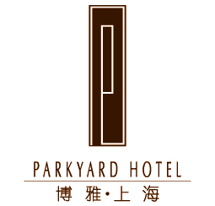
Parkyard Hotel Reservation
Please send you reservation to the hotel at the latest by February 28, 2010
Email: rsvn@sh.parkyard.net or Fax: +86 21 61621170
Event Name: ITU-T SG9 WP2 Meeting

Warmest greetings from the Parkyard Hotel Shanghai!
With reference to your room reservation, please provide the details as shown below:

Guest Name:
Check-in Date:
Check-out Date:
Room Type: | Business Room (King/ Twin)
Room Quantity:
Room Rate: | 850 RMB per night  (One daily buffet breakfast, internet, 15% surcharge and tax are included)
Credit Card No.
(Guarantee Booking Only)
Credit Card Validity:
Type of Credit Card: | Visa/Master/AMEX
Remark:

Terms of Conditions:
* Please provide us with a credit card number in order to guarantee your booking for late arrival, otherwise, the booking will be released at 6:00 p.m. on the expected arrival day.
* Please note that the check-in time is 2:00 p.m. should you wish to check-in earlier, please contact us in advance.
* The check-out time is 12:00 noon. For late check-out from 1:00 pm until 6:00 p.m., a charge of 50% of your room rate will apply. Check out after 6:00 p.m. will be charged at the full room rate.
* Any cancellation within 24 hours or NO SHOW, one night room rate will be charged from your credit card.
Should you have any further requirements that we can assist you with, please do not hesitate to contact us at Tel: +86 21 61621168, Fax: +86 21 61621170 or E-mail: rsvn@sh.parkyard.net.
Thank you for choosing to stay at the Parkyard Hotel. We look forward to welcoming you.
Address: 699 Bibo Road, Pudong District, Shanghai, China 201203
Website: www.parkyard.com

ANNEX 4
(to TSB Collective letter 3/9)
ITU-T SG9 meetings of the Joint Rapporteur Group and Working Party 2/9
(Shanghai, China, March 15-19, 2010)

INVITATION LETTER REQUEST FORM
To enter China for the meetings indicated above, you may need a letter of invitation from the Chinese host, which you will need to present to the Chinese Embassy/Consulate in your area in order to obtain your visa. In order to obtain the invitation letter, please fill in the form below and send it to:
- Ms Liu Qiong of ZTE Corporation

Email: liu.qiong@zte.com.cn

With the email subject: ITU-T SG9 WP2 Meeting – Invitation Letter Request

Company
Applicant Information | [ Click and Type in your full name ] |  |  | rMr rMs rMrs
Applicant Information | [ Nationality ] |  |  | [ Passport No.]
Applicant Information | Date of birth : [ Year ] [ Month] [ Day ] |  |  | [ Job Title ]
Applicant Information | If the country in which you'll obtain your visa is different from your nationality, please indicate it here:  [ Country to obtain your visa]
Address | [Click and Type in your address and ZIP code]  Telephone Number: [Click and Type in phone number]  Fax Number: [Click and Type in fax number]  E-mail: [Click and Type in email]
Places to visit after entry | (In this case, it is Shanghai by default; if you want to visit other places than Shanghai, please indicate here.)
Date of arrival in China |  |  | Date of departure from China

After the end of 2008 Beijing Olympic Games, a scanned copy of the invitation letter is typically accepted by local Chinese Embassies / Consulates for processing visa requests. Therefore, without a special request for original invitation letter, ZTE Corporation will provide by default a scanned copy of the invitation letter. Please confirm whether your local Chinese Embassy / Consulate requires the original invitation letter for processing your visa request and let us know if it is needed.
______________________

