|  |  |
| --- | --- |
| **Oficina de Normalización de las Telecomunicaciones** | **logo_S_** |
|  |  |

Ginebra, 22 de febrero de 2010

|  |  |  |
| --- | --- | --- |
| Ref.: | **Carta Colectiva TSB 2/3** |  |
| Tel.: | +41 22 730 5887 |  |
| Fax:  Correo-e: | +41 22 730 5853  [tsbsg3@itu.int](mailto:tsbsg3@itu.int) | A las Administraciones de los Estados Miembros de la Unión, a los Miembros del Sector UIT‑T y a los Asociados del UIT-T que participan en los trabajos de la Comisión de Estudio 3 |

|  |  |
| --- | --- |
| Asunto: | **Reunión de la Comisión de Estudio 3 Seúl (Corea (Rep. de)), 17‑21 de mayo de 2010** |

Muy Señor mío/Muy Señora mía:

1 De conformidad con el programa de reuniones del Sector de Normalización de las Telecomunicaciones de la UIT para 2010 (véase la Circular TSB 80 de 14 de diciembre de 2009), me complace informarle de que la Comisión de Estudio 3 (*Principios de tarificación y contabilidad, incluidos los temas relativos a economía y política de las telecomunicaciones*) se reunirá en el Hotel Ritz Carlton de Seúl, Corea, del 17 al 21 de mayo de 2010, ambos inclusive.

La reunión comenzará a las 09.30 horas del primer día. La inscripción de los participantes comenzará a las 08.30 horas. En las pantallas situadas a la entrada del lugar de celebración se dará información detallada sobre las salas de reunión.

2 La reunión contará con un servicio de interpretación, de conformidad con las disposiciones vigentes.

3 En el **anexo 1** adjunto figura el proyecto de orden del día preparado por el Presidente. En los **anexos 2** a **4** pueden encontrarse los proyectos de orden del día de los Grupos de Trabajo.

4 En el **anexo 5** adjunto figura el proyecto de programa de trabajo preparado por el Presidente y su Equipo de Gestión.

5 El **anexo 6** contiene información complementaria sobre la reunión.

6 De conformidad con lo dispuesto en la Recomendación A.1 (Johannesburgo, 2008), las contribuciones a los trabajos de la Comisión de Estudio se transmitirán a la Oficina de Normalización de las Telecomunicaciones (TSB). Las contribuciones recibidas por la TSB por lo menos diez días naturales antes de la fecha fijada para el comienzo de la reunión se publicarán en la dirección web de la Comisión de Estudio 3. Por tanto estas contribuciones deberán obrar en poder de la TSB **a más tardar el** **6 de mayo de 2010**. Las contribuciones recibidas por lo menos dos meses antes del comienzo de la reunión podrán traducirse, llegado el caso, con arreglo a las disposiciones en vigor.

Se alienta a los participantes a presentar contribuciones mediante el correspondiente formulario disponible en la página web inicial de la Comisión de Estudio 3, o por correo electrónico a la siguiente dirección: [tsbsg3@itu.int](mailto:tsbsg3@itu.int). En la dirección web del UIT‑T figuran instrucciones detalladas.

Le recomendamos encarecidamente que utilice el juego de plantillas a fin de armonizar la presentación de los documentos del UIT-T y, al mismo tiempo, facilitar y hacer más eficaz su producción. Se pueden descargar desde la página web de cada Comisión de Estudio del UIT-T en "Delegate resources" ([http://www.itu.int/ITU-T/studygroups/templates/index.html](http://www.itu.int/ITU/studygroups/templates/index.html)).

Para resolver todas las posibles cuestiones que se planteen en relación con las contribuciones, en adelante se indicará en las mismas el apellido de la persona encargada, sus números de telefax y de teléfono, así como su dirección de correo electrónico (e-mail). Para ello, le ruego indique esta información en la portada de todos los documentos.

7 Para que la TSB pueda tomar las disposiciones necesarias sobre la documentación y la organización de la reunión, le ruego me comunique cuanto antes, por carta, por fax (+41 22 730 5853) o por correo electrónico ([tsbreg@itu.int](mailto:tsbreg@itu.int)) y **a más tardar el 18 de abril de 2010**, una lista de las personas que representarán a su Administración, Miembro del Sector, Asociado, organización regional y/o internacional u otra entidad. Se ruega también a las Administraciones que indiquen el nombre de su Jefe de Delegación (y jefe adjunto, si procede).

8 **No olvide que la preinscripción de los participantes a las reuniones del UIT‑T se efectúa *en línea* desde la página web del UIT‑T:   
(**[**http://www.itu.int/ITU-T/studygroups/com03/index.asp**](http://www.itu.int/ITU-T/studygroups/com03/index.asp)**)**.

9 Los participantes presentes en la reunión que hayan solicitado por adelantado copias en papel en los formularios de inscripción recibirán sólo los documentos publicados en la página web del UIT‑T con tres días de antelación a la reunión (***14 de mayo de 2010*)** y hasta el final de la misma.

Para racionalizar la distribución de documentos durante las reuniones, se recuerda que los miembros de los Grupos de Trabajo recibirán únicamente los documentos que les conciernen. A tal efecto, le ruego indique claramente en el formulario de inscripción, el o los Grupos de Trabajo en que desea participar.

10 Se insta a los participantes a trabajar en formato electrónico y contribuir así a reducir la cantidad de papel necesaria para la reunión. Tenga en cuenta que los delegados disponen de instalaciones de red local inalámbrica en las zonas aledañas a las principales salas de conferencias.

Los participantes que se alojen en el Hotel Ritz Carlton tendrán a su disposición un servicio de alquiler de ordenadores portátiles. Puede encontrar más información al respecto en el **anexo 6**.

11 Para las sesiones previstas con interpretación, tenga en cuenta que ésta se proporcionará únicamente si así lo solicitan los Estados Miembros en el formulario de inscripción o por notificación especial a la TSB y **al menos con un mes de antelación al comienzo de la correspondiente sesión**. Es imperativo respetar el plazo indicado en el formulario de inscripción para que la TSB pueda tomar las medidas necesarias a fin de facilitar la interpretación.

12 Se adjunta a todos los efectos útiles como **anexo 7** un formulario de confirmación de hotel (véase la lista de hoteles en el **anexo 6**). Tenga en cuenta que la reserva de hotel ha de efectuarse **antes del 15 de abril de 2010**.

13 Deseamos recordarle que los participantes habrán de dirigirse a la representación consular de Corea más cercana a fin de saber si necesitan un visado de entrada en Corea. En caso de necesitar una carta de invitación personal para obtener el visado, se deberá rellenar el formulario que puede encontrar en el **anexo 8** y enviarlo al coordinador del anfitrión **antes del 18 de abril de 2010, a más tardar**.

Si necesita ayuda para obtener el visado, póngase en contacto con:

Sra. Sesoon Oh  
TTA  
Tel.: +82 31 724 0085  
Fax: +82 31 724 0109  
Correo-e: [sg3@tta.or.kr](mailto:sg3@tta.or.kr)

Atentamente,

Malcolm Johnson  
Director de la Oficina de Normalización  
de las Telecomunicaciones

**Anexos: 8**

ANNEX 1  
(to TSB Collective letter 2/3)

***Meeting of ITU-T SG3  
Seoul, Korea, 17-21 May 2010***

***Draft agenda***

**1 Opening plenary meeting**

1.1 Opening of the meeting

1.2 Adoption of the agenda and other administrative issues

1.3 Results of SG3 work and follow-up actions

1.4 Progress reports on the work of the regional groups

1.5 Results of other ITU meetings related to Study Group 3

Results of the meetings of other study groups related to Study Group 3

1.6 Examination of documents available

1.7 Procedural notifications

**2 Closing plenary meeting**

2.1 Reports of the meetings of Working Parties, Questions, and ad hoc groups

Results of the workshops

2.2 Approval of Recommendations under TAP

2.3 Determination of Recommendations under TAP

2.4 Deletion or renumbering of Recommendations

2.5 Approval or deletion of Supplements

2.6 Liaison statements

2.7 Recommendation status and work plans

2.8 Dates of future meetings

2.9 Other business

2.10 Closure of the meeting

ANNEX 2  
(to TSB Collective letter 2/3)

***Meeting of ITU-T SG3  
Seoul, Korea, 17-21 May 2010***

***Draft agenda for Working Party 1/3***

1 Opening of the meeting

2 Adoption of the agenda

3 Inventory of available documents

4 Review of Working Party 1/3 activities and approval of report of previous meeting

5 Examination of study items

5.1 Mobile Communications

5.2 “IP Telephony”

5.3 International Internet Connectivity, including IP peering and cost of provision of services

5.4 Traffic Flow Multifactors and Internet Traffic Flow Methodology

5.5 Next Generation Networks (NGN)

5.6 Accounting and settlement based on IP Data Records (IPDR)

5.7 Charging and accounting principles associated with enhanced signalling

5.8 Other charging, accounting, and economic issues arising out of use of next-generation networks and any future development

6 Liaison issues

7 Other business

8 Closure of the meeting

ANNEX 3  
(to TSB Collective letter 2/3)

***Meeting of ITU-T SG3  
Seoul, Korea, 17-21 May 2010***

***Draft agenda for Working Party 2/3***

1 Opening of the meeting

2 Adoption of the agenda

3 Inventory of available documents

4 Review of Working Party 2/3 activities and approval of report of previous meeting

5 Examination of study items

5.1 Mobile Communications

5.2 Mobile Termination Rate

5.3 Fixed Termination Rate

5.4 Flat Rate for Mobile

5.5 Flat Rate for Fixed

5.6 Flat Rate for Fixed to Mobile and vice-versa

5.7 Accounting and Settlement Rates for Fixed

5.8 Alternative Accounting Procedures (e.g. changes in deadlines for settlements)

5.9 Mobile Roaming

5.10 Tariff Issues for Cross-Border Connectivity for Mobile

5.11 Tariff Issues for Short Message Service (SMS) and Multimedia Messaging Service (MMS)

5.12 Leased Line Tariff

5.13 Transit Traffic

5.14 Alternative Calling Procedures (e.g. call-back, re-file)

5.15 Guidelines Based on International and Regional Practices for Resolution of Disputes Regarding Charging (e.g duration, origin of traffic, etc.)

5.16 Accounting and Settlement Procedures, including their Evolution

6 Liaison issues

7 Other business

8 Closure of the meeting

ANNEX 4  
(to TSB Collective letter 2/3)

***Meeting of ITU-T SG3  
Seoul, Korea, 17-21 May 2010***

***Draft agenda for Working Party 3/3***

1 Opening of the meeting

2 Adoption of the agenda

3 Inventory of available documents

4 Review of Working Party 3/3 activities and approval of report of previous meeting

5 Examination of study items

5.1 Policy and Economic Issues

5.2 Network Externalities

5.3 Universal Service Obligations

5.4 Impact of the Choice of Accounting Rate Currency

5.5 Impact of Convergence of Services

5.6 International Telecommunication Regulations

5.7 Revenue Protection Mechanisms

5.8 Misuse of Facilities and Services (see WTSA Resolution 20)

5.9 Financial Aspects of Network Security

6 Liaison issues

7 Other business

8 Closure of the meeting

ANNEX 5  
(to TSB Collective letter 2/3)

***Meeting of ITU-T SG3  
Seoul, Korea, 17-21 May 2010***

***Draft Timetable***

|  |  |  |  |  |  |  |  |  |  |  |  |
| --- | --- | --- | --- | --- | --- | --- | --- | --- | --- | --- | --- |
|  | **Monday 17 May 2010** | | **Tuesday 18 May 2010** | | **Wednesday 19 May 2010** | | **Thursday 20 May 2010** | | | **Friday 21 May 2010** | |
|  | **am** | **pm** | **am** | **pm** | **am** | **pm** | **am** | | **pm** | **am** | **pm** |
| ***Plenary*** | X |  |  |  |  |  |  | |  | X | X |
| ***Q.1/3*** |  | X |  |  |  |  |  | |  |  |  |
| ***Q.2/3*** |  |  | (1) | X |  |  |  | |  |  |  |
| ***Q.3/3*** |  |  |  |  | X |  |  | |  |  |  |
| ***Developing country issues*** |  |  |  |  |  |  | X |  |  |  |  |
| ***Ad-hoc meetings*** |  |  |  |  |  | (2) |  | (2) | (2) |  |  |

X: Meetings scheduled

(1) Workshop on SMS services

(2) Ad hoc meetings will be scheduled as needed

**Notes:**

(a) The Management Team will meet on Sunday, 16 May

ANNEX 6  
(to TSB Collective letter 2/3)

***Meeting of ITU-T SG3  
Seoul, Korea (Rep. of), 17-21 May 2010***

***Practical information***

**I Venue Information**

**Venue: The Ritz-Carlton Hotel, Seoul**

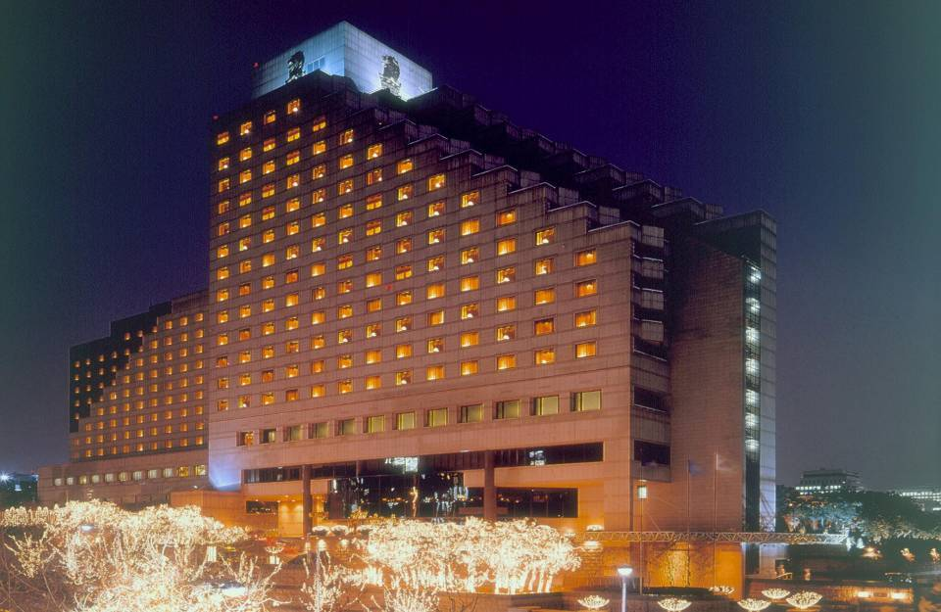

Address: 602 Yeoksam-Dong, Gangnam-Gu, Seoul, 135-080, Korea

Phone: +82-2-3451-8000 (indicate “ITU-T” as group name)

Fax: +82-2-3451-8188 (indicate “ITU-T” as group name)

Email: [ian.kim@ritzcarlton.com](mailto:ian.kim@ritzcarlton.com) (indicate “ITU-T” as group name)

Website: [**http://www.ritzcarltonseoul.com**](http://www.ritzcarltonseoul.com)

**Floor Information (A3)**

**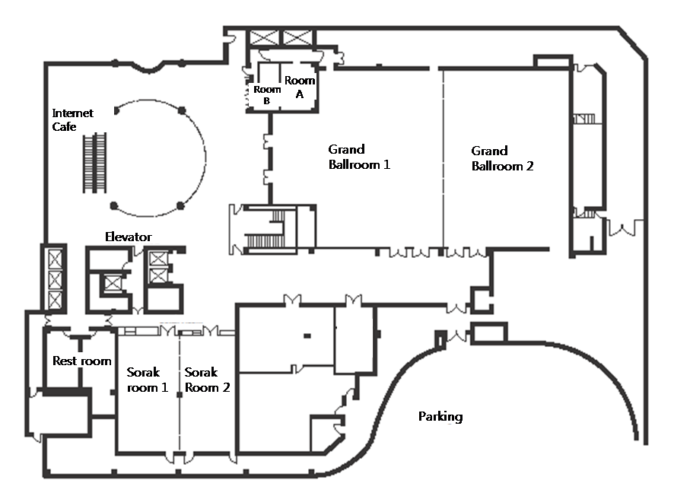**

1. Meeting room: Grand Ballroom 1
2. Small mtg room: Sorak room 1
3. Chairman room: Room A
4. ITU-T Secretariat: Room B
5. Local Secretariat: Sorak room 2
6. Banquet: Grand Ballroom 2

**II Hotels**

|  |  |  |
| --- | --- | --- |
| **Hotel** | **Room** | **Rate** |
| The Ritz-Carlton, Seoul  (★★★★★), **Venue** | Superior Deluxe | KRW 150,000 |
| Balcony Deluxe | KRW 190,000 |
| Novotel Ambassador Gangnam (★★★★★) | Standard | KRW 140,000 |

The Ritz-Carlton, Seoul, is located in the thriving commercial and residential district of Gangnam and minutes from the COEX exhibition centre, World Trade Centre, department stores, designer boutiques and Olympic Stadium.

* Korea has blocked 120 rooms at The Ritz-Carlton, Seoul, for the ITU-T SG3 Meeting. Since hotel rooms shall be assigned on a first-come, first-served basis, early reservation is recommended.
* To guarantee your reservation, your credit card information is necessary in making a one-night deposit. The total hotel fees shall be charged directly by the hotel upon check-out.
* The hotel should be informed of any and all changes or cancellations regarding room reservation via email or fax.
* Any changes or cancellations regarding room reservation should be informed by e-mail or faxed to the hotel.
* Korea has blocked maximum 30 rooms at Novotel Ambassador Gangnam which is located next The Ritz-Carlton, Seoul.

Internet Service at the Ritz-Carlton, Seoul

The Ritz-Carlton, Seoul provides high-speed Internet service to guests who are using laptops (Plug & Play System). Simply plug the Internet connection line into the plug jack. Payments for Internet use will be automatically added to your room. In addition, The Ritz-Carlton, Seoul provides a laptop rental service at Business Center. Rental fee for one hour is KRW 20,000 (Exclusive VAT) and for 24 hrs use KRW 120,000 (Exclusive VAT). Internet Access fee is KRW 23,000 (Exclusive VAT, for 24hrs). Please inquire when making a reservation or upon arrival at the check-in counter. This service will be charged separately from your room bills.

Tourist Office

The Ritz-Carlton, Seoul Guest Relations  
Tel.: +82-2-3451-8293

**Hotel Reservation and Cancellation**

Reservation requests should be received no later than **15 April 2010**. Hotel rooms must be guaranteed using a credit card. For cancellations, the reservation must be canceled **3 days prior to the arrival date** to avoid paying a “no-show” charge. Rooms shall be assigned on a first-come, first-served basis. Room availability and rate after 15 April 2010 may not be guaranteed.

**III Travel Information**

**1 Visa**

Any foreign visitors wishing to enter Korea must have a valid passport. Tourists may visit Korea for 15 days without a visa, but proof of confirmed round air reservation is required. However, some countries require visas to enter the Republic of Korea. For more information, please visit the Ministry of Foreign Affairs and Trade at [**www.mofat.go.kr**](http://www.mofat.go.kr).

**2 Currency & Exchange**

The Korean currency unit is the WON (indicated ￦). Bank notes are ￦50,000, ￦10,000, ￦5,000, ￦1,000 bills and coin denominations are ￦500, ￦100, ￦50, ￦10. Money can be exchanged at Incheon International Airport, banks, and hotels:  
[**http://www.keb.co.kr/IBS/english/fx/rate/average/index.jsp**](http://www.keb.co.kr/IBS/english/fx/rate/average/index.jsp).

Approximative exchange rate as of November 2009:

USD 1 = ￦1,200

**3 Weather**

The Weather in May is usually warm. The average temperature is 20~24°C (68~75.2°F). For more detailed climate information, please contact the Korea Meteorological Administration at [**http://www.kma.go.kr/**](http://www.kma.go.kr/).

**4 Electricity**

The standard supply is 220 volts with AC/60 cycles. Outlets for 220 volts are available at the hotels.

The two following outlets are compatible with those available in Korea.

a) This is popularly known as the europlug which is described in CEE 7/16

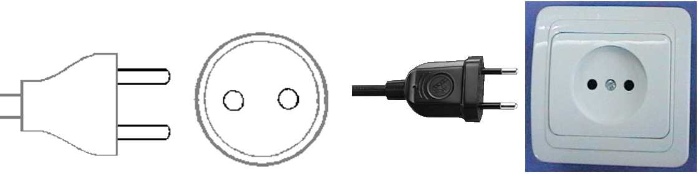

b) This plug is similar to the above except that it is round and has the addition of two grounding clips on the side of the plug

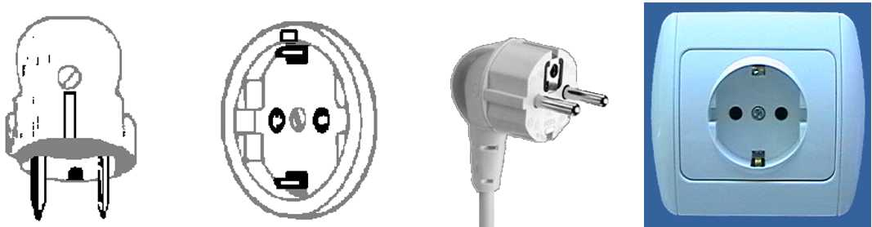

5 Telephone Calls

A local calls cost ￦70 for three minutes. To make an international call, first dial the international dialling code(001, 002 or 00700), then the country code, area code, and the local telephone number. You may also rent a cellular phone at the Incheon International Airport.

**6 Emergencies**

Police----------------------------------112  
Fire Department----------------------119  
Medical Emergencies ---------------1339

**7 Business Hours**

Government offices are open from Monday to Friday between 0900h and 1800h.

Most private businesses open some time between 0830h and 1000h and are open continuously until the evening.

Banks are a major exception. Their business hours are from 0900h to 1600h on weekdays. They are closed during weekends.

Foreign diplomatic missions in Seoul generally maintain strict business hours including lunch. They are usually open from 0900h to 1700h on weekdays and are closed on Saturdays and Sundays.

Major departments stores are usually open from 1030h to 2000h, including Sundays, but smaller shops tend to be open earlier and close later every day of the week.

**8 Automated Teller Machines (ATM) for Foreign Traveller**

Travellers who carry internationally recognized credit cards can get a cash advances in Korean won at Automated Teller Machines (ATMs) installed at airports, major hotels, department stores, subway stations and tourist attractions.

**9 Tipping**

Tipping is not a traditional Korea custom. A 10% service charge is added to your bill at all tourist hotels and 3-10% at some big restaurants.

**10 Tax**

Value-added tax (VAT) is levied on most goods and services at a standard rate of 10% and is included in the retail price. In tourist hotels, this 10% tax applies to meals and other services and is added into the bill.

**11 Mail**

Domestic postal rates are ￦190 for a letter of up to 25g, ￦1,490 for registered letter of no more than 25g, and ￦1,500 or ￦2,000 for a package of up to 2kg. A postcard costs ￦160.

Korea post: [**www.koreapost.go.kr**](http://www.koreapost.go.kr).

**12 Newspaper, TV and Radio**

There are three English-language dailies. The Korea Times, the Korea Herald, and the International Herald Tribune Joongang Daily. They are available at most news stands and in most hotel gift shops.

Korea has fine TV networks, all broadcasting in Korean (KBS1, KBS2, MBC, SBS, and EBS). Along with the national broadcasting networks, there are also many cable TV channels specializing in a wide field of programming including news, movies, entertainment, sports, etc. Of note is Arirang TV, a special English channel produced in Korea (cable channel #50). The channel features programming in politics, the economy, community, and culture, providing insight and understanding about things Korean through popular TV serial dramas with English subtitles. Some 90 hotels in Korea offer Arirang TV on cable or satellite.

**13 Korea & Korean Tourism**

Please visit the following Websites for more information on Korea and possible tours:

<http://www.kois.go.kr>

[http://www.tour2korea.com](http://www.tour2korea.com )

**14** **Local time**

GMT + 9 hours (same as Tokyo time).

**15 Computer Networking**

Each meeting room will be equipped with wireless access (Wireless LAN, supporting IEEE802.11b, 4GHz band) to the Internet. Those who wish to use the wireless access must be equipped with the necessary hardware and correctly configured PC.

**16 Airport**

The closest airport is the **Incheon** **International Airport**

**17** **Transportation** (From the Incheon International Airport to Ritz Carlton Seoul Hotel)

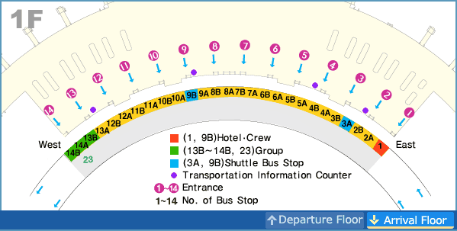

**(1) KAL Limousine Bus**

**- From the Airport to the Hotel**: KAL Limousine Bus No. 3 at the **Bus Stop 4B** (between gate 4 and gate 5)**, 10B** (between gate 10 and gate 11). Bus Fare is 14,000 won and the journey takes around one and half hours. The departure time will change depending on traffic conditions. The distance from the Incheon International airport to the Venue is 70km.

The first bus is at 0515h and last one at 2220h. Average bus interval is 30mns.

- **From the hotel to the Airport**: The first bus is at 0458h and last one at 0658h pm.

- Contact: KAL Limousine Headquarters (02-2667-0386)  
Incheon International Airport Information (1577-2600)

**(2) TAXI**

- Regular taxi stop is number 5 and deluxe taxi is number 21, which are in front of the gate number 7 and 11 respectively.

- The charge of regular taxi from the airport will be around KRW 50,000 ~ KRW 60,000

- The charge of deluxe taxi from the airport will be around KRW 80,000 ~ KRW 90,000

- The journey would take about 70 minutes in normal traffic conditions.

- No reservations are necessary.

- If you plan to take a taxi, please show the following note to the taxi driver:

|  |
| --- |
| **강남 리츠칼튼 호텔에 데려다 주세요.**  **(Please take me to The Ritz-Carlton Hotel.)** |

**(3) Car Rental**

If you want to arrange a car pick up service from our hotel rent car, the rate will be KRW 140,000 per car. Our driver will be waiting for the guests in front of hotel

**Location (map and directions)**

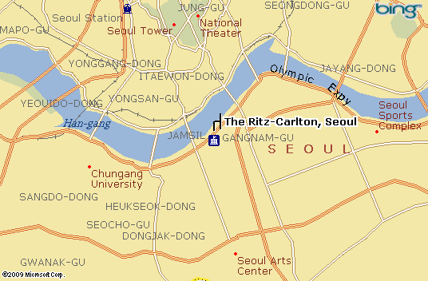

[**Map of the Seoul Subway**](http://211.54.2.50/eng/smt/lineMap/lineMap_index.jsp)

**[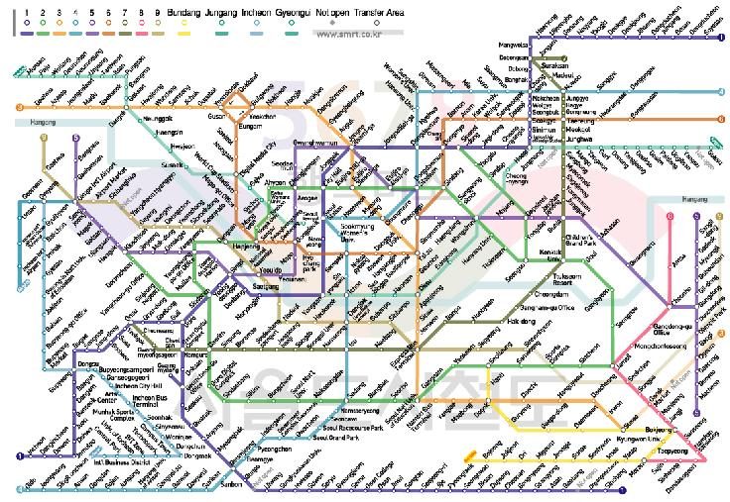](http://211.54.2.50/eng/smt/lineMap/lineMap_index.jsp)**

**About Korea & Seoul**

**Korea**

Korea is proud of 5,000 years of history through which a unique culture has flourished. Modern Korea is a nation that has rebuilt itself from the devastation of the Korean war and has achieved an economic miracle in just 50 years. The Korean peninsula extends southward from the eastern end of the Asian continent and is approximately 1,000 km long and 216 km wide at its narrowest point.

**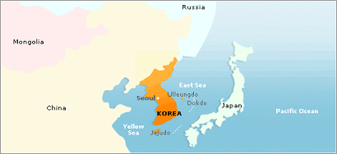**

**Seoul**

Seoul is a city of contrasts. From ancient palaces with centuries of history to high-tech skyscraper of steel and glass, from ancient texts dating back millennia to the highest rate of broadband Internet access in the world, Seoul is a place where the old and new exist in harmony. With one foot in the past and another in the future, Seoul is a city that never ceases to amaze.

Seoul is also the center of the so-called “Korean Wave” sweeping Asia. As Korean dramas, film and music reach a wider audience abroad, more and more visitors are coming to Seoul to experience first-hand the city’s rich culture and make use of its extensive cultural facilities.

Due to the division of the nation and the proximity of the DMZ with North Korea just an hour’s drive away, some might think Seoul to be a somewhat risky place to visit. Foreign news reports aside, nothing could be further from the truth---Seoul is one of the safest places in the world for foreign travelers, with low levels of crime, a hospitable population, cutting-edge medical facilities and capable police and security authorities. Seoul’s security situation, in fact, has never been better.

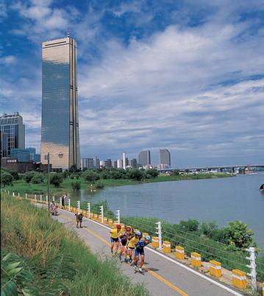

**Attractions**

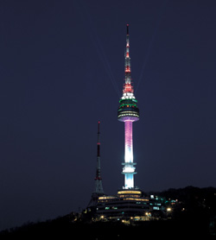

**\* COEX**

It is located on top of Namsan Mountain and is a place where you can get fine views of Seoul. It was opened to the public in 1980. Since then, it has been popular place to relax for Seoul citizens. There is lighting show every night in N Seoul tower and it begins at 5PM until 11PM with various color presentations. The lighting show of N Seoul tower is very impressive and it is one of the must-see attractions when you visit Seoul.

**\* N Tower**

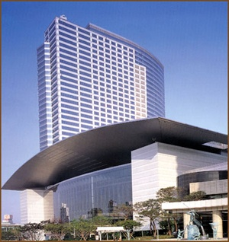

The COEX building serves as the World Trade Center Seoul that includes a convention center, exhibition hall, and mall. It is a place for international conferences and cultural and arts events. COEX mall constitutes many other leisure places such as Aquarium, Megabox Movie Theater, Kimchi field museum, event court, and food court. Especially, Aquarium has more than 40,000 fish of 600 species and dozens of large sharks. You will see the extensive Kimchi displays and have opportunity to learn about recipes and techniques of Kimchi. If you had a chance to participate in one of international or art events, you probably have been this place already. Countless people visit place daily for various reasons. It is especially very crowded on weekends and holidays.

The Lotte World complex is a theme park bonanza that also abounds with both shopping and entertainment facilities. The Folk Museum offers colorful insight into Korea’s 5000-year history, while the indoor grounds of Lotte World is filled with specialty boutiques, toy stores that will delight children of all ages, and a large, reputable Lotte Department Store on one end of the mall and a bargain hunter’s Lotte Mart on the other. Lotte World remains a popular shopping and leisure destination for parents with small children.

**\* Lotte World**

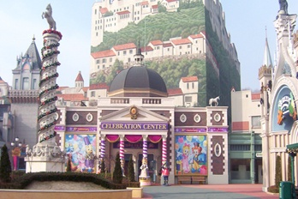

**\* Insadong**

[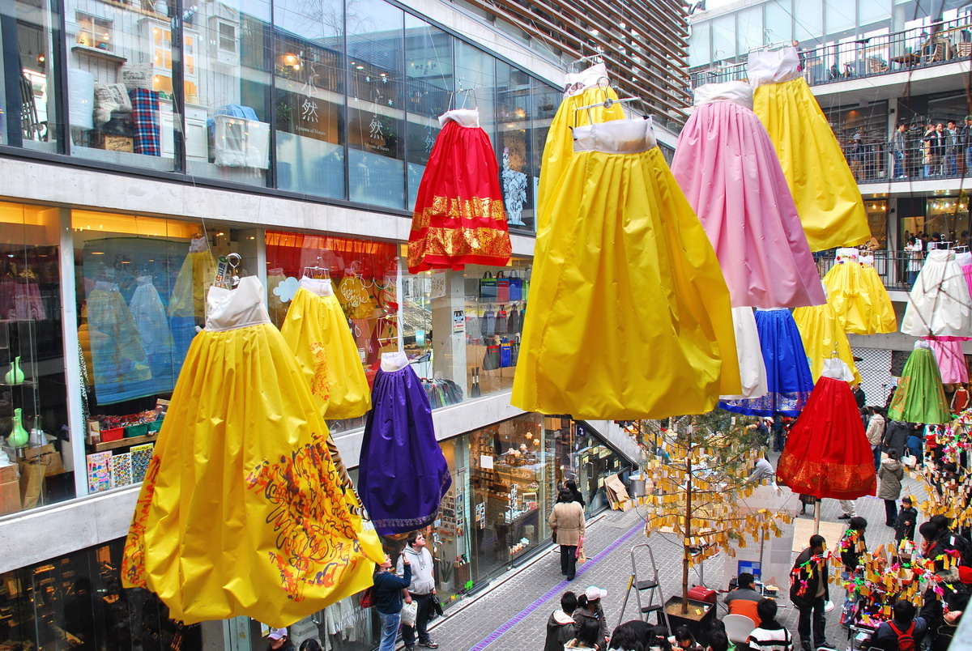](javascript:self.close())

Because it is the largest market of traditional Korean art and products, Insadong is the ideal place for visitors who want to experience the true character of Korea with its subtle, enduring beauty. Once you are in Insadong, you will immediately be drawn to the small alleys lined with numerous shops and galleries, both tiny and spacious: antique shops, Korean stationery stores, frame shops, handicraft shops, pottery and porcelain shops, bookstores and painting studios, and art supply stores. In addition, restaurants and cafes serve traditional food and teas. Recently, a shuttle bus service linking galleries in different parts of Seoul has started running between Insadong and Pyeongchangdong.

ANNEX 7

(to TSB Collective letter 2/3)

***Meeting of ITU-T SG3  
Seoul, Korea (Rep. of), 17-21 May 2010***

*Hotel Reservation Form*

**Please fill out this form and send it to the hotel \*\*contact person**

**by fax or email no later than 15 April 2010**

**Family name: First name:**

**Organization:**

**Country:**

**Telephone: Fax:**

**Email:**

**Check-in date: Check-out date:**

**No. of days of stay: days Number of persons: persons**

|  |  |  |  |  |  |
| --- | --- | --- | --- | --- | --- |
| **Hotel** | **Room Rate** | | | **\*\*Contact Person** | **Remarks** |
| **The Ritz-Carlton, Seoul**  **(Venue)** | Superior Deluxe | Double bed ( )  Twin bed ( ) | KRW 150,000 | **Ian Kim**  [ian.kim@ritzcarlton.com](mailto:Ian.kim@ritzcarlton.com)  Tel: +82-2-3451-8220  Fax: +82-2-3451-8282 | Breakfast is not included  \*Breakfast : KRW20,000 per person  Yes( ) No ( ) |
| Balcony Deluxe | Double bed ( )  Twin bed ( ) | KRW 190,000 |
| **Novotel Ambassador Gangnam** | Standard | Double bed ( )  Twin bed ( ) | KRW 140,000 | **David Kim**  [nagsales1@ambatel.com](mailto:Nagsales1@ambatel.com)  Tel: +82-2-531-6666  Fax: +82-2-562-0120 | Breakfast is not included  \*Breakfast : KRW20,000 per person  Yes( ) No ( ) |

\* The above room rates are excluded 10% VAT and 11% service charge.

\* The above room rates are excluded breakfast.

\* All rates are quoted in KRW (Korean Won). The exchange rate for US Dollar is subject to change.

\* This room rate is specially discounted for the ITU-T Meetings.

\* Hotel rooms must be guaranteed using a credit card; for cancellations, any reservation must be canceled 3 days before the arrival date to avoid paying a “no-show” charge.

**Please encircle one *of the following:***

**VISA, MASTERCARD, AMERICAN EXPRESS, DINERS CLUB, etc.**

**Credit card no.: ………………………………..*……* *Expiry date: …………………………………***

***Name of cardholder: ………………………………………………………………………………………***

**Signature**: ………………………………………………………………………………………….

ANNEX 8

(to TSB Collective letter 2/3)

***Meeting of ITU-T SG3  
Seoul, Korea (Rep. of), 17-21 May 2010***

Request for letter of invitation for issuing VISA

Should you require a personalised invitation letter in order to obtain your entry visa to Korea, please return this form duly completed to **no later than 18 April 2010** to:

Ms. Sesoon Oh  
 Email: [sg3@tta.or.kr](mailto:sg3@tta.or.kr)  
 Phone: +82 31 724 0085  
 Fax: +82 31 724 0109

|  |  |
| --- | --- |
| **Family Name** |  |
| **Given Name** |  |
| **Date of Birth (yyyy/mm/dd)** |  |
| **Gender** |  |
| **Company (Individual Member)** |  |
| **Nationality** |  |
| **Passport Number** |  |
| **Mailing Address**  **(With postal code)** |  |
| **Expected entry date** |  |
| **Expected departure date** |  |
| **Tel.** |  |
| **Fax.** |  |
| **E-mail** |  |

\_\_\_\_\_\_\_\_\_\_\_\_\_\_\_\_