|  |  |
| --- | --- |
| **电信标准化局** | **logo_C_** |
|  |  |

2010年2月22日，日内瓦

|  |  |  |
| --- | --- | --- |
| 文号： | **电信标准化局第2/3号集体函** |  |
| 电话： 传真：  电子 邮件： | +41 22 730 5887 +41 22 730 5853  [tsbsg3@itu.int](mailto:tsbsg3@itu.int) | 致国际电联各成员国主管部门、 ITU-T部门成员和参加第3研究组 工作的ITU-T部门准成员 |

|  |  |
| --- | --- |
| 事由： | **第3研究组的会议 2010年5月17-21日，韩国首尔** |

尊敬的先生/女士：

1 根据国际电联电信标准化部门2010年的会议安排（见2009年12月14日第80号电信标准化局通函），我谨通知您，第3研究组（包括相关电信经济及政策问题在内的资费及结算原则）将自2010年5月17日至21日在韩国首尔丽思卡尔顿酒店（Ritz Carlton）召开会议。

第一天的会议将于09:30开始。与会者的注册工作将自08:30开始。有关会议厅安排的具体信息将在会议地点入口处的电视屏幕上显示。

2 根据现行有关规定，该会议将提供口译服务。

3 由主席起草的议程草案见本函**附件1**。各工作组的议程草案见本函**附件2**至**附件4**。

4 由主席及其管理团队起草的时间表草案见本函**附件5**。

5 有关会议的其它信息见本函**附件6**。

6 根据A.1建议书（2008年，约翰内斯堡）的规定，有关研究组工作的文稿应提交电信标准化局（TSB）。电信标准化局在会议召开日的至少十个日历日以前收到的文稿将发布在第 3 研究组的网站上。因此，此类文稿必须在**2010年5月6日之前**寄达电信标准化局。按照现行规定，对于在会议开始日至少两个月之前收到的文稿，可以应要求予以翻译。

欢迎与会者以第3研究组主页上提供的网上提交表格或电子邮件的方式向以下地址提交文稿：[tsbsg3@itu.int](mailto:tsbsg3@itu.int)。详尽指南见ITU-T网站。

我们大力提倡您使用已制作出的一套模版，它们既能够使ITU-T文件的格式保持一致，又可以方便文件制作、提高效率。这些模版可以在ITU-T各研究组网页中的“代表资源”（Delegate resources）（[http://www.itu.int/ITU‑T/studygroups/templates/index.html](http://www.itu.int/ITUT/studygroups/templates/index.html)）处找到。

为了解决与文稿有关的问题，请在文稿上注明联系人的姓名、传真和电话号码以及电子邮件地址。因此，务请在所有文件的首页注明这些细节。

7 为了便于电信标准化局进行文件制作和会议组织方面的必要安排，我希望您能通过信函、传真（号码：+41 22 730 5853）或电子邮件（[tsbreg@itu.int](mailto:tsbreg@itu.int)%20%20)）的方式尽早、但**不迟于2010年4月18日**将代表贵主管部门、部门成员、部门准成员、区域性组织和/或国际组织或其它实体出席会议的人员名单发至我处，同时，希望各主管部门注明其代表团团长（如果有副团长，亦盼一并注明）的姓名。

8 **请注意，ITU-T会议的与会者只能通过ITU-T网址进行网上预注册：**[**http://www.itu.int/ITU-T/studygroups/com03/index.asp**](http://www.itu.int/ITU-T/studygroups/com03/index.asp)。

9事先通过报名表要求得到纸质文件的实际到会的与会者，将仅收到会议开始3天前**（2010年5月14日）**至会议结束时公布在ITU-T网站上的文件。

为在会议期间合理分发文件，特在此提醒工作组成员，他们将仅收到那些与之有关的文件。因此，请在报名表上详细注明您希望参加的工作组。

10 鼓励与会者以电子方式开展工作，并由此有助于减少会议所需的用纸数量。敬请知悉，主要会议厅区域设有无线局域网设施，可供代表使用。

对于在丽思卡尔顿酒店住宿的与会者，可提供笔记本电脑租赁服务。详情请查阅本通函**附件6**。

11 请注意，对于安排有口译服务的会议，只有当成员国**至少在会议召开的一个月前**通过报名表或向电信标准化局（TSB）提出专门要求时，才可能提供口译服务。务请遵守报名表规定的截止日期，以便于电信标准化局做出口译方面的必要安排。

12 本函**附件7**中有一份酒店预定单，供参考（酒店列表见**附件6**）。务请在**2010年4月15日前**预定酒店。

13 我们谨在此提醒您，与会者应尽早向距您最近的韩国领事代表机构查询是否需要获得签证才能入境韩国。如与会者需要发给个人的邀请函才能获得签证，必须填妥**附件8**中的表格并**最迟在2010年4月18日前**将其返回给主办方的联系人。

负责协助提供签证的人员的联系方式如下：

Sesoon Oh女士  
TTA  
电话：+82 31 724 0085  
传真：+82 31 724 0109  
电子邮件：[sg3@tta.or.kr](mailto:sg3@tta.or.kr)

顺致敬意！

电信标准化局主任  
 马尔科姆•琼森

**附件**：8 件

ANNEX 1  
(to TSB Collective letter 2/3)

***Meeting of ITU-T SG3  
Seoul, Korea, 17-21 May 2010***

***Draft agenda***

**1 Opening plenary meeting**

1.1 Opening of the meeting

1.2 Adoption of the agenda and other administrative issues

1.3 Results of SG3 work and follow-up actions

1.4 Progress reports on the work of the regional groups

1.5 Results of other ITU meetings related to Study Group 3

Results of the meetings of other study groups related to Study Group 3

1.6 Examination of documents available

1.7 Procedural notifications

**2 Closing plenary meeting**

2.1 Reports of the meetings of Working Parties, Questions, and ad hoc groups

Results of the workshops

2.2 Approval of Recommendations under TAP

2.3 Determination of Recommendations under TAP

2.4 Deletion or renumbering of Recommendations

2.5 Approval or deletion of Supplements

2.6 Liaison statements

2.7 Recommendation status and work plans

2.8 Dates of future meetings

2.9 Other business

2.10 Closure of the meeting

ANNEX 2  
(to TSB Collective letter 2/3)

***Meeting of ITU-T SG3  
Seoul, Korea, 17-21 May 2010***

***Draft agenda for Working Party 1/3***

1 Opening of the meeting

2 Adoption of the agenda

3 Inventory of available documents

4 Review of Working Party 1/3 activities and approval of report of previous meeting

5 Examination of study items

5.1 Mobile Communications

5.2 “IP Telephony”

5.3 International Internet Connectivity, including IP peering and cost of provision of services

5.4 Traffic Flow Multifactors and Internet Traffic Flow Methodology

5.5 Next Generation Networks (NGN)

5.6 Accounting and settlement based on IP Data Records (IPDR)

5.7 Charging and accounting principles associated with enhanced signalling

5.8 Other charging, accounting, and economic issues arising out of use of next-generation networks and any future development

6 Liaison issues

7 Other business

8 Closure of the meeting

ANNEX 3  
(to TSB Collective letter 2/3)

***Meeting of ITU-T SG3  
Seoul, Korea, 17-21 May 2010***

***Draft agenda for Working Party 2/3***

1 Opening of the meeting

2 Adoption of the agenda

3 Inventory of available documents

4 Review of Working Party 2/3 activities and approval of report of previous meeting

5 Examination of study items

5.1 Mobile Communications

5.2 Mobile Termination Rate

5.3 Fixed Termination Rate

5.4 Flat Rate for Mobile

5.5 Flat Rate for Fixed

5.6 Flat Rate for Fixed to Mobile and vice-versa

5.7 Accounting and Settlement Rates for Fixed

5.8 Alternative Accounting Procedures (e.g. changes in deadlines for settlements)

5.9 Mobile Roaming

5.10 Tariff Issues for Cross-Border Connectivity for Mobile

5.11 Tariff Issues for Short Message Service (SMS) and Multimedia Messaging Service (MMS)

5.12 Leased Line Tariff

5.13 Transit Traffic

5.14 Alternative Calling Procedures (e.g. call-back, re-file)

5.15 Guidelines Based on International and Regional Practices for Resolution of Disputes Regarding Charging (e.g duration, origin of traffic, etc.)

5.16 Accounting and Settlement Procedures, including their Evolution

6 Liaison issues

7 Other business

8 Closure of the meeting

ANNEX 4  
(to TSB Collective letter 2/3)

***Meeting of ITU-T SG3  
Seoul, Korea, 17-21 May 2010***

***Draft agenda for Working Party 3/3***

1 Opening of the meeting

2 Adoption of the agenda

3 Inventory of available documents

4 Review of Working Party 3/3 activities and approval of report of previous meeting

5 Examination of study items

5.1 Policy and Economic Issues

5.2 Network Externalities

5.3 Universal Service Obligations

5.4 Impact of the Choice of Accounting Rate Currency

5.5 Impact of Convergence of Services

5.6 International Telecommunication Regulations

5.7 Revenue Protection Mechanisms

5.8 Misuse of Facilities and Services (see WTSA Resolution 20)

5.9 Financial Aspects of Network Security

6 Liaison issues

7 Other business

8 Closure of the meeting

ANNEX 5  
(to TSB Collective letter 2/3)

***Meeting of ITU-T SG3  
Seoul, Korea, 17-21 May 2010***

***Draft Timetable***

|  |  |  |  |  |  |  |  |  |  |  |  |
| --- | --- | --- | --- | --- | --- | --- | --- | --- | --- | --- | --- |
|  | **Monday 17 May 2010** | | **Tuesday 18 May 2010** | | **Wednesday 19 May 2010** | | **Thursday 20 May 2010** | | | **Friday 21 May 2010** | |
|  | **am** | **pm** | **am** | **pm** | **am** | **pm** | **am** | | **pm** | **am** | **pm** |
| ***Plenary*** | X |  |  |  |  |  |  | |  | X | X |
| ***Q.1/3*** |  | X |  |  |  |  |  | |  |  |  |
| ***Q.2/3*** |  |  | (1) | X |  |  |  | |  |  |  |
| ***Q.3/3*** |  |  |  |  | X |  |  | |  |  |  |
| ***Developing country issues*** |  |  |  |  |  |  | X |  |  |  |  |
| ***Ad-hoc meetings*** |  |  |  |  |  | (2) |  | (2) | (2) |  |  |

X: Meetings scheduled

(1) Workshop on SMS services

(2) Ad hoc meetings will be scheduled as needed

**Notes:**

(a) The Management Team will meet on Sunday, 16 May

ANNEX 6  
(to TSB Collective letter 2/3)

***Meeting of ITU-T SG3  
Seoul, Korea (Rep. of), 17-21 May 2010***

***Practical information***

**I Venue Information**

**Venue: The Ritz-Carlton Hotel, Seoul**

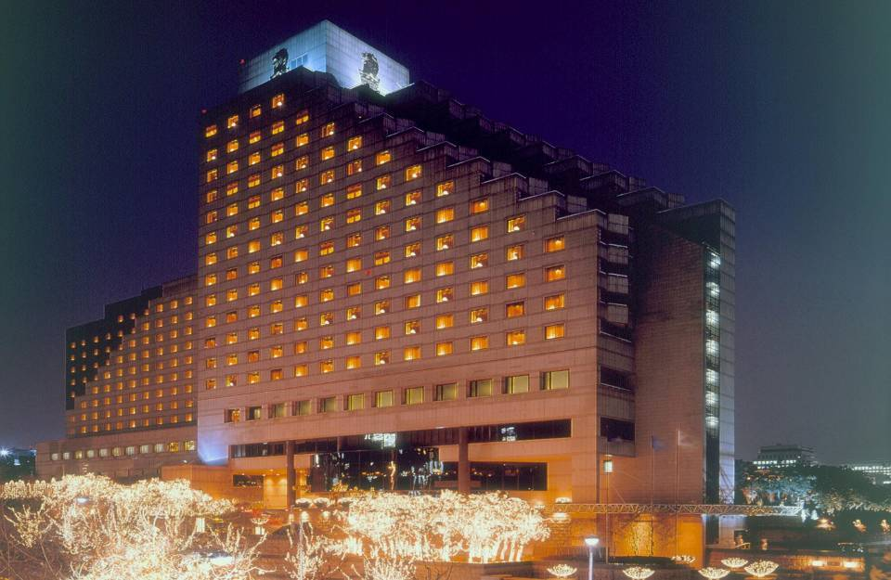

Address: 602 Yeoksam-Dong, Gangnam-Gu, Seoul, 135-080, Korea

Phone: +82-2-3451-8000 (indicate “ITU-T” as group name)

Fax: +82-2-3451-8188 (indicate “ITU-T” as group name)

Email: [ian.kim@ritzcarlton.com](mailto:ian.kim@ritzcarlton.com) (indicate “ITU-T” as group name)

Website: [**http://www.ritzcarltonseoul.com**](http://www.ritzcarltonseoul.com)

**Floor Information (A3)**

**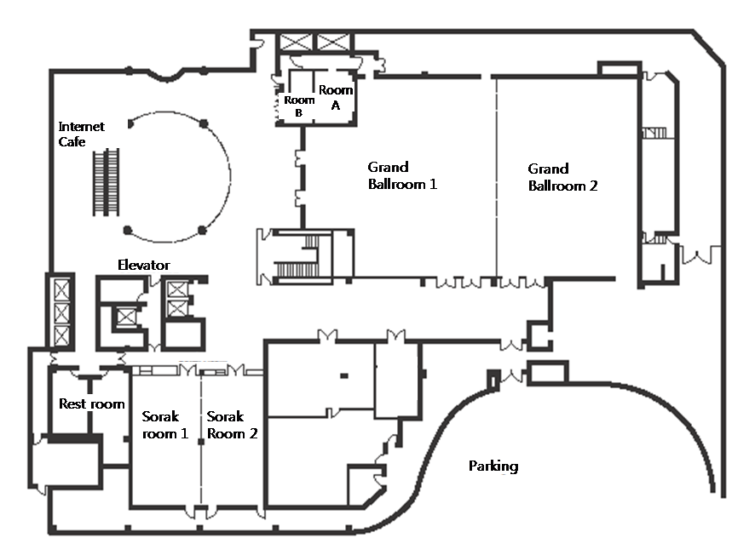**

1. Meeting room: Grand Ballroom 1
2. Small mtg room: Sorak room 1
3. Chairman room: Room A
4. ITU-T Secretariat: Room B
5. Local Secretariat: Sorak room 2
6. Banquet: Grand Ballroom 2

**II Hotels**

|  |  |  |
| --- | --- | --- |
| **Hotel** | **Room** | **Rate** |
| The Ritz-Carlton, Seoul  (★★★★★), **Venue** | Superior Deluxe | KRW 150,000 |
| Balcony Deluxe | KRW 190,000 |
| Novotel Ambassador Gangnam (★★★★★) | Standard | KRW 140,000 |

The Ritz-Carlton, Seoul, is located in the thriving commercial and residential district of Gangnam and minutes from the COEX exhibition centre, World Trade Centre, department stores, designer boutiques and Olympic Stadium.

* Korea has blocked 120 rooms at The Ritz-Carlton, Seoul, for the ITU-T SG3 Meeting. Since hotel rooms shall be assigned on a first-come, first-served basis, early reservation is recommended.
* To guarantee your reservation, your credit card information is necessary in making a one-night deposit. The total hotel fees shall be charged directly by the hotel upon check-out.
* The hotel should be informed of any and all changes or cancellations regarding room reservation via email or fax.
* Any changes or cancellations regarding room reservation should be informed by e-mail or faxed to the hotel.
* Korea has blocked maximum 30 rooms at Novotel Ambassador Gangnam which is located next The Ritz-Carlton, Seoul.

Internet Service at the Ritz-Carlton, Seoul

The Ritz-Carlton, Seoul provides high-speed Internet service to guests who are using laptops (Plug & Play System). Simply plug the Internet connection line into the plug jack. Payments for Internet use will be automatically added to your room. In addition, The Ritz-Carlton, Seoul provides a laptop rental service at Business Center. Rental fee for one hour is KRW 20,000 (Exclusive VAT) and for 24 hrs use KRW 120,000 (Exclusive VAT). Internet Access fee is KRW 23,000 (Exclusive VAT, for 24hrs). Please inquire when making a reservation or upon arrival at the check-in counter. This service will be charged separately from your room bills.

Tourist Office

The Ritz-Carlton, Seoul Guest Relations  
Tel.: +82-2-3451-8293

**Hotel Reservation and Cancellation**

Reservation requests should be received no later than **15 April 2010**. Hotel rooms must be guaranteed using a credit card. For cancellations, the reservation must be canceled **3 days prior to the arrival date** to avoid paying a “no-show” charge. Rooms shall be assigned on a first-come, first-served basis. Room availability and rate after 15 April 2010 may not be guaranteed.

**III Travel Information**

**1 Visa**

Any foreign visitors wishing to enter Korea must have a valid passport. Tourists may visit Korea for 15 days without a visa, but proof of confirmed round air reservation is required. However, some countries require visas to enter the Republic of Korea. For more information, please visit the Ministry of Foreign Affairs and Trade at [**www.mofat.go.kr**](http://www.mofat.go.kr).

**2 Currency & Exchange**

The Korean currency unit is the WON (indicated ￦). Bank notes are ￦50,000, ￦10,000, ￦5,000, ￦1,000 bills and coin denominations are ￦500, ￦100, ￦50, ￦10. Money can be exchanged at Incheon International Airport, banks, and hotels:  
[**http://www.keb.co.kr/IBS/english/fx/rate/average/index.jsp**](http://www.keb.co.kr/IBS/english/fx/rate/average/index.jsp).

Approximative exchange rate as of November 2009:

USD 1 = ￦1,200

**3 Weather**

The Weather in May is usually warm. The average temperature is 20~24°C (68~75.2°F). For more detailed climate information, please contact the Korea Meteorological Administration at [**http://www.kma.go.kr/**](http://www.kma.go.kr/).

**4 Electricity**

The standard supply is 220 volts with AC/60 cycles. Outlets for 220 volts are available at the hotels.

The two following outlets are compatible with those available in Korea.

a) This is popularly known as the europlug which is described in CEE 7/16

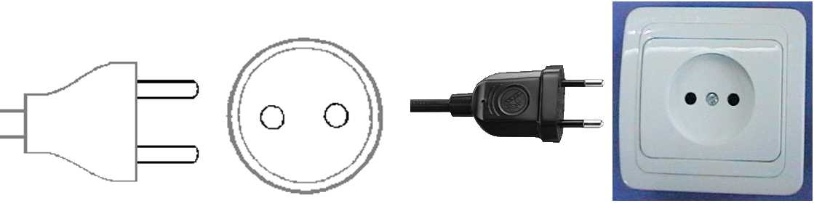

b) This plug is similar to the above except that it is round and has the addition of two grounding clips on the side of the plug

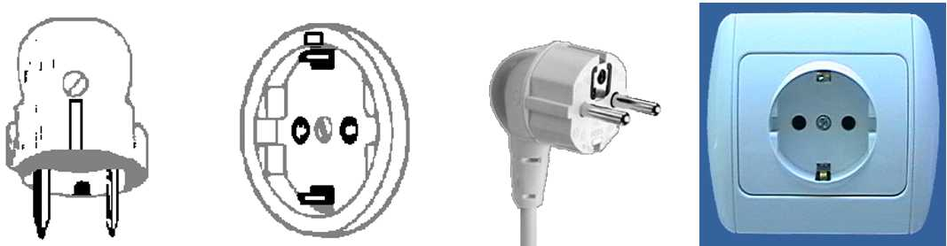

5 Telephone Calls

A local calls cost ￦70 for three minutes. To make an international call, first dial the international dialling code(001, 002 or 00700), then the country code, area code, and the local telephone number. You may also rent a cellular phone at the Incheon International Airport.

**6 Emergencies**

Police----------------------------------112  
Fire Department----------------------119  
Medical Emergencies ---------------1339

**7 Business Hours**

Government offices are open from Monday to Friday between 0900h and 1800h.

Most private businesses open some time between 0830h and 1000h and are open continuously until the evening.

Banks are a major exception. Their business hours are from 0900h to 1600h on weekdays. They are closed during weekends.

Foreign diplomatic missions in Seoul generally maintain strict business hours including lunch. They are usually open from 0900h to 1700h on weekdays and are closed on Saturdays and Sundays.

Major departments stores are usually open from 1030h to 2000h, including Sundays, but smaller shops tend to be open earlier and close later every day of the week.

**8 Automated Teller Machines (ATM) for Foreign Traveller**

Travellers who carry internationally recognized credit cards can get a cash advances in Korean won at Automated Teller Machines (ATMs) installed at airports, major hotels, department stores, subway stations and tourist attractions.

**9 Tipping**

Tipping is not a traditional Korea custom. A 10% service charge is added to your bill at all tourist hotels and 3-10% at some big restaurants.

**10 Tax**

Value-added tax (VAT) is levied on most goods and services at a standard rate of 10% and is included in the retail price. In tourist hotels, this 10% tax applies to meals and other services and is added into the bill.

**11 Mail**

Domestic postal rates are ￦190 for a letter of up to 25g, ￦1,490 for registered letter of no more than 25g, and ￦1,500 or ￦2,000 for a package of up to 2kg. A postcard costs ￦160.

Korea post: [**www.koreapost.go.kr**](http://www.koreapost.go.kr).

**12 Newspaper, TV and Radio**

There are three English-language dailies. The Korea Times, the Korea Herald, and the International Herald Tribune Joongang Daily. They are available at most news stands and in most hotel gift shops.

Korea has fine TV networks, all broadcasting in Korean (KBS1, KBS2, MBC, SBS, and EBS). Along with the national broadcasting networks, there are also many cable TV channels specializing in a wide field of programming including news, movies, entertainment, sports, etc. Of note is Arirang TV, a special English channel produced in Korea (cable channel #50). The channel features programming in politics, the economy, community, and culture, providing insight and understanding about things Korean through popular TV serial dramas with English subtitles. Some 90 hotels in Korea offer Arirang TV on cable or satellite.

**13 Korea & Korean Tourism**

Please visit the following Websites for more information on Korea and possible tours:

<http://www.kois.go.kr>

[http://www.tour2korea.com](http://www.tour2korea.com )

**14 Local time**

GMT + 9 hours (same as Tokyo time).

**15 Computer Networking**

Each meeting room will be equipped with wireless access (Wireless LAN, supporting IEEE802.11b, 4GHz band) to the Internet. Those who wish to use the wireless access must be equipped with the necessary hardware and correctly configured PC.

16 Airport

The closest airport is the **Incheon** **International Airport**

17 Transportation (From the Incheon International Airport to Ritz Carlton Seoul Hotel)

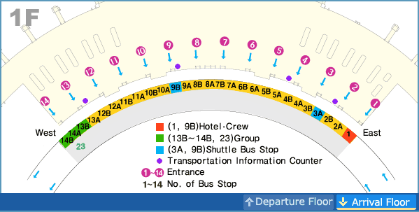

**(1) KAL Limousine Bus**

**- From the Airport to the Hotel**: KAL Limousine Bus No. 3 at the **Bus Stop 4B** (between gate 4 and gate 5)**, 10B** (between gate 10 and gate 11). Bus Fare is 14,000 won and the journey takes around one and half hours. The departure time will change depending on traffic conditions. The distance from the Incheon International airport to the Venue is 70km.

The first bus is at 0515h and last one at 2220h. Average bus interval is 30mns.

- **From the hotel to the Airport**: The first bus is at 0458h and last one at 0658h pm.

- Contact: KAL Limousine Headquarters (02-2667-0386)  
Incheon International Airport Information (1577-2600)

**(2) TAXI**

- Regular taxi stop is number 5 and deluxe taxi is number 21, which are in front of the gate number 7 and 11 respectively.

- The charge of regular taxi from the airport will be around KRW 50,000 ~ KRW 60,000

- The charge of deluxe taxi from the airport will be around KRW 80,000 ~ KRW 90,000

- The journey would take about 70 minutes in normal traffic conditions.

- No reservations are necessary.

- If you plan to take a taxi, please show the following note to the taxi driver:

|  |
| --- |
| **강남 리츠칼튼 호텔에 데려다 주세요.**  **(Please take me to The Ritz-Carlton Hotel.)** |

**(3) Car Rental**

If you want to arrange a car pick up service from our hotel rent car, the rate will be KRW 140,000 per car. Our driver will be waiting for the guests in front of hotel

**Location (map and directions)**

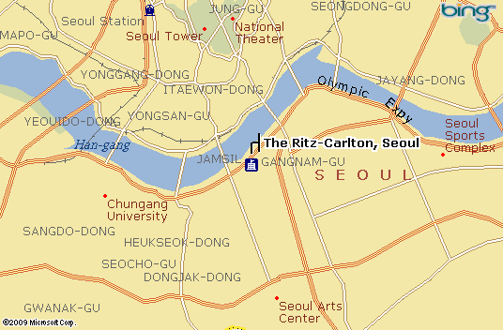

[**Map of the Seoul Subway**](http://211.54.2.50/eng/smt/lineMap/lineMap_index.jsp)

**[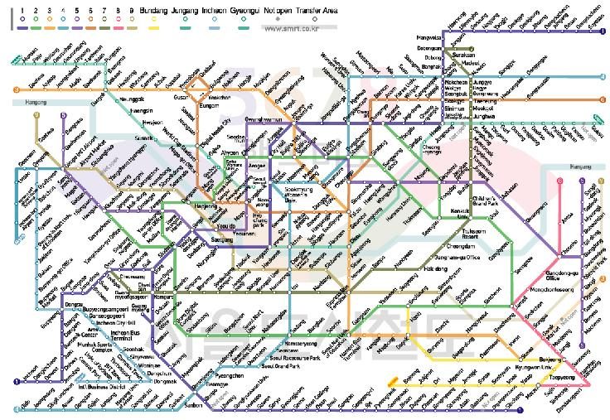](http://211.54.2.50/eng/smt/lineMap/lineMap_index.jsp)**

**About Korea & Seoul**

**Korea**

Korea is proud of 5,000 years of history through which a unique culture has flourished. Modern Korea is a nation that has rebuilt itself from the devastation of the Korean war and has achieved an economic miracle in just 50 years. The Korean peninsula extends southward from the eastern end of the Asian continent and is approximately 1,000 km long and 216 km wide at its narrowest point.

**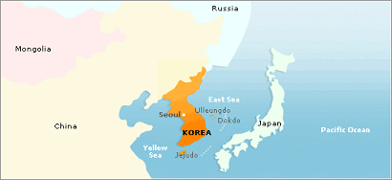**

**Seoul**

Seoul is a city of contrasts. From ancient palaces with centuries of history to high-tech skyscraper of steel and glass, from ancient texts dating back millennia to the highest rate of broadband Internet access in the world, Seoul is a place where the old and new exist in harmony. With one foot in the past and another in the future, Seoul is a city that never ceases to amaze.

Seoul is also the center of the so-called “Korean Wave” sweeping Asia. As Korean dramas, film and music reach a wider audience abroad, more and more visitors are coming to Seoul to experience first-hand the city’s rich culture and make use of its extensive cultural facilities.

Due to the division of the nation and the proximity of the DMZ with North Korea just an hour’s drive away, some might think Seoul to be a somewhat risky place to visit. Foreign news reports aside, nothing could be further from the truth---Seoul is one of the safest places in the world for foreign travelers, with low levels of crime, a hospitable population, cutting-edge medical facilities and capable police and security authorities. Seoul’s security situation, in fact, has never been better.

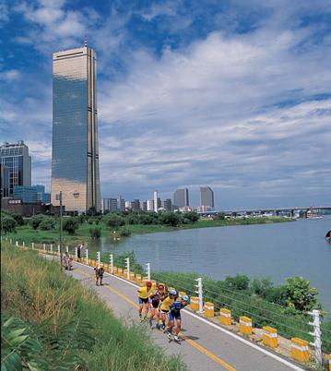

**Attractions**

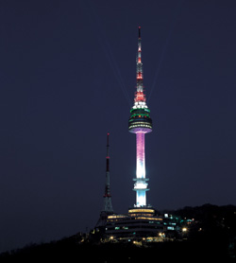

**\* COEX**

It is located on top of Namsan Mountain and is a place where you can get fine views of Seoul. It was opened to the public in 1980. Since then, it has been popular place to relax for Seoul citizens. There is lighting show every night in N Seoul tower and it begins at 5PM until 11PM with various color presentations. The lighting show of N Seoul tower is very impressive and it is one of the must-see attractions when you visit Seoul.

**\* N Tower**

**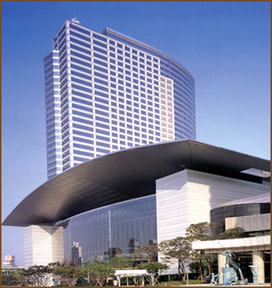**

The COEX building serves as the World Trade Center Seoul that includes a convention center, exhibition hall, and mall. It is a place for international conferences and cultural and arts events. COEX mall constitutes many other leisure places such as Aquarium, Megabox Movie Theater, Kimchi field museum, event court, and food court. Especially, Aquarium has more than 40,000 fish of 600 species and dozens of large sharks. You will see the extensive Kimchi displays and have opportunity to learn about recipes and techniques of Kimchi. If you had a chance to participate in one of international or art events, you probably have been this place already. Countless people visit place daily for various reasons. It is especially very crowded on weekends and holidays.

The Lotte World complex is a theme park bonanza that also abounds with both shopping and entertainment facilities. The Folk Museum offers colorful insight into Korea’s 5000-year history, while the indoor grounds of Lotte World is filled with specialty boutiques, toy stores that will delight children of all ages, and a large, reputable Lotte Department Store on one end of the mall and a bargain hunter’s Lotte Mart on the other. Lotte World remains a popular shopping and leisure destination for parents with small children.

**\* Lotte World**

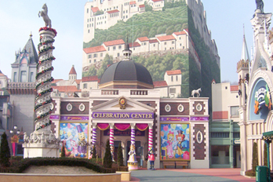

**\* Insadong**

[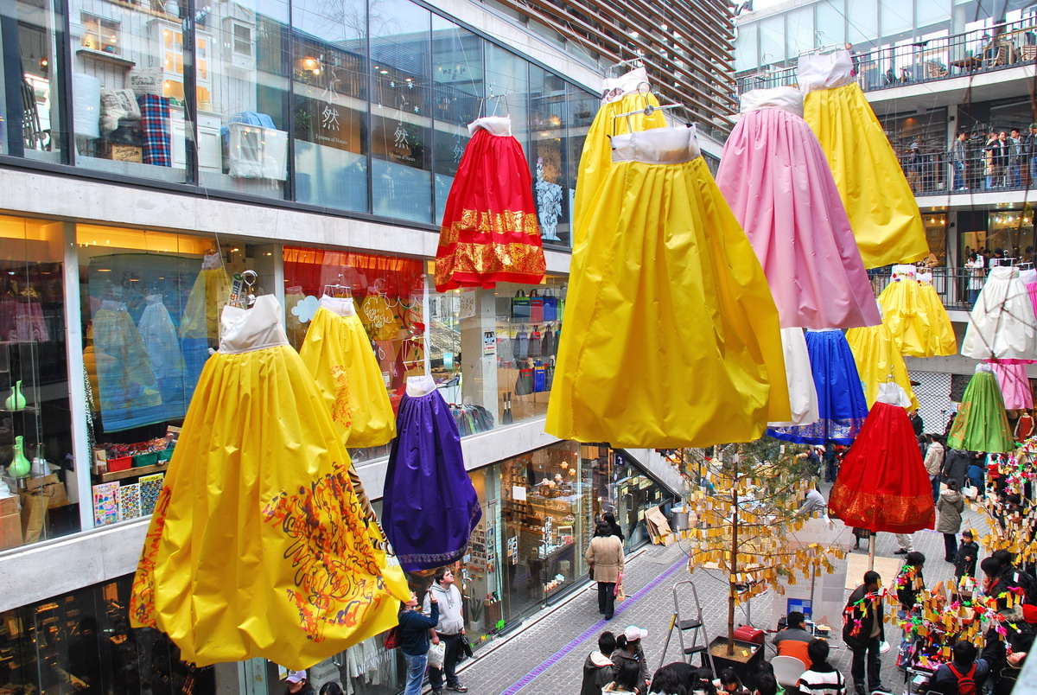](javascript:self.close())

Because it is the largest market of traditional Korean art and products, Insadong is the ideal place for visitors who want to experience the true character of Korea with its subtle, enduring beauty. Once you are in Insadong, you will immediately be drawn to the small alleys lined with numerous shops and galleries, both tiny and spacious: antique shops, Korean stationery stores, frame shops, handicraft shops, pottery and porcelain shops, bookstores and painting studios, and art supply stores. In addition, restaurants and cafes serve traditional food and teas. Recently, a shuttle bus service linking galleries in different parts of Seoul has started running between Insadong and Pyeongchangdong.

ANNEX 7

(to TSB Collective letter 2/3)

***Meeting of ITU-T SG3  
Seoul, Korea (Rep. of), 17-21 May 2010***

*Hotel Reservation Form*

**Please fill out this form and send it to the hotel \*\*contact person**

**by fax or email no later than 15 April 2010**

**Family name: First name:**

**Organization:**

**Country:**

**Telephone: Fax:**

**Email:**

**Check-in date: Check-out date:**

**No. of days of stay: days Number of persons: persons**

|  |  |  |  |  |  |
| --- | --- | --- | --- | --- | --- |
| **Hotel** | **Room Rate** | | | **\*\*Contact Person** | **Remarks** |
| **The Ritz-Carlton, Seoul**  **(Venue)** | Superior Deluxe | Double bed ( )  Twin bed ( ) | KRW 150,000 | **Ian Kim**  [ian.kim@ritzcarlton.com](mailto:Ian.kim@ritzcarlton.com)  Tel: +82-2-3451-8220  Fax: +82-2-3451-8282 | Breakfast is not included  \*Breakfast : KRW20,000 per person  Yes( ) No ( ) |
| Balcony Deluxe | Double bed ( )  Twin bed ( ) | KRW 190,000 |
| **Novotel Ambassador Gangnam** | Standard | Double bed ( )  Twin bed ( ) | KRW 140,000 | **David Kim**  [nagsales1@ambatel.com](mailto:Nagsales1@ambatel.com)  Tel: +82-2-531-6666  Fax: +82-2-562-0120 | Breakfast is not included  \*Breakfast : KRW20,000 per person  Yes( ) No ( ) |

\* The above room rates are excluded 10% VAT and 11% service charge.

\* The above room rates are excluded breakfast.

\* All rates are quoted in KRW (Korean Won). The exchange rate for US Dollar is subject to change.

\* This room rate is specially discounted for the ITU-T Meetings.

\* Hotel rooms must be guaranteed using a credit card; for cancellations, any reservation must be canceled 3 days before the arrival date to avoid paying a “no-show” charge.

**Please encircle one *of the following:***

**VISA, MASTERCARD, AMERICAN EXPRESS, DINERS CLUB, etc.**

**Credit card no.: ………………………………..*……* *Expiry date: …………………………………***

***Name of cardholder: ………………………………………………………………………………………***

**Signature**: ………………………………………………………………………………………….

ANNEX 8

(to TSB Collective letter 2/3)

***Meeting of ITU-T SG3  
Seoul, Korea (Rep. of), 17-21 May 2010***

Request for letter of invitation for issuing VISA

Should you require a personalised invitation letter in order to obtain your entry visa to Korea, please return this form duly completed to **no later than 18 April 2010** to:

Ms. Sesoon Oh  
 Email: [sg3@tta.or.kr](mailto:sg3@tta.or.kr)  
 Phone: +82 31 724 0085  
 Fax: +82 31 724 0109

|  |  |
| --- | --- |
| **Family Name** |  |
| **Given Name** |  |
| **Date of Birth (yyyy/mm/dd)** |  |
| **Gender** |  |
| **Company (Individual Member)** |  |
| **Nationality** |  |
| **Passport Number** |  |
| **Mailing Address**  **(With postal code)** |  |
| **Expected entry date** |  |
| **Expected departure date** |  |
| **Tel.** |  |
| **Fax.** |  |
| **E-mail** |  |

\_\_\_\_\_\_\_\_\_\_\_\_\_\_\_\_