INTERNATIONAL TELECOMMUNICATION UNION |  | Focus Group on ICT&CC
TELECOMMUNICATION  STANDARDIZATION SECTOR |  | FG ICT&CC-DOC-14
English only
Original: English
 |  | Hiroshima, Japan, March 24, 2009
Document
Source: | Editor’s Group of Deliverable 3:  Yoh Somemura (NTT), Chairman  Takeshi Origuchi (NTT), Editor  Gilbert Buty (Alcatel-Lucent), Co-editor  Didier Marquet (France Telecom), Co-editor  Willem Vereecken, (Ghent University), Co-editor  Yong-Woon KIM (ETRI), Co-editor  Hans-Otto Scheck (Nokia Siemens Networks), Co-editor
Title: | Draft Text of Deliverable 3, “Methodology”, March 24, 2009

Draft text of deliverable 3: Methodology

Scope

In this section, we describe the proposed methodology of the Focus Group. The methodologies cover the assessment of the green house gas (GHG) emission of the ICT sector over the entire life cycle of ICT devices. Additionally, we propose methods for increasing the efficiency of the ICT sector and reducing global GHG emission through the adoption of ICTs in other relevant sectors.

Relevant metrics and units

Measuring climate and energy impact

There is more than one single metric to express the progress made by the ICT sector in the climate-change-related domain.

As a prerequisite, the results should be expressed in ISO 1000 (ICS 01 060) units to avoid confusion.

The metric system is chosen, as it is the internationally recognized system.

Power unit: 1 W = 1 kg m² s⁻³
- Energy unit: 1 J = 1 Ws

- 1 kWh= 3,600,000 J
- 1 TOE = 41.868 GJ, or 11,630 kWh

Climate change is internationally recognised as a consequence of anthropogenic greenhouse gas emissions, which can be measured in tonnes of CO2-equivalent (tCO2e). The Kyoto proposal stated 6 major greenhouse gases: Carbon dioxide (CO2), Methane (CH4), Nitrous oxide (N2O), Sulfur hexafluoride (SF6), HFCs, and PFCs. Each has different Global Warming Potential (GWP) values for 100 years time horizon as follows:But this progress is also very dependant on carbon fuel use as measured in oil equivalent tons (toe).

- Carbon dioxide (CO2) = 1 CO2e
- Methane (CH4) = 25 CO2e
- Nitrous oxide (N2O) = 298 CO2e
- Sulfur hexafluoride (SF6) = 22,800 CO2e
- HFC-23 (CHF3) = 14,800 CO2e
- PFC-14 (CF4) = 7,390 CO2e[Kim: reference]

ICT essentially consumes electricity in its use phase, which produces waste heat. This consumed energy, also termed direct energy use, is expressed in kWh, Joule, or toe. Using direct energy units is typically less subject to conversion factor variations, which is important for ensuring reliable intermediate calculations of environmental impact.

During the production phase, typically it is more accurate to consider the direct energy as a fundamental and intermediate value for the ICT environmental impact assessment method, since this is a stable and tangible indicator for all stakeholders and is easily expressed in kWh and cost. Other indicators, such as GHG emissions, are converted data that can be understood with complementary information because they are very dependent on both the manufacturer location and the industrial process solutions. As an example, heat can come from coal, but also from sun or agri-fuel, and plastic can come from oil or be replaced by vegetal. Similarly, when considering the energy mix in a country, a coal plant can be replaced by hydro-electric, solar, or wind energy plants.

These arguments also apply when considering the use phase where electricity is essentially used (France Telecom Group’s environmental report indicates that more than 70% of the energy used during this phase is electricity), and the GHG emissions will depend a lot on how electricity is produced. Energy consumption is also the result of hardware technologies or architecture and software implementation. Improvements in these two areas can have a direct impact on energy consumption, which can be easily measured. The methodology of measurements can be standardized in order to obtain reliable results and produce further benchmarks.

When considering the ICT impact on other sectors, the final or direct energy consumed is also a good choice, since it can be used to easily express the gain for end users.

For example, a teleconference should save on transportation, which can be expressed in kilometres. Here again, it seems better to continue using direct energy, since significant changes are expected in the future in vehicle technologies and in the fuel production process (agri-fuel, oil from coal, etc.). It should be possible to use the average distance for one trip, which is the more direct variable, and then convert it to a chosen unit for energy usage or GHG emissions with the relevant conversion macro-coefficients (to be provided at the national, regional, or worldwide level).

Additionally, direct energy is the best intermediate value for ICT impact assessment is the fact that legislation and standards are mainly based on power or energy data. The European Codes of Conduct (CoC), the Energy using Products Directive, and other regulations require effort and put targets in power levels expressed in Watts (Broadband CoC), efficiency (Data Center CoC), or power supply adaptors (CoC, Energy Star, etc.).

The ICT industry has data available on power consumption measured in Watts for their equipment as well as figures on the savings made on power consumption compared to the equipment of former generations.
From a practical point of view, measurement tools (power meters etc.) exist and make it possible to measure the power consumption of equipment. These tools provide results in Watts and are used similarly by all the stakeholders. Should macro-economic analysis be needed to assess the energy consumption of a family of products, the ICT industry can establish pre-defined use profiles for the given product family. Such profiles could then enable the conversion of a product’s instant power consumption features (W) into typical product energy consumption over a given time period (kWh).

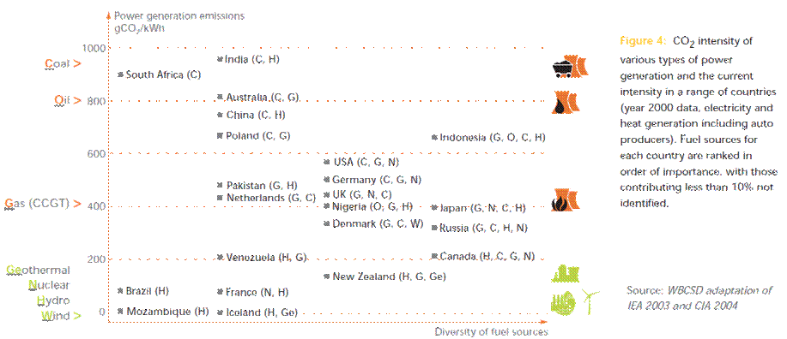
Figure 7.2-1 CO₂ intensity of various types of power generation

The GHG emissions generated when using a product depend largely on the country/region where the equipment is used. There are many ways of producing electricity (hydro power, nuclear power, wind turbines, etc.) that have different levels of GHG emissions per kWh. Thus, a given piece of equipment will generate different GHG emissions when used, for example, in France, China, or South Africa (Fig. 7.2-1).
For this reason, it is not practical for the ICT industry to assess the global warming impact of its products in using a GHG emissions indicator, as its value would depend on the place where the product will be used.

The focus group proposes to use energy expressed in kWh as the unit instead of GHG emissions.

Correlation between economical and environmental aspects
One should consider that when reducing the CO2 emissions of the ICT sector with regard to the 1990 levels this is extremely challenging since the industry has grown with several orders of magnitude. This clearly indicates that when reviewing specific sectors or technologies the factor of economical benefit should be accounted for. We therefore propose two different performance indicators:

- Energy per service
- Earnings per emission for a specific service

The energy per service can be roughly calculated from the energy per bit figures and the average volume (number of bits) for a given service. For example the popular mobile short messages cause an average CO2 emission of about 30mg CO2 per SMS, a mobile phone call of 30 minutes results in about 400g CO2 emission. Similar figures could be calculated for fixed networks accordingly. Based on the higher energy consumption of mobile networks, a voice call on a fixed network emits less CO2e, however, that doesn’t take into account the availability and as such the value of the call. The second indicator “earnings per emission per service” would take the value of the transported bits into account. As an example we take again the SMS: the earning per emission value of an SMS is ~0.1€/30mg = 3€/g. The value per mobile voice call of 0.5h would be roughly 0.01-0.02€/g, while a 0.5h call on a fixed line could be ~0.1€/g for a traditional call and ~0.01€/g for internet telephony.

The figures become particularly interesting if we compare them with the trading price of CO2 emissions of ~10€/tCO2 (http://climatecorp.com/pool.htm) we realize the tremendous value gain from the telecom industry:

 | SMS | Mobile call | Fixed call | Carbon trading
Earnings per kg CO2 | 10³ | 10-20 | 10-100 | 10⁻²

With other words, CO2 emissions resulting from traditional telecom services create ~1’000 -100’000 times the revenue than simple CO2 trading. In a similar way we could calculate and compare services from other industries. The above performance indicator could be one way to measure the economical benefits vs. their environmental impact of different industries.

Methodologies for ICT impact assessment

The GHG emissions impact assessment of ICT solutions should be made using LCA methodology, which has been identified as the most capable of providing such exhaustive information. Such methodology has to follow the ISO 14040 series, which currently has the most recognized guidelines, and the UK BSI PAS 2050 for conversion in GHG emissions. Moreover, ISO 14064 is used for accounting and reporting the results. The focus group has made a liason with ATIS which has produced the “Energy Efficiency for Telecommunication Equipment: Methodology for Measurement and Reporting” documents. They provide a uniform method for measuring telecommunication equipment energy consumption. [REF: IPCC Report http://www.ipcc.ch/pdf/assessment-report/ar4/wg1/ar4-wg1-chapter2.pdf ]

The most fundamental requirements of above mentioned methodologies are:
- The extraction, production, transportation, use, and disposal phases in the life cycle assessment shoud be covered. However, the phases having negligible effect on the assessment may be ignored.

- Preferably the same functional units should be used when comparing ICT and non-ICT services. (e.g., a videoconference and physical meeting as a “1 hour face-to-face” functional unit). When functional units cannot be equal, similar ones should be used and the limitations should be clearly defined and their impacts highlighted.
- When performing the LCA the following tasks are to be covered: Measurement, Quantification, Reporting, Verification and Validation.

For LCA and GHG calculations general methodologies are available which will not be discussed in this document. Moreover, a

Heuristic and iterative method rather than a very systematic investigation is required in order to assure consistency in results.

Particular attention should be given to the quality of data used by the LCA, either coming from a verified database or collected from the supply chain.

    - Impact of own GHG emissions

In this section, we focus on ICTs own emissions.
Studies have demonstrated that more than half of these emissions could originate from life cycle phases other than the use phase. While these estimations are very rough, they make clear that Life Cycle Assessment is an indispensable tool measuring ICTs own GHG emissions.
Moreover, ICTs are typically distributed systems. An ICT system is usually very large and encompasses data centers, access networks, backhaul networks, user equipment, etc. When evaluating a technology, the technology located at these different premises must be taken into account.

Measurement & Quantification

The proposed methodology for GHG emission assessment of ICT is based on LCA. It starts from individual products and covers the emissions in all phases of the product’s life cycle: material extraction, manufacturing, transportation, use, and disposal. The analysis can then be extended to higher levels, such as networks, services, companies, etc.
LCA is a bottom-up methodology. This means that a modular approach is to be used when analyzing complex systems. This requires the following elements.
- A clear functional unit

- A clear time unit relative to which the results are expressed
- Relevant and international physical units.

When performing an LCA, one will typically divide an entity into smaller entities on which the LCA is performed in turn. This iterative process is executed until functional units are obtained for which
- the LCA can easily be performed, and
- the LCA is already available.
In the latter case, the LCA used can be obtained from other sources. For example, a switch manufacturer will require LCA information from the manufacturers that provide him with components. This requires a traceable and homogenous methodology.

The boundaries of the LCA should be homogeneous in all phases. The most straightforward is limiting the depth of investigation to the primary impact of the ICT devices. For example, when considering transportation, one includes the impact of transporting the devices but not secondary impacts, such as those from building roads and trucks used to deliver the ICT devices.

Modular LCA methodology

When initiating an LCA, the scope needs to be determined. This means defining the
- entity for which LCA is executed,
- boundaries of the LCA, and
- level of detail that is required.
For the entity, the functional unit and time unit are defined. All results are projected relative to this functional unit and time unit.
The entity is divided into modules. These modules encompass the different life cycle stages and components of which the entity consists. For each of the modules, one defines the following.
- Initial or investment impact: This is the impact the module has already caused. Its result will be based on the previous modules.
- Life impact: This is the impact of using the module. It contains both direct elements and indirect elements. The indirect elements are elements that do not immediately emit GHG but can be considered as a root cause of GHG emissions. A typical example is electricity consumption.
- Projected impact: This consists of the elements that will cause emissions in the future. A typical example is the power consumption by the system load function.
In this stage, it is important to define these impacts but it is not yet required to estimate them. It is also possible that one or more of the above elements are not applicable for a certain module. Note that these impacts must be projected relative to the functional unit and the time unit [REF].
These modules cover the entire life cycle of the functional unit. The modules are then linked together to comprise the LCA.
A heuristic and iterative algorithm – rather than a very systematic investigation – is used to calculate the LCA.
- Collect data from several sources to get a sound approximation.
- Compare this input to the global cumulated impact. If the impact is significant, a more precise value is required. If not, the rough estimation is kept.
- For those entities for which a more precise value is required,
  - Find more reliable data,
  - Subdivide into more modules for which more precise data can be obtained, or
  - Use a different methodology to obtain the required results.
- The confidence level and error estimation is to be traced through the calculation and communicated in the final result.
This is typically a method of equation system-solving by approximation where there are more unknown variables than equations. It is well known in chemical-reaction-solving, for example.
The following considerations have to be taken into account.
- Black box algorithms are to be avoided. The main problem of LCAs is that we do not have criteria or rules for concrete calculation methods, functional units, and system boundaries when performing the LCA. Sources are sometimes lost, and there are too many conversion coefficients that can change with time, so the global error of the result can be very high.
- The system boundaries should be clearly communicated.

Hierarchical layering of LCAs and input-output analysis

The LCA can be performed on different levels. A consequence of the modular methodology is that any entity can be considered a module for a larger scope LCA. Thus, a hierarchical layering between of the type of functional units becomes clear. This is demonstrated in Figure 7.3-1.

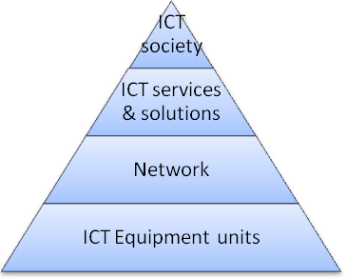 | Hard LCA | Easy  Input-output
 | Difficult LCA | Available  Input-output
 | Available LCA | Difficult  Input-output
 | Easy LCA | Avoid Input-output

Figure 7.3-1 LCA applicability vs. scope

On the lower layers, e.g., equipment units, it is relatively easy to perform LCAs since the scope is very limited. However, as the scope increases, the complexity becomes larger as well. Moreover, the availability of LCAs as input decreases. Hence, the higher the layer, the more difficult it becomes to obtain all available information to perform an accurate LCA.
On a macroscopic level, the top-down methodology of input-output analysis is also available. Input-output analysis is an economical methodology that can be applied for GHG emissions. It determines flows between economical units (countries and sectors), in this case the ICT sector, and the levels of GHG emissions they are accountable for. Due to its top-down character, input-output analysis tends to become more difficult when going into more details, i.e., in lower hierarchical layers.
When performing an LCA on higher layers, it is important to use reliable data. When lower-layer LCAs are not available, input-output analysis data is a good alternative source.

Use phase power consumption

One of the most important aspects in the LCA for ICT is determining the impact of the use phase. This impact is mainly determined by the power consumption of the equipment.
The following information is required:
- Equipment use profiles (to be provided by operators),
- Equipment power consumption as a function of the use profile (to be provided by equipment vendors)

The load of the systems is linked to the equipment use profiles. Equipment is seldomly used at full load. Therefore, it is important that the power consumption be projected in function of the actual load. The definition of this load depends on the type of equipment. For some equipment, the bit rate is a relevant parameter; for other equipment, the number of connected users is relevant.

Telecommunication networks provided by large-scale carriers are consisting of a complex set of systems and network elements in multi-stage architectures resulting in the fact that data flows are transmitted and processed by a number of network elements. In addition, typical telecommunication networks have to fulfil a lot of requirements concerning quality of service: Reliability and stability play a major role in the telecommunications business. Such issues via resilience and protection concepts implicitly contribute to the energy consumption of networks. Furthermore network operators are faced with typical deployment aspects, in particular in the access network, where subscribers are connected following a certain acceptance rate of new services. Therefore during a considerable time from the beginning of the deployment of new network elements they are not fully utilized in terms of used ports. These aforementioned characteristics are examples of network specifics which have to be covered by appropriate power and energy efficiency metrics. Therefore besides the energy consumption view on the network elements a view from the network perspective is necessary.
Energy and power consumption metrics for carrier-grade telecommunication networks should consider the following aspects:
- Average network load and transport volume per unit time
- Network architecture and topology (e. g. multiple network elements are involved into a traffic flow)
- An average across multiple access points, for example a sub-network with N ingress/egress points
- Temporal parallel operation of network segments during migration phases and associated migration concepts
- Resilience and protection concepts
- Degree of utilization of network elements (e. g. in terms of used ports)
- User behaviour (e. g. on and off times) determining the traffic load from the access network up to transport networks to a certain extent
- Protocols and software architectures in network nodes (e. g. IP routers)
- Activation and de-activation of network elements and network sections (e. g. due to temporally varying traffic demands)

Additionally, the power consumption in full load is not sufficient when determining the power consumption in function of the use profile.
A useful method is the energy consumption rating (ECR) and the energy efficiency rating (EER). [REF to CONTRIBUTION 32 OR WEBPAGE]

Reporting
When performing the impact assessment the modular nature of the methodology should be considered and the report should provide a large transparency. Moreover, the focus group suggests the report to be submitted to a verification and/or validation organisation for quality assurance.
An organisation may report GHG emissions from its associated business processes based on the below three scopes identified in the GHG protocol.
- Scope 1: Direct GHG emissions occur from sources that are owned or controlled by the company, e.g., emissions from combustion in owned or controlled boilers, furnaces, vehicles, etc.
- Scope 2: Electricity indirect GHG emissions originate from the generation of purchased electricity consumed by the company.
- Scope 3: Other indirect GHG emissions encompass the treatment of all other indirect emissions. Scope 3 emissions are a consequence of the activities of the company, but occur from sources not owned or controlled by the company. These originate, for example, from equipment the company places at the customer premises or activities outsourced to other companies.

Application of the methodology on specific cases
This section contains contributions submitted to the Focus Group, which are illustrative for the proposed methodology.

[IP network + Mobile Network + Transmission Network + Services + Contrib 54 Section II, II1, II2]

        - Quantification methods for IP network infrastructure

Network perimeter

For this study, it seems more practical that the network perimeter includes equipment and devices used in running the network. Specifically, three classes of equipment are considered.
- Subscriber station: This includes a personal computer (PC), digital service unit (DSU), ADSL modem, and optical network unit (ONU).
- Access network equipment: This includes the metallic cables, optical cables, telephone poles, manholes, conduits, subscriber modules, digital subscriber line access multiplexers (DSLAMs), and optical line terminals (OLTs). The environmental impact of facilities is allocated according to the number of subscribers accommodated by each facility.
- Transfer facility: This includes the optical terminating equipment for users, local area network (LAN) switches, routers, power/air-conditioning facilities, and communication buildings.
Equipment used for maintenance and user management is not included because its environmental impact is considered to be very small.
The assessed life cycle stages include production (including construction), use, and disposal/recycling (including removal of facilities) in the life cycle of each facility.

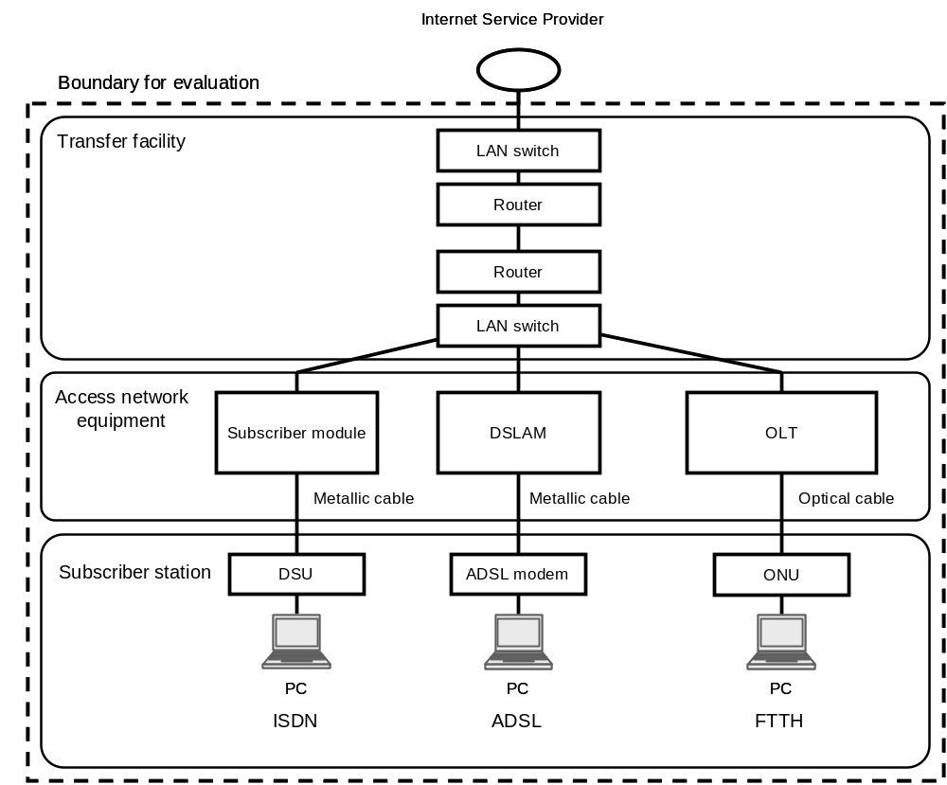
Figure 7.3-2 Evaluation model for IP-based networks.

Quantification procedure

The environmental impact is evaluated by the process sum method (bottom-up approach) referring to generic data (reference unit) on materials composing the ICT devices and facilities composing the network infrastructure.

Quantification method for mobile network infrastructure

Life cycle assessment of 3G mobile communication services in Japan is described as an example based on the basic evaluation method for the environmental impact of the network infrastructure and the above allocation method.

          - Network perimeter

Evaluation targets include equipment and devices for running the network.
The evaluation targets for MSs are cellular phones. As far as the core network is concerned, the local switch (LS), gateway switch (GS), toll switch (TS), wireless protocol conversion gateway (WPCG), and CiRCUS (a general term for a gateway system of the packet data exchange system) are included in the perimeter. It also includes devices, cables, and power/air-conditioning facilities. Equipment used for maintenance and user management is not included because the environmental impact is very small.
The assessed life cycle stages include production (including construction), use, and disposal/recycling (including removal of facilities) in the life cycle of each facility.

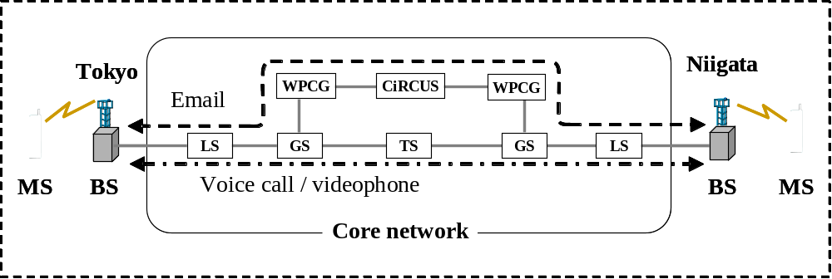
Figure 7.3-3 Evaluation model for W-CDMA-based service in Japan.

Evaluation procedure

In this manner, the evaluation of environmental impact must be divided into a fixed part regardless of the usage situation and a variable part corresponding to the usage situation, which is shown in Figure A.5.1-1. The environmental impact corresponding to the usage time or amount of information of the MS and core network, with the exception of the BS, should be evaluated. This allocation method conforms to the basic evaluation method for the environmental impact of the network infrastructure.
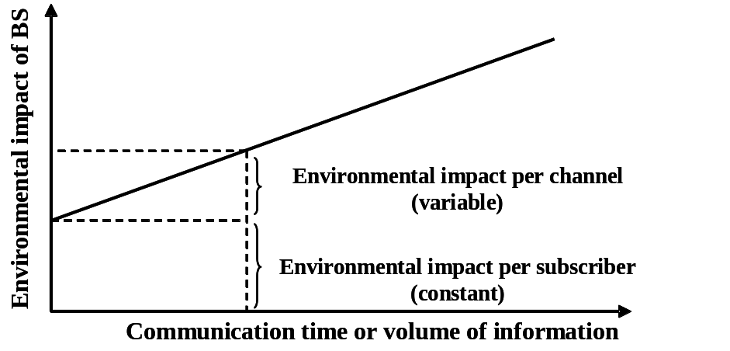
Figure A.5.1-1 Allocation method of environmental impact from BS.

Quantification evaluation method for transmission networks

For a transmission network including optical cables, it could be:
Life energy = Equipment Number × [(individual equipment power × (conversion + cooling coefficient)*8766 + yearly energy for maintenance]
Initial or investment energy = ICT manufacturing / ICT lifetime in year + cable concrete installation energy/m × cable length in m/cable lifetime in year

Quantification for services

Functional units should be chosen that allow a fair comparison between the environmental impact of ICT services and the impact of services ICTs could replace.
Typical functional units could be as follows.
- For an IP based network: “A customer uses the IP-based Internet connection service to access the Internet for x hours and transmits/receives y MB of data each day throughout a year”.
- For mobile networks: “A customer uses the W-CDMA-based service to make or receive voice calls for x minutes and videophone calls for y minutes and to transmit z1 e-mails and receive z2 e-mails by packet data communication each day throughout a year”.
Then, the use is weighted according to the functional or service/product unit over the estimated ICT lifetime for each device. As an example for devices used in teleconferencing services, the unit of use can be a bit quantity during a user time unit (one hour per user). We may estimate the lifetimes as 4 years for a laptop, 6 years for a blade server, 10 years for an Ethernet switch, 15 years for an ADSL cabinet, and 40 years for a copper or optical network. The manufacturing energy is then weighted by the use and the lifetime.
This could be illustrated by the formula
Energy over the considered period = Sum of (mode power × time in this mode) + environment energy consumption (cooling) sometimes expressed as a coefficient (energy conversion efficiency, cooling system performance coefficient, etc.).
On the operational use side, the assessment will be based on a power measurement method in Watts in different modes defined by standards such as ETSI and ATIS. Targets are already defined by the EU code of conduct, rules, or directives.
Then, the energy can be assessed using average user profiles, which define use times in the different use modes.

Use case assessing ICT contribution on energy saving and on fossil CO₂ equivalent emission reduction

The method is first described in general terms to be applied either for a telecom service, a travel or other services. The method is then applied to a specific telecom service of France Telecom. Finally, after studying with the same method the necessary consumptions of the substituted travel, the gain of using the telecom service instead of the travel is determined.

General information

Type of methodology
To achieve these goals the method relies on a process based analysis. Input/Output table approach [4] will not be used except in a first step of estimate and in the absence of readily accessible data, or for small contributions to the energy balance. Because of some drawbacks [5] Input/Output table method can only give an order of magnitude of the energy consumption to obtain a product or a service.

Intermediate variables
In the process analysis, energy consumptions are reported as much as possible in direct energy (electricity, petroleum products, etc). The reason is that the value is directly measured and less affected by conversion error.
For example, in ICT sector, electricity is mainly used by equipment and a convenient unit of energy will be kWh.

Terminology used to describe the method:

- Service or product:
This is the result of one operation or set of operations each requiring some energy consumptions to run.
An end service or end product means more specifically the result of the overall operations under study (the ICT service or the physical service or product that is replaced by ICT service).

A sub-service or sub-product represents an intermediate operation result necessary to achieve the end service, such as a server processing operation.

- Unit of service or product:
This is the reference unit to measure the quantity of a service or a product.

For the end ICT service, the end service unit can be one hour or one Gbit of service per user.

For an end physical service that is replaced, the unit can be one person attending one meeting per travelled km.

For the overall comparison between the telecom service and the physical displacement, another unit might be introduced, for example: one meeting.
This meeting can be caracterized by the required energy consumption integrated over the average duration, the average number of participants and the cumulative travelled distance.

For the sub-service, the unit can be one active hour of a server or one km for one passenger in a car or a plane. For the sub-product, the unit can be one server or one PC or one phone. When an intermediate unit is used, it is necessary to have a clear link of this sub-service unit to the end service unit to be able to make the end calculation.

- Consumption C_{i}:
This is one form i of energy involved for one operation i.e. to manufacture and install the equipment, and then to operate the equipment.

Ci is associated to a sub-service or a sub-product made by the operation. C_{i} is expressed per unit of this production like kWh per manufactured server or kWh per hour of use of one server.

Before its operation life, Ci is the energy to manufacture a device and it will be designated as investment consumption. For ICT, this can be the amount of direct energy (in kWh) to build a server, a network equipment, a CPE, etc. For physical counterparts replaced by ICT service, this can be the energy to produce a sheet of paper, or a car, etc. Because of similarities for the end calculation, consumptions for the device maintenance and its end of life phase are also considered as investment consumptions.

During its operation life, Ci is the energy used for the service and it will be designated as the operational consumption. This is the amount of electricity used by the network, servers, CPE (e.g. in kWh per one hour of use) or the amount of fuel during the car displacement (in kWh of fuel per km).

- Consumption rate R_{i}
This is the energy consumption expressed per unit of the end service like kWh per one hour of the telecom service and per user.
Ri determination from each Ci needs the calculation of the amount of production of the end service Pi associated to Ci.

Ri is calculated by the relationship Ri = Ci/Pi.

- Production Pi
Pi is associated to C_{i} and corresponds to the amount of end service or product that C_{i} will permit.

For instance Pi can be the number of hours of a telecom service achieved by a server or a phone during its life time.

- The overall consumption rate R for an end product or service
R corresponds to the sum of all Ri. The unit of R is the same as the unit of all Ri, i.e. kWh per unit of the end service or product.

Analysis of a service energy consumption

The objective is to assess the service energy consumption rate R (related to one unit of end service). The following steps are necessary for R assessment:

1 Identification of the different sub-systems and required operations for separate studies purpose.
2 Gathering of raw data for each operation to determine their energy consumptions C_{i}.
3. Choice of the unit to express the consumption rates R_{i} based on the end service or product. Introduction of the production P_{i} corresponding to the amount of the end service or product done with Ci and conversion of each C_{i} in R_{i} using P_{i}.
4 Energy efficiency analysis with R_{i}: comparison between R_{i} for different situations, influence of parameters, and final assessment for ICT service (sum of R_{i})

The flow chart in fig. 1 shows the analysis of the service under study. It describes one generic service and gives an illustration by one example of a teleservice: the cooperative telework.
NOTE: Let's consider that the example is not described with full details, there may be for example user of mobile phone, other using old switched phone, other using IP phone.

The flow chart points out a dominant structure of operations in series. The serial form implies mathematical sums of operation consumption rates.

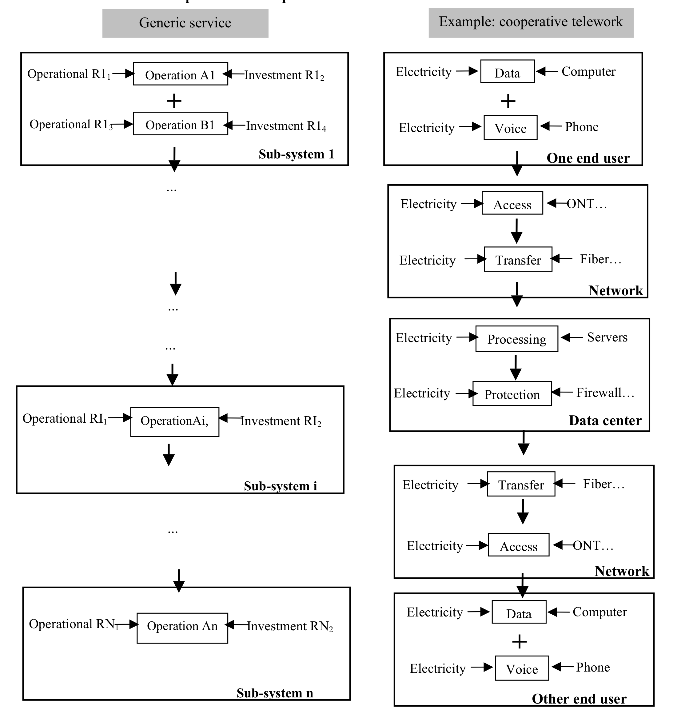
Fig 1: schematic of the method to estimate energy consumption of a service. The generic flow chart is illustrated by one example of a teleservice.
The sign + indicates operations achieved in parallel whereas arrows indicate operations done in series along the flow of services or products corresponding to the end service.
End service or product
- Step 1 Identification of the different sub-systems
The different sub-systems, and for each sub-system the different operations, are identified along with their delimited flow of energy or material. Each sub-system will be studied separately to simplify the analysis. These sub-systems can be the devices at the user level, the network including the access network, or the datacenter with the servers used for the telecom service. Between the sub-systems there is a flow of service or product (for instance flow of data and information to perform the teleservice).

- Step 2 Gathering data
For each operation, the raw data or data as measured (such as the different flows of energy and equipment along with their characteristics), are collected to calculate the end service energy consumption.
The analysis of each operation allows determining the energy consumptions C_{i} of the different sub-systems, being either operational or investment energy consumption. Sensitive parameters for the consumption (like flow of bits or number of servers to perform the service under study) should be identified.
Scientifically or empirically well established relationships may help to identify these parameters. They can also complete information from accessible data.

Important information about data details:
Between different sources of energy assessment, discrepancies on consumptions can arise which are significant compared to the overall consumption. One method to overcome this problem is to derive the same information from different sources where details to establish it are given, or by other means such as the use of established relationships. This may help to evaluate and point out the uncertainty of some data for further improvements and/or for realistic conclusions.

The different energy consumptions Ci are naturally expressed in various units such as kWh per working hour, kWh per device, kWh per bit transferred, kWh per bit per km, etc.
The different C_{i} units express the fact that the various consumptions refers to various sub-services or sub-products and not necessarily to the end service or product.
On the practical side, these values can come from:
- Power (in Watt) of the equipment in a defined operation mode as expressed by the manufacturer - Direct measurement in laboratory or in the field
- Indirect and statistical calculation from long term records (e.g. electricity metering related to user statistics).

- Step 3 Choice of unit
To allow comparison between consumptions and to allow their addition, all C_{i} will be converted to the same chosen service unit of the end service or product. For instance the unit can be one hour of the service for one user (h.user). The chosen unit should be convenient to deal with the different Ci of the service.

NOTE: to draw a comparison with the physical travel that the telecom service will substitute for, another unit of service may be at the end chosen. In particular consumptions for the travel are highly dependent on the distance and so the unit of physical service will reflect this, whereas for the telecom service because of negligible influence on consumptions, distance will be discarded. For comparison between the two services unit of the physical displacement will be chosen as the common one. Because this latter unit will be less convenient to convert the different consumptions of the teleservice, it will be only applied on the overall result.

For each C_{i}, in order to calculate the consumption rate R_{i}, it will be necessary to introduce a new variable: the production Pi, or the amount of units of end service associated with C_{i}.
For instance for a C_{i} in kWh per bit and a unique unit of the end service in h.user, we’ll need to introduce and calculate the P_{i}, which will represent the number of h.user per bit.

Then, the R_{i} in kWh per h.user will be calculated in this way:

R_{i} = C_{i} / P_{i}.

NOTE: the unit of end service can be also the unit of an intermediate service.

For the energy consumption to manufacture a computer, P_{i} is the amount of h.user done with the computer during its life time. In this case the total number of active hours performed on a computer appears to be an important parameter for the consumption rate calculation. To calculate P_{i} one hour of the teleservice may be assumed to be equivalent to any active hour whatever the service performed. The idle and shut down times are not considered productive and so cannot amortize the device manufacturing consumptions.
Parasitic operational consumptions (like during standby mode or transfer of megabyte sized advertising) may be shared out among useful operational consumptions to take into account the full consumptions.

Please refer to figure 1 in chapter II-2 for better understanding of Ri through illustration.

- Step 4 Energy efficiency analysis
At this step all Ri, which are by construction expressed in the same unit (the unit of the end service), are added up directly to obtain the end consumption of the service (R = SR_{i}). They can also be compared to determine which operations contribute most to the overall energy consumption of the service.
A sub-system of the service or one of its operation can be changed for an alternative of known Ri. The exchange of Ri gives the modified overall consumption rate and hence the benefit of the change.
This allows a lot of simulation to assess evolution trends.

Summary
The analysis of the ICT service impacts is based on the calculation of an indicator: the power consumption rate R. All energy consumptions C_{i} of sub-systems and individual operations are normalized in Ri. The advantages of working with Ri are:

- The different consumptions in the form of R_{i} can be directly added,
- With R_{i}, a hierarchy of consumptions can be established to identify the sub-systems or the operations of the service where consumptions are highest and where efforts should be done to improve the accuracy of data. For much smaller consumptions an estimate will be sufficient, provided it is realistic and it is at the high end of possible values,
- The R_{i} hierarchy is also a tool to identify the processes where efficiency must be prioritized.
- The R_{i} calculation forces the introduction of variables P_{i} which appear important parameters to control the energy efficiency of the different sub-system of the service,
- The method with Ri is highly modular. It allows easy simulation of influence of technology evolution just by changing R_{i} values to ones corresponding to new or different technologies.

Example: cooperative telework
Generic service
Operation A1
Operational R1₁
Investment R1₂
Operational R1₃
...
...
Investment R1₄
Data
Electricity
Voice
Computer
+
Access
Electricity
Transfer
Network
Electricity
ONT…
Fiber…
Processing
Electricity
Protection
Electricity
Servers
Firewall…
Data
Electricity
Voice
Electricity
Computer
Phone
+
Access
Electricity
Network
ONT…
Transfer
Electricity
Fiber…
...
...
+

Operation B1
Phone
Electricity
Sub-system 1
One end user

Investment RI₂

Data center
OperationAi,
Operational RI₁

Sub-system i

Operational RN₁
Operation An
Investment RN₂

Other end user
Sub-system n

End service or product

Case study to assess the ICT impact of IP-based networks and mobile networks.

The paragraphs below give some results carried out by ITU Members and Sector Members for certain types of architectures or services.

For IP-based networks

The results of our environmental impact evaluation of CO₂ emissions and energy consumption from the targeted services based on LCA are shown in Figs. A.5.3-2 and A.5.3-3, respectively. “Recovery by recycling” means the indirect effect of recycling on reducing the environmental impact on society; it is indicated as a negative quantity in the evaluation. When the metal in a product is recycled as pig iron, for example, the environmental impact of the recycling is added as a negative number to the “disposal/recycling” stage, while the environmental impact of the lower production of pig iron, which is the product of the weight of pig iron obtained from recycling multiplied by the generic data (reference unit) for pig iron in production, is expressed as a negative number in the “recovery by recycling” stage.
The results of environmental impact evaluation for the targeted services indicate the following.
- CO₂ emissions and energy consumption for the ISDN Internet connection service throughout its life cycle are approximately 83 kg-CO₂/year/subscriber and 0.86 GJ/year/subscriber (including the volume for recovery by recycling), respectively. The breakdowns of CO₂ emissions and energy consumption for this service show that approximately 22% and 36% of the total environmental impact occurred in the production stage, approximately 76% and 67% in the use stage, and about 2% and 1% in the disposal/recycling stage, respectively.
- The CO₂ emissions and energy consumption for the ADSL Internet connection service throughout its life cycle are approximately 107 kg-CO₂/year/subscriber and 1.06 GJ/year/subscriber (including the volume for recovery by recycling), respectively. The breakdowns of CO₂ emissions and energy consumption from this service show that approximately 18% and 30% of the total environmental impact occurred in the production stage, approximately 80% and 72% in the use stage, and about 2% and 1% in the disposal/recycling stage, respectively.
- The CO₂ emissions and energy consumption for the FTTH Internet connection service throughout its life cycle were approximately 57 kg-CO₂/year/subscriber and 0.66 GJ/year/subscriber (including the volume for recovery by recycling), respectively. The breakdowns of CO₂ emissions and energy consumption from this service show that approximately 33% and 50% of the total environmental impact occurred in the production stage, approximately 63% and 52% in the use stage, and about 4% and 2% in the disposal/recycling stage, respectively.

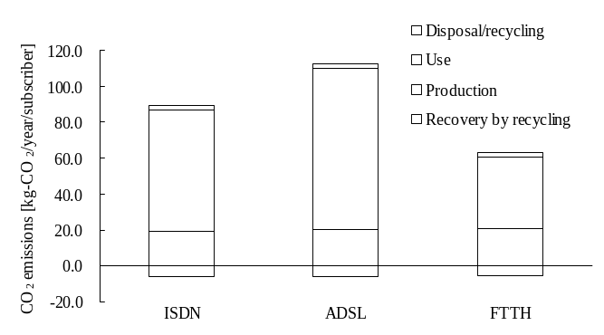
Figure 7.3-5 Results of environmental impact evaluation for IP-based Internet connection services (CO₂ emissions).

For mobile networks

The results of the environmental impact evaluation of CO₂ emissions and energy consumption for the W-CDMA-based service in Japan are shown in Figs. 7.3-6 and 7.3-7, respectively. “Disposal/recycling” includes the indirect effect of recycling on reducing the environmental impact on society, which is indicated as a negative quantity in the evaluation. When the metal in a product is recycled as pig iron, for example, the environmental impact of lower production of pig iron is added as a negative number to the “disposal/recycling” stage, which is the product of the weight of pig iron obtained from recycling multiplied by the generic data (reference unit) for pig iron in production.
CO₂ emissions and energy consumption from the W-CDMA-based service throughout its life cycle are approximately 53 kg-CO₂/year/subscriber and 0.57 GJ/year/subscriber (including the volume for recovery by recycling), respectively. The breakdowns of CO₂ emissions and energy consumption for this service show that approximately 50% and 64% of the total environmental impact occurred in the production stage, approximately 55% and 45% in the use stage, and about -5% and -9% in the disposal/recycling stage, respectively. These environmental impacts from the W-CDMA-based service mainly came from MSs and BSs. The environmental impacts from MSs mainly occurred in the production stage, while the environmental impacts from BSs mainly occurred in the usage stage.

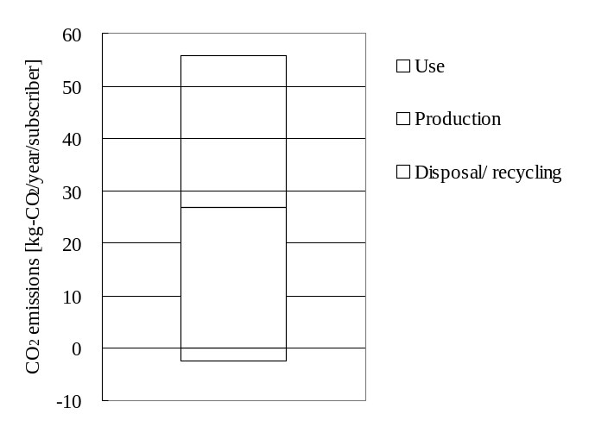
Figure 7.3-6 Results of environmental impact evaluation for W-CDMA-based service (CO₂ emissions).
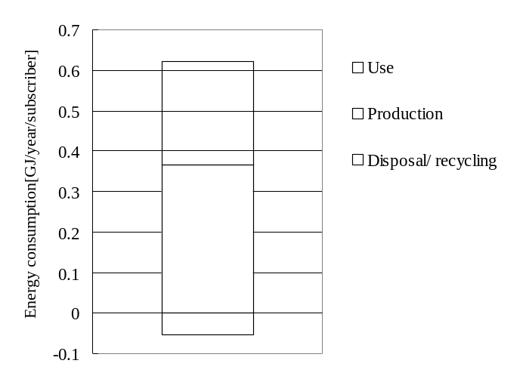
Figure 7.3-7 Results of environmental impact evaluation for W-CDMA-based service (energy consumption).

Impact on other sectors

Measurement & Quantifications

When estimating the impact of ICT on other sectors. The same methodology can be used. However, some key considerations need to be made.

The system that will be replaced by the ICT solution should be clearly defined. It could include systems such as those related to document management, financial accounting, general affairs, and personnel. It should also take into account the resources necessary to achieve the upgrading of administrative management and improvement of work efficiency with the introduction of the ICT system.

The new ICT system should be described to ensure that it is comparable with the system that was replaced. The functional unit, time unit and system boundaries should be the same before and after the introduction of ICT.

A balance between positive and negative effects as a result of introducing the ICT system will be produced. This is displayed in Figure NUMBER
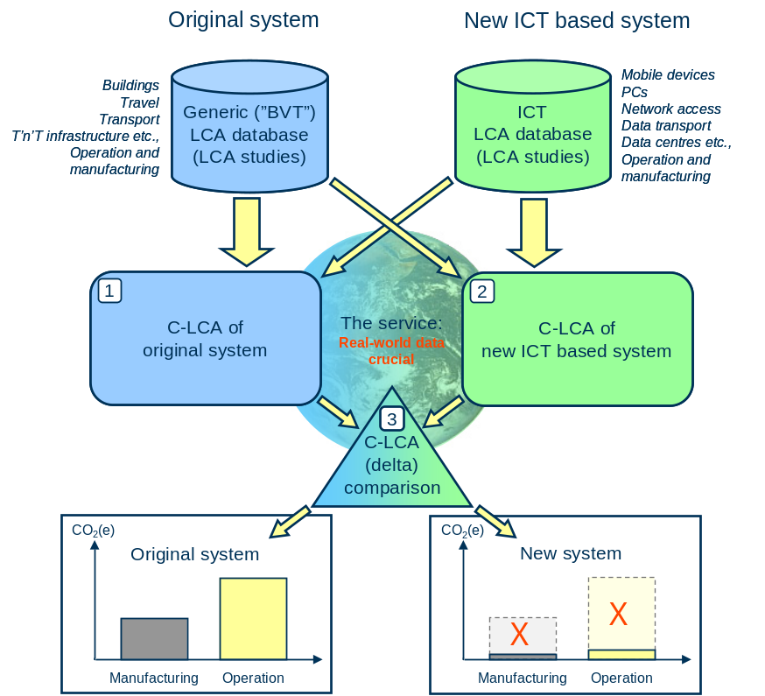
Figure NUMBER Overview of the method for comparing new ICT based systems to original systems that carry out an equal service. (C-LCA = CO₂(e) based life cycle assessment, ICT = Information and Communication Technology, BVT = Building and Vehicle Technology, TT = Travel and Transport)

The rebound effect on consumptions induced by the use of the ICT should be taken into account. The ICT service is not only used to substitute for physical displacements or for materials but has its own added value. Thus, it may induce a higher use rate (and higher energy consumption) than just the replaced use.

Following items should be considered when assessing the replaced systems.

(1) Consumption of goods (paper, CDs, DVDs, etc.)

(Energy reduction) = (Energy consumption to produce one unit of the product) × (Amount reduced)
(E.g., Reduction of paper: (Energy to produce paper (A4 size, 1 sheet) (J)) × (Quantity reduced (Sheets))

(2) Power consumption/energy consumption (electricity, gasoline, kerosene, light oil, heavy oil, town gas, etc.)

(Energy reduction) = (Unit energy consumption for each type of fuel) × (Fuel consumption reduced)
(E.g., Reduction of heavy oil: (Energy per litre of heavy oil (J)) × (Fuel reduced (L))

(3) Movement of people (cars, buses, rail, aircraft, etc.)
(Energy reduction) = (Unit energy consumption per traffic volume (passenger-km) for each transportation means) × (Transportation distance reduced (km)) × (Number of passengers transported (passenger))
(E.g., Reduction of railroad transportation: (Energy consumption per passenger-km (J))
× (Transportation distance reduced (km)) × (Number of transported passengers reduced (passenger))

(4) Movement of goods (mail, trucks, rail cargo, cargo ships, etc.)

(Energy reduction) = (Unit energy consumption for each transportation means (J)) × (Transportation distance reduced (km))
(E.g., Reduction of the number of mails: (Energy consumption per mail (J)) × (Number of mails reduced (mail))
Reduction of truck transportation: (Energy consumption per ton-km (J)) × (Transportation distance reduced (km)) × (Cargo weight reduced (t))

(5) Improved efficiency of office space (electricity, office area, etc.)

(Energy reduction) = (Unit energy consumption) × (Amount reduced)
(E.g., Reduction of office floor area: (Energy consumption per m2 (J)) × (Area reduced (m2))

The typical CO2 emissions per unit area of office space in Japan are shown in the table below.

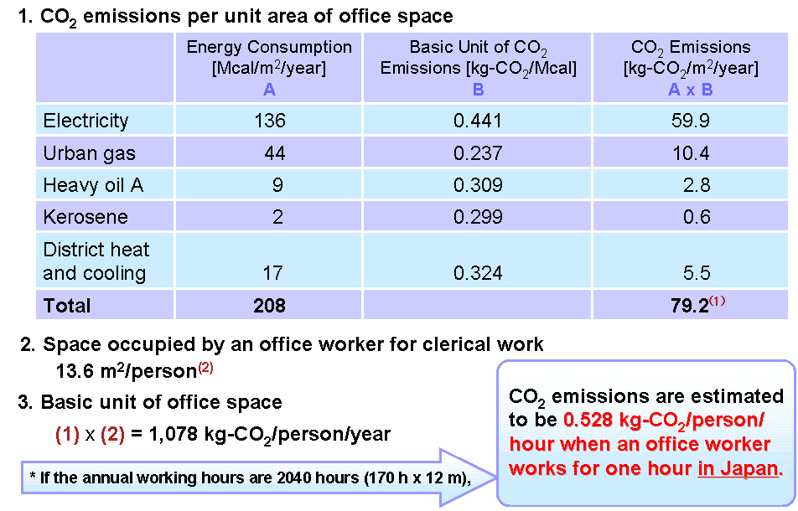

The typical CO2 emissions per unit area of office space in the US are shown in the table below.

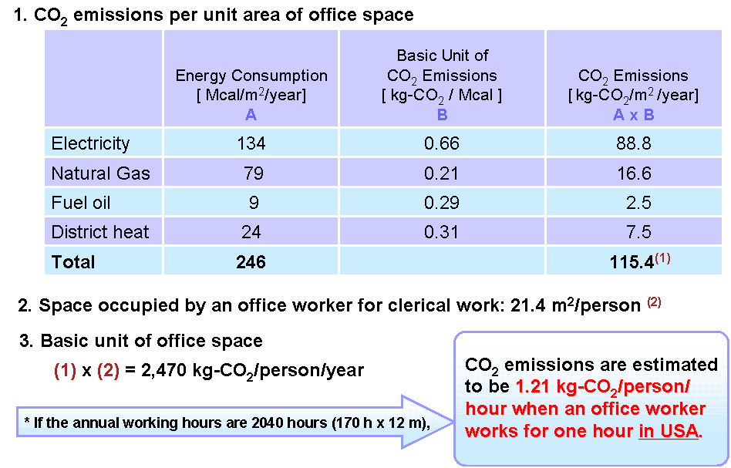

(6) Storage of goods (electricity, warehouse area, etc.)

(Energy reduction) = (Unit energy consumption) × (Amount reduced)
(E.g., Reduction of warehouse area: (Energy consumption per m2 (J)) × (Area reduced (m²))

(7) Improved work efficiency (workload etc.)

(Energy reduction) = (Energy consumption per m2 of office (J)) × (Area used per person (m2)) × (Workload improved (person-year))

(8) Waste (Wastepaper, garbage, plastic, industrial wastes, etc.)

(Energy reduction) = (Unit energy consumption for each type of waste) × (Amount reduced)
(E.g., Reduction of wastepaper: (Energy consumption to dispose of 1 kg of wastepaper (J))
× (Amount reduced (kg))

Reporting
The same considerations as in the previous section still apply when reporting the impacts on other sectors. However, it is important to point out that the reporting should also be compliant with the requirements of the other sectors that are considered.

Application of the methodology on specific cases
This section contains examples of the application of the methodology and use cases that could be considered for application of the methodology.

Cooperative Networks

As an example, France Telecom has developed for its employees a teleservice to enable a cooperative meeting among many participants at different locations through phone and computer connections. The product, Cooperative Network (CN), enables the sharing of electronic documents on computers at a distance.
In 2007, 516,000 conferences over CN took place, each having 4.5 participants on average and being of 1 hour 40 min average duration. Dedicated servers in data centers, both for the computer connection (24 servers) and for the phone connection (11 servers), process and store the information regarding the conference, and process the data transferred. The energy analysis breaks down the system into three sub-systems:
- user level with a phone and a computer,
- network with the fibers and amplifiers, including the access sub-system, and
- dedicated servers and other devices in data centers.

Tables 1(a,b,c) summarize the main results for the energy consumptions of the different sub-systems of the system in the forms C_{i}, P_{i}, and R_{i}.
This is a preliminary result that may be refined later (by taking into account some forgotten parasitic consumptions resulting from, e.g., additions in the ICT dataflow or lighting, heating of empty offices rather than one meeting room, etc., all of them requiring a deep level of analysis).
Each table row gives the consumptions of the various operations or elements of each sub-system (such as a computer or a server). Each element may be associated with an individual operational consumption (flow of energy consumed along the flow of data transferred) and an investment consumption (energy necessary to manufacture a device). The energy consumptions C_{i} are reported in direct energy, usually electricity, except some parts of the investment consumptions.
The service unit is one hour of teleservice for one user (h_{CN}.user). From a survey of several uses of CN, it can be assumed that 1 h_{CN}.user represents presently 0.75 Gbit on average. Hence, for each consumption C_{i}, its P_{i} is calculated in order to determine associated R_{i}.

The investment consumptions have been estimated roughly, sometimes maximized by taking a value in primary energy from a life cycle analysis database. A more accurate analysis can be performed. However, their consumption rates from the first estimate show they are small in comparison to R_{i} at the user level. The corresponding production P_{i} is the number of h_{CN}.user performed by the device during its lifetime. When the device performs different services, the consumption is distributed among them according to their duration or to their weight in bits.

CN Service | Operational consumptions | Investment consumptions
Desktop computer (with cathodic tube ray display) | Ci = 250 W  Ri = 250 Wh/h_{CN}.user | Not considered
Phone (analogical) | Ci = 5 W  Ri = 5 Wh/h_{CN}.user | Not considered
Table 1a: consumption rates of CN service at user level.

CN service | Operational consumptions | Investment consumptions
Computer connection  (24 servers)  (2 × 2 + 22 × 0.7)×1.8 kW | Ci = 310 MWh.year⁻¹  Pi = 3.9 M h_{CN}.user.year⁻¹  Ri = 79 Wh/h_{CN}.user | Ci < 93 = 24 × 3.9 MWh  Pi = 11.6 M h_{CN}.user  (3 years lifetime)  Ri < 8 Wh/h_{CN}.user
Phone connection  (11 servers)  (2 × 700 + 9 x.450)×1.8 W | Ci = 86 MWh.year⁻¹  Pi = 3.9 M h_{CN}.user.year⁻¹  Ri = 25 Wh/h_{CN}.user | Ci < 43 = 11 × 3.9 MWh  Pi = 11.6 M h_{CN}.user  (3 year lifetime)  Ri < 3.7 Wh/h_{CN}.user
Firewalls and switches  (6 F and 20 S)  (6 × 30 + 20 × 100)×1.8 W | Ci = 34 MWh.year⁻¹  Pi = 3.9 M h_{CN}.user.year⁻¹  Ri = 9 Wh/h_{CN}.user | Ci < 18 = 26 × 0.7 MWh  Pi = 11.6 M h_{CN}.user  (3 years lifetime)  Ri < 1.5 Wh/h_{CN}.user
Table 1b: consumption rates of CN service at data center level.

CN service | Operational consumptions | Investment consumptions
Access core network | Ci = 15 W.user⁻¹  Pi = 1 h_{CN}.h⁻¹  Ri = 15 Wh/h_{CN}.user | Ri assumed negligible
Core network  (fibers) | Ci < 0.01 Wh.(Gbit.1000 km)⁻¹  Pi = 4/3 h_{CN}.user.Gbit⁻¹  Ri < 0.01 Wh.(h_{CN}.user.1000 km)⁻¹ | 10 to 100 Gbit.s⁻¹  40 years lifetime  Ri assumed negligible
Table 1c: consumption rates of CN service at core network level.

The investment consumption of the personal computer and the phone are not taken into account if each participant is assumed to already have both devices (which is the case at France Telecom). In an opposing situation, the investment consumption rate for those devices is estimated and added to the overall rate, which is very easy because the method is modular.

The investment consumptions for the core network are assumed to be negligible due to their long lifetime and the large flow of data, hence services, they can support continuously during this time. From Table 1c, it appears that the consumption rate of the element of the core network distance dependent is negligible for a distance of several thousand kilometres (still under detailed study).
The most important contribution of the overall consumption rate arises from the user level. The electrical consumption of a computer or a server is very weakly dependent on the level of activity or flow of bits transferred in active mode. Consequently, a better use of the device close to its capacity allows a smaller consumption rate, as is the case for the servers. This could change for the user, with new hardware and software being very energy aware, especially in the portable world.
The consumption rate of physical travel is reported for 1 km and 1 user to take into account the dependence on the distance. Only the operational consumptions are reported, assuming the infrastructure R_{i} is negligible and the purchase of a car is not due to meeting travel.

NOTE: Regarding the investment consumption of travel, from different sources, the average energy to manufacture a car is found to be equivalent to the fuel consumption of the car to travel 20,000 km, i.e., around 7 to 20% of its operational consumption during its lifetime (100,000 to 300,000 km).

The energy consumption rate is still dependent on the distance. Indeed, according to the distance to be travelled, different modes or sets of modes of transport are used, each mode having a given consumption rate. A survey developed in France is used to derive both the consumption rate of each mode and their share for all the travels types according to the distance. It turns out that the dependence of R_{i} with the distance is relatively small because the R_{i} of the dominant modes of transport is close and efficient modes, such as electric trains or tramways, are yet poorly developed.

To simplify the analysis, all the energy consumption for the cooperative teleservice (CN) is given in electrical form, whereas transport uses only petroleum products. This situation is close to the present one. The overall consumption rates of the physical and ICT services for a meeting are compared in Figs. 7.3-8 to 7.3-10. To carry out this comparison, the consumption rates are integrated over the distance, assuming the travel of only one participant. This assumption is highly favorable for physical travel because the true physical distances are generally higher, e.g., also including local travel to hotels.
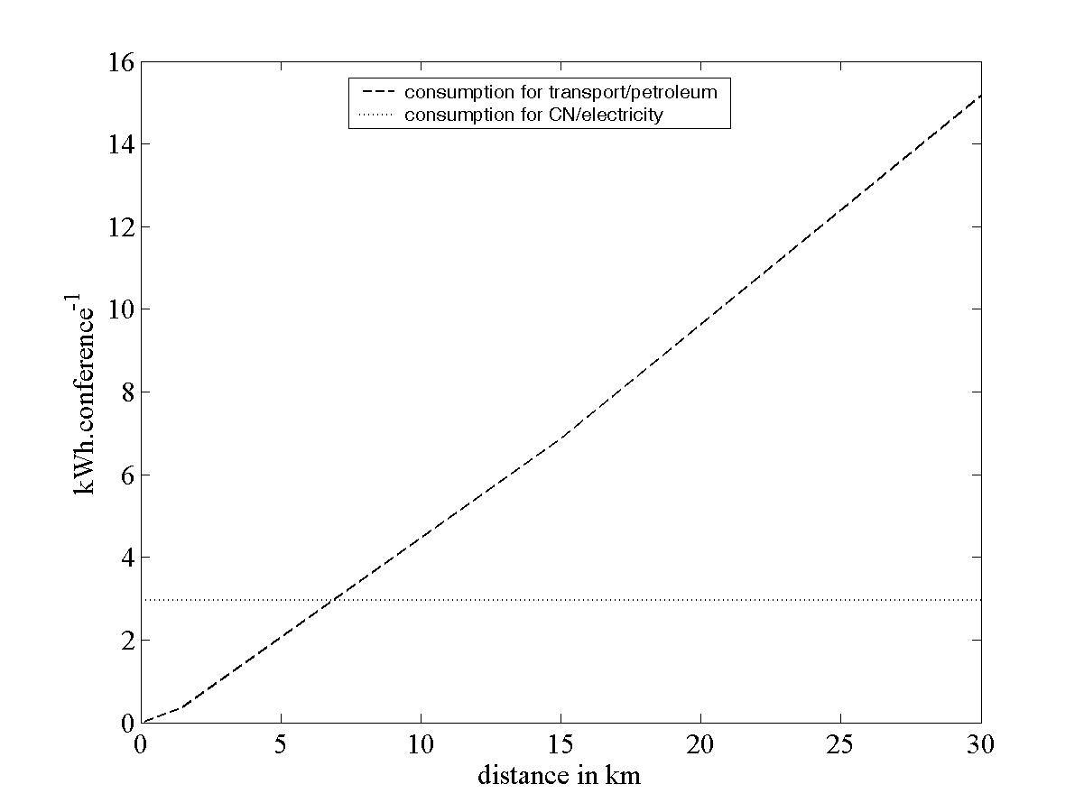
Figure 7.3-8 Comparison of consumptions in direct energy between CN teleservice and travel depending on distance.

The consumption rates are reported in direct energy in Fig. 7.3-8. The distance above which a telecom service can save energy (the breakeven distance) is around 7 km, assuming direct energy parity.
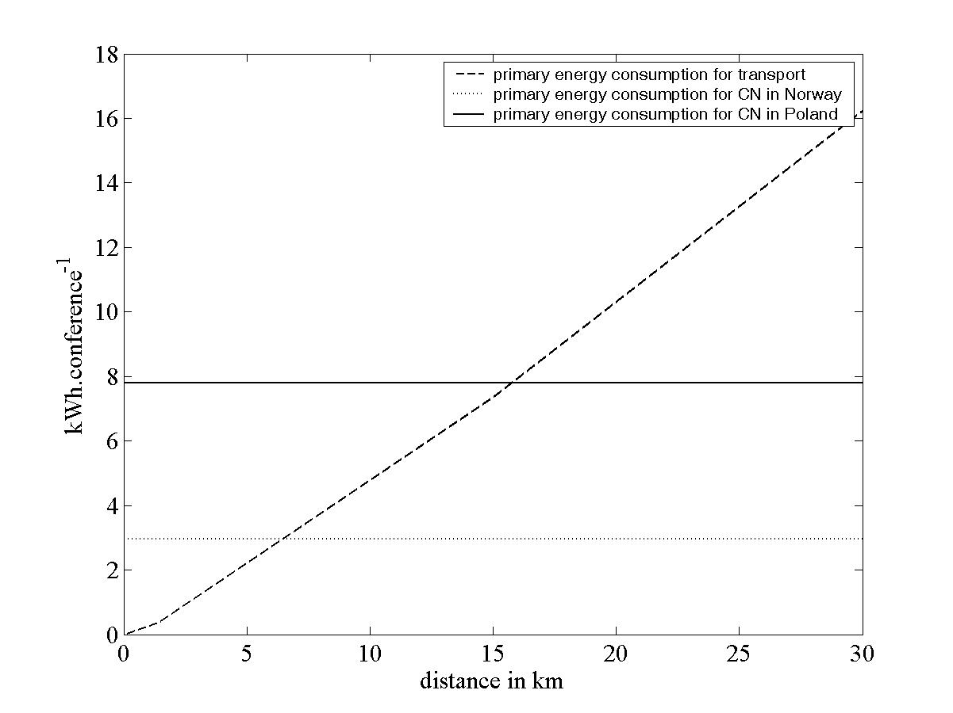
Figure 7.3-9 Comparison of consumptions in primary energy between CN teleservice and travel depending on distance.

To take into account the difference of conversions between energy types, consumptions are reported in primary energy in Fig. 7.3-9. For oil products, a unique factor of 1.09 is chosen to convert to a crude oil equivalent. For the electricity conversion, two extreme cases are chosen: one corresponding to the Norwegian situation with 100% waterfall and a factor of one, and the other corresponding to the Polish situation with 100% coal plants and a factor of 1/0.38 (assuming an average coal plant efficiency PCS/net electricity of 38%). The breakeven distance varies according to the country (from 7 for Norway to about 16 for Poland).
NOTE: This should not be exactly one in Norway if waterfall and grid maintenance must be included. The important point to stress is the consequence of differences in electricity production between two countries.
Last, the fossil CO₂ emissions of each situation are reported in Fig. 7.3-10. For the CN teleservice, the two extreme cases are reported with zero emission for Norway and an emission rate of 900 g_{CO2} per kWh of electricity for Poland. In the case of crude oil, the conversion factor is 270 g_{CO2} per kWh. This figure shows the distances above which a telecom service can reduce fossil CO₂ emission. They depend strongly on the share of primary energy to produce the electricity. In Norway, this distance will remain at zero. This result will be true whatever the telecom service considered in Norway and its electrical consumption. Travel distances have to be more than 20 km for CO₂ saving in Poland with the CN teleservice.
The breakeven distances remain relatively low, making the CN teleservice a good alternative to transport.

NOTE: See previous note about difference between Norway and Poland electricity production. It applies also to CO₂ emission (not strictly equal to 0 in Norway).

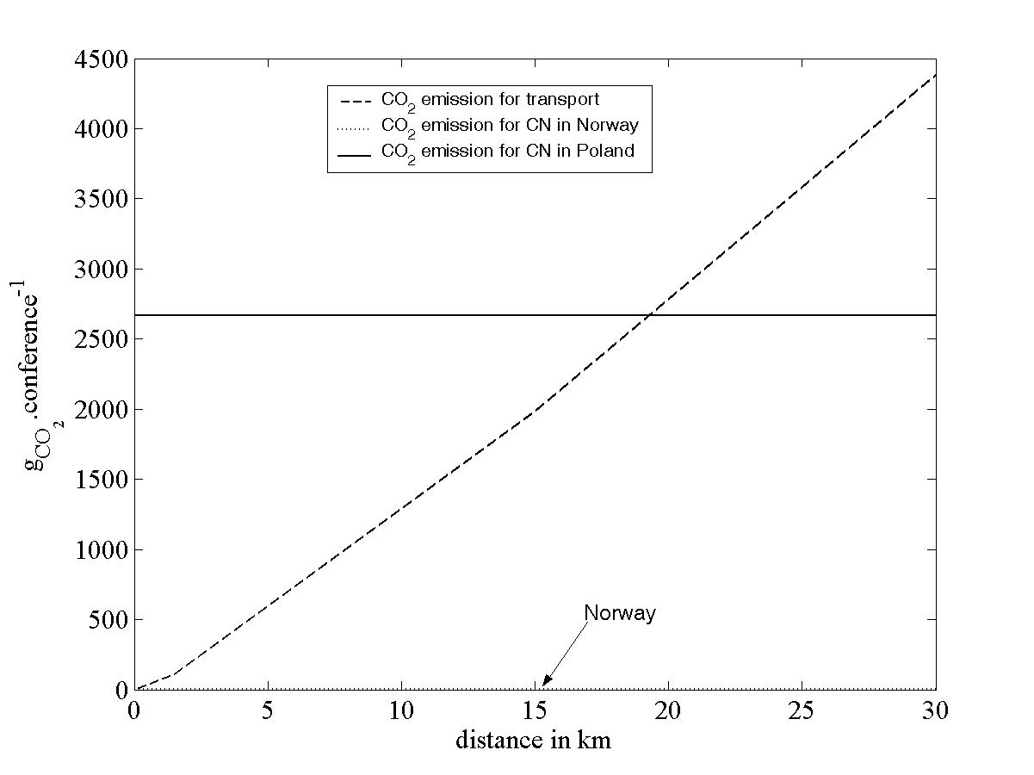
Figure 7.3-10 Comparison of amount of fossil CO₂ emission between teleservice and travel depending on distance.

Further considerations

The end results depend on several assumptions made (equipment used for the CN teleservice, cumulative distance travelled for one meeting, energy mix for the electricity production, energy mix used for the transport, etc). These assumptions based on particular situations can evolve with technical progress or a new economic situation. The bottom-up approach exposed here with the consumption rate R tool is able to test the effect of different situations on the overall energy consumption. This capability makes it a predictive instrument.
To close this bottom-up approach, the saving achieved over a company or a country can be deduced from the saving at the scale of one service. With respect to this, it is interesting to note that for the CN service, 516,000 conferences are carried out over one year with a total of 2.3 million participants (corresponding in reality to 45,000 different employees of France Telecom using this service several times a year). It is hard to imagine that each teleservice substitutes for one meeting with physical travel. The convenience has brought about the extensive use of the teleservice, more than simply in substitution for physical travel. The real saving is related to the amount of avoided physical travel. Hence, this number also appears to be a crucial parameter to study the global impact of a teleservice. Assumptions should be made based on realistic situations or on expected trends.
For example, if three teleconferences occur for each cancelled face-to-face meeting, ICT consumptions for each meeting will be three times as high as the calculated consumption for one teleservice. The breakeven point is then around 50 km in the worst condition (Poland values). As on average the real distance for a meeting is at least ten times as high, the CN service remains advantageous in saving energy and CO_{2.}

Videoconference service

In case 1, a videoconference was held between Tokyo and Yokohama by 2 people in each office, once a week (48 times/year) for 1 hour each time. The value in parenthesis (namely 91%) is obtained only when the stage of use has been taken into account.

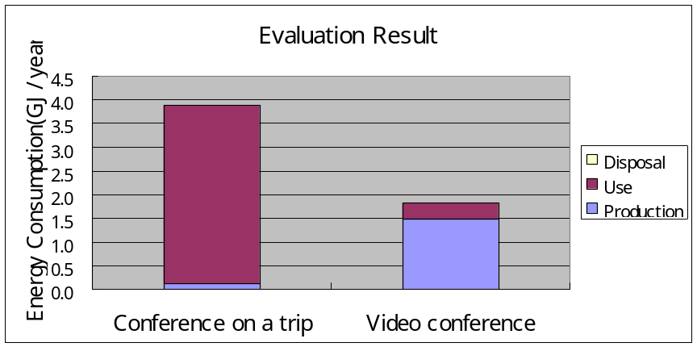
Reduction of 53% (91%)
Case 1

It should be noted that the proportion of energy consumption in the production stage of videoconference devices is high; therefore, it will be essential to take the production stage into account.
In case 2, a videoconference was held between Tokyo and Yokohama by two people in each office during every working day (240 times/year) for 8 hours each time. The value in parentheses (namely 59%) is obtained only when the stage of use has been taken into account.
In contrast to case 1, a high frequency of use significantly increases energy consumption. Therefore, the production stage is of less influence. Thus, energy consumption and its potential reduction significantly vary depending on the videoconference devices and the conditions of their use.

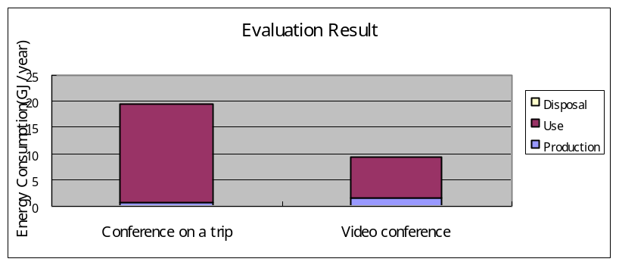

Reduction of 52% (59%)

Case 2

Mobile telemedicine - case study
Ericsson Research has used the method for a study on the potential CO₂ emission reduction from the use of a mobile telemedicine system. Below an application of the proposed method is presented.

Conventional homecare
A. System
The healthcare process selected for this study is homecare of patients with hard to heal leg and foot ulcers (wounds). The patients are consulted by the general physician or the wound care center ones a month for therapy adjustment. This meeting includes physical travel for the patients. The system boundaries are set to only include the CO₂ emissions from the transport of the patients and for Swedish conditions.
B. Data collection
In the transportation scenario only the patient travel will be affected and not the staff travel. Statistics are collected for the traditional homecare process and the patient transports. The number of consultations for this kind of treatment is 12 consultations per year.
About 85% of the patients having leg ulcers are older than 64 and it is realistic to assume that most of the patients are going by taxi or patient transport to the consultations and it is assumed that cars used are newly produced. The average transport distance to a healthcare facility in Sweden is 25.3 km which will result in a total distance of 50.6 km per consultation.
C. CO₂ assessment
In average CO₂ emissions of all new petrol and diesel cars in Sweden 2007 was 181 g CO₂ per km. Also, LCA data from fuel, material and vehicle production are used. For a normal petrol car 25% of the total CO₂ emissions can be added to also include the material and vehicle production. However, taxi cars have longer driving distance per year then a normal petrol car and will result in a lower environmental impact due to the manufacturing phase in a lifecycle perspective. For this reason it is assumed that the CO₂ emissions from material and vehicle production are about 8% of the total CO₂ emissions from driving. For the production of fuel 11% of the total emissions from driving are added. Compensating the average CO₂ emission figure for fuel, material and vehicle production the resulting figure is 216 g CO₂/km.
There are 12 consultations per year that requires personal transport of 12*50.6 km = 607 km per year and patient. This will result in a yearly CO₂ emission of 131.2 kg per patient.

Introducing telemedicine
D. System
The targeted patient group for the telemedicine service is elderly with leg or foot wounds assisted by homecare nurses. The homecare nurse can capture and transmit digital photographs, videos, sound recordings and text from the patient’s home to a medical doctor in a clinic using a mobile phone, se Figure 2. The medical doctor can view the material and give medical advice to the homecare nurse. The teleconsultation can replace some of the conventional face-to-face consultations. Published studies have shown that at least 50% of the face-to-face consultations can be replaced with maintained medical results and quality of care introducing teleconsultations, i.e. 6 consultations per year can be avoided.

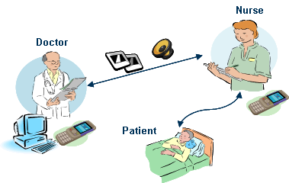
Figure 1 Overview of the healthcare process and telemedicine system
It is assumed that the homecare staff already has a mobile phone and that the doctor has a computer with Internet connection. Both the mobile phone and the computer are used for other tasks than for the homecare application for the majority of the time. The energy consumption for the computer and the mobile phone when using the homecare application is negligible compared to the transportation reduction potential.
The consultations are carried out in the same facilities as if it was a regular face-to-face consultation. The teleconsultation is faster and will result in a time gain. This is beneficial for the patients, the finances and the efficiency but does not directly lead to less office floor space if no organizational changes take place to ensure this.
E. Data collection
The amount of data generated by the homecare application is estimated to be 24 MB/year/patient (12 MB sent and 12 MB received). The total amount of data for one telemedicine consultation between the doctor and the homecare nurse is 2MB. This includes three medical images, text and a one minute voice recording of 1.6MB sent by the homecare nurse to the doctor and one voice message answer from the doctor of 0.4MB. These figures are used when estimating the CO₂e emissions associated with the operation of the telemedicine system (PC, and mobile phone) for one homecare patient during one year.
The average data traffic per mobile subscriber is about 150 MB/year [1], [2] and the average CO₂ emissions associated with a mobile phone subscription, about 25 kg/year [3]. The data traffic (24 MB/year) is used to dimension network resources, which are allocated based on data traffic.
The average data traffic per PC is about 50 GB/year Error: Reference source not found and the CO₂ emissions associated with an average PC and all network resources and broadband connection requires about 485 kg Error: Reference source not found. The system requires one hour extra PC use time per year and patient. This extra time is used to dimension the CO₂ emissions from the use of the PC. The data traffic (24MB/year) is used to dimension other network resources, which are allocated based on data traffic.
F. CO₂ assessment based on LCA method
The assessment builds on extensive LCA studies on mobile communication systems by Ericsson. Every part of the system that is needed to be able to communicate with a mobile phone is included, and the whole life cycle of these parts.
Table 1 shows the CO₂e emissions associated with the use of mobile phone and PC calculated for one patient. The results include the use time (energy consumption) of mobile phones and PCs and the energy consumption of data centers, core network and transmission allocated based on data traffic. For the assessing of the electricity and power production the fuel supply chain is included as well as the manufacturing of power plants and the grid itself, with all the poles and cables. Also, all waste is included with metal recycling on the positive side and end-storage of nuclear waste on the negative side. For more information about the electricity model, see Ericsson contribution (C67).
Table 1 CO₂e emissions associated with the operation of the telemedicine system for one homecare patient during one year. Figures are based on mobile phone data transfer (24 MB/year) and PC use (1 h/year) with Swedish average electricity production.
Emissions from use/data
(Swedish average electricity production)
Mobile phone | 0.14 kg
PC | 0.03 kg
Total: | 0.17 kg
In table 2 the weighted CO₂ emissions originating from the manufacturing of phones and PCs and infrastructure (RBS sites, cables, etc.) are presented.
Table 2 CO₂e emissions associated with the manufacturing of the telemedicine system for one homecare patient during one year. Figures are based on mobile phone data transfer (24 MB/year) and PC use (1 h/year) with Swedish average electricity production
Emissions from whole life cycle excluding use/data
(Swedish use)
Mobile phone | 2.35 kg
PC | 0.07 kg
Total: | 2.4 kg
With this telemedicine system at least 50% of the face-to-face consultations can be replaced, i.e. 6 consultations per year can be avoided. However, still 6 consultations will have to take place. This will result in a yearly CO₂ emission of 65.6 kg per patient.

3.3 Comparison of original homecare system and telemedicine
A summary of the CO₂ emission contributions before and after introducing the telemedicine service is shown in Table 3. The figures are for one average homecare patient with a leg ulcer that requires continuous treatment in the home.
Table 3 Comparison of different CO₂ emission components for an average patient before and after introduction of telemedicine service. The data for CO₂ emission from energy production is based on production in Sweden. Further it is assumed that both PC and mobile is used for other things than homecare (based on global figures for average use). The figures are in kilogram CO₂e/patient/year.
Process component | Conventional homecare | Introducing telemedicine | Diff.
Patient transportation including vehicle, fuel and material production | 131.2 | 65.6 | -65.6
Manufacturing of mobile phone | not applicable | 2.35 | 2.35
Data transfer and overhead CO₂ emission for the mobile network | not applicable | 0.14 | 0.14
Manufacturing of PC | not applicable | 0.07 | 0.07
Internet data transfer and overhead CO₂ emissions form the internet (including application server) | not applicable | 0.03 | 0.03
Total (kgCO₂e/patient/year) | 131.2 | 68.2 | -63.0

The CO₂ reduction potential when introducing telemedicine in the homecare program is 63 kg CO₂e per year for the average patient, which is a decrease of 48 % compared to a conventional homecare process. The CO₂ reduction results from cutting the patient transportation.

Home appliances

AIM architecture
There is a relevant project called AIM that fosters a harmonized technology for profiling and managing the energy consumption of home appliances in either the active or stand-by states. In doing so, the project introduces energy consumption monitoring and management mechanisms in the home network and a proper service creation environment to serve the virtualization of energy consumption, with the final aim of offering users a number of standalone and operator services.
The project applies its technology to three appliance types, namely, white goods (refrigerators, kitchens and washing machines), communication devices (cordless phones and wireless communication devices for domestic use) and audiovisual equipment (TV sets and set-top-boxes), targeting delivery of energy saving applications grouped in three use cases.
- For residential users to be used for managing the energy consumption of their households intelligently, e.g., automated stand-by devices that detect and switch off in the absence of people at home or during the night, setting of maximum levels of energy consumption, etc.
- For utility companies to plan better energy generation.
- For network operators, for subscribers wishing to monitor and manage the energy consumption of their households remotely.
The AIM technology will be evaluated in the context of experiments that will be hosted, initially in a virtual home environment and later on in real households.
To implement its technology, the project has envisaged the architecture depicted in Fig. 7.4-6, consisting mainly of three components:

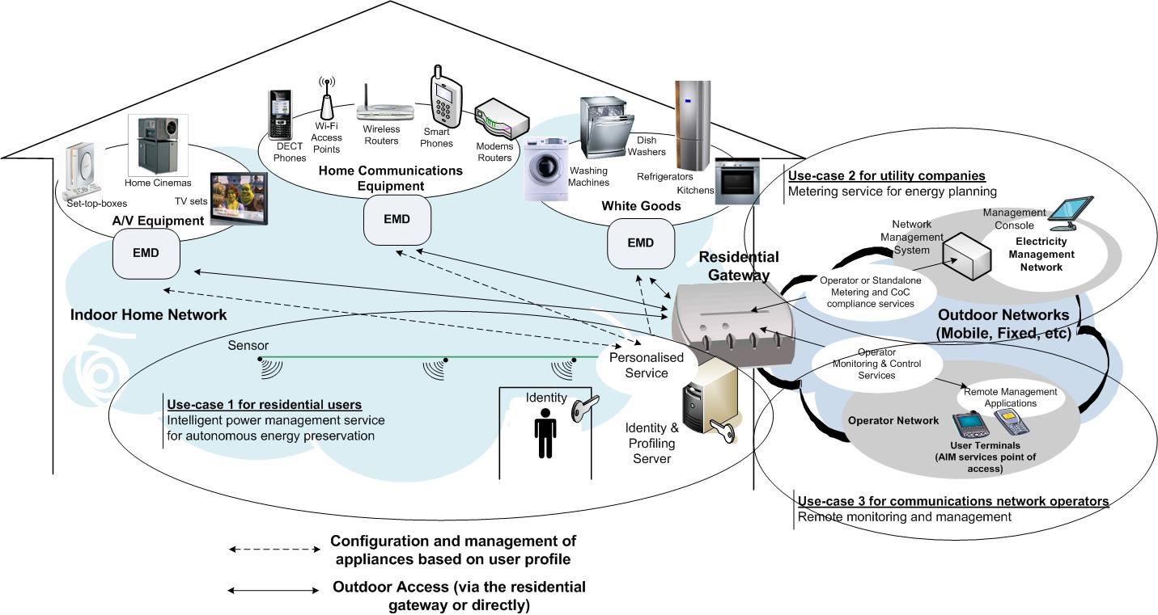
Figure 7.4-6 AIM architecture

- household appliances equipped with network interfaces,
- residential gateway in the role of service broker towards the user, and
- energy monitoring device (EMD), which performs communication homogenization on the interface between itself and the residential gateway by hiding the specifics of the various network interfaces of the household appliances.

Under the given network architecture, energy saving applications become possible through the adoption of the following concepts.

Service accommodation: Energy monitoring services are accommodated on the residential gateway, which also performs
- household appliances recognition and internal functions control;
- “energy resources” virtualization and instantiation in the context of user-created services. The term “energy resources” is used to identify all appliances that consume energy, their internal functions, e.g., the washing programs of washing machines, the communication modes of a wireless hot spot, etc., as well as energy control methods, e.g., set up of energy consumption thresholds, masking of appliance functions, etc.; and
- service creation and personalized execution.

Appliance profiling: Appliances’ internal functions are analyzed and grouped in power modes with regard to their contribution to logical operations, such as washing programs for washing machines, viewing modes for TV sets, communication modes for gateways, digital phones and wireless hot spots, etc. (Fig. 7.4-7). Each power mode is assigned a certain energy consumption level, thus making possible creation of profiles per appliance type. By accommodating these profiles on the residential gateway, the network may estimate in real time the energy consumed within the household, simply by determining the state of each appliance. Appliance profiles are also useful for determining the operational state of each appliance, e.g., if it is switched on or in stand-by mode.

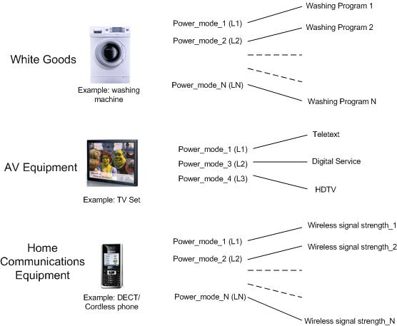
Figure 7.4-7 Examples of appliance profiles

Logical interfaces: A part of the three main components noted earlier, the AIM architecture encompasses a number of logical interfaces whose role is to provide physical communication and integrate the functionality of the AIM components within the context of user applications.

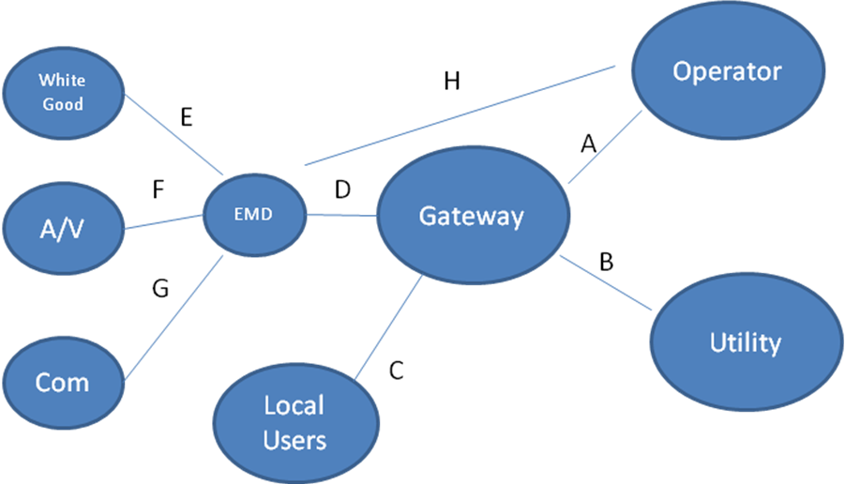
Figure 7.4-8 Logical representation of AIM components and interconnecting interfaces

Interface A: binds the applications of the network operator with the services of the gateway.
Interface B: binds the applications of the utility with the services of the gateway.
Interface C: binds the applications of the local user with the services of the gateway. This interface may be implemented using standard service execution interfaces, such as JAVA APIs.
Interface D: implements a protocol that is common for all appliances and allows the gateway to
- request appliance status information from the EMD(s);
- control the appliances, e.g., switch off an appliance, mask a particular appliance function, etc.; and
- perform special initialization functions, e.g., retrieve the number and type of connected appliances and determine their internal functions, power modes, etc.
Interfaces E, F, G: may be of proprietary or standard type. These interfaces implement protocols that allow EMD(s) to access appliances’ internal functions. Depending on the appliance model, access may be confined to simple “status read” cycles or may also comprise “write” cycles, using a particular set of control primitives.
Interface H: similar in function to interface A, but the services of the gateway are replaced by corresponding services in the operator network, whereas the user application communicates directly with the appliances via the EMD.
During the definition phase of the AIM architecture, it was found that developing networked technologies for energy management and monitoring of household appliances largely relies on the establishment of generic communication interfaces between the controlled devices and the management logic of the network.

Measuring energy consumption of home appliances
An issue not covered by the bodies working on energy profiling issues, such as the CoC activity, is the specification of associations between the energy consumption levels of appliances and their internal operation modes.

Because household appliances are made up of electronic components, the energy they consume can be estimated in simple terms as the sum of the energy that the individual electronic components consume. Thus, energy profiles can be drawn up by estimating the amount of energy the appliances consume while operating a particular operation mode.

Specification of operation modes can be defined in two ways. One way is to follow the modes set for the internal electronics of the appliance by the manufacturer, (e.g. hot plates function for cook tops) or to follow the modes defined by appliance manufacturers as user programmes, e.g. the eco-washing programme of washing machines. The former operation mode type is applicable on manufacture level, while the latter is applicable on user level.

From the point of view of the AIM architecture, utilization of user level operation modes makes easier normalization of energy profiles among all appliances of same type as it helps eliminating dependency from complex manufacturing data (e.g. manufacturing technology) that change from model to model and manufacturing technology.

Thus, selecting user level operation modes reinforces viability of the energy measuring methodology. Scalability is also strengthened as new operation modes may be profiled independently of the existing ones.

Following the user level operation mode concept, we may simply estimate the total energy an appliance consumes with the following formula:
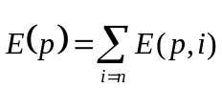,

where:
p: is the user level operation mode (programme type),
E(p)= is the sum of energy consumed by the appliance, while it functions in programme p,
E(p,i)= is a two-dimensional array with i columns corresponding to the energy consumed by the i internal component that participates in the implementation of programme p.

The formula expressed above is directly applicable on the second appliance category (appliances of which total amount of energy consumption is manageable), but it may also be used for the first appliance category if peak consumption values are to be profiled.

Total estimation of energy consumption by user operation modes can be performed using the following generic for all appliance categories formula:

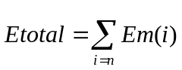

E_{total}: Total energy consumption
E_{m}(i): energy consumed in user operation mode i

Since E_{m}(i) is a function of time, it can be calculated as following:

- Appliances of which instantaneous power consumption is manageable: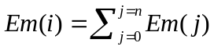, where Em(j) is the energy consumed at time interval j.

- Appliances of which total power consumption is manageable: The energy consumed in mode m, Em is steady.

- Appliances of which energy consumption is hardly manageable: Em may be only experimentally measured through real time energy measurements. In that case total energy consumption in each user operation mode is a function of time and can be expressed as: 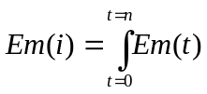, where Em(t) is only experimentally measured.

Applying user-operation-mode-based energy management methodology in real households

Having defined a way of identifying appliance operation modes from user perspective and a simple formula of energy estimation, in this section we introduce an architecture that performs energy management relying on this methodology.

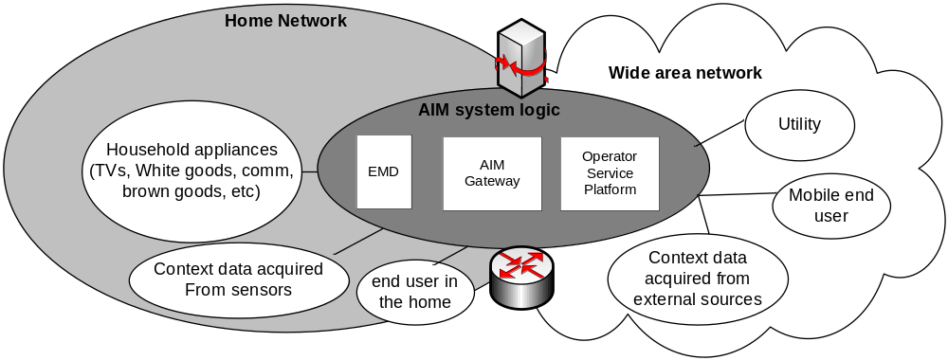
Figure 2: Architecture for the implementation of user-operation-mode-based energy management methodology

The architecture is built around the EMD-Energy Monitoring Device that performs the following functions:
- understands the user modes of active appliances and is able of tracing appliances set in standby mode.
- energy control:
  - Switching off appliances in standby mode
  - Switching off appliances in active mode
  - Switching between user programmes in order to maintain minimal energy consumption levels.
- energy monitoring by communicating the energy consumption figures of appliances to peripheral devices (e.g. user terminals) requiring status information. For appliances falling in the third appliance category the EMD performs real time energy consumption measurements.

The AIM Gateway, together with the Operator Service Logic are introduced as alternative hosts of the energy management logic. Under this scheme users are free to decide whether energy management logic is concerted and administered by the network operator or locally by themselves. In either cases, users are free to access the energy management service for configuration, management and use purposes, through any kind of terminal.

Customization of the two hosts on per household basis is achieved with a supplementary database where different household appliances types can be registered along with their energy profiles and user programmes.

The architecture is completed by a sensor network that adds intelligence to the supported energy management functions, such as autonomous and proactive operation based on the observation of users’ movements.

The formulas introduced in previous section are applied by the energy management logic. The energy management logic also manages the EMD functions in order to get status information or implement energy control.

EMD communication with the household appliances has been realized using the power line network and the KNX protocol. Nevertheless, this communication solution is not restrictive and the EMD may use any wireless/wired home communication interface. The power line communication technology has been selected having in mind to keep the energy consumption of the architecture components as low as possible. Since all appliances are connected on the power line network, whereas many of them, especially white goods, have already power line modules integrated, the power line solution has appeared as the most appropriate solution.

From users’ perspective energy management is performed by means of setting limits for the energy consumption of the entire home environment and letting it self organized appliances’ operation to match these levels.

Flexible Working Practice
Teleworking or home-working is already seen as beneficial in terms of reducing commuter travel-related greenhouse gas emissions, both directly and indirectly, via reduced congestion. Furthermore, companies opting for “agile working” practices can also reduce their own carbon footprint by lowering the need for office space (closing floors/buildings) and by supporting a more efficient utilisation of desk space. On such a high level, known sustainability benefits of home-working include:
- Flexible work / life balance for employees
- Employee retention & productivity
- Reduction in commuter travel-related CO2 emissions
On a finer-grained scale though, additional, case-specific constraints and opportunities will strongly affect the actual benefits of any given agile working policy. "Free parameters" such as which offices to use/close can be exploited to fine-tune a company’s agile working strategy. Many variables also need to be factored in, such as seasonal effects on home-working emissions (e.g. winter heating or summer cooling, depending on geographic location). Finally, the possible role of intermediate solutions between home-working and a metropolitan office, such as tele-cottages, must be evaluated.
In this context, it will become increasingly important to know the fully quantified effects of home/office-based working CO2 trade-offs. This knowledge can then be used to inform optimised agile working policies as well as to identify “hotspots” where intervention would be most beneficial. Such targeted improvements have the potential of making home-working even more attractive from a CO2 reduction and sustainability perspective, by further lowering the average carbon footprint of homeworkers while simultaneously optimising the energy-efficiency of the office-based workforce..
It is fairly obvious that ICT provides the means for teleworking, via such tools as audio/video conferencing. This contribution focuses on the industry’s potential to play a key role in the measurement and modelling of the energy/carbon tradeoffs between different modes of agile working (home/office/mobile), allowing these to be optimised.

2. A methodology to address and quantify ICT-supported agile-working CO2e benefits
- Attribute CO2 emissions to existing home/office working practices, by drawing upon readily available statistical data
- Obtain representative data on commute-travel distances, home energy use and behavioural factors
- Model the actual difference in energy consumption and CO2 emissions resulting from a worker being present at home during business hours (must take into account variation between households)
- Combine home, office and travel-related carbon emissions to understand existing trade-offs and identify the main contributors
- Investigate alternative scenarios that could impact on the overall carbon footprint such as, e.g., company or government-sponsored home improvements resulting in better energy efficiency, seasonal variations in home-working policy, building of tele-cottages in residential areas etc.
- Apply country or region-specific parameters and conversion factors reflecting the local climate and the fossil fuel component in the generation infrastructure
- Carry out case studies, informed by all or part of the above tools, to test the feasibility of alternative agile working policies and refine them

3. Tool example for flexible working practice
The four figures below show how trade-offs between the various components adding-up to form the overall carbon footprint of an organisation can change under various hypotheses. The vertical axis are carbon emissions (arbitrary unit), the horizontal axis is the fraction of office-based workers (0-100%). Individual curves represent the contribution of additional home energy consumption (green), total office consumption (red), commuter travel (blue) and the normalised total (black).
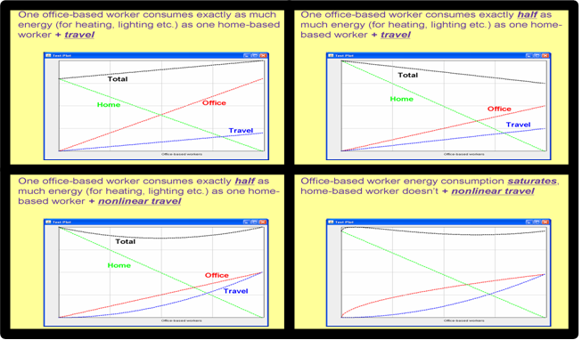
ICT tools could also be developed that would simplify the task of optimising desk occupancy so as to maximise opportunities for powering down rooms, floors or entire buildings, while simultaneously taking into account semi-flexible employees’ preferences or requirements. This particular instance of a well-known NP-hard problem (timetabling) can be tackled using advanced techniques to efficiently explore a huge solution space.
The snapshot below shows a working demonstrator developed by BT Innovate. It illustrates how aggregating space-time slots can free individual rooms that would otherwise have been sub-optimally occupied by a small number of office-based workers. Legend: horizontal “traffic lights” represent mobility in time (green = flexible), vertical ones mobility in space of half-day desk slots initially specified by employees. This small-scale example shows allocation of seven desks, unevenly distributed between two rooms (black line = separator), over a five days working week (one column = one half-day).
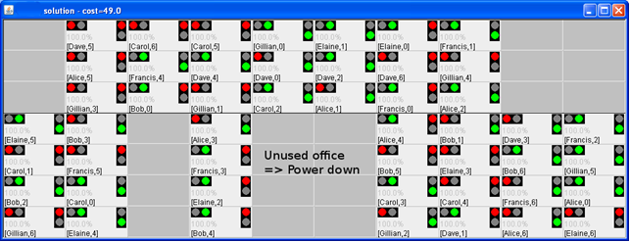

Postal services

Editors comment: This section is not compliant with the methodology since the premise of replacing one letter by one e-mail is factually wrong. Therefore we recommend to remove this contribution as it will undermine the value of D3.

Postal mail services cause a lot of human interventions and car traffic through postal mail deliveries. Various business sectors use postal mail services to send invoices, marketing brochures, bills, etc. to their customers. Instead of postal mail services, e-mail services by ICT can reduce GHG emission dramatically. For example, Japan carried out an evaluation scenario with 940 million pieces of postal mail and e-mails per year and 10 kbytes per e-mail. The evaluation showed that the e-mail services had 98.5% less GHG emission than postal mail services.

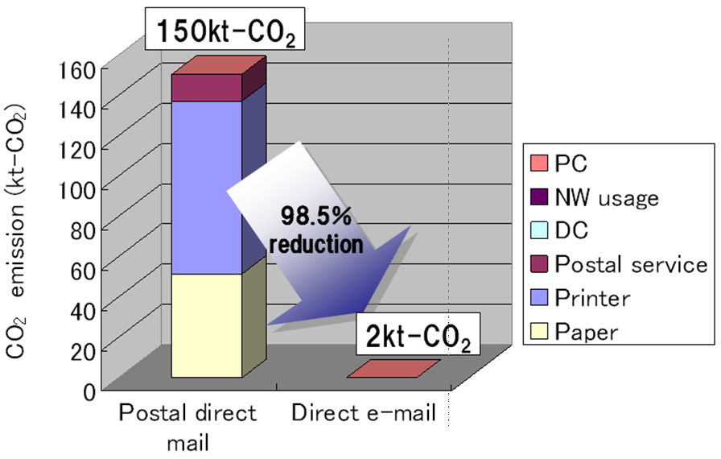
Figure 7.4-9 Comparison of GHG emissions of postal mail and e-mail services

Education
Distance-learning has become a viable alternative option to traditional education and can be an effective tool in combating illiteracy in developing countries. More and more universities are offering the possibility of interactive participation in virtual classrooms, where the students receive all the necessary material without any waste in paper and using digital media. E-learning offers a great range of possibilities for students, since the only requirement is normally an Internet connection. With NGN and the extension of broadband service, the use of the web for educational purposes can only increase and reach a bigger number of users. One example is the ITU e-Learning Centre established in 2002, which provides flexible access to training material for telecommunication staff worldwide, thereby reducing training costs.

Shopping
Electronic commerce has become a standard practice in many countries thanks to the widespread availability of online services. The use of the Internet and other computer networks to buy and sell products has dramatically increased over the last decade, particularly for products like books, plane tickets and electronic devices. Everyday one can find many kinds of new e-businesses opening, with virtual offices, where one not only saves GHG emissions in travelling to a traditional shopping centre, but also presents savings in the price of goods and services.

Impacts of ICTs on climate change

ICT-sector GHG emissions mitigation approaches

Energy efficient network infrastructure
ITU-T has developed NGN-relevant standards to provide a new network infrastructure for various advanced telecommunication services. Next Generation Networks (NGNs) are seen by many as the new network architecture that will unify today’s fixed, mobile and broadcast networks. This innovative technology is expected to bring about greater energy efficiency than legacy networks. In turn, by improving the energy efficiency of ICTs, NGN can potentially make a significant contribution in the battle against global warming.

NGNs are packet-based networks, which provide telecommunication services to users, able to make use of multiple broadband technologies, with independence of service-related functions from transport technologies.

Traditionally each telecommunication service has been built on its separate own network, with each of them having its own architecture. Today’s operators generally run a number of different networks for different services which need to be interconnected. For example the public switched telephone network (PSTN) has been, to date, the main network for fixed line telephony. Similarly, the global system for mobile communications (GSM) has emerged as the main networks for mobile telephony, and the Internet (both on fixed and mobile platforms) is used for a range of different services. Unlike the other two, the Internet has always been packet-switched rather than circuit-switched. An NGN can be used as a basis for all these services, using the same platform and therefore presents important differences with legacy networks, as indicated below:

Table X – Comparison between legacy networks and NGNs
Legacy networks | Next Generation Networks
- Dedicated (controlled) network  - Multiple Circuit-switched and packet switched platforms  - Different signalling systems, low digitalization degree  - Separated services and transmission  - Routing  - Network independent  - Blurred boundaries multiple handoff situations creating blurred boundaries  - Dedicated trunk circuits  - Separate platforms for connection oriented and connection-less platforms  - Classical switches | - Sharing same network  - All IP  - Converged Packet-switched network  - Converged services between Fixed/Mobile  - Network User centric service creation  - Clear network boundaries  - Multiple Routing of calls for resilience  - Single softswitch platform for  connection-oriented or connectionless communications  - Softswitch: software-based call control  - Quality of Service enabled  - Generalized mobility: ubiquitous provision of services to users  - Improved energy efficiency

NGNs take advantage of following contributors to energy efficiency.

Internet Protocol systems
The migration to NGN is expected to reduce power consumption by approximately 30-40 per cent by introducing Internet Protocol transmission, as compared with the current public switched telephone network (PSTN). The shift to IP-based routing and switching systems has improved the efficiency of the core network substantially over the past decade. This is especially true for the transmission of voice, where digital compression techniques have provided a 60–70 per cent reduction in transmission capacity requirements. Furthermore, as networks converge in one platform, which may be fixed or wireless, this should reduce costs, and in turn reduce prices, thereby extending universal service.

Introduction of multiple power modes
NGN-related technology may reduce energy by making use of more recent standards which specify multiple power modes, for instance full-power, low-power, stand-by and hibernation. Whereas traditional equipment, for instance DSL modems, has only two power modes (on and off), this differentiation among power modes can reduce the energy waste when the equipment is not in constant use.

With this objective, the European Commission, as part of a broader initiative to improve the energy efficiency of electrical equipment, has published five different Codes of Conduct for ICT equipment, including the application of multiple power modes for broadband equipment.

[Note] A Code of Conduct is understood as a voluntary commitment of individual companies with the aim of reducing energy consumption of products and systems without hampering the fast technological developments and the service provided. See more about the European Commission Codes of Conduct in www.sunbird.jrc.it/energyefficiency/html/standby_initiative.htm.

Energy savings for transmission systems
All forms of broadband consume more power than narrow band; however the introduction of low power modes should help to reduce energy consumption in the future. Moreover, the traditional digital subscriber line (DSL) is being substituted in many countries by optical transmission, which should ultimately offer lower energy solutions than DSL because the signal levels are lower.

DSL, the predominant technology used by traditional telephone companies to deliver broadband over twisted pair copper telephone wires, presents opportunities for power saving by optimizing service, transport, and physical (PHY) layer techniques.

Unified network architecture
Network convergence, which is one of the principles inherent in NGN, involves a migration from multiple separate networks to a unique IP based network and requires a centralization of applications and services control. Traditional separate networks (for voice, video and data) have their own billing, management systems etc, which duplicates the same functionality, whereas the evolution to a unified network could allow telecom operators to share network equipment and management functions. This would dramatically reduce the required number of operations to execute the services, and consequently decrease energy costs. The centralization advantages of NGN, in terms of consumption of energy and resources, can include:
- Dissemination of simpler terminals that are less energy and material intensive;
- Reducing manufacturing complexity and electronic waste: cables, installation space, etc.;
- Offering the possibility to share central, powerful, up-to-date computing resources in data centres;
- Reducing the energy consumption of server farms; and
- Increasing efficiency (eco-efficiency) by requiring fewer premises.

Reduction in the number of switching centres
Every communication network requires switching or routing centres to interconnect end users’ equipment either via the service provider’s network or via other providers’ switching/routing centres, establishing the optimal route for a given information packet. Traditional networks require separate switching centres for fixed line, mobile phone line, TV, multimedia services, etc. all of which consume significant energy. An NGN architecture greatly reduces the number of centres required because of the use of higher capacity routers and higher speed transmission.”

Energy Efficiency of Data Centers

To enable environmentally friendly operation of data centers, it is necessary to promptly implement measures, beginning with those that can be accepted by the data center operators.

In addition to direct usage by private and corporate users by means of hosting, ordinary users often access data centers indirectly through ASP/SaaS operators.

The latter relationship among the data center operators, ASP/SaaS operators, and ordinary users can be represented as shown in Fig. 7.4-1.

Looking at the above relationship and with the rapid proliferation of ASP/SaaS in recent years, it is considered that schemes that motivate ASP/SaaS operators and ordinary users as well as data center operators into reducing GHG emissions are effective.

To cut GHG quickly, first it is necessary to promote GHG emission reductions by transferring servers owned by ordinary users to data centers run by operators and, if possible, to virtualize them for shared use. The data center operators improve the energy efficiency of air conditioners by installing and operating more environmentally friendly facilities. The ASP/SaaS operators can appeal to ordinary users, on environmental grounds, to use data centers with reduced GHG emissions and energy-saving servers.

The following schemes can be considered for ordinary users, data center operators, and ASP/SaaS operators for reducing GHG promptly.
Hosting service
ASP・SaaS
（Including by hosting）

Hosting service
ASP･SaaS operators
Ordinary users
Data center operators
Figure 7.4-1 Relationship among data center operators, ASP/SaaS operators, and ordinary users

(A) Data center usage (including by ASP/SaaS)
Servers owned by persons and companies include unused data areas and usage time, which results in power consumption being wasted. Consolidating these servers into virtual servers at data centers reduces GHG emissions. Consolidated operation also improves energy usage for cooling compared to distributed operations, thus further reducing GHG.
The main targets of this scheme are ordinary users and ASP/SaaS operators.

(B) Data center design
More efficient cooling methods and equipment and the use of clean electric power saves on energy for cooling servers. Efficient use of power and reduction in power loss are also promising areas for consideration.
An analysis of energy consumption at a data center reported the following.
- Computer room air-conditioning 50%
- Server/Storage 26%
- Conversion 11%
- Network 10%
- Lighting 3%
Regarding the computer room air-conditioning, SK Telecom, Korea, reported an energy-saving case from 6750 to 1650 kWh by redesigning the air stream and introducing cold air from the outside in winter.
The main targets of this scheme are data center operators.

(C) Use and operation of energy-saving equipment
Active introduction of energy-saving servers, storage, network devices, energy-conservation devices, and methods cuts energy consumption. This includes the use of energy-saving equipment at ASP/SaaS operators (hosting), as well as the transfer of energy-saving equipment from ordinary users (hosting).
The main targets of this scheme are ordinary users and ASP/SaaS operators.

Evaluation indexes

Setting environmentally conscious indexes is one approach that may motivate data center operators and ASP/SaaS operators to try to reduce GHG emissions.
In other words, if users are provided with some types of indexes for comparing the energy efficiency of data centers and ASP/SaaS, they can select operators from the viewpoint of energy saving as well as services.
Such indexing enables those operators who are working hard to improve energy efficiency to advertise their environmentally conscious management. It also turns the environmentally conscious management of data centers and ASP/SaaS from qualitative to quantitative. Last, public organization activities and various environmental protection assistance activities are expected to use the indexes.
Such indexing may be represented as a label of energy efficiency.

(A) Data center operators
For data center operators, there are a few candidates for energy efficiency evaluation, such as power usage effectiveness (PUE) and data center infrastructure efficiency (DCiE). The Green Grid proposed the use of PUE and its reciprocal, data center efficiency (DCE) metrics, which enable data center operators to quickly estimate the energy efficiency of their data centers, compare the results against other data centers, and determine if any energy efficiency improvements need to be made. Since then, PUE has been widely used in the industry, but DCE has had limited success due to the misconception of what data center efficiency really means. As a result, the Green Grid re-affirms the use of PUE but redefines its reciprocal as DCiE. This refinement will avoid much of the confusion around DCE.

Power usage effectiveness (PUE)
Data centers as ICT infrastructure have spread rapidly in recent years. It is not easy to compare the environmental awareness and energy use efficiency of operations among operators. In the US, data center density (DCD) has been widely used as an index for relatively evaluating the environmental consciousness of data centers.

DCD ＝ | (Power consumption of all equipment on free-access floor of a data center)
DCD ＝ | (Area of free-access floor)

DCD is the power consumption of all data center equipment divided by the total floor space used for data center operations (i.e., free-access floor space). It indicates the performance of a data center with the power consumption per area. This value depends on the floor area and power consumption. Therefore, DCD reflects the reduction of GHG emissions in each ICT device, but it does not show the efficiency of an entire data center including air-conditioning facilities.

Fans, 4%
Air-conditioning, 44%
Reduction of Power Usage by IT Devices Themselves
Reduction of Power Usage by Auxiliary Facilities
Power Supplies,
13%
CPU, Memory, and HDD, 32%
UPS Power
Distributions,
7%
Figure 7.4-2 Power consumption of data center

A general breakdown of the power consumption in a data center is shown in Fig. 7.4-2. It indicates that auxiliary facilities (e.g., air conditioners) consume as much as ICT devices themselves (e.g., CPUs and memories). It follows that DCD on its own is not an appropriate index. Instead, PUE, which is an index that includes auxiliary facilities, is more effective. This index is defined by the following formula, whereby the PUE for the breakdown in the above figure is 2.04 (= 100/49; 49 is the total percentage of the CPU/memory (32), fans (4), and power supply (13)).

PUE ＝ | Total facility power consumption
PUE ＝ | ICT equipment power consumption

The total facility power consumption is defined as the power consumption measured at the utility meter, i.e., the power consumption dedicated solely to the data center (this is important in mixed-use buildings that house data centers as one of a number of consumers of power). This includes everything that supports the IT equipment load, such as the following.
- Power delivery components, e.g., UPSs, switch gears, generators, PDUs, batteries, and distribution losses external to the IT equipment.
- Cooling system components, e.g., chillers, computer room air conditioning units (CRACs), direct expansion air handler (DX) units, pumps, and cooling towers.
- Computing, network, and storage nodes.
- Other miscellaneous component loads, e.g., data center lighting.
The ICT equipment power consumption is defined as the equipment that is used to manage, process, store, or route data within the data center. This includes the load associated with all of the ICT equipment, such as computing, storage, and network equipment, along with supplemental equipment, such as KVM switches, monitors, and workstations/laptops used to monitor or otherwise control the data center.
The PUE of typical data centers is 2.3 to 2.5. A PUE value of 2.0 or lower implies excellent power use efficiency. The results of a PUE survey conducted by EPA are shown in Fig. 7.4-3. A data center of Hitachi, Japan reported its PUE as 1.6, which is the highest.

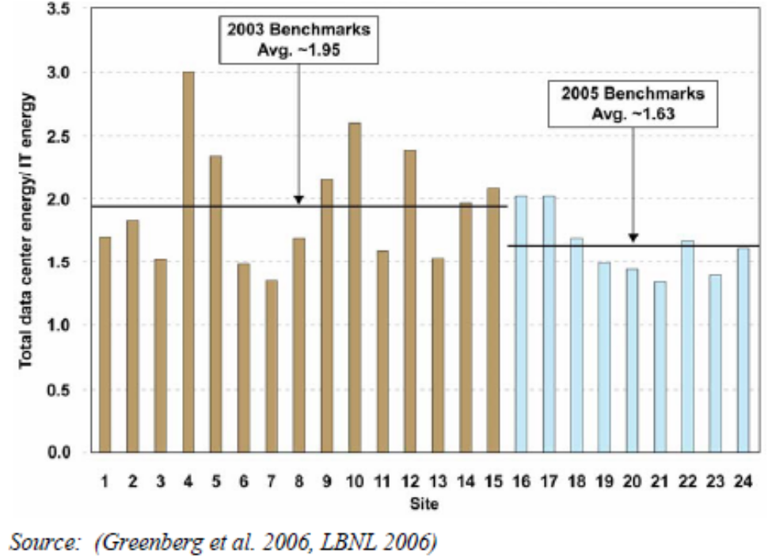
Source: US EPA, Report to Congress on Server and Data Center Energy Efficiency Public Law 109-431

Figure 7.4-3 PUE comparison among data centers

An uninterrupted power supply (UPS) that provides power during an outage is an indispensable device for data centers. However, its AC-DC-AC conversion causes energy loss. Since the utility power is AC, it is impossible to reduce this loss to zero. However, the final conversion stage (DC to AC) can be eliminated by adapting the servers to a DC power supply.
For air-conditioning, candidate schemes are optimally laying out data center equipment, resolving hot spots by monitoring with temperature sensors, improving performance by liquid cooling, and using natural air-cooling. Needless to say, the power consumption for cooling should be closer to zero.
The reciprocal of PUE is data center infrastructure efficiency (DCiE). It is an index recommended by The Green Grid, a data center industry group in the US. Its characteristics are the same as PUE. However, it is often preferred because its presentation as a percentage is clearer than a ratio.

DCiE ＝ | 1 × 100 (%)
DCiE ＝ | PUE

Regardless of the size of the data center, PUE and DCiE are useful indexes for comparing different data centers. Moreover, by tracing these indexes in a time series, it is possible to quantitatively evaluate the power-saving measures (e.g., introduction of power-saving servers and improvement of air-conditioning facilities) taken by the data center operator.
As data centers are generally equipped with functions that boost energy consumption, such as redundancy for improving reliability, it is preferable to quantitatively evaluate the power consumption by applying the indexes to services, security, and reliability.
In a hosting service that accepts user devices in a data center, the user installs the devices in a rack and wires them. If the installation and wiring work is not appropriate, hot spots and inefficient cooling airflow may occur. Therefore, publishing energy-saving measures that can be taken by data center users and evaluations by data center operators on the status of these measures may help cut energy consumption.

(B) ASP/SaaS Operators
When users evaluate and select ASP/SaaS and other services in general, they look at the characteristics of the services, such as fees, contents, reliability, and guarantees. Given global warming parameters on power consumption and GHG emissions, for example, users could select service operators based on their environmental attitude. The parameters could also be used by service operators to promote themselves. Thus, the global warming parameters are advantageous for both users and operators. The environmental impact basic unit, which represents the power consumption or GHG emissions per unit of service, is considered to be a useful parameter.
Therefore, if the amount of GHG emissions (or power consumption) per unit of ASP/SaaS service can be indicated quantitatively in a clear format, it would be an effective index for evaluating and selecting operators from an environmental perspective. The following formula is one example.

Environmental Impact Basic Unit for ASP/SaaS Services
= GHG Emissions (or Power Consumption) per Unit of ASP/SaaS Service
= (Annual GHG Emissions (or Power Consumption) from the Target Service)
(Annual Service Supply)

ASP/SaaS services are diverse, but it is not necessary to indicate the environmental impact basic unit for every service; it may be sufficient to show the environmental impact basic units in a common usage environment for some typical ASP/SaaS services.
In general, the above formula seems to give a purely logical estimation by dividing the annual power consumption of the equipment of an ASP/SaaS operator under certain conditions by the total amount of services provided. However, as described in the previous section, the PUE and GHG emissions factor of the data center where the equipment is installed affects the calculation. Therefore, it is necessary to undertake calculations and evaluations based on the actual data over a certain period of time.
Thus, it would be preferable to review an effective way to indicate and check environmental impact by means of basic units, such as defining the process of calculation and evaluation under an actual environment for a certain period, and in some cases, providing a mechanism for performing reliable verifications by third parties.
With a view to introducing methods that establish basic units for the definition and assessment of environmental impact with respect to ASP/SaaS services, it would be preferable for specialists to conduct detailed examinations at ITU.

Network equipment

The ICT sector incorporates a lot of network equipment that consumes electric power. The power consumption forecast until 2025 (Source: IDC 2007) is shown in Fig. 7.4-4. For example, an average core router draws about 62,600 kWh of power consumption from 7.1 kW × 24 hours × 365 days. There is other network equipment, such as firewalls, edge routers, multipurpose routers, Ethernet switches, WAN/Broadband devices, etc. Thus, each network equipment should take power-saving techniques into account.
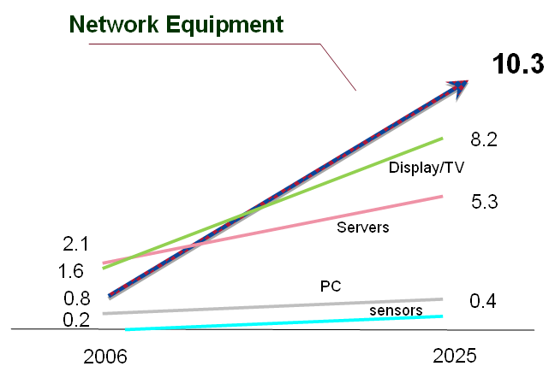
Figure 7.4-4 Energy consumption forecast (Billions kWh, 2005 – 2025)

      - HVDC system for supplying power to ICT equipment
The HVDC system, whose voltage is several hundred V, has ability to solve these problems. For, example, when a voltage at input port of ICT equipment increase, a current flowing on the cable decreases if the device consumes same energy. This phenomenon leads decreasing diameter of cable, running down the thermal loss and the voltage drop at the cable, and reducing amount of the material (e.g. copper) used to the cable. Therefore, it has a lot of advantage for improving energy consumption compared by conventional 48 Vdc power feeding system.

The HVDC power feeding system is presently being studied in various organisations or countries ^{[1-2]}. For example, the Green Grid, Non-Profit Organisation in U.S.A, have a discussion about this system, and ETSI, European (Telecommunications Standards Institute) also start to study specifications of the HVDC power supply system. Furthermore, several research reports have been presented in international symposium regarding telecommunication energy [1][2].According to Reference [1], HVDC system has ability to improve energy efficiency of the power feeding system. Power saving effect is about 7%. Therefore, HVDC is considered as one of the solution for reducing energy consumption in ICT power feeding system.

(Comment: Impact of HDVC on standardization D4)

Impact of ICT on other sectors

The Stern Review summarized global CO₂e emissions by sector as shown in Fig. 7.4-5. The emissions include 2.5% due to ICTs that, however, may help other application sectors mitigate GHG emissions.
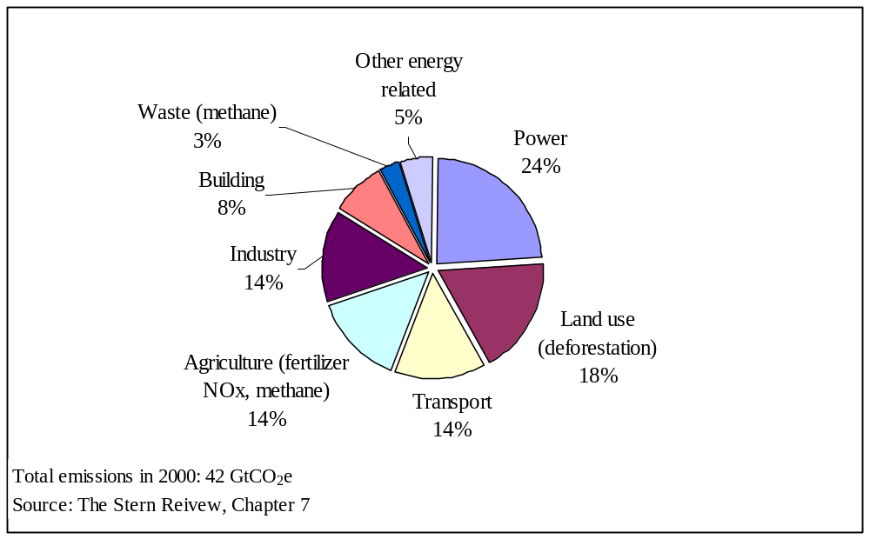
Figure 7.4-5 Global emissions by sector

As examples, the following positive impacts could be clarified.

Table 7.4-1 Summary of positive impacts by using ICT
Category | Effects
Consumption of goods | By reducing goods consumption (consumption of paper etc.), energy consumption related to goods production and disposal as well as waste generation can be reduced.
Power consumption/energy consumption | By enhancing the efficiency of power and energy use to reduce consumption, energy consumption related to power generation, power transmission, etc. can be reduced.
Movement of people | By reducing the movement of people, energy consumption required for transportation means can be reduced.
Movement of goods | By reducing the movement of goods, energy consumption required for transportation means can be reduced.
Improved efficiency of office space | By using office space efficiently, power consumption for lighting, air conditioning, etc. can be reduced, thus reducing energy consumption. For example, nomadic workers do not have exclusive desks and may work at any empty desk by utilizing ubiquitous networking, which saves on power consumption as well as work space.
Storage of goods | By reducing the storage space of goods, power consumption for lighting, air conditioning, etc. can be reduced, thus reducing energy consumption. For example, ICT-assisted on-line shopping may save on storage space.
Improved work efficiency | By enhancing work efficiency, resource and energy consumption can be reduced.
Waste | By reducing waste emissions, energy consumption required for environmental preservation as well as for waste disposal etc. can be reduced.

The following table describes a few specific ICT use cases of other sectors.

Table 7.4-2 Use cases of ICT
ICT solutions | Benefits
Telework | Telework by 10% of workers in the EU-25 countries will reduce CO₂ by 22 million tons annually.
Audio-conference | Replacement of conferences by audio-conferences once a year by workers in the EU-25 countries will reduce CO₂ by 2.128 million tons annually.
Videoconference | Replacement of 20% of business trips with videoconferences in the EU-25 countries will reduce CO₂ by 22.35 million tons annually.
Online phone billing | Online billing to all households with Internet access in the EU-15 countries and all mobile phone subscribers in the EU-25 countries will reduce CO₂ by 1.03 million tons annually.
Web-based tax returns | Filing tax returns over the Internet by all (193 million) workers in the EU-25 countries will reduce CO₂ by 195,790 tons annually.

  - Factors potentially influencing adoption of ICT solutions

The solutions ICT provides show only what is possible in one context, and results will be dependent on the political, financial, informational and behavioural barriers specific to the context.

Standby Power Consumption
The standby power consumption is power consumption by machinery and tools, when connected to the external power supply, while not performing their primary functions or while awaiting instructions to provide full services. Additionally the active standby power consumption is defined as power consumption for the sole purpose of external communication in standby mode (Even though consumer switches off the power of machinery and tools, the internal circuit still consumes standby power to wait for external cord/cordless signals.)

The IEA reported in 2002 the portion of standby power consumption in a household as follows:
- USA 5%
- France 7%
- Japan 9.4%
- OECD 10%
- Korea 11%
- New Zealand 11%
- Australia 12%

Average standby power consumed by a home network appliance reaches to 10 W ~ 30 W. The variation in standby power consumption was investigated in ten homes, California, USA. Total standby power in the homes ranged from 14–169 W, with an average of 67 W. This corresponded to 5%–26% of the homes’ annual electricity use. The appliances with the largest standby losses were televisions, set-top boxes and printers. The large variation in the standby power of appliances providing the same service demonstrates that manufacturers are able to reduce standby losses without degrading performance. Replacing existing units with appliances with 1 W or less of standby power would reduce standby losses by 68%. Thus the standby power consumption shall be taken into account to adopt ICT solutions.

Vision of 2-kW society

The 2,000-Watt society is a vision in which each person in the developed world will cut their over-all rate of energy use to an average of no more than 2,000 Watt-hours (i.e., 17,520 kiloWatt-hours per person per year for all energy use, not only electrical) by the year 2050, without lowering their standard of living. The concept addresses not only personal or household energy use, but the total for the whole of society, divided by the population.
Approximately 2,000 Watts is the current world average rate of total energy use. In comparison, there are averages of around 6,000 Watts in Western Europe, 12,000 Watts in the United States, 1,500 Watts in China, 1,000 Watts in India, and only 300 Watts in Bangladesh. Switzerland, currently using an average of around 5,000 Watts, was last a 2,000-Watt society in the 1960s. The total energy use of Korea per person may be given more specifically as follows:
- Total energy use per person in 2006 was 4.83 TOE;
- The International Energy Agency and OECD defined 1 TOE to be equal to 11,630 kWh; and
- Total energy use per person per hour was 6,412 Watt-hours by ((4.83 / (365 × 24)) × 11,630,000 Watt-hours).
This 2000-Watt vision will change human behaviour as it requires more energy efficiency, energy savings, and new technologies in both non-ICT and ICT sectors. These methods should save about 30% of the current energy demand for Switzerland, Western Europe, and Korea by 2050. The United States would require more time.

Editor’s Note: the final layout has not yet been finished. Also some references need to be added.

“University Jussieu Paris 7 methodology using the general principles based on the limits of the thermodynamics laws as well as the practical tools to determine the energy yield of energy industries such as the oil and gas or the agrofuel industries.” (from X. Chavanne and J.-P. Frangi, 2007. Concerning the determination of energy systems yield. C.R. Acad. Sci. DOI: 10.1016/j.crte.2007.06.004, Vol. 339/8, pp. 519-535). Its scope extends to the estimation of energy consumptions of all industries, such as the ICT to produce a good or a service. The described methodology is based on process levels. It derives from raw data, the specific characteristics of the industry processing chain, and from well established relationships in sciences and engineering, the indicators of energy efficiency of the industry, namely the energy consumption to obtain one "functional" unit of the final good or service. The method estimates the uncertainty of the raw data and how they propagate to the indicators. Obviously, it requires a comprehensive and well-defined set of raw data. The method intends also to derive the technical and fundamental parameters that govern the evolution of the indicators in existing or future contexts. This work must limit the use of arbitrary assumptions that can invalidate energy analysis studies. (See contribution C55 modular model with unified service unit in ITU-T FG ICT and climate change.)
Reminder: 1 kWh = 3.6 MJ, 1 kWh = 860 kcal k=kilo=thousand, M=million, G=Giga=billion, T=Tera=trillion, P=Peta=thousand of trillion (e.g. kWh, MWh, GWh, TWh and sometimes PJ for PetaJoule)
See more about ITU e-learning centre at www.itu.int/ITU-D/hrd/elearning/index.asp.
Source: The Green Grid, “The Green Grid Data Center Power Efficiency Metrics: PUE and DCiE”, http://www.thegreengrid.org/sitecore/content/Global/Content/white-papers/The-Green-Grid-Data-Center-Power-Efficiency-Metrics-PUE-and-DCiE.aspx
ATTENTION: The Green Grid stated for the metrics, “All rights reserved. No part of this publication may be used, reproduced, photocopied, transmitted or stored in any retrieval system of any nature, without the written permission of the copyright owner.” Thus, a written permission is required to keep this text included in the report.
Source: Created by NEC based on "Powering Computer Platforms in High Efficiency Data Centers" (Intel Developer Forum, Fall 2006)
NEDO Kaigai (Overseas) Report No. 1013 (December 12, 2007)
Source: J.P. Ross, University of California, Berkeley, USA, and Alan Meier, Lawrence Berkeley National Laboratory, USA, “Whole-House Measurements of Standby Power Consumption,” The Second International Conference on Energy Efficiency in Household Appliances, Naples (Italy), September 2000, http://www.osti.gov/bridge/servlets/purl/793739-FoRVRe/native/793739.pdf

