INTERNATIONAL TELECOMMUNICATION UNION |  | Focus Group on ICT&CC
TELECOMMUNICATION  STANDARDIZATION SECTOR  STUDY PERIOD 2009-2012 |  | FG ICT&CC-DOC-6Rev.1
English only
Original: English
 | WG C | Geneva, 25-28 November 2008
DOCUMENT
Source: | Editors of deliverable 4
Title: | Provisional text for deliverable 4 (25~28 November 2008)

Draft text of deliverable 4:
Direct and indirect impact (on energy) of ITU-T standards

8. Direct and Indirect impact of ITU-T standards 2

8.1 Checklist 2
8.1.1 Checklists for adopting eco-friendly ICT framework 2
8.1.2 Checklists for choosing eco-friendly ICT devices 3
8.1.3 Checklists for adopting eco-friendly ICT providers 3
8.1.4 Checklists for using ICT systems in an eco-friendly way 3
8.1.5 Checklists for disposing and recycling of ICT systems in an eco-friendly way 3

8.2 Networks and Systems influencing climate change 3
8.2.1 Fixed line vs. wireless/mobile networks 3
8.2.1. Data servers (data center) 3
8.2.2 Cooling System 3
8.2.3 Audio and Video conferencing system. 3

8.3 Use of ITU-T Standards 3
8.3.1 Next Generation Networks (NGN) 3
8.3.2 Ubiquitous Sensor Network (USN) 3
8.3.3 Intelligent Transport System (ITS) 3
    - Tag-based Identification Applications and Services 3

[Editor’s note: FG ICT&CC will ask to ITU-T and ITU-R SG chairmen to fill FG’s questionnaire to collect more information on ITU-T standards which impact climate change in both positive and negative way. The information will be included in the Deliverable 4, and used to improve the Deliverable.]

[Editor’s note: C-61 was presented at the D4 session during 25~28 Nov., 2008 meeting. It is agreed that the text fits in D2, but D4 can check the idea and technical issues to take over. Other contributions may also be included later with the same view point.]

[Editor’s note: red-font is marking newly included text as results of 25~28 Nov. 2008 meeting]

Direct and Indirect impact of ITU-T standards
Deliverable 4 should develop tools (e.g. Checklists) and guidelines to allow ITU-T SGs to evaluate, for each Question, the possible future CO2E (carbon dioxide equivalent) reduction of technologies in terms of direct emissions from ICTs and possible savings in terms of Climate Change mitigation from the use of ICTs.

Checklist
[Editor’s note: The following text is from C-8.]
[Editor’s note: Checklist examples were provided but are not fully supported by consensus. We recommend more contributions are called for (e.g. What quantifiable benefit is there regarding GHG emissions reduction?)]

Information and Communications Technology (ICT) is an indispensable infrastructure that can dramatically improve the efficiency of economic activities such as production, distribution and consumption, and government administration. It also helps us to create a society in which information is accessible to all people, at all times, everywhere and, having such an integral part in our daily lives, is expected to play a significant role in reducing our environmental burden, or the negative impacts our activities have on the environment.
On the other hand it has been pointed out that the increased sophistication and use of ICT devices will increase power consumption, meaning potentially more emissions of greenhouse gases, including carbon dioxide (CO₂), and a greater environmental burden.
The Focus Group has thus developed checklists below for corporations and organizations that use ICT systems with the aim of providing advice to help limit the negative and enhance the positive impacts on the environment when ICT systems are introduced, operated, and disposed.

Checklists for adopting eco-friendly ICT framework
Table 8-1 can be used to assess the negative and positive environmental impacts of a proposed ICT system. Table 8-2 shows examples of how to verify the environmental burden by comparing an estimated consumption/ performance value of a system before its introduction with a value after its implementation. This helps to determine the most effective framework in terms of environmental sustainability.
Additionally, after implementing a new ICT system, the environmental impact values can be compared to the values of the previous system. This helps develop effective measures to maintain ICT systems in an environmentally sustainable manner.

Table 8-1 Environmental checklist for introducing a new ICT framework
Objective | Check item | Description
Adopting an eco-friendly ICT framework | Will introduction of the ICT system reduce use of office consumables (e.g., paper)? | Reduced use of consumables leads to reduced CO₂ emissions and waste production from production or disposal of office consumables.
Adopting an eco-friendly ICT framework | Will introduction of the ICT system improve power and energy efficiency? | Improved efficiency and reduced consumption of power and/or energy leads to a reduction in CO₂ emissions from power generation and transmission.
Adopting an eco-friendly ICT framework | Will introduction of the ICT system reduce the movement of people? | When the movement of people is reduced, energy consumption from commuting and the attendant CO₂ emissions can be reduced.
Adopting an eco-friendly ICT framework | Will introduction of the ICT system reduce the movement of goods? | When the movement of goods is reduced, energy consumption for transport and the attendant CO₂ emissions can be reduced.
Adopting an eco-friendly ICT framework | Will introduction of the ICT system make the use of office space more efficient? | Effective use of office space leads to a reduction in electricity consumption for lighting and air-conditioning and the attendant CO₂ emissions.
Adopting an eco-friendly ICT framework | Will introduction of the ICT system reduce the space needed to store goods? | When storage space is reduced, power consumption for lighting and air-conditioning and the attendant CO₂ emissions can be reduced.
Adopting an eco-friendly ICT framework | Will introduction of the ICT system improve the operational efficiency? | A streamlined operation leads to a reduction in resource and energy consumption and the attendant CO₂ emissions.
Adopting an eco-friendly ICT framework | Will introduction of the ICT system reduce waste production? | Reduction in waste production contributes to environmental conservation and reduces the energy consumption required for waste disposal as well as the attendant CO₂ emissions.

Table 8-2 Example of how to check environmental burden
Environmental burden | Before system introduction | After system introduction (forecast)
Paper consumption | _ sheets/year | _ sheets/year
Electricity consumption of ICT devices | _ kWh/year | _ kWh/year
Movement of people | _-seater private car, _km/year | _-seater private car, _ km/year
Movement of goods | _-ton truck, _km/year | _-ton truck, _km/year
Storage space | _ m² | _ m²

Checklists for choosing eco-friendly ICT devices
Electrical power consumption of ICT devices is the biggest environmental burden in the overall life cycle of ICT systems. One of the ways to reduce electrical power consumption is to purchase ICT devices with energy-saving features. .
There are other critical factors when purchasing ICT systems such as, whether the device contains substances that have adverse effects on human health, and whether it is designed to have a smaller environmental impact at all stages of its life cycle; from raw material extraction through disposal.
Table 8-3 below lists key factors to consider when choosing an eco-friendly ICT device.

Table 8-3 Environmental checklist for choosing an ICT device
Objective | Check item | Description
Choosing an eco-friendly ICT device | Is the ICT device designed not to use or emit substances that have an adverse effect on the environment or human health? | Reduction in the use or emission of substances harmful to the human body or the environment contributes to the protection of human health and the environment.
Choosing an eco-friendly ICT device | Does the ICT device consume less resources and energy during the production and distribution processes and during its use? | Reduction in resource and energy consumption over the entire life cycle of the product contributes to a reduction in CO₂ emissions.
Choosing an eco-friendly ICT device | Does the ICT device use renewable natural resources? | When natural resources are used in a sustainable manner (e.g., forest resources), the environmental burden is reduced.
Choosing an eco-friendly ICT device | Can the ICT device be used for a long period of time? | Use of the ICT device over a long period of time reduces the environmental burden of production and disposal.
Choosing an eco-friendly ICT device | Is the ICT device, including its components, designed for reuse? Is there a framework in place for collection after final use? | Reuse of the ICT device reduces the environmental burden of production and disposal.
Choosing an eco-friendly ICT device | Is the ICT device made from materials that can be easily recycled? Is it designed for easy disassembly and separation per material type? Is there a framework in place for collection after final use? | If components that are not reusable can be separated and recycled, the environmental burden of production and disposal can be reduced.
Choosing an eco-friendly ICT device | Is the ICT device made from recycled materials or components? | Use of recycled materials or components generally saves resources, reduces waste, and promotes more recycling.
Choosing an eco-friendly ICT device | Is the ICT device designed for easy separation and collection of materials, and separation and removal of harmful substances upon its disposal? | If an ICT device is designed to have less environmental impact when it is disposed of or recycled, it has less environmental impact over its life cycle.
Choosing an eco-friendly ICT device | Have the designer, manufacturer and distributor of the ICT device been committed to environmental sustainability? | If you choose ICT providers who are committed to environmental sustainability, you can reduce the environmental burden over the life cycle of the device. For ideas for assessing companies,.

Checklists for adopting eco-friendly ICT providers
In order to limit the negative environmental impacts and enhance the positive impacts of ICT systems at all stages of its life cycle, it is important to take into account the environmental burden imposed by the providers of ICT devices and services. Environmental awareness can be raised by choosing products and services based on the environmental impact of ICT providers. Another way is to encourage ICT manufacturers to take initiatives to reduce the environmental impacts caused by the production processes of ICT devices or provision of ICT services. In choosing an ICT provider, you should consider the factors listed in Table 8-4.

Table 8-4 Environmental checklist for choosing an ICT provider
Objective | Check item | Description
Choosing an eco-friendly ICT provider | Does the ICT provider have an internal framework in place for environmental activities (e.g., an environmental management system)? | If a framework for environmental activities is in place, the provider can continue to carry out eco-friendly business activities.
Choosing an eco-friendly ICT provider | Has the ICT provider been carrying out environmental activities, such as conservation of resources and energy, management and reduction of harmful substances, green purchasing and waste reduction? | It is crucial to assess specific environmental activities or achievements of the ICT provider.
Choosing an eco-friendly ICT provider | Is the ICT provider proactively disclosing plans and achievements in regard to its environmental initiatives, or environmental information about its products or services? | It is important to assess whether the provider has actively disclosed environmental information through a variety of media, including product catalogs, web sites and environmental reports, and whether the provider has been making efforts to provide this information to purchasers.

Checklists for using ICT systems in an eco-friendly way
ICT systems should be periodically monitored to verify their environmental impact values are still within specification By keeping track of specific impacts assessed before introducing an ICT system (see Table 8-1), improvements to limit the environmental impact can be developed when the system is operational (see Table 8-5), Consumption of consumable by ICT devices such as paper or electrical power can largely depends on how an ICT system is used. Regular monitoring of consumables and comparing the monitored values with the estimated values recorded before the system was implemented can provide a way to verify the system’s environmental impact. (See Table 8-6)

Table 8-5 Environmental checklist for using an ICT system
Objective | Check item | Description
Using an ICT system in an eco-friendly way | Has the ICT system contributed to reducing use of office consumables (e.g., paper)? | It is helpful to compare the current consumption against the forecasts made before the introduction of the ICT system.
Using an ICT system in an eco-friendly way | Has the ICT system actually contributed to a reduction in electricity or energy consumption? | It is helpful to compare the current electricity and energy consumption against the values before the introduction of the ICT system.
Using an ICT system in an eco-friendly way | Has the ICT system actually contributed to a reduction in the movement of people? | It is helpful to compare the current movement of people against the value before the introduction of the ICT system.
Using an ICT system in an eco-friendly way | Has the ICT system actually contributed to a reduction in the movement of goods? | It is helpful to compare the current movement of goods against the value before the introduction of the ICT system.
Using an ICT system in an eco-friendly way | Has the ICT system actually contributed to effective use of your office space? | It is helpful to compare the current use of office space against the use of space before the introduction of the ICT system.
Using an ICT system in an eco-friendly way | Has the ICT system actually contributed to a reduction in storage space for goods? | It is helpful to compare the current storage space against the space used before the introduction of the ICT system.
Using an ICT system in an eco-friendly way | Has the ICT system actually contributed to an improvement in operational efficiency? | It is helpful to compare the current operational efficiency (e.g., productivity) against the value before the introduction of the ICT system.
Using an ICT system in an eco-friendly way | Has the ICT system actually contributed to a reduction in waste production? | It is helpful to compare the current waste production against the value before the introduction of the ICT system.

Table 8-6 Example of monitoring the environmental burden of the ICT system
Environmental burden | Before system introduction | After system introduction (forecast) | After system introduction  (actual results)
Paper consumption | _ sheets/year | _ sheets/year | _ sheets/year
Power consumption of ICT devices | _ kWh/year | _ kWh/year | _ kWh/year
Movement of people | _-seater private car,  _ km/year | _-seater private car,  _ km/year | _-seater private car,  _ km/year
Movement of goods | _-ton truck, km/year | _-ton truck, _ km/year | _-ton truck, _ km/year
Storage space | _ m² | _ m² | _ m²

Checklists for disposing and recycling of ICT systems in an eco-friendly way
It is crucial to reduce the environmental burden affected by disposing of or recycling ICT devices. Donating ICT devices for reuse should be considered before disposal. To reduce the environmental impact from disposing or recycling ICT equipment, various organizations committed to sustaining the environment are interested in receiving equipment that they can either reuse or resell

Table 8-7 Environmental checklist for disposing of and recycling ICT systems
Objective | Check item | Description
Disposing of or recycling an ICT device in an eco-friendly way | Have you considered re-using the ICT device? | Using devices for a long period of time reduces their environmental impact, such as CO₂ emissions, of production and disposal of the devices.
 | Are you using an eco-friendly company to dispose of or recycle ICT devices? | Choosing an eco-friendly company may reduce the environmental impact of the process of disposal or recycling.

Networks and Systems influencing climate change
[Editor’ note: Introductory text will be added]

Fixed line vs. wireless/mobile networks
[Editor’s note: Introductory text will be added]
[Editor’s note: Currently D4 has not been received enough contributions for this clause. Editors’ team decided to keep the clause title. After reviewing other contributions submitted before Nov. 30, the text will be included if there are suitable text for this clause. Other than that, this clause will be removed.]

[Editor’s note: the following text and figure is from C-17. Text needs to be clarified and refined.]
CDMA
O By locating marine observation sensors in the seabed,
- gathered data is sent in real time through CDMA network (800MHz).

O By using CDMA network,
- marine information related to sensors is collected, and processed in real time,
(such as water direction/velocity/temperature and wave height)
- to be utilized for marine weather forecasts.
- The collected information is provided to corresponding institutions and persons with credibility.
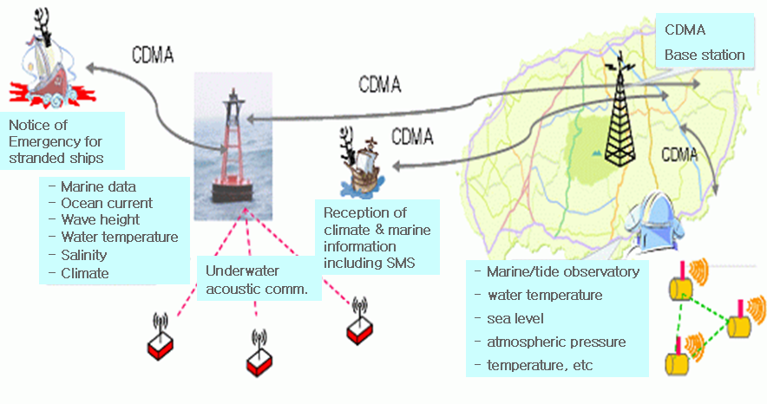
Figure 8-1 Marine observation service by CDMA and Sensor Networks

Data servers (data center)

[Editor’s note: previous text from C-42 is moved to D3 after the meeting on Nov.27. At this moment, editors’ team decided to keep the clause title. After reviewing other contributions submitted before Nov. 30, the text will be included if there are suitable text for this clause. Other than that, this clause will be removed.]

Cooling System
[Editor’s note: the following text and figure is from C-17. Text needs to be clarified and refined.]

O Installation of Energy-saving facilities through installation of electric power savers at the base station
- power factors and harmonic waves have improved.
- Generation of harmful electromagnetic waves have been deterred,
- finally operation of stable devices has been promoted.
- This system is saving more than 10%.
O using natural cold air in winter season
- Reduction in use of air conditioners by inducing cold air from outside to inside in winter.
- This system is saving more than 15%.
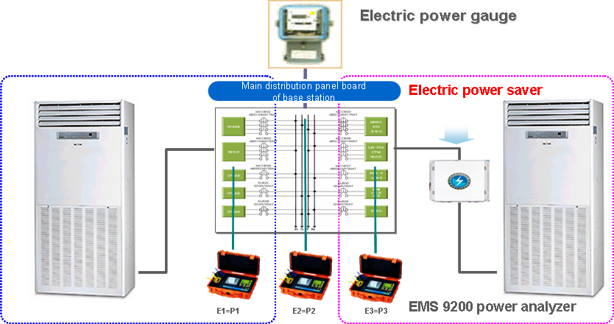
Figure 8-2 Power Server System at the base station

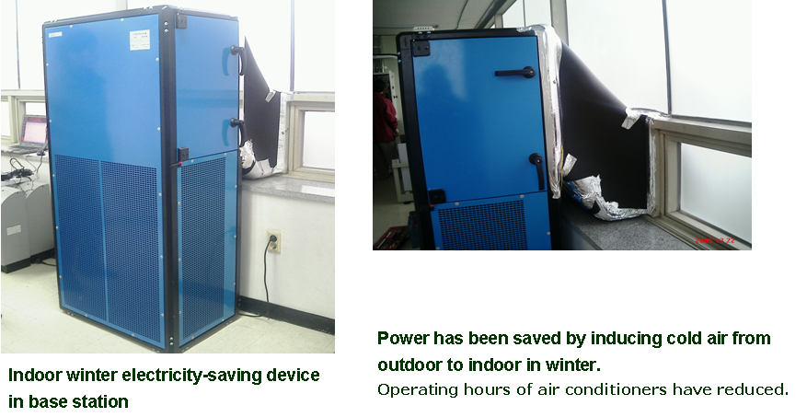
Figure 8-3 Cooling system by natural air

Audio and Video conferencing system.
[Editor’s note: The current text is from C-7 Appendix A.5.1.5. It needs to be refined and add more information for this clause.]

Audio and Video conferencing system is one of the key ICT technologies to reduce CO2 emission by reducing physical meeting. The following example shows the use-case of CO2 reduction by teleconference.

Video conference held between Tokyo and Yokohama, once a week (48 times / year), one hour each time, participated in by two people from each office
Video conference held between Tokyo and Yokohama, every working day (240 times / year), eight hours each time, participated in by two people from each office
Case 1
Case 2
Reduction of 53% (91%)
Reduction of 52% (59%)
The figure in ( ) is based on only the stage of use taken into account.
The figure in ( ) is based on only the stage of use taken into account.
In Case 1, the proportion of energy consumption in the production stage of Video conference devices is high; therefore, it will be essential to take the production stage into account. In contrast, in Case 2, a high frequency of use significantly increases energy consumption through conferences on a trip and Video conferences (in the use stage); therefore, the production stage influences less. Thus, energy consumption and their reduction significantly vary depending on the Video conference devices and the conditions of their use.

Use of ITU-T Standards
[Editor’s note: Introductory text will be followed.]

Next Generation Networks (NGN)
[Editor’s note: The following text is from C-12.]
Next Generation Networks (NGNs) are seen by many as the new network architecture that will unify today’s fixed, mobile and broadcast networks. This innovative technology is expected to bring about greater energy efficiency than legacy networks. In turn, by improving the energy efficiency of Information and Communication Technologies (ICTs), NGN can potentially make a significant contribution in the battle against global warming.
1) NGNs providers and manufacturers should commit to reducing power consumption through migration to NGN. Some of the actions to be taken could include:
-applications while maintaining the best quality.
- Lessening the number of electronic devices required in order to reduce emissions from the manufacturing and distribution of devices.
- Lowering the overall consumption of energy in data centres and developing energy efficiency servers.
- NGNs related technology should make use of more tolerant climatic range specification.
2) Making use of Multiple Power Modes in NGNs’ related technology. These could include:
-Full Power Mode- Maximizing Network capacity.
- Improving IP systems, reducing energy requirements of VoIP services and multimedia
-Low Power Mode
-Stand by
-Hibernation
Power requirements in each mode should be provided as well. The existing Code Of Conduct for Power Modes in Broadband equipment of the European Commission could be adopted as a reference.
3) Power consumption should be monitored in NGN devices to encourage their most efficient use. Elements in NGNs architecture where power consumption could be measured include:
- Transmission systems: Optic fiber, DSL, and Wireless.
- Swiching Centres
- Data centres
- Applications of the network, e.g. to evaluate total power reduction by remote tools.
This monitored data should be publicly available to allow the user to know how much energy ICTs usage requires.
4) Following SG15 work on the Energy Saving Checklist, ITU Study Groups could present new energy saving checklists, as a recommended tool for manufacturers and providers. An example could be an energy saving checklist for materials used in transport systems, where type, size, raw material and recycling options should be evaluated to be catalogued as energy efficient.

Ubiquitous Sensor Network (USN)
[Editor’s note: The following text is from C-15 and C-16.]

Ubiquitous Sensor Network (USN) is a conceptual network and an informational infrastructure which delivers sensed information and knowledge services to anyone at anywhere and anytime where the information and knowledge is developed by using context awareness.
USN applications and services are created by integration of sensor network services into network infrastructure. They are applied to everyday life in an invisible way as everything is virtually linked by pervasive networking between users (including machine and human) and sensor nodes, relayed through intermediate networking entities such as application servers, middleware entities, access network entities, and USN gateways. USN applications and services can be used in many civilian application area such as industrial automation, home automation, agricultural monitoring, healthcare, environment, pollution and disaster surveillance, homeland security, military field.
USN is built on wireline sensor networks and/or Wireless Sensor Networks (WSNs). WSN, a wireless network consisting of spatially distributed autonomous devices using sensors to cooperatively monitor physical or environmental conditions, such as temperature, sound, vibration, pressure, motion or pollutants, at different locations, has been studied and implemented as isolated networks for the sensor applications. The isolated sensor network applications have been simply designed to capture and transmit the sensed data only to the designated application systems.
Such isolated simple applications have been changing with network evolution, network and service integration, enhancing data processing scheme by business logics and data mining rules, context awareness scheme, development of hardware and software technologies, etc. These technical developments enable the ability to build an intelligent information infrastructure of sensor networks connected to the existing network infrastructure.
Figure 1 shows domains for development and standardization common to all USN applications. Other domains may be USN application specific.

Figure 8-4 USN domains for development and standardization

8.3.2.1 USN use-cases for monitoring climate change
Sensor nodes can measure and deliver diverse environmental data such as:
- Pressure, Humidity, Temperature, Light, Chemicals, Strain and tilt, Speed and acceleration, Magnetic fields, Vibrations, Motion, Metal detection, Sound, etc.
The sensing parameters are used to measure climate change and understand climate phenomena. The issues are how to deliver the sensed data and to manage the data to make value-added information for countering climate change.

(1) Direct climate change monitoring
In order to help counter climate change, it is important to monitor the climate to verify if changes to the environment are caused by human influence or natural phenomena. Research in using sensor networks to monitor climate have been studied for decades, and the technology and techniques have recently developed into a viable solution for monitoring climate change. This section will briefly introduce examples of how USNs are applied to monitoring climate. It should be noted that USNs have multiple applications in addition to the examples introduced in this section.

- Climate monitoring
Sensor networks are used to monitor a variety of systems (see Figure 8-4) and are installed over a wide area and in diverse range of domains to monitor climate information. The recorded sensor data is used to analyze climate at national meteorological centers, as well as help forecast weather events at weather forecast offices. The analyzed data can be used for early-detection and to prepare for natural disasters.
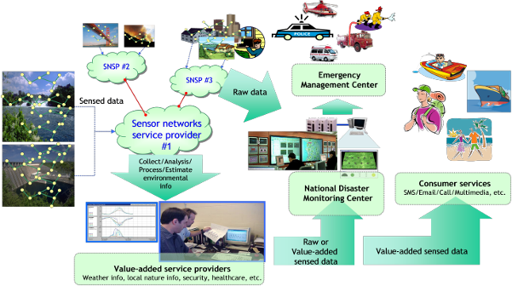
Figure 8-5 – An example service model for climate monitoring

- Marine environment monitoring
Jeju island, Republic of Korea, has tested one of the biggest IP based USN. This system demonstrates that IP enabled sensor nodes can directly connect an IP infrastructure. The data of the sensor nodes used to monitor real-time status of the seashore and marine environment is transmitted to the local weather station by means of a wireless mesh network.

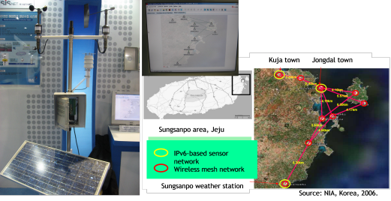
Figure 8-6 – A pilot project of monitoring seashore and marine environment

- Glacier monitoring
USNs are also used to monitor glacier thickness and size. In the 1st ITU symposium of ICT & CC, Nepal research and education network presented their study on monitoring glacier lakes and showed how wireless networks can be made to work in remote areas. To reduce the impact on the fragile ecosystem, these types of networked sensor devices are low-power, self-sufficient devices embedded with appropriate sensors. The study points out, however; that the power storing technology needs to mature to enable these sensors to function in arctic conditions. This study shows how data from USNs can be transmitted to an existing infrastructure.

• Pangboche
• Dingboche
• Namche bazaar
• Chhukung Ri
• Kalapathar
• Quangde
• Tengboche
• Loboche (Pyramid)
• Phortse
• Everest base camp
• Imja lake
• Khumbu Glacier
• Everest
25 Km
Source: Nepal research and education network
Figure 8-7 – Monitoring glacier lakes in Himalaya

(2) Monitoring and control of the GHG emission
USN applications can be developed to automatically monitor and limit power consumption levels. Various USN applications have the ability to monitor electric power consumption and air pollution emission to alert users when their systems exceed established thresholds.

- Management of city facilities:
USN applications exist that can manage various components of an urban infrastructure such as roads; sewer, water, and gas lines. In the event USNs senses a failure, maintenance systems would be called up to correct the malfunction. The road management system captures road conditions and provides drivers with road conditions and weather information USN applications also have the ability to monitor and control GHG emissions by rerouting traffic to less congested routes thereby reducing GHG emissions caused by stop and go traffic.
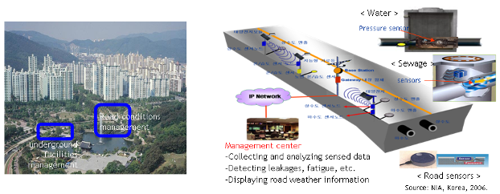
Figure 8-8 – u-city pilot project –Republic of Korea

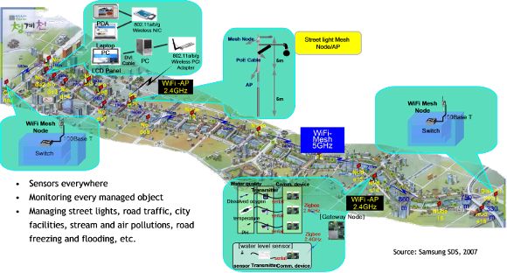
Figure 8-9 – Chung-gyeo-cheon stream in Seoul

- Home automation
Sensor networks are one of the key technologies for home automation. Light bulbs can automatically control the appropriate brightness based on information from motion sensors and ambient light.. Home appliances and other electronic gadgets can save energy when not used. Handheld LCD units are able to display the monitored power consumption levels to allow homeowners to adjust usage level appropriately. These monitoring and control systems can reduce GHG emissions.
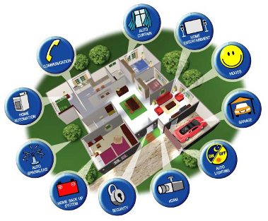picture source:CSEC solutions
Figure 8-10 –An example of home automation

- Industry automation and commercial building control
Power consumption levels and GHG emissions of industrial and commercial building complexes cannot be classified with consumption and emissions levels of single family homes. However, the same type of automation equipment used to save energy in homes can be used in commercial buildings to help reduce GHG emissions.
(3) Indirect monitoring to learn climate features
There are many USN applications that allow indirect monitoring for the acquisition of climate data. These type USNs are essential in allowing researchers to analyze and understand climate change. The following show some examples of these types of USN are used.

- Watershed monitoring
“Understanding climate change is the first step in developing strategies to deal with impending crises that could threaten global supplies for drinking, sanitation and irrigation.” The Hydro Watch project in Berkley built wireless sensor networks to more closely examine the water cycle. This is a good example of how USNs can be used to understand climate phenomena. USNs can be extensively deployed to monitor any environmental changes and help understand the cause of the change. The results of the collected data can be used to predict future changes.
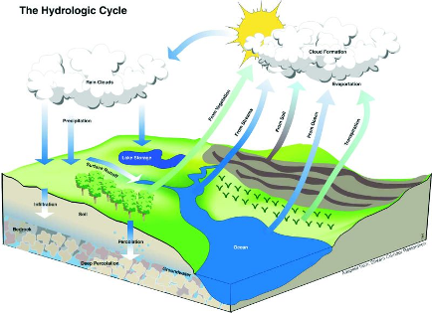Source: Berkely Science review
Figure 8-11 – Observation of hydrologic cycle

- Plants monitoring
Sensor nodes can also be installed in green houses or in open fields. The sensor network application monitors the agricultural environment and learns the plants’ habitat in order to help manage optimal growing conditions for plants.

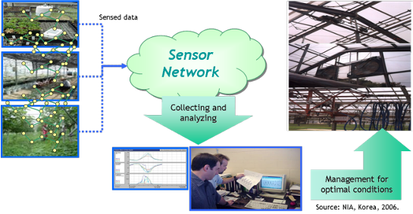
Figure 8-12 – Agriculture monitoring and management application

8.3.2.2 Perspective USN work items on behalf of FG ICT&CC activities
Section 3 showed how each SDO has developed or has been developing its standards within its work scope. However, there are other work items to realize a vision of USN applications and services in a viewpoint of monitoring climate change.
This section discusses the perspective USN work items on behalf of monitoring climate change. These items can be discussed with close collaboration between FG ICT&CC and the relevant ITU-T SGs and SDOs.
- Development of USN use-cases for monitoring climate changes
- Analysis of the functional requirements on behalf of monitoring climate changes from the use-cases
- Build-up reference models using USN for monitoring climate changes
- Build-up early-warning models and decision support models based on the USN
- In addition to the items, FG ICT &CC may give the relevant ITU-T SGs input of the necessary work items for the reference models
- Inter-networking between sensor networks and the existing network infrastructure: especially consider harsh outdoor environments
- Self-configurable networks
- Remote network management
- Power supply for the harsh remote environment
- Service registration and discovery (context-awareness service discovery)
- Management of vast of database
- QoS for emergency data
- Security issues, etc.

Intelligent Transport System (ITS)
[Editor’s note: The following text is from C-49.]

ITS is designed to achieve;
- Improvement of road safety and reduction of traffic accidents - It is a startling fact that nearly 1.2 million people are estimated to die on the world's roads each year, and over 50 million are injured or disabled.
- Increase of traffic efficiency;
- Improvement of freight and public transportation efficiency;
- Reduction of CO2 emissions.
- Driver assist and management

ITS can be facilitated with interaction of four essential components, as shown in Figure 1:
- Vehicle collects real time data (information and conditions of vehicle computers, positioning, etc.) with the help of sensors;
- Driver employs various services, for instance for navigation, entertainment, telematics, ITS application and other services with nomadic devices, etc.;
- Infrastructure is for which Green ITS can provide monitoring, detection, road management and the ubiquitous connectivity; and,
- Service includes Emergency notification, Telematics services, Fee and toll collection management, etc.
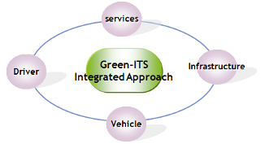
Figure 8-13. Main elements of Green-ITS

Green ITS will improve fuel efficiency and reduce the CO2 emission leading more efficient use of road infrastructure and fostering multimodal transport. The main effect of ITS for Climate Change is to reduce vehicle emissions. Various examples of Green ITS for reducing vehicle emissions are as follows:
- Dynamic Navigation (Collection of traffic, environment, and floating car data, Dynamic route guidance)
- ADAS (Adaptive Cruise Control(ACC), Intelligent Speed Adaption(ISA), etc.)
- Telematics Services (Real-time remote diagnostics, Alteration of driver behaviour, etc.)
- Delivery of Congestion and danger spots information by using Vehicle-to-vehicle and vehicle-to-infrastructure communications
Several leading auto-makers have studied idle-stop control device which stops engine while traffic idles. The unnecessary engine idling makes 17% fuel loss but IT converged idling stop technology proves that more than 5% fuel loss will be saved. To implement this technology, wireless communication between the light controller and cars should be further studied and standardized.

Tag-based Identification Applications and Services
[Editor’s note: The following text is from C-51.]

RFID is a representative Tag-based identification which wireless communication technology is used to transmit the identifiers stored in an RFID tag to an RFID terminal. An RFID can hold multiple identifications for different purpose of wireless data communication, which enhances the efficiency of the process of the identification.
RFID represents one of the most significant advances in supply-chain management since the first bar code was scanned in 1974. Electronic product codes transmitted through RFID can determine product arrival and departure at all points of the supply chain. Already, supermarkets are tagging pallets, cases, and other returnable transit containers such as plastic crates used for fresh foods. Tagging these items permits transparent and total visibility of assets and inventory. The ability to write to the RFID tag also allows the entry and management of information such as contents, expiry date, manufacturer and country of origin. With sensor enabled tag, it can provide temperature information for the preservation.
Food traceability is one of the most important applications that materialize public safety/security by the Networked RFID technology. Traceability of food chain enables tracing and tracking of the food and the information at each stage of the food chain including the production, processing, distribution and sales. When a food accident occurs, this approach is employed to search the related information to determine the range of the damage by tracking the cause. Utilization of the RFID is especially expected in the parts of identification, compilation of data, and collation of data.
The use of RFID which has been taking a pivot role for supply chain can be expanded to the whole lifecycle management. Already such a trial has been making. The Figure 1 shows lifecycle management in logistics. RFID has been so far applied to forward logistics in the Figure, and RFID technology enables to manage reverse logistics as well.

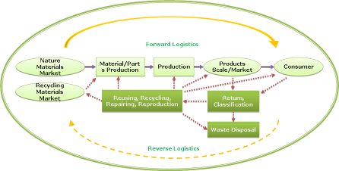

Source: GLOBE (Green Logistics Oriented Business Environment) project, Korea
Figure 8-14. Flow of lifecycle management in logistics

Use of RFID in forward logistics is well known. The Figure 2 shows reverse logistics to manage lifecycle of products. RFID is installed on a device from the manufacturer and logs every delivery status, repairing. When the consumers do not want to keep the device anymore, they return it to their service centre. In a recycle process, material information can get from the RFID. Reuse/Disposal report will be logged in the tag. After final recording, the tag is reused as well.

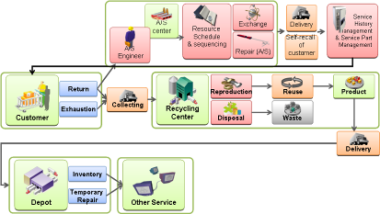
Source: GLOBE (Green Logistics Oriented Business Environment) project, Korea
Figure 8-15. Service model of after-sale

In the not too distant future, RFID and its technologies will contribute every single object identifiable and addressable. Smart components will be able to execute different set of actions, according to their surroundings and the tasks they are designed for. There will be no limit to the actions and operations these smart “things” will be able to perform: for instance, devices will be able to direct their transport, adapt to their respective environments, self-configure, self-maintain, self-repair, and eventually even play an active role in their own disposal.

World Health Organization, at http://www.who.int/mediacentre/news/notes/2007/np34/en/index.html.

