INTERNATIONAL TELECOMMUNICATION UNION |  | Focus Group on ICT&CC
TELECOMMUNICATION  STANDARDIZATION SECTOR  STUDY PERIOD 2009-2012 |  | FG ICT&CC-77
English only
Original: English
 |  | Hiroshima, 24-27 March 2009
CONTRIBUTION
Source: | BT Group plc
Title: | Flexible working practices to minimise carbon footprint
1. Introduction
Teleworking or home-working is already seen as beneficial in terms of reducing commuter travel-related greenhouse gas emissions, both directly and indirectly, via reduced congestion. Furthermore, companies opting for “agile working” practices can also reduce their own carbon footprint by lowering the need for office space (closing floors/buildings) and by supporting a more efficient utilisation of desk space. On such a high level, known sustainability benefits of home-working include:
- Flexible work / life balance for employees
- Employee retention & productivity
- Reduction in commuter travel-related CO2 emissions
On a finer-grained scale though, additional, case-specific constraints and opportunities will strongly affect the actual benefits of any given agile working policy. "Free parameters" such as which offices to use/close can be exploited to fine-tune a company’s agile working strategy. Many variables also need to be factored in, such as seasonal effects on home-working emissions (e.g. winter heating or summer cooling, depending on geographic location). Finally, the possible role of intermediate solutions between home-working and a metropolitan office, such as tele-cottages, must be evaluated.
In this context, it will become increasingly important to know the fully quantified effects of home/office-based working CO2 trade-offs. This knowledge can then be used to inform optimised agile working policies as well as to identify “hotspots” where intervention would be most beneficial. Such targeted improvements have the potential of making home-working even more attractive from a CO2 reduction and sustainability perspective, by further lowering the average carbon footprint of homeworkers while simultaneously optimising the energy-efficiency of the office-based workforce..
It is fairly obvious that ICT provides the means for teleworking, via such tools as audio/video conferencing. This contribution focuses on the industry’s potential to play a key role in the measurement and modelling of the energy/carbon tradeoffs between different modes of agile working (home/office/mobile), allowing these to be optimised.

2. A methodology to address and quantify ICT-supported agile-working CO2e benefits
- Attribute CO2 emissions to existing home/office working practices, by drawing upon readily available statistical data
- Obtain representative data on commute-travel distances, home energy use and behavioural factors
- Model the actual difference in energy consumption and CO2 emissions resulting from a worker being present at home during business hours (must take into account variation between households)
- Combine home, office and travel-related carbon emissions to understand existing trade-offs and identify the main contributors
- Investigate alternative scenarios that could impact on the overall carbon footprint such as, e.g., company or government-sponsored home improvements resulting in better energy efficiency, seasonal variations in home-working policy, building of tele-cottages in residential areas etc.
- Apply country or region-specific parameters and conversion factors reflecting the local climate and the fossil fuel component in the generation infrastructure
- Carry out case studies, informed by all or part of the above tools, to test the feasibility of alternative agile working policies and refine them
3. Proposal
BT would like the methodology detailed in section 2 above to be considered for inclusion in Deliverable 3. Section 1 may be used as introductory material and adapted as appropriate by D3 editors. The appendix below shows some preliminary results and tools that could be developed to support the principled, organisation and country-specific optimisation of agile working practices. We will present these in more details during the Hiroshima meeting and some of this material can be made available as an informative annex to D3.

Appendix
The four figures below show how trade-offs between the various components adding-up to form the overall carbon footprint of an organisation can change under various hypotheses. The vertical axis are carbon emissions (arbitrary unit), the horizontal axis is the fraction of office-based workers (0-100%). Individual curves represent the contribution of additional home energy consumption (green), total office consumption (red), commuter travel (blue) and the normalised total (black).
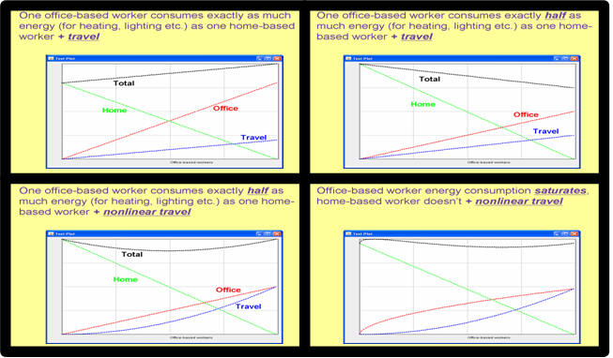
ICT tools could also be developed that would simplify the task of optimising desk occupancy so as to maximise opportunities for powering down rooms, floors or entire buildings, while simultaneously taking into account semi-flexible employees’ preferences or requirements. This particular instance of a well-known NP-hard problem (timetabling) can be tackled using advanced techniques to efficiently explore a huge solution space.
The snapshot below shows a working demonstrator developed by BT Innovate. It illustrates how aggregating space-time slots can free individual rooms that would otherwise have been sub-optimally occupied by a small number of office-based workers. Legend: horizontal “traffic lights” represent mobility in time (green = flexible), vertical ones mobility in space of half-day desk slots initially specified by employees. This small-scale example shows allocation of seven desks, unevenly distributed between two rooms (black line = separator), over a five days working week (one column = one half-day).
