INTERNATIONAL TELECOMMUNICATION UNION |  | Focus Group on ICT&CC
TELECOMMUNICATION  STANDARDIZATION SECTOR  STUDY PERIOD 2009-2012 |  | FG ICT&CC-C-54
English only
Original: English
 |  | Geneva, 25-28 November 2008
CONTRIBUTION
Source: | Université de Paris Diderot and Institut de Physique du Globe de Paris  France Telecom
Title: | Input for Deliverable 3 : ICT impact assessment method, targets and result

Methodology to assess ICT contribution on energy saving and on fossil CO₂ equivalent emission reduction

I Introduction

Threats about man made climate change due to excessive greenhouse gas emission have spurred the search of solutions to slow these emissions. To these threats adds the imminent end of cheap oil production due to declining flow from large and old fields, poor amount of discoveries by comparison with the present consumption and the complexity to develop remaining prospects which put pressures on energy supply and in the medium and long term on energy prices.
Among alternatives to cope with these various challenges, a range of telecommunication (telecom) services can be used to substitute for fossil fuel driven services such as physical travels. However a thorough evaluation of these various telecom services is necessary to establish their actual impact and by which amount they can reduce the use of fossil fuels or other energies (other energies freed thanks to these services can be used to save fossil fuel energy in other sectors).

This paper presents a methodology to assess the energy consumption – hence the fossil CO₂ emission – of a telecom service. The same method can be applied for the physical service the telecom can substitute for. The difference of consumptions between the two services permits to estimate the possible amount of energy, or CO₂, saving, depending also on the rate of penetration of these services. This methodology is inspired from efficiency analysis of processes in energy industries [1, 2]. Its aim is also to give practical tools to deal with the inherent complexity of energy systems and come up with reasonable conclusions.

The scope of the study covers all ICT equipment required to establish telecom services including telecom network elements and customer premises equipment (CPE), such as phone, personal computer, home gateway, etc.
All life cycle energy consumptions are considered: ICT operational energy consumptions (equipment use) and ICT investment energy consumption (equipment manufacturing, end of life treatment).

The method must reduce the use of arbitrary assumptions and when unavoidable must explicit them. Arbitrary means that the assumption can be independent of the service performance and/or cannot be realistic. This is the case of conversion coefficients of direct energy to primary energy or to CO₂ emission rate. As computers do not emit CO₂ like cars, the fossil CO₂ emission assessments are very dependant of these conversion coefficients. For the same service and the same direct energy consumptions – mostly in the form of electricity –, these coefficients will differ radically according to the country considered to derive them. The striking example is the difference between Norway where 99% of electricity is produced from water falls, and Poland where around 95% of electricity is produced from coal plants and 98% form fossil fuels [3].

For these reasons, intermediate results (e.g. direct energies or distance), must be indicated as well as the assumptions used to convert these energies in primary energies and/or fossil CO₂ equivalent emission.

The proposed method starts by splitting-up the ICT service and the replaced physical service into sub-systems.
The same approach is used to study either ICT or the physical service that is substituting by the ICT service. Then, for each sub-system, energy consumptions can be studied in detail and independently from available raw data. Physical and technical parameters involved in the energy consumption, like use rate of a device, bit flows of the service, etc, should be identified to check data consistency and establish some predictions. They should normally give better insight on weakness and strength of a service and indicate how to use better it or to improve it.

This method leads to sub-system modules that can be reused further for other services studies.

II Methodology

The method is first described in general terms to be applied either for a telecom service, a travel or other services. The method is then applied to a specific telecom service of France Telecom. Finally, after studying with the same method the necessary consumptions of the substituted travel, the gain of using the telecom service instead of the travel is determined.

II-1 General information

Type of methodology
To achieve these goals the method relies on a process based analysis. Input/Output table approach [4] will not be used except in a first step of estimate and in the absence of readily accessible data, or for small contributions to the energy balance. Because of some drawbacks [5] Input/Output table method can only give an order of magnitude of the energy consumption to obtain a product or a service.

Intermediate variables
In the process analysis, energy consumptions are reported as much as possible in direct energy (electricity, petroleum products, etc). The reason is that the value is directly measured and less affected by conversion error.
For example, in ICT sector, electricity is mainly used by equipment and a convenient unit of energy will be kWh.

Terminology used to describe the method:

- Service or product:
This is the result of one operation or set of operations each requiring some energy consumptions to run.
An end service or end product means more specifically the result of the overall operations under study (the ICT service or the physical service or product that is replaced by ICT service).

A sub-service or sub-product represents an intermediate operation result necessary to achieve the end service, such as a server processing operation.

- Unit of service or product:
This is the reference unit to measure the quantity of a service or a product.

For the end ICT service, the end service unit can be one hour or one Gbit of service per user.

For an end physical service that is replaced, the unit can be one person attending one meeting per travelled km.

For the overall comparison between the telecom service and the physical displacement, another unit might be introduced, for example: one meeting.
This meeting can be caracterized by the required energy consumption integrated over the average duration, the average number of participants and the cumulative travelled distance.

For the sub-service, the unit can be one active hour of a server or one km for one passenger in a car or a plane. For the sub-product, the unit can be one server or one PC or one phone. When an intermediate unit is used, it is necessary to have a clear link of this sub-service unit to the end service unit to be able to make the end calculation.

- Consumption C_{i}:
This is one form i of energy involved for one operation i.e. to manufacture and install the equipment, and then to operate the equipment.

Ci is associated to a sub-service or a sub-product made by the operation. C_{i} is expressed per unit of this production like kWh per manufactured server or kWh per hour of use of one server.

Before its operation life, Ci is the energy to manufacture a device and it will be designated as investment consumption. For ICT, this can be the amount of direct energy (in kWh) to build a server, a network equipment, a CPE, etc. For physical counterparts replaced by ICT service, this can be the energy to produce a sheet of paper, or a car, etc. Because of similarities for the end calculation, consumptions for the device maintenance and its end of life phase are also considered as investment consumptions.

During its operation life, Ci is the energy used for the service and it will be designated as the operational consumption. This is the amount of electricity used by the network, servers, CPE (e.g. in kWh per one hour of use) or the amount of fuel during the car displacement (in kWh of fuel per km).

- Consumption rate R_{i}
This is the energy consumption expressed per unit of the end service like kWh per one hour of the telecom service and per user.
Ri determination from each Ci needs the calculation of the amount of production of the end service Pi associated to Ci.

Ri is calculated by the relationship Ri = Ci/Pi.

- Production Pi
Pi is associated to C_{i} and corresponds to the amount of end service or product that C_{i} will permit.

For instance Pi can be the number of hours of a telecom service achieved by a server or a phone during its life time.

- The overall consumption rate R for an end product or service
R corresponds to the sum of all Ri. The unit of R is the same as the unit of all Ri, i.e. kWh per unit of the end service or product.

II-2 Analysis of a service energy consumption

The objective is to assess the service energy consumption rate R (related to one unit of end service). The following steps are necessary for R assessment:

1 Identification of the different sub-systems and required operations for separate studies purpose.
2 Gathering of raw data for each operation to determine their energy consumptions C_{i}.
3. Choice of the unit to express the consumption rates R_{i} based on the end service or product. Introduction of the production P_{i} corresponding to the amount of the end service or product done with Ci and conversion of each C_{i} in R_{i} using P_{i}.
4 Energy efficiency analysis with R_{i}: comparison between R_{i} for different situations, influence of parameters, and final assessment for ICT service (sum of R_{i})

The flow chart in fig. 1 shows the analysis of the service under study. It describes one generic service and gives an illustration by one example of a teleservice: the cooperative telework.
NOTE: Let's consider that the example is not described with full details, there may be for example user of mobile phone, other using old switched phone, other using IP phone.

The flow chart points out a dominant structure of operations in series. The serial form implies mathematical sums of operation consumption rates.

Example: cooperative telework
Generic service
Operation A1
Operational R1₁
Investment R1₂
Operational R1₃
...
...
Investment R1₄
Data
Electricity
Voice
Computer
+
Access
Electricity
Transfer
Network
Electricity
ONT…
Fiber…
Processing
Electricity
Protection
Electricity
Servers
Firewall…
Data
Electricity
Voice
Electricity
Computer
Phone
+
Access
Electricity
Network
ONT…
Transfer
Electricity
Fiber…
...
...
+

Operation B1
Phone
Electricity
Sub-system 1
One end user

Investment RI₂

Data center
OperationAi,
Operational RI₁

Sub-system i

Operational RN₁
Operation An
Investment RN₂

Other end user
Sub-system n

Fig 1: schematic of the method to estimate energy consumption of a service. The generic flow chart is illustrated by one example of a teleservice.
The sign + indicates operations achieved in parallel whereas arrows indicate operations done in series along the flow of services or products corresponding to the end service.
End service or product
- Step 1 Identification of the different sub-systems
The different sub-systems, and for each sub-system the different operations, are identified along with their delimited flow of energy or material. Each sub-system will be studied separately to simplify the analysis. These sub-systems can be the devices at the user level, the network including the access network, or the datacenter with the servers used for the telecom service. Between the sub-systems there is a flow of service or product (for instance flow of data and information to perform the teleservice).

- Step 2 Gathering data
For each operation, the raw data or data as measured (such as the different flows of energy and equipment along with their characteristics), are collected to calculate the end service energy consumption.
The analysis of each operation allows determining the energy consumptions C_{i} of the different sub-systems, being either operational or investment energy consumption. Sensitive parameters for the consumption (like flow of bits or number of servers to perform the service under study) should be identified.
Scientifically or empirically well established relationships may help to identify these parameters. They can also complete information from accessible data.

Important information about data details:
Between different sources of energy assessment, discrepancies on consumptions can arise which are significant compared to the overall consumption. One method to overcome this problem is to derive the same information from different sources where details to establish it are given, or by other means such as the use of established relationships. This may help to evaluate and point out the uncertainty of some data for further improvements and/or for realistic conclusions.

The different energy consumptions Ci are naturally expressed in various units such as kWh per working hour, kWh per device, kWh per bit transferred, kWh per bit per km, etc.
The different C_{i} units express the fact that the various consumptions refers to various sub-services or sub-products and not necessarily to the end service or product.
On the practical side, these values can come from:
- Power (in Watt) of the equipment in a defined operation mode as expressed by the manufacturer - Direct measurement in laboratory or in the field
- Indirect and statistical calculation from long term records (e.g. electricity metering related to user statistics).

- Step 3 Choice of unit
To allow comparison between consumptions and to allow their addition, all C_{i} will be converted to the same chosen service unit of the end service or product. For instance the unit can be one hour of the service for one user (h.user). The chosen unit should be convenient to deal with the different Ci of the service.

NOTE: to draw a comparison with the physical travel that the telecom service will substitute for, another unit of service may be at the end chosen. In particular consumptions for the travel are highly dependent on the distance and so the unit of physical service will reflect this, whereas for the telecom service because of negligible influence on consumptions, distance will be discarded. For comparison between the two services unit of the physical displacement will be chosen as the common one. Because this latter unit will be less convenient to convert the different consumptions of the teleservice, it will be only applied on the overall result.

For each C_{i}, in order to calculate the consumption rate R_{i}, it will be necessary to introduce a new variable: the production Pi, or the amount of units of end service associated with C_{i}.
For instance for a C_{i} in kWh per bit and a unique unit of the end service in h.user, we’ll need to introduce and calculate the P_{i}, which will represent the number of h.user per bit.

Then, the R_{i} in kWh per h.user will be calculated in this way:

R_{i} = C_{i} / P_{i}.

NOTE: the unit of end service can be also the unit of an intermediate service.

For the energy consumption to manufacture a computer, P_{i} is the amount of h.user done with the computer during its life time. In this case the total number of active hours performed on a computer appears to be an important parameter for the consumption rate calculation. To calculate P_{i} one hour of the teleservice may be assumed to be equivalent to any active hour whatever the service performed. The idle and shut down times are not considered productive and so cannot amortize the device manufacturing consumptions.
Parasitic operational consumptions (like during standby mode or transfer of megabyte sized advertising) may be shared out among useful operational consumptions to take into account the full consumptions.

Please refer to figure 1 in chapter II-2 for better understanding of Ri through illustration.

- Step 4 Energy efficiency analysis
At this step all Ri, which are by construction expressed in the same unit (the unit of the end service), are added up directly to obtain the end consumption of the service (R = ΣR_{i}). They can also be compared to determine which operations contribute most to the overall energy consumption of the service.
A sub-system of the service or one of its operation can be changed for an alternative of known Ri. The exchange of Ri gives the modified overall consumption rate and hence the benefit of the change.
This allows a lot of simulation to assess evolution trends.

Summary
The analysis of the ICT service impacts is based on the calculation of an indicator: the power consumption rate R. All energy consumptions C_{i} of sub-systems and individual operations are normalized in Ri. The advantages of working with Ri are:

- The different consumptions in the form of R_{i} can be directly added,
- With R_{i}, a hierarchy of consumptions can be established to identify the sub-systems or the operations of the service where consumptions are highest and where efforts should be done to improve the accuracy of data. For much smaller consumptions an estimate will be sufficient, provided it is realistic and it is at the high end of possible values,
- The R_{i} hierarchy is also a tool to identify the processes where efficiency must be prioritized.
- The R_{i} calculation forces the introduction of variables P_{i} which appear important parameters to control the energy efficiency of the different sub-system of the service,
- The method with Ri is highly modular. It allows easy simulation of influence of technology evolution just by changing R_{i} values to ones corresponding to new or different technologies.

II-3 Analysis of the positive impact of the ICT service (energy reduction)

Scope of the method
There are many differences between an ICT service and a physical service. For example a physical media can be replaced by a file to be downloaded which makes also a lot of change in user habits. It is not possible just to replace the previous service by the new one doing a one for one substitution. As a consequence, it is very difficult to assess all the impacts of such substitution.

Many environmental impacts are addressed in eco-designs and in the so-called life cycle analysis such as water use, air pollution, ground pollution, material saving (suppression of printed papers, downloaded files replacing physical media, etc). Because of the complexity of all these topics the present study intends to focus on the energy efficiency and hence on fossil CO2 emission rate.

Unit choices and conversion for ICT benefit expression
To explain how to assess the ICT positive impact, we will analyse it on the example of the physical travels that a telecom service will substitute for.

For a travel, the more direct unit to calculate the consumption rate from raw data (as estimated by national or international agencies), is liter of fuel or kWh per km and per passenger (or liter of fuel or kWh per km per tonne of freight if the aim of the teleservice under study is to reduce the freight transportation via a better optimization). Knowing the volumetric heating values of the fuels, all consumptions can be converted in kWh per km and per passenger for each mode of transport.
Depending on the distance, different modes of transport, or set of modes, are used, from the walk to the long haul flights. For distances longer than 2 km, we can consider that presently most of them use petroleum products (gasoline, diesel, kerosene and fuel oil). Road transportation, the most used mode expressed in travelled km.vehicle, is overwhelmingly fuelled by petroleum. An important part of rail transport uses petroleum too.

However it should be kept in mind that state of the art on techniques makes possible a large scale transition from petroleum fuelled transportation to an all electric one, except probably in the aerial sector. Of course such a transition will span several years even some decades. In order to assess realistic ICT impact and its evolution with time, the proposed method must be able to take into account the consequences of such technology change by calculating the corresponding consumption rate from consumption values for current and prototype electric vehicles.

Consumption Rate calculation (R_{i})
To draw a comparison between the telecom service and the substituted physical travel, energy consumptions are put in the same unit. For instance the consumption is reported for one conference. The consumption rate of the teleservice expressed per hour and user is integrated over its average duration and over the number of all participants.
The analysis put in evidence the determinant role played by the distance between participants.
In principle the overall consumption rate R of each service can be break down into two contributions, one distance dependent and the other non dependent. The analysis shows that for the teleservice case the distance dependent contribution is negligible with respect to the fixed contribution, even for distance as large as 10 000 km, whereas for the physical travel it is the contrary.

The consequence is that the saving through substitution is all the more important that the cumulative distance to be travelled by participants is large.
It is not a surprising result, however, what is interesting is that the consumption rate analysis can quantify more precisely the saving, for instance by determining the distance above which a teleservice is more efficient than the corresponding physical trip. Likewise the analysis can determine other parameters of influence.

Refining the model

It shall be taken into account the so-called rebound effects on consumptions induced by the use of the teleservice:
-the ICT service is not only used to substitute for physical displacements or for materials but has its own added value. So it may induce more use (more emails than postal mails, more teleconferences than physical conferences, more downloadings than equivalent physical media).
-the time saved by the teleconference (corresponding to the travel duration) can be filled by other energy consuming activities.

These rebound effects would be better taken into account on the energy consumptions after calculating firstly the overall consumption rates of both services under study. An example is given in § III-2.

III Study and preliminary results for a France Telecom service

III-1 Application of the method

France Telecom has developed for its employees a teleservice to permit a cooperative meeting among many participants at different locations through phone and computer connections. The product, named thereafter Cooperative Network (CN), allows sharing electronic documents on computers at a distance.
In 2007, 516 000 conferences CN have taken place, each among 4.5 participants on average and of 1 hour 40 min average duration. Dedicated servers in data centers, both for the computer connection (24 servers) and for the phone connection (11 servers), process and store the information regarding the conference, and process the data transferred. The energy analysis breaks down the system in three sub-systems:
- the user level with a phone and a computer,
- the network with the fibers and amplifiers, including the access sub-system,
- the dedicated servers and other devices in data centers.

Tables 1(a,b,c) summarize the main results about the energy consumptions of the different sub-systems of the system in form C_{i}, P_{i} and R_{i}.
This is a preliminary result which may be refined later (by taken into account some forgotten parasitic consumptions resulting from e.g. additions in the ICT dataflow or lighting and heating of empty offices rather than one meeting room, etc, all of them requiring deep level of analysis).
Each table row gives the consumptions of the various operations or elements of each sub-system (like a computer or a server). To each element may be associated an individual operational consumption (flow of energy consumed along the flow of data transferred), and an investment consumption, energy necessary to manufacture a device. The energy consumptions C_{i} are reported in direct energy, usually electricity except some parts of the investment consumptions.
The service unit is one hour of teleservice for one user (h_{CN}.user). From a survey of several CN, it can be assumed that 1 h_{CN}.user represents presently 0.75 Gbit in average. Hence for each consumption C_{i}, its P_{i} is calculated in order to determine associated R_{i}.

The investment consumptions have been estimated roughly, sometimes maximized by taking a value in primary energy from a life cycle analysis database. A more accurate analysis can be performed. However their consumption rates from the first estimate show they are small by comparison with R_{i} at the user level. The corresponding production P_{i} is the number of h_{CN}.user performed by the device during its lifetime. When the device performs different services, the consumption is distributed among them according to their duration or to their weight in bits.

CN Service | Operational consumptions | Investment consumptions
desktop computer (with cathodic tube ray display) | Ci = 250 W  Ri = 250 Wh/h_{CN}.user | Not considered
Phone (analogical) | Ci = 5 W  Ri = 5 Wh/h_{CN}.user | Not considered
Table 1a: consumption rates of a CN service at user level.

CN service | Operational consumptions | Investment consumptions
Computer connection  (24 servers)  (2 x 2 + 22 x 0.7)x1.8 kW | Ci = 310 MWh.year⁻¹  Pi = 3.9 M h_{CN}.user.year⁻¹  Ri = 79 Wh/h_{CN}.user | Ci < 93 = 24x3.9 MWh  Pi = 11.6 M h_{CN}.user  (3 years lifetime)  Ri < 8 Wh/h_{CN}.user
Phone connection  (11 servers)  (2 x 700 + 9 x.450)x1.8 W | Ci = 86 MWh.year⁻¹  Pi = 3.9 M h_{CN}.user.year⁻¹  Ri = 25 Wh/h_{CN}.user | Ci < 43 = 11x3.9 MWh  Pi = 11.6 M h_{CN}.user  (3 year lifetime)  Ri < 3.7 Wh/h_{CN}.user
Firewalls and switches  (6 F and 20 S)  (6 x 30 + 20 x 100)x1.8 W | Ci = 34 MWh.year⁻¹  Pi = 3.9 M h_{CN}.user.year⁻¹  Ri = 9 Wh/h_{CN}.user | Ci < 18 = 26x0.7 MWh  Pi = 11.6 M h_{CN}.user  (3 years lifetime)  Ri < 1.5 Wh/h_{CN}.user
Table 1b: consumption rates of a CN service at the data center level.

CN service | Operational consumptions | Investment consumptions
Access Core network | Ci = 15 W.user⁻¹  Pi = 1 h_{CN}.h⁻¹  Ri = 15 Wh/h_{CN}.user | Ri assumed negligible
Core network  (fibers) | Ci < 0.01 Wh.(Gbit.1000 km)⁻¹  Pi = 4/3 h_{CN}.user.Gbit⁻¹  Ri < 0.01 Wh.(h_{CN}.user.1000 km)⁻¹ | 10 to 100 Gbit.s⁻¹  40 years lifetime  Ri assumed negligible
Table 1c: consumption rates of a CN service at the core network level.

The investment consumption of the personal computer and the phone are not taken into account by assuming a situation where each participant has already both devices (which is the case at France Telecom). In opposite contrary situation, their investment consumption rate is estimated and added to the overall rate, which is very easy, because the method is modular.

The investment consumptions for the core network are assumed negligible due to their long lifetime and the large flow of data, hence of services, they can support continuously during this time. From table 1c it appears that the consumption rate of the element of the core network distance dependent is negligible for distance of several thousand of km (still under detailed study).
The most important contribution of the overall consumption rate arises from the user level. The electrical consumption of a computer or a server is very weakly dependent on the level of activity or flow of bits transferred in active mode. Consequently a better use of the device close to its capacity allows a smaller consumption rate as it is the case for the servers. This could change for the user, with new hardware and software, very energy aware especially in the portable world.
The consumption rate of physical travel is reported for one km and one user to take into account the dependence on the distance. Only the operational consumptions are reported, assuming the infrastructure R_{i} negligible and the purchase of a car not due to the meeting travel.

NOTE about the investment consumption of a travel: from different sources, the average energy to manufacture a car is found to be equivalent to the fuel consumption of the car to travel 20 000 km, i.e. around 7 to 20% of its operational consumption during its life (100 to 300 000 km).

The energy consumption rate is still dependent on the distance. Indeed, according to the distance to be travelled, different modes or set of modes of transport are used, each mode having a given consumption rate. A survey realised in France is used to derive both the consumption rate of each mode and their share for all the travels types according to the distance. It turns out that the dependence of Ri with the distance is relatively small because the R_{i} of the dominant modes of transport are close and the efficient ones like electric train or tramway are yet poorly developed.

To simplify the analysis, all the energy consumption for the cooperative teleservice (CN) is given in electrical form whereas the transport uses only in petroleum products, situation close to the present one. In figures 2 to 4 are compared the overall consumption rates of the physical and ICT services for a meeting. To carry out this comparison the consumption rates are integrated over the distance, assuming the travel of only one participant. This assumption is highly favorable to the physical travel, because the true physical distances are higher in general including also local displacement to hotels for example.
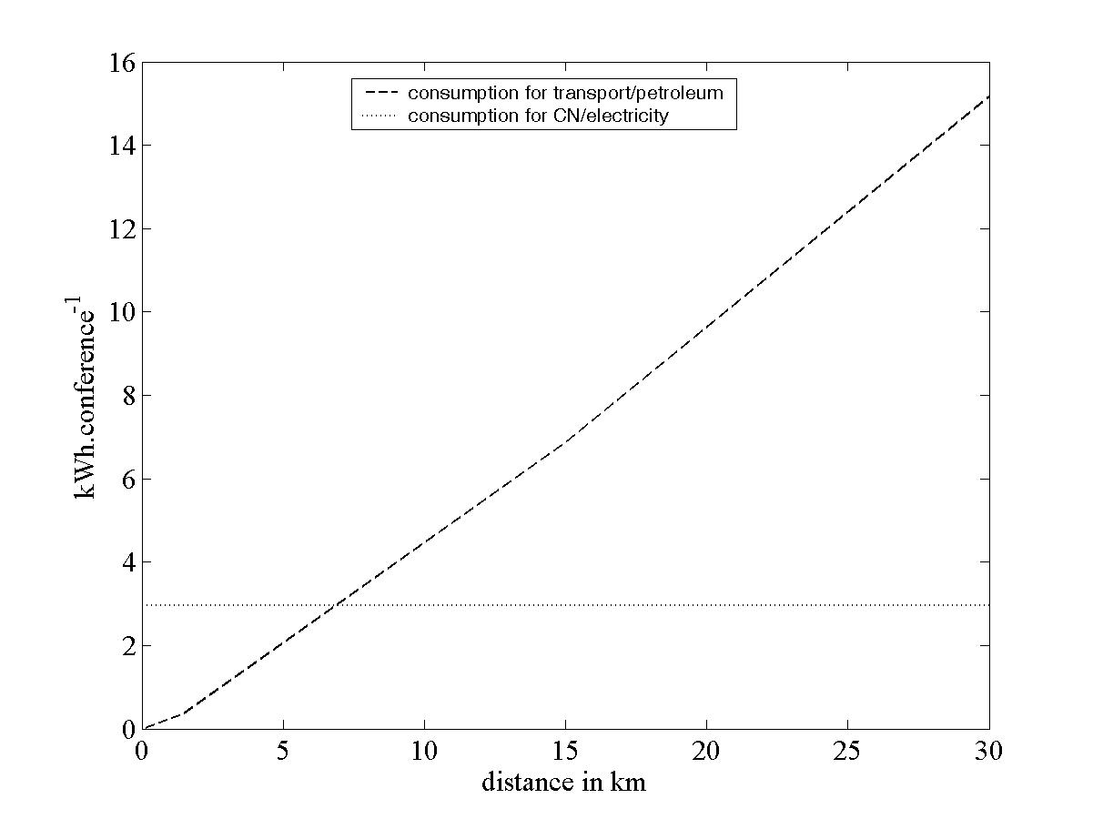
Fig. 2: comparison of consumptions in direct energy between the CN teleservice and a travel depending on the distance.

In fig. 2 the consumption rates are reported in direct energy. The distance above which a telecom service can save energy (distance break-even) is around 7 km, assuming direct energy parity.
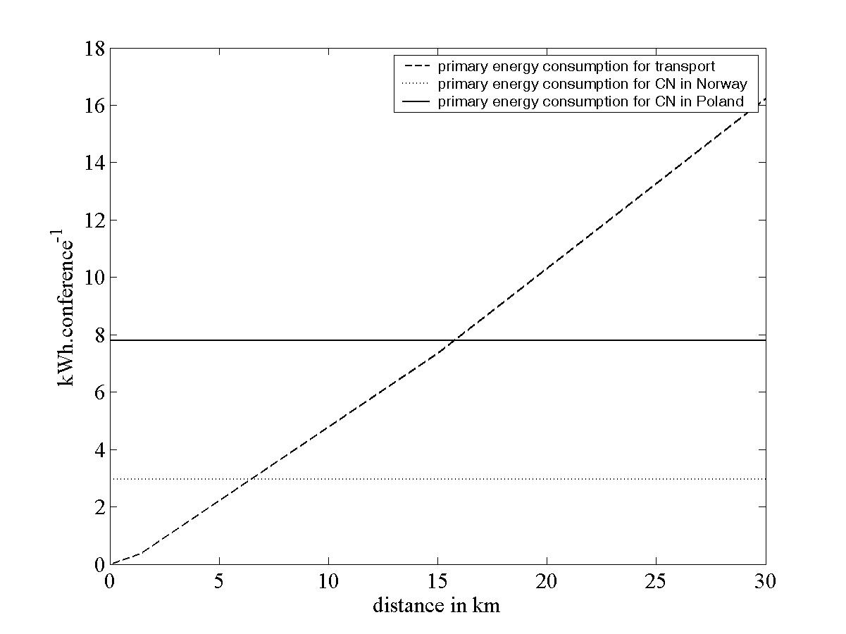
Fig. 3: comparison of consumptions in primary energy between the CN teleservice and a travel depending on the distance.

To take into account the difference of conversion between energy, consumptions are reported in primary energy in fig. 3. For oil products a unique factor of 1.09 is chosen to convert in crude oil equivalent. For the electricity conversion, two extreme cases are chosen: one corresponding to the Norwegian situation with 100% waterfall and a factor of one, and the other corresponding to the Polish situation with 100% coal plants and a factor of 1/0.38 (assuming an average coal plant efficiency PCS/net electricity of 38%). Break-even distance varies according to the country (from 7 for Norway to about 16 for Poland).
NOTE: this should not be exactly one in Norway if waterfall and grid maintenance must be included. The important point to stress is the consequence of difference in electricity production between two countries.
Lastly in figure 4 are reported the fossil CO₂ emissions of each situation. For the CN teleservice the two extreme cases are reported with zero emission for Norway and an emission rate of 900 g_{CO2} per kWh of electricity for Poland. In the case of crude oil the conversion factor is 270 g_{CO2} per kWh. This figure shows the distances above which a telecom service can reduce fossil CO₂ emission. They depend strongly on the share of primary energy to produce the electricity. In Norway this distance will remain to zero. This result will be true whatever the telecom service considered in Norway and its electrical consumption. Travel distances have to be more than 20 km for CO₂ saving in Poland with the CN teleservice.
The break-even distances remain relatively low making the CN teleservice a good alternative to transport.

NOTE: see previous note about difference between Norway and Poland electricity production. It applies also for CO₂ emission (not strictly equal to 0 in Norway)

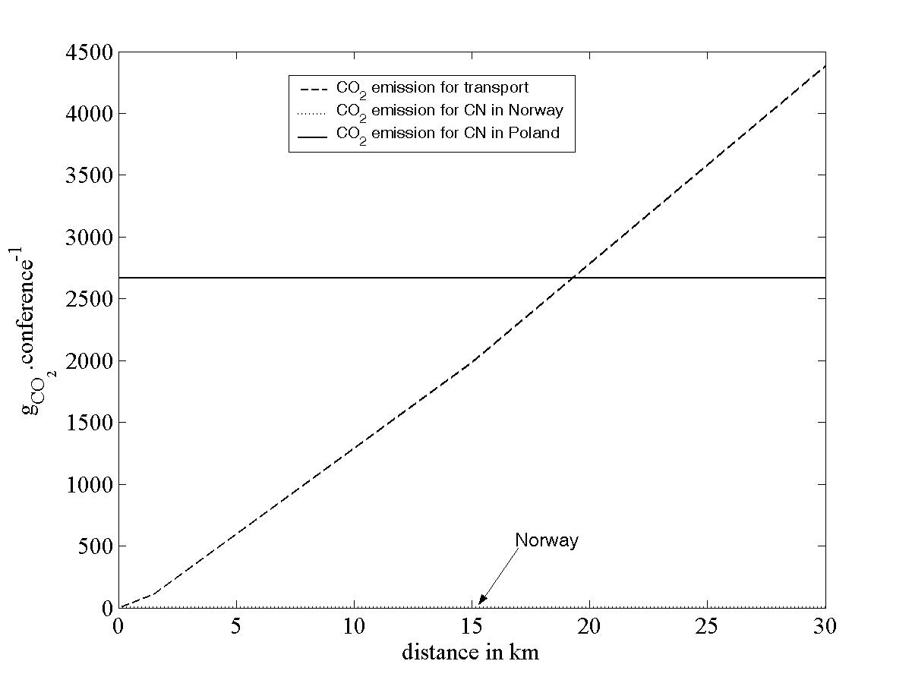
Fig. 4: comparison of amount of fossil CO₂ emission between a teleservice a travel depending on the distance.

III-2 Further considerations

End results depend on several assumptions made (equipment used for the CN teleservice, cumulative distance travelled for one meeting, energy mix for the electricity production, energy mix used for the transport, etc). These assumptions based on particular situations can evolve with technical progresses or a new economic situation. The bottom up approach exposed here with the consumption rate R tool is able to test the effect of different situations on the overall energy consumption. This capability makes it a predictive instrument.
To close this bottom up approach, it can be deduced from the saving at the scale of one service the saving achieved over a company or a country. With respect to this, it is interesting to note that for CN service, 516 000 conferences are carried out over one year with a total of 2.3 millions participants (corresponding in reality to 45 000 different employees of France Telecom using several time a year this service). It is hard to imagine that each teleservice substitutes for one meeting with physical travels. The teleservice convenience has brought about its extensive use, much over the substituted physical travels. The real saving is related to the number of avoided physical travels. Hence this number appears also a crucial parameter to study the global impact of a teleservice. Assumptions should be made based on realistic situations or on expected trends.
For example if three teleconferences occur for each cancelled face to face meeting, ICT consumptions for each meeting will be three time as high as the calculated consumption for one teleservice. The breakeven point is then around 50km, in the worst condition (Poland values). As in average, the real distance for a meeting is at least 10 times as high, CN service remains advantageous to save energy and CO_{2.}

IV Conclusion

In this document has been presented a method to estimate from raw data, the energy consumption of a telecom service and its energy gain by comparison with a replaced physical service (in the case study, the travel it substitutes for). From the energy results and further assumptions, CO₂ equivalent emissions can be assessed.

The method decomposes the service in its different sub-systems, and studies their energy consumptions. To allow their comparison and addition they are reported in the same unit as consumptions rates Ri. This conversion, along with raw data analysis, introduces some driving parameters of the consumptions useful for predictions and optimisations.

This approach and its modular indicator, the consumption rate R, are able to deal with the natural and unavoidable complexity of ICT and other service energy use, while remaining simple enough to give quantitative elements of answer, within a margin of uncertainty. They can also take into account changes expected from state of the art techniques in energy consumptions of the different services.

Notes and References

[] Chavanne X, Frangi JP, «De la détermination du rendement des filières énergétiques», C. R. Geoscience vol. 339, n° 8, 2007, 519-535.
[2] Chavanne X, Frangi JP, «Le rendement énergétique de la production d’éthanol à partir de maïs», C. R. Geoscience vol. 340, n°, 2008, DOI: 10.1016/j.crte.2008.01.006
[3] IEA Energy Statistics. 2005 energy indicators for Poland. Available at: http://www.iea.org/Textbase/stats/electricitydata.asp?COUNTRY_CODE=PL [20 Oct. 2008].
[4] Bullard C. W. and Herendeen R. A. The energy cost of goods and services. Energy Policy Vol. 3, Issue 4, Dec. 1975, 268-278.
[5] Weaknesses of Input/Output table method arise from its aggregate nature (concerning a limited number of economic sectors such as the overall telecommunication sector) and its indirect measure of the energy weight in a sector via monetary values. This method assumes also that only energy modifies the value of a sector production and that dependence occurs through a linear relationship. The energy monetary costs represent usually a few percent of the production revenue. For instance the bill of the main energy used by France Telecom, electricity, was in 2007 about 0.25 G€ while for the same year the gross revenue was 53 G€.

Reminder: 1 kWh = 3.6 MJ, 1 kWh = 860 kcal k=kilo=thousand, M=million, G=Giga=billion, T=Tera=trillion, P=Peta=thousand of trillion (e.g. kWh, MWh, GWh, TWh and sometimes PJ for PetaJoule)

