INTERNATIONAL TELECOMMUNICATION UNION |  | Focus Group on ICT&CC
TELECOMMUNICATION  STANDARDIZATION SECTOR  STUDY PERIOD 2009-2012 |  | FG ICT&CC-C-51
English only
Original: English
 |  | Geneva, 25-28 November 2008
CONTRIBUTION
Source: | ETRI
Title: | Tag-based identification and lifecycle management of ICT devices
- Overview
FG ICT&CC has been launched to study the ICT impact against climate change, and one of its study areas is possible savings in terms of Climate Change mitigation from the use of ICTs.
Tag-based identification applications and services is one of the key ICT solutions which can be used for lifecycle management of ICT products. ITU-T has been working on their standardization at SG13, SG 16, and SG17 with collaboration and coordination with other SDOs.
This contribution is to explain the use of RFID for lifecycle management of ICT devices. It is a good example to show that how Tag-based identification applications and services can be used as a green technology to mitigate climate change.
- Tag-based identification applications and services
RFID is a representative Tag-based identification which wireless communication technology is used to transmit the identifiers stored in an RFID tag to an RFID terminal. An RFID can hold multiple identifications for different purpose of wireless data communication, which enhances the efficiency of the process of the identification.
RFID represents one of the most significant advances in supply-chain management since the first bar code was scanned in 1974. Electronic product codes transmitted through RFID can determine product arrival and departure at all points of the supply chain. Already, supermarkets are tagging pallets, cases, and other returnable transit containers such as plastic crates used for fresh foods. Tagging these items permits transparent and total visibility of assets and inventory. The ability to write to the RFID tag also allows the entry and management of information such as contents, expiry date, manufacturer and country of origin. With sensor enabled tag, it can provide temperature information for the preservation.
Food traceability is one of the most important applications that materialize public safety/security by the Networked RFID technology. Traceability of food chain enables tracing and tracking of the food and the information at each stage of the food chain including the production, processing, distribution and sales. When a food accident occurs, this approach is employed to search the related information to determine the range of the damage by tracking the cause. Utilization of the RFID is especially expected in the parts of identification, compilation of data, and collation of data.
The use of RFID which has been taking a pivot role for supply chain can be expanded to the whole lifecycle management. Already such a trial has been making. The Figure 1 shows lifecycle management in logistics. RFID has been so far applied to forward logistics in the Figure, and RFID technology enables to manage reverse logistics as well.

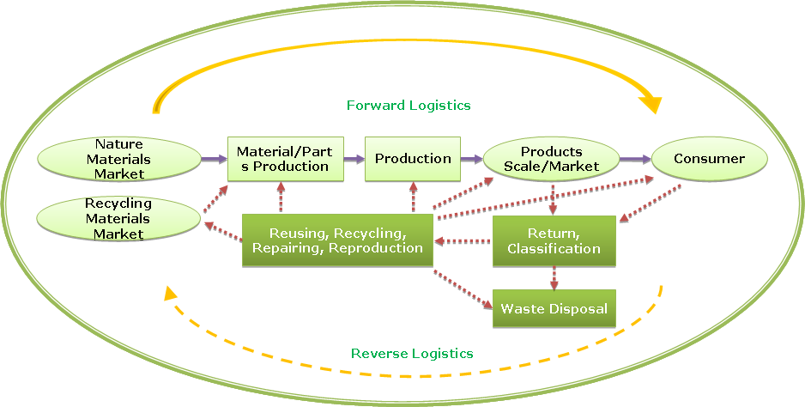

Source: GLOBE (Green Logistics Oriented Business Environment) project, Korea
Figure 1. Flow of lifecycle management in logistics
Use of RFID in forward logistics is well known. The Figure 2 shows reverse logistics to manage lifecycle of products. RFID is installed on a device from the manufacturer and logs every delivery status, repairing. When the consumers do not want to keep the device anymore, they return it to their service centre. In a recycle process, material information can get from the RFID. Reuse/Disposal report will be logged in the tag. After final recording, the tag is reused as well.
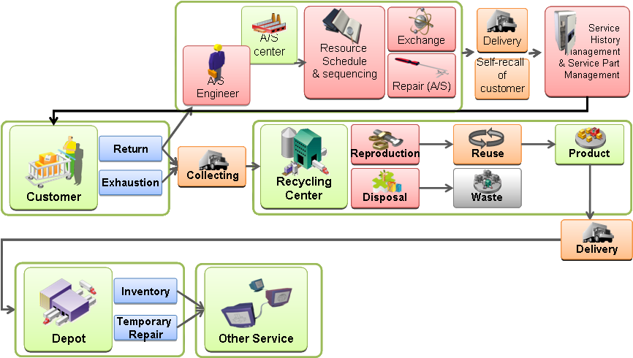
Source: GLOBE (Green Logistics Oriented Business Environment) project, Korea
Figure 2. Service model of after-sale
In the not too distant future, RFID and its technologies will contribute every single object identifiable and addressable. Smart components will be able to execute different set of actions, according to their surroundings and the tasks they are designed for. There will be no limit to the actions and operations these smart “things” will be able to perform: for instance, devices will be able to direct their transport, adapt to their respective environments, self-configure, self-maintain, self-repair, and eventually even play an active role in their own disposal.
- Proposal
It proposes to consider Tag-based identification as a candidate solution to deal with lifecycle management, and FG ICT&CC deliverables include the Tag-based identification works.
Appendix. Scope of Tag-based applications and services

Scope of standardization for tag-based applications is drawn in Figure 1. In order to figure overall standards development on tag-based identification and make possible harmonized collaborations, existing standards and standardization area are summarized.
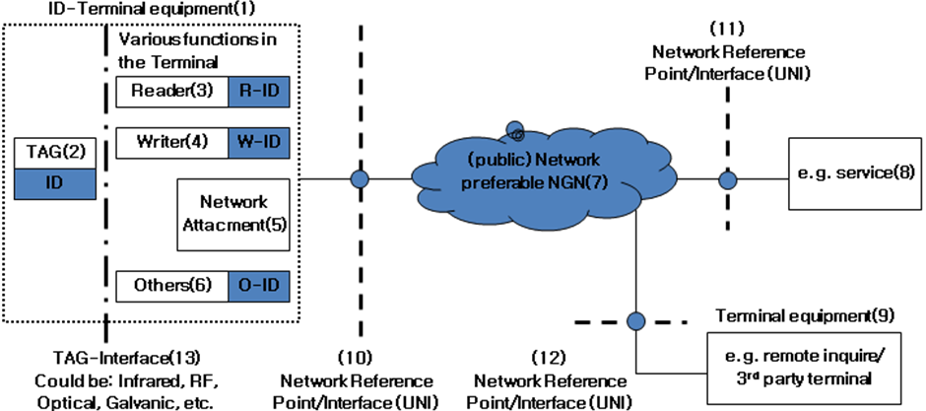
Figure 1. Scope of standardization for Tag-based identificaion

Standard technologies for Tag-based applications and services are summarized in Figure 2.
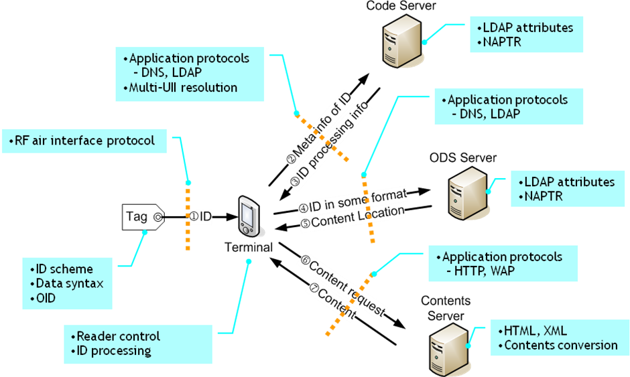
Figure 2. Standard technologies for Tag-based applications and services

