INTERNATIONAL TELECOMMUNICATION UNION |  | Focus Group on ICT&CC
TELECOMMUNICATION  STANDARDIZATION SECTOR  STUDY PERIOD 2009-2012 |  | FG ICT&CC-C-48
English only
Original: English
 |  | Geneva, 25-28 November 2008
CONTRIBUTION
Source: | Republic of Korea
Title: | Energy efficiency control program of Korea

1. Summary
Korea has four certification programs for energy efficiency control: energy efficiency grading; energy efficiency grading for buildings; standby power warning; and device certification of high efficiency of energy consumption.
This contribution introduces only the energy efficiency grading and standby power warning programs because these focus on electric power consumption and every ICT device consumes electric power.
Solutions and their consequences of ICT&CC may be evaluated by an appropriate metric. Those certification programs could be referred to for development of an evaluation program for ICT&CC.

2. Energy efficiency grading program
The energy efficiency grading program is comprised of three management points: grading label; minimum efficiency guideline; and target efficiency guideline. It applies to imported devices too. This program applies to refrigerator, freezer, kimchi refrigerator, air cooler, washer, electric bulb, fluorescent lamp, car, etc.
Figure 1 – Label of the energy efficiency grade
The grading label is classified into 5 to 1 grades as shown above where the grade 1 is the best and can support 30% to 40% of energy saving compared with the grade 5. It aims at helping consumers take decisions when they buy relevant devices.
The minimum efficiency guideline is the minimum value of energy efficiency to be provided and forces manufacturers to develop energy saving technologies. Failed devices must be taken out from the market.
The target efficiency guideline is a target value to be met after a certain time.

3. Standby power warning program
The standby power warning label is affixed by force at devices which cannot meet their standby power guideline. This program applies to imported devices too. The standby power means power consumption by machinery and tools, when connected to the external power supply, while not performing their primary functions or while awaiting instructions to provide full services.
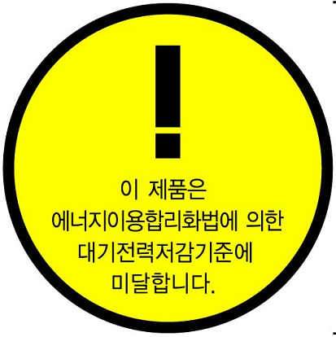
Figure 2 – Label of the standby power warning
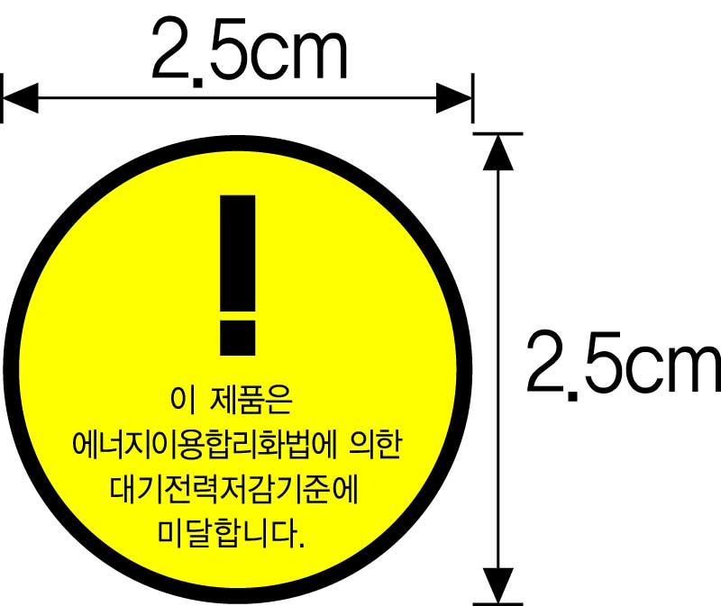
Figure 3 – Size of the standby power warning label
This program has the following roadmap:
- From August 28, 2008: the program has applied only to televisions.
- From July 1, 2009: it applies to computers, monitors, printers, printer-fax-copier-scanner combined devices, set-top boxes, and microwave ovens.
- From January 1, 2010: it applies to faxes, copiers, scanners, video players, audio players, DVD players, radios, door phones, wire-line and cordless phones (including VoIP phones), modems, home gateways and bidets.
Korea expects that the market share of good products would be increased to 90% until 2010 from 14%, 2007 and resulting energy saving would be 1,100GWh (about 100 billion dollars).

________________________

