INTERNATIONAL TELECOMMUNICATION UNION |  | Focus Group on ICT&CC
TELECOMMUNICATION  STANDARDIZATION SECTOR  STUDY PERIOD 2009-2012 |  | FG ICT&CC-C-45
English only
Original: English
 |  | Geneva, 25-28 November 2008
CONTRIBUTION
Source: | Japan
Title: | Evaluation of CO2 emissions of postal direct mail and direct e-mail
1. Introduction
In contribution C-7 entitled “Proposed draft text for Methodology” submitted to the first meeting of the ITU Focus Group held on 1-3 September 2008 in Geneva, we provided an overview of an evaluation method of CO2 reduction effect of ICT. In the evaluation method the CO2 reduction effect is composed of reduction by ICT itself, and reduction by other sectors thanks to ICT. The details of the method are described in [1].
The purpose of standardizing the evaluation method is to enable ICT users to quantitatively show their CO2 reduction when they effectively use ICTs in their activities. Standardizing the calculation method can also clarify the contribution of the ICT sector to other sectors, and will make it possible to study effective method of ICT use to combat global warming.
2. Discussions
We present how to use the proposed evaluation method for ICTs in this contribution, which clearly shows that the shift from physical means to the internet has a great effect on the reduction of CO2 emissions.
3. Proposal
We propose to use the method to evaluate the ICT CO2 reduction effect that consists of reduction by ICT itself and reduction by other sectors thanks to ICT.
4. Reference
[1] The Japan Forum on Eco-efficiency, ‘Guideline for Information and Communication Technology (ICT) Eco-Efficiency Evaluation,’ March 2006.

-----------------------------------------
(ANNEX attached)

ANNEX
- Service outline
Direct e-mail is one of the internet services provided by internet service providers.
A provider sends a subscriber a mail magazine e-mail that include advertisement.
- CO₂ emission evaluation
- Purpose of the evaluation
is to appeal to the clients that the use of direct e-mail reduces CO₂ emission.
- Evaluation unit
starts when a postal/internet direct mail is sent, and ends when it is received and read by the recipient.
Evaluation period is a year.
- System boundary
is shown in figure 1.
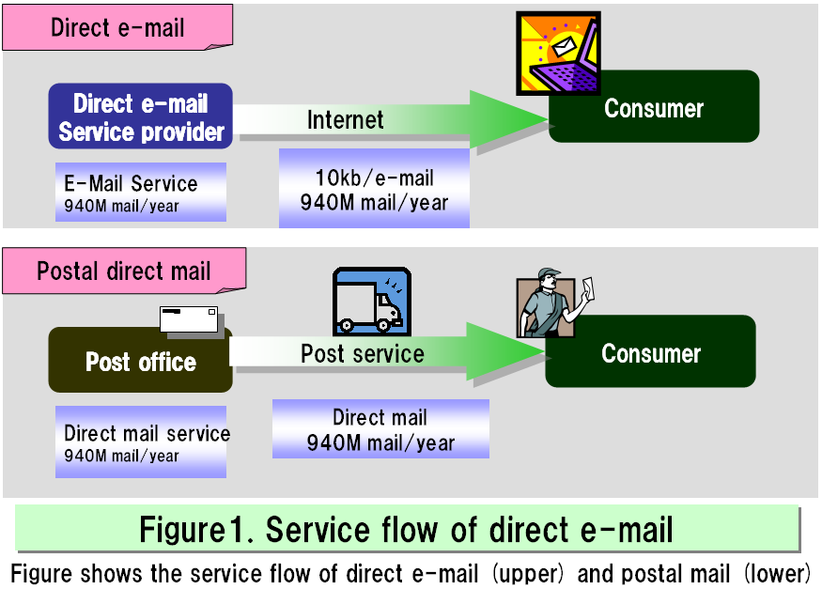

Modelling condition is described below.
- Before the introduction of direct e-mail
- Mailing service
Mails are sent by the post service.
- After the introduction of direct e-mail.

- Mailing service
e-Mails are sent by a service provider.
- Result
Figure 2 shows the CO2 emission evaluation result of postal direct mail and direct e-mail. It shows direct e-mail has the effect of 98.5% CO2 emission reduction compared with that of postal direct mail.





