INTERNATIONAL TELECOMMUNICATION UNION |  | Focus Group on ICT&CC
TELECOMMUNICATION  STANDARDIZATION SECTOR  STUDY PERIOD 2009-2012 |  | FG ICT&CC-C-35
English only
Original: English
 |  | Geneva, 25-28 November 2008
CONTRIBUTION
Source: | Chairman
Title: | Lifecycle Analysis Definitions for FG on ICTs and Climate Change
1. Introduction (italics refer to text already presented for D1)
ISO 14040 “Environmental Management-Life cycle Assessment-Principles and Framework
This standard outlines in general terms how a LCA may be carried out without specific reference to ICTs, climate change or carbon dioxide.
“LCA addresses the environmental aspects and potential environmental impacts (e.g. use of resources and the environmental consequences of releases) throughout a product's life cycle from raw material acquisition through production, use, end-of-life treatment, recycling and final disposal (i.e. cradle-to-grave). There are four phases in an LCA study:
a) the goal and scope definition phase,
b) the inventory analysis phase,
c) the impact assessment phase, and
d) the interpretation phase.
The scope, including the system boundary and level of detail, of an LCA depends on the subject and the intended use of the study. The depth and the breadth of LCA can differ considerably depending on the goal of a particular LCA”.
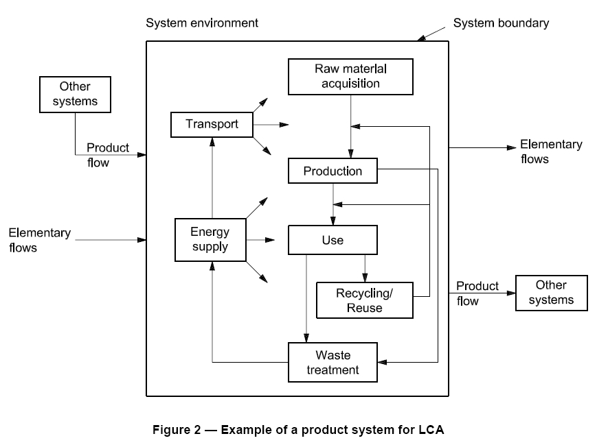
Figure 2 (as Figure 2 in the source document) is copied directly from ISO 14040 which shows energy supply in the raw material, production, use, recycling and waste treatment phases. The energy supplied may be direct as in fossil fuels used for transport, or indirect as in energy used from suppliers of mains electricity.
So far the FG has concentrated on ‘use phase’ where indirect electrical energy (typically measured in kilowatt-hours, Watt-hours or Joules) is typically converted to heat which is vented to the environment.
As the work progresses direct emissions from fossil fuel burn in production or transport will need to be included. These emissions can be reduced by up to 90% by recycling.

Definitions
Total Energy Supply J_{t} = J_{r}+J_{p}+J_{w}+J_{u}t
Where
J_{r} is the energy used in extracting raw materials,
J_{p} is the energy used in production,
J_{w} is the energy used in extracting raw materials from waste
J_{u} is the energy in use per unit time

C_{r} to C_{w} are the corresponding CO2e emissions for each process step.
Embodiment energy, J_{e} is the energy conversion involved in manufacture= J_{r}+J_{p}+J_{w}
Embodiment emissions, C_{e} is the summation of the corresponding emissions.

Figure 3 Cumulative energy for device#1 replaced by device#2
The ‘time to benefit’ T_{b} is shown on Figure 3.
It can be seen that for the ‘time to benefit’ T_{b} to exist at all the rate of use of energy for device #2 must be less than device #1 and it must have a service life which exceeds the time to benefit. (Some work on freezers may be of interest here as an example device. However this reference does not show a graph of the type shown in Figure 3).
In the case of telecommunication equipment Figure 3 could be used when considering the viability of replacement of broadband line cards in central offices. In this case L2 mode ADSL could be used to improve energy efficiency. The service life is likely to be around 13 years. The corresponding customer equipment is likely to have a service life of only 6 years.
In the case of recycling equipment, e.g. mobile phones, the old unit may contain more raw materials than the new one because the new one has less mass. Embodiment #2 could therefore require much less energy than Embodiment #1.
“To replace or not to replace” is an issue which needs further discussion. It will depend upon economic factors as well as CO2e impact on climate change.
Proposal
It is proposed that the contribution in the section on Definitions above is considered for inclusion in Deliverable 1 to introduce the concept of life cycle analysis (LCA) and associated definitions. This is additional to the proposal made in 24-09-08#9 “A Review of Lifecycle Analysis for FG on ICTs and Climate Change”.

Annex 1
Warning –life-cycle and solar panels

Figure 4 Cumulative energy for solar panel#1 replaced by solar panel#2
This Figure illustrates a risk with solar panels. The service life of device#1 was not long enough to and/or its quantum efficiency was too low to produce a positive supply of energy. The efficiency of device #2 was higher and did return a net benefit.

http://www.iso.org/iso/iso_catalogue/catalogue_ics/catalogue_detail_ics.htm?csnumber=37456 Your corporation may already have a copy.
http://mail.mtprog.com/CD_Layout/Day_1_21.06.06/1400-1545/ID122_Ruedenauer_final.pdf

