INTERNATIONAL TELECOMMUNICATION UNION |  | Focus Group on ICT&CC
TELECOMMUNICATION  STANDARDIZATION SECTOR  STUDY PERIOD 2005-2008 |  | FG ICT&CC-C-30
English only
Original: English
 |  | Geneva, 25-28 November 2008
CONTRIBUTION
Source: | Chairman of Side Event on Climate Change
Title: | Report on the side event on climate change held on Friday 24 October 2008 at the ITU-T World Telecommunication Standardization Assembly

The Chairman, Professor John Nkoma, Director-General, the Tanzania Communications Regulatory Authority, drew attention to the growing importance of climate change in Member States, in the United Nations system, including the ITU, and, in particular, the proposals for a Resolution at the WTSA. | 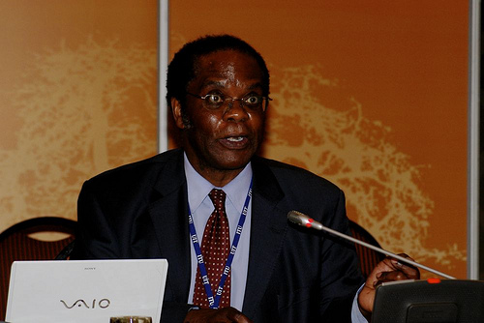

A member state
Antonio Guimarães, Adviser on International Affairs, National Telecommunications Agency of Brazil (Anatel), presented the views of a Member State. His country was directly affected by climate change, with rising temperatures, with desertification in the North-Eastern region of Brazil and with more powerful tornados coming ashore from the South Atlantic.

Brazil was now the fifth largest national market for ICTs. Its use of ICTs was expected to continue to grow at a significant rate, requiring more electric power and creating more Green House Gases (GHGs). Containing the growth of the GHG emissions had to be addressed, as had the proper disposal of waste products, where recycling was not possible.

Satellite monitoring of the environment was now being used extensively in Brazil, partly based on technological collaboration with China. For example, the DETER system – Detecção de Desmatamento em Tempo Real – provides real time information about deforestation, and the patterns over the two decades (see figure 1).
Figure 1 Satellite image history of an area in Itaúba (MT)

Since 1925, ethanol had been used as a fuel for vehicles in Brazil. Recently, production of bio-ethanol from sugar cane had been increased with a view to reducing GHG emissions from vehicles and from power generation.

Other means to reduce GHGs included the use of teleconferences as a substitute for travel, both domestic and international. The introduction of paperless meetings was making a useful contribution in both in Brazil and in the ITU.

Brazil sought simultaneously to measure deforestation using ICTs, to expand access to ICTs, especially among the poor and those living in the rural and remote areas, while endeavouring to limit the growth of GHG emissions and to replace activities that generated GHGs with ICT applications that allowed a net reduction in emissions.

A sector member
Keith Dickerson, Head of Global Standards, BT plc, gave the views of a Sector Member. He noted that ICTs had been associated with at least half of the economic growth in the past 50 years and that this interaction would be likely to continue, with the further expansion of the use of ICTs. A significant portion of the global population had yet to join the network society, with the further expansion of the use ICTs. The consequence would be substantial growth in ICT-related emissions.

The Global e-Sustainability Initiative (GeSI) had estimated a carbon footprint for the ICT sector and its likely growth to 2020 (see figure 2). Developing countries would increase their contribution to GHGs, from increased use of ICTs.

Figure 2 The changing geographical sources of GHG emissions from ICTs
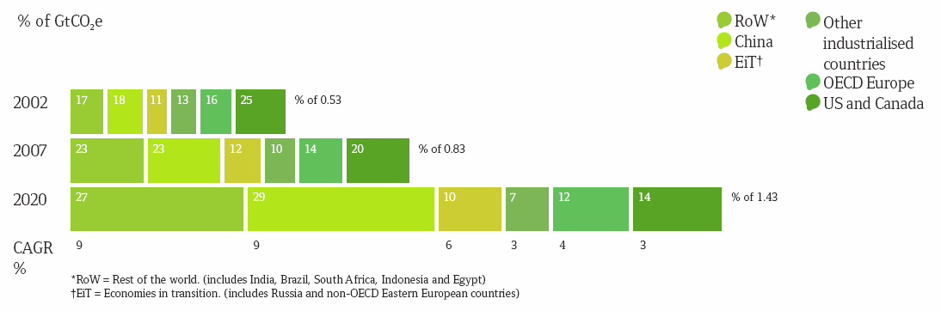

BT was responsible for a surprising 0.7% of the total power consumed in the United Kingdom, for its offices and network facilities. However, it had reduced its carbon footprint by 58%, against the figure in 1996, and now projected the reduction to be 80% by 2016 in the UK and by 2020 in the rest of the world.

These savings had been made by improving energy efficiencies in its network and data centres and by purchasing renewable energy. A carbon content labelling scheme for power sources would greatly assist firms, such as BT, in ensuring procurement of cleaner energy.

BT was also using its own technologies in order to work flexibly, to enable home-working and “home-shoring” and to reduce travel. Significant CO₂ emissions had been avoided by replacing face-to-face meetings with the use of conferencing systems (see Figure 3). | Figure 3 Annual savings in CO₂
For residential customers, it would be possible to move from always-on to always-available broadband. Minimal use of power in standby mode would cut emissions and also save money for customers. For businesses, applications of ICTs in smart metering, smart logistics, smart motor systems, smart buildings and smart electricity grids, which could all lead to very significant reductions in emissions. It would be very beneficial to develop an open standard for the interactive interrogation of equipment to measure and to manage their energy consumption.

BT recognized that ICTs were part of the problem and part of the solution. Appropriately and rapidly applied, ICTs could be used to achieve reductions in GHG emissions in other sectors of the economy by as much as 20% by 2020. That would be the equivalent of the total emissions of the USA.

Leadership in reducing GHG emissions, in which the development of ICT standards played a crucial role, were seen as vital to the future of BT.

Telecommunication Standardization Bureau
Ewan Sutherland, a specialist working in the TSB, provided information about the work of the ITU, within the United Nations system.

The United Nations Framework Convention on Climate Change had been signed in 1992. Five years later, the Kyoto Protocol was adopted in which some developed countries made commitments to stabilize and to reduce their GHG emissions. Subsequently, developing countries had undertaken to monitor and to report their GHG emissions.

New negotiations had begun towards commitments for the period 2012-20, due to be finalized in December 2009. The Fourth Assessment Report of the IPCC had shown an “unequivocal” link between GHG emissions and climate change, with emissions continuing to grow as developing countries proceeded with industrialization. The Bali Action Plan stressed the importance of measuring, reporting and verifying emissions and savings. While there was no explicit role for ICTs, the Plan called for action by specific economic sectors and identified a leadership role for multi-lateral bodies.

A range of GHG savings had been identified for telecommunications, directly, for example, through energy-saving, indirectly, for example, through carbon abatement, and systemically, for example, by dematerialization. Making the ITU-T Recommendations available on-line was estimated to save 105 tonnes of CO₂ annually, in both paper and its distribution. NGNs are estimated to reduce GHG emissions from network by 40% (see, Tech Watch Report #7).

The ITU had held two symposia, the first in April in Kyoto and the second in June in London, with plans for two events in other regions in 2009. The presentations and reports had recognized the need for common standards to measure the effects of ICTs on climate change

In response to these events, TSAG had established a Focus Group on ICTs and Climate Change in July 2008. This had held its first meeting in September and would meet again 25-28 November 2008 – though most of the work was being undertaken by conference calls. The Chairman, Dave Faulkner (BT) was keen to encourage wider participation and, in particular, to receive contributions to its work.

Discussion
Uganda asked about the economic effects of any decline in tourism due to individuals acting to reduce their “carbon footprints”. Some prospective tourists might decide not to travel by air, not least as the issue was presented as a moral imperative to which individuals were called to respond. The economic effects could range from mild to severe, depending on the importance of tourism to an economy, creating a need for assistance in the development of new economic activities, including capacity building and retraining for individuals.

Australia asked about the evaluation of complete systems of products and services. While there were techniques for life cycle assessment, notably ISO 14040, there remained a need for a methodology to analyze the GHG emissions of the full scope of a service and any changes or improvements that might be made to it. This would have to encompass network and consumer or end-user equipment, including embedded carbon, plus the use of the service, with sets of potentially complex scenarios.

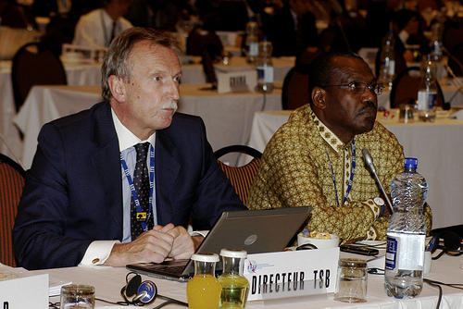
Malcolm Johnson (Director, TSB) and Hamadoun Touré (Secretary General)

The GSM networks now had a far greater geographic coverage than the electricity networks in many developing countries, with the result that many base stations had to be powered by diesel taken to them by tanker lorry. Work had begun on alternative sources, such as bio-diesel, solar panels, wind power and pico-hydro, though most of these required substantial additional investments.

Professor Nkoma looked forward to the discussions on the resolution on climate change in the WTSA Plenary and to the further development of this work in the ITU Council and in the ITU-T Study Groups.

Copies of the presentations are available at:
http://www.itu.int/ITU-T/wtsa-08/se/climatechange/index.html

A webcast of the event is available at:
http://web.itu.int/ibs/ITU-T/wtsa08/side-events/links/A-20081024-1800-fl.asx

http://www.obt.inpe.br/deter/avaliacao/RelatorioMonitoramento.pdf
http://www.smart2020.org/
Further information can be found at: http://www.geog.ox.ac.uk/news/events/ccamts/

