INTERNATIONAL TELECOMMUNICATION UNION |  |  | Focus Group On  Car Communication
TELECOMMUNICATION  STANDARDIZATION SECTOR  STUDY PERIOD 2009-2012 |  |  | FG CarCOM-LS 2 – E
English only
Original: English
 |  |  | Ulm, 10-11 May 2010
LIAISON STATEMENT
Source: | ITU-T FG-CarCOM
Title: | Signalling of signal processing capabilities between terminals and networks
LIAISON STATEMENT
For action & information to: |  | 3GPP – SA4 ; 3GPP2; Bluetooth SIG TWG; CTIA audio-ad-hoc group; ITU-T SG16; ITU-T SG11
Approval: |  | Agreed to at FG CarCOM meeting (Ulm, 11 May 2010)
Deadline: |  | 16 July 2010
Contact: | H.W. Gierlich  HEAD acoustics  Germany |  |  | Tel: +49 2407 57722  Fax: +49 2407 57799  Email: h.w.gierlich@head-acoustics.de
Please don’t change the structure of this table, just insert the necessary information.
In today’s telecommunication systems signal processing such as noise- and echo-cancellation is found in mobile terminals, mobile networks and fixed networks. However, tandeming of this type of non linear and time variant signal processing typically is not beneficial for the overall speech quality as perceived by the users. Often speech is degraded due to this tandemed signal processing. Typical examples are

- Degraded speech in uplink due to tandemed noise cancellation
- Poor double talk performance due to tandemed echo cancellation

One audio example is inserted below in order to illustrate the problem.
In G.799.2 “Mechanism for Dynamic Coordination of Signal Processing Functions” ITU-T SG 16 recently defined a mechanism for implementation in terminals and networks which can form the basis for a control of signal processing functions across terminals and networks. An appropriate protocol for wired and optical networks needed to implement this mechanism will be developed in ITU-T SG 11. A similar type of protocol then would be needed in the mobile networks. FG CarCom strongly believes that the overall quality perception of the users can be greatly improved if this type of mechanism would be supported by mobile phones and mobile networks and signal processing functions not needed in a connection would be switched off. FG CarCom therefore would like to encourage all mobile phone manufacturers, manufacturers of phone accessories such as headsets, hands-free devices and operators to consider the integration of this type of mechanism in their devices. FG CarCom would be pleased to support this type of mechanism on their side.

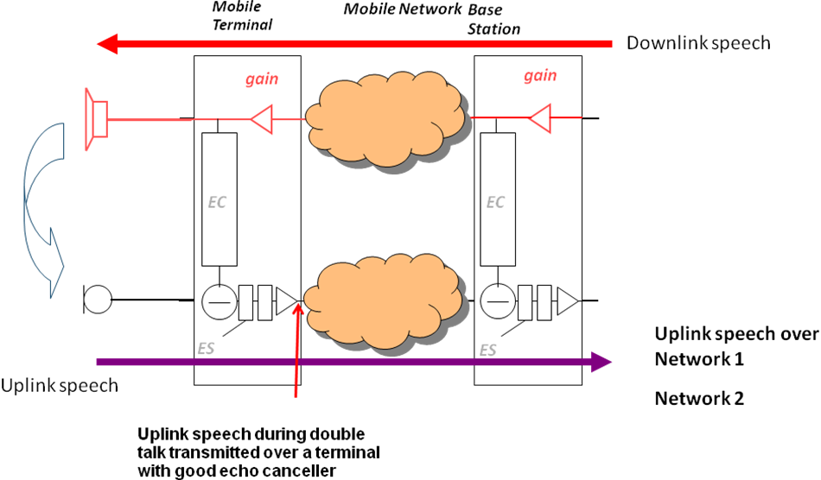
Example 1: Double talk – Terminal Echo Canceller and Network Echo Canceller active
(In network 2 tandeming leads to complete interruption of speech parts)

_____________

