INTERNATIONAL TELECOMMUNICATION UNION |  | Focus Group On  Car Communication
TELECOMMUNICATION  STANDARDIZATION SECTOR  STUDY PERIOD 2009-2012 |  | FG CarCOM-C-12
English only
Original: English
 |  | Kyoto, 11-12 November 2010
CONTRIBUTION
Source: | Ingenjörsfirma Mats Forsen Data AB
Title: | Need for requirements for Inband modem solutions(European e-call)?
The European Commission is working actively to legislate that all vehicles sold in Europe shall have a system to automatically send an alarm in case of a car accident (European eCall). Probably timeframe is that this will be required from 2013-2014.

The European ecall solution will use an inband modem to send data (MSD) in the voice channel in an E112 call to the emergency center PSAP.
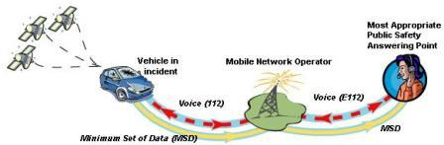

Information regarding selected inband modem solution can be found at http://www.qualcomm.com/common/documents/white_papers/eCall.pdf.

The question to FG CARCOM is if there is a need to define testing requirements to ensure that the speech systems services / transport subsystem in the vehicle does not interfere with the inband modem or other valid requirements?
In such case these requirements and test methods needs to be defined.

Med Vänliga Hälsningar / Best Regards
Mats

Here are some information and links that can be of interest:
Wikipedia:
http://en.wikipedia.org/wiki/ECall

Ertico:
http://www.ertico.com/eu-news-ecall-implementation-platform/

European standard works in Technical Committee CEN/TC 278:.
EN 15722:
Road transport and traffic telematics - ESafety - ECall minimum set of data.
EN 16062:
Intelligent transport systems - ESafety - ECall high level application requirements (HLAP)
EN 16072:
Intelligent transport systems – ESafety – Pan European eCall – Operating requirements.

Information regarding selected inband modem solution can be found at http://www.qualcomm.com/common/documents/white_papers/eCall.pdf.

_________________

