INTERNATIONAL TELECOMMUNICATION UNION |  | Focus Group On  Car Communication
TELECOMMUNICATION  STANDARDIZATION SECTOR  STUDY PERIOD 2009-2012 |  | FG CarCOM-ADM-3
English only
Original: English
 |  | Ulm, 10-11 May 2010
ADMIN DOCUMENT
Source: | FG Chairman
Title: | Invitation to the 2nd Meeting of the Focus Group CarCOM

Aachen, 30 July 2026
Invitation to the 2nd Focus Group Meeting to be held
10-11 May 2010 in Ulm
Link to registration & meeting documents:
http://www.itu.int/ITU-T/focusgroups/carcom/
Dear Colleagues,
On behalf of the ITU-T Focus Group CarCOM I have the pleasure of informing you of the arrangements for the above-mentioned meeting hosted by NUANCE COMMUNICATIONS Aachen GmbH.
Address of the meeting | NUANCE COMMUNICATIONS Aachen GmbH  Dr.-Ing. Tim Haulick  Senior Manager Acoustic Speech Enhancement  Soeflinger Str. 100  D-89077 Ulm  Tel.: +49 (0)731 3994 - 116  Fax.: +49 (0)731 3994 - 250  Mail: tim.haulick@nuance.com
mEETING SCHEDULE | The meeting will start on May 10, 2010 at 09.00  The meeting will end on May 11, 2010 at 13.00
REGISTRAtion | Please register at the focus group website before April, 30, 2010
Documents for the meeting | Please send meeting documents in advance of the meeting to TSB for uploading to the Focus Group website.

Hotel Information | http://www.moevenpick-hotels.com/en/pub/your_hotels/worldmap/ulm/overview.cfm - nice view onto the skyline of downtown Ulm  http://www.intercityhotel.com/en/Ulm - hotel is directly located at Ulm main station, 15min to walk to Nuance  http://www.maritim.com/en/hotels/germany/hotel-ulm - luxury hotel  http://www.lago-ulm.de/ - brand new, attractive offers, streetcar connection from hotel to company available  http://www.hotelschiefeshausulm.de – renovated medieval building with special ambience
How to find the meeting place |  | 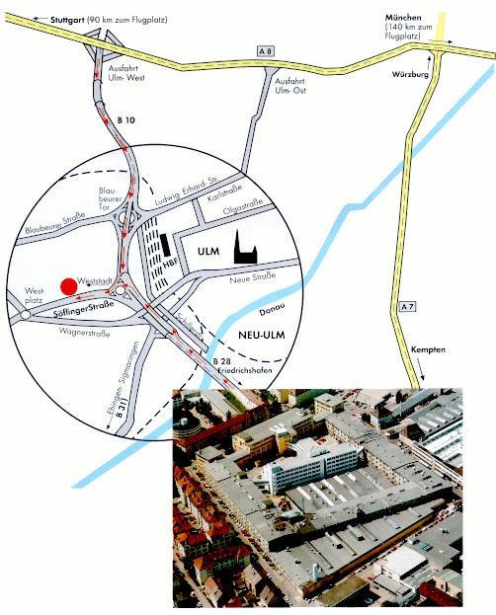
I look forward to seeing you in Ulm
Yours sincerely
Hans W. Gierlich
______________

