INTERNATIONAL TELECOMMUNICATION UNION |  |  |  |  |  | Focus Group On "From/In/To Cars Communication II"
TELECOMMUNICATION  STANDARDIZATION SECTOR  STUDY PERIOD 2009-2012 |  |  |  |  |  | FG CarCom-ADM-11
English only
Original: English
 |  |  |  |  |  | Gothenburg, 3-4 September 2009
ADMIN DOCUMENT
Source: |  |  |  | FG Chairman
Title: |  |  |  | Invitation to the 6th meeting of the Focus Group CarCom
Invitation to the 6th meeting of the Focus Group CarCom
to be held 3-4 September 2009 in Gothenburg (Göteborg)
Link to registration & meeting documents:
http://www.itu.int/ITU-T/studygroups/com12/fgcarcom/index.html
Dear Colleague,
On behalf of the ITU-T Focus Group CarCom I have the pleasure of informing you about the arrangements for the above-mentioned meeting kindly hosted by Ingenjörsfirma Mats Forsén Data AB.
 | Address of the meeting |  |  |  | Ullevi Restaurang & Konferens  Paradentrén  SE-41140 GÖTEBORG  Phone: +46 31 739 09 50  Mats Forsén  Phone: +46 733 47 12 41  Email: mats(at)forsen.se
 | mEETING SCHEDULE |  |  |  | The meeting will start on September, 3, 2009 at 09.00.  The meeting will end on on September, 4, 2009 at 13.00.
 | REGISTRAtion |  |  |  | Please register at the Focus Group website before August, 27, 2009.
 | meeting Documents |  |  |  | Please send meeting documents in advance of the meeting to TSB for uploading to the Focus Group website.

Hotel Information  &  Meeting Place Information | The meeting will be held in the same location as the FITCAR meeting in January, 24, 2008.  This is the entrance in the north east side of the stadium called Nya Ullevi (the blue dot in the map below).  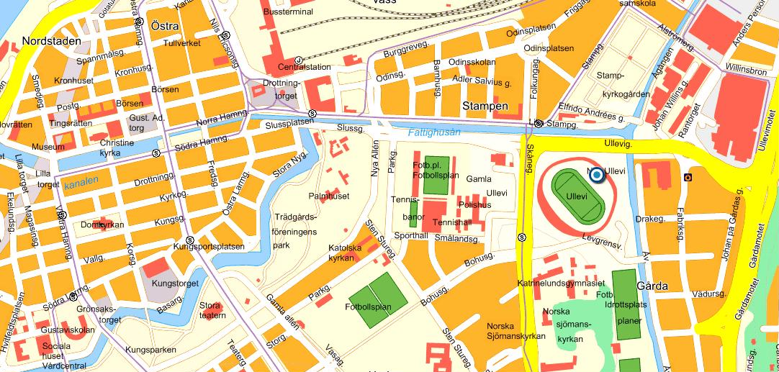  There are a lot of hotels in the area.  Hotels.com has a good search service. Just search for Nya Ullevi Stadium, Gothenburg, Sweden  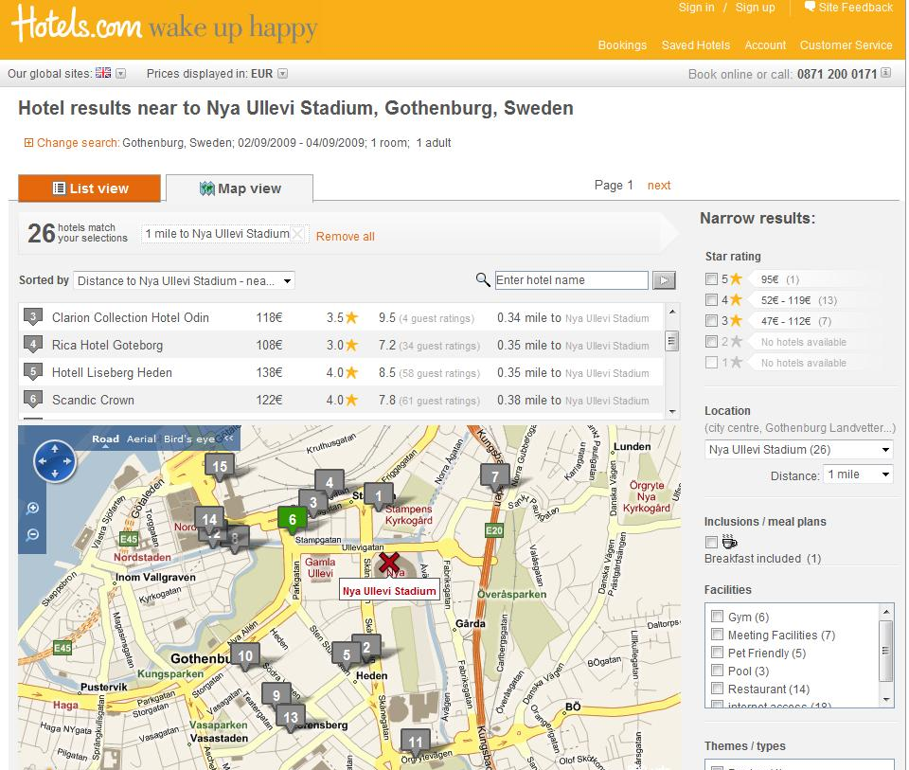  Here is the link:  http://www.hotels.co.uk/search.do?compUrl=H4sIAAAAAAAAAF2PT0_CMBjGv8pOPbGlmxPDoTELQ7MIG3HTi_Hwsr6yJl2Lb1sI314MUcTz83v-3TsE6oc1EIwuASK1B12CR8GzmM_ijPMZu2Ik7oB8IDxT-S_1GZCOD5bG1n8r82XTLkqmbQ9eWSOWRV2uiuenOJ1OeZ79T1XOg-lRpAm_Vpwl35BEEmXVdkU9XzCJzitzjq2PEL1ojXsVnXqlCuMkerR-QLMJtJ1E7QElGuYGe2jVqDRQeXE74Skg6welJaF54-_ip_1V4aE77lCsivX1ILJ2dCc0MWHcIDUfhQzaO5GyHWxPB_7Oq6RIs7tZfnvDoPdqjx1sRLlou6ouuqqpvwDp-q87fwEAAA%3D%3D  Also www.booking.com is very useful.  Search for destination landmark:Ullevi  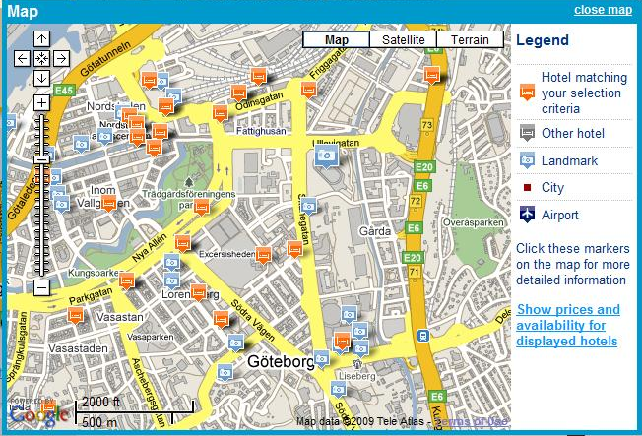  Here is the link:  http://www.booking.com/searchresults.html?landmark=12856&error_url=http%3A%2F%2Fwww.booking.com%2Flandmark%2Fse%2Fullevi.en.html%3Faid%3D310018%3Blabel%3Dlandmark-se-ullevi-sv-CTG5tqr24U84ut0QSS8gfwS820810986%3Bsid%3Dbdbcfecdb5975e0fcbca5d11b94fbb83%3B&aid=310018&label=landmark-se-ullevi-sv-CTG5tqr24U84ut0QSS8gfwS820810986&lang=en&sid=bdbcfecdb5975e0fcbca5d11b94fbb83&checkin_monthday=2&checkin_year_month=2009-9&checkout_monthday=4&checkout_year_month=2009-9  Transportation:  Several buses and trams can be used. There is a very good search page at västtrafik that can be used.  http://www.vasttrafik.se/en/  Use ULLEVI ARENA as your destination (Ullevi Norra is the closest to the meeting).  Please note that tickets MUST be bought before the travel (it’s not possible to buy on the bus/tram). Tickets can be bought for example in The Pressbyrån shop and 7-Eleven.  More information can be found at http://www.vasttrafik.se/en/Startpage/Are-you-a-tourist/  Parking garage:  There is a parking garage under the stadium that can be used if travelling by car. Please inform Mats Forsen if you plan to go by car, so you can to get a free parking ticket.
I look forward to seeing you in Gothenburg.

Yours sincerely,
Hans W. Gierlich
__________________

