电信标准化局 | 
2008年7月4日，日内瓦

文号：  电话：  传真： | 电信标准化局第225号通函  TSB Workshops/P.R.  +41 22 730 5235  +41 22 730 5853 | - 致国际电联各成员国主管部门；  - 致ITU-T部门成员；  - 致ITU-T部门准成员；
电子邮件： | tsbworkshops@itu.int | 抄送：  - ITU-T研究组正副主席；  - 电信发展局主任；  - 无线电通信局主任

事由： | 有关“从语音到音频：带宽扩展、双耳知觉”的ITU-T研讨会  2008年9月10-12日，法国拉尼翁（Lannion）
尊敬的先生/女士，
1 我谨通知您，法国电信将于2008年9月10-12日在位于拉尼翁（法国）22307 Pierre Marzin大街2号的研发部门主办有关“从语音到音频：带宽扩展、双耳知觉”的ITU-T研讨会。
研讨会将于会议第一天的14时开始。有关会议厅的具体信息将在研讨会会场显示。
2 讨论将仅用英文进行。虽然会场提供连接互联网和打印机的复印机和计算机，但我们建议与会者尽量自带有无线连接功能的笔记本电脑，以接入会场提供的无线网络。
3 国际电联成员国、部门成员和部门准成员以及愿参加此工作的来自国际电联成员国的任何个人均可参加此研讨会。这里所指的“个人”亦包括作为国际、区域和国家组织成员的个人。研讨会不收取任何费用，但亦不发放与会补贴。
4 研讨会的目的是：
- 就制定新的工作方法提出意见，使该方法涵盖从窄频到全频的全部音频带宽，并继续确保与现有ITU-T建议书的兼容性。
b. 研究终端特性，以应对随编解码器、传输技术和核心/接入网络（全IP、NGN、移动）发展而变化的新带宽需求和多频道问题。
此次研讨会的目的是在大学、标准化机构和公司之间建立建设性对话，整合行动与技能，开创能够吸引世界各地相关方的标准，共同推进创新。
5 研讨会的初步议程草案见本文附件1。
6 实用信息见本文附件2。有关研讨会的最新消息与信息将在ITU-T网站的下列地址提供：http://www.itu.int/ITU-T/worksem/speechaudio/index.html。
7 请与会者通过以下链接，直接向各自选中的拉尼翁（Lannion）或佩罗斯-吉雷克（Perros-Guirec）的旅馆预订房间
http://www.sites-hotels.com/bretagne/hotels_cotes_d_armor.htm。
8 为便于电信标准化局就该研讨会的组织做出必要安排，我希望您能通过http://www.itu.int/ITU-T/worksem/speechaudio/index.html网址以在线形式向电信标准化局尽早、但不迟于2008年8月26日进行注册。请注意，自现在起，研讨会与会者的注册仅以在线方式进行。
9 我们谨在此提醒您，一些国家的公民需要获得签证才能入境法国并在该国逗留。在此情况下，签证必须向驻贵国的法国代表机构（使馆或领事馆）申请和领取。如贵国没有此类机构，则请向驻离贵国最近的国家的此类机构申请并领取。
为领取法国入境签证而需要主办国提供邀请函和/或签证办理证明函的与会者，请将各自的护照信息提供给：

Catherine Quinquis
France Telecom TECH/SSTP（法国电信）
2, avenue Pierre-Marzin
22307 Lannion Cedex
France（法国）
电话：+33 2 96 05 14 93
传真：+33 2 96 05 35 30
电子邮件：catherine.quinquis@orange-ftgroup.com

顺致敬意！

电信标准化局主任
马尔科姆•琼森

附件：2件
ANNEX 1
(to TSB Circular 225)

ITU-T workshop on "From Speech to Audio: bandwidth extension, binaural perception"
Lannion, France, 10-12 September 2008
Advance Programme

DAY 1 – 10 September 2008
14:00 – 15:30 | Opening Session and keynote speakers
15:30 – 16:00 | Coffee break
16:00 – 17:30 | Round Table with SDOs
DAY 2 – 11 September 2008
09:00 – 10:30 | SESSION 1: Loudness  Objectives: The goal of this session is to initiate significant technical work on a common loudness rating algorithm for all bandwidths from narrowband to full band audio signals.  The multimedia revolution has led to an increase in the required audio signal bandwidth for next-generation networks. In addition to existing narrowband and wideband codecs, development of full band is taking place.  In order to ensure coherency for the transmission plan of end-to-end multi-bandwidth audio applications through the network for both narrowband / wideband and full band, it is highly desirable to develop an algorithm aiming to calculate the loudness ratings for all bandwidths.  As concrete example: at the last ITU-T/SG12 meeting in October 2007, it was pointed out that there is confusion in the wideband loudness ratings calculation. Today, the last revision of P.79 gives the preferred methods for calculating loudness ratings in two different ways: the first one applicable to narrowband and dual-mode (narrowband – wideband); the second one applicable to full wideband. These two methods lead to different values for LR calculation. This situation is not satisfactory because it leads to a mismatch in transmission for both narrowband / wideband and full band.
10:30 – 11:00 | Coffee break
11:00 – 12:30 | SESSION 2: Modelling: binaural, spatialisation  Objectives: Recent developments in terminals and content have led to a change in the listening condition from monaural to binaural and therefore binaural perception has to be taken into account (headphones or free-field listening with loudspeaker system). For subjective assessment of codecs and audio/multimedia, the new dimension of sound spatialisation should also be added to the quality rating, which implies new methodologies and new criteria. Defects induced by codecs when applied to 3D audio content are another issue of concern.
12:30 – 14:00 | Lunch break
14:00 – 15:30 | SESSION 3: Artificial Head, Ear and Mouth  Objectives: With the evolution of multimedia applications and telephony towards an increasing high frequency range, artificial head, ears and mouth available on the market today naturally need to follow the same trend.  The purpose of this session is to gather information from all the players involved in the telecommunication and audio industry, and related fields, which would form the basis of scientific work aiming to address all the aspects of this topic, among which acoustic impedance of human ears is of primary importance.
15:30 – 16:00 | Coffee break
16:00 – 17:30 | SESSION 4: Terminals characteristics and teleconferencing  Objectives: Standards for speech and multimedia terminals. This session will address the consequences on requirements for future terminals implementing superwideband or fullband and 3D, in particular in the context of teleconferences. Moreover, the main parameters to be defined in order to guarantee relevant quality for these terminals as well as to ensure the quality for the local user(s) and the far end user(s) will be considered.  In addition, new technologies to be implemented in the next three years in those terminals will also be addressed.

DAY 3 – 12 September 2008
09:00 – 10:30 | SESSION 5: Test methodologies: extensions, new parameters, test signals, calibration  Objectives: Foreseen applications for super wideband and full band conversational codecs are not only speech based services but also mixed contents or even music based services. Mixed content represents advertisement, ring back tones, music-on-hold and even film trailers. Adaptation of ACR and DCR methodologies to accommodate such signals was felt difficult.  This session will address how quality assessment methodologies for stereo and 3D signals and calibration signals for the sound reproduction system used for testing have to be adapted to wider bandwidths. Moreover, questions such as what is nominal level for stereo input signals, how to calibrate stereo signals have to be solved. How to define sound pressure level for stereo output signals will also be considered.
10:30 – 11:00 | Coffee break
11:00 – 12:30 | - Wrap-up session and conclusions

________________
ANNEX 2
(to TSB Circular 225)

Practical information

MEETING VENUE

The venue will be in Lannion, at the France Telecom R&D site. Delegates are requested to use the main entrance of the premises.

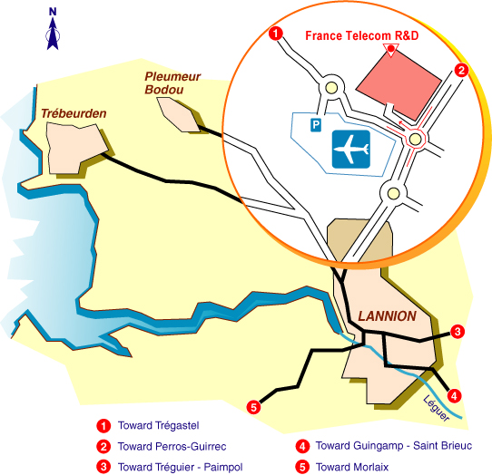

ACCESS TO MEETING VENUE
For security reasons, once registered, it is imperative to provide the following information by email or fax to: Catherine Quinquis, Fax: +33 2 96 05 35 30, Email: catherine.quinquis@orange-ftgroup.com

- PARTICIPANT'S SURNAME:
- FIRST NAME:
- COMPANY:
- Mailing address:
- Telephone:
- Fax:
- E-mail:
- Passport n° and Country

HOTEL ACCOMMODATION
No block hotel reservations have been made. As such, delegates are requested to make their hotel reservations directly with the hotel of their choice in Lannion or Perros-Guirec using the following URL: http://www.sites-hotels.com/bretagne/hotels_cotes_d_armor.htm
TRANSPORTATION
NOTE: No transport arrangements will be made. It is suggested to rent a car.

How to reach Lannion and Perros-Guirec ?
Apologies, some websites are in French. For flight timetables, please see: http://www.amadeus.net/

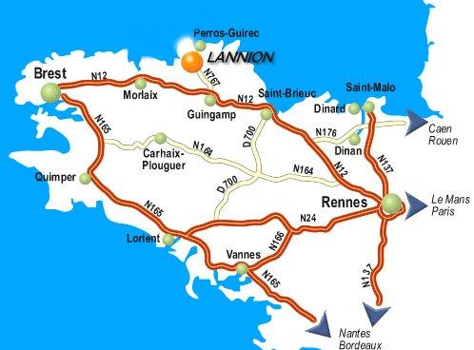

- By plane to Lannion
There are two or three flights a day between Paris Orly West airport and Lannion (except on Saturday). Please see:
http://www.lannion.aeroport.fr/recherche-vols/
For those who will arrive in Paris Roissy Charles-de-Gaulle airport (CDG) and have to transfer to Orly West, there are three possibilities:
- An Air France bus shuttle from Roissy to Orly West airport. This bus leaves every 30 minutes. The journey lasts approximately 60 minutes (possibly a little more depending on the traffic). Note: Do not forget that you will have to reclaim your luggage in Charles-de-Gaulle airport so plan to allow at least 3 hours between your two flights.
- Take a taxi: Costs between 40 and 50 euros (minimum time: 50 minutes - max depending on the traffic, generally busy).
- Public transportation in Paris: RER Line B + Orlyval (with connection in Antony), it will take more than 60 minutes.
At your arrival in Lannion airport, you can take a taxi or rent a car to go to Perros-Guirec (about 7 kms).

- By train to Lannion
Once in Paris, you need to go to Montparnasse SNCF train station. More information with timetables is available at:
http://www.voyages-sncf.com/dynamic/_SvTermCommVoySaisie?_TMS=1203512030844&_DLG=SvTermCommVoySaisie&_LANG=FR&_AGENCY=VSC
There is an Air France shuttle bus between Paris Roissy Charles-de-Gaulle airport and Montparnasse station. The journey time is approximately 60 minutes and this bus leaves every half an hour.
The same from Paris Orly airport to Montparnasse. The journey time is approximately 45 minutes and this bus leaves every 12 minutes.
The journey by train between Paris and Lannion takes 4 hours by TGV with a quick change either in Guingamp or in Plouaret. This way of travelling will allow you to fully appreciate the French landscape.
Warning: Reservation is mandatory for the TGV !
In Lannion station, you can take either a cab (about 25 euros) or a bus to go to Perros-Guirec.
- By plane via Brest
There are several flights a day between Paris Roissy, Charles-de-Gaulle airport and Brest airport http://www.airport.cci-brest.fr/
From there, 2 possibilities: either rent a car to go to Lannion. In this case, the journey between Brest and Lannion lasts 1 hour on an easy road; take the N12 road and after the Morlaix bridge take the direction of Lannion (see map).
Or take a train from Brest (15 km between Brest airport to Brest railway station) to Lannion. At your arrival in Lannion station, take a cab (about 25 euros) or a bus.
VISA REQUIREMENTS
For entry requirements and visa application forms for France, please see:
http://www.visafrance.co.uk/ and http://france.visahq.com/requirements/France/

REGISTRATION
Registration of participants to the workshop will be carried out exclusively online.
Participants are kindly requested to register via the online form at
http://www.itu.int/ITU-T/worksem/speechaudio/index.html, as soon as possible, but not later than 26 August 2008 and to provide the requested information mentioned under the item “Access to the meeting venue”.

___________________

