2008年4月9日，日内瓦
国 际 电 信 联 盟
电信标准化局 电信发展局
文号：  联系人：  电话：  传真：  电子邮件： | 电信标准化局第204号通函  Tim Kelly  +41 22 730 5111  +41 22 730 5853  Tim.kelly@itu.int | 文号：  联系人：  电话：  传真：  电子邮件： | 电信发展局第04号通函  俄联邦，莫斯科，国际电联区域代表处  Andrei Untila  +7 495 540 6070  +7 459 540 6073  andrei.untila@itu.int
- 国际电联成员国主管部门；
- ITU-T和ITU-D部门成员；
- ITU-T和ITU-D部门准成员
抄送：
- ITU-T和ITU-D各研究组正副主席；
- 无线电通信局主任
事由： | 2008年6月10-11日在乌兹别克斯坦塔什干为独联体国家、中东欧与波罗的海国家举办的国际电联2008年区域性发展论坛：“缩小发展中国家的ICT标准化差距”；2008年6月12-13日在乌兹别克斯坦塔什干为独联体国家、中东欧与波罗的海国家举办的WTSA-08筹备会议
尊敬的先生/女士：,
1. 根据WTSA-04、WTDC-06和RA-07的结果以及第123号决议（2006年，安塔利亚，修订版）的规定，我们谨通知您，将于2008年6月10-11日在塔什干为独联体国家（CIS）、中东欧（CEE）与波罗的海国家举办国际电联区域性发展论坛，该论坛2008年重点讨论“弥合发展中国家的ICT标准化鸿沟”问题。论坛将由乌兹别克斯坦电信主管部门盛情承办。论坛之后，区域通信联合体（RCC）将在同一会址于2008年6月12-13日举办WTSA-08筹备会议。论坛第一天的会议将于09:30时开始。会议地点为塔什干狄德曼丝绸之路（Dedeman Silk Road）酒店。
2. 国际电联区域性发展论坛（2008年6月10-11日）面向来自该区域各ICT部委和国家监管机构、电信运营商和服务提供商的高级管理人员，他们需要及时掌握电信/ICT标准化方面的最新动向并了解国际电联、特别是各研究组的活动。此外，论坛将突出独联体国家、中东欧与波罗的海国家区域在国际电联标准化工作和标准落实中加强合作和参与的方式及手段。该论坛还将为活跃在该区域的各国运营商和外国运营商提供一个可资利用的独特交流场合。另外，论坛还将探讨RA-07（2007年，日内瓦）、WTDC-06（2006年，多哈）和 WTSA-04（2004年，弗洛里亚诺波利斯）的相关决议，以便在第123号决议（2006年，安塔利亚，修订版）的框架内缩小发展中国家和发达国家之间的标准化差距。
3. 国际电联成员国、部门成员和部门准成员以及愿意参加此项工作的国际电联成员国的任何个人均可出席此论坛。此处所指的“个人”亦包括来自国际、区域和国家组织的成员。论坛免费参加。
4. 独联体国家WTSA-08筹备会议（2008年6月12-13日）旨在协调该区域的意见，重点涉及提交国际电联世界电信标准化全会（WTSA-08）的区域提案的汇总和编排问题。该会议将于2008年10月21-30日在南非约翰内斯堡召开。在该会议前夕，将于10月20日在同一地点召开题为“弥合ICT标准化鸿沟”的全球标准专题研讨会。WTSA-08筹备会议仅限国际电联成员国、独联体国家的部门成员及其它区域性组织的代表参加。（注：CEPT正在为其它国家另外组织一个WTSA-08筹备会议。）
5. 国际电联区域性发展论坛和WTSA-08筹备会议的初步议程见本文附件1。实用信息见附件2。附件3中有一份酒店预订单，附件4中有一份要求协助办理签证的表格（截止日期为2008年5月15日）。有关最新议程、发言介绍及相关信息，请查询网址：http://www.itu.int/ITU-T/wtsa-08/prepmeet/index.html#CIS。
6. 会议讨论将以英文和俄文进行。会议将提供同声传译。虽然将提供配备互联网和打印机连接的复印机和电脑，但我们建议与会者尽量自带有无线连接的笔记本电脑，以接入会场提供的无线网络。
7. 我们高兴地通知您，为方便与会，国际电联将向此区域符合条件的国家提供数量有限的与会津贴，每个国家仅提供一份，用于旅行、食宿以及杂项开支。但是，各国与会代表人数不限。申请与会津贴的与会者请填妥附件5中的与会津贴申请表，最迟在2008年5月15日之前送达国际电联。
8. 请注意，论坛和WTSA-08筹备会议与会者的注册工作将完全通过网址：http://www.itu.int/ITU-T/wtsa-08/prepmeet/index.html#CIS在线进行。为便于我们为论坛和WTSA-08筹备会议的组织做出必要安排，请尽快、最迟在2008年5月30日之前完成注册。
9. 我们在此谨提醒您，一些国家的公民需要获得签证才能进入乌兹别克斯坦并逗留。在此情况下，必须向驻贵国的乌兹别克斯坦代表机构（使馆或领事馆）申请并领取签证。希望东道国协助办理签证的与会者应在2008年5月15日之前向Umida Rakhmatdzhanova MUSAEVA女士（musaeva@aci.uz）提供其护照信息（要求协助办理签证的表格见附件4）和传真号码。
顺致敬意！

电信标准化局主任  马尔科姆·琼森 | 电信发展局主任  萨米·阿勒巴舍里·阿勒穆什德

附件：5件

ANNEX 1
(to TSB Circular 204 - BDT Circular/04)
ITU Regional Development Forum 2008 for the Commonwealth of Independent States (CIS), Central and Eastern Europe (CEE) and the Baltic States
“Bridging the ICT standardization gap in developing countries”
Tashkent, Uzbekistan, 10-11 June 2008
Followed by
WTSA-08 Regional Preparatory Meeting for CIS Countries
Tashkent, Uzbekistan, 12-13 June 2008
Advance Programme

 | ITU Regional Development Forum: Tuesday 10 June
9:30 – 10:15 | Opening remarks:  Welcome and Keynote addresses
10:15 – 10:45 | Coffee break
10:45 – 12:15 | Session 1: The ICT standardization and development gaps in the CIS, CEE and Baltic States  Objectives: This session will provide an overview of the current status of ICT standardization and will provide an opportunity for policy-makers from the region to express their future requirements. This session will also include a presentation on the standardization gap and the wider digital divide, and what can be done to overcome it.
12:15 – 13:30 | Lunch
13:30 – 15:00 | Session 2: Overview of ITU activities and how to participate  Objectives: This session will provide an overview on ITU activities with specific relevant to the CIS, CEE and Baltic States. It will highlight decisions taken by the last Plenipotentiary Conference in 2006 concerning bridging the standardization gap (Resolution 123 PP-06) and the activities carried out by the three ITU sectors. It will also provide a practical guide to how to participate in ITU’s activities.
15:00 – 15:30 | Coffee break
15:30 – 17:00 | Session 3: Development issues in the CIS, CEE and Baltic States  Objectives: This session will focus on ITU-D activities to promote ICT development and implementation. Topics will include ICT application and cybersecurity, technology and network development, capacity-building and the work of the ITU-D Study Groups. The session will also include a presentation on the activities of the ITU-D area office in Moscow.
 | Wednesday 11 June
09:30 – 10:45 | Session 4: Current ITU standardization hot topics  Objectives: This session will address current standardization topics in ITU-T. It will present each topic from various perspectives: technology, evolution and trends, current and future studies, and new services that could derive from new technologies particularly focusing on how they could serve the CIS, CEE and Baltic States. Issues to be discussed will include fixed-mobile convergence, Multimedia, Optical Transport Networks & broadband access issues, Voice over IP (VoIP), Accessibility, and ICTs and Climate Change.
10:45 – 11:00 | Coffee break
11:00 – 12:30 | Session 5: International radiocommuncation standards and guidelines  Objectives: This session will address the ITU-R standards-making process, with emphasis on collaboration with external organizations and the participation of developing countries, and how to participate effectively in ITU-R activities. Proposals on how to address the standardization gap issues, as it affects radiocommunication, will also be presented.
12:30 – 14:00 | Lunch
14:00 – 15:30 | Session 6: Security and regulatory issues  Objectives: This session will provide an overview of security standards and current security standardization work. It will assess whether developing countries and countries with economies in transition have any special security needs that are not already being addressed by the current work. Security topics will include cybersecurity, combating spam, and identity management. The session will also address regulatory issues and the role of the regulators and regulatory bodies. It will include a presentation of the outcomes from this year’s Global Symposium for Regulators, which this year looked at the theme of infrastructure sharing.
15:30 – 16:00 | Coffee Break
16:00 – 17:00 | Session 7: Next-Generation networks (NGN): Development trends and migration scenarios  Objectives: This session will present the evolution of NGN and future perspectives in the relevant access technologies, service and network architecture with a special focus on convergence, home, office and mobile applications, IP-Based platforms, Multiple Access Networks, and relevant business models for NGN. Moreover, this session will examine charging and accounting principles for NGN and will look at migration scenarios towards NGN, including related telecommunication economic and policy issues at regional level.
17:00 – 17:30 | Conclusions and wrap-up

WTSA-08 Regional Preparatory Meeting for CIS Countries
Tashkent, Uzbekistan, 12-13 June 2008

 |  | WTSA-08 Regional Preparatory Meeting: 12 June 2008
09:00 – 09:30 | Opening and introduction of moderators
09:30 – 10:45 | Session A: WTSA preparation briefing  Objectives: This session will review the major outcomes of WTSA-04 (Florianópolis, 2004) and the preparation status of WTSA-08, including expected participants, objectives of WTSA-08, and information on logistics. There will also be information on the Global Standardization Symposium to be organized on 20 October 2008 just ahead of WTSA-08.
10:45 – 11:00 | Coffee break
11:00 – 12:30 | Session B: WTSA-08 – Major issues for the ITU-T work programme and working methods  Objectives: This session will review the major WTSA Resolutions and Recommendations, and look at the changes that have been proposed for WTSA-08. It will also look at likely hot topics on the agenda of WTSA-08, including the possible restructuring of the study groups, and will provide contact information for the relevant TSAG correspondence groups.
12:30 – 14:00 | Lunch
14:00 – 15:30 | Session C: WTSA-08 -- Regional preparatory meeting  Objectives: The following sessions will discuss regional concerns, determine issues on which proposals should be drafted, consider and adopt texts of proposals. In particular, the regional preparatory meeting might develop regional positions concerning Study Group restructuring.
15:30 – 16:00 | Coffee break
16:00 – 17:30 | Session C: WTSA-08 -Regional preparatory meeting (Continuation)
 | 13 June 2008
09:30 – 10:30 | Session D: WTSA-08 -Regional preparatory meeting  Objectives: This session will discuss regional concerns, consider issues related to enhancing ITU-T working methods and proposals of other Regional organizations.
10:30 –11:00 | Coffee break
11:00 – 12:00 | TV bridge with Japan (upon the agreement with APT)
12:00 – 12:30 | Session E: WTSA-08 -Regional preparatory meeting  Conclusion of the discussion and review of draft texts and regional positions, including chairmanships and vice-chairmanships for Study Groups and TSAG, to be adopted at WTSA-08.
12:30 – 14:00 | Lunch

ANNEX 2
(to TSB Circular 204 - BDT Circular/04)

Practical Information
Event Venue
Hotel “Dedeman Silk Road Tashkent ”
Conference room “Silk Road”, 1st floor
Amir Temur Str.,C 4, No 7/8, Tashkent, 700000, Uzbekistan
Tel: +(998) 71 120 37 00, +(998) 71 134 85 85
Fax: +(998) 71 134 42 42
www.dedeman.com

Registration
Registration will be conducted exclusively online at: http://www.itu.int/ITU-T/wtsa-08/prepmeet/index.html#CIS. To enable us to make the necessary arrangements concerning the organization of the Forum and of the WTSA-08 Preparatory, we should be grateful if you would register as soon as possible, but not later than 30 May 2008.

On-site registration will begin on Tuesday, 10 June 2008, at 9.00 am at the Forum venue, on the1st floor, Conference room “Silk Road”, Hotel “Dedeman Silk Road Tashkent ”.

Working languages
The Forum will be held in English and Russian with simultaneous translation.

Accommodation

Hotel “Dedeman Silk Road Tashkent ” ****
Amir Temur Str.,C 4, No 7/8, Tashkent
700000, Uzbekistan
Tel: +(998) 71 120 37 00, +(998) 71 134 85 85
Fax: +(998) 71 134 42 42
www.dedeman.com

Accommodation of the fellowship holders is envisaged in this hotel.
Located 8 km from Tashkent International Airport, in the city center of Tashkent, this is also the venue of the Forum itself.
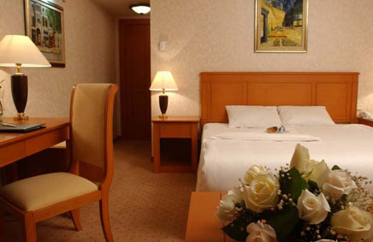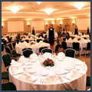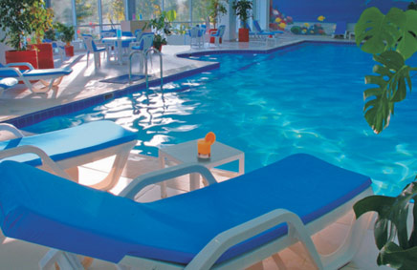

Room Type | Special Rates
Standard Room | USD 65.00
Double Room | USD 85.00
Deluxe | USD 70.00
Junior Suite | USD 250.00
Extra bed - 20 USD except in suite rooms. Accompanying guest is free of charge in suite rooms.
Rich Open Buffet Breakfast and all local taxes are inclusive of single or double occupancy
Free Usage of Life Style Health Center (indoor & outdoor swimming pools, sauna, gym)
Free Unlimited Wireless Internet service in all Guest Rooms.
Free Wireless Internet service on the Public Area.
All above mentioned room rates are valid until 31.12.2008
InterContinental Tashkent *****
107A, A.Temur Street,
Tashkent, 100084, Uzbekistan
Tel.: (998 71) 1207000 ext. 4229
Fax: (998 71) 1206459
www.ihg.com

Opened in 1997, established 5 star hotel is ideally located within a business park near the National Bank of Uzbekistan, Shopping Centre and the Telecommunication Center, adjacent to a lake and near the main trade fair site, close to city center. Distance from International airport: 10 km or 20 minutes drive. Distance to city center: 5 km.

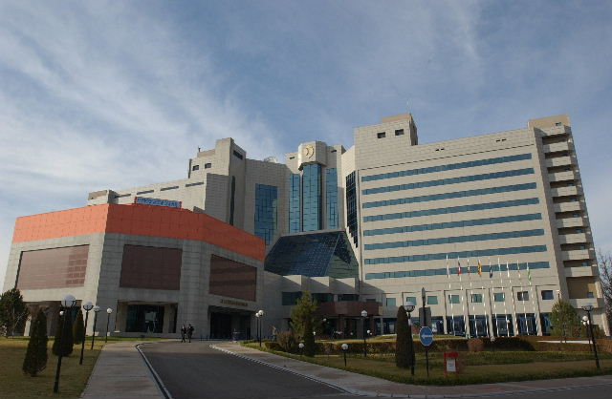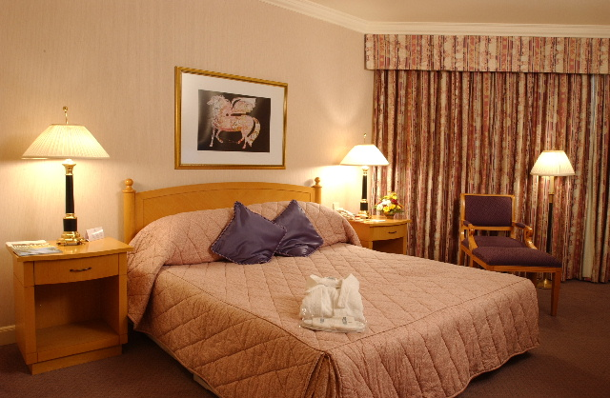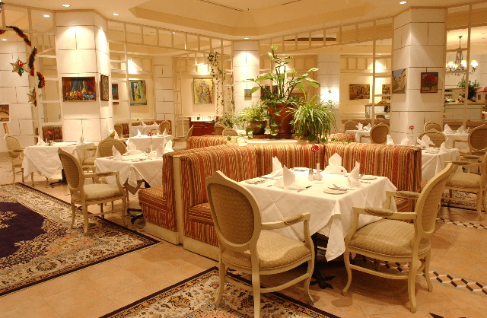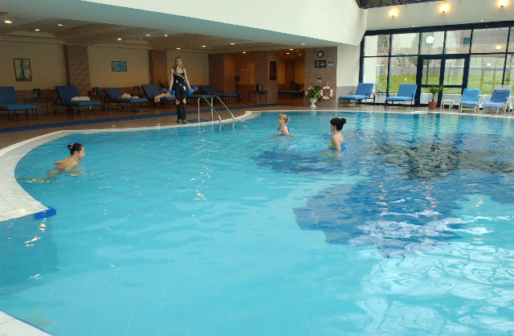

Room Type | Special Rates
Standard Room | USD 130.00
Double Room | USD 168.00
Superior Room | USD 150.00
Junior Suite | USD 300.00
Room rate includes one Full American Buffet breakfast. And also free of charge: Instant check-in/check-out, Luggage storage, in-room-safe, 24 hours security, 24 hours services of Fitness Center, 24 hours services of Gymnasium; use of Swimming Pool, Steam and Sauna during working hours, Wireless internet access in the Hotel Lobby. Also available Currency exchange office and Ticket Office of “Lufthansa” Airlines.

Payment for the services shall be made by guest's credit card (American Express /Visa/ EuroMaster card) or by bank transfer.

Radisson SAS Hotel Tashkent ****
88, A.Temur Street,
Tashkent, 100084, Uzbekistan
Tel.: +998 71 1204900
Fax: +998 71 1204902
www.radissonsas.com

The Radisson SAS Hotel in Tashkent is on the Amir Temur road, in the heart of the banking and business district. The hotel is just 15 minutes from the international airport and has 111 beautifully designed rooms with all modern amenities: individually controlled heating and air-conditioning system, direct-dial telephones and Internet port, electronic safe, TV Set with 24 worldwide channels, bathroom with bath-tub, mini-bar and hair-drier. The Hotel has 2 Bars, 2 Restaurants, Fitness center (swimming pool, sauna and gym), 24 hours open Business Center with all facilities, laundry & dry-cleaning service, outdoor parking lot, currency exchange office.

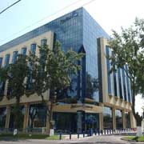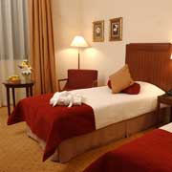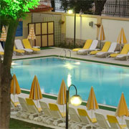

Room Type | Special Rates
Standard Single | 85 USD
Standard Double | 115 USD
Junior Suite | 200 USD
Executive Suite | 350 USD
The above rates include:
- open Buffet breakfast;
- fitness center use: swimming pool, sauna and gym;
- complimentary Internet in the room & wireless internet use in all public areas;
- V.A.T.
check-in time at the hotel is 14:00 and check-out is 12:00 (noon).
Accounts can be settled by major credit cards: Visa, AmEx, MasterCard, Diners Club, JCB or Cash.
If participants need a hotel reservation, they are kindly asked to complete the HOTEL AND TRANSFER RESERVATION FORM (Annex 4) and send it to the national coordinator Mrs. Umida Musayeva, Senior Specialist of International Relations Coordination Department of the Communications and Information Agency of Uzbekistan. by fax: + 998 71 139-87-82, or e-mail : musaeva@aci.uz, by 15 May 2008 at the latest. (for inquiries, tel: +998 71 138-41-41)

Transportation
Transportation will be available for delegates from the airport to their respective hotels, as well as from the hotels to the Forum venue and back. If you need the transfer from the airport to the hotel upon your arrival and from the hotel to the airport when you depart please provide relevant information in Annex 4
Airport
There are currently twelve airports in Uzbekistan that are operated by Uzbekistan Airways National Air Company. Five of them: Tashkent, Samarkand, Bukhara, Urgench and Termez airports are international.

Tashkent International Airport completely meets international standards and the ICAO requirements and receives all the types of aircraft. Following a complete overhaul the passenger terminal for international flights provides a maximum level of convenience and services for passengers. It can serve up to one thousand passengers per hour and services over twenty million passengers annually.
Distance from city center 15-30 minutes, Ground transportation options Taxi, Route-taxi, bus.
Entry Requirements and Visa Information for Republic of Uzbekistan

Those participants requiring entry visa to the Republic of Uzbekistan are requested to contact their local Embassy/Consulate of the Republic of Uzbekistan for information well in advance.
Visas are issued to foreign citizens in the diplomatic and consular missions of the Republic of Uzbekistan abroad on the basis of the Visa Support Letter (permission from the Ministry of Foreign Affairs of Uzbekistan).
In Tashkent International Airport Consular Bureau visas can only be issued to those foreign citizens arriving from the countries that do not have diplomatic or consular missions of the Republic of Uzbekistan. In this case visa support from the hosting administration is required.
Should the participants need a visa support, they are kindly asked to complete the Visa Support Form (Annex 5 to the Invitation letter) and send it together with the copy of passport to the national coordinator Mrs. Umida Musayeva, by fax: + 998 71 139-87-82, or
e-mail: musaeva@aci.uz, by 15 May 2008 at the latest. (for inquiries, tel: +998 71 138-41-41).

There is a bilateral Visa Free Regulation with Azerbaijan, Armenia, Belarus, Georgia, Kazakhstan, Moldova, Russia, Ukraine as well as Kyrgyzstan.

General Information
The Republic of Uzbekistan is situated between the rivers of Amudarya and Syrdarya and occupies 447,400 square kilometers. The span of the territory from the west to the east is 1,425 km and from the north to the south - 930 km. The territory borders on Kazakhstan in the north, on Kyrgyzstan and Tajikistan in the east and southeast, on Turkmenistan in the west, and on Afghanistan in the south.
Uzbekistan is the oldest land in Central Asia having a twenty-five centuries long history, the country with the arranged specific historical and cultural community different from that of other regions. Lately, tourism interests in Uzbekistan have been noticeably raised and accordingly, the range of travel facilities and services of local tour operators are being increased year by year for attracting more travellers to explore this wonderful place.
On the spaces of Uzbekistan there are many cities where hundreds of architectural monuments of different epochs are located. Among them are Samarkand, Bukhara, Khiva, Shakhrizabs, Termez and Kokand. These cities were the centers of science and the art.
The Great Silk Road, one of the most significant achievements in history of the World civilization has also passed through these cities.
Insurance
Insurance is not necessary for coming to Uzbekistan.
Vaccination requirements and medical facilities
No need for vaccination. A Medical Service will be available on-site, with immediate transportation and admission to a hospital for emergencies. During the Forum first medical aid will be provided.
Climate
The climate of Uzbekistan is sharply continental, characterized by high amplitude of day and night, summer and winter temperatures. The temperature varies rather considerably with respect to the seasons. Average temperature in January falls below -6 0C, while the average temperature in June may rise above +30-+32 0C. Average annual atmospheric precipitation on the plains is 120-200 mm, in mountainous areas - 1000 mm. The amount of precipitations is low, which is why the agriculture relies on irrigation to a great degree.

Time Zone
Uzbekistan is 5 hours ahead of Greenwich Mean Time (GMT+5).
Currency
The national currency of the Republic of Uzbekistan is the Uzbek Sum. All payments must be made in the national currency. Currency exchange offices are available in every city of Uzbekistan. Also currency can be exchanged at bureau de changes in hotels and at banks.
Banks are open from 09:00 am till 19:00 pm from Monday to Saturday.

Changed on 25.03.2008г.

# | Currency |  | CB | Buy | Cell
1 | US dollar | 1 UZS | 1300.03 | 1311.00 | 1313.00 | USD
2 | EURO | 1 UZS | 2042.22 | 2020.00 | 2050.00 | EUR

Telecommunications
Among the Fixed Line Operators there are three companies namely: JS “Uzbektelecom”, JV “Est Telecom”, JV “Buzton”. Mobile operators are Uzdunrobita - trade mark “МТS” (GSM), Unitel - trade mark “Beeline” (GSM), Coscom (GSM), Rubicon Wireless Comm. (CDMA 800), UzbekTelecom-Mobile (CDMA 450).
Participants of the Forum can get Internet access in the respective hotels and at venue of the meeting. High-quality and cheap telephone services are possible through IP-telephony cards. Tashkent code is +998 71. A local call from a regular phone will cost you around 4 Sum per minute. For international calls from Tashkent you should dial 8 10 + code of the country and city) or follow the instructions on telephone card.

Safety:
Security will be guaranteed.

Electricity
The standard supply is 220 volt, 50 Hz, C.A. Outlets for 220 volts are available at the hotels.

ANNEX 3
(to TSB Circular 204 - BDT Circular/04)

 | ITU Regional Development Forum 2008: “Bridging the ICT Standardization Gap in Developing Countries” for CIS, CEE and Baltic countries, Tashkent, Uzbekistan, 10 – 11 June 2008  and  CIS WTSA-08 Preparatory Meeting,  12 – 13 June 2008, Tashkent, Uzbekistan,

HOTEL AND TRANSFER RESERVATION FORM

This form should be sent to the national coordinator in Republic of Uzbekistan, to ensure booking of hotel and transfer to and from the airport by fax at: + 998 71 139-87-81 or by e-mail: musaeva@aci.uz, info@aci.uz

Information about the hotels – see Annex 2
Family name -------------------------------------------------------------------------------------------------------------------

First name ------------------------------------------------------------------------------------------------------------------

Address ------------------------------------------------------------------------ Tel: -------------------------------

----------------------------------------------------------------------------------------- Fax: -------------------------------

----------------------------------------------------------------------------------------- E-mail: ------------------------------
Name of Hotel ------------------------

------------ single/double room(s) at the Regional Development Forum preferential rate
from________________________ June 2008 to________________________June 2008

Date ------------------------------------------------------ Signature ---------------------------------------------------

TRANSFER INFORMATION

Transportation will be provided from the airport to the hotels and to the venue of the Forum.

Date of Arrival |  |  | Time of Arrival |  | FLIGHT NO.
Date of Departure |  |  | Time of Departure |  | FLIGHT NO.

ANNEX 4
(to TSB Circular 204 - BDT Circular/04)
ITU Regional Development Forum 2008: “Bridging the ICT Standardization Gap in Developing Countries” for CIS, CEE and Baltic countries, Tashkent, Uzbekistan, 10 – 11 June 2008
and
CIS WTSA-08 Preparatory Meeting,
12 – 13 June 2008, Tashkent, Uzbekistan,

Visa Support Form (Deadline 15 May)
Please use CAPITAL letters.

Surname & first name(s):
Sex:
Position:
Organization:
Address:
Telephone:
Fax:
Nationality:
Passport number:
Date of issue:
Date of expiry:
Country & city where you will obtain visa to Uzbekistan:
Date of birth:
Place of birth:
Date of arrival:
Date of departure:

XEROCOPY OR SCANNED COPY OF YOUR NATIONAL PASSPORT IS TO BE ENCLOSED
Please fax or e-mail this form duly completed by May 15 2008, the latest, to the following officer:

Mrs. UMIDA MUSAEVA
Senior Specialist
International Relations Coordination Department
Communications & Information Agency of Uzbekistan
tel. (+998-71) 138-4141
fax (+998-71) 139-8782
email: musaeva@aci.uz, http://www.aci.uz

ANNEX 5
(to TSB Circular 204 - BDT Circular/04)

ITU Regional Development Forum 2008: “Bridging the ICT Standardization Gap in Developing Countries” for CIS, CEE and Baltic countries, Tashkent, Uzbekistan, 10 – 11 June 2008
and
CIS WTSA-08 Preparatory Meeting,
12 – 13 June 2008, Tashkent, Uzbekistan,
Please return to: |  | Meetings Organization & Support (MOS) – ITU/BDT  Geneva (Switzerland) | E-mail : bdtfellowships@itu.int  Tel: +41 22 730 5095  Fax: +41 22 730 5778
Request for a fellowship to be submitted before 15 May 2008
Participation of women is encouraged
Country: ……………………………………………………………….………..……………………………..
Name of the Administration or Organization: ………...……………….…..………………………………
Mr. / Ms.: ……………….………………………………….………………………………………………….
(family name) (given name)
Title: ………………………………………………..…………………………….……………………………
Address: ……………………………………………………………………………………………………….
………………………………………………………..…………………………………………………………
Tel: ……………………….……. Fax: …………..…….………...
E-Mail: …...………………………………………………………………………………….
PASSPORT INFORMATION:
Date of birth: ……………………………. Nationality: ……………………………….……………………
Passport Number: ……………….…………… Date of issue: ……………………...….………..………
In (place): ……………………………….…..… Valid until (date): ………….…………………………….
CONDITIONS
- One fellowship per eligible country.
- A daily allowance to cover accommodation, meals and incidental expenses.
- It is imperative that fellows be present from first day to end of the Forum.
Signature of fellowship candidate: ………………………………………….. Date: ……...……………...
TO VALIDATE FELLOWSHIP REQUEST, NAME AND SIGNATURE OF CERTIFYING OFFICIAL DESIGNATING PARTICIPANT MUST BE COMPLETED BELOW WITH OFFICIAL STAMP.

Signature: ……..………………………………………. Date: ……………………………………………..

