Ginebra, 28 de mayo de 2007
UNIÓN INTERNACIONAL DE TELECOMUNICACIONES
Oficina de Normalización
de las Telecomunicaciones

Ref:  Tel.:  Fax: | Circular TSB 141  COM 13/BGS  +41 22 730 5994  +41 22 730 5853 | - A las Administraciones de los Estados Miembros de la Unión
Correo-e: | tsbsg13@itu.int | Copia:  - A los Miembros del Sector UIT-T;  - A los Asociados del UIT-T;  - A los Presidentes de las Comisiones de Estudio del UIT-T;  - A los Presidentes de las Comisiones de Estudio del UIT-R;  - A los Presidentes de las Comisiones de Estudio del UIT-D;  - Al Director de la Oficina de Desarrollo de las Telecomunicaciones;  - Al Director de la Oficina de Radiocomunicaciones

Asunto: | Segunda reunión del Grupo de Coordinación Intersectorial sobre asuntos de satélites (ICG-SAT) (Montreal (Canadá) 14 de julio de 2007)

Muy señora mía/Muy señor mío:
1 A petición del Presidente del Grupo de Coordinación Intersectorial sobre asuntos de satélites (el Sr. M. Neibert, INTELSAT), con el respaldo de la Comisión de Estudio 13 del UIT-T y el acuerdo del Sr. V. Timofeev, Director de la Oficina de Radiocomunicaciones, tengo el placer de informarle que la segunda reunión del Grupo de Coordinación Intersectorial sobre asuntos de satélites (ICG-SAT) del periodo de estudios 2005-2008 se reunirá en Montreal (Canadá) el 14 de julio de 2007. La reunión será organizada por la Alliance for Telecommunications Industry Solutions (ATIS).
2 La reunión tendrá lugar en el hotel Delta Centre-Ville.
La reunión comenzará a las 09.00 horas del primer día, iniciándose el proceso de inscripción a las 08.00 horas en el lugar de la reunión.
3 Los debates se celebrarán únicamente en inglés. Se recuerda a los participantes que se trata de una reunión sin documentos impresos. Los documentos relativos al ICG-SAT pueden consultarse en la página web del ICG-SAT del UIT-T, http://www.itu.int/ITU-T/othergroups/icg-sat/index.asp. Sírvase consultar en dicha dirección más información al respecto.
4 En el anexo 1 figura el proyecto de orden del día de la reunión, propuesto de común acuerdo con el Presidente del ICG-SAT.
5 El anexo 2 contiene información sobre disposiciones de tipo práctico relacionadas con la reunión.
6 Las contribuciones al trabajo del ICG-SAT deberán presentarse a la Secretaría del ICG-SAT: tsbsg13@itu.int, preferiblemente antes del 6 de julio de 2007.
7 Para que la TSB y la organización anfitriona puedan tomar las disposiciones necesarias sobre la organización de la reunión, le agradecería que me comunicase cuanto antes, por correo postal, por Fax (Nº +41 22 730 5853) o por correo electrónico (tsbreg@itu.int) y a más tardar el 2 de julio de 2007, la lista de personas que representarán a su Administración, Agencia de explotación reconocida, organismo científico o industrial, otra entidad que se ocupa de cuestiones de telecomunicaciones u organización regional y/o internacional. Debe anexarse a la lista el formulario de inscripción que figura en el anexo 3 a la presente, debidamente rellenado (un ejemplar por participante).
8 Le recordamos que los ciudadanos procedentes de ciertos países necesitan visado para entrar y permanecer en Canadá. Ese visado debe solicitarse y obtenerse en la oficina (embajada o consulado) que representa a Canadá en su país o, en su defecto, en la más próxima a su país de partida.
Se ruega a los participantes que necesiten una carta de invitación y/o una carta que justifique la petición del visado, que contacten a la oficina de inscripciones de la TSB: tsbreg@itu.int e incluyan la información que figura en el anexo 2, antes del 26 de junio de 2007.

Le saluda muy atentamente,
Malcolm Johnson
Director de la Oficina de
Normalización de las Telecomunicaciones

Anexos: 3
ANNEX 1
(to TSB Circular 141)
Draft Agenda for the Second Meeting
of the Intersector Coordination Group on Satellite Matters
(ICG-SAT)
(Montreal, 14 July 2007)

- Opening of the meeting
- Approval of the Agenda
- Purpose of the ICG-SAT
- Review of the outcome of the Workshop on Next Generation Networks/Satellites
- Areas requiring coordination
- ICG-SAT work plan for ITU-T Study Groups
- ICG-SAT work plan for ITU-R Study Groups
- ICG-SAT work plan for ITU-D Study Groups
- Review of the work programme of ICG-SAT
- Update of the list of representatives of Study Groups
- Recommendation to ITU-T Study Group 13 on future activities
- Any other business
- Closure of the meeting

ANNEX 2
(to TSB Circular 141)
Additional information on the ICG-SAT meeting
(Montreal, Canada, 14 July 2007)
- Workshop Venue
Delta Centre-Ville
777 University Street
Montréal, Québec H3C 3Z7
Tel: 800-268-1133 or +1 514-879-1370
Fax: 888-315-1515 or +1 514-879-1831
http://www4.deltahotels.com/hotels/hotels.php?hotelId=35

2 Accommodation
ATIS has reserved a room block at the Delta Centre-Ville, where the meeting itself will be held. Refer to "Alliance for Telecommunications Industry Solutions-ATIS" when making reservations. Reservations can be made by calling the Delta Centre-Ville at Tel: 800-268-1133 or 514-879-1370.
The cut-off date is June 14, 2007. Please ensure you make your reservations by this date.
Room Rates for the Delta are $179 CAD (~$155 USD) for single or double occupancy plus applicable taxes.
*There is free internet access available in the sleeping rooms*
Please note that you will be asked to verify your check-out date upon check-in and a penalty will be assessed if you leave prior to that date.

3 Access to town from airport
The closest airport is Montreal's Dorval International Airport (YUL, also named Pierre Elliot Trudeau International Airport). Taxi service would be approximately $30.00-$35.00 CAD (~$25.00-$30.00 USD), each way, and bus service would be $15.00 CAD (~$12.00 USD). The airport is approximately 15 miles from the hotel.
Directions from the airport to the hotel can be found on the hotel's web page at http://www4.deltahotels.com/hotels/hotels.php?hotelId=35.
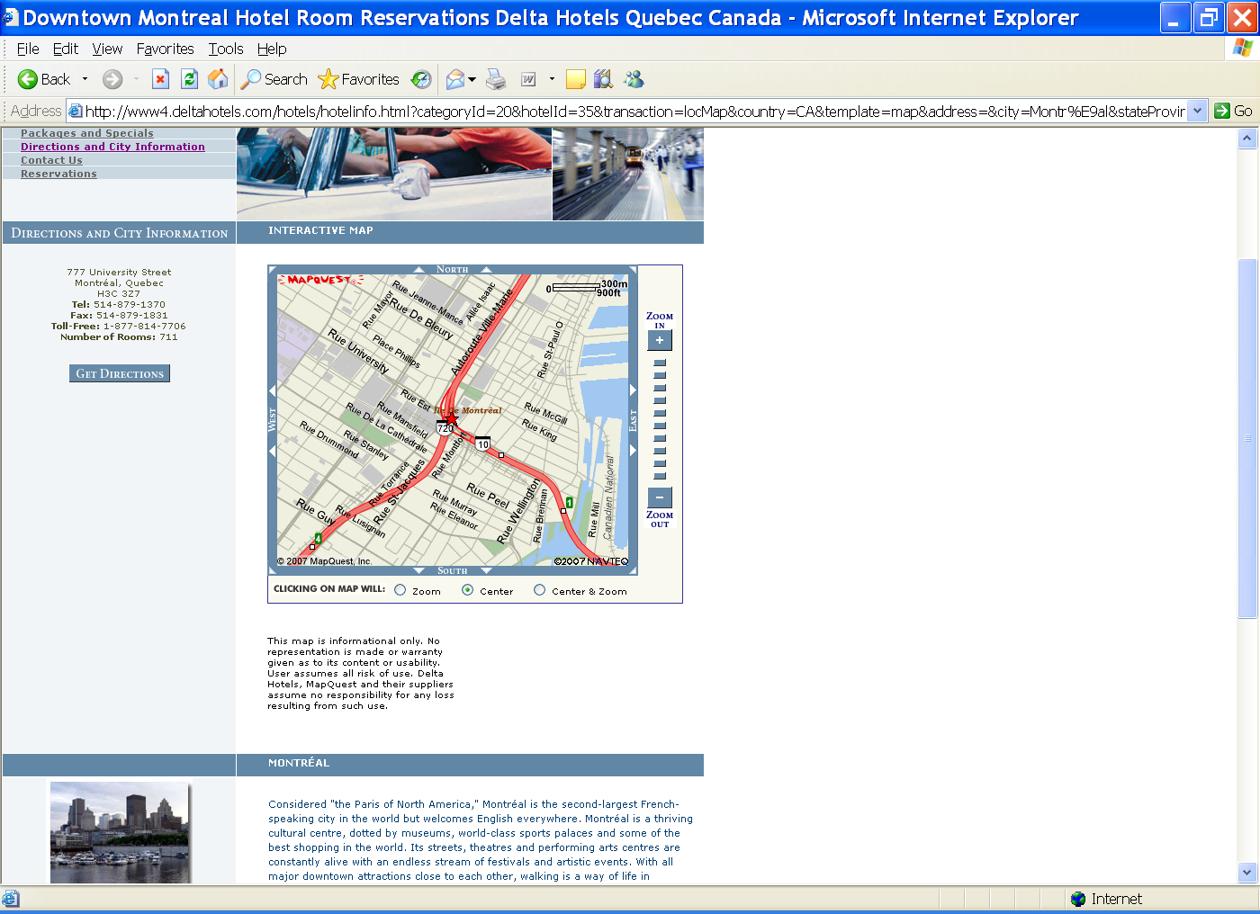

4 Visa information for Canada
Visa requirements vary on a country-per-country basis. If you need and invitation letter for visa application, please contact TSB Registration (tsbreg@itu.int) with the following information and a copy of the passport:
1 First Name as on the Passport
2 Last Name as on the Passport
3 Gender (Male/Female)
4 Company name
5 Date and place of birth
6 Passport number
7 Date and place of issue
8 Date of expiration
9 Email address
10 Intended length of stay in Canada
11 Place where visa will be issued (with fax number)
12 Nationality
The appropriate invitation letter will be sent to the Canadian Embassy/Consulate given in point 11 above and copied to the applicant.

5 General information
5.1 Currency
Commonly used small coins are the 1-cent ("penny"), 5-cent ("nickel"), 10-cent ("dime") and 25-cent ("quarter") pieces. The two main coins are the $1 gold-coloured coin, commonly called a "loonie" (the loon is the bird engraved on one side), and the $2 silver and gold-toned coin (the "toonie"). Paper bills come in $5, $10, $20, $50, $100, and $1,000 denominations. The Canadian dollar is not equal in value to the U.S. dollar. Note: A bank will give you a better exchange rate than stores or restaurants. For current exchange rates, visit the Bank of Canada’s website.
5.2 Climate
July Weather in Montreal:
- Average July temperature: 21ºC / 68ºF
- July average high: 24ºC / 80ºF
- July average low: 16ºC / 60ºF
- Visitors can expect rain about 10 days out of 31 in July.
5.3 Time Difference
Montreal is under the Eastern Time (ET) Zone, which is five hours behind Greenwich Mean Time (GMT). During Daylight Savings Time (DST), March to October, clocks are turned ahead one hour.
5.4 Electricity
The main power supplies in Canada are 110 volts - 60 Hz.
5.5 Information on Montreal
Please visit the Montreal Official Tourist Information Web Site, which is an online reference for Montreal, located at www.tourisme-montreal.org.
5.6 Vaccination requirements and medical facilities
Generally, no medical examination is required for a visit to Canada with duration of less than 6 months. There are no vaccination requirements for humans, only for pets, to enter Canada.
Good medical care is widely available and the level of public health and sanitation in Canada is high. The largely state-run Canadian health care system is managed by each province (e.g. the province of Ontario has its own hospital insurance plan as does each of the other provinces and territories) and is funded by Canadian taxpayers. Tourists and temporary visitors do not qualify for this health care plan and are well advised to have their own insurance to cover any medical expenses. Some health care professionals in the province of Quebec might only speak French. Information on other health precautions, such as safe food and water precautions and insect bite protection, may be obtained from the Centers for Disease Control and Prevention’s hotline for international travelers at 1-877-FYI-TRIP (1-877-394-8747) or via the CDC’s Internet site at http://www.cdc.gov/travel. For information about outbreaks of infectious diseases abroad consult the World Health Organization’s (WHO) website at http://www.who.int/en. Further health information for travelers is available at http://www.who.int/ith.

The address of The Montreal General Hospital is:
Montreal General Hospital
1650 Cedar Avenue
Montreal, Quebec
H3G 1A4
Telephone: (514) 934-1934
5.7 Taxes
Visitors to Montreal must pay a provincial sales tax (TVQ) of 7.5 per cent and a federal sales tax (GST) of 6 per cent on most goods purchased in the city. However, some exemptions are made for grocery food items (not including restaurant meals) and reading materials. That being said, visitors from out of town may be eligible for a tax rebate from the federal government by filling out an Application for Visitor Tax Refund (GST-176) form; GST-176 forms are available at the airport and at various tourist information centres around the city. You can also download the form here. The provincial government does not offer tourists a rebate on the TVQ.
Tax Refunds: Visitor Rebate Program 1-800-668-4748 (within Canada); (902) 432-5608 (international calls).

ANNEX 3
(to TSB Circular 141)

ITU-TSB | Second Meeting  of the Intersector Coordination Group on Satellite Matters  Montreal, Canada, 14 July 2007
REGISTRATION FORM
To be returned to TSB by fax (+41 22 730 5853) or e-mail (tsbreg@itu.int) by 2 July 2007

Mr Mrs Ms Miss |  |  |  |  | _______________________________________________  Country
____________________________________________  Family name |  |  |  |  | ______________________________________________  Name of Administration of Member State*
____________________________________________  First name |  |  |  |  | ______________________________________________  Name of Sector Member / Associate / other
Full address of administration or organization:
______________________________________________ |  |  |  | Tel: _____________________________________________
______________________________________________ |  |  |  | Fax: _____________________________________________
______________________________________________ |  |  |  | E-mail: __________________________________________
*For delegates of Member States: Function at the meeting |  |  |  |  | Hotel or other address in Montreal
 |  |  |  |  | Hotel: __________________________________________
(C) Head of delegation |  |  |  |  | Address: ________________________________________
(CA) Deputy head of delegation |  |  |  |  | ___________________________________________
(D) Delegate |  |  |  |  | Tel: ____________________________________________
The meeting of ICG-SAT will be paperless
Date:_______________________________ | Signature: ______________________________________

______________

