Genève, le 10 novembre 2006
UNION INTERNATIONALE DES TÉLÉCOMMUNICATIONS
Bureau de la normalisation
des télécommunications

Réf:  Tél.:  Fax:  E-mail: | Circulaire TSB 123  NGN-GSI/TK  +41 22 730 5994  +41 22 730 5853  tsbngngsi@itu.int | - Aux administrations des Etats Membres de l'Union
Copie:
- Aux Membres du Secteur UIT-T;
- Aux Associés de l'UIT-T;
- Aux Présidents et Vice-Présidents des commissions d'études de l'UIT-T;
- Au Directeur du Bureau de développement des télécommunications;
- Au Directeur du Bureau des
radiocommunications

Objet: | Réunion sur l'Initiative NGN-GSI  Beijing (République populaire de Chine),  8-12 janvier 2007

Madame, Monsieur,
1 A la suite des réunions sur l'Initiative NGN-GSI qui ont eu lieu en 2006 à Genève et à Kobé (Japon), et conformément à la décision qui a été prise au cours des deux réunions tenues sur ce thème à Genève en juillet et en octobre-novembre dernier, j'ai l'honneur de vous informer que la prochaine réunion sur cette initiative se tiendra au Beijing Friendship Hotel, à Beijing (République populaire de Chine), du 8 au 12 janvier 2007 inclus, à l'aimable invitation de l'Association chinoise de normalisation des communications (China Communications Standards Association, CCSA).
2 La réunion du Groupe mixte de Rapporteurs, prévue dans le cadre de l’Initiative NGN-GSI, commencera à 9 h 30 le premier jour par la réunion chargée de l'examen technique et stratégique (TSR) des NGN-GSI. L'inscription des participants débutera à 8 h 30 le même jour. Les précisions relatives aux salles de réunion seront affichées sur le site web du NGN-GSI ainsi que sur des panneaux à l'entrée de l'hôtel et de chaque salle.
3 Les séances et les débats se dérouleront en anglais.
4 Vous trouverez dans l'Annexe 1 un projet de programme ainsi que diverses dispositions d'ordre logistique prises pour ces réunions, comme convenu par les rapporteurs et présidents concernés.
5 Des informations à jour concernant les réunions mentionnées seront disponibles sur le site web de l'Initiative NGN-GSI de l'UIT-T à l'adresse: http://www.itu.int/ITU-T/ngn/events/index.asp.
6 L'ordre du jour proposé par les Groupes de Rapporteurs sera publié sur la page web créée pour les réunions NGN-GSI à l'adresse: http://www.itu.int/ITU-T/ngn/events/index.asp.
7 Les contributions doivent être soumises au secrétariat du TSB chargé de l'Initiative (tsbngngsi@itu.int). Etant donné qu'un grand nombre de personnes seront en congé pour les fêtes de fin d'année, et à titre exceptionnel, la date limite de soumission des contributions est fixée au 3 janvier 2007.
8 L'Annexe 2 contient des renseignements pratiques sur les réunions, le Beijing Friendship Hotel et le pays, qui ont été fournis par l'organisation hôte.
9 Pour faciliter vos démarches, vous trouverez un formulaire de réservation d'hôtel à l'Annexe 3.
10 Veuillez noter que la réunion se déroulera sans documents papier. Des équipements de réseau local sans fil seront à la disposition des délégués. Nous vous conseillons de vous munir de votre carte hertzienne si vous en possédez une. Dans le cas contraire, vous pourrez en louer une sur place auprès du secrétariat.
11 Afin de permettre à l'organisation hôte et au TSB de prendre les dispositions nécessaires concernant l'organisation des réunions, nous vous saurions gré de bien vouloir vous préinscrire en faisant parvenir à l'organisation hôte, par fax (+86-10-82053019) ou par courrier électronique (NGNGSI_meeting@ccsa.org.cn), le formulaire d'inscription dûment rempli, que vous trouverez à l'Annexe 4, à raison d'un exemplaire par participant et au plus tard le 22 décembre 2006.
12 Nous vous rappelons que, pour les ressortissants de certains pays, l'entrée et le séjour sur le territoire de la République populaire de Chine est soumis à l'obtention d'un visa. Ce visa doit être demandé et obtenu auprès de la représentation de la Chine (ambassade ou consulat) dans votre pays ou, à défaut, de celle qui est la plus proche de votre pays de départ. Nous vous recommandons de demander votre lettre d'invitation le plus tôt possible car l'obtention du visa peut prendre du temps.
Il est recommandé aux personnes ayant besoin d'une lettre d'invitation et/ou d'une lettre d'accompagnement pour le visa d'entrée sur le territoire de la Chine de se mettre en relation avec la personne à contacter, dont les coordonnées sont données ci-après:
M. Qi Xu
CCSA Standardization Promoting Center
Tél.: +86-10-82050013
Mobile: +86 13466724696
E-mail: qixu@ptsn.net.cn
Veuillez agréer, Madame, Monsieur, l'assurance de ma considération distinguée.
H. Zhao
Directeur du Bureau de la
normalisation des télécommunications
Annexes: 4

ANNEX 1
(to TSB Circular 123)
NGN-GSI time plan
Beijing, China, 8-12 January 2007

Monday | 08/01 | Tuesday | 09/01 | Wednesday | 10/01 | Thursday | 11/01 | Friday | 12/01
AM | PM | AM | PM | AM | PM | AM | PM | AM | PM

TSR | 2/13 | 2/13 | 2/13 | 2/13 | 2/13 | 2/13 | 2/13 | 2/13 | 2/13 | 2/13 | 2/13 | 2/13 | 2/13 | 2/13 | 2/13 | 2/13 | 2/13 | 2/13 | TSR
TSR | 3/13 | 3/13 | 3/13 | 3/13 | 3/13 | 3/13 | 3/13 | 3/13 | 3/13 | 3/13 | 3/13 | 3/13 | 3/13 | 3/13 | 3/13 | 3/13 | 3/13 | 3/13 | TSR
TSR | 4/13 | 4/13 | 4/13 | 4/13 | 4/13 | 4/13 | 4/13 | 4/13 | 4/13 | 4/13 | 4/13 | 4/13 | 4/13 | 4/13 | 4/13 | 4/13 | 4/13 | 4/13 | TSR
TSR | 15/13 | 15/13 | 15/13 | 15/13 | 15/13 | 15/13 | 15/13 | 15/13 | 15/13 | 15/13 | 15/13 | 15/13 | 15/13 | 15/13 | 15/13 | 15/13 | 15/13 | 15/13 | TSR
TSR | 8/13 | 8/13 | 8/13 | 8/13 | 8/13 | 5/11 | 8/13 |  |  | 8/13 |  | 8/13 | 8/13 |  |  | 8/13 | 8/13 | 8/13 | TSR
TSR | 13/13 | 13/13 | 13/13 | 9/13 | 9/13 | 9/13 | 13/13 | 9/13 | 9/13 | 9/13 | 9/13 | 9/13 |  | 9/13 | 9/13 |  |  |  | TSR
TSR | 2/11 | 2/11 | 2/11 | 7/13 | 5/11 | 7/13 | 7/13 | 7/13 | 7/13 |  | 5/11 |  | 7/13 | 7/13 |  |  |  |  | TSR
TSR | 1/13 | 7/13 | 1/13 | 1/13 | 1/13 | 3/11 | 3/11 | 1/13 | 3/11 | 3/11 | 3/11 | 3/11 | 3/11 | 3/11 | 3/11 | 3/11 | 3/11 | 3/11 | TSR
TSR | 8/11 | 5/11 | 8/11 | 7/11 | 7/11 | 7/11 | 1) | 5/11 | 5/11 | 5/11 | 1/13 | 5/11 | 5/11 | 5/11 | 5/11 | 5/11 | 5/11 | 5/11 | TSR

Legend:
TSR: NGN-GSI Technical and Strategy Review Activity
Note 1: Joint Qs.5 & 7/11 meeting

Some arrangements for the NGN-GSI meeting

- The meetings will be run paperless: no paper copies of the documents will be distributed. Meeting documents will be available on http://www.itu.int/ITU-T/ngn/events/index.asp. This page is accessible from the main NGN-GSI webpage http://www.itu.int/ITU-T/ngn/index.phtml.
- Similar to the previous NGN-GSI event in Geneva, the document handling for the NGN-GSI events held as co-located Rapporteur groups meetings (beyond Study Group structure) will be carried out by TSB. Therefore, contributions to this meeting should be sent to the TSB secretariat for NGN-GSI (tsbngngsi@itu.int), with copy to the Rapporteur concerned. Please use the template for the documents available from http://www.itu.int/ITU-T/ngn/events/index.asp.
- The deadline for the submission of contributions is set at 3 January 2007, midnight, Geneva time.
- For this NGN-GSI event a website has been created to give access to the input and output documents via the regular ITU document management system (DMS). As for the previous event, all input and output documents from the various Rapporteur groups for this event will be processed by the TSB, loaded onto the DMS and mirrored onto the FTP area established for this meeting. Mr. Georges Sebek, TSB acting coordinator for the NGN-GSI, is the focal point to carry out this task. His contact details are as follows:
Georges Sebek
TSB/ITU
Place des Nations
CH-1211 Geneva 20
Switzerland
Tel : +41 22 730 5994
Fax : +41 22 730 5853
E-mails : tsbngngsi@itu.int
georges.sebek@itu.int
- Meeting logistics will also be coordinated by TSB. Please contact TSB secretariat for this event at tsbngngsi@itu.int.
- Any requests for information on meetings should be sent to Georges Sebek, TSB acting coordinator for NGN-GSI.
ANNEX 2
(to TSB Circular 123)

Practical Information

- Venue
The Beijing Friendship Hotel (****) Tel: +86-10-68498888
1 Zhongguancun Nandajie, Haidian District, Fax: +86-10-68498866
Beijing, China
For detailed information about Beijing Friendship Hotel, please see:
http://www.bjfriendshiphotel.com/enew.htm
  - How to get there
There are 2 ways to get from the airport to the hotel:
First, a Shuttle Bus from Beijing Capital International Airport to Beijing Friendship Hotel goes every 30 minutes (from 8:00-23:00); the fare is 16 RMB.
Second, you may wish to take a taxi from airport to hotel. Average fare from the airport to the hotel is approximately 120 RMB for a regular taxi but it may cost more depending on traffic during rush hours.
- Entry Notes
Visa requirements
Please contact Mr. Qi Xu (qixu@ptsn.net.cn) should you require an individual invitation letter while obtaining your visa. Your email must include the following information in order to be processed:
- Family name (last name)
- Forename (first name)
- Birth date (month, day, year)
- Passport number, issuing country, issuing date and expiry date
- Gender
- Occupation
- Company name
- Company’s mailing address
- Postal Code
- Country
- Telephone number
- Fax number
- Name of meeting (ITU-T NGN-GSI event)
Letters will only be sent via Express mail upon request. Letters will be sent via fax unless otherwise indicated on the request.
Letters will be processed within 14 days of receiving an email request. If you have not received your letter within 14 days or wish to make changes after receiving a faxed copy, please contact Mr. Qi Xu (qixu@ptsn.net.cn).
In addition, you may be asked for specific documentation showing strong social, economic, and other ties to your home country.
Customs Regulations and Vaccination Requirements
See the above attachment for reference or check this website:
http://www.hlraohe.gov.cn/kajm/crj/xz.htm
Hotel Reservation Procedure
A total of about 100 rooms in the Beijing Friendship Hotel Building NO.4 have been blocked for the participants at preferential rates. The preferential rates will start when the participants arrive at the hotel and be cut off when the meeting closed.
The hotel is pleased to offer you a standard room (single/twin) and a suite (single/twin) in the Building NO.4. The fare for stay in the standard room (single/twin) is US$72 per night (including breakfast), and the fare for the suit (single/twin) is US$127 per night (including breakfast). The fare for the lunch is US$12, and the fare for the lunch and supper will be US$24.
Participants wishing to make reservations should fulfil the reservation form in Annex 3 and send it to the following address: NGNGSI_meeting@ccsa.org.cn (hosting organization focal point for this meeting).
We should be grateful if you would send your reservation as soon as possible, but not later than 20 December 2006.
3. Map directions
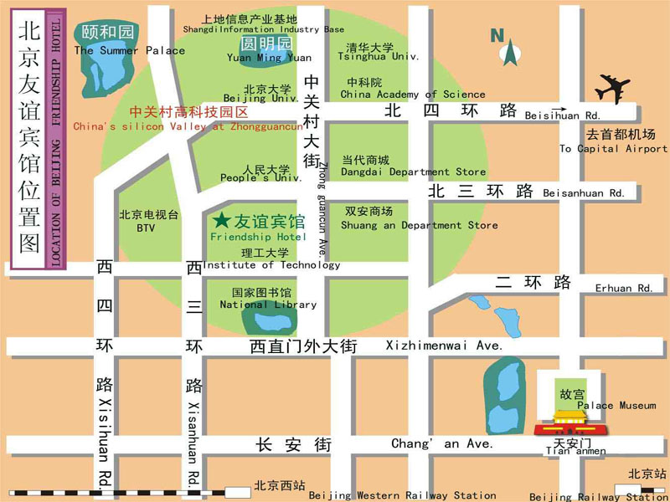
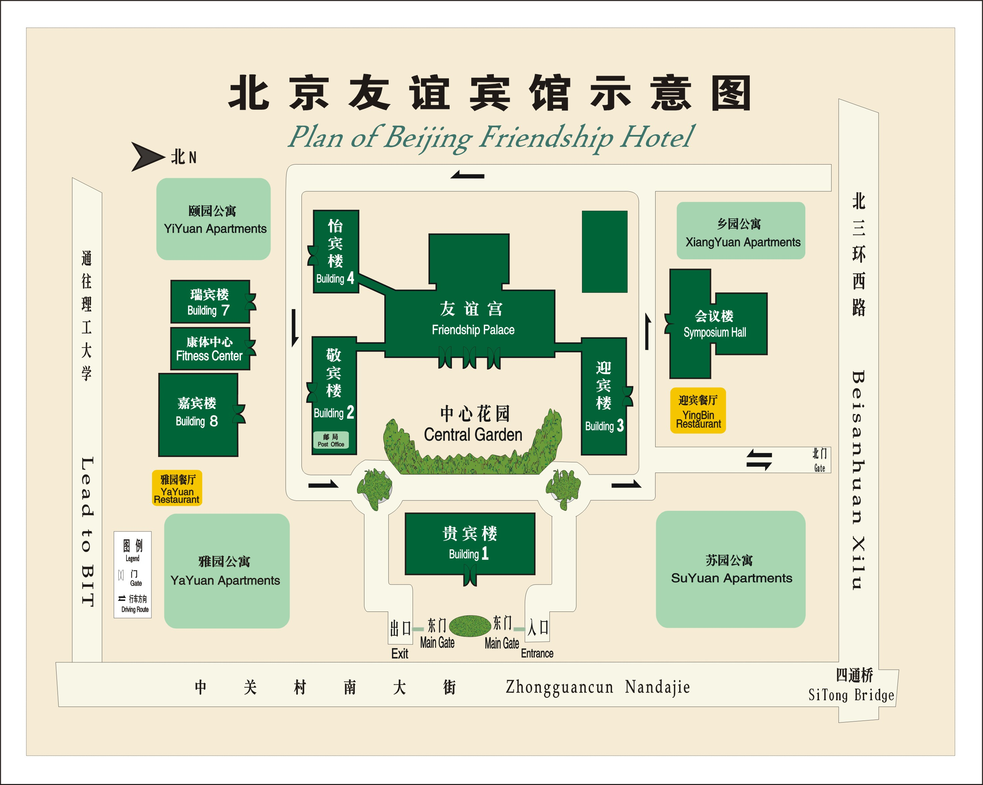
Medical services around the hotel
For medical emergencies, there are two major hospitals around the Beijing Friendship Hotel. They are Peking University Third Hospital and Beijing Haidian Hospital.
Bank services around the hotel
Around the Beijing Friendship Hotel, there are branches of China CITIC Bank and Bank of Beijing. You can go to these for financial business.
4. Miscellaneous
GSM and ACDMA Coverage
There are GSM and CDMA 95/1X coverage in Beijing.
Currency
Local currency RMB Yuan ( ¥ ). The bank and hotel can provide multi-currency service. The currency exchange desk is situated on the 1st floor of Building NO.4, Beijing Friendship Hotel.
Exchange rates
Online spot exchange rates are shown at: http://www.china.org.cn/english/BAT/31.htm
Exchange rate as of 6 November 2006.
US Dollar 100 | 779.42 RMB
Euro 100 | 976.21 RMB

Tipping

Tipping is not necessary.
Time Zone
Central Time Zone (GMT +8 hours, Beijing, Hong Kong).
Climate
Beijing's climate is defined as "continental monsoon". The four seasons are distinctly recognizable. The climate of Beijing in winter is cold and snowy. Average temperature during the January is: -4.6C. Although winter is technically longer, that should not keep you from travelling to Beijing as indoor heating is widely available. Nevertheless, as the indoor/outdoor temperature difference is rather large, travellers should be prepared with warm clothing and a thick coat is recommended for the colder months of the year.
Phone charges
Each delegate is responsible for verifying any toll charges that may be incurred by placing local, long distance and toll-free calls from a guest room.
In-town transport
Taxi rate: Typical minimum charge is RMB ¥10 (covering preliminary 3 kilometers), and extra RMB ¥ 2.0 per additional kilometre.
Subway and City Rail: There are 2 subway lines and 1 city rail in Beijing, as presented in the map below.
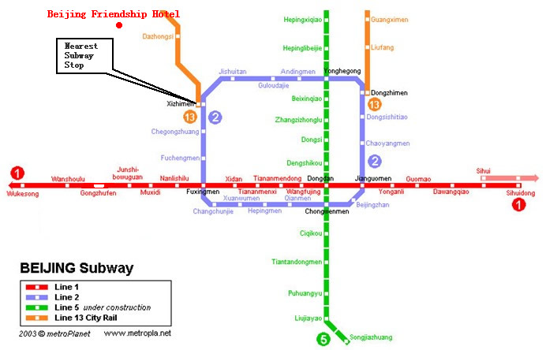
Subway System in Beijing
Currently there are three subway (or city railway) lines running in Beijing, which are line 1, 2, 13.
Line 1: line-style subway; the nearest subway stop to Beijing Friendship Hotel is Xizhimen stop;
Line 2: ring-style subway; running around the Beijing downtown area;
Line 13: sector-style city railway; running at the suburb area in the northern part of Beijing.
Electricity
220 Volt. Please be sure you have the correct adapter. Voltage converters will NOT be provided at the meeting.
The type of electrical socket at the venue of the meeting is type B.

Type B – Oblique flat blades (inverted V-shape) with ground
About Beijing
You are welcome to visit http://www.ebeijing.gov.cn, the official website of Beijing City as well as the 2008 Olympics.
Network
There will be Wireless LAN (802.11) Service in meeting rooms. Please bring your WLAN card, if you have it. WLAN cards can also be rented at the meeting secretariat (there will be a total of 50 WLAN cards available for rent).
Wired Broadband Access to Internet is available in guest rooms, which is charged 50 RMB per day.

ANNEX 3
(to TSB Circular 123)
HOTEL RESERVATION FORM
for NGN-GSI event
(Beijing, 8– 12 January, 2007)
Please complete and return this form to: NGNGSI_meeting@ccsa.org.cn
by 20 December 2006

(Please type or print in block letters and check appropriate items.)
NAME: □ Mr □ Ms.
Last name First name

ORGANIZATION:

ADDRESS: □ Office □ Home _________________

Postal code_ Country
Phone: Fax:

Name of Accompanying Person(s), if any:
□ Mr □ Ms. Last name First name
Flight Schedule: Arriving at (airport) on (date) by (flight number)

HOTEL ACCOMMODATION
Hotel Name | Room Type |  | Period of stay
Beijing Friendship Hotel  (Building NO.4) | Standard Room | Single | Check In:
Beijing Friendship Hotel  (Building NO.4) | Standard Room | Twin | Check In:
Beijing Friendship Hotel  (Building NO.4) | Suite | Single | Check Out:
Beijing Friendship Hotel  (Building NO.4) | Suite | Twin | Nights:

REMITTANCE
- Cash
- □ Credit card: □ VISA □ MasterCard □ Diners Club □ AMEX □ Other ( )
Card number:
Name of card holder: Expiration date: / /
Authorized signature:
ANNEX 4
(to TSB Circular 123)

Registration Form
ITU-T NGN-GSI event
8-12 January 2007, Beijing, P.R. China

Please fill in this form and send it by  22 December 2006 to:  (beyond this date you will be registered on site) | E-Mail: NGNGSI_meeting@ccsa.org.cn  Fax: +86-10-82053019

Title: | Ms. Mr
Last Name:
First Name:
Company:
Mailing address:
Country:
Telephone:
Fax:
Email Address:

_____________

