Ginebra, 28 de enero de 2005
UNIÓN INTERNACIONAL DE TELECOMUNICACIONES
Oficina de Normalización
de las Telecomunicaciones

Ref:  Tel.:  Fax: | Circular TSB 19  TSB Workshops/X.Y.  +41 22 730 6206  +41 22 730 5853 | - A las Administraciones de los Estados Miembros  de la Unión;  - A los Miembros del UIT-T;  - A los Presidentes y Vicepresidentes de las Comisiones de Estudio del UIT-T;  - A los Asociados del UIT-T
Correo-e: | tsbworkshops@itu.int | Copia:  - Al Director de la Oficina de Desarrollo de las Telecomunicaciones;  - Al Director de la Oficina de Radiocomunicaciones

Asunto: | Taller Técnico sobre Redes de la próxima generación (NGN)  Isla de Jeju, República de Corea, 14-15 de marzo de 2005

Muy señora mía/Muy señor mío:
1 Deseo informarle que el Taller Técnico NGN tendrá lugar en el Hotel Lotte de la Isla de Jeju, República de Corea, del 14 al 15 de marzo de 2005, por amable invitación del Gobierno de Corea. El taller se celebrará inmediatamente antes de la reunión del 5º Grupo Temático sobre Redes de la próxima generación (FGNGN) que tendrá lugar en el mismo lugar entre los días 16 y 22 de marzo de 2005. Para más información sobre la 5ª reunión del FGNGN consulte la dirección web: http://www.itu.int/itu-t/ngn/fgngn.
El taller comenzará a las 09.00 horas. A la entrada del lugar de la reunión figura la información detallada sobre las salas de reunión.
2 Los debates se celebrarán únicamente en inglés.
3 La participación está abierta a los Estados Miembros, a los Miembros de Sector y a los Asociados de la UIT, y a cualquier persona de un país que sea Miembro de la UIT y desee contribuir a los trabajos. Esto incluye a las personas que también sean miembros de organizaciones nacionales, regionales e internacionales. La participación en el taller es gratuita pero no será concedida ninguna beca.
4 En el Anexo 1 adjunto figura un proyecto de programa de trabajo del taller.
5 En el Anexo 2 adjunto aparece información práctica sobre el taller.
6 La información relativa al taller estará disponible en la siguiente dirección web del UIT-T: http://www.itu.int/ITU-T/worksem/ngntech/index.html.
7 A fin de facilitar sus trámites, se adjunta, en Anexo 3 un formulario de reserva del hotel. Las peticiones de reserva deben recibirse a más tardar el 4 de marzo de 2005.
8 Para que la TSB pueda tomar las disposiciones necesarias relativas a la organización del taller, le agradecería que enviase a la TSB el formulario de inscripción del Anexo 4, debidamente rellenado (uno por participante) por fax (Nº: +41 22 730 5853), por correo-e (tsbreg@itu.int) o a través del formulario en línea (http://www.itu.int/ITU-T/worksem/ngntech/registration.html) a la mayor brevedad posible, pero a más tardar el 6 de marzo de 2005.
9 Les recordamos que los ciudadanos procedentes de algunos países necesitan visado para entrar y permanecer en Corea. El visado debe solicitarse y obtenerse en la oficina (embajada o consulado) que representa a Corea en su país o, en su defecto, en la más próxima a su país de partida.
Se ruega a los participantes que necesiten una carta de invitación y/o una carta que justifique la petición del visado para entrar en Corea que contacten con la siguiente persona:
Sr. Youngjae Kim, TTA
Tel.: +82 31 724 0195
Fax: +82 31 724 0119
Correo-e: fgngn@tta.or.kr
Atentamente,
H. Zhao
Director de la Oficina de
Normalización de las Telecomunicaciones

Anexos: 4
ANNEX 1
(to TSB Circular 19)
Advance Program NGN Technical Workshop
14 – 15 March 2005
Lotte Hotel, Jeju Island, Korea (Republic of)
Kindly note that the detailed program for this workshop will be available at:
http://www.itu.int/ITU-T/worksem/ngntech/index.html

14 March 2005 (Monday)

08:00 – 09:00 Registration
Opening Session
Keynote 1 BcN Deployment Strategies in Korea
Keynote 2 FGNGN Activities

Session I: NGN Framework and Architecture
Session II: NGN Services
Session III: Group Discussions 1

15 March 2005 (Tuesday)

Keynote 3 The Octave Project: Beyond Broadband Business

Session IV: NGN Applications
Session V: NGN Technology I
Session VI: NGN Technology II
Session VII: Group Discussions 2

Closing Session
ANNEX 2
(to TSB Circular19)
PRACTICAL INFORMATION
NGN Technical Workshop
(Jeju, Korea, 14 – 15 March 2005)

Meeting Venue
JEJU Lotte Hotel
2812-4, Saekdal-dong, Seogwipo City
Jeju -do, South Korea 697-130
Phone: (82)(2)759-7051~4 (Seoul Office) (Please quote group name 'ITU-T')
Fax: (82)(2)779-1353(Seoul Office) (Please quote group name 'ITU-T')
Sales Executive : JW Park
Email: jwparka@hotellotte.co.kr (Please quote group name 'ITU-T')
Home Page: http://www.hotellotte.co.kr
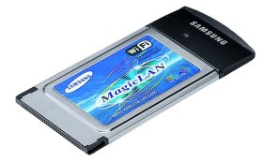
Computer Networking
Each meeting room will be equipped with wireless access (Wireless LAN, supporting IEEE802.11b, 2.4GHz band) to the Internet. Those who wish to use the wireless access must be equipped with the necessary hardware and correctly configured PC.
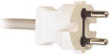
Electricity & Voltage

Jeju Lotte Hotel is equipped with V220 electricity outlets only (the shape of plug is the same as in France), but a transformer for V110 is also available upon request.
Airport
The closest airport is the Jeju International Airport
Transportation
(From Jeju International Airport to Jeju Lotte Hotel)
* Only Korean currency (Won) can be used for all transportation.
1. Limousine Bus
For visitor’s convenience, Samyoung Limousine bus is in service between the Jeju Lotte Hotel and the Jeju Airport
– Operation Hour: Everyday 06:20 – 22:00 (15minutes interval – A 50minutes ride from the Airport)
– Charge: 3,900 Korean Won (approximately 3.9 USD)
2. Taxi
It costs approximately 35,000 Korean Won (approximately 35 USD) from Jeju Airport to Jeju Lotte Hotel.
3. Rental car Information
Kumho Rent a car
Tel: +82-64-738-8101
We recommend that you take public transportation.
Map of Jeju island
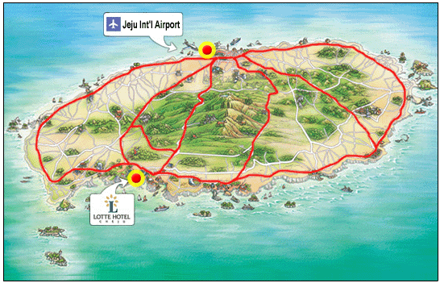
Hotel Information
1. Jeju Lotte Hotel
Address: 2812-4, Saekdal-dong, Seogwipo City, Jeju -do, South Korea 697-130
Phone: (82)(2)759-7051~4 (Seoul Office) Fax: (82)(2)779-1353(Seoul Office)
Home Page: http://www.hotellotte.co.kr
Category: 5 Star
There are 500 rooms equipped with cable TV, internet access, air conditioner, hairdryer, bath, telephone, voice mail, radio, alarm clock, in-house movie, writing desk and mini bar. The Hotel offers coffee/tea facilities and parking.
2. Hana Hotel
Address: 2812-2 sackkdaldong(Chung Mun Tourist Area), Seokkwipo, Cheju
Phone: +82-64-738-7001~2 FAX : +82-64-738-7000
Home Page: http://www.hotelhana.co.kr/

Category: 4 Star
There are 86 guest rooms equipped with color TV, air conditioner, telephone, radio, alarm clock, and mini bar, writing desk. The Hotel offers coffee/tea facilities and parking. The distance to Jeju Lotte Hotel is about 2 minutes on foot.
3. Hankook(Korea) Condominium
Home Page: http://www.koreacondo.co.kr
Home Page: http://www.koreacondo.co.kr/branch/branch_jeju_s.asp
Category: 4 Star
There are 216 apartments equipped with color TV, air conditioner, telephone, radio, alarm clock, and mini bar, writing desk. Each apartment accommodates up to 5 people with cooking facility. The distance to Jeju Lotte Hotel is about 2 minutes on foot.
Hotel Reservation and Cancellation
Reservation requests should be received no later than 4 March 2005. You are kindly requested to make use of the indicated hotel and the attractive rate offered. No other hotel room blocks have been reserved. Should you wish to seek other accommodation, please see: http://dir.yahoo.com/Regional/Countries/Korea__South/Provinces/Jeju_do/Travel_and_Transportation/Lodging/.
Hotel rooms must be guaranteed against a credit card and the reservation must be cancelled 3 days prior to arrival day to avoid a “no-show” charge.
Map of nearby Hotels
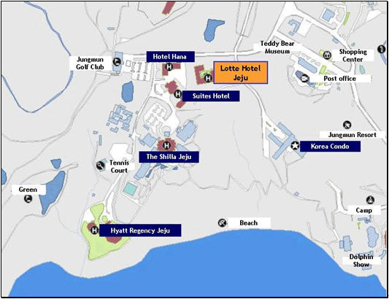
Passports and Visas
Most visitors with confirmed outbound tickets may stay up to fifteen days without visas. However, this does not apply to certain nationalities. Please check with your travel agent, Korean embassy or Korean consulate in your country in advance of your trip. Participants who need an invitation letter and/or visa-supporting letter for entering into Korea are strongly advised to contact the following person:
Mr. Youngjae Kim, TTA
Tel: +82 31 724 0195
Fax: +82 31 724 0119
Email: fgngn@tta.or.kr
The 18 Countries that need VISA: Cuba, Macedonia, Palestine, China, Mongolia, Philippine, Vietnam, Nepal, Sri Lanca, and India. Chinese nationals with more than five people to a group with a sightseeing purpose do not require visa. For further information, contact your local Korean Embassy or visit the website at http://www.mofat.go.kr/en/visa/e_visa.mof
About the Place
Jeju island is located at the southwest of Korean peninsula. The island is somewhat warmer than Seoul and has excellent beach resorts. It is favored with nature, clean water, fresh air and blessed climate. Jeju island’s total area is 1,845 km². It is the smallest Province of Korea. The land is flat and oval-shaped but with Mt. Halla at center of the Island, contour lines draw concentric circles, letting the cultivated lands spread on the seacoast. Hilly areas of 200-300m above the sea level are gently sloped but most of them are idle land or meadows.
Jeju Island is a place favored by many honeymooners because of it’s weather, resorts, and beautiful surroundings. Also, Jeju Island has all the ingredients for an attractive convention or incentive tour site. For detailed information about Jeju, please find at http://www.jeju.go.kr
Climate & Clothing
The climate of Jeju during meeting may be a little bit cool. The temperature is around 13 degrees Celsius during March. For more detailed climate information, please contact the Korea Meteorological Administration (http://www.kma.go.kr/ema/eindex.htm )
Currency
Korea’s currency is called the won. Coins come in denominations of W 10, W 50, W 100, and W 500 and notes come in denominations of W 1,000, W 5,000, and W 10,000. The exchange rate fluctuates daily, dependent on international foreign exchange rates. Foreign currencies and traveler’s cheques can be exchanged at banks, airports, international ferry terminals and hotels.
* Current exchange rate: W1,039 / 1 USD ( as of 14 Jan 2005)
Credit Cards
Credit cards (Visa, American Express, Diners Club, Master Card and etc.) are accepted in almost all places such as major hotels, and major restaurants.
Korea & Korean Tourism
Please visit the following Websites for more information on Korea and possible tours:
http://www.kois.go.kr and http://www.visitkorea.or.kr/
Local time
GMT + 9 hours.
ANNEX 3
(to TSB Circular 19)
HOTEL RESERVATION FORM
To be sent to:
Fax: +82 2 779 1353
E-mail: jwparka@hotellotte.co.kr
This form should be send not later than 4 March 2005.
- I will participate in the NGN Workshop (14-15 March 2005)
- I will participate in the ITU-T Focus Group NGN Meeting (16-22 March 2005)
Family Name: …………………………..……… First Name: ………………………………………
Organization: ……………………………..…… Country: ………………………………………….
Telephone: ………………………………...…… Fax: ………………………………………………
E-mail: …………………………………….……
Check in date: ………………………………… Check out date: …………………………………
Room Nights: ………… Days Number of people: ………… Person

Hotel | Room |  | Fare
Hotel |  |  | Fare for mountain view | Fare for ocean view
Jeju Lotte Hotel | W/O breakfast  (for 1 or 2 person) | Single bed ( )  Double bed ( )  Twin bed ( ) | ( ) US $135 | ( ) US $195
Jeju Lotte Hotel | With breakfast  (for 1 person) | Single bed ( )  Double bed ( )  Twin bed ( ) | ( ) US $155 | ( ) US $215
Jeju Lotte Hotel | With breakfast  (for 2 person) | Double bed ( )  Twin bed ( ) | ( ) US $178 | ( ) US $238
Hana Hotel | With breakfast | Single bed | ( ) US $70 | -
Hana Hotel | With breakfast | Double/Twin bed | ( ) US $80 | -
Hankook Condominium | 1 to 5 person in one apartment  (two rooms and one bed in each apartment) |  | ( ) US $66 | -
* Please choose only one type of room and fare
* All tax included
Please circle one credit card from the following:
VISA, MASTER CARD, AMERICAN EXPRESS, DINERS CLUB
Credit Card No: ………………………………..…… Expire date: …………………………………
Name of the card holder: ………………………………………………………………………………
Signature: …………………………………………………………………………………
ANNEX 4
(to TSB Circular 19)

 | ITU-TSB | NGN Technical Workshop  Jeju Island, Korea (Republic of), 14-15 March 2005
 | REGISTRATION FORM
 | To be returned to TSB (Fax: +41 22 730 5853/tsbreg@itu.int) by 6 March 2005
Mr. Mrs. Ms. Miss |  |  |  |  |  | Administration of ITU Member State
____________________________________________  Family Name |  |  |  |  |  | ITU Sector Member
 |  |  |  |  |  | ITU Associate
____________________________________________
First Name
 |  |  |  |  |  | Non-Member
Name and complete address of Administration or Organization:
__________________________________________ |  |  |  |  | Tel.: ______________________________________
__________________________________________
__________________________________________ |  |  |  |  | Fax :______________________________________
_________________________________________ |  |  |  |  | E-mail: __________________________________
NOTE:
REGISTRATION FOR THE 5TH FGNGN MEETING (16 - 22 March 2005) IS TO BE DONE SEPARATELY VIA THE ONLINE FORM AVAILABLE AT: http://www.itu.int/itu-t/ngn/fgngn

Hotel:
________________________________________________ |  |  |  |  | Tel.: _______________________________________
Date: ________________________ |  |  | Signature: ______________________________________

