Ginebra, 27 de julio de 2007
UNIÓN INTERNACIONAL DE TELECOMUNICACIONES
Oficina de Normalización
de las Telecomunicaciones

Ref: | Carta colectiva TSB 6/9
Tel: | +41 22 730 6071
Fax:  Correo-e: | +41 22 730 5853  tsbsg9@itu.int | A las Administraciones de los Estados Miembros de la Unión, a los Miembros del Sector UIT-T y a los Asociados del UIT-T que participan en los trabajos de la Comisión de Estudio 9

Asunto: | Reunión de la Comisión de Estudio 9  Louisville, Colorado (Estados Unidos), del 29 de octubre al 2 de noviembre de 2007

Muy señora mía/Muy señor mío:
1 A petición del Presidente de la Comisión de Estudio 9 (Redes de cables de banda ancha y transmisión de televisión y sonido), me complace informarle de que esta Comisión se reunirá en Louisville, Colorado (Estados Unidos), del 29 de octubre al 2 de noviembre de 2007 ambos inclusive, gracias a la amable invitación de Cable Television Laboratories (CableLabs).
La reunión comenzará a las 09.30 horas del primer día. La inscripción de los participantes comenzará a las 08.30 horas. En las pantallas situadas en lugar de celebración se dará información detallada sobre las salas de reunión.
2 La reunión se celebrará únicamente en inglés.
3 No se distribuirán documentos en papel.
4 En el anexo 1 adjunto figura el proyecto de orden del día preparado por el Presidente de la Comisión de Estudio 9, previa consulta con la TSB.
5 En el anexo 2 adjunto figura el proyecto de programa de trabajo preparado por el Presidente de la Comisión de Estudio 9, previa consulta con la TSB.
6 El anexo 3 contiene información práctica facilitada por la organización anfitriona.
7 De conformidad con lo dispuesto en la Recomendación A.1 (2006), las contribuciones a los trabajos de la Comisión de Estudio se transmitirán a la Oficina de Normalización de las Telecomunicaciones (TSB) al menos diez días naturales antes de la fecha de comienzo de la reunión y a más tardar el 18 de octubre de 2007. Las contribuciones recibidas por la TSB se publicarán en la dirección web de la Comisión de Estudio 9. Las contribuciones recibidas por lo menos dos meses antes del comienzo de la reunión podrán traducirse, llegado el caso, con arreglo a las disposiciones en vigor.
Se alienta a los participantes a que presenten las contribuciones mediante el correspondiente formulario disponible en el sitio web de la Comisión de Estudio 9 (http://www.itu.int/ITU-T/studygroups/com09/edh/index.html) o por correo electrónico a la siguiente dirección: tsbsg9@itu.int.
Le recomendamos encarecidamente que utilice el juego de plantillas a fin de armonizar la presentación de los documentos del UIT-T y, al mismo tiempo, facilitar y hacer más eficaz su producción. Se pueden descargar desde la página web de cada Comisión de Estudio del UIT-T en "Guides, Tools and Templates" (http://www.itu.int/ITU-T/studygroups/templates/index.html).
Para resolver todas las posibles cuestiones que se planteen en relación con las contribuciones, en adelante se indicará en las mismas el apellido de la persona encargada, sus números de telefax y de teléfono, así como su dirección de correo electrónico (e-mail). Para ello, le ruego indique esta información en la portada de todos los documentos.
8 Para que la TSB pueda tomar las disposiciones necesarias sobre la documentación y organización de la reunión, le ruego me comunique cuanto antes, por carta, por fax (Nº: +41 22 730 5853) o por correo electrónico (tsbreg@itu.int) y a más tardar el 28 de septiembre de 2007, la lista de las personas que representarán a su Administración, Miembro del Sector, Asociado, organización regional y/o internacional u otra entidad. Se ruega también a las Administraciones que indiquen el nombre de su jefe de delegación (y jefe adjunto, si procede). Deberá adjuntarse a dicha lista el formulario de inscripción debidamente rellenado (un ejemplar por participante) que figura en el anexo 4 a la presente.
9 Les recordamos que los ciudadanos procedentes de ciertos países necesitan visado para ingresar y permanecer en Estados Unidos. Ese visado debe solicitarse en la oficina (embajada o consulado) que representa a Estados Unidos en su país o, en su defecto, en la más próxima a su país de partida. Se ruega a los participantes que necesiten una carta de invitación y/o una carta que justifique la petición del visado para Estados Unidos contacten con la persona encargada en este país, la Sra. Christie Poland, cuya información de contacto figura en § 7 del anexo 3.
Atentamente,
Malcolm Johnson
Director de la Oficina de Normalización
de las Telecomunicaciones

Anexos: 4
ANNEX 1
(to TSB Collective letter 6/9)

Draft Agenda for the Plenary sessions of Study Group 9
(Louisville, Colorado, USA, 29 October - 2 November 2007)
1. Welcome and approval of agenda
2. Objectives and Work Plan for this meeting
- Working Groups
3. Allocation of documents and incoming Liaison Statements
4. Feedback on interim activities since last meeting
Rapporteurs' Group meetings and Reports
- Joint Q6/9 and Q9/9 meeting (Aug. 2007)
- Q14/9, VQEG/JRG and MMQA meeting (Sept. 2007)
5. Other Groups/Workshops
- Report on 5th (July 2007) and 6th (Oct. 2007) FG IPTV meetings
- Report on NGN-GSI co-located Rapporteur Groups meeting (Sept. 2007)
- Others
6. Intellectual Property Rights inquiry
7 Approval of a Recommendation under WTSA-04 Resolution 1 (TAP)
8. “Consent” on draft Recommendations proposed for approval in accordance with
Recommendation A.8
9. Proposed revision and deletion of SG 9 Questions
10. Approval of Working Group reports and Outgoing Liaison statements
11. Future Work Programme
12. Approval of outgoing Liaison Statements
13. Date and place of the next meeting
14. Future Interim activities
15. Other
16. Closing
-)-(-
ANNEX 2
(to TSB Collective letter 6/9)
Draft work programme for the meeting of Study Group 9
(Louisville, Colorado, USA, 29 October - 2 November 2007)
 | 29 October  Monday |  |  |  | 30 October  Tuesday |  |  |  | 31 October  Wednesday |  |  |  | 1 November  Thursday |  |  |  | 2 November  Friday
 | A.M |  | P.M. |  | A.M. |  | P.M. |  | A.M. |  | P.M. |  | A.M. |  | P.M. |  | A.M. | P.M.
Plenary | X |  |  |  |  |  | X¹ |  |  |  |  |  | X¹ |  |  |  | X | X
WG 1 |  | X | X | X | X | X | X | X | X | X |  |  | X
WG 2 |  |  | X | X |  |  |  |  | X | X |  |  | X
WG 3 |  |  |  |  |  | X | X | X | X | X |  |  | X | X
WG 4 |  |  |  |  | X | X |  |  |  |  |  |  | X
WG 5 |  | X | X | X | X | X | X | X |  | X |  |  | X | X
WG 6 |  |  |  |  |  |  |  |  | X | X |  |  |  |  | X | X
WG 7 |  |  | X | X | X | X | X | X | X | X |  |  |  | X
WG 82 |  |  |  |  |  |  | X | X | X |  |  |  | X
WG 9 |  |  |  |  | X | X | X | X |  |  |  |  |  | X
¹Short Plenary
²Subject to contributions received.
- Tentative Working Group structure:
WG 1 IPCablecom Qs 6/9, 9/9
WG 2 Cable Modems Q. 8/9
WG 3 Network Transport Qs 1/9, 7/9, 12/9
WG 4 Conditional Access, Webcasting Qs 3/9, 11/9
WG 5 Quality Assessment Qs 2/9, 14/9
WG 6 Work Programme, Questions, Liaisons QsAll/9
WG 7 APIs Q. 4/9
WG 8 LSDI Q. 15/9
WG 9 Home Networks, Set-top Box Qs 5, 10/9
- A meeting of the Study Group 9 Management Team will be planned for 28 October 2007
ANNEX 3
(to TSB Collective letter 6/9)
Practical Information
(Louisville, Colorado, USA, 29 October - 2 November 2007)
- Venue
Cable Television Laboratories, Inc Tel. +1-303-661-9100
(CableLabs)
858 Coal Creek Circle Fax +1-303-661-9199
Louisville, Colorado USA.
2. Transportation to CableLabs and Hotels nearby:
Denver International Airport (DIA as shown on the map) serves the area in which CableLabs is located. Rental cars are available there and the map in Appendix 1 shows the route from the Denver International Airport (DIA) to CableLabs. However, it is very convenient to use hourly public transportation directly to hotels within walking distance to CableLabs and this may be the most convenient way for most delegates to travel. The location of these hotels is identified in the route map and it is suggested that participants make reservations at one of them. For those desiring to stay in hotels in Boulder, Westminster, or Broomfield, they will find that a rental car would be desirable in order to get from those hotels to CableLabs as public transportation is not directly available for this. A list of hotels and telephone numbers is also given in Appendix 2.
“Boulder Super Shuttle” is the name of the public transportation company providing public transportation from the Denver International Airport. Direct transportation to hotels adjacent to CableLabs and others may be obtained by informing the ticket agent when tickets are purchased. Tickets may be purchased at the airport. The Super Shuttle tickets may be obtained by taking two left turns immediately after taking the escalator up from the train termination which delivers one from the air line arrival gates into the main terminal where baggage claim also is located. Advanced reservations for transportation from DIA to the various Broomfield, Louisville, and Boulder hotels are not accepted. Once your flight arrives at DIA, go directly to the luggage carousel to claim your luggage. Once you have your luggage, go to the Super Shuttle counter to request transportation to your hotel. Super Shuttle will inform you of the next departure time and provide detail on boarding the shuttle. For return transportation from your hotel or CableLabs, you will need to make a reservation with Supper Shuttle. More information regarding the Super Shuttle may found at: http://www.bouldersupershuttle.com/supershuttle/boulder_supershuttle_home.htm.
3. Passports and Visas
All foreign visitors entering the United States (US) must have a valid passport. Visitors from countries whose citizens require a visa should at the earliest time and well in advance of travel apply for a visa at a US Embassy or consulate. The following provides information relating to entry into the U.S.
US ENTRY FOR NONIMMIGRANTS
The US State department issued a detailed update of the current Visa Policy. Click on the link below for complete information.
US State Dept. Visa Policy Update - 3/1/05
For assistance with your visa, visit the following websites:
International Visitors Office site: http://www.nationalacademies.org/visas
Official information on the visa application process: http://travel.state.gov/visa
Visa wait times are available at: http://travel.his.com/visa/tempvisitors_wait.php
4. Climate
The climate in Colorado in the late October – November time frame is usually comparatively dry with clear blue skies, but on occasion precipitation in the form of rain or snow could occur. Monthly Average values are given in the table.
 | October | November
Average Max Temperature | 67°F/19°C | 53°F/12°C
Average Minimum Temperature | 54°F/4°C | 29°F/-2°C
Average Precipitation | 1.3”/3.3cm | 1.2”/3cm
Average Snow Depth | 0” | 1”/2.54cm
5. Altitude
The nominal altitude in the Boulder – Louisville area is about 5300 feet/1615meters. Boulder lies up against the foothills of the Colorado Rocky Mountains, and the continental divide (precipitation falling on one side goes to the Pacific Ocean and the other side to the Atlantic Ocean) is about 20 miles west and rises to over 14000feet/4300meters.
6. Electrical Appliances
Throughout the U.S. electrical appliances operate from 120V, 60Hz. power supplies with plugs as shown below. It is suggested guests bring their own power converters and wall plug adapters to allow use of international appliances. Hotels typically provide irons, ironing boards and hair dryers in the hotel rooms, so there is no need to bring these items with you.
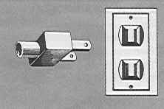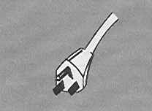
7. Contact Point
If you have any questions about the meeting arrangements, please contact:
Christie Poland; email c.poland@cablelabs.com or telephone +1-303-661-3786
Appendix 1

Map showing route to CableLabs and vicinity from Denver International Airport.
(Hotels adjacent to CableLabs indicated on map)

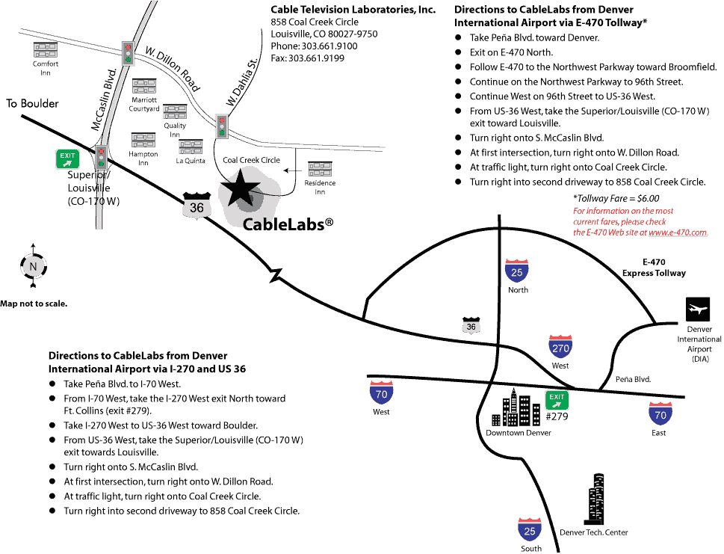

Appendix 2
Hotels
[Distance (miles/kilometers) one-way from Hotel to CableLabs in brackets]
Louisville: Hotels in Louisville are not-full service hotels. They typically offer breakfast and limited room service. However these hotels are in walking distance of CableLabs and a variety of local restaurants, so a rental car is not absolutely necessary.
Residence Inn Marriott  845 Coal Creek Circle  Louisville CO 80027  +1 (303) 665-2661  [.05m/.07km]  Offering a rate of $119 per night for the dates of October 27 – November 2. Please reference “CableLabs ITU Study Group 9 meeting” to secure this special rate. On-line reservations will not be able to honor this special rate – it is necessary to call the hotel directly. Residence Inn Louisville provides an enhanced continental breakfast (several hot and cold items) free of charge to all guests.  http://www.marriott.com/hotels/travel/vborl-residence-inn-boulder-louisville/ | Courtyard Marriott  948 W Dillon Rd  Louisville CO 80027  +1 (303) 604-0007  [.37m/.6km]  Offering a rate of $99 per night for the dates of October 27 – November 2. Please reference “CableLabs ITU Study Group 9 meeting” to secure this special rate. On-line reservations will not be able to honor this special rate – it is necessary to call the hotel directly. Courtyard Marriott offers a hot breakfast buffet daily, at an additional charge per guest.  http://www.marriott.com/hotels/travel/denls-courtyard-boulder-louisville/
Hampton Inn  912 W Dillon Road  Louisville CO 80027  +1 (303) 666-7700  [.19m/.31km] | La Quinta Inn & Suites  902 Dillon Road  Louisville CO 80027  +1 (303) 664-0100  [.15m/.24km]
Quality Inn & Suites  960 W. Dillon Road  Louisville CO 80027  +1 (303) 327-1215  [.35m/.57km] | Comfort Inn  1196 Dillon Road  Louisville CO 80027  +1 (303) 604-0181  [1.08m/1.74km]
Broomfield:
Omni Interlocken Resort  500 Interlocken Blvd  Broomfield CO 80021  +1 (303) 438-6600  [4.43m/7.12km] | Renaissance Boulder Suites Hotel at FlatIron  500 Flatiron Boulevard  Broomfield, CO 80021  +1 (303) 464-8400  [4.07m/6.55km]
Westminster:
The Westin Westminster Hotel
10600 Westminster Blvd
Westminster CO 80020
+1 (303) 410-5000
[8.33m/13.41km]
Boulder:
Boulder Marriott  2660 Canyon Blvd  Boulder CO 80302  +1 (303) 440-8877  [7.7m/12.4km] | Hotel Boulderado  2115 13th Street  Boulder CO 80302  +1 (303) 442-4344  [8.83m/14.21km]
St. Julien Hotel & Spa  900 Walnut Street  Boulder CO 80302  +1 (720) 406-9696  [8.96m/14.42km] | Millennium Harvest House  1345 28th St  Boulder CO 80302-6899  +1 (303) 443-3850  [7.37m/11.85km]
Homewood Suites
4950 Baseline Road
Boulder CO 80303
+1 (303) 499-9922
[5.67m/9.12km]

ANNEX 4
(to TSB Collective letter 6/9)

ITU-TSB | Study Group 9 meeting  (Louisville, Colorado, USA, 29 October - 2 November 2007)
REGISTRATION FORM
To be returned to TSB by fax (+41 22 730 5853) or e-mail (tsbreg@itu.int) by 28 September 2007

Mr Mrs Ms Miss |  |  |  |  | _______________________________________________  Country
____________________________________________  Family name |  |  |  |  | ______________________________________________  Name of Administration of Member State*
____________________________________________  First name |  |  |  |  | ______________________________________________  Name of Sector Member / Associate / other
Full address of administration or organization:
______________________________________________ |  |  |  | Tel: _____________________________________________
______________________________________________ |  |  |  | Fax: _____________________________________________
______________________________________________ |  |  |  | E-mail: __________________________________________
*For delegates of Member States: Function at the meeting |  |  |  |  | Hotel or other address in the USA
 |  |  |  |  | Hotel: __________________________________________
(C) Head of delegation |  |  |  |  | Address: ________________________________________
(CA) Deputy head of delegation |  |  |  |  | ___________________________________________
(D) Delegate |  |  |  |  | Tel: ____________________________________________
Important note:
The meeting will be paperless.
Date: ___________________________ | Signature: ______________________________________

For TSB use only
Pigeonhole
______________

