Geneva, 11 July 2006
INTERNATIONAL TELECOMMUNICATION UNION
Telecommunication
Standardization Bureau

Ref: | TSB Collective letter 4/9
Tel:  Fax:  E-mail: | +41 22 730 6071  +41 22 730 5853  tsbsg9@itu.int | To Administrations of Member States of the Union, to ITU-T Sector Members and to ITU-T Associates participating in the work of Study Group 9

Subject: | Meeting of Study Group 9  Tokyo, Japan, 2-6 October 2006

Dear Sir/Madam,
1 In reference to TSB Collective letter 3/9 of 6 February 2006, I should like to inform you that Study Group 9 (Integrated broadband cable networks and television and sound transmission) is to meet in Tokyo, Japan, from 2 to 6 October 2006 inclusive at the kind invitation of the Ministry of Internal Affairs and Communications of Japan.
The venue of the meeting will be the Keio Plaza Hotel, Tokyo, Japan.
The meeting will open at 0930 hours on the first day. Participant registration will begin at 0830 hours. Detailed information concerning the meeting rooms will be displayed at the venue.
2 The discussions will be held in accordance with decisions taken pursuant to the relevant provisions in force.
3 The draft agenda, as prepared by the Chairman of Study Group 9 in consultation with TSB, is set out in Annex 1 hereto.
4 The draft timetable, as prepared by the Chairman of Study Group 9 in consultation with TSB, is set out in Annex 2 hereto.
5 Annex 3 gives practical information provided by the host organization. Particular attention is drawn to the link for the hotel web page. Bookings should be made as soon as possible, preferably before 10 September 2006.
6 Pursuant to the provisions of Recommendation A.1 (2006), contributions to the work of the study group are to be submitted to the Telecommunication Standardization Bureau (TSB).
Contributions received by TSB at least ten calendar days before the date set for the opening of the meeting will be published on the Study Group 9 website, and be distributed at the beginning of the meeting to participants actually present and having requested paper copies in advance by means of the registration form. Such contributions must therefore be received by TSB not later than 21 September 2006. Contributions received at least two months before the start of the meeting may be translated, if required, according to the provisions in force.
Participants are encouraged to submit contributions using the web-based submission form available on the Study Group 9 homepage, or by electronic mail to the following address:
tsbsg9@itu.int. Detailed instructions can be found on the ITU-T website.
We would strongly encourage you to use the set of templates that has been created to harmonize the appearance of ITU-T documents while making their production easier and hence more efficient. The templates are accessible from each ITU-T study group web page, under “Guides, Tools and Templates” (http://www.itu.int/ITU-T/studygroups/templates/index.html).
With a view to settling any questions that might arise concerning contributions, the name, fax and telephone numbers and e-mail address of the person to be contacted should be indicated on contributions. Accordingly, please include those details on the cover page of all documents.
7 To enable TSB to make the necessary arrangements concerning the documentation for, and organization of, the meeting, I should be grateful if you would send me, by letter, fax (+41 22 730 5853) or e-mail (tsbreg@itu.int), as soon as possible but not later than 1 September 2006 , the list of people who will be representing your Administration, Sector Member, Associate, regional and/or international organization or other entity. Administrations are requested also to indicate the name of their head of delegation (and deputy head, if applicable). The registration form in Annex 4, duly completed (one per participant), should be attached to the above-mentioned list.
8 We would remind you that citizens of some countries are required to obtain a visa in order to enter and spend time in Japan. Where this is the case, the visa must be requested and obtained from the office (embassy or consulate) representing Japan in your country or, if there is no such office in your country, from the one that is closest to the country of departure.
Participants who need an invitation letter and/or a visa supporting letter for entering Japan are advised to get in touch with the contact person in Japan, before 15th September 2006. The detailed information is as follows:
Ms Hideyo Banishky
Technical Department, The ITU Association of Japan, Inc.
3rd floor Kanda KS Building,
1-8-6 Kaji-cho, Chiyoda-ku, Tokyo, 101-0032, Japan
Tel: +81 3 5207 5722
Fax: +81 3 5207 5731
E-mail: itu-t@ituaj.jp
Yours faithfully,
H. Zhao
Director of the Telecommunication
Standardization Bureau
Annexes: 4
ANNEX 1
(to TSB Collective-letter 4/9)

Draft Agenda for the Plenary sessions of Study Group 9
(Tokyo, Japan, 2-6 October 2006)

1. Welcome and approval of agenda
2. Objectives and Work Plan for this meeting
- Working Groups
3. Allocation of documents and incoming Liaison statements
4. Feedback on interim activities since last meeting
Rapporteurs' Group meetings and Reports
- Qs. 9 & 14/9 (24-28 April 2006)
- Qs. 5,8,9,10,11 & 12/9 (21-25 August 2006)
5. Other Groups/Workshops
- Report on JCA-HN meeting (3 July 2006)
- Report on First meeting of the FG IPTV (July 2006)
- Report on TSAG and IPR Ad Hoc group meetings (June, July 2006)
- Others
6. Intellectual Property Rights inquiry
7. “Consent” on draft Recommendations proposed for approval in accordance with
Recommendation A.8
8. Proposed revision and deletion of SG 9 Questions
9. Approval of Working Group reports and Outgoing Liaison statements
10. Future Work Programme
11. Approval of outgoing Liaisons
12. Date and place of the next meeting
13. Future Interim activities
14. Other
15. Closing
-)-(-
ANNEX 2
(to TSB Collective-letter 4/9)
Draft work programme for the meeting of Study Group 9
(Tokyo, Japan, 2-6 October 2006)
 | 2 Oct.  Monday |  |  |  | 3 Oct.  Tuesday |  |  |  | 4 Oct.  Wednesday |  |  |  | 5 Oct.  Thursday |  |  |  | 6 Oct.  Friday
 | A.M |  | P.M. |  | A.M. |  | P.M. |  | A.M. |  | P.M. |  | A.M. |  | P.M. |  | A.M. | P.M.  ¹Short PL
Plenary | X |  |  |  |  |  | X¹ |  |  |  |  |  | X¹ |  |  |  | X | X
WG 1 |  | X | X | X | X | X | X | X | X | X |  |  | X
WG 2 |  |  | X | X |  |  |  |  | X | X |  |  | X
WG 3 |  |  |  |  |  | X | X | X | X | X |  |  | X | X
WG 4 |  |  |  |  | X | X |  |  |  |  |  |  | X
WG 5 |  | X | X | X | X | X | X | X |  | X |  |  | X | X
WG 6 |  |  |  |  |  |  |  |  | X | X |  |  |  |  | X | X
WG 7 |  |  | X | X | X | X | X | X | X | X |  |  |  | X
WG 8³ |  |  |  |  |  |  | X | X | X |  |  |  | X
WG 9 |  |  |  |  | X | X | X | X |  |  |  |  |  | X
Technical visit² |  |  |  |  |  |  |  |  |  |  | X | X
Tentative Working Group structure:
WG 1 IPCablecom Qs 6/9, 9/9
WG 2 Cable Modems Q. 8/9
WG 3 Network Transport Qs 1/9, 7/9, 12/9
WG 4 Conditional Access, Webcasting Qs 3/9, 11/9
WG 5 Quality Assessment Qs 2/9, 14/9
WG 6 Work Programme, Questions, Liaisons Qs All/9
WG 7 APIs Q. 4/9
WG 8 LSDI Q. 15/9
WG 9 Home Networks, Set-top Box Qs 5, 10/9
² The technical visit will be organized in the afternoon of Wednesday 4 October 2006 in cooperation with NHK. Detailed information will be available at the venue.
³ Subject to contributions received.
ANNEX 3
(to TSB Collective-letter 4/9)

Practical Information

(2-6 October 2006, Tokyo)
- VENUE
The Keio Plaza Hotel Tokyo Tel: +81 3 3344 0111
2-2-1 Nishi-Shinjuku, Shinjuku-ku Fax: +81 3 3345 8269
Tokyo, 160-8330, Japan
For further detailed information about the Keio Plaza Hotel Tokyo, please visit the following Web site: http://www.keioplaza.com/index.html
- ACCESS TO The Keio Plaza Hotel Tokyo
There are several alternatives to get to the Keio Plaza Hotel Tokyo from the Narita International Airport.
  - Narita Airport limousine
Airport ticket counters are located in the arrival lobbies of terminal 1 and 2 at the Narita International Airport. The Airport limousine bound for Shinjuku area leaves every 30 to 40 minutes and takes about 100 minutes from the Narita International Airport. For more detailed information, please visit the following Web sites:
Airport ticket counter: http://www.narita-airport.jp/en/guide/service/list/svc_32.html
Airport limousine: http://www.limousinebus.co.jp/e/timetable/index_n/shinjuku_h.html
2.2 JR Narita Express train
The JR Narita Express train bound for Shinjuku takes approximately 80 minutes. It takes 5 minutes by foot from West Exit, Shinjuku Station to Keio Plaza Hotel. For more detailed information, please see the following Web sites:
JR Narita Express train: http://www.narita-airport.jp/en/access/train/index.html
Keio Plaza Hotel Map: http://www.keioplaza.com/map/index.html

3. HOTELS
3.1 Hotel list
A Total of about 100 rooms in 3 hotels in the Shinjuku area, including the Keio Plaza Hotel, Tokyo, have been blocked for the participants of the ITU-T SG9 meeting in Tokyo at preferential rates.
All reservation requests must be made no later than 10 September 2006. Availability and room rates are not guaranteed after this date.
3.2 Reservations
The preferential rates apply only to the reservations made through the following URL:
http://www.kingtour.com/itu_sg9_tokyo/

4. GENERAL INFORMATION ON JAPAN AND TOKYO
4.1 Electrical Appliances
Japan operates on 100 volts for electrical appliances. The frequency is 50 Hz in eastern Japan including Tokyo. The type of power outlet/connector used in Japan is A type which is two parallel pronged type.
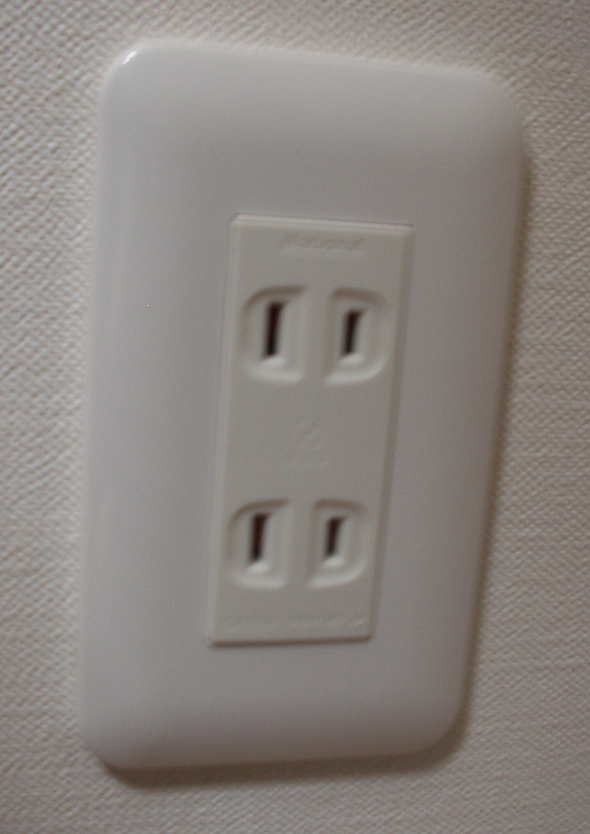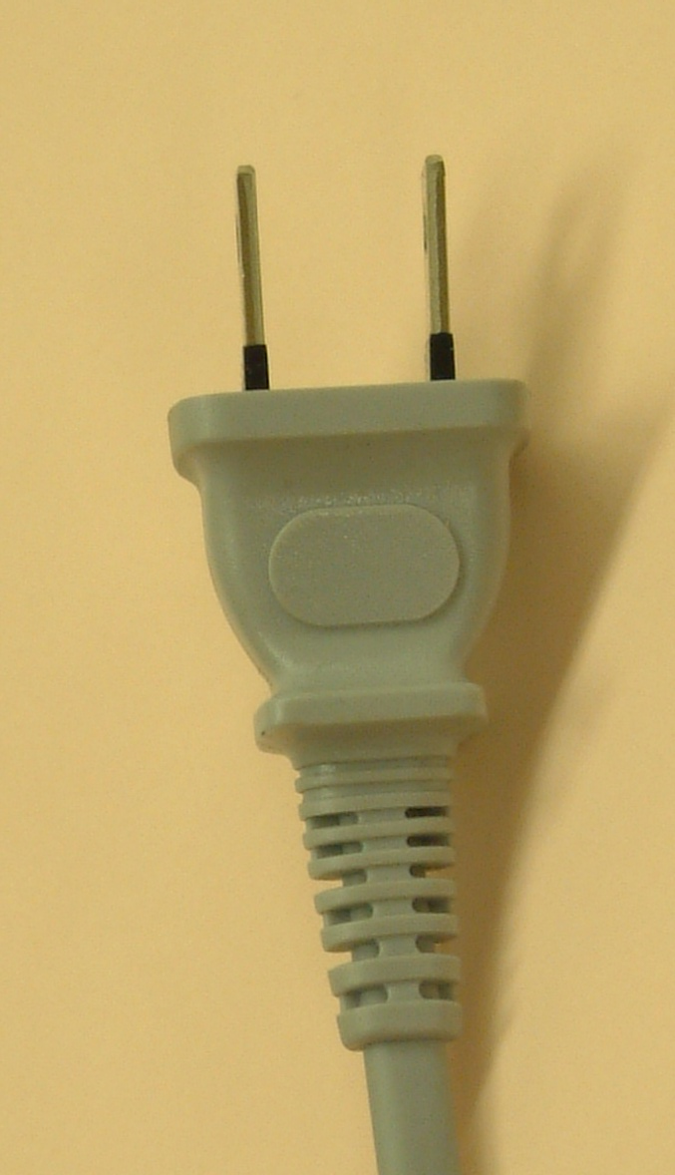
If your appliances operate on a different voltage, please bring your own transformers.
4.2 Passports and visas
All foreign visitors entering Japan must have a valid passport. Participants from countries whose citizens require visa should, well in advance, apply for a visa to a Japanese consulate or diplomatic mission in their respective country prior to departure. Participants are also advised to contact their local travel agents or carriers.
Those participants who need a VISA Supporting Letter for entering Japan are strongly advised to get in touch with the Contact Person by 15 September 2006, at the latest.
4.3 Currency exchange
Only Japanese Yen is accepted at stores and restaurants. At foreign exchange banks and other authorized money exchangers, you can exchange major foreign currencies to Yen on presentation of your passport. There are a few branches of local banks in Shinjuku where you can exchange.
4.4 Exchange rate
Online spot exchange rates are shown at: http://finance.yahoo.com/currency?u
Exchange rate as of 30 June 2006:
US Dollar: 1＄ | 114.75（JPY）
Euro: 1 Euro | 145.88（JPY）

4.5 Tipping

Tipping is not necessary.
4.6 Climate
The climate of Tokyo in October is comparatively dry with clear blue skies. Average temperature during the season is:

September | October | November
23.5 C (74.3 F) | 18.2 C (64.76 F) | 13.0 C (55.4 F)

4.7 Local time
GMT + 7 hours
4.8 Computer networking
Each meeting room will be equipped with wireless access to the Internet. Those who wish to use wireless access must be equipped with the necessary hardware and correctly configured PC.
4.9 Tourist information
Useful Web site related to general information of Tokyo:
http://www.tcvb.or.jp/en/index_en.htm

5. CONTACT POINT
If you have any questions about the meeting arrangements, please contact:
Ms Hideyo Banishky
Technical Department, The ITU Association of Japan, Inc.
3rd floor Kanda KS Building,
1-8-6 Kaji-cho, Chiyoda-ku, Tokyo, 101-0032, Japan
Tel: +81 3 5207 5722
Fax: +81 3 5207 5731
E-mail: itu-t@ituaj.jp
ANNEX 4
(to TSB Collective-letter 4/9)
ITU-TSB | Study Group 9 meeting  (Tokyo, Japan, 2-6 October 2006)
REGISTRATION FORM
To be returned to TSB by fax (+41 22 730 5853) or e-mail (tsbreg@itu.int) by 1 September 2006

Mr Mrs Ms Miss |  |  |  |  | _______________________________________________  Country
____________________________________________  Family name |  |  |  |  | ______________________________________________  Name of Administration of Member State*
____________________________________________  First name |  |  |  |  | ______________________________________________  Name of Sector Member / Associate / other
Full address of administration or organization:
______________________________________________ |  |  |  | Tel: _____________________________________________
______________________________________________ |  |  |  | Fax: _____________________________________________
______________________________________________ |  |  |  | E-mail: __________________________________________
*For delegates of Member States: Function at the meeting |  |  |  |  | Hotel or other address in Tokyo
 |  |  |  |  | Hotel: __________________________________________
(C) Head of delegation |  |  |  |  | Address: ________________________________________
(CA) Deputy head of delegation |  |  |  |  | ___________________________________________
(D) Delegate |  |  |  |  | Tel: ____________________________________________
Important note:
Paper copies of meeting documents will be provided only upon request.
I need paper copies of Contributions:
I need paper copies of Temporary Documents:

Date: ___________________________ | Signature: ______________________________________

For TSB secretariat use only
Pigeonhole

