2006年7月11日，日内瓦
国 际 电 信 联 盟
电信标准化局

文号： | 电信标准化局第4/9号集体函
电话：  传真：  电子  邮件： | +41 22 730 6071  +41 22 730 5853  tsbsg9@itu.int | 致国际电联成员国各主管部门、ITU-T部门成员和参加第9研究组工作的  ITU-T 部门准成员

事由： | 第9研究组会议  2006年10月2-6日，日本东京

尊敬的先生/女士：
1 根据电信标准化局2006年2月6日的第3/9号集体函，我谨通知您，应日本内务和通信省的邀请，第9研究组（综合宽带有线网和电视及声音传输）将自2006年10月2-6日在日本东京召开会议。
会议地点为日本东京Keio Plaza酒店。
第一天的会议将于09:30开始。与会代表的注册工作从08:30开始。有关会议厅安排的具体信息将在会场的电视屏幕上显示。
2 该会议的讨论将根据现行有关规定进行。
3 由第9研究组主席与TSB协商后起草的议程草案见本函附件1。
4 由第9研究组主席与TSB协商后起草的时间表草案见本函附件2。
5 由东道国组织提供的实用信息见本函附件3。在此特提请贵方注意有关酒店网页的链接。请尽快并最好于2006年9月10日前预订酒店房间。
6 根据第A.1 号建议（2006年）的条款，有关该研究组工作的文稿应提交电信标准化局（TSB）。

电信标准化局在会议召开日的至少十个日历日以前收到的文稿将发布在第9研究组的网站上。这些文稿将仅根据事先通过报名表提出的要求，在会议开始时发给在场的与会代表。因此，此类文稿必须在2006年9月21日之前寄达电信标准化局。按照现行规定，可以应要求翻译在会议开始至少两个月前收到的文稿。
欢迎与会代表以第9研究组主页提供的网上提交表或电子邮件的方式向以下地址提交文稿：tsbsg9@itu.int。详尽指南见ITU-T网站。
我们大力提倡您使用已制作出的一套新模版，它们既能够使ITU-T文件的格式保持一致，又可以方便文件制作、提高效率。这些模版可以在ITU-T每个研究组网页中的“指南、工具和模版”（http://www.itu.int/ITU-T/studygroups/templates/index.html）处找到。
为了解决与文稿有关的问题，请在文稿上注明联系人的姓名、传真和电话号码以及电子邮件地址。同样，务请在所有文件的首页注明这些细节。
7 为了便于电信标准化局进行文件制作和会议组织方面的必要安排，我希望您能通过信函、传真（号码：+41 22 730 5853）或电子邮件（tsbreg@itu.int）的方式尽早、但不迟于2006年9月1日将代表贵主管部门、部门成员、部门准成员、区域性和/或国际组织或其它实体出席会议的人员名单发至我处。同时，希望各主管部门注明其代表团团长（如果有副团长，亦盼一并注明）的姓名。填妥的附件4中的报名表（每位与会代表一份）应附于上述名单后。
8 我们在此谨提醒您，一些国家的公民需要获得签证才能入境日本并在此逗留。签证必须向驻贵国的日本代表机构（使馆或领事馆）申请和领取。如果贵国没有此类机构，则请向驻离贵国最近的国家的此类机构申请并领取。需要持邀请函和/或签证证明函入境日本的代表请在2006年9月15日之前与日方联系人联系，具体方式如下：
Ms Hideyo Banishky
Technical Department, The ITU Association of Japan, Inc.
3rd floor Kanda KS Building,
1-8-6 Kaji-cho, Chiyoda-ku, Tokyo, 101-0032, Japan
Tel: +81 3 5207 5722
Fax: +81 3 5207 5731
E-mail: itu-t@ituaj.jp
顺致敬意！

赵厚麟
电信标准化局主任

附件：4件
ANNEX 1
(to TSB Collective-letter 4/9)

Draft Agenda for the Plenary sessions of Study Group 9
(Tokyo, Japan, 2-6 October 2006)

1. Welcome and approval of agenda
2. Objectives and Work Plan for this meeting
- Working Groups
3. Allocation of documents and incoming Liaison statements
4. Feedback on interim activities since last meeting
Rapporteurs' Group meetings and Reports
- Qs. 9 & 14/9 (24-28 April 2006)
- Qs. 5,8,9,10,11 & 12/9 (21-25 August 2006)
5. Other Groups/Workshops
- Report on JCA-HN meeting (3 July 2006)
- Report on First meeting of the FG IPTV (July 2006)
- Report on TSAG and IPR Ad Hoc group meetings (June, July 2006)
- Others
6. Intellectual Property Rights inquiry
7. “Consent” on draft Recommendations proposed for approval in accordance with
Recommendation A.8
8. Proposed revision and deletion of SG 9 Questions
9. Approval of Working Group reports and Outgoing Liaison statements
10. Future Work Programme
11. Approval of outgoing Liaisons
12. Date and place of the next meeting
13. Future Interim activities
14. Other
15. Closing
-)-(-
ANNEX 2
(to TSB Collective-letter 4/9)
Draft work programme for the meeting of Study Group 9
(Tokyo, Japan, 2-6 October 2006)
 | 2 Oct.  Monday |  |  |  | 3 Oct.  Tuesday |  |  |  | 4 Oct.  Wednesday |  |  |  | 5 Oct.  Thursday |  |  |  | 6 Oct.  Friday
 | A.M |  | P.M. |  | A.M. |  | P.M. |  | A.M. |  | P.M. |  | A.M. |  | P.M. |  | A.M. | P.M.  ¹Short PL
Plenary | X |  |  |  |  |  | X¹ |  |  |  |  |  | X¹ |  |  |  | X | X
WG 1 |  | X | X | X | X | X | X | X | X | X |  |  | X
WG 2 |  |  | X | X |  |  |  |  | X | X |  |  | X
WG 3 |  |  |  |  |  | X | X | X | X | X |  |  | X | X
WG 4 |  |  |  |  | X | X |  |  |  |  |  |  | X
WG 5 |  | X | X | X | X | X | X | X |  | X |  |  | X | X
WG 6 |  |  |  |  |  |  |  |  | X | X |  |  |  |  | X | X
WG 7 |  |  | X | X | X | X | X | X | X | X |  |  |  | X
WG 8³ |  |  |  |  |  |  | X | X | X |  |  |  | X
WG 9 |  |  |  |  | X | X | X | X |  |  |  |  |  | X
Technical visit² |  |  |  |  |  |  |  |  |  |  | X | X
Tentative Working Group structure:
WG 1 IPCablecom Qs 6/9, 9/9
WG 2 Cable Modems Q. 8/9
WG 3 Network Transport Qs 1/9, 7/9, 12/9
WG 4 Conditional Access, Webcasting Qs 3/9, 11/9
WG 5 Quality Assessment Qs 2/9, 14/9
WG 6 Work Programme, Questions, Liaisons Qs All/9
WG 7 APIs Q. 4/9
WG 8 LSDI Q. 15/9
WG 9 Home Networks, Set-top Box Qs 5, 10/9
² The technical visit will be organized in the afternoon of Wednesday 4 October 2006 in cooperation with NHK. Detailed information will be available at the venue.
³ Subject to contributions received.
ANNEX 3
(to TSB Collective-letter 4/9)

Practical Information

(2-6 October 2006, Tokyo)
- VENUE
The Keio Plaza Hotel Tokyo Tel: +81 3 3344 0111
2-2-1 Nishi-Shinjuku, Shinjuku-ku Fax: +81 3 3345 8269
Tokyo, 160-8330, Japan
For further detailed information about the Keio Plaza Hotel Tokyo, please visit the following Web site: http://www.keioplaza.com/index.html
- ACCESS TO The Keio Plaza Hotel Tokyo
There are several alternatives to get to the Keio Plaza Hotel Tokyo from the Narita International Airport.
  - Narita Airport limousine
Airport ticket counters are located in the arrival lobbies of terminal 1 and 2 at the Narita International Airport. The Airport limousine bound for Shinjuku area leaves every 30 to 40 minutes and takes about 100 minutes from the Narita International Airport. For more detailed information, please visit the following Web sites:
Airport ticket counter: http://www.narita-airport.jp/en/guide/service/list/svc_32.html
Airport limousine: http://www.limousinebus.co.jp/e/timetable/index_n/shinjuku_h.html
2.2 JR Narita Express train
The JR Narita Express train bound for Shinjuku takes approximately 80 minutes. It takes 5 minutes by foot from West Exit, Shinjuku Station to Keio Plaza Hotel. For more detailed information, please see the following Web sites:
JR Narita Express train: http://www.narita-airport.jp/en/access/train/index.html
Keio Plaza Hotel Map: http://www.keioplaza.com/map/index.html

3. HOTELS
3.1 Hotel list
A Total of about 100 rooms in 3 hotels in the Shinjuku area, including the Keio Plaza Hotel, Tokyo, have been blocked for the participants of the ITU-T SG9 meeting in Tokyo at preferential rates.
All reservation requests must be made no later than 10 September 2006. Availability and room rates are not guaranteed after this date.
3.2 Reservations
The preferential rates apply only to the reservations made through the following URL:
http://www.kingtour.com/itu_sg9_tokyo/

4. GENERAL INFORMATION ON JAPAN AND TOKYO
4.1 Electrical Appliances
Japan operates on 100 volts for electrical appliances. The frequency is 50 Hz in eastern Japan including Tokyo. The type of power outlet/connector used in Japan is A type which is two parallel pronged type.
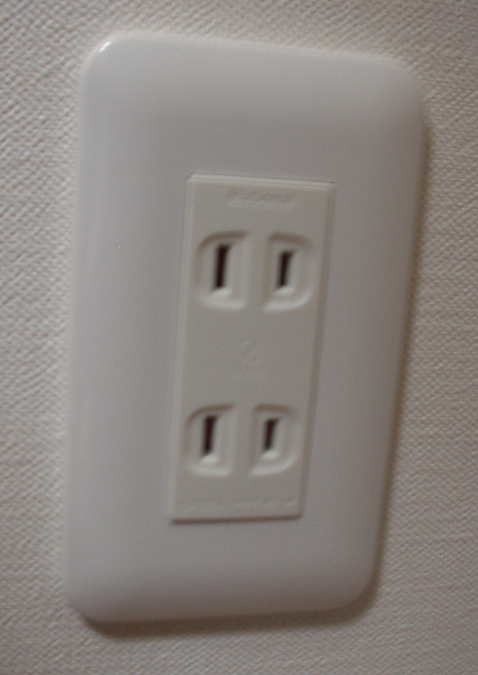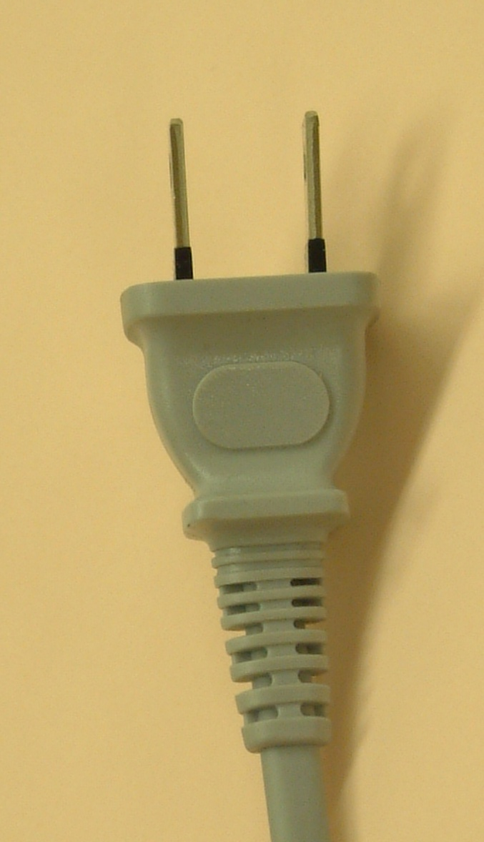
If your appliances operate on a different voltage, please bring your own transformers.
4.2 Passports and visas
All foreign visitors entering Japan must have a valid passport. Participants from countries whose citizens require visa should, well in advance, apply for a visa to a Japanese consulate or diplomatic mission in their respective country prior to departure. Participants are also advised to contact their local travel agents or carriers.
Those participants who need a VISA Supporting Letter for entering Japan are strongly advised to get in touch with the Contact Person by 15 September 2006, at the latest.
4.3 Currency exchange
Only Japanese Yen is accepted at stores and restaurants. At foreign exchange banks and other authorized money exchangers, you can exchange major foreign currencies to Yen on presentation of your passport. There are a few branches of local banks in Shinjuku where you can exchange.
4.4 Exchange rate
Online spot exchange rates are shown at: http://finance.yahoo.com/currency?u
Exchange rate as of 30 June 2006:
US Dollar: 1＄ | 114.75（JPY）
Euro: 1 Euro | 145.88（JPY）

4.5 Tipping

Tipping is not necessary.
4.6 Climate
The climate of Tokyo in October is comparatively dry with clear blue skies. Average temperature during the season is:

September | October | November
23.5 C (74.3 F) | 18.2 C (64.76 F) | 13.0 C (55.4 F)

4.7 Local time
GMT + 7 hours
4.8 Computer networking
Each meeting room will be equipped with wireless access to the Internet. Those who wish to use wireless access must be equipped with the necessary hardware and correctly configured PC.
4.9 Tourist information
Useful Web site related to general information of Tokyo:
http://www.tcvb.or.jp/en/index_en.htm

5. CONTACT POINT
If you have any questions about the meeting arrangements, please contact:
Ms Hideyo Banishky
Technical Department, The ITU Association of Japan, Inc.
3rd floor Kanda KS Building,
1-8-6 Kaji-cho, Chiyoda-ku, Tokyo, 101-0032, Japan
Tel: +81 3 5207 5722
Fax: +81 3 5207 5731
E-mail: itu-t@ituaj.jp
ANNEX 4
(to TSB Collective-letter 4/9)
ITU-TSB | Study Group 9 meeting  (Tokyo, Japan, 2-6 October 2006)
REGISTRATION FORM
To be returned to TSB by fax (+41 22 730 5853) or e-mail (tsbreg@itu.int) by 1 September 2006

Mr Mrs Ms Miss |  |  |  |  | _______________________________________________  Country
____________________________________________  Family name |  |  |  |  | ______________________________________________  Name of Administration of Member State*
____________________________________________  First name |  |  |  |  | ______________________________________________  Name of Sector Member / Associate / other
Full address of administration or organization:
______________________________________________ |  |  |  | Tel: _____________________________________________
______________________________________________ |  |  |  | Fax: _____________________________________________
______________________________________________ |  |  |  | E-mail: __________________________________________
*For delegates of Member States: Function at the meeting |  |  |  |  | Hotel or other address in Tokyo
 |  |  |  |  | Hotel: __________________________________________
(C) Head of delegation |  |  |  |  | Address: ________________________________________
(CA) Deputy head of delegation |  |  |  |  | ___________________________________________
(D) Delegate |  |  |  |  | Tel: ____________________________________________
Important note:
Paper copies of meeting documents will be provided only upon request.
I need paper copies of Contributions:
I need paper copies of Temporary Documents:

Date: ___________________________ | Signature: ______________________________________

For TSB secretariat use only
Pigeonhole

