2008年2月7日，日内瓦
国 际 电 信 联 盟
电信标准化局

文号： | 电信标准化局第6/6号集体函
电话：  传真：  电子  邮件： | +41 22 730 5515  +41 22 730 5853  tsbsg6@itu.int | 致国际电联成员国各主管部门、ITU-T部门成员和参加第6研究组工作的ITU-T部门准成员

事由： | 第6研究组会议  2008年4月14-18日，中国武汉

尊敬的先生/女士：
1 根据2008年国际电联电信标准化部门会议日程表（见http://itu.int/events/upcomingevents.asp?sector=ITU-T），我谨通知您，在中国信息产业部的热热忱邀请下，第6研究组（户外设施及相关室内装置）将自2008年4月14日至18日在中国武汉召开会议。
会议地点为中国武汉东湖宾馆。
第一天的会议将于09:00开始。与会代表的注册工作从08:00开始。有关会议厅安排的具体信息将在会议地点显示。
2 该会议的讨论将根据现行有关规定采取的决定进行。
3 由第6研究组主席起草的议程草案见本函附件1。
4 由第6研究组管理小组起草的时间表草案见本函附件2。
5 有关主办方的实用信息见本函附件3。
6 为方便您与会，附件4包含了一份宾馆确认单。
7 我们谨此告知与会者，会议将在无纸化的环境中进行。每一个会议厅均将配备互联网无线接入（无线局域网，支持IEEE802.11b，2.4GHz频段）。希望使用无线接入的代表必须拥有必要的硬件和正确配置的个人电脑。希望使用纸页文件的代表可以在代表区打印文件或者自己携带。会议上不分发文件。文稿可以直接从ITU-T的网站上下载http://www.itu.int/md/T05-SG06-080414/sum/en）。
8 根据第A.1号建议（2006年）的条款，有关该研究组工作的文稿应提交电信标准化局（TSB）。电信标准化局在会议召开日的至少十个日历日以前收到的文稿将发布在第6研究组的网站上。因此，此类文稿必须在2008年4月3日之前寄达电信标准化局。按照现行规定，可以应要求翻译在会议开始至少两个月前收到的文稿。
欢迎与会代表以第6研究组主页提供的网上提交表或电子邮件的方式向以下地址提交文稿：tsbsg6@itu.int。详尽指南见ITU-T网站。
我们大力提倡您使用已制作出的一套新模版，它们既能够使ITU-T文件的格式保持一致，又可以方便文件制作、提高效率。这些模版可以在ITU-T每个研究组网页中的“指南、工具和模版”（http://www.itu.int/ITU-T/studygroups/templates/index.html）处找到。
为了解决与文稿有关的问题，请在文稿上注明联系人的姓名、传真和电话号码以及电子邮件地址。同样，务请在所有文件的首页注明这些细节。
9 为了便于电信标准化局进行文件制作和会议组织方面的必要安排，我希望您能通过信函、传真（号码：+41 22 730 5853）或电子邮件（tsbreg@itu.int）的方式尽早、但不迟于2008年3月14日将代表贵主管部门、部门成员、部门准成员、区域性和/或国际组织或其它实体出席会议的人员名单发至我处。同时，希望各主管部门注明其代表团团长（如果有副团长，亦盼一并注明）的姓名。填妥的附件5中的报名表（每位与会代表一份）应附于上述名单后。
10 我们谨此提醒您，有些国家的公民前往中国需要事先获得签证。您可以从中国驻贵国代表处（大使馆或领事馆）申请并领取签证。如果贵国没有此类机构，则请向驻离出发国最近的此类机构申请并领取。需要邀请函或辅助签证文件前往中华人民共和国的代表，请与中方联络人Nancy Li女士联系，同时抄送至Li Jing女士。其详细联络信息参见附件3第3部分。
请注意，批准签证可能需要一些时间，请尽快请求邀请函。
11 主办方将于2008年4月19日（星期六）组织游览三峡大坝。报名表见附件4。
顺致敬意！
电信标准化局主任
马尔科姆•琼森
附件：5件
ANNEX 1
(to TSB Collective letter 6/6)
Draft agenda for the meeting of Study Group 6
(Wuhan, 14-18 April 2008)
Opening of meeting
Approval of agenda
Feedback and status reports on interim activities (since November 2007)
SG chairmen’s meetings (matters of interest to SG 6)
TSAG meetings (matters of interest to SG 6)
Status on EDH facilities
Questionnaires issued
Objectives for this meeting
Work Plan for this meeting
Conduct of and facilities available for the meeting
Documents and their allocation
Guidelines for the meeting of Working Parties
Intellectual Property Rights Inquiry (Plenary)
Reports of Working Parties
Approval of any draft Recommendations referred back to SG during AAP
Consent of any draft Recommendations for AAP
Agreement on other texts
Liaison and interaction with other groups
Review of work programme
Other matters for resolution at Study Group level
Future activities
Miscellaneous
Closing

ANNEX 2
(to TSB Collective letter 6/6)
Draft timetable for the meeting of Study Group 6
(Wuhan, 14-18 April 2008)

1Q 09:30 - 10:45  2Q 11:15 - 12:30  3Q 14:30 - 15:45  IV 4Q 16:15 - 17:30 | Monday  14  April |  |  |  | Tuesday  15  April |  |  |  | Wednesday16  April |  |  |  | Thursday  17  April |  |  |  | Friday  18  April
 | 1Q | 2Q | 3Q | 4Q | 1Q | 2Q | 3Q | 4Q | 1Q | 2Q | 3Q | 4Q | 1Q | 2Q | 3Q | 4Q | 1Q | 2Q | 3Q | 4Q
SG 6 Plenary
Working Party Plenaries
Working Parties
Workshop ^{(Note)}

Note: Tentative workshop structure
Subject: Fibre and cable infrastructure technologies for NGN and FTTH deployment
- Session 1: Planning and Design of the Access network
- Session 2: Standardization of new fibres/cables and PON network measurements and maintenance
- Session 3: Improved installation techniques
- Session 4: Round table
- YOFC company visit

ANNEX 3
(to TSB Collective letter 6/6)

Additional information on the meeting of Study Group 6
(Wuhan, China, 14-18 April 2008)

1 Venue of the meeting
Beijing
Wuhan
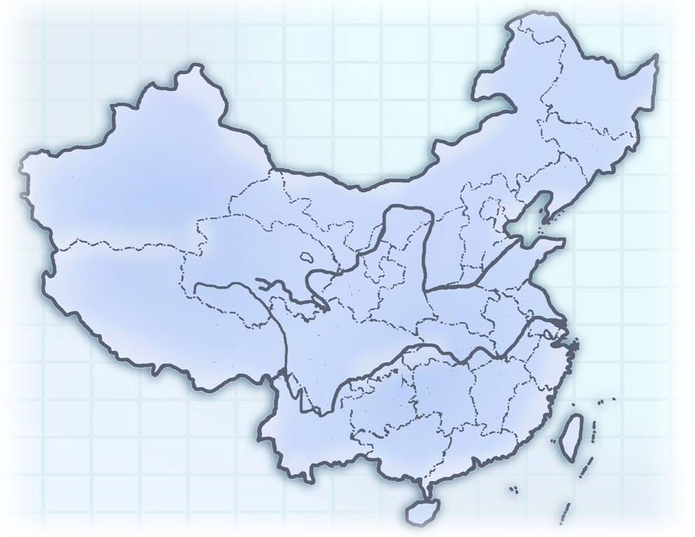
The meeting will be held in
East Lake (Donghu) Hotel, Wuhan.
Hotel Address: 142 East Lake Road, Wuchang District, Wuhan, China
Tel: + 86-27-68881888
Fax: + 86-27-68881659

You can get more information of the hotel from the website: http://www.el-h.com
It will take about one hour from Wuhan Tianhe Airport to the hotel by taxi.

2 Accommodation
The meeting will be held in East Lake (Donghu) Hotel. So we suggest you to stay in the same hotel.

General information of the hotel:
Wuhan East Lake Hotel is a garden-style hotel with an area of 0.83 km². It’s located by the side of scenic East Lake, bordering the East Lake Park in the east and facing Luojia Hill and Mo Hill across the lake in the west. East Lake Hotel presents the most pleasurable views with tall trees and beautiful flowers everywhere in the courtyard, which is now known as Hubei State Hotel for its beautiful natural environment and impressive history. It has received Chinese government leaders such as Mao Zedong, Zhou Enlai, Deng Xiaoping, Hu Jintao, etc.

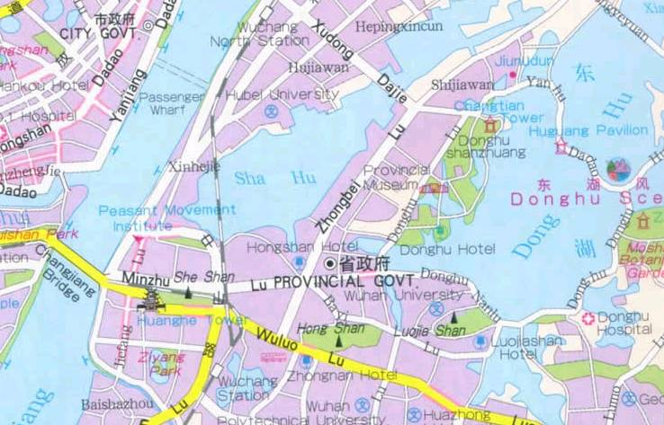
East Lake (Donghu) Hotel

The sketch map of East Lake Hotel is shown below.
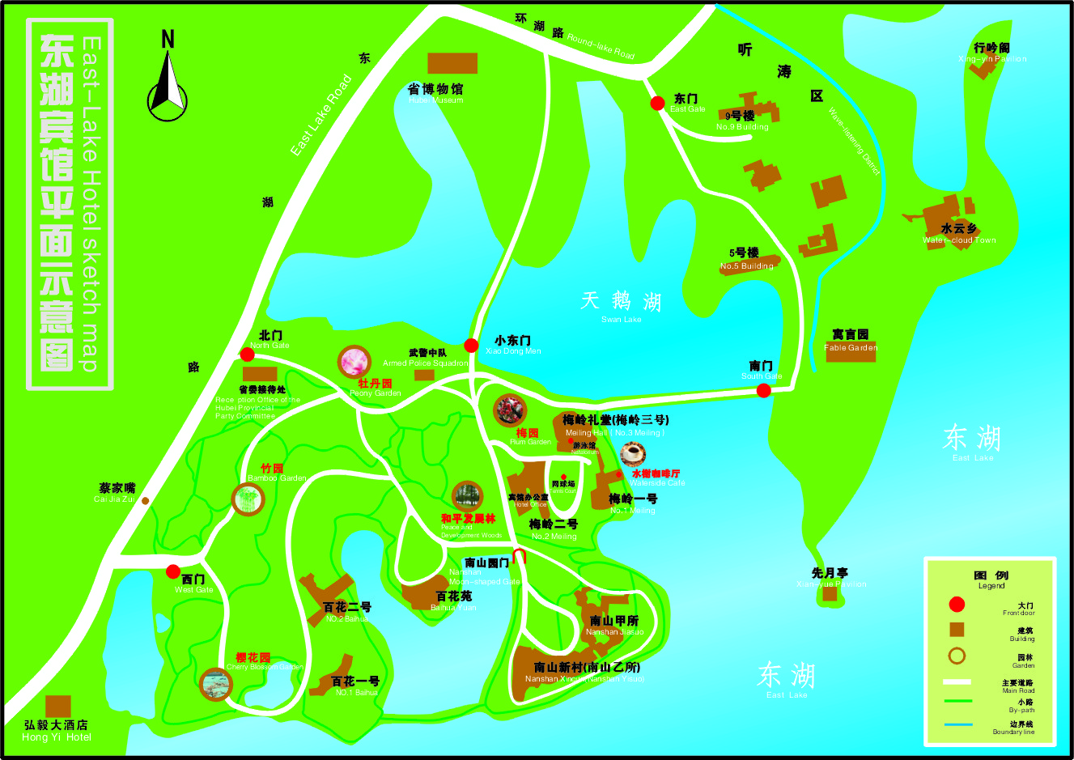

The rooms in Nanshan Yisuo are reserved for the meeting, and you can check in just on the first floor of Nanshan Yisuo.
The meeting will be held in Honghu Hall on the second floor of the same building.

Nanshan Yisuo
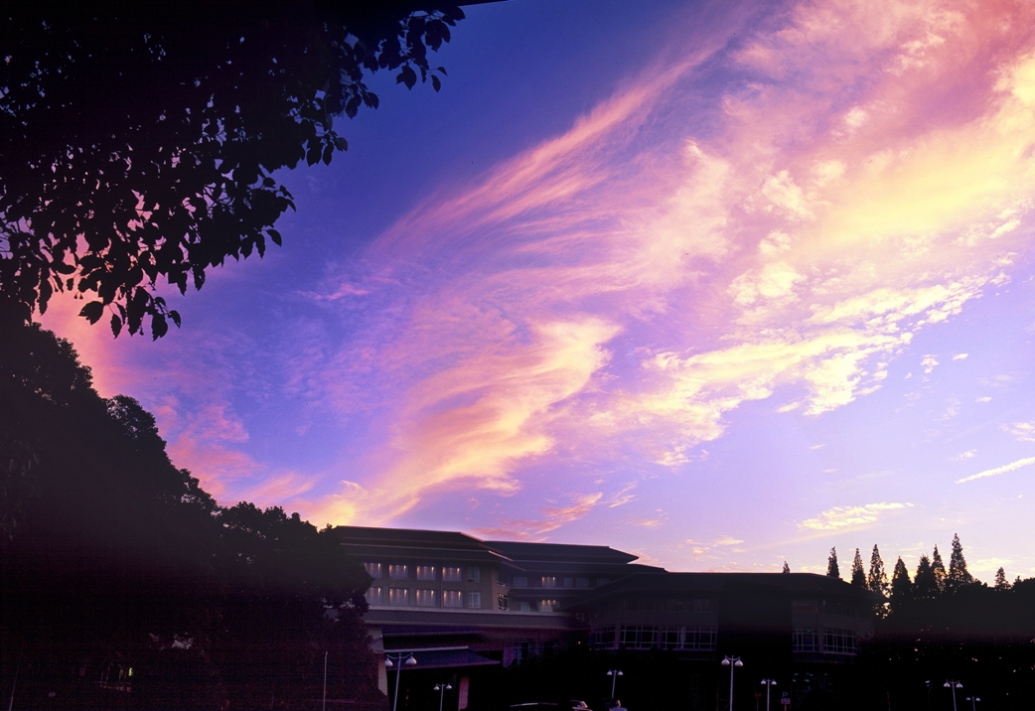

3 Hotel booking
For East Lake Hotel booking, please fill in the attached "Hotel booking form (Annex 4)" and send it to the contact persons before 30 March 2008 (Beijing time):

Ms. Nancy Li | Ms. Jing Li
Yangtze Optical Fibre and Cable Company Ltd. | Yangtze Optical Fibre and Cable Company Ltd.
4# Guanshan Er Road | 4# Guanshan Er Road
Wuhan, China | Wuhan, China
Tel: +86-27-67887324 | Tel: +86-27-67887636
Fax: +86-27-87801760 | Fax: +86-27-87412477
E-mail: lijun_mkt@yofc.com | E-mail: lijing@yofc.com

Room rates:
888 RMB per night for single room, 988 RMB per night for deluxe standard room and 100 RMB per night for extra bed.
No charge for children under 12 years old when sharing the same room with their parents. All major credit cards are accepted.

Transportation
Pick-up service will be arranged at Wuhan Tianhe Airport. Please inform the contact persons in China of your arrival date and flight number by email before March 30, 2008.

If you don’t need pick-up, you can take a taxi to get to the hotel from the airport:
- The hotel is 42 kilometres from Wuhan Tianhe Airport;
- It takes you about 1 hour by taxi to get to the hotel from the airport;
- The taxi fee is about 110 RMB, which is about 15 USD. (You can change your money at the airport.)
- There is a region outside the arrival hall specially for taking the taxi.

5 Visa requirements
All foreigners intend to enter into or exit from the Chinese territory should apply to the Chinese visa authorities for a Chinese visa before entry.
Where to apply for Chinese visa?
The overseas Chinese visa authorities are Chinese embassies, consulates, visa offices, and other agencies abroad authorized by the Ministry of Foreign Affairs of China. Applicant should apply to the nearest Chinese visa authorities.
When to apply for the visa?
The best time to apply for your visa is one month before your departure. The visa is normally good for entry within 90 days of issuance. Single-entry visa is usually valid for a 30-day visit, which means the visa is only good for 30 days after your entry date.
What to submit?
To apply for a Chinese visa you should prepare:
- Your passport should have a full blank visa page, and the period of validity should be more than 6 months from the date you submit your materials;
- Filling out the “VISA APPLICATION FORM OF THE PEOPLE’S REPUBLIC OF CHINA” ;
- A recent 2-inch, bareheaded and full-faced passport photo;
- And some other applying materials;
For further information, please consult the nearest Chinese visa authorities.
Validity of visa: normally speaking, a visa is valid for 3 months from the date of issuance and on any day within this period, the visa holder may enter China.
Duration of stay specified in the visa: normally speaking, a visa holder may stay in China for 1 month which counts from the date of his/her entrance into China. To stay longer, you need to specify your request in your application form and it will be subject to the permission of the consul in charge.
For further information, please consult the nearest Chinese visa authorities.
There is a brief introduction to Chinese visa and the procedure for visa application at the website of Chinese government: http://english.gov.cn/2005-08/27/content_26714.htm

Participants who need an invitation letter and/or a visa supporting letter for entering China, please fill in the form below, and send it to the contact persons in China (see section 3 above).
In consideration of the time for applying for a Chinese visa, please send the information for invitation before 29 February, 2008. After the contact persons get the information, they will fax you the VISA APPLICATION FORM with the seal of the Foreign Affairs Division of the Ministry of Information Industry of China. The original VISA APPLICATION FORM is only provided upon request.

Name
Gender
Nationality
Passport No.
Title
Date of birth
Fax No.
If you need more help, please do not hesitate to get in touch with the contact persons in China.

6. General information of China

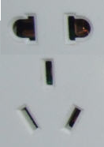
6.1 Electrical appliances
The standard AC power supply in China is 220V, 50 Hz. The typical power outlet/connector used in China is shown in the picture on the right. The normal 3-pin US power input or 2-pin European power input doesn't fit to them well. If your appliances operate on a different voltage, please take your transformers along with you.

6.2 Currency, credit cards and traveller cheques
The currency in China is RMB; most places don’t accept other kind of currency. However, most hotels and banks in China can change foreign currency for RMB. Credit cards can be used in hotels, restaurants and shopping malls. Traveller cheque is not very convenient to use in China. The table below lists the approximate exchange rate for RMB：

1USD | 7.245 RMB
1 EUR | 10.545RMB

6.3 Climate in Wuhan
Wuhan has a sub-tropical wet monsoon climate with four distinct seasons. The city enjoys abundant rainfall, with an average annual rainfall of about 1,200 millimetres (47 inches). The sunshine is sufficient, accounting for 1,810-2,100 hours a year. The average yearly temperature is 15.8-17.5 ℃ (60.4-63.5 ℉). As one of the three 'Furnace Cities' in China, it has an unbearably sultry and hot summer. Every summer, days with a temperature reaching over 40 ℃ (104 ℉) number around a dozen. In winter, coldness penetrates every corner of the city. It is quite pleasant in spring and autumn, and the best time to visit Wuhan is March, April, September and October.
In April, the average high temperature is 20-22℃(68-72℉) and the average low is 11-13℃ (52-56 ℉).

6.4 Time difference
Wuhan is in the GMT+8 time zone.
ANNEX 4
(to TSB Collective letter 6/6)

Meeting of Study Group 6
(Wuhan, China, 14-18 April 2008)
HOTEL AND TOUR RESERVATION FORM
Reservation:
Name of the hotel: |  | East Lake (Donghu)Hotel
Room Type |  | Single Room 888RMB  Deluxe Standard Room 988 RMB
Bed Number
Number of Breakfast
Smoking or non-smoking
Check-in date: |  |  | Check-out date:
Personal information:
Your name and first name:
Name of your Company:
Address of your Company:
Tel: |  |  |  | Fax:
E-mail address:
Optional tour:
Optional tour to the Three Gorges Dam will be arranged on April 19, 2008. Do you wish to take the tour?
Yes No

Note: Please send this form by 30 March directly to the contact persons in China:
Ms. Nancy Li  Yangtze Optical Fibre and Cable Company Ltd.  4# Guanshan Er Road  Wuhan, China  Tel: +86-27-67887324  Fax: +86-27-87801760  E-mail: lijun_mkt@yofc.com | Ms. Jing Li  Yangtze Optical Fibre and Cable Company Ltd.  4# Guanshan Er Road  Wuhan, China  Tel: +86-27-67887636  Fax: +86-27-87412477  E-mail: lijing@yofc.com

ANNEX 5
(to TSB Collective letter 6/6)

ITU-TSB | Study Group 6 meeting  Wuhan, China, 14-18 April 2008
REGISTRATION FORM
To be returned to TSB by fax (+41 22 730 5853) or e-mail (tsbreg@itu.int ) by 14 March 2008

Mr Mrs Ms Miss |  |  |  |  | _______________________________________________  Country
____________________________________________  Family name |  |  |  |  | ______________________________________________  Name of Administration of Member State*
____________________________________________  First name |  |  |  |  | ______________________________________________  Name of Sector Member / Associate / other
Full address of administration or organization:
______________________________________________ |  |  |  | Tel: _____________________________________________
______________________________________________ |  |  |  | Fax: _____________________________________________
______________________________________________ |  |  |  | E-mail: __________________________________________
*For delegates of Member States: Function at the meeting |  |  |  |  | Hotel or other address in Wuhan
 |  |  |  |  | Hotel: __________________________________________
(C) Head of delegation |  |  |  |  | Address: ________________________________________
(CA) Deputy head of delegation |  |  |  |  | ___________________________________________
(D) Delegate |  |  |  |  | Tel: ____________________________________________
Important Note:

This meeting will be paperless
Date: ___________________________ | Signature: ______________________________________

________________

