2007年2月2日，日内瓦
国 际 电 信 联 盟
电信标准化局

文号： | 电信标准化局第5/5号集体函
电话：  传真：  电子  邮件： | +41 22 730 5780  +41 22 730 5853  tsbsg5@itu.int | 致国际电联成员国各主管部门、ITU-T部门成员和参加第5研究组工作的ITU-T 部门准成员

事由： | 第5研究组会议  2007年5月14-18日，中国，北京

尊敬的先生/女士：
1 根据国际电联电信标准化部门2007年会议日程表（见2007年7月28日的电信标准化局第105号通函）和第5研究组上次会议（2006年9月18-22日，日内瓦）达成的协议（将2007年的会议地点设在日内瓦以外的地方），我谨通知您，应中国信息产业部的诚挚邀请，第5研究组（对电磁环境效应的防护）将自2007年5月14日至18日在中国北京召开会议。
会议地点为中国北京的友谊饭店。
第一天的会议将于09:30开始。
2 会议将用英文进行讨论。
3 由第5研究组主席起草的议程草案见本函附件1。
4 由第5研究组管理班子起草的时间表草案见本函附件2。
5 附件3为主办机构提供的实用信息。
6 根据第A.1 号建议（2006年）的条款，有关该研究组工作的文稿应提交电信标准化局（TSB）。TSB在会议召开日的至少十个日历日以前收到的文稿将发布在第5研究组的网站上。因此，此类文稿必须在2007年5月3日之前寄达TSB。按照现行规定，可以应要求翻译在会议开始至少两个月前收到的文稿。
欢迎与会代表以第5研究组主页提供的网上提交表或电子邮件的方式向以下地址提交文稿：tsbsg5@itu.int 。详尽指南见ITU-T网站。
我们大力提倡您使用已制作出的一套新模版，它们既能够使ITU-T文件的格式保持一致，又可以方便文件制作、提高效率。这些模版可以在ITU-T每个研究组网页中的“指南、工具和模版”（http://www.itu.int/ITU-T/studygroups/templates/index.html ）处找到。
为了解决与文稿有关的问题，请在文稿上注明联系人的姓名、传真和电话号码以及电子邮件地址。同样，务请在所有文件的首页注明这些细节。
7 为了便于TSB进行文件制作和会议组织方面的必要安排，我希望您能通过信函、传真（号码：+41 22 730 5853）或电子邮件（tsbreg@itu.int）的方式尽早、但不迟于2007年4月14日将代表贵主管部门、部门成员、部门准成员、区域性和/或国际组织或其它实体出席会议的人员名单发至我处。同时，希望各主管部门注明其代表团团长（如果有副团长，亦盼一并注明）的姓名。填妥的附件5中的报名表（每位与会代表一份）应附于上述名单后。
8 事先通过报名表要求得到纸页文件的实际到会的与会代表，将仅收到会议开始前3天（2007年5月11日）至会议结束时公布在ITU-T网站上的文件。
为在会议期间合理分发文件，特在此提醒工作组成员，他们将仅收到那些与其有关的文件。因此，请在报名表上详细注明您希望参加的工作组。
9 附件4为供您参考的一份宾馆确认单，请在2007年4月30日前将其直接发给有关联系人（见附件3）。
10 我们在此谨提醒您，一些国家的公民需要获得签证才能入境中华人民共和国并做逗留。签证必须向驻贵国的中国代表机构（使馆或领事馆）申请和领取。如贵国没有此类机构，则请向驻离出发国最近的此类机构申请并领取（见附件3第5节）。
如与会代表为入境中华人民共和国需要出具邀请函和/或签证证明函，则请与中方的Nancy Cao女士联系，并将函件抄送Julie Li女士。有关这两人的详细联系方式见附件3第3节。
顺致敬意！

马尔科姆•琼森
电信标准化局主任
附件：5件
ANNEX 1
(to TSB Collective letter 5/5)
Draft agenda for the meeting of Study Group 5
(Beijing, 14-18 May 2007)

- Opening of the meeting
- Adoption of the agenda
- Highlights of the last Chairmen and TSAG meetings
- Meeting of Working Parties
- Technical Session: "New Infrastructure Elements in the Access Network; e.g. Automated Main Distribution Frame and Crossconnect"
- Review of Question 14/5
- Report of Working Parties
- Consent/agreement on recommendations and other texts
- Outgoing liaison statements
- Regional Groups and Action Plan for developing countries and countries with economies in transition
- Future activities (intermediate meetings, workshops, technical sessions, etc.)
- AOB
- Closing

ANNEX 2
(to TSB Collective letter 5/5)

 | Morning |  | Afternoon
Monday  14 May | Plenary | Working Party 2/5  & ad-hoc meetings for  WP 1/5 Questions | Working Party 1/5  & ad-hoc meetings for  WP 2/5 Questions
Tuesday  15 May | Working Party 1/5  & ad-hoc meetings for  WP 2/5 Questions |  | Working Party 2/5  & ad-hoc meetings for  WP 1/5 Questions
Wednesday  16 May | Technical session  "New Infrastructure Elements in the Access Network; e.g. Automated Main Distribution Frame and Crossconnect" |  | Working Party 1/5  & ad-hoc meetings for  WP 2/5 Questions | Working Party 2/5  & ad-hoc meetings for  WP 1/5 Questions
Thursday  17 May | Working Party 1/5  & ad-hoc meetings for  WP 2/5 Questions |  | Working Party 2/5
Friday  18 May | Plenary |  | ___________

ANNEX 3
(to TSB Collective letter 5/5)

Additional information on the meeting of Study Group 5
(Beijing, China, 14-18 May 2007)

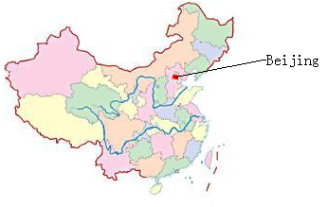
1 Venue of the meeting
The meeting will be held in
Beijing Friendship Hotel, Beijing.
Hotel Address: 3 Bai Shi Qiao Road, Haidian District, Beijing, China
Tel: + 86-10-68498888
Fax: + 86-10-68498866
You can get more information of the hotel from the website: http://www.bjfriendshiphotel.com
It will take about one hour from Beijing International airport to the hotel by taxi.

2 Accommodation
The meeting will be held in Beijing Friendship Hotel. So we suggest you stay in the same hotel.
General information of the hotel:
The Beijing Friendship Hotel is one of the largest garden-style hotels in Asia. Built in 1954, it covers an area of 335,000 square meters. It combined the style of classic elegance with traditional Chinese architecture.
As you can see from the picture overleaf, Beijing Friendship Hotel lies in the Hi-tech Development Zone of Beijing, bordering the Third-Ring Road.

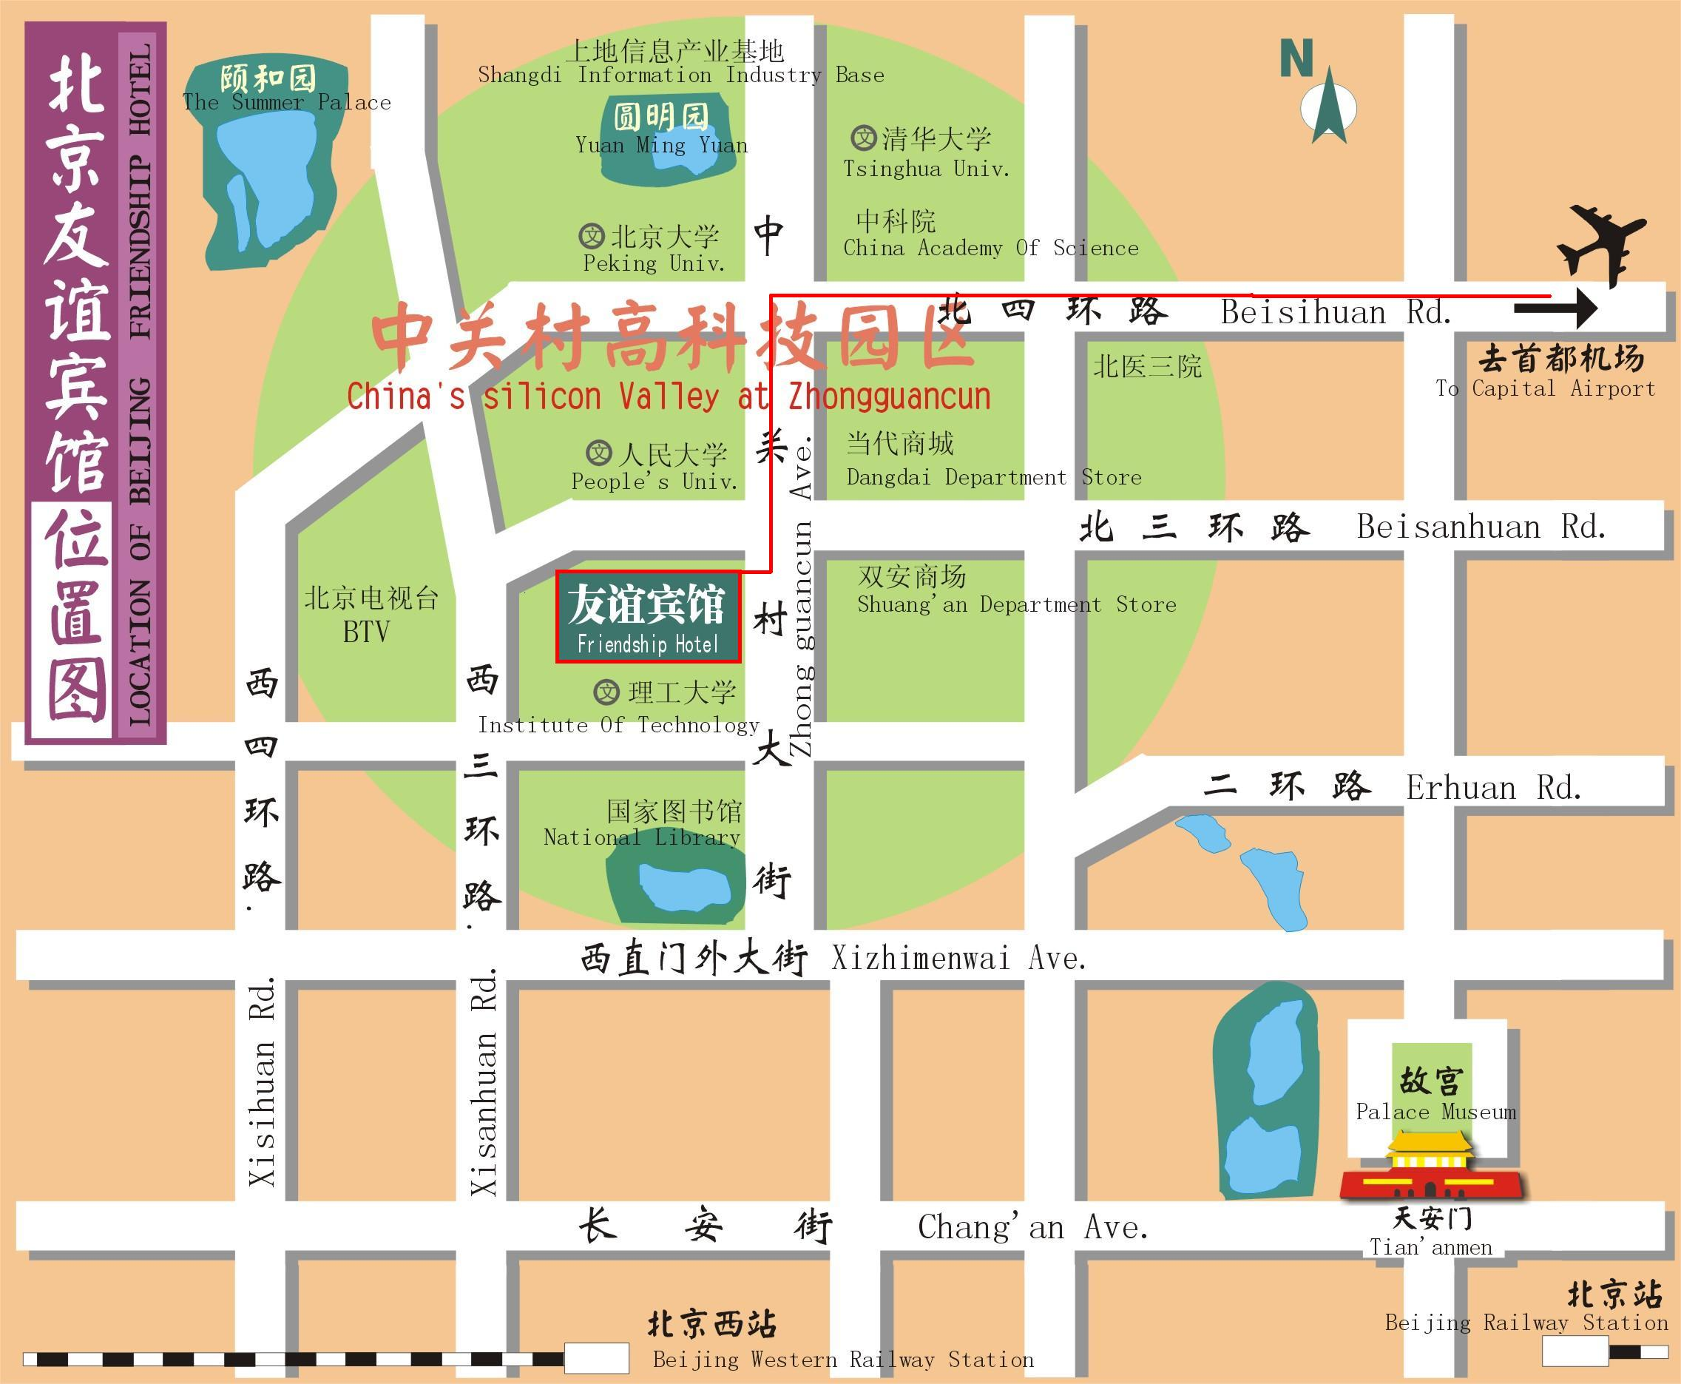

The Plan of Beijing Friendship Hotel is shown in the picture overleaf.
The rooms in Building 4 are reserved for the meeting, and you can check in just on the first floor of Building 4.
The meeting will be held on the first floor of Building 8.
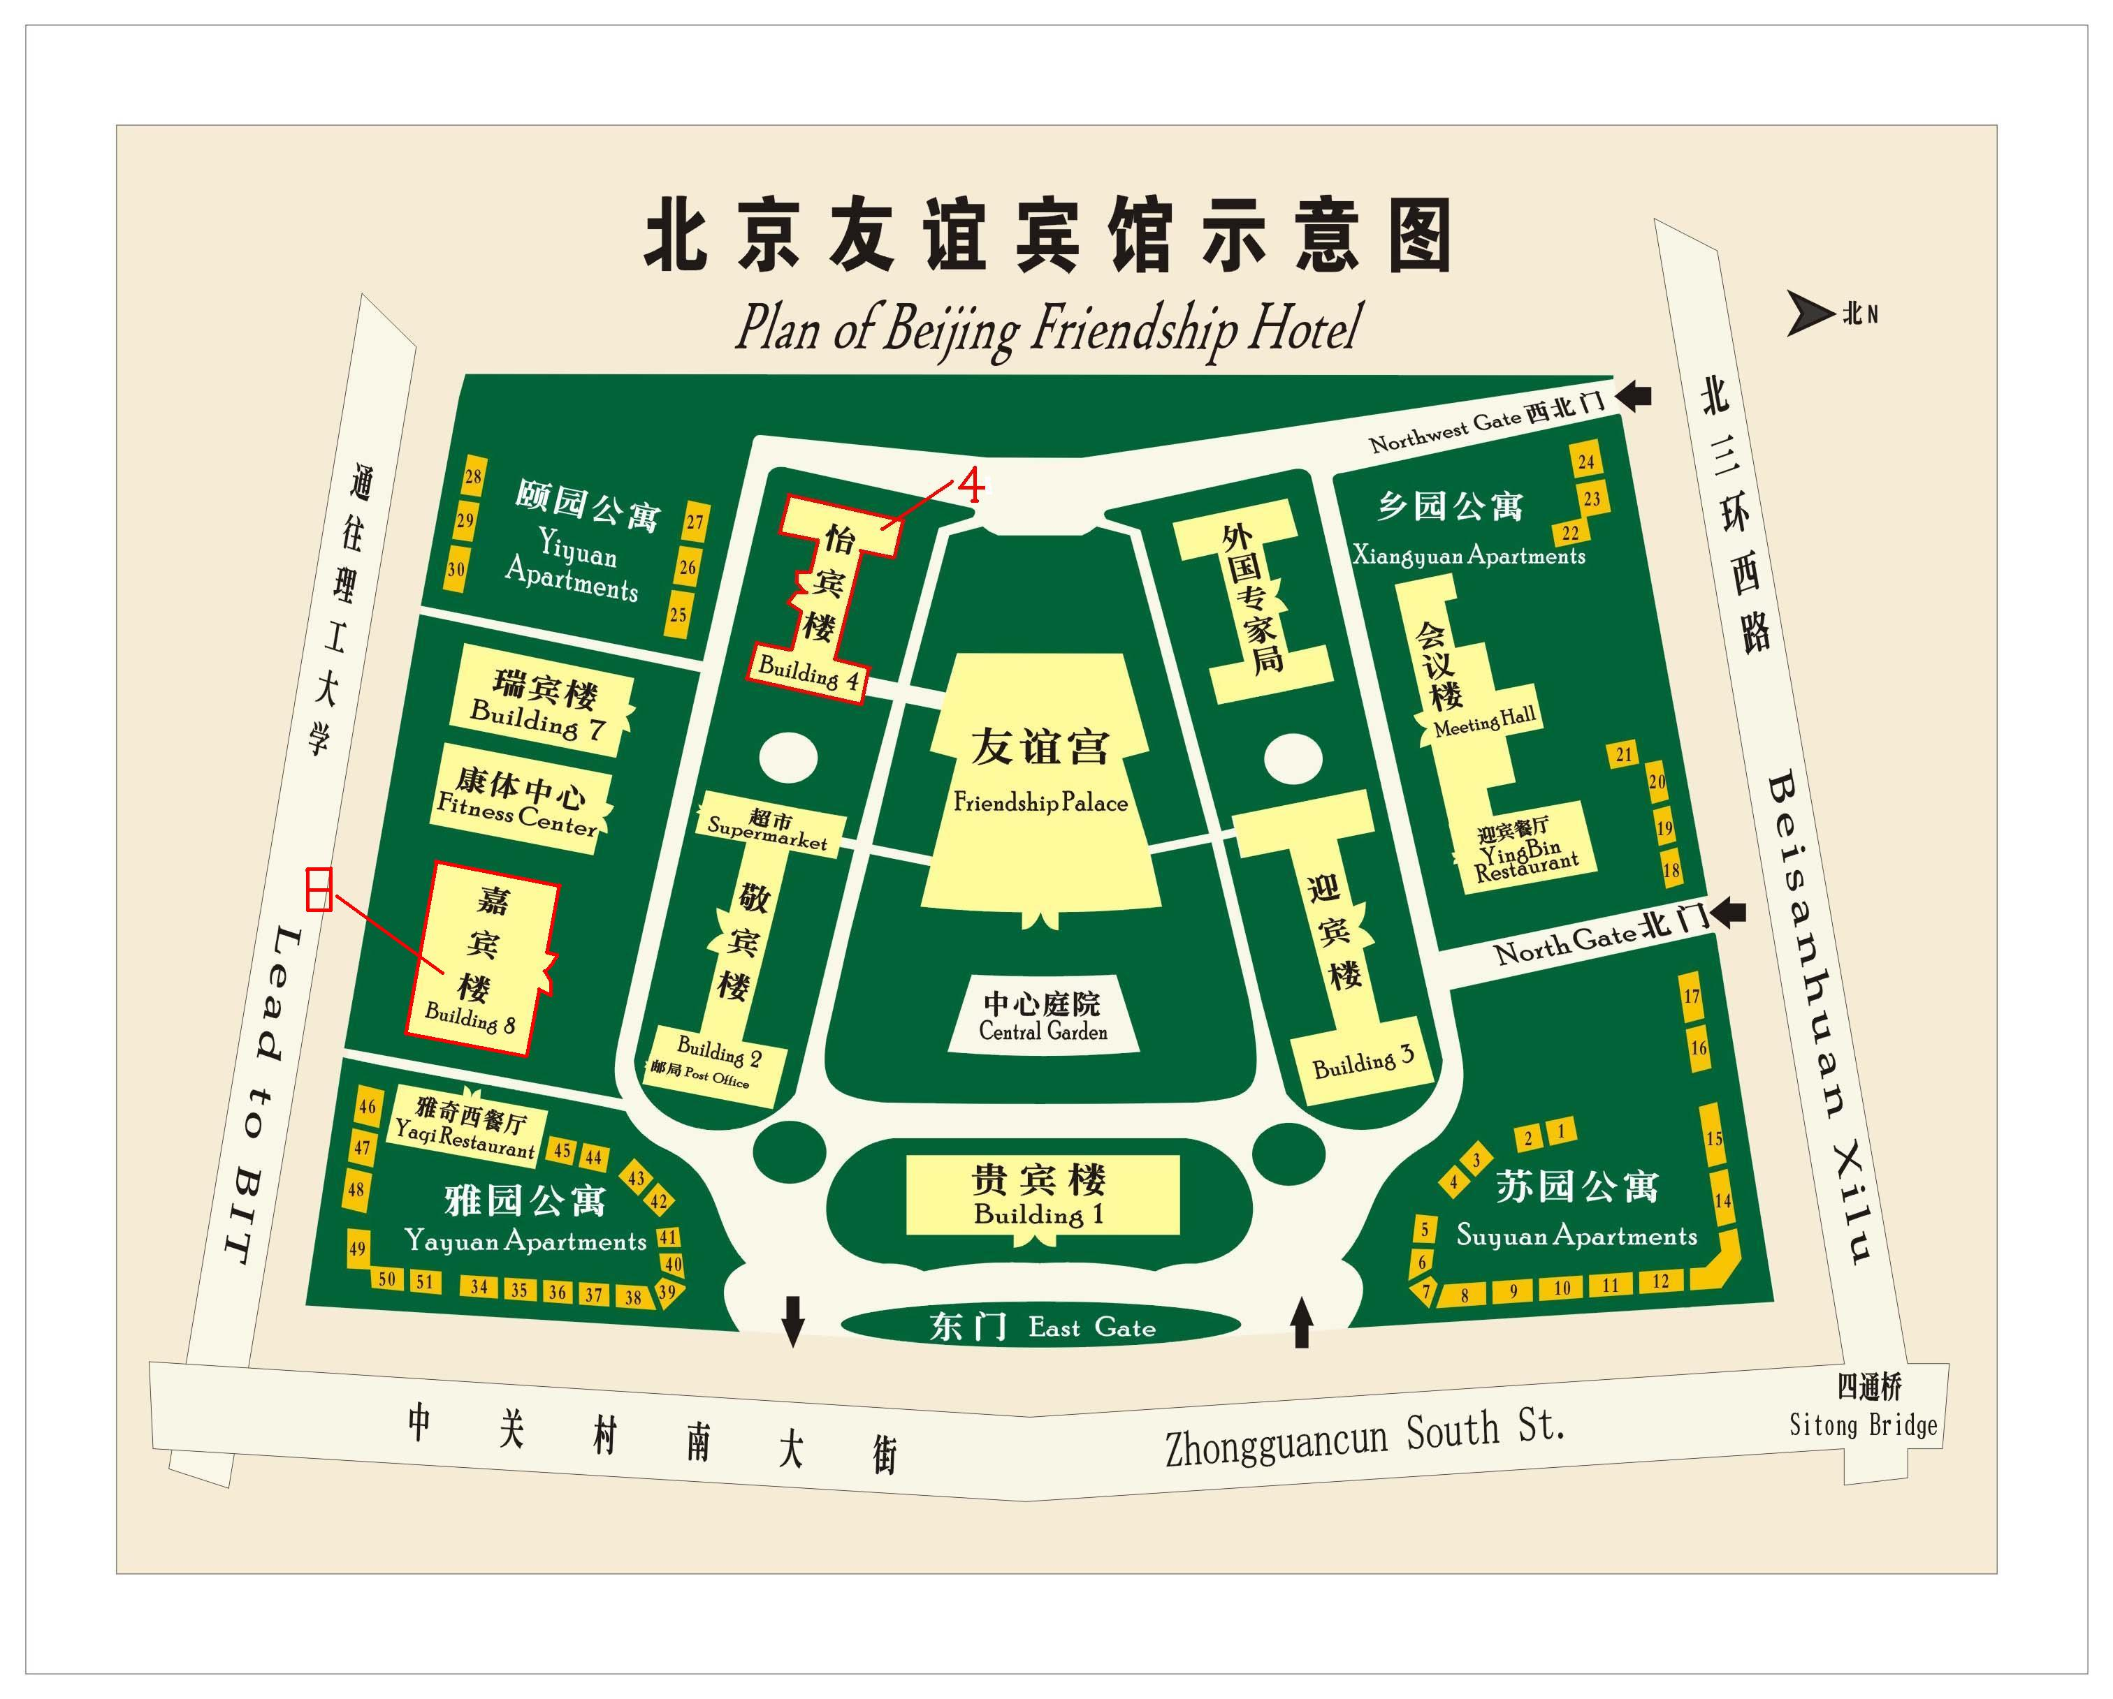

3 Hotel booking
For Beijing Friendship Hotel booking, please fill in the attached "Hotel booking form (Annex 4)" and send it to the contact person before 30 April 2007 (Beijing time):

Ms. Nancy Cao | Ms. Julie Li
Radio Telecommunication and EMC Lab | Radio Telecommunication and EMC Lab
No. 52, Huayuanbei Road, Haidian District, | No. 52, Huayuanbei Road, Haidian District,
Beijing, China | Beijing, China
Tel: +86-10-62304152 | Tel: +86-10-62303288 Ext. 2092
Mobil: +86-13911615786 | Mobil: +86-13910119823
Fax: +86-10-62304133 | Fax: +86-10-62304793
E-mail: caoshinan@catr.com | E-mail: lizhuofang@emcite.com

Room rates :
550 RMB per night for standard room, and 850 RMB per night for suite.
The above room rates include service charge and single person’s breakfast, and if you need more person’s breakfast, another 40 RMB/person will be charged.

4 Transportation
How to take a taxi to get to the hotel from the airport:
- The hotel is 33 kilometres from Beijing Capital International Airport;
- It takes you about 1 hour by taxi to get to the hotel from the air port;
- The taxi fee is about 120 RMB ,that is about 15 USD. (You can change your money in the airport.)
- There is a region outside the arrivial hall specially for taking the taxi.

5 Visa requirements
All foreigners intend to enter into, exit from the Chinese territory should apply to the Chinese visa authorities for a Chinese visa before entry.
Where to apply Chinese visa?
The overseas Chinese visa authorities are Chinese embassies, consulates, visa offices, and other agencies abroad authorized by the Ministry of Foreign Affairs of China. Applicant should apply to the nearest Chinese visa authorities.
When to apply the visa?
The best time to apply for your visa is one month before your departure. The visa is normally good for entry within 90 days of issuance. Single-entry visa is usually valid for a 30-day visit, which means the visa is only good for 30 days after your entry date.
What to submit?
To apply for a Chinese visa you should prepare:
- Your passport should have a full blank visa page, and the period of validity should be more than 6 months form the date you submit your materials;
- Filling out the “VISA APPLICATION FORM OF THE PEOPLE’S REPUBLIC OF CHINA” ;
- A recent 2-inch, bareheaded and full-faced passport photo;
- And some other apply material;
For further information, please consult the nearest Chinese visa authorities.
Validity of visa: normally speaking, a visa is valid for 3 months from the date of issuance and on any day within this period, the visa holder may enter China.
Duration of stay specified in the visa: normally speaking, a visa holder may stay in China for 1 month which counts from the date of his/her entrance into China. To stay longer, you need to specify your request in your application form and it'll be subject to the permission of the consul in charge.
For further information, please consult the nearest Chinese visa authorities.
There is a brief introduction to Chinese visa and the procedure for visa application at the website of Chinese government: http://english.gov.cn/2005-08/27/content_26714.htm

Participants who need an invitation letter and/or a visa supporting letter for entering China, please fill in the form below , and send it to the contact persons in China (see section 3 above).
In consideration of the time for applying a Chinese visa, please send the information for invitation before 30 March, 2007.

Name
Gender
Nationality
Passport No.
Title
Date of birth
Fax No.
If you need more help please do not hesitate to get in touch with the contact person in China.

6. General information of China

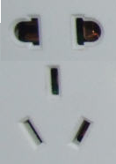
6.1 Electrical appliances
The standard AC power supply in China is 220V, 50 Hz. The typical power outlet/connector used in China is shown in the picture on the right. The normal 3-pin US power input or 2-pin European power input doesn't fit to them well. If your appliances operate on a different voltage, please take your transformers along with you.

6.2 Currency, credit cards and traveller cheques
The currency in China is RMB; most places don’t accept other kind of currency. Most hotels and banks in China can change foreign currency for RMB. It’s easier to use credit cards in China. Credit cards can be used in hotels, restaurants and shopping malls. Traveller cheque is not very convenient to use in China. The table below lists the exchange rate for RMB:

100 USD | 784.36 RMB
100 EUR | 1031.37 RMB

6.3 Climate in Beijing
Beijing is located in the warm temperature zone and has a continental climate. I’m glad to tell that May is the best time to visit Beijing, most of the day is sunny, and so you can enjoy the warm sunshine and blue sky. During the meeting week, weather in Beijing is cool and quite dry, the average temperature is about 20℃(68℉), and the highest temperature in the afternoon is usually between 24℃ to 28℃ (74℉- 82℉),and temperature quickly falls down to 14℃-18℃(58℉-65℉) in the night. So it’s better to bring some heavy clothes to keep warm in the evening, and maybe some moisturizer for your dry skin.

6.4 Time difference
Beijing is in the GMT+8 time zone.
ANNEX 4
(to TSB Collective letter 5/5)

Meeting of Study Group 5
(Beijing, China, 14-18 May 2007)
HOTEL RESERVATION FORM for Beijing Friendship Hotel
RESERVATION:
Name of the hotel: |  | Beijing Friendship Hotel
Room Type (Standard or suite)
Bed Number
Number of Breakfast
Smoking or non-smoking
Check in date: |  |  | Check out date:
Personal information:
Your name and first name:
Name of your Company:
Address of your Company:
Tel: |  |  |  | Fax:
E-mail address:

Note: Please send this form by 30 April directly to the contact person in China (see details in Annex 3, section 3):

ANNEX 5
(to TSB Collective letter 5/5)

ITU-TSB | Study Group 5 meeting  Beijing, China, 14-18 May 2007
REGISTRATION FORM
To be returned to TSB by fax (+41 22 730 5853) or e-mail (tsbreg@itu.int ) by 14 April 2007)

Mr Mrs Ms Miss |  |  |  |  | _______________________________________________  Country
____________________________________________  Family name |  |  |  |  | ______________________________________________  Name of Administration of Member State*
____________________________________________  First name |  |  |  |  | ______________________________________________  Name of Sector Member / Associate / other
Full address of administration or organization:
______________________________________________ |  |  |  | Tel: _____________________________________________
______________________________________________ |  |  |  | Fax: _____________________________________________
______________________________________________ |  |  |  | E-mail: __________________________________________
*For delegates of Member States: Function at the meeting |  |  |  |  | Hotel or other address in Beijing
 |  |  |  |  | Hotel: __________________________________________
(C) Head of delegation |  |  |  |  | Address: ________________________________________
(CA) Deputy head of delegation |  |  |  |  | ___________________________________________
(D) Delegate |  |  |  |  | Tel: ____________________________________________
Important Note:
Paper copy of meeting documents will be provided only upon request.

I need paper copies of meeting documents posted on or after 11 May 2007 for : | GEN

Date: ___________________________ | Signature: ______________________________________

