Geneva, 3 March 2006
INTERNATIONAL TELECOMMUNICATION UNION
Telecommunication
Standardization Bureau

Ref: | TSB Collective-letter 4/4
Tel:  Fax:  E-mail: | +41 22 730 5515  +41 22 730 5853  tsbsg4@itu.int | - To Administrations of Member States of the Union, to ITU-T Sector Members and to ITU-T Associates participating in the work of Study Group 4

Subject: | Meeting of Study Group 4  Beijing, 24 May-2 June 2006

Dear Sir/Madam,
1 In accordance with the schedule of ITU Telecommunication Standardization Sector meetings for 2006 (see TSB Circular 58 of 1 December 2005), I would like to inform you that Study Group 4 (Telecommunication management) is to meet at Beijing XinYuan Hotel (Beijing, China), from 24 May to 2 June 2006 inclusive, at the kind invitation of the Beijing University of Posts and Telecommunications (BUPT)
The meeting will open at 0930 hours on the first day. Participant registration will start at 0800 hours. Detailed information concerning the meeting rooms will be displayed at the venue.
A workshop on Telecommunication Management and Operations Support Systems will also be held in the same hotel from 22 to 23 May. Detailed information regarding this workshop can be found in TSB Circular 76.
2 The discussions will be held in accordance with decisions taken with reference to the provisions in force.
3 The draft agenda, as prepared by the Chairman of Study Group 4, is set out in Annex 1 hereto.
4 The draft meeting schedule, as prepared by the Chairman of Study Group 4, is set out in Annex 2 hereto.
5 Additional information on the meeting is provided in Annex 3.
6 Participants are advised that the meeting will be conducted paperless. A wireless LAN will be provided. Delegates wishing paper copies may print them in the delegates’ zone or bring them with them. There will be no distribution of papers. Contributions may be downloaded directly from the ITU-T web site (http://www.itu.int/md/T05-SG04-060524-TD/en).
7 Pursuant to the provisions of Recommendation A.1 of WTSA (Florianópolis, 2004), contributions to the work of the study group shall be submitted to the Telecommunication Standardization Bureau (TSB).
a) Contributions received at least two months before the meeting will be published and mailed to the Administrations of Member States of the Union, to ITU-T Sector Members and to ITU-T Associates registered in this study group who have requested paper copies, and will be available on the Study Group 4 website.

b) Contributions received by TSB less than two months but not less than seven working days before the date set for the opening of the meeting shall be published as "delayed contributions", shall be posted to the Study Group 4 website and shall be distributed, upon request only at the beginning of the meeting to only the participants present. Therefore, such contributions must be received by TSB not later than 12 May 2006.
Participants are encouraged to submit contributions by electronic mail to the following address:
tsbsg4@itu.int. Detailed instructions can be found on the ITU-T website.
We strongly encourage you to use the set of templates that has been created to harmonize the appearance of ITU-T documents, while making the production of the documents easier and thus more efficient. These templates are accessible from each ITU-T Study Group web page, under “Guides, Tools and Templates” (http://www.itu.int/ITU-T/studygroups/templates/index.html).
With a view to settling any questions which might arise concerning contributions, the name, the fax and telephone numbers and the e-mail address of the person to be contacted should be indicated on contributions. Accordingly, please give those details on the cover page of all documents.
8 In order to enable the host and TSB to make the necessary arrangements concerning the documentation and organization of the meeting, I should be grateful if you would send me by letter, fax (No.: +41 22 730 5853) or e-mail (tsbreg@itu.int), as soon as possible, but not later than 24 April 2006, the list of people who will be representing your Administration, Sector Member, Associate, regional and/or international organization or other entity. Administrations are requested also to indicate the name of their head of delegation (and deputy-head, if applicable). The registration form in Annex 5, duly completed (one per participant), should be attached to the above-mentioned list.
9 Each meeting room will be equipped with wireless access (Wireless LAN, supporting IEEE802.11b, 2.4GHz band) to the Internet. Those who wish to use the wireless access must be equipped with the necessary hardware and correctly configured PC.
10 For your convenience, a hotel reservation form is enclosed as Annex 4.
11 We would remind you that citizens of some countries are required to obtain a visa in order to enter China. The visa must be requested and obtained from the office (embassy or consulate) representing China in your country or, if there is no such office in your country, from the one that is closest to the country of departure. Please be aware that visa approval might take time so kindly make your request for the invitation letter as soon as possible.
Participants who need an individual invitation letter and/or a visa supporting letter are advised to contact Ms Lanlan RUI via email at llrui@bupt.edu.cn .
Your e-mail must include the information contained in Annex 3.

Yours faithfully,
H. Zhao
Director of the Telecommunication
Standardization Bureau
Annexes: 5

ANNEX 1
(to TSB Collective-letter 4/4)
Proposed agenda for SG4 meeting
Beijing, 24 May - 2 June 2006

24 May 2006 (morning)
1 | Opening  - Introduction  - Agreement on agenda
2 | Brief review of activities since September 2005  - SG and WP meeting reports (September 2005)  - TSAG meeting (November 2005)  - NGNMFG and MTNMFG  - Other interim SG4 activities
3 | Lead SG Activities  - Telecommunication Management Project  - Other Lead SG activities
4 | Study Group Administration  - IPR disclosure requirements  - Organization and leadership  - Work programme  - EDH  - Terminology  - Liaison statements  - Meeting schedule and room assignments  - Other topics
5 | Activities related to Recommendation Approval  - Review of AAP actions initiated in September 2005  - Candidate Recommendations for approval initiation at this meeting
6 | Interaction with and key activities of outside organizations  - TeleManagement Forum  - IETF  - MEF  - 3GPP  - Regional/national bodies
7 | Other business

24 May (afternoon) to 2 June (morning)
8 | Working Party meetings, including opening and closing plenaries
2 June (afternoon)
9 | Working Party requests and issues (Note)  - Updated study questions and organizational structure  - Updated work programme  - Proposed liaison statements  - Updated Implementors’ Guides  - Focus Group status  - Recommendations for Resolution 1 “determination” and Recommendation A.8 “consent”  - Proposed interim meetings  - Other requests and issues
10 | SG4 reports (including proposed SG4 liaison statements) on and issues regarding:  - SG4 Management Team  - Lead SG activities  - Terminology  - EDH  - Interim meeting summary  - Other business
11 | Closing
Note – To make most efficient use of SG4 meeting time, there will be no presentation of Working Party results at the SG4 closing plenary. Only Working Party issues for SG plenary decisions will be dealt with as shown in the agenda above. The Working Party closing plenaries will deal with all other issues. This is a preliminary agenda subject to change

ANNEX 2
(to TSB Collective-letter 4/4)

Preliminary meeting schedule SG4
Beijing, 24 May-2 June 2006

Body |  |  |  |  |  |  |  |  |  |  |  |  |  |  |  |  |  |  |  |  |  |  |  |  |  |  |  |  |  |  |  |  |  |  |  |  | Note 0) Begins at 0930  Note 1) Begins at 12.00  Note 2) Begins at 16.00  Note 3) Begins at 1400  Note 4) Joint Q2+ Q7  Note 5) joint Q4 + Q5  Note 6) Joint Q6+Q7+Q9  Note 7) Begins at 0900  Note 8) Begins at 11:00  Note: This is a preliminary  Agenda and subject to change
Body | Wednesday  24 May |  |  |  |  | Thursday  25 May |  |  |  | Friday  26 May |  |  |  |  | Monday  29 May |  |  |  | Tuesday  30 May |  |  |  | Wednesday  31 May |  |  |  | Thursday  1 June |  |  |  |  | Friday  2 June
SG 4 | 0 |  |  |  |  |  |  |  |  |  |  |  |  |  |  |  |  |  |  |  |  |  |  |  |  |  |  |  |  |  |  |  |  |  | 3
WP1/4 |  | 1 |  |  |  |  |  |  |  |  |  |  |  |  |  |  |  |  |  |  |  |  |  |  |  |  |  |  |  |  | 2
Q1
Q2 |  |  |  |  |  |  |  |  |  |  |  |  |  |  |  |  |  |  |  |  | 4
Q3
Q4 |  |  |  |  |  |  |  |  |  |  |  |  |  |  |  |  | 5
Q5 |  |  |  |  |  |  |  |  |  |  |  |  |  |  |  |  | 5
WP2/4 |  |  | 1 |  |  |  |  |  |  |  |  |  |  |  |  |  |  |  |  |  |  |  |  |  |  |  |  |  |  |  |  |  | 7
Q6 |  |  |  |  |  |  |  |  |  | 6 | 6 | 6 | 6
Q7 |  |  |  |  |  |  |  |  |  | 6 | 6 | 6 | 6 |  |  |  |  |  |  |  | 4
Q8
Q12
WP3/4 |  |  | 1 |  |  |  |  |  |  |  |  |  |  |  |  |  |  |  |  |  |  |  |  |  |  |  |  |  |  |  |  |  |  | 8
Q9 |  |  |  |  |  |  |  |  |  | 6 | 6 | 6 | 6
Q10
Q11

ANNEX 3
(to TSB Collective-letter 4/4)
Information of facilities and services for the ITU-T Study Group 4 meeting, Beijing, China, 24 May-2 June 2006)

Host: Beijing University of Posts and Telecommunications (BUPT)

General Information
- Meeting Venue
- Name: Beijing XinYuan Hotel
- Address: No.6 ShiFangYuan, HaiDian District, Beijing, China
- Telephone: +86 10 63901951
- Fax: +86 10 63968680
- Email: sales@xinyuanhotel.com.cn
- Web site: http://www.telehotels.net.cn

- Entry Notes
  - Visa Requirements
Please contact Ms Rui Lanlan (llrui@bupt.edu.cn) and (CC to Mr Qi Feng (qifeng@bupt.edu.cn) should you require an individual invitation letter while obtaining your visa. Your email must include the following information in order for it to be processed:
- Family name (last name)
- Forename (first name)
- Birth date (month/date/year)
- Passport number, issuing country, issuing date and expiry date
- Gender
- Occupation
- Company name
- Company/mailing address
- Postal Code
- Country
- Telephone number
- Fax number
- Name of meeting: ITU-T SG4 Plenary Meeting
Letters will only be sent via Express mail upon request. Letters will be sent via fax unless otherwise indicated on the request. If you have any changes after receiving a faxed copy, please contact Ms Rui Lanlan at llrui@bupt.edu.cn.
Letters will be processed within 14 days of receiving an email request. If you have not received your letter within 14 days or wish to make changes after receiving a faxed copy, please contact Ms Lanlan RUI.
In addition, you may be asked for specific documentation showing strong social, economic, and other ties to your home country.

  - Customs Regulations & Vaccination Requirements
See the above attachment for reference or check this website:
http://www.hlraohe.gov.cn/kajm/crj/xz.htm.

  - Hotel Reservation Procedure
A block of rooms has been reserved at the “Beijing XinYuan Hotel” under the name of ITU-T SG4. For your hotel reservation, you should send hotel reservation form by fax directly to the hotel. The reduced room rate is:
Room Type | Room Rate
Standard Room | RMB 720 (about $90) Net (1 breakfast and tax included)
Deluxe Room | RMB 800 (about $100) Net (1 breakfast and tax included)
Standard executive Room | RMB 960 (about $120) Net (1 breakfast and tax included)
Executive suite | RMB 1200 (about $150) Net (1 breakfast and tax included)
You will find a reservation fax form at the end of this invitation. Please read the reservations section of the invitation for more information regarding booking your room.
The hotel contact person for room reservation is:
Name: Ms Yu Jingyan
Telephone: +86 10 63901951
Mobile: +86 13 501382567
Fax: +86 10 63968680
Email: sales@xinyuanhotel.com.cn
Please make sure to provide the following subject for room reservation when you send emails or fax: “To: Yu Jingyan, ITU-T SG4 meeting”

- Cut-off Date: 12 May, 2006
Please be sure to make your reservation before the cut-off date to insure the lower group rate. Rates may be higher after the cut-off date.

- Cancellation:
Reservations must be cancelled 72 hour prior to arrival to avoid a penalty of one night’s room and tax. Please be sure to ask for a cancellation number should you need to cancel your reservation.

Please Note: BUPT is not responsible for the confirmations of reservation, cancellation or changing of reservations, or no-shows. Please contact the hotel contact person directly to make any changes.

- Map Directions

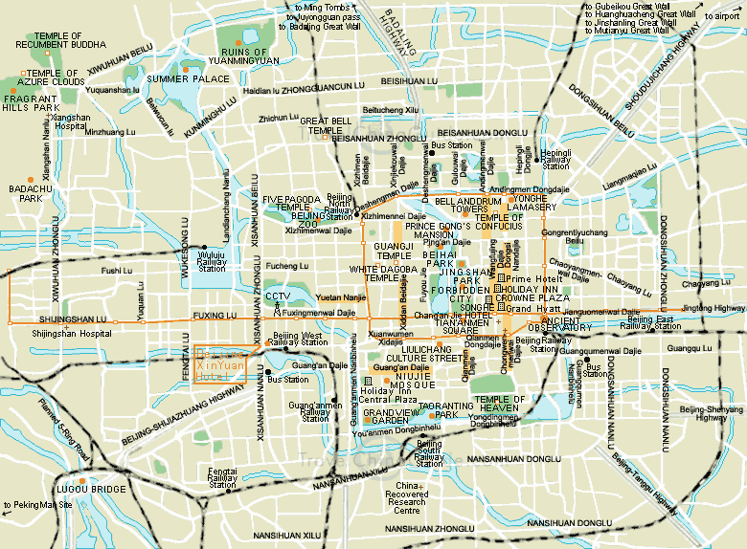
Map 1 Beijing Downtown Overview
Map1 illustrates the basic avenues in Beijing downtown for your reference.

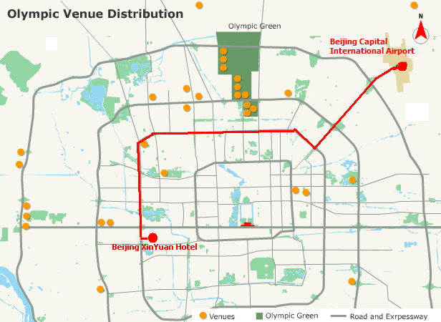
Map 2 Route Illustration

  - Arrival Airport: Beijing Capital International Airport
  - Your Destination: Beijing XinYuan Hotel

The route from the airport to the hotel is marked red in Map2 above.

- It should take about 50 minutes from the airport to the hotel.
Taxi as recommended, average cost RMB 95￥(12$/10€) one way.
- Or take a shared ride shuttle from the airport to ‘Gong Zhu Fen’ stop costing RMB ￥16 one way, then take taxi to the hotel directly costing RMB 10￥.

  - Medical Services around the Hotel:
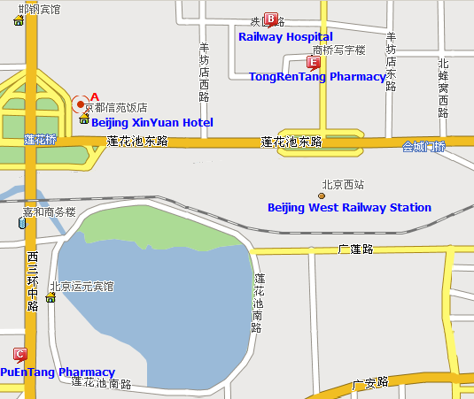
Map 3 Medical Services around the Hotel

      - Railway Hospital, northeast of the hotel (location A), 800m away.
        - 51875544 (Local)
        - Location B in the Map below
      - TongRenTang Pharmacy, northeast of the hotel (location A), 800m away.
        - 63955127 (Local)
        - Location E in the Map
      - PuEnTang Pharmacy, south of the hotel (location A), 600m away.
        - Location C in the Map
        - 63323422 (Local)

  - Bank Services around the Hotel:
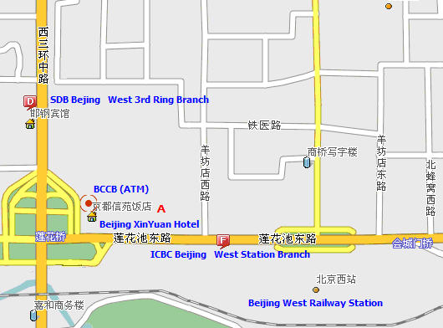
Map 4 Bank Services around the Hotel

      - BCCB (Beijing City Commercial Bank, also known as Bank of Beijing) ATM, right located in the hotel (location A).
        - Please refer to the crew of the hotel for the exact position
        - Location A in the Map
      - SDB (Shenzhen Development Bank) Beijing West 3rd Ring Branch, northwest of the hotel (location A), 500m away.
        - 63983622 or 63984901 (Local)
        - 95501 (24-hour Service Hot Line)
        - Location D in the Map
      - ICBC (Industry and Commercial Bank of China) Beijing West Station Branch, east of the hotel (location A), 500m away.
        - 63955315 or 63955321 (Local)
        - Location F in the Map

- Miscellaneous
  - GSM and CDMA Coverage:
There are GSM and CDMA 95/1X coverage in Beijing.
  - Currency:
Local currency RMB Yuan(￥). The bank and hotel can provide multi-currency service.
  - Time Zone:
Central Time Zone (GMT+8 hours, Beijing, Hong Kong)
  - Climate:
Warm & Dry with the average temperature of 20℃~25℃
  - Phone charges:
Each delegate is responsible for verifying any toll charges that may be incurred by placing local, long distance and toll-free calls from a guest room. IP card can be bought from the hotel reception for reducing fees of long distance calls.

  - In-town transport:
Taxi rate: Typical minimum charge is RMB 10￥ (covering preliminary 3 kilometers), and extra RMB ￥1.6 per kilometer after preliminary 3 kilometers.
Subway and City Rail: There are 2 lines subway and 1 city rail in Beijing as presented in Map 5.
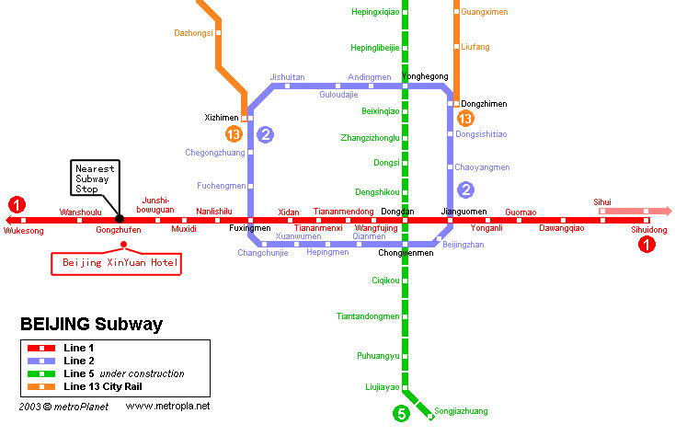
Map 5 Subway System in Beijing
Currently there are three subway(or city railway) lines running in Beijing, which are line 1, 2,13 and are marked as ❶, ❷ etc, in Map 5, where:
Line 1: line-style subway; the nearest subway stop to Beijing XinYuan Hotel is “GongZhuFen” stop;
Line 2: ring-style subway; running around the Beijing downtown area;
Line 13: sector-style city railway; running at the suburb area in the northern part of Beijing.

  - Electricity:
220 Volt. Please be sure you have the correct adapter. Voltage converters will NOT be provided at the meeting.

The type of electrical outlet common in the guest room is Type A and Type B as below.

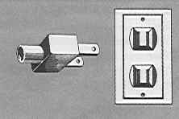
Type A Flat blade attachment plug

Type B Oblique flat blades (inverted V-shape) with ground

The electrical outlet in the meeting room is more diversiform.

  - About Beijing:
You are welcome to visit http://www.ebeijing.gov.cn/, the official website of Beijing City as well as the 2008 Olympics.
  - Network:
There will be Wired and Wireless LAN (802.11) Service in meeting rooms. Please bring your WLAN card if you have. WLAN cards can also be rented at reception (there will be a total of thirty WLAN cards for rent.)
  - Social Event:
Detailed social event arrangement will be available during the meeting.

Meeting Rooms
Meeting rooms supporting the whole SG4 and each working party meetings (including each questions) have been booked. Detailed room assignment information will be provided one week before the opening plenary meeting.
Each meeting room will be equipped with one video projector, one screen for displaying computer files and one white board or flip-chart with pens.
Wireless LAN will be provided. A hub with electric extension leads for laptop PCs will also be provided in each meeting room.

REGISTRATION OF PARTICIPANTS
Pre-registration will be done by TSB in Geneva. Onsite registration will be done by TSB and BUPT.
A registration desk will be provided to receive participants and distribute badges on the same floor as the meeting room located.

ANNEX 4
(to TSB Collective-letter 4/4)
HOTEL RESERVATION FORM
ITU-T SG4 Meeting 24 May – 2 June 2006
Beijing XinYuan Hotel
No.6 ShiFangYuan, HaiDian District Beijing, China
Telephone: 86-10-63901951 Fax : 86-10-63968680
Cut-off Date: 12 May, 2006
Cancellation Policy: Reservations must be cancelled 72 hours before arrival to avoid a penalty of one night’s room and tax.
Name of Meeting: ITU-T SG4 Meeting
Meeting Date: 24 May - 2, June 2006
Please fax this form to Hotel at 86-10-63968680
Guest Information
Name of Guest:
Number of people:
Room Type and Room Rate: |  Standard Room: RMB 720 (about $90) Net (1 breakfast and tax included)   Deluxe Room: RMB 800 (about $100) Net (1 breakfast and tax included)   Standard executive Room: RMB 960 (about $120) Net (1 breakfast and tax included)   Executive suite: RMB 1200 (about $150) Net (1 breakfast and tax included)
Guest Address:
Date of Arrival:
Date of Departure:
Guest Telephone Number:
Guest Fax Number:
Email Address:
Billing information to be used as a guarantee
Credit Card Type:
Credit Card Number:
Expiration Date:
Billing Address:
Signature:
Room Type (Please circle one)
Smoking Non-Smoking
Single Double
Please make your reservations before the cut-off date (12 May, 2006) to insure the reduced group rate.

ANNEX 5
(to TSB Collective-letter 4/4)

 | ITU-TSB | Study Group 4 Meeting  (Beijing, 24 May-2 June 2006)
 | REGISTRATION FORM
 | To be returned to TSB (Fax: +41 22 730 5853 / tsbreg@itu.int) by 24 April 2006
 |  |  | Plen | WP1 | WP2 | WP3
I participate in :

Mr Mrs Ms Miss |  |  |  |  | _______________________________________________  Country
____________________________________________  Family Name |  |  |  |  | ______________________________________________  Name of Administration of Member State*
____________________________________________  First Name |  |  |  |  | ______________________________________________  Name of Sector Member / Associate / Other
Complete address of Administration or Organization:
______________________________________________ |  |  |  | Tel: _____________________________________________
______________________________________________ |  |  |  | Fax: _____________________________________________
______________________________________________ |  |  |  | E-mail: __________________________________________
*For delegates of Member States: Function at the meeting |  |  |  |  | Hotel/Address in Beijing
 |  |  |  |  | Hotel: __________________________________________
(C) Head of delegation |  |  |  |  | Address: ________________________________________
(CA) Deputy Head |  |  |  |  | ___________________________________________
(D) Delegate |  |  |  |  | Tel: ____________________________________________
Important Note: this meeting will be paperless.

Date: ___________________________ | Signature: ______________________________________

For TSB Secretariat use only
Pigeon-hole

