2006年3月3日，日内瓦
国 际 电 信 联 盟
电信标准化局

文号： | 电信标准化局第4/4号集体函
电话：  传真：  电子  邮件： | +41 22 730 5515  +41 22 730 5853  tsbsg4@itu.int | - 致国际电联会员国各主管部门、ITU-T各部门成员和参加第4研究组工作的ITU-T 部门准成员

事由： | 第4研究组会议  2006年5月24日-6月2日，日内瓦

尊敬的先生/女士
1 根据关于2006年的国际电联电信标准化部门会议日程表（见2005年12月1日电信标准化局58号通函），我谨通知您，应北京邮电大学（BUPT）的盛情邀请，第4研究组（电信管理）将自2006年5月24日至6月2日在京都信苑饭店（中国，北京）召开会议。
第一天的会议将于09:00 时开始。代表注册从08:00开始。有关会议室安排的具体信息届时将在会场显示。
5月22至23日在同一饭店还将举办一场电信管理和运行支持系统的讲座。详情请见TSB76号通函。
2 该会议的讨论将根据现行有关规定进行。
3 由第4研究组主席起草的会议日程见附件 1。
4 由第4研究组主席起草的时间表见附件 2。
5 有关会议的其它信息见附件3。
6 本次会议不提供纸页文件。会议配备一个无线局域网，需要纸页文件的代表可在代表区打印或随身携带。会议不分发纸页文件。会议文稿可直接从ITU-T网站上下载（http://www.itu.int/md/05-SG04-060524-TD/en ）。
7 根据世界电信标准化全会（WTSA）第A.1 号建议（2004年，弗洛里亚诺波利斯）的条款，有关该研究组工作的文稿应提交电信标准化局（TSB）。
a) 在会议召开日至少两个月前收到的文稿将予以出版并将寄至提出接收纸页文件要求的国际电联会员国主管部门、ITU-T部门成员和报名参加该研究组工作的ITU-T 部门准成员，并将及时发布在第4研究组的网站上。

b) 在会议召开日前两个月以内、但不迟于七个工作日以前收到的文稿将作为“迟到文稿”出版，并将发布在第4研究组的网站上。这些文稿将仅根据要求在会议开始时发给在场的与会者。因此，此类文稿必须在2006年5月12日前寄达电信标准化局。
欢迎与会者以电子邮件的方式向以下地址提交文稿：tsbsg4@itu.int。详尽指南见ITU-T网站。
我们大力提倡您使用已制作出的一套新模版，它们既能够使ITU-T文件的格式保持一致，又可以方便文件制作、提高效率。这些模版可在每个ITU-T 研究组或电信标准化顾问组（TSAG）的网页中“指南、工具和模版” (http://www.itu.int/ITU-T/studygroups/templates/index.html)处找到。
为了解决与文稿有关的问题，请在文稿上注明联系人的姓名、传真和电话号码以及电子邮件地址。同样，务请在所有文件的首页注明这些细节。
8 为了便于东道主和电信标准化局进行文件制作和会议组织方面的必要安排，我希望您能通过信函、传真 (号码：+41 22 730 5853) 或电子邮件 (tsbreg@itu.int) 的方式尽早、但不迟于2006年4月24日将代表主管部门、部门成员、部门准成员、区域性和/或国际组织或其它实体出席会议的人员名单发至我处。同时，希望各主管部门注明其代表团团长(如果有副团长，亦盼一并注明)的姓名。填妥的附件5中的报名表(每位与会者一份)应附于上述名单后。
9 每间会议室均配备无线互联网（无线局域网、支持IEEE802.11b，2.4GHz带宽）。如需要无线上网，请自备必要的硬件和相应配置的个人电脑。
10 附件4中有一份宾馆预定单。
11 我们在此谨提醒您，一些国家的公民需要获得签证才能入境中国。签证必须向驻贵国的中国代表机构(使馆或领事馆)申请领取；如果贵国没有此类机构，则请向驻离离境国最近的国家的此类机构申请并领取。请注意，签证审批可能需要一定时间，因此，请尽快办理邀请函事宜。
如需个人邀请函或申领签证的辅助文件，请与RUI Lanlan女士联系，电子邮件地址为：llrui@bupt.edu.cn。
请务在您的电子邮件中写明附件3所含的信息。

顺致敬意，

赵厚鳞
电信标准化局主任
附件：5

ANNEX 1
(to TSB Collective-letter 4/4)
Proposed agenda for SG4 meeting
Beijing, 24 May - 2 June 2006

24 May 2006 (morning)
1 | Opening  - Introduction  - Agreement on agenda
2 | Brief review of activities since September 2005  - SG and WP meeting reports (September 2005)  - TSAG meeting (November 2005)  - NGNMFG and MTNMFG  - Other interim SG4 activities
3 | Lead SG Activities  - Telecommunication Management Project  - Other Lead SG activities
4 | Study Group Administration  - IPR disclosure requirements  - Organization and leadership  - Work programme  - EDH  - Terminology  - Liaison statements  - Meeting schedule and room assignments  - Other topics
5 | Activities related to Recommendation Approval  - Review of AAP actions initiated in September 2005  - Candidate Recommendations for approval initiation at this meeting
6 | Interaction with and key activities of outside organizations  - TeleManagement Forum  - IETF  - MEF  - 3GPP  - Regional/national bodies
7 | Other business

24 May (afternoon) to 2 June (morning)
8 | Working Party meetings, including opening and closing plenaries
2 June (afternoon)
9 | Working Party requests and issues (Note)  - Updated study questions and organizational structure  - Updated work programme  - Proposed liaison statements  - Updated Implementors’ Guides  - Focus Group status  - Recommendations for Resolution 1 “determination” and Recommendation A.8 “consent”  - Proposed interim meetings  - Other requests and issues
10 | SG4 reports (including proposed SG4 liaison statements) on and issues regarding:  - SG4 Management Team  - Lead SG activities  - Terminology  - EDH  - Interim meeting summary  - Other business
11 | Closing
Note – To make most efficient use of SG4 meeting time, there will be no presentation of Working Party results at the SG4 closing plenary. Only Working Party issues for SG plenary decisions will be dealt with as shown in the agenda above. The Working Party closing plenaries will deal with all other issues. This is a preliminary agenda subject to change

ANNEX 2
(to TSB Collective-letter 4/4)

Preliminary meeting schedule SG4
Beijing, 24 May-2 June 2006

Body |  |  |  |  |  |  |  |  |  |  |  |  |  |  |  |  |  |  |  |  |  |  |  |  |  |  |  |  |  |  |  |  |  |  |  |  | Note 0) Begins at 0930  Note 1) Begins at 12.00  Note 2) Begins at 16.00  Note 3) Begins at 1400  Note 4) Joint Q2+ Q7  Note 5) joint Q4 + Q5  Note 6) Joint Q6+Q7+Q9  Note 7) Begins at 0900  Note 8) Begins at 11:00  Note: This is a preliminary  Agenda and subject to change
Body | Wednesday  24 May |  |  |  |  | Thursday  25 May |  |  |  | Friday  26 May |  |  |  |  | Monday  29 May |  |  |  | Tuesday  30 May |  |  |  | Wednesday  31 May |  |  |  | Thursday  1 June |  |  |  |  | Friday  2 June
SG 4 | 0 |  |  |  |  |  |  |  |  |  |  |  |  |  |  |  |  |  |  |  |  |  |  |  |  |  |  |  |  |  |  |  |  |  | 3
WP1/4 |  | 1 |  |  |  |  |  |  |  |  |  |  |  |  |  |  |  |  |  |  |  |  |  |  |  |  |  |  |  |  | 2
Q1
Q2 |  |  |  |  |  |  |  |  |  |  |  |  |  |  |  |  |  |  |  |  | 4
Q3
Q4 |  |  |  |  |  |  |  |  |  |  |  |  |  |  |  |  | 5
Q5 |  |  |  |  |  |  |  |  |  |  |  |  |  |  |  |  | 5
WP2/4 |  |  | 1 |  |  |  |  |  |  |  |  |  |  |  |  |  |  |  |  |  |  |  |  |  |  |  |  |  |  |  |  |  | 7
Q6 |  |  |  |  |  |  |  |  |  | 6 | 6 | 6 | 6
Q7 |  |  |  |  |  |  |  |  |  | 6 | 6 | 6 | 6 |  |  |  |  |  |  |  | 4
Q8
Q12
WP3/4 |  |  | 1 |  |  |  |  |  |  |  |  |  |  |  |  |  |  |  |  |  |  |  |  |  |  |  |  |  |  |  |  |  |  | 8
Q9 |  |  |  |  |  |  |  |  |  | 6 | 6 | 6 | 6
Q10
Q11

ANNEX 3
(to TSB Collective-letter 4/4)
Information of facilities and services for the ITU-T Study Group 4 meeting, Beijing, China, 24 May-2 June 2006)

Host: Beijing University of Posts and Telecommunications (BUPT)

General Information
- Meeting Venue
- Name: Beijing XinYuan Hotel
- Address: No.6 ShiFangYuan, HaiDian District, Beijing, China
- Telephone: +86 10 63901951
- Fax: +86 10 63968680
- Email: sales@xinyuanhotel.com.cn
- Web site: http://www.telehotels.net.cn

- Entry Notes
  - Visa Requirements
Please contact Ms Rui Lanlan (llrui@bupt.edu.cn) and (CC to Mr Qi Feng (qifeng@bupt.edu.cn) should you require an individual invitation letter while obtaining your visa. Your email must include the following information in order for it to be processed:
- Family name (last name)
- Forename (first name)
- Birth date (month/date/year)
- Passport number, issuing country, issuing date and expiry date
- Gender
- Occupation
- Company name
- Company/mailing address
- Postal Code
- Country
- Telephone number
- Fax number
- Name of meeting: ITU-T SG4 Plenary Meeting
Letters will only be sent via Express mail upon request. Letters will be sent via fax unless otherwise indicated on the request. If you have any changes after receiving a faxed copy, please contact Ms Rui Lanlan at llrui@bupt.edu.cn.
Letters will be processed within 14 days of receiving an email request. If you have not received your letter within 14 days or wish to make changes after receiving a faxed copy, please contact Ms Lanlan RUI.
In addition, you may be asked for specific documentation showing strong social, economic, and other ties to your home country.

  - Customs Regulations & Vaccination Requirements
See the above attachment for reference or check this website:
http://www.hlraohe.gov.cn/kajm/crj/xz.htm.

  - Hotel Reservation Procedure
A block of rooms has been reserved at the “Beijing XinYuan Hotel” under the name of ITU-T SG4. For your hotel reservation, you should send hotel reservation form by fax directly to the hotel. The reduced room rate is:
Room Type | Room Rate
Standard Room | RMB 720 (about $90) Net (1 breakfast and tax included)
Deluxe Room | RMB 800 (about $100) Net (1 breakfast and tax included)
Standard executive Room | RMB 960 (about $120) Net (1 breakfast and tax included)
Executive suite | RMB 1200 (about $150) Net (1 breakfast and tax included)
You will find a reservation fax form at the end of this invitation. Please read the reservations section of the invitation for more information regarding booking your room.
The hotel contact person for room reservation is:
Name: Ms Yu Jingyan
Telephone: +86 10 63901951
Mobile: +86 13 501382567
Fax: +86 10 63968680
Email: sales@xinyuanhotel.com.cn
Please make sure to provide the following subject for room reservation when you send emails or fax: “To: Yu Jingyan, ITU-T SG4 meeting”

- Cut-off Date: 12 May, 2006
Please be sure to make your reservation before the cut-off date to insure the lower group rate. Rates may be higher after the cut-off date.

- Cancellation:
Reservations must be cancelled 72 hour prior to arrival to avoid a penalty of one night’s room and tax. Please be sure to ask for a cancellation number should you need to cancel your reservation.

Please Note: BUPT is not responsible for the confirmations of reservation, cancellation or changing of reservations, or no-shows. Please contact the hotel contact person directly to make any changes.

- Map Directions

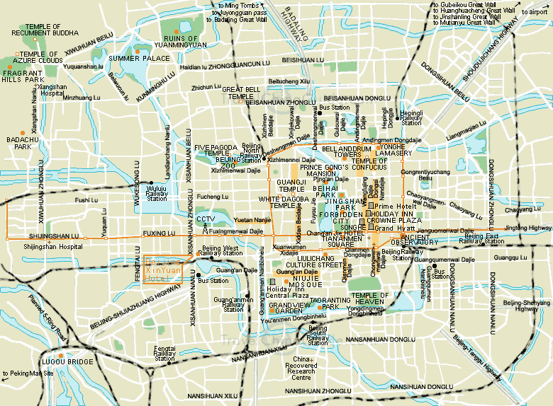
Map 1 Beijing Downtown Overview
Map1 illustrates the basic avenues in Beijing downtown for your reference.

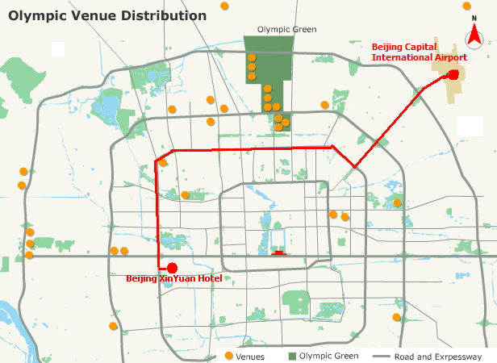
Map 2 Route Illustration

  - Arrival Airport: Beijing Capital International Airport
  - Your Destination: Beijing XinYuan Hotel

The route from the airport to the hotel is marked red in Map2 above.

- It should take about 50 minutes from the airport to the hotel.
Taxi as recommended, average cost RMB 95￥(12$/10€) one way.
- Or take a shared ride shuttle from the airport to ‘Gong Zhu Fen’ stop costing RMB ￥16 one way, then take taxi to the hotel directly costing RMB 10￥.

  - Medical Services around the Hotel:
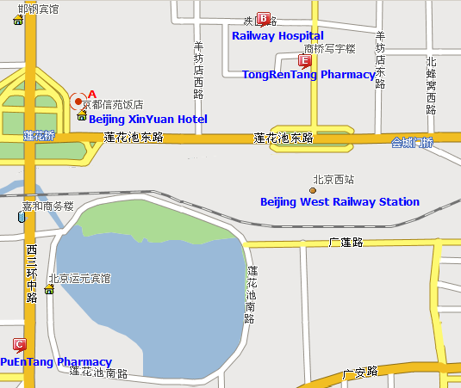
Map 3 Medical Services around the Hotel

      - Railway Hospital, northeast of the hotel (location A), 800m away.
        - 51875544 (Local)
        - Location B in the Map below
      - TongRenTang Pharmacy, northeast of the hotel (location A), 800m away.
        - 63955127 (Local)
        - Location E in the Map
      - PuEnTang Pharmacy, south of the hotel (location A), 600m away.
        - Location C in the Map
        - 63323422 (Local)

  - Bank Services around the Hotel:
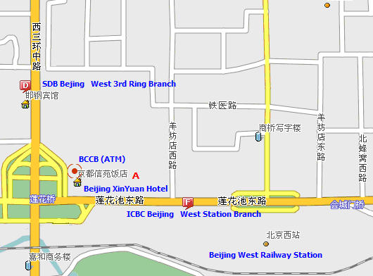
Map 4 Bank Services around the Hotel

      - BCCB (Beijing City Commercial Bank, also known as Bank of Beijing) ATM, right located in the hotel (location A).
        - Please refer to the crew of the hotel for the exact position
        - Location A in the Map
      - SDB (Shenzhen Development Bank) Beijing West 3rd Ring Branch, northwest of the hotel (location A), 500m away.
        - 63983622 or 63984901 (Local)
        - 95501 (24-hour Service Hot Line)
        - Location D in the Map
      - ICBC (Industry and Commercial Bank of China) Beijing West Station Branch, east of the hotel (location A), 500m away.
        - 63955315 or 63955321 (Local)
        - Location F in the Map

- Miscellaneous
  - GSM and CDMA Coverage:
There are GSM and CDMA 95/1X coverage in Beijing.
  - Currency:
Local currency RMB Yuan(￥). The bank and hotel can provide multi-currency service.
  - Time Zone:
Central Time Zone (GMT+8 hours, Beijing, Hong Kong)
  - Climate:
Warm & Dry with the average temperature of 20℃~25℃
  - Phone charges:
Each delegate is responsible for verifying any toll charges that may be incurred by placing local, long distance and toll-free calls from a guest room. IP card can be bought from the hotel reception for reducing fees of long distance calls.

  - In-town transport:
Taxi rate: Typical minimum charge is RMB 10￥ (covering preliminary 3 kilometers), and extra RMB ￥1.6 per kilometer after preliminary 3 kilometers.
Subway and City Rail: There are 2 lines subway and 1 city rail in Beijing as presented in Map 5.
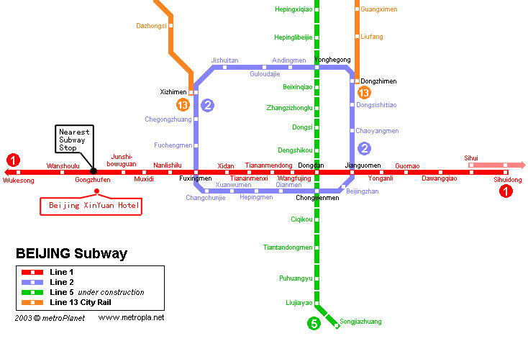
Map 5 Subway System in Beijing
Currently there are three subway(or city railway) lines running in Beijing, which are line 1, 2,13 and are marked as ❶, ❷ etc, in Map 5, where:
Line 1: line-style subway; the nearest subway stop to Beijing XinYuan Hotel is “GongZhuFen” stop;
Line 2: ring-style subway; running around the Beijing downtown area;
Line 13: sector-style city railway; running at the suburb area in the northern part of Beijing.

  - Electricity:
220 Volt. Please be sure you have the correct adapter. Voltage converters will NOT be provided at the meeting.

The type of electrical outlet common in the guest room is Type A and Type B as below.

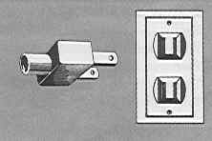
Type A Flat blade attachment plug

Type B Oblique flat blades (inverted V-shape) with ground

The electrical outlet in the meeting room is more diversiform.

  - About Beijing:
You are welcome to visit http://www.ebeijing.gov.cn/, the official website of Beijing City as well as the 2008 Olympics.
  - Network:
There will be Wired and Wireless LAN (802.11) Service in meeting rooms. Please bring your WLAN card if you have. WLAN cards can also be rented at reception (there will be a total of thirty WLAN cards for rent.)
  - Social Event:
Detailed social event arrangement will be available during the meeting.

Meeting Rooms
Meeting rooms supporting the whole SG4 and each working party meetings (including each questions) have been booked. Detailed room assignment information will be provided one week before the opening plenary meeting.
Each meeting room will be equipped with one video projector, one screen for displaying computer files and one white board or flip-chart with pens.
Wireless LAN will be provided. A hub with electric extension leads for laptop PCs will also be provided in each meeting room.

REGISTRATION OF PARTICIPANTS
Pre-registration will be done by TSB in Geneva. Onsite registration will be done by TSB and BUPT.
A registration desk will be provided to receive participants and distribute badges on the same floor as the meeting room located.

ANNEX 4
(to TSB Collective-letter 4/4)
HOTEL RESERVATION FORM
ITU-T SG4 Meeting 24 May – 2 June 2006
Beijing XinYuan Hotel
No.6 ShiFangYuan, HaiDian District Beijing, China
Telephone: 86-10-63901951 Fax : 86-10-63968680
Cut-off Date: 12 May, 2006
Cancellation Policy: Reservations must be cancelled 72 hours before arrival to avoid a penalty of one night’s room and tax.
Name of Meeting: ITU-T SG4 Meeting
Meeting Date: 24 May - 2, June 2006
Please fax this form to Hotel at 86-10-63968680
Guest Information
Name of Guest:
Number of people:
Room Type and Room Rate: |  Standard Room: RMB 720 (about $90) Net (1 breakfast and tax included)   Deluxe Room: RMB 800 (about $100) Net (1 breakfast and tax included)   Standard executive Room: RMB 960 (about $120) Net (1 breakfast and tax included)   Executive suite: RMB 1200 (about $150) Net (1 breakfast and tax included)
Guest Address:
Date of Arrival:
Date of Departure:
Guest Telephone Number:
Guest Fax Number:
Email Address:
Billing information to be used as a guarantee
Credit Card Type:
Credit Card Number:
Expiration Date:
Billing Address:
Signature:
Room Type (Please circle one)
Smoking Non-Smoking
Single Double
Please make your reservations before the cut-off date (12 May, 2006) to insure the reduced group rate.

ANNEX 5
(to TSB Collective-letter 4/4)

 | ITU-TSB | Study Group 4 Meeting  (Beijing, 24 May-2 June 2006)
 | REGISTRATION FORM
 | To be returned to TSB (Fax: +41 22 730 5853 / tsbreg@itu.int) by 24 April 2006
 |  |  | Plen | WP1 | WP2 | WP3
I participate in :

Mr Mrs Ms Miss |  |  |  |  | _______________________________________________  Country
____________________________________________  Family Name |  |  |  |  | ______________________________________________  Name of Administration of Member State*
____________________________________________  First Name |  |  |  |  | ______________________________________________  Name of Sector Member / Associate / Other
Complete address of Administration or Organization:
______________________________________________ |  |  |  | Tel: _____________________________________________
______________________________________________ |  |  |  | Fax: _____________________________________________
______________________________________________ |  |  |  | E-mail: __________________________________________
*For delegates of Member States: Function at the meeting |  |  |  |  | Hotel/Address in Beijing
 |  |  |  |  | Hotel: __________________________________________
(C) Head of delegation |  |  |  |  | Address: ________________________________________
(CA) Deputy Head |  |  |  |  | ___________________________________________
(D) Delegate |  |  |  |  | Tel: ____________________________________________
Important Note: this meeting will be paperless.

Date: ___________________________ | Signature: ______________________________________

For TSB Secretariat use only
Pigeon-hole

