 | INTERNATIONAL TELECOMMUNICATION UNION |  |  |  | Focus Group On IPTV
 | TELECOMMUNICATION  STANDARDIZATION SECTOR  STUDY PERIOD 2005-2008 |  |  | FG IPTV-IL-0042
 |  |  |  | English only
WG(s): 6 |  |  | 3rd FG IPTV meeting:  Mountain View, USA, 22-26 January 2007
INCOMING LIAISON STATEMENT

Source: |  | DVB Project (www.dvb.org)  Liaison Officer : Mark Jeffrey (mark.jeffrey@microsoft.com)  Contact : Bill Foote (bill.foote@sun.com)
Title: |  | GEM-IPTV White Paper

GEM-IPTV white paper

Friday, 12 January 2007

Prepared by:
Paul Bristow, Osmosys
With assistance from
Bill Foote, Sun Microsystems
Jon Piesing, Philips
Damien Alliez, NDS

Please send any feedback to p.bristow@osmosys.tv

What is GEM and why should I care?

GEM stands for “Globally Executable MHP” and it specifies the core of Blu-ray’s BD-J, OCAP and MHP. For broadcast, it can best be thought of as the overlap between the MHP and OCAP standards for interactive television. It’s a formally standardised Java-based platform for interactive content and applications. GEM has been standardised by DVB, and adopted by ETSI, the ITU, CableLabs, ARIB, ACAP, and the Blu-ray Disc Association.

The differences between MHP and OCAP essentially come down to the support necessary for the differences in network signalling between the DVB world, and the US cable world. The GEM specification is sufficiently high level, for example talking about services without worrying about exactly how those services are carried, that it makes it very useful for writing iTV or web-2.0 style applications that don’t need to know anything specific about the network it is carried on.

The fact that GEM is essentially network independent makes it particularly useful in an IPTV environment.

GEM-IPTV

The IPTV profile of GEM is formally a subset of the MHP 1.2 specification which includes IPTV support.

In a little more detail:

Existing Networks

Where GEM-IPTV scores over its non-standardised competitors is that this standard can be used in a proprietary network either to break the single supplier lock, or to provide a migration path away from the proprietary solution without having to replace huge amounts of back office infrastructure.

You can maintain existing deployments of proprietary consumer devices, add GEM-IPTV devices and use GEM-IPTV applications to provide an identical or even better user experience. Because the GEM-IPTV application paradigm is Java-based using local processing, you benefit from enhanced scalability and reduced network loading.

Even better, GEM has DVR APIs available, which can be used to manage either HDD-based or network based storage.

Hybrid devices

For hybrid markets, you have the choice.

MHP + GEM-IPTV for a combination of satellite, terrestrial or cable + IPTV in a proprietary network

MHP + MHP-IPTV for a combination of satellite, terrestrial or cable + IPTV in a fully standardised DVB network

OCAP + GEM-IPTV for a combination of US Cable plus IPTV

All these are valid combinations.

GEM Applications
GEM applications for IPTV can support VOD, nVOD, network DVR, broadcast TV – all the standard IPTV services.

In addition, a wealth of GEM applications are available for more traditional iTV applications, such as EPGs, ESGs, email, chat, SMS, enhanced TV, news weather, ticker. These java-based GEM applications can be run directly from standard web servers and can easily support web 2.0 features like RSS feeds, P2P, user-contributed content etc etc.

An application is a pure GEM app IF
- It doesn’t use any MHP-specific APIs
- It doesn’t use any OCAP-specific APIs

Such an application will run across
- MHP, OCAP,and GEM-IPTV

Extending this, not using any broadcast APIs will allow the use of single applications across MHP, OCAP, GEM-IPTV and Blu-ray BD-J.

With GEM at the core of Blu-Ray's BD-J specification, interactive features and extras for a movie title originally written for an optical disc can be easily moved to a VOD network via Cable or Broadband.

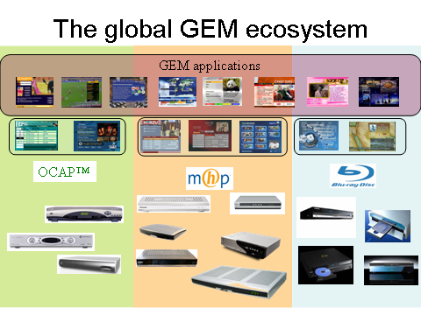
Standardisation Status

MHP-IPTV is a part of the MHP 1.2 specification which has been approved by the DVB Technical Module and will be sent to ETSI soon.

GEM-IPTV is formally a subset of the MHP 1.2 specification above and will be approved by the DVB Technical module in January (it already has preliminary approval) and sent to ETSI for formal standardisation shortly afterwards. In parallel, it will be submitted to the ITU IPTV Working Group, and to CableLabs in the US.

It is certain that GEM-IPTV applications will be binary compatible with MHP-IPTV. It is likely that GEM-IPTV will be chosen by CableLabs for OCAP, and hence GEM-IPTV applications should be binary compatible with OCAP-IPTV, when it exists.

Conclusion

GEM-IPTV provides a way out of the proprietary confusion that is being created in IPTV, without abandoning investment in head-end infrastructure.

You can use standardised applications, in line with the standards being deployed in the digital TV landscape, and have the option of moving to an end-to-end standardised solution whenever you choose.

___________

