IPTV Service scenarios
INTERNATIONAL TELECOMMUNICATION UNION |  |  |  | Focus Group On IPTV
TELECOMMUNICATION  STANDARDIZATION SECTOR  STUDY PERIOD 2005-2008 |  |  | FG IPTV-DOC-0170
 |  |  | English only
WG(s): 1 |  | 6th FG IPTV meeting:  Tokyo, Japan, 15-19 October 2007
OUTPUT DOCUMENT
Source: | Editor
Title | Living List: IPTV service scenarios
Summary
The purpose of this working document is :
- to identify and define the IPTV services relevant for the IPTV FG activities
- to identify the different players and roles in the value chain
- to classify these IPTV services
- to specify use cases for these IPTV services
- to specify requirements for the different players involved in these IPTV services
- to specify scenarios identifying the flows between functions of players
Contributions are requested for the next meeting on:
- the identification of IPTV services, confirmation of relevance of proposed services
- the definition of these services
- the classification/grouping of all these services by criteria such as proximity, commonality, importance, relevance, priority, etc. Considering that work on use cases and scenarios will start with the most important/relevant services. We might identify a core set of services and additional services and reject some services depending on the received support.
- Use cases
- High level requirements for the different players
- Service scenarios
Keywords
<Optional>
Introduction
<Optional – This clause should appear only if it contains information different from Scope and Summary>
1 Scope

2 References
<The following ITU-T Recommendations and other references contain provisions, which, through reference in this text, constitute provisions of this Recommendation. At the time of publication, the editions indicated were valid. All Recommendations and other references are subject to revision; users of this Recommendation are therefore encouraged to investigate the possibility of applying the most recent edition of the Recommendations and other references listed below. A list of the currently valid ITU-T Recommendations is regularly published.
The reference to a document within this Recommendation does not give it, as a stand-alone document, the status of a Recommendation>

3 Definitions
<Check in ITU-T Terms and definitions database under http://www.itu.int/sancho/index.htm if the term is not already defined in another recommendation. It could be more consistent to refer to such a definition rather than redefine it>

<C-203>
It is proposed to add the following to the list of terms in clause 3.
3.1 Advertising: A service rendered by the service provider which facilitates insertion of advertisement material to be seen by the viewers or listeners of linear broadcast TV.
3.2 Electronic publishing: A service providing users the ability of receiving and downloading books, magazines or other types of publications on a computer or a device located in the customer premises.
3.3 Game delivery: A service in which a video game playable on a computer (PC games) or a television (Console game) is delivered to the user either for instant (interactive) play or to be recorded by the user on a device located in the customer premises for future use.
3.4 Interactive TV (iTV): A service in which the user can send requests, within a browser environment, to the service provider in order to obtain additional information. This capability requires channels to have what is known as a 'return path'.
3.5 Linear broadcast TV: A service in which the user is provided with continuous video and voice streams flowing to the user terminal located at the customer premises or a user mobile device. The user has no control on the content or its delivery time and duration.
3.6 Music on demand (MoD): A service in which the subscriber can listen to music whenever desired, assuming the content is stored on the provider’s server. Subscribers can start listening at any time and typically have the ability to pause, rewind, fast forward the content, or even stop listening and return to it at a later time.
3.7 Pay per view (PPV): A service in which the user pays a fee to view content such as a movie, sporting event or concert at a predetermined start time, or times, set by the provider.
3.8 Personal video recording (PVR): A service which allows the user to store content (i.e. video, audio, graphics or text) on a digital storage medium or on a network storage device. If the recording device is at the customer premises, it is called a personal video recorder or digital video recorder. The device at the customer premises may be comprised of a stand-alone set-top box and associated software. Subscribers typically have the ability to pause, rewind, fast forward the content, or even stop viewing it and return to it at a later time.
3.9 Short message service (SMS): An interactive service that allows sending and receiving of short messages (text) between two users of personal computer, mobile devices or television consoles.
3.10 Tele-learning: An instructional service for delivering education to students who are physically located in a different geographic area than the instructor. Teachers and students can communicate in real time (i.e. both present at the same time) and/or non-real time (i.e. at time of their own choosing using a messaging capability).
3.11 Third party content delivery: A service provided to the user by a content provider not affiliated with the user’s service provider (i.e. a third party content provider).
3.12 Video on demand (VoD): A service in which the subscriber can view video content whenever desired. The operating assumption is that the content is stored on the provider’s VoD server. Subscriber accesses the movie from a library directory which may include search engine that accesses movie description and rating. Subscribers typically have the ability to pause, play, rewind, fast forward the content, or even stop viewing it and return to it at a later time when using this service.

<C-193>

Time-shifting service

Definition
An IPTV service in which subscribers can access (pause, rewind, fast forward, and etc) IPTV contents without time limitation.

<C-192>

Place-shifting service

Definition
An IPTV service in which subscribers can access (pause, rewind, fast forward, and etc) IPTV contents without place limitation.

4 Abbreviations
<Include all abbreviations used in this Recommendation>

5 Conventions
<Describe any particular notation, style, presentation, etc. used within the Recommendation if any>

6 Proposed unordered list of services for the IPTV FG activities
In order to have a better understanding of what is IPTV, this section provides a list of the IPTV services to be considered in the activities of the ITU FG IPTV. This list is unordered.
Contributions are expected on this list for clarification, support, relevance to the FG
- Linear/Broadcast TV (audio, video and data)
- Linear Broadcast TV with Trick Modes
- Multi-angle service
- Time-shift TV
- Pay Per View (PPV)
- Video/TV on Demand (VOD)
  - Near VoD (Video on Demand) broadcasting
  - Real VoD
- Download Based Video Content Distribution Services (Push VOD)
- Content download service
- PVR service (network or client-based)
- Interactive TV (iTV)
- Consumer Originated content (Video, etc. and applications)
- Consumer Originated broadcast TV (e.g. C2C hosting)
- Linear Broadcast Audio
- MoD (Music on Demand) including Audio book
- Pictures
- T-Learning (education for children, elementary, middle and high school student, languages and estate, etc.)
- Games
- Regulatory Information services
- T-information (news, weather, traffic and advertisement etc.)
- T-commerce (security, banking, stock, shopping, auction and ordered delivery, etc.)
- T-communication (e-mail, instant messaging, SMS, channel chatting, VoIP, Web, multiple video conference and video phone, etc.)
- T-entertainment (photo album, games, karaoke and blog, etc.)
- Presence service
- Advertising
- Communications Messaging
- Service Information (EPG: Electronic Program Guide, ECG: Electronic Content Guide, etc.)
- Portal services
- Hybrid services
- 3rd party content services

7 Definitions/descriptions of IPTV Services

7.1 Linear/Broadcast TV (audio, video and data)
Contributions are expected on this
<C-132>
2.1.1 Linear/Broadcast TV (audio, video and data)
- Linear/ Broadcast TV with audio and video: Linear/Broadcast TV with audio and video provides a picture quality similar to digital versatile disk (DVD) or higher quality display in many resolutions. A/V (Audio and Video) signals are broadcasted and distributed to the downlink without uplink feedback in real time.
- Audio only: Audio only Linear/Broadcast TV means for delivering only audio signals of sound, which has been processed like CD players from one point to another. Audio signals are broadcasted and distributed to the downlink without uplink feedback in real time.
- Linear/ Broadcast TV with audio, video, and data: These services are A/V services which are combined with interactive data for the related or supplementary information of A/V program using bi-directional link. User can enjoy the downlink A/V stream and access more detailed or value-added information via uplink simultaneously.

<C-176>
Broadcasting TV(BTV)
BTV is similar to the traditional CATV. BTV service forwardly pushes the same video-audio streams to large numbers of users at the same time, and the user must join acertain broadcasting channel when he wants to enjoy this service.
The external TV program sources include satellite TV、CATV and DVB etc, and the content of media-streams lies on the broadcast service provider, such as television station. The programs which are carried by BTV can be SDTV or HDTV, and its content is continuous and there is no obvious strat or end.
If the transmission networks support multicast, the IPTV system can provide BTV service to the users through multicast to improve the utilization of the network bandwidth; If the transmission networks don’t support multicast, the IPTV system can provide BTV service to the users through unicast.

7.2 Linear/Broadcast TV with trick modes
Contributions are expected on this
<C-132>
2.1.2 Linear Broadcast TV with Trick Modes (which is called as PVR, DVR, Time-shifted)
- Linear Broadcast TV with Trick Modes allows customer to pause live TV, instant replay of interesting scenes, and skip advertising through PVR or DVR system.
- PVR service (network or client-based)
The Personal Video Recorder service is consumer based electronic device service that records live program to the hard drive digital storage in standalone set-top boxes or network. This can provide the “time shifting”, “trick modes”, and complementary convenience functions such as recording onto DVDs, commercial skip, sharing of recordings over the Internet, programming and remote control by PDA, networked PC, or web browser.

<C-176>
Time-shift TV
The implementation of Time-shifted TV is to store the TV program into the network system while broadcasting TV program , the TV program will be stored according to prearranged time and displayed on the user terminal. When the user selects such TV program for some periods of time through EPG, the system can quickly go to right time point of the corresponding media-file and play the program to the user. When the user enjoys Time-shifted TV service, the user can finish the program pause、rewind、forward operation and give chase to the currently broadcasting program. Time-shifted TV service is an application which beautifully combines the content broadcasting capability and content storage capability.
When watching time-shift TV, the manipulation manner for watching is just like VoD.

PVR
PVR is that the users or operators record the broadcasting TV program for latter enjoyment or time-shift TV. PVR service includes Networked Personal Video Recorder(nPVR), Client Personal Video Recorder(cPVR).
When watching PVR, the manipulation manner for watching is just like VoD.

<C-193>

Time-shifting service
In a traditional TV service the time shifting service has been provided by the recording functionality such as VCR (Video Cassette Recorder). Then, some products using hard drive instead of tape are starting to prevail while supporting some fancy services such as automatic recording with key words, the name of actor, and etc, which is called as DVR (Digital Video Recorder) or PVR (Personal Video Recorder).
Note that the content should be stored so that subscribers can retrieve it later. The PVR devices are storing the contents in local hard drive. We can call this approach as subscriber-based time-shifting service. However, if we consider some cases in which it is not appropriate to save the contents locally. For example, if the IPTV terminal is PDA, the size of hard drive is limited. The network-based time-shifting mechanism is needed for those kinds of cases, which is also called as NVR (Network Video Recorder). In those solutions, hard drives are located at the network head-end as opposed to the subscriber's set-top box. In the network-based time-shifting service, the broadcasting traffic is transformed into on-demand traffic and service providers can leverage their existing VOD infrastructure already in place. Subscribers sign up for specific network-based time-shifting service and storage limits, and the service provider then gives them access to the IPTV content as it is delivered to their own terminals.
In summary, we can define two types of time-shifting service, subscriber-based and network-based time-shifting services in IPTV. The service name can be used as a representative service name of PVR, DVR, NVR, IPTV broadcasting with trick mode, and TV anytime.

7.3 Place-shifting service

<C-192>

Place-shifting service
This service makes subscriber see his or her subscribed IPTV contents anywhere. The place-shifting basically is to support users who move to the other place from the place where he or she originally subscribed for. This service is assuming that a user’s terminal can even be a mobile phone. However, since the mobile IPTV will be addressed in a separate category, we would not consider the case specifically.
Depending on who is taking care of redistributing the IPTV traffic, we can define two types of place shifting service, subscriber-based place-shifting and network-based place-shifting service. In subscriber-based place-shifting, a subscriber device redistributes traffic to the place where the user is currently located. In network-based place-shifting, service provider send the IPTV traffic to the moved place. The following sub-sections explain each type of the place-shifting service.

Subscriber-based place-shifting
In this method, service provider is just sending the traffic to the subscriber’s original place and a device in that place such as set-top box redirects the traffic to the subscriber’s current location after encoding the traffic as the format that the terminal which is located in the moved place can accept. Service provider is not involved in how the traffic is redirected after it sent the traffic to the original place. The advantage of this method is on its simplicity. All the intelligence is placed only in the device at home such as set-top box. However, content providers are not happy with this approach since contents are redistributed without their knowledge. DRM or CAS will help to solve the issue.

Network-based place-shifting
In this method, if a subscriber wants to receive IPTV traffic when he or she is away from home, he or she notifies to service provider that he or she moved to a different place and wants to receive the IPTV traffic in the current place. When the IPTV request comes from the new place, it has to make sure that the request is legitimate by using AAA (Authentication, Authorization, and Accounting) procedure. In addition, service provider has to send the IPTV traffic as a proper encoding format according to the new terminal’s capabilities.
There are several possible scenarios to support network-based place-shifting service. These scenarios can be arguable, but please see this as an initial working document to define this service. A scenario is to make users see their channels on PC or notebook without set-top box when he is away from home. Another scenario is to make users see their channels through the other persons’ set-top boxes.

7.4 Pay Per View (PPV)

<C-132>
2.1.3 Pay Per View (PPV)
- Pay per view is a streaming service that customers can purchase events or program to be seen on TV and pay for the choice of that events or program later. The user can buy the PPV service via on-screen guide, a telephone, or through a live customer service representative and see the events or program at any time within the expiration date.
- OPPV (Order-ahead PPV): The ability to order PPV programming ahead of time.
- IPPV (Impulsive PPV): The ability to order PPV programming impulsively.

7.5 Multi-angle service

<C-132>
2.1.4 Multi-angle service
- Multi-angle service is to provide more various different camera angles than the one station view. The viewer can select angle which he likes to watch. For example, when the customer watches the baseball game in TV, he can see the first base, third base, or backfield according to view’s wish not by the channel director’s attention.

7.6 Electronic Program Guide (EPG)

<C-132>
2.1.5 Electronic Program Guide (EPG)
- Electronic program guide (EPG) is sometimes also known as an IMG (Internet Media Guide), IPG (Interactive Program Guide), or BCG (Broadband Contents Guide) in an equivalent meaning on-screen guide to scheduled service program, contents and additional descriptive information, allowing a viewer to navigate, select and discover content by time, title, channel, genre, etc, by using of his remote control, a keyboard, a touchpad or even a phone keypad. Generally, EPG can be displayed in several types such as Mosaic EPG, Box EPG, Text EPG, Mini EPG, Tree EPG and so forth in according to the service provider’s business model.

7.7 Traditional Broadcast Advertising

<C-132>
2.1.6 Traditional Broadcast Advertising
- Traditional broadcast advertising is a commercial advertising or public promotion of goods, services, companies and ideas that are broadcast to the entire subscriber base in a region, usually inserted into between A/V programs. Each advertising service can be provided on a national basis or locally in a video clip or exclusive channel according to the service type and contract.

7.8 Video on Demand (VoD)

<C-132>
2.2.1 Video/TV on Demand (VoD)
- VoD is a service where customers select and watch video content over a network. Depending of the transmission method, the VoD can be sub-categorized as below:
- Near VoD service is a consumer based video service which is broadcasted by multi-channel broadcasters using high-bandwidth distribution mechanisms. Multiple copies of a program are broadcast at short time intervals (typically 10–20 minutes) providing convenience for viewers, who can watch the program without needing to tune in at a scheduled point in time. The customer has no control over the session except in choosing which program to watch.
- Real VoD service allows customers to select and watch video content over a network as part of an interactive and enhanced selective service. Real VoD service is “stream” content service that is consumed while it is being delivered. The customer has control over choosing which program or clips to watch.
- Push VoD (Which is a kind of download based video content distribution services) service is similar to the Real VoD in that customers can select and watch video content over a network as part of an interactive and enhanced selective service. However, Push VoD is “download” content service that is brought in it entirely or partially to a set-top box or similar device before viewing starts.

<C-176>
VoD
VoD is that the single user plays and watches video-audio stream program according to his own requirement and VoD is a point-to-point service. VoD can make the user control his time at his will and enjoy the program which he want. The user can find what he want in best times by browsing、querying and searching the content source data-base which is provided by the IPTV system, then the user submits his request through the terminal STB and enjoys the corresponding program. VoD can support fast-forward、rewind、pause operations.

<C-185>
- VoD based IPTV Service description
Here is the VoD based IPTV service description:
VoD based IPTV service is the on-demand video/audio/data streaming service triggered by user’s selection. It is usually provided as multiple independent unicast viewing sessions for the chosen content. It has few variations based on the billing/charging policy or add-on functions.

7.9 Music on Demand (MoD)

<C-132>
2.2.2 Music on Demand (MoD)
- Music on Demand service allows user to select and appreciate music or audio contents such as music file, music video and audio book over an IP network as an interactive enhanced selective service like the Real VoD.

7.10 Game on Demand (GoD)

<C-132>
2.2.3 Game on Demand (GoD)
- Game on Demand service allows user to select and enjoy computer or video games over an IP network as an interactive enhanced selective service like the Real VoD. GoD can encompass interactive video games on television involving single and multiplayer competitions.

7.11 interactive service

<C-132>
- Interactive service lets customers send various types of requests and receive feedback with interactivity.

7.12 T-information

<C-132>
2.3.1 T-information (news, weather, transportation, local community etc.)
- T-information is a television information service that supports a considerable amount of useful information such as news, weather, traffic situation and advertisements. Viewer can choose contents on the overlapped linked program screen or independent menu.

<C-203>

6.5.1 Community related information
These are services providing community related information, such as announcements, bus routes, weather and government services related information.

7.13 Monitoring services

<C-203>

6.3.2 Monitoring services
These are services which provide monitoring ands surveillance capability. Examples of such services are heath monitoring, surveillance of places, etc.

7.14 T-commerce

<C-132>
2.3.2 T-commerce (banking, stock, shopping, ticketing, auction, product delivery, event, etc.)
- T-commerce is a television commercial service that allows viewer to purchase goods and use financial services such as banking, stock, auction etc. For example, personal banking service can help user to view account balances, review past account activity, pay bills, and transfer money between accounts.

7.15 T-communication

<C-132>
2.3.3 T-communication (e-mail, messenger, SMS, channel chatting, VoIP, web surfing, multiple video conference, video phone, etc.)
- T-communication is a television communication service that enables customer to exchange information such as voice, video, and data. Users can send (or receive) the mail and message while watching TV. In addition, viewers can simultaneously interact with other people via two-way video and audio transmissions using video conference. T-communication is a key convergence service of telecommunication and broadcasting in the IPTV.

<C-203>

6.2.2 Messaging
An interactive service which offers user-to-user telecommunication between individual users. Messaging services may be immediate (e.g. instant messaging (IM)) or of a store-and-forward type (e.g. email and voice mail).

7.16 T-entertainment

<C-132>
2.3.4 T-entertainment (games, karaoke, photo album, lottery, blog, etc.)
- T-entertainment is a television entertainment service that contributes viewer’s amusement by providing exciting items such as games, karaoke, and photo album. Games can be sub-divided into single player and multi-player games according to the number of player. Moreover, it can be classified into a network linked game and a stand alone game according to the network interaction type. In the photo album, user can enjoy pictures which they upload or which are provided by provider and transfer it to other people’s TV, mobile phone or etc.

7.17 T-learning

<C-132>
2.3.5 T-learning (infant, children, school student, languages, financial skill, etc.)
- T-learning is a television learning service that educates viewers through lectures, tutorials, simulations, quiz, job aids, game, and more. Also, T-learning can be effectively provided by either combining distance learning with direct contact of human educational resources, or combining software driven resources with any other educational academy resources.

7.18 T-government

<C-132>
2.3.6 T-government (notice, civil appeal, tax payment, poll, etc.)
- T-government is a television government service that treats civil appeal, tax payment, public poll, Government Issue notice and etc. T-government enhances the government productivity and transparence by unifying and opening administration service.

7.19 Interactive Program Guide (IPG) / Electronic Contents Guide (ECG)

<C-132>
2.3.7 Interactive Program Guide (IPG) / Electronic Contents Guide (ECG)
- IPG / ECG is on-screen guiding to scheduled interactive service program, contents and additional descriptive information. It allows a viewer to navigate, select and discover content by time, title, channel, genre, etc, by using of his remote control, a keyboard, a touchpad or even a phone keypad. IPG/ECG is similar to the EPG of linear broadcast service in the meaning.

7.20 Targeted Advertising

<C-132>
2.3.8 Targeted Advertising (personal, interactive, on demand related advertising, etc.)
- Target Advertising is a commercial advertising or public promotion of goods, services, companies and ideas, usually personalized for customer’s desired profile characteristics in order to match the audience with the campaign objective requirements. The advertising can be targeted according to a number of factors such as their programs of interest by utilizing niche programming, demographic classification (such as gender, age, language, education, income, race or ethnicity and geography), the time of day, shopping habits and personal preferences. Target advertising can be more relevant in IPTV services than today’s TV advertising with personal, interactive, customer related advertising characteristics.

7.21 Portal Service

<C-132>
2.4 Portal Service
- Portal service is a branded aggregation of products and services designed to satisfy a large majority of user’s needs, such as VoD, shopping, banking, communication, entertainment and other interactive services with portal menu. Portal service can target of customers with broadcasting of commercials, advertisements and interactive response advertising.

7.22 Terrestrial portal

<C-132>
2.4.1 Terrestrial portal (news, drama, sports, movies, etc.)
- Terrestrial portal service is a branded aggregation of terrestrial contents such as news, drama, sports, movies, and talk show, etc. It provides basic terrestrial channel, VoD, PPV, contents connected interactive service, and multi-angle service with various terrestrial contents.

7.23 Data portal

<C-132>
2.4.2 Data portal (walled garden, internet access, etc.)
- Data portal service is a branded aggregation of internet contents with wall garden access for information, shopping, banking, learning and other communication service with interactivity.
Also, it can support direct internet access for more specific information search.

7.24 Hosting Service

<C-132>
2.5 Hosting Service
- Hosting service is a type of IPTV platform & service hosting that provides organizations and individual users with on, off-line system and network for storing information, image, video, or any content accessible via the IPTV.

7.25 Business to business IP hosting

<C-132>
2.5.1 Business to business IP hosting
- The business to business hosting service is an IPTV hosting service for the special group or business unit subscriber. It connects the channel, VoD, and portal service made by customer business unit to the IPTV platform to supply particular groups with real time broadcasting channels, value-added interactive services and T-community activity etc. Generally, it includes a regional community, religion unit, and small business company broadcasting and interactive data service.

7.26 User Created Contents (UCC) hosting

<C-132>
2.5.2 User Created Contents (UCC) hosting (consumer originated broadcast TV, content service, etc.)
- User Created Contents (UCC) hosting service is an IPTV hosting service for individual customer as a user generated Video, interactive content data. This service allows customer to make their own channel like personal web TV by uploading A/V, application and other contents that they generate through IPTV hosting platform.

7.27 3rd Party Content Services

<C-132>
2.6 3rd Party Content Services
- 3rd Party Content Service is a consumer based wide selection service of contents. This 3rd party content service can provide interoperability of contents selection and supply between customer and service provider. For this service, internetworking interface, interoperable middleware to support various selections of different contents source and contents protection scheme such as DRM (including CAS) are required to provide appropriate adaptation of 3rd party content service.

8 Players/roles

8.1. Identification of players/roles
- Content providers
- Application providers
- Content aggregators
- Service providers
- Network providers
- Consumers (subscriber, viewer, etc.)
- Regulators

Some companies may play several roles.

8.2. Definition of players/roles
These definitions are extracted from contribution ID-25. More official definitions are expected.

Content provider: The content provider is the entity owning contents or being licensed to sell content assets. Their role is contents production and delivery.

Application provider (from ID-16): The application provider is the entity providing IPTV-related user interface applications.

Content aggregator (from ID-19): aggregate contents a la TV channel for example.
Service provider: The service provider is the entity providing a service to end-user through a procedure of receiving, manipulating, value-added processing and transmitting contents with security and management using an IPTV platform.
Network provider: The network provider is the entity connecting customer and service providers with control and management for the secured delivery of contents in several layers such as core, distribution and access layer.
Consumer: The customer is the entity that the IPTV services are consumed.
Regulator: TBD.

9 Classification of IPTV Services
Contributions are expected on this

<C-114>
This is the list of potential IPTV services. And we suggest that the IPTV services should be classified into Entertainment Services, Application Services, Advertising and Hybrid Services according to the aspect of user experience and usage.
- Entertainment Services
  - Multimedia Entertainment Services
- Broadcast TV (audio, video and data)
- Multi-angle service
- Broadcast TV with Trick Modes
- Time-shift TV
- Pay Per View (PPV)
- Video/TV on Demand (VOD)
  - Near VoD (Video on Demand) broadcasting
  - Real VoD
- Download Based Video Content Distribution Services (Push VOD)
- PVR service (network or client-based)
- Interactive TV (iTV)
- Consumer Originated broadcast TV (e.g. C2C hosting)
- Consumer Originated Video
- Broadcast Audio
- MoD (Music on Demand) including Audio book
- Content download service
- Interactive Entertainment Services
- Games
- Pictures
  - photo album
- karaoke
- blog
- Application Services
- T-information (news, weather, traffic and advertisement etc.)
- T-commerce (security, banking, stock, shopping, auction and ordered delivery, etc.)
- T-communication (e-mail, instant messaging, SMS, channel chatting, VoIP, Web, multiple video conference and video phone, etc.)
- Communications Messaging
- Presence service
- T-Learning (education for children, elementary, middle and high school student, languages and estate, etc.)
- ADVERTISING
- Advertising
- Targeted Advertising
- Interactive Advertising
- Portal Services
- Regulatory Information services
- Hybrid Services
- 3rd party content services
Service Information (EPG: Electronic Program Guide, ECG: Electronic Content Guide, etc.)

<C-131>
Main classifications of IPTV services should be considered basically and first in IPTV service. Other services can be added into the optional classification.

Table 1. Main classifications of IPTV Services
Classification |  | Priority
1st classification | 2nd classification | Stage 1 | Stage 2 | Stage 3
Broadcast Service | Linear/Broadcast TV (audio, video and data) | √
Broadcast Service | Linear Broadcast TV with Trick Modes  (PVR, DVR, Time-shifted) |  | √
Broadcast Service | Pay Per View (PPV) (OPPV, IPPV) | √
Broadcast Service | Multi-angle service |  | √
Broadcast Service | Electronic Program Guide (EPG) | √
Broadcast Service | Traditional Broadcast Advertising | √
On Demand Service | Video on Demand (RVoD, NVoD, Push VoD, etc.) | √
On Demand Service | Music on Demand (Music, Music Video, Audio Books etc.) | √
On Demand Service | Game on Demand |  | √
Interactive  Service | T-information  (News, weather, transportation, local community etc.) | √
Interactive  Service | T-commerce (Banking, stock, shopping, ticketing, auction, delivery, event etc.) | √
Interactive  Service | T-communication (e-mail, messenger, SMS, channel chatting, VoIP, web surfing, multiple video conference, video phone, etc.) | √
Interactive  Service | T-entertainment  (Games, karaoke, photo album, lottery, blog, etc.) | √
Interactive  Service | T-learning  (Infant, children, school, languages, financial skill, etc.) | √
Interactive  Service | T-government (notice, civil appeal, tax payment, poll etc.) |  | √
Interactive  Service | Interactive Program Guide (IPG)  Electronic Contents Guide (ECG) | √
Interactive  Service | Targeted Advertising  (Personal, interactive, On demand related advertising, etc.) |  | √

Table 2. Optional classifications of IPTV Services
Classification |  | Priority
1st classification | 2nd classification | Phase 1 | Phase 2 | Phase 3
Portal Service | Terrestrial portal (news, drama, sports, movies, etc.) | √
Portal Service | Data portal (walled garden, internet access, etc.) |  | √
Hosting Service | Business to business IP hosting |  | √
Hosting Service | User Created Contents (UCC) hosting  (consumer originated broadcast TV, content service, etc.) |  | √
3rd Party Content Service |  |  |  | √

Main classification of IPTV services can be categorized as follows more specific:
First, Broadcast Service is composed of linear/Broadcast TV, Linear Broadcast TV with Trick Modes (It is can be called with PVR, DVR, and Time-shifted), Pay Per View (PPV), Multi-angle service, Electronic Program Guide (EPG), and Broadcast advertising.
Second, On Demand Service can be categorized with Video on Demand (VoD), Music on Demand (MoD) and Game on Demand (GoD). VoD can be sub-divided Real VoD, Near VoD, and Push VoD according to the implementation method.
Third, Interactive Service is made up of several interactive service topics such as T-information (News, weather, transportation, local community etc.), T-commerce (Banking, stock, shopping, ticketing, auction, delivery, event etc.), T-communication (e-mail, messenger, SMS, channel chatting, VoIP, web surfing, multiple video conference, video phone, etc.), T-entertainment (Games, karaoke, photo album, lottery, blog, etc.), T-learning (Infant, children, school, languages, financial skill, etc.), T-government (notice, civil appeal, tax payment, poll etc.) and service information such as IPG or ECG, and finally, the targeted advertising such as personal, interactive, and on demand related advertising.

1.2 Optional Classifications of IPTV services
Optional classifications of IPTV services can be categorized as follows more specific:
First, Portal Service consists of terrestrial portal and data portal service. Terrestrial portal provides a lot of terrestrial contents such as news, drama, sports, movies, etc. with a type of Live Broadcast, VoD or other information service. Data portal treats web based contents in a PC with a type of walled garden service or real internet access data service.
Second, Hosting Service contains the Business to Business (BtoB) IP hosting service for some organization and User Created Contents (UCC) hosting for the individual customer.
Third, 3rd Party Content Service can provide interoperability of contents selection and supply. This allows customer to select wider contents in several service providers and different networks via adaptive interface.

Above classifications of IPTV services give the guide line of IPTV service scope and service scenario with IPTV service definition. As emerge a new service in IPTV, we can classify and add it into the 1st category or 2nd category vertically.

This contribution proposes classifications of IPTV services for the IPTV service scenario as a development point in a global IPTV issue. It is proposed to transfer this contribution as a valuable input in ITU-T FG IPTV study for further discussion.

<C-184>
2. IPTV Service classifications and descriptions

- IPTV-Communication
IPTV-Communication is the IPTV-based communication service that provides methods for video, audio and data (text) information exchange. This service includes SMS (Short Message Service), T-mail (sending e-mail by TV terminals), VoIP, Video Conference, TV Messaging (instance messaging or chatting through TV terminal) and so on.

- IPTV-Interactive
IPTV-Interactive is the IPTV-based interactive service which provides contents or information service with interactive communications between service providers and users. This service includes network games, Information services (news, weather, traffic, movie/theater ticket query), e-Learning (real-time, distance learning), TV Voting (TV survey, TV quiz), TV karaoke and so on.

- IPTV-Commerce
IPTV-Commerce is the IPTV-based commerce service which allows users to purchase goods and use financial services by providing means of payment and secured financial service supporting programs through the TV terminal. This service includes shopping, Interactive Advertisement (interactive-AD: TV banner, PIP Advertisements), T-Banking, stock market service and so on.

- IPTV-VOD
IPTV-VOD is the IPTV-based Video-on-demand service that provides video, audio and data service triggered by user’s selection. This service includes SVoD (subscribtion-VoD), FVoD (Free-VoD), Push VoD, NVoD (Near Vod), Time-shift TV and so on.

- IPTV-Channel
IPTV-Channel is the IPTV-based channel service that provides video, audio and data linear broadcasting service.

Table 1. IPTV service classifications
Classifications | Example Services | Sub-classifications | Features
IPTV-Communication | SMS, T-mail, VoIP, Video Conference, TV Messaging (instance messaging or chatting) |  | QoS/QoE
IPTV-Communication |  |  | Storage & security
IPTV-Communication |  | Mobile IPTV service | Network control including mobility
IPTV-Communication |  | EPG/IPG | Media processing & control
IPTV-Communication |  | Portal Service | Navigation & Discovery
IPTV-Interactive | Information services (news, weather, traffic, movie/theater ticket query), e-Learning, TV Voting (TV survey, TV quiz), Games, TV karaoke |  | QoS/QoE
IPTV-Interactive |  | Download service | Storage & security
IPTV-Interactive |  | Mobile IPTV service | Network control including mobility
IPTV-Interactive |  | EPG/IPG | Media processing & control
IPTV-Interactive |  | Portal Service | Navigation & Discovery
IPTV-Commerce | Shopping, T-Banking, Stock market service, Interactive Ad. (Picture-in-picture Advertisement, banner) |  | QoS/QoE
IPTV-Commerce |  |  | Storage & security
IPTV-Commerce |  | Mobile IPTV service | Network control including mobility
IPTV-Commerce |  | EPG/IPG | Media processing & control
IPTV-Commerce |  | Portal Service | Navigation & Discovery
IPTV-VOD | SVoD, FVoD, PPV |  | QoS/QoE
IPTV-VOD | SVoD, FVoD, PPV | PVR, Push VoD, Download service | Storage & security
IPTV-VOD | SVoD, FVoD, PPV | Mobile IPTV service | Network control including mobility
IPTV-VOD | SVoD, FVoD, PPV | EPG/IPG, Multi angle/channel service, Time-shift TV, NVoD | Media processing & control
IPTV-VOD | SVoD, FVoD, PPV | Portal Service | Navigation & Discovery
IPTV-Channel | Linear Audio/Video/data broadcast, PPV |  | QoS/QoE
IPTV-Channel | Linear Audio/Video/data broadcast, PPV | PVR | Storage & security
IPTV-Channel | Linear Audio/Video/data broadcast, PPV | Mobile IPTV service | Network control including mobility
IPTV-Channel | Linear Audio/Video/data broadcast, PPV | Linear broadcast with trick mode, Multi angle/channel service | Media processing & control
IPTV-Channel | Linear Audio/Video/data broadcast, PPV | Portal Service | Navigation & Discovery

<C-196>

Classifications of IPTV Services
The IPTV services can be classified into 4 major categories as shown in Table 1.
- Content service : these services guide the user accessing content, deliver content to the user and let the user control the delivered content in its consumption. The content may include various types of media including video, music, audio, text, picture and so on.
  - Channel service : these services continuously provide series of content in the pre-programmed order. These services can be implemented with multicast streaming.
  - Content-On-demand service : these services provide content on user’s request with streaming or download. These services differ from channel services in that the user controls when and what to be transmitted, and the on-demand content has a defined beginning and end.
  - Navigation service : these services give the user information on what/how to access the content and services.
- Interactive service : these services need the individual service logic to be executed on the customer device and/or the service server. This category may include T-information, T-entertainment, T-government and so on.
  - Bound interactive service : these services are bound to or associated with the current channel/content and provided in relation with the current channel/content in terms of time. This category includes quiz, survey, game and information services on the current content.
  - Unbounded interactive service : these services are not related with the current channel/content. Each service can be executed independently with the current channel/content. This category includes game and information services such as weather, traffic, news service.
- Commerce service : these services support user’s business activity. These can be considered as a variation of the interactive service. However, these services require high level of security and reliability, by the nature of services.
  - Interactive advertisement service : these services provide user information on goods and services, interactively.
  - Trade service : these services are enable user to make commercial transaction including shopping, banking, stock trading and so on.
- Communication service : these services provide users the means for interacting with others, such as messaging, e-mail, phone call.
  - Internet-based communication service : these services provide internet-based interaction between users, such as e-mail, instance messaging and presence service.
  - Telephony-based communication service : these services provide telephony-based interaction between users, such as VoIP (Voice over IP) call, video conference and short messaging service.
IPTV services are supposed to be provided in the cooperation of various kinds of players, Content Service Provider (CSP), Internet Service Provider (ISP), Application Service Provider (ASP) and Telecommunication Service Provider (TSP). Event if IPTV Service Provider (IPTV SP) may play several roles, each player can be identified by its native role.
The IPTV service provider implements the IPTV services with following steps.
- Acquires content and service logic
- Processes (reformat, encode, add/delete content and create service information) or verifies them
- Deploys them into its delivery platform and service platform
- Delivers content or service logic to the customer device (Service logic may be delivered as the embedded application in the customer device or downloaded when needed.)
The service logic delivered to the customer device is executed to realize service to the user. And the content is processed and presented to the user by service logic. Services can be classified as follows with the entity processing the user’s request.
- By the customer device – the user request is processed with only the customer device’s functionality.
- By another SP’s server - the user request is processed with interaction between the customer device and another service provider without any intervention of IPTV SP’s service platform.
- By the IPTV SP’s server – the user request is processed with interaction between the customer device and IPTV SP’s service platform.
- By the IPTV SP’s server and Another SP’s server – the user request is processed with interaction between the customer device and another service provider, but IPTV SP mediate the interaction (i.e. The IPTV SP translates, relays, controls, monitors the on-going service and provides information for the service).

Figure 1 Types of IPTV Service System Entity Relation

Table 1 Classification of IPTV Services
Service Category |  | The Entity to process the user’s request
1st Level | 2nd Level | Customer device | Another SP’ server | IPTV SP’s server | IPTV SP’s server and another SP’s server
Content | Channel | Trick Mode  PVR |  | Linear/Broadcast TV and Audio  Broadcast Ad.  Time-shift TV  PPV  Emergency Information  Closed Caption | 3rd Party Channel  Consumer Originated Broadcast TV
Content | On Demand |  |  | Real/Near/Push Content on Demand  NPVR  Multi-angle | 3rd Party Content  Consumer Originated Content
Content | Navigation | Home Network Content Access |  | Service Information  Content Advisory  Walled Garden  IPTV Portal
Interactive | Bound |  | Content-related quiz/poll/information | T-Learning
Interactive | Unbound | Game | Weather  Traffic  News  Stock Ticker  Game | Karaoke
Commerce | Interactive advertisement |  |  | Interactive Ad.  Targeted Ad.
Commerce | Trade |  | Shopping  Auction  Banking  Stock Trading
Communication | Internet based |  | Internet Portal  Internet Access  Web based internet service |  | E-mail  Presence  Chat
Communication | Telephony based |  |  |  | SMS  Caller ID  VoIP call/conference  Video call/conference

Discussion
Each service category in Table 1 has its specific technical issues. Table 2 lists the technical issues for implementing services in each service category. Table 3 shows the related IPTV standardization area for each type of IPTV service system entity relation. We use “IPTV Service System Model” in FG IPTV OD-30 for categorizing issues and standardization area of Table 2 and 3.
In general, each row in Table 1 means additional complexity for IPTV service systems. And each column in Table 1 means scope of standardization for services. The service, that needs only the customer device for processing, can be standardized by defining specific function for the service. However, if the service is processed by another SP’s server, it implies additional consideration for interworking and compatibility.

Comment on relevance of hybrid service : Hybrid service, which means IPTV service provider delivers content and service via the IPTV network and the other network, is listed as one of IPTV services in FG IPTV OD-26. Hybrid service does not mean another service in user’s perspective, but a technical candidate for implementing and providing IPTV services.

Table 2 Technical Issues
1st Level | Content |  |  | Interactive |  |  | Commerce |  | Communication
2nd Level | Channel | On Demand | Navigation | Bound | Unbound |  | Advertise-ment | Trade | Internet based | Telephony based
Distribution network model | Multicast, Bandwidth, Delay, Jitter |  |  |  |  |  | Security |  |  | Security, Bandwidth, Delay, Jitter
IPTV service server entity model | Metadata, Storage, Signalling |  |  |  |  |  | Privacy, Security |  |  | Privacy, Protocol stack, Transcoding, Numbering, Charging
CPE model | Digital right management, Media format/codec, Storage |  |  | Execution engine, Security, Protection |  |  | Execution engine, Security, Protection |  | User interface (keyboard support, display)  Compatibility (browser capability, character set, …)  Protocol stack | User interface (mic./camera support)  Codecs  Protocol stack
Home network model | Selection among various standards |  |  |  |  |  |  |  | Selection among various standards
Related SP | CSP |  |  | CSP |  | ASP | ASP |  | ISP | TSP

Table 3 Related Standardization Areas
 | The Entity to process the user’s request
 | Customer device | Another SP’s server | IPTV SP’s server | IPTV SP’s server and another SP’s server
Distribution network model |  |  | Yes | Yes
IPTV service server entity model |  |  | Yes | Yes
CPE model | Yes | Yes | Yes | Yes
Home network model | Yes

10 Use cases for IPTV Services
Contributions are expected on this.

10.1 Linear/Broadcast TV (audio, video and data)
Contributions are expected on this.

10.2 Linear/Broadcast TV with trick modes
Example of use case to be used as a model for contribution on use cases
A consumer will want to pause live incoming content on their receiving device so that they can "resume" later and continue to watch the content in time shift mode.

10.f PVR Services (network- or client-based)
Example of use case to be used as a model for contribution on use cases
A consumer will want to allow the PVR to automatically capture content based on their viewing behaviour (profiling).

10.n SI Information
Other example of use case to be used as a model for contribution on use cases
A consumer will want to view a schedule of forthcoming items so they can choose content to record.

11 Use cases for combination of IPTV Services

Contributions are expected on this
E.g.: viewing a content and messaging the content reference to a friend.

12 Commercial/business models
Further contributions are expected on this
There are a number of well-known business models for service providers to support IPTV service and to make profitable revenue by composing various service products.
Generally, classified service products can be commercial model according to the service provider’s policy and marketing.
Here is a proposed list of business/commercial models but other models and combinations might be possible.
- Free
A viewer can watch IPTV service or use it without paying for it.
- Subscription
A viewer should pay an amount of money regularly in order to watch or use IPTV service.
- Pay per view (PPV) / Pay per use (PPU)
A viewer can purchase each service, content or application to be seen on TV at any time and pay for the only item he buys. E.g. each service or content can be purchased using an on-screen guide, an automated telephone system, or through a live customer service representative.
- A La Carte
A viewer can buy whichever channels and contents he wants, and pay a price for each. In this time, the channel is composed not by the service provider but by the user.
- Cash-back Point
A cash-back point is prepaid e-money or ticket for IPTV service. With these cash-back points user can pay the service fee in IPTV service domain like real-money. User can acquire the cash-back points by buying it with real money or accumulating bonus cash-back point which accrues in a particular rate when they use the IPTV service. The cash-back point can be a unit of price of detailed service. (Similar to frequent flyers miles)
- Package
A viewer can select and use a set of products such as VOD (including channel) and T-entertainment (including game, karaoke and so forth) which are already organized by the service provider. Then, pay for the set of products which he or she chooses.
- Etc.

13 General (end-user) requirements
This includes for example requirements on:
- Service roaming between access networks
- Service roaming between countries/operators
- Multi-device service delivery
- Etc.
Contributions are expected on this

14 High level requirements from other players
Requirements from consumers have already been specified by the use cases in the previous chapters.
Contributions are expected on this

14.1 High level requirements from Content Providers
Contributions are expected on this
Example of requirement to be used as a model for contribution on requirements
The rights of the content providers shall be preserved along the value chain.

14.2 High level requirements from Service Providers
Contributions are expected on this
Example of requirement to be used as a model for contribution on requirements
The service provider shall be able to upgrade the firmware of the devices that can access the services.

14.3 High level requirements from Network Providers
Contributions are expected on this

14.4 High level requirements from Regulators
Contributions are expected on this

15 Services scenarios with flows between functions of players

Contributions are expected on service scenarios (as illustrated below) and on scenario description describing the identified flows.

<C-134>
1. Identification of functional components of players.
With regard to the requirement and architecture of IPTV, this contribution uses the player with “contents provider”, “service provider”, “network provider”, and “customer”.
Each functional component identified as follows:
1.1 Functional components of contents provider
Contents provider is the entity owning contents (including application) or being licensed to sell its content assets. Their role is contents production, delivery, management and aggregation.
- Contents production
- Contents delivery
- Contents management
- Contents aggregation
- CP, PP, DP Server

1.2 Functional components of service provider
Service provider is the entity providing a service to end-user by using IPTV platform. Their role is service providing in procedure of contents receiving, manipulating, value-added processing and transmitting with security and management.
- Contents receiving function – baseband system.
- Contents manipulation function – content ingestion, encoding, and multiplexing.
- Interactive data processing function – data broadcasting generation, data aggregation, data encoding, PSI/SI generation, portal sub-system, and data middleware.
- Security function – DRM (Digital Right Management), and CAS (Conditional Access System) sub-system.
- Media operation management function – contents contraction, common data management, service scheduling, service products management, commercials, monitoring & supervision
- On demand streaming function – VoD (MoD, GoD) stream control, and streaming storage.
- CRM (Customer relationship management) function – Customer profile management, customer identity, and Billing
- Portal Server
- Hosting Server
- Return Path Server
- Call Center
- 3rd Party Contents Service Provider

1.3 Functional components of network provider
Network provider is the entity connecting customer and service provider with control and management for secured delivery of contents in several layers such as core, distribution and access layer through fixed line (xDSL, fiber, and cable) or mobile network
- Network control and management function- network authentication function, QoS & admission control function.
- Fixed network (xDSL, fiber, and cable)
- Mobile network
- Core layer
- Distribution layer
- Access layer

1.4 Functional components of customer
Customer is the entity that the IPTV services are consumed.
- Home gateway
- Set-Top-Box (can include storage for PVR)
- Display
- Mobile terminal
- PC & Browser
- Phone
2. Each service scenario of IPTV services.
2.1 Broadcast Service
2.1.1 Linear/Broadcast TV (audio, video and data)
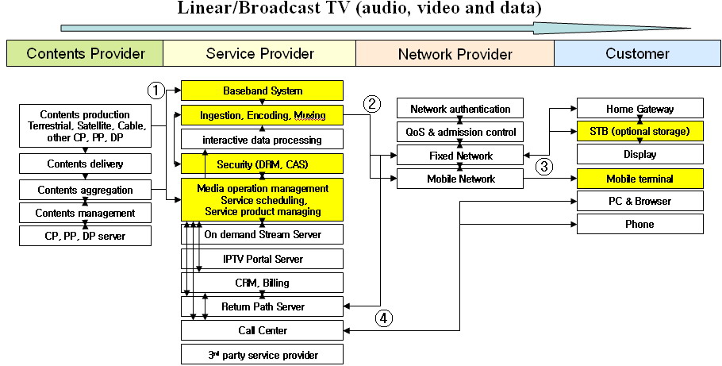
Linear/ Broadcast TV (audio, video and data) service is proceeding as follows:
- Program contents which are produced by terrestrial, satellite, cable and other CP, PP, DP are aggregated and delivered to the Baseband System. At the same time the program schedule and specific metadata are delivered to the Media operation management.
- First, Media operation management controls the service schedule and composes service product. Then, encoded, scrambled contents and interactive processed data are muxed. Finally, muxed program contents are transmitted to the network.
- STB or Mobile terminal receives the program contents through multicast join and displays it.
- If the customer wants more additional service, the user can request it by PC, Phone, STB itself to the Call Center or CRM via return path server.

2.1.2 Linear Broadcast TV with Trick Modes (which is called as PVR, DVR, Time-shifted)
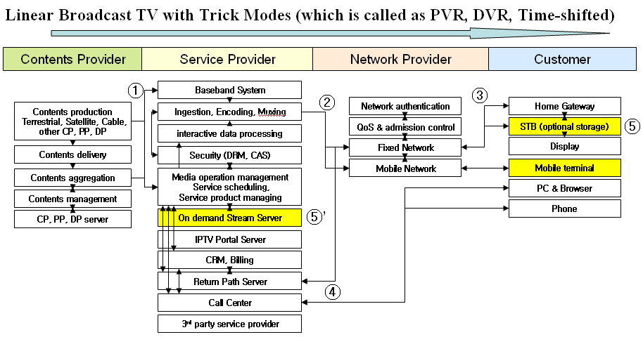
Linear Broadcast TV with Trick Modes (which is called as PVR, DVR, and Time-shifted) is proceeding as follows:
- ~ ④ The Linear Broadcast TV service is same with the 2.1.1.
- When the customer requests the trick mode service (PVR, DVR, Time-shifted), the STB records the program contents in the STB storage. Then, the stored program contents are displayed. In this time, trick mode, forwarding, rewinding, pause, stop function are possible.
⑤' When the customer requests the trick mode service (PVR, DVR, Time-shifted), the Service Provider records the program contents in the On demand Stream Server, especially PVR(DVR) network storage. Then, the stored program contents are displayed. In this time, trick mode, forwarding, rewinding, pause, stop function are possible.
2.1.3 Pay Per View (PPV)
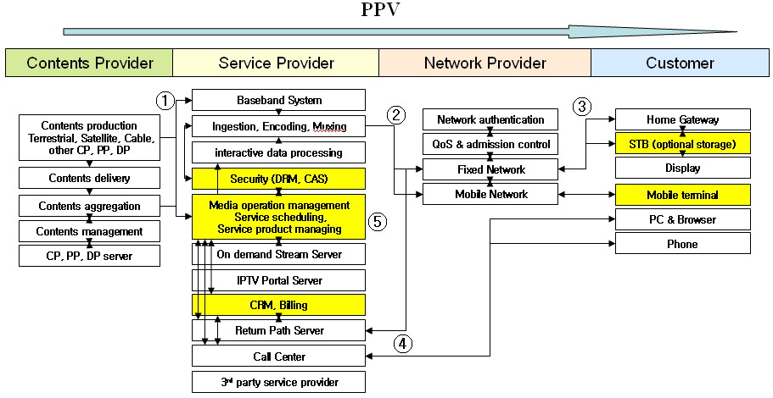
PPV (Pay Per View) is proceeding as follows:
①~ ④ The Linear Broadcast TV service is same with the 2.1.1.
- According to the customer’s request, the CRM changes the status of customer and charges the service price. At the same time, the Media operation management allows the customer to watch the requested program contents in terms of Security control.

2.1.4 Multi-angle service
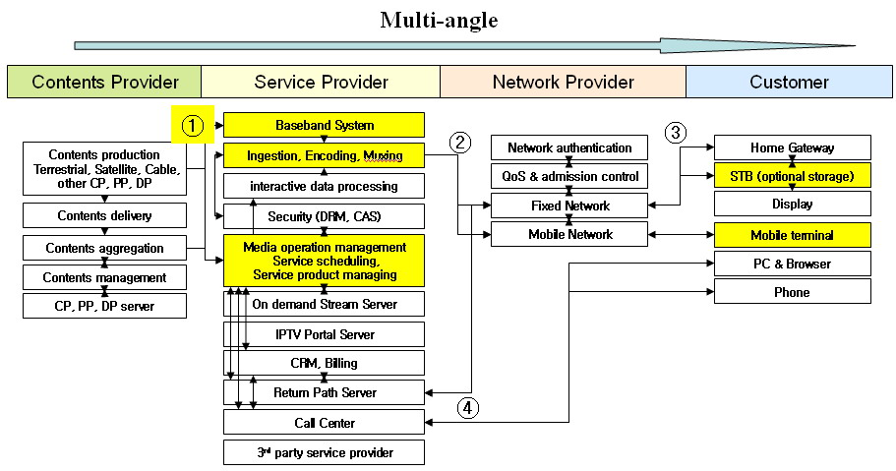
Multi-angle service is proceeding as follows:
- Program contents which are produced by terrestrial, satellite, cable and other CP, PP, DP are aggregated and delivered to the Baseband System. At this time, program content contains several angles of program. For example, in the baseball game program content, there are first base view, second base view, third base view, and backfield view, etc. At the same time the program schedule and specific metadata are delivered to the Media operation management.
- First, Media operation management controls the service schedule and composes service product. Then, encoded, scrambled contents and interactive processed data are muxed. Finally, muxed program contents are transmitted to the network.
- STB or Mobile terminal receives the program contents through multicast join and displays it. The viewer can select angle which he likes to watch.
- If the customer wants more additional service, the user can request it by PC, Phone, STB itself to the Call Center or CRM via return path server.
2.1.5 Electronic Program Guide (EPG)
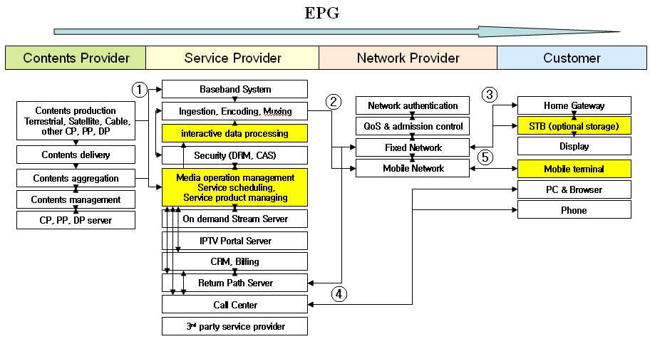
EPG (Electronic Program Guide) is proceeding as follows:
①~ ④ The Linear Broadcast TV service is same with the 2.1.1.
- According to the customer’s request, the EPG application shows specific information and A/V in several types such as mosaic, text, box, mini and navigator EPG. When the viewer selects particular channel or program, the EPG application links to the channel or program through the multicast join.
2.1.6 Traditional Broadcast Advertising
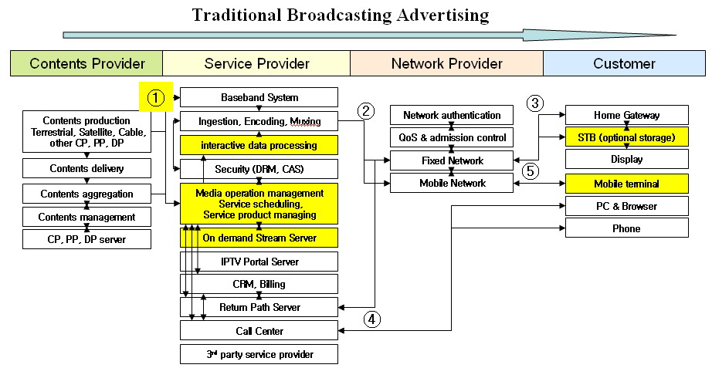
Traditional Broadcast Advertising is proceeding as follows:
- Broadcast advertising and program contents which are produced by terrestrial, satellite, cable and other CP, PP, DP are aggregated and delivered to the Baseband System. At the same time, broadcast advertising and program schedule with specific metadata are delivered to the Media operation management.
- First, Media operation management controls the broadcast advertising schedule and inserts the advertising between program contents. Then, encoded, scrambled advertising contents and interactive processed data are muxed. Finally, muxed program contents are transmitted to the network.
- STB or Mobile terminal receives advertising contents with broadcast programs through multicast join and displays it.
- If the customer wants more additional service, the user can request it by PC, Phone, STB itself to the Call Center or CRM via return path server.
- When the customer participates in the special events or additional information of advertising, the customer’s terminal displays them through multicast join.

2.2 On Demand Service
2.2.1 Video on Demand (VoD)
2.2.2 Music on Demand (MoD)
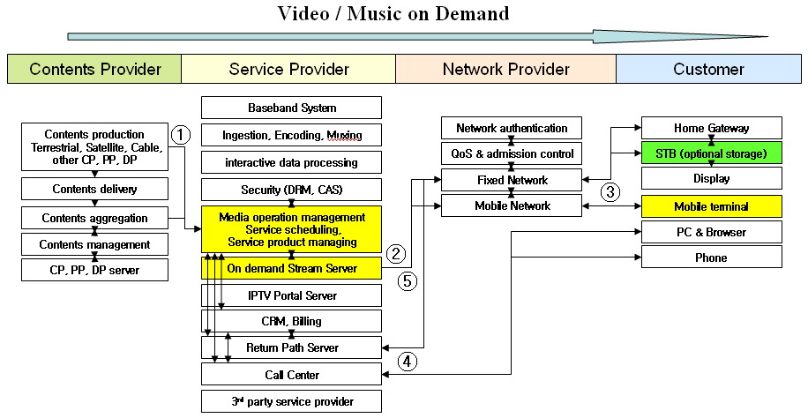
Video / Music on Demand service is proceeding as follows:
- Video / music program contents which are produced by terrestrial, satellite, cable and other CP, PP, DP are aggregated and delivered to the Media operation management.
- Media operation management transmits the received contents to the on demand Stream Server after additional processes such as service product managing, contents encryption, etc. Then, the contents list and main frame are distributed to the network.
- The customer selects video / music program contents via STB or Mobile terminal. According to the service type, the procedure is divided like this:
i) NVoD: STB or Mobile terminal access contents through multicast join and display it.
ii) RVoD: STB or Mobile terminal access contents through unicast request and display it.
iii) Push VoD: STB or Mobile terminal receives the contents in each storage advance, then, when some degrees of content are received, contents are displayed.
- If the customer wants more additional service, the user can request it by PC, Phone, STB itself to the Call Center or CRM via return path server.
- According to the customer’s request, the CRM changes the status of customer and charges the service price. At the same time, the Media operation management allows the customer to watch the requested program contents in terms of Security control.

<C-185>
- VoD based IPTV service scenario
In general, the Video on Demand (VoD) service is composed by two phased distribution − initial source acquiring and content manipulating phase done by Contents Provider and Service Provider and secondary service querying and distribution phase done by interaction between the Content Provider and user and Network Provider.
Here we depict a basic VoD based IPTV service scenario with following components:

- VOD source: Content source that is pre-recorded on a medium such as videotape, memory card or hard disk.
- VOD encoder: Receives the pre-recorded source and outputs VOD contents that are properly compressed and formatted with value-added processing.
- VOD streaming system: A media server that serves the stored VOD contents for customers’ request. It could be consists of multiple servers like server farm and it also could be comprises some security servers and contents management systems.
- Subscriber management system: Integrates customer activity and offers additional customer services, such as an electronic program guide (EPG) and charging/billing.
- IP network. A broadband IP-based network that supports IPTV services.
- Customer set-top box (STB) or PC or Access Point (AP): The device on the customer’s side that performs as a contents decoder, service arbitrator and also provides any interactive features, such as an EPG, Web browsing, and PVR (Personal Video Recorder) functionality.
- Television or monitor or Mobile: The end user terminals that interface with users and display the IPTV services.

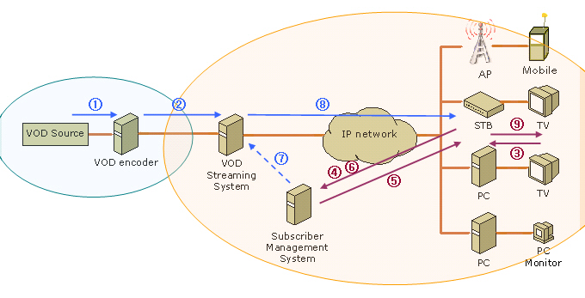
[Figure 1] A basic VoD based IPTV service scenario

- Service Provider acquires/receives video/audio source from Contents Providers and manipulate it into IPTV service contents.
- Then Service Provider stores the contents into the VoD streaming system.
- When user selects available VoD content through EPG from Service Provider or navigation, the request is transmitted through IPTV set-top box.
- IPTV set-top box queries the request to Service Provider’s subscriber management system.
- The subscriber management system asks to the set-top box for the user’s information to check the authority and billing.
- User’s IPTV set-top box responses to the request. Those responses would be encrypted.
- On user’s response, if the subscriber management system confirms the request then it sends the request to the VoD streaming system. (Otherwise it sends reject message to the user’s set-top-box with reason.)
- The VoD streaming system transmits the contents to the user as they have requested.
- The user’s IPTV set-top box receives and decodes the content and displays it to the user.

(Editor Note) The following functions are requested to be considered for further study issues for enhanced VoD service:
- QoS/QoE
- Storage & security
- Network control include mobility
- Contents processing & control
- Navigation & Discovery

<C-134> Continued
2.2.3 Game on Demand (GoD)
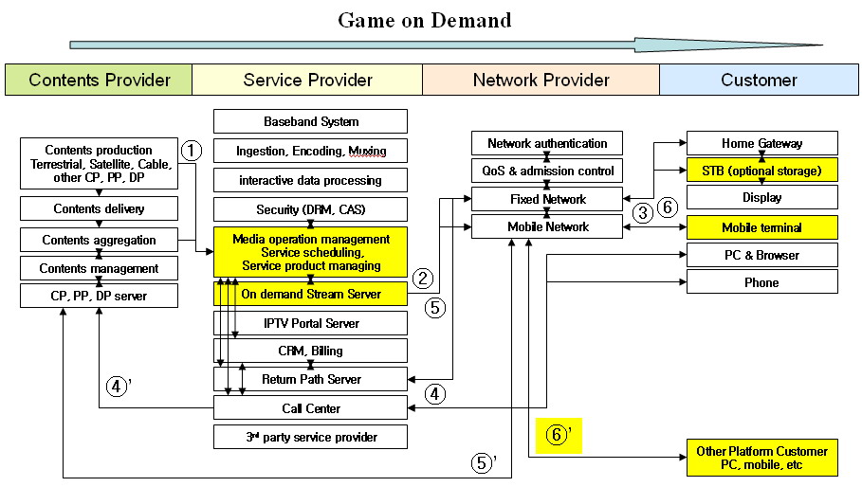
Game on Demand service is proceeding as follows:
- Game program contents which are produced by terrestrial, satellite, cable and other CP, PP, DP are aggregated and delivered to the Media operation management.
- Media operation management transmits the received contents to the on demand Stream Server after additional processes such as service product managing, contents protection, etc. Then, the contents list and main frame are distributed to the network.
- The customer selects game program contents via STB or Mobile terminal.
- If the customer wants more additional service, the user can request it by PC, Phone, STB itself to the Call Center or CRM via return path server.
④’ Customer’s requests are delivered to the CP, PP, DP (Game) Server
- According to the customer’s request, the CRM changes the status of customer and charges the service price. At the same time, the Media operation management allows the customer to enjoy the requested game program contents in terms of Security control.
⑤’ According to the customer’s request, the CP, PP, DP (Game) Server allows the customer to enjoy the requested game program contents in terms of security.
- The customer enjoys the game on demand via STB and mobile terminal with standalone.
⑥’ Customers can enjoy the multi-player game on demand with other platform customers such as PC, mobile, etc.

2.3 Interactive Service
Interactive service lets customers send various types of requests and feedback with interactivity.
2.3.1 T-information (news, weather, transportation, local community etc.)
2.3.2 T-commerce (banking, stock, shopping, ticketing, auction, product delivery, event, etc.)
2.3.3 T-communication (e-mail, messenger, SMS, channel chatting, VoIP, web surfing, multiple video conference, video phone, etc.)
2.3.4 T-entertainment (games, karaoke, photo album, lottery, blog, etc.)
2.3.5 T-Learning (infant, children, school student, languages, financial skill, etc.)
2.3.6 T-government (notice, civil appeal, tax payment, poll, etc.)
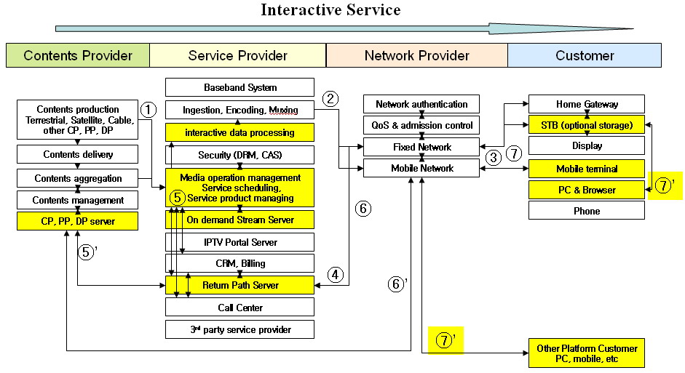
Interactive Service is proceeding as follows:
- Interactive Service program contents such as T-information, T-commerce, T-communication, T-entertainment, T-learning, and T-government related video, audio, application, and data which are produced by terrestrial, satellite, cable and other CP, PP, DP are aggregated and delivered to the Media operation management.
- Media operation management transmits the received A/V contents to the on demand Stream Server after additional processes such as service product managing, contents protection, etc. Simultaneously, Media operation management delivers each interactive service application to the network via interactive data processing and mux.
- First, STB or Mobile terminal receives each interactive application through multicast join and updates the application version. Then, the customer selects interactive service program contents through STB or Mobile terminal with multicast join and enjoys the interactive service. The user can request each more specific contents of the service.
- The customer’s request is transmitted to the Return Path Server.
⑤, ⑥ Media operation management checks the requested specific contents in the on demand server and transmits them to the STB or Mobile terminal with unicast.
⑤', ⑥’ According to the characteristics and type of the interactive service, the Return Path Server delivers the customer’s request to the each CP, PP, DP server. Then, each CP, PP, DP server checks the requested specific contents and transmits them to the STB or Mobile terminal with unicast.
- STB or Mobile terminal receives the requested contents and with broadcast programs through multicast join and displays it.
⑦’ In case of the T-communication and T-entertainment, customer can communicate and enjoy each A/V (ex. video conference), voice (ex. VoIP), data (ex. SMS, messenger, album graphics) and game with other platform customers such as PC, mobile, etc.

2.3.7 Interactive Program Guide (IPG) / Electronic Contents Guide (ECG)
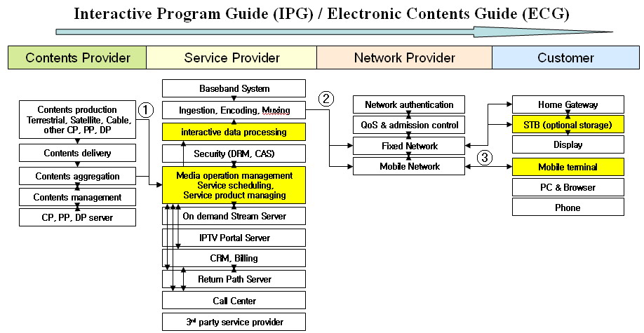
IPG (Interactive Program Guide) / ECG (Electronic Contents Guide) is proceeding as follows:
- IPG / ECG application which are produced by terrestrial, satellite, cable and other CP, PP, DP are aggregated and delivered to the Media operation management.
- Media operation management delivers IPG / ECG application to the network via interactive data processing and mux.
- According to the customer’s request, the IPG / ECG application shows interactive program list and specific information. When the viewer selects particular interactive service or program, the IPG / ECG application links to the service channel or program through the multicast join.

2.3.8 Targeted Advertising (personal, interactive, on demand related advertising, etc.)
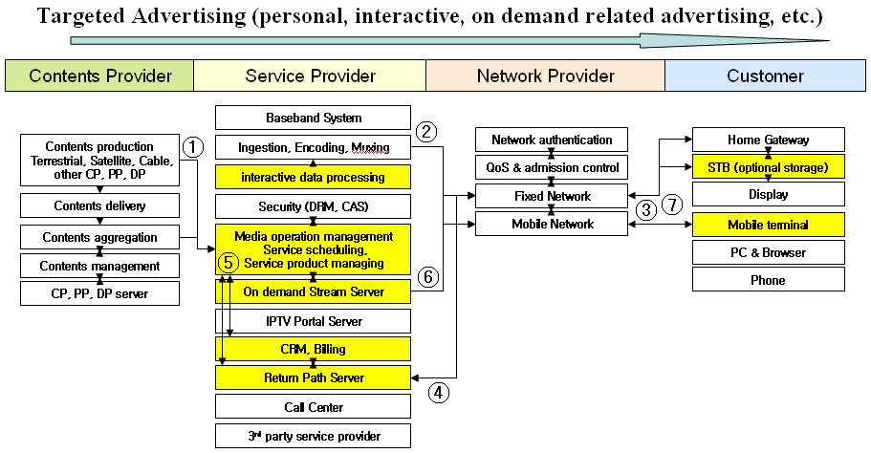
Targeted Advertising is proceeding as follows:
- Targeted Advertising contents according to the customer’s factors such as interest, demographic characteristics, the time of day, etc. which are produced by terrestrial, satellite, cable and other CP, PP, DP are aggregated and delivered to the Media operation management.
- Media operation management transmits the received Targeted Advertising contents to the on demand Stream Server after additional processes such as service product managing, contents protection, etc. Simultaneously, Media operation management delivers Targeted Advertising application to the network via interactive data processing and mux.
- Customer enjoys various IPTV services through STB or Mobile terminal. In this time, Targeted Advertising application coordinates various commercial events and other advertisements to the customer.
- The log of the service which customer uses is remained in the Return Path Server.
⑤, ⑥ First, CRM and Media operation management analyze the remained log in the Return Path Server. Then, Media operation management sends the targeted advertising contents to the customer or group according to the customer’s factors such as interest, demographic characteristics, the time of day, etc.
⑦ Customer enjoys various IPTV services with Targeted Advertising via STB or Mobile terminal.
2.4 Portal Service
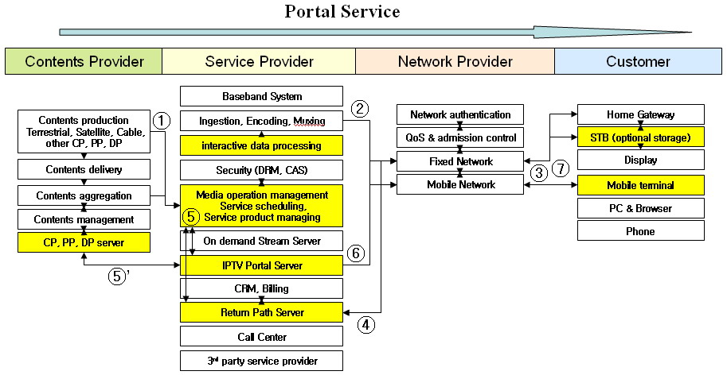
Portal Service is proceeding as follows:
- Portal Service program contents and application which are produced by terrestrial, satellite, cable and other CP, PP, DP are aggregated and delivered to the Media operation management.
- Media operation management transmits the received A/V contents to the IPTV Portal Server after additional processes such as service product managing, contents protection, etc. Simultaneously, Media operation management delivers each portal application to the network via interactive data processing and mux.
- First, STB or Mobile terminal receives application through multicast join and updates the application version. Then, the customer selects portal service program contents via STB or Mobile terminal with multicast join and enjoys them. The user can request each more specific contents of the portal service.
- The customer’s request is transmitted to the Return Path Server.
⑤, ⑥ Media operation management checks the requested specific contents in the IPTV Portal Server and transmits them to the STB or Mobile terminal with unicast.
⑤' For the continuous update of Portal Service contents, CP, PP, and DP server deliver their own portal contents to the IPTV Portal Server.
⑦ Customer enjoys various IPTV portal services through STB or Mobile terminal.
2.5 Hosting Service
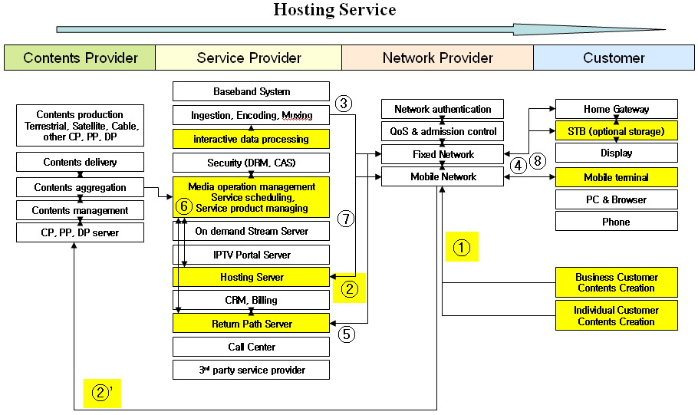
Hosting Service is proceeding in several routes as follows:
First: Contents Creation → Contents aggregation → Service Provider → Network → Customer.
- ~② Hosting Service program contents such as video, audio, application and other data which are produced by Business Customer and Individual Customer are delivered to the Contents aggregation’s Server.
③ Media operation management transmits the received Hosting Service program contents to the Hosting Server after additional processes such as service product managing, contents protection, etc. Simultaneously, Media operation management delivers each service application to the network via interactive data processing and mux.
④ First, STB or Mobile terminal receives each Hosting service application through multicast join and updates the application version. Then, the customer selects service program contents through STB or Mobile terminal with multicast join and enjoys it. The user can request each more specific contents of the service.
⑤ The customer’s request is transmitted to the Return Path Server.
⑥, ⑦ Media operation management checks the requested specific contents in the Hosting Server and transmits them to the STB or Mobile terminal with unicast.
- STB or Mobile terminal receives the requested contents and displays it.
Second: Contents Creation → Service Provider → Network → Customer.
- ~② Hosting Service program contents such as video, audio, application and other data which are produced by Business Customer and Individual Customer are delivered to the Hosting Server of the Service provider.
③ ~⑧ are same in the first procedure.
Third: Contents Creation → Network → Customer.
- Hosting Service contents such as video, audio, application and other data which are produced by Business Customer and Individual Customer are delivered to the Network directly. In this time, each Business or Individual Customer has their own server.
④ STB or Mobile terminal receives the Host Service contents and displays it.

2.6 3rd party content services
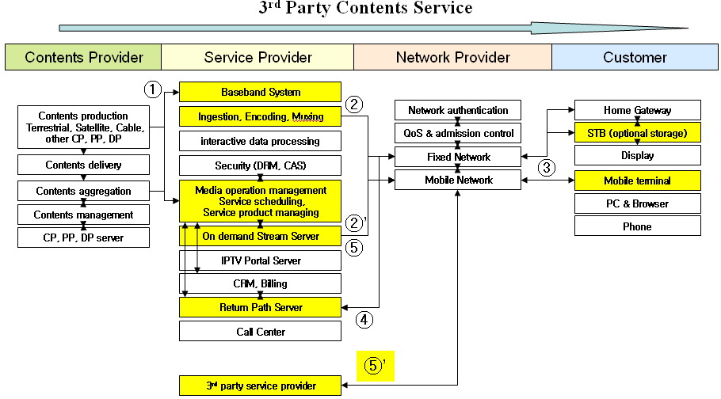
3rd party content service is proceeding as follows:
- Program contents which are produced by terrestrial, satellite, cable and other CP, PP, DP are aggregated and delivered to the Baseband System. At the same time, the program schedule and specific metadata are delivered to the Media operation management.
- First, Media operation management controls the service schedule and composes service product. Then, encoded, scrambled contents and interactive processed data are muxed. Finally, muxed program contents are transmitted to the network.
②’ Media operation management transmits the received contents to the on demand Stream Server after additional processes such as service product managing, contents encryption, etc. Then, the contents list and main frame are distributed to the network.
- STB or Mobile terminal receives the program contents and displays it.
- ~ ⑤ If the customer requests specific contents, the STB or Mobile terminal accesses the Return Path Server and receives the requested contents through the on demand server.
⑤' According to the contents characteristics, the customer also can request specific contents through 3rd party contents provider. This 3rd party content service can provide interoperability of contents selection and supply.

This contribution contributes to IPTV service scenarios with functional components of players as a development point in a global IPTV issue. It is proposed to transfer this contribution as a valuable input in ITU-T FG IPTV study for further discussion.

<C-191>
This contribution describes two major scenarios for T-Health Care service. First scenario-1(figure 1), T-Health Care service providers can support on-line general hospitals service to customers. Patients at home or office can make a reservation to a hospital via IPTV services(VoIP(Video and Audio) service or Web page service). When requiring his or her vital information, patients can send his or her vital information to the hospital via IPTV set-top box which can inter-work with the medical sensor at home or office. Then patients can see the doctor via IPTV services(VoIP service or Chatting service) at home. After seeing the doctor, patients can make a deal with his or her insurer via IPTV service. Second secenario-2(figure 2), a T-Health Care service provider can support e-health information from general hospitals to customers. Patients at home or office can navigate and get the e-health information via IPTV services to promote his or her health better.

Figure 1: T-Health Care Service Scenario-1 for the integrated with other health care services.

Figure 2: T-Health Care Service Scenario-2 for the other E-health links services

_______________

