INTERNATIONAL TELECOMMUNICATION UNION |  |  |  | Focus Group On IPTV
TELECOMMUNICATION  STANDARDIZATION SECTOR  STUDY PERIOD 2005-2008 |  |  | FG IPTV-DOC-0164
 |  |  | English only
WG(s): 6 |  | 6th FG IPTV meeting:  Tokyo, Japan, 15-19 October 2007
OUTPUT DOCUMENT
Source: | Editor
Title: | Working Document : Service Navigation System

CONTENTS
1. Scope 3
2. References 3
3. Definitions 3
4. Abbreviations and acronyms 4
5. Generic Service Navigation System 6
6. Web-based service navigation system 7
6.1 Functional entities of the Service navigation system 7
6.1.1 Service/application management Functional Entity (navigation backstage) general functional requirements: 7
6.1.2 Navigation Functional Entity (navigation front stage) general functional requirements: 7
6.2 Web-based realization reference model 8
6.3 Metadata flow and Syndication capability in service navigation system 9
7. Middleware-based service navigation system 10

Service Navigation System

1. Scope
This working document presents a generic service navigation system architecture and its functional entities.

2. References
The following ITU-T Recommendations and other references contain provisions, which, through reference in this text, constitute provisions of this working document. At the time of publication, the editions indicated were valid. All Recommendations and other references are subject to revision; users of this working document are therefore encouraged to investigate the possibility of applying the most recent edition of the Recommendations and other references listed below. A list of the currently valid ITU-T Recommendations is regularly published.
The reference to a document within this working document does not give it, as a stand-alone document, the status of a Recommendation
[xxx] TBD

3. Definitions
3.1 This working document uses the following terms defined elsewhere:
3.1.1 Application manager [ITU J.200]: The entity that is responsible for managing the lifecycle of the applications. It manages applications running in both the Presentation engine and Execution engine if both are present.
3.1.2 Application Program Interface (API) [ITU J.200]: Consists of software libraries that provide uniform access to system services.
3.1.3 Content [ITU J.200]: A general term that refers to any of the following: application, application resource collection, or application resource.
3.1.9 Content Syndication : (provisional, not yet agreed) Content Syndication is a way to provide the end-user with description of published contents
3.1.5 EPG provider [ITU J.90]: The entity that collects collates and assembles the elements of information that constitute the EPG database.
3.1.6 Functional Entity [ITU Y.2012]: An entity that comprises an indivisible set of specific functions. Functional entities are logical concepts, while groupings of functional entities are used to describe practical, physical implementations.
3.1.7 Metadata [ITU J.98]: Metadata is descriptive data associated with a content asset package or file. It may vary in depth from merely identifying the content package title or information to populate an EPG to providing a complete index of different scenes in a movie or providing business rules detailing how the content package may be displayed, copied, or sold. Separate uses for metadata have originated from the studios, distribution networks (Cable, Satellite), down to the CPE (STBs, PVRs).
3.1.8 Service [ITU Y.101]: A structure set of capabilities intended to support applications.
3.2 This working document defines the following terms:
    - Lifetime/Lifecycle of an application: Characterizes the time from which the application is loaded to the time the application is destroyed. (CableLabs, OC-SP-OCAP1.0-I16-050803, Section 3.2.1)
    - Navigation: The process of selection and movement among analogue and digital services offered on the cable network. The service information tables defined in this protocol assist in the navigation process by providing physical service locations, channel names and numbers for user reference. Those tables supporting electronic program guides also assist the navigation process. (ITU-T, J.94 Amd. 1 (00), B.3.2.3)
    - Service Navigation: The presentation of information that allows the end-user to discover, select and consume services.
Editor's note: following definitions still to be discussed
    - [From China Telecom] Portal: The Portal is the function which organizes various contents and information and provides access and navigation methods to the visitors according to their interests through a uniform interface. (to be revisited, definition available from a web site)
    - [From China Telecom]IPTV portal:The IPTV portal is the function which provides service navigation with content and data according to user’s attribution and requirements. (to be revisited)
    - [From China Netcom]IPTV Portal:The IPTV portal is an unified entry interface on which each kind of service/service package as a channel and traditional TV channels are presented on it.It fulfil the service navigation according to end-user’s requirements by remote controller or keyboard (to be revisited)
    - IPTV page: In IPTV, a page is a single file written with html. Usually it contains text and specifications about where images or other files are to be placed when the page is displayed by a browser.

    - Presentation: The operation of rendering the content of a document in a form perceptible to a human being. (ITU-T, T.411 (93), 3.158)

4. Abbreviations and acronyms
This working document uses the following abbreviations and acronyms.
API Application Program Interface
BOSS Business and Operational Support System
CP Content Provider
CPE Customer Premises Equipment
DB DataBase
EPG Electronic Program Guide
ESG Electronic Service Guide
HTML HyperText Markup Language
IPG Interactive Program Guide
PVR Personal Video Recorder
SP Service Provider
STB Set-Top Box
VoD Video on Demand
XML Extensible Markup Language

5. Generic Service Navigation System
Editor's note: contribution needed for a more conceptual model/description.

The following diagram shows a view of an integrated service navigation system. This architecture is the model that can support the navigation through the presentation of various kinds of services and contents irrespective of implementation.

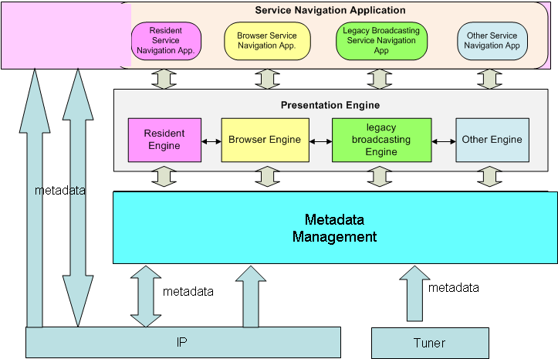
Figure 5-1 Generic Service Navigation System Architecture
Figure to be harmonized with the Middleware document (name of blocks, etc.)
Editor's note: the following paragraphs need to be discussed
The Service Navigation Manager of Base MW (middleware) receives the metadata based on XML from the IP connection, parses and stores it into the local storage. The metadata can be retrieved through the metadata API by the Presentation Engine. The IPTV terminal may have tuner to receive broadcasting services (e.g. through the MPEG-2 transport stream) and in that case, the service information can be retrieved through the metadata API by the Presentation Engine.
Various solutions exist for the Presentation Engine. The Presentation Engine displays the metadata according the design template and the navigation.
The Service Navigation Application, on top of the architecture, is to provide the navigation functionality for the services and contents..

It could be possible for the application to request metadata directly to the remote server using http.

6. Web-based service navigation system

Figure 6.1 Web-based Service Navigation System Architecture

6.1 Functional entities of the Service navigation system
The service navigation system generally includes two parts. The first part is service/application management Functional Entity. It receives and manages service and content metadata, account/bill data and service-ordered information.. At the same time, it responds to the request of the user’s VOD, BTV and time-shift TV as well as other services and applications.
Mainly, service/application management Functional Entity fulfils the service/application logical processing of users’ requests. More details are considered by the realization method. The second part is a navigation Functional Entity (Portal & page production and presentation), which is the man-machine interface of user’s interacting with the IPTV platform. Service Navigation System’s generic functional requirements are as following:

6.1.1 Service/application management Functional Entity (navigation backstage) general functional requirements:
(1) Service/application management
(2) Metadata Database management
(3) Respond to user’s request and accomplish service/application logical processing
(4) Live TV channel management
(5) ……

6.1.2 Navigation Functional Entity (navigation front stage) general functional requirements:
(1) Based on Web method
- Based on HTML/XML mechanism
- An only/unified IPTV Portal
- Permission to integrate Internet Portal
- Pages presentation(including services and channel list)
- Additional services list
- …….

6.2 Web-based realization reference model
6.2.1 Web-based reference model architecture
Figure 6-3 Web-based service navigation system reference model architecture

The service provider(s) obtain users’ service-ordered information from IPTV BOSS, and send them to the Service Navigation System. The service-ordered information includes user’s information and service information. Service information includes content package and the account/bill information. Sometimes a service with price and other attributes is called a product.
Service/application management interacts with other IPTV systems to get user’s information (such as user’ name, password, service-order information etc.) and service information (such as price, location etc.), and bind these information to provide service/application logical process. For example, Service/application management encapsulates all those logic as service/application logic APIs, and these APIs are called by Navigation application of Web server.
Navigation application of Web server obtains metadata from Metadata Database,and use the service-ordered information to produce customized pages(HTML/XML language). Operators often provide many service page templates for users to choose, and these templates correspond to the service-ordered information. The introduction of intermediate layer (Web Server) will improve the capability of service navigation system, accelerate the browsing.Through the intermediate layer (Navigation application), the logical process of service/application management are shielded. Simultaneously, customized pages could be produced.
The service/application logical process is independent to STB. The Navigation application of Web Server produces an only and unified IPTV Portal and pages and delivers them to STB, and the STB presents them to users by Web browser. The user’s requests are sent to Navigation application of Web Server, and the Navigation application invoke the backstage service/application logic(APIs) to respond user’s requests or redirect to other application servers.
Web-based mechanism is consistent with the Internet navigation mechanism, and easier to realize distributed navigation, to satisfy large scale operation requirements.

6.3 Metadata flow and Syndication capability in service navigation system
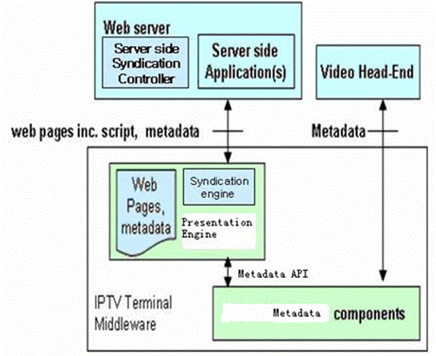
Figure 6.4: Metadata flow and Syndication capability in Service Navigation Systems
Presentation Engine is IPTV client module that loads and renders IPTV pages encoded in a mark-up language mostly based on HTML/XML, and a scripting language.It can be applications,web browser etc.
Navigation application use metadata and backstage services logic to produce IPTV Portal and pages(which is some HTML/XML or client side scripts) and send them to IPTV Terminal.
Presentation Engine is executed locally to control the navigation user interface.
Presentation Engine can also invoke Metadata API located on IPTV Terminal and produce navigation page..

Syndication controller provides metadata adaptation function with metadata DB and manages metadata with browser syndication engine. It classifies and customizes metadata from IPTV metadata DB for web browser in IPTV terminal. The data format between syndication controller and syndication engine could be standardized syndication format such as RSS/Atom.
Syndication engine in browser manages the metadata information from server side and it can provide the aggregated feeding and customized retrieval of metadata information.

7. Middleware-based service navigation system
Editor note: More contribution is welcome.

8. Syndication-based service navigation system
The figure 8.1 shows implementation model to support the enhanced metadata capabilities of EPG. It contains the necessary modules for customization and for multiple terminals environment. The enhanced metadata server consists of three modules, i.e., syndication controller module, metadata adaptation module and device management module. And, this server is also interoperable with metadata and navigation system.
In enhanced metadata server, syndication controller and syndication engine have capabilities to provide customized IPTV service. It can be implemented by RSS based syndication mechanism. This module provides client to reconstruct channel/program information easily and supports consistent service UI (User Interface) under the case of different types of devices. Syndication controller has several functionalities. For example, it receives the channel’s RSS feed information through metadata adaptation module from metadata. Then it supports RSS information management and search capabilities.
Metadata adaptation module is for metadata transformation from other metadata to standardized syndication format such as RSS format. And it also can get metadata from external system and then provide to syndication format to syndication controller.
Device management module is for the processing of multiple types of devices in client. Customer can have different types of devices. Once customer is set up of his/her own personalized EPG, the EPG needs to support UI consistency through different devices. For this operation, device management module can support the device’s profile information between syndication controller and client.

.
Figure 8.1. Enhanced Metadata Server Model

8.1 Gap analysis

Method | Related Standard Activity
Syndication controller | RSS-DEV
Metadata adaptation | W3C CSS, XSL, UWA WG
Device management | W3C DDWG(Device Description), OMA UAProfile

Appendix 1. Implementation Guidelines
Editor's note: More contributions are expected on this appendix.

Electronic Programme Guide (EPG)
- EPG supports retrieval capabilities including fast search, semantic search and quick selection.
    - EPG information should be selectable by various methods. This can be implemented by keyword-based search and/or menu-driven selection for program. In order to provide the intelligent EPG search function, semantic mechanism such as ontology-based program search or semantic tagging could be used.
  - EPG can have customized capabilities including on-demand feeding, transforming, filtering, and gathering function.
    - It allows customer to retrieve the EPG information as required at anytime. This can be implemented by using of syndication technique such as RSS based information feeding.
    - Using this kind of customized capability, it can implement distributed IPTV service for service provider which can support different content providers over the network. It can also provide personalized EPG service for end-users and flexible EPG service for various terminals. For example, EPG information might be converted to lightweight format to support the mobile terminal.
  - EPG can have layout flexibility on various devices
    - EPG information allows client to present various layouts as client’s environment. It also allows EPG server to convert or to transform the EPG information for different client environments (e.g., Mobile client).
    - This can be implemented using web-based techniques such as XML-based EPG as a data format and CSS as layout form.
  - An EPG application can support PVR applications (recording, storing).
    - Using EPG information, EPG application should support a recording operation for selected program at client side as reservation-basis and/or time-shift basis. It can also support multiple-recording operation which enables to record the multiple programs which are selected by user simultaneously unlikely with traditional PVR operation.

_________________

