INTERNATIONAL TELECOMMUNICATION UNION |  |  |  | Focus Group On IPTV
TELECOMMUNICATION  STANDARDIZATION SECTOR  STUDY PERIOD 2005-2008 |  |  | FG IPTV-DOC-0157
 |  |  | English only
WG(s): 4 |  | 6th FG IPTV meeting:  Tokyo, Japan, 15-19 October 2007
OUTPUT DOCUMENT
Source: | Acting Editors
Title: | Working Document: IPTV Multicast Frameworks
Editor’s Note:
      - IPTV service provider may implement IPTV service in two typical ways; VoD-type IPTV service and linear-type IPTV service and more. Among the two typical types of IPTV services, multicast delivery mechanism is very important to delivery liner-type IPTV service. Because multicast delivery mechanism can save network resources as well as head-end to support great number of receivers simultaneously.
      - For IPTV service based on multicast mechanism, it is quite necessary to have detailed descriptions as followings:
        - the descriptions on multicast delivery mechanism to support IPTV service
        - the descriptions on interactions between IPTV architecture to support multicast based IPTV service; and the examples are how end-user interacts with IPTV service provider, how end-user interacts with network provider, how IPTV service provider interacts with other components, and so on.
      - This document will be aligned with on-going ITU-T FGIPTV working documents; IPTV requirements, IPTV architecture, network control aspects, and so on.
      - The main contents of IPTV multicast framework will consist of the following items to provide detailed descriptions for IPTV service based on multicast delivery mechanism in non-NGN environment. However, the items listed below must align with on-going FGIPTV documents:
- Terminology for IPTV multicast service,
- Requirements for IPTV multicast service,
  - The requirement described in this WD is recommended to be described clearly but enough in detail.
  - The requirements must be practical. Because this requirement will be used by whom to prepare IPTV service promptly.
  - Each requirement is required to be able to be directly mapped into functional architecture for IPTV multicast service. (verification is necessary)
- Functional architecture for IPTV multicast service;
  - The functional architecture must align with IPTV architecture.
  - Detailed description on each functional block is required.
- IPTV service scenario based on multicast delivery,
  - This service scenario must be able to implement with verification.

IPTV Multicast Frameworks

Summary
<Mandatory Material>
Editor’s Note: To be provided

Keywords
<Optional>
Editor’s Note: To be provided

CONTENTS
1 Scope 6
2 References 6
3 Definitions 6
3.1 Terms defined elsewhere 6
3.2 Terms defined in this Recommendation 6
4 Abbreviations and acronyms 7
5 Conventions 8
6 IPTV multicast requirements 8
6.1 IPTV multicast transport requirement 8
6.1.1 Implementation model of IPTV Multicast transport 8
6.1.1.1 Any Source Multicast 9
6.1.1.2 Source Specific Multicast 9
6.1.3.1 Technical information of Multicast Group management in access node 14
6.1.3.1.1. Internet Group Management Protocol 14
6.1.3.1.2. IGMP Transparent Snooping 15
6.1.3.1.3. IGMP Proxy 15
6.1.3.1.4. Fast Leave / Immediate Leave 16
6.2 QoS requirements of IPTV multicast 17
6.3 Security requirements of IPTV multicast 19
6.4 Interoperability requirement of IPTV multicast 20
6.5 Service management requirements of IPTV multicast 22
7 IPTV Multicast Architecture 27
7.1 End-user Functions (EFs) for IPTV multicast 27
7.2 Application Functions(AFs) for IPTV multicast 28
7.3 Content Delivery Functions (CDFs) for IPTV multicast 29
7.4 Service Control Functions (SCFs) for IPTV multicast 29
7.5 Management Functions (MFs) for IPTV multicast 30
7.6 Content Provider Functions (CPFs) for IPTV multicast 30
8 IPTV Multicast scenario 30
8.1 Pure IP multicast scenario 30
8.2 Alternative multicast scenario 32
9 Other aspects 38
10 Overlay multicast networking 38
10.1 Control framework for IPTV service level multicast 38
10.2 Overlay IPTV multicast control 41
10.3 QoS control at overlay multicast network for IPTV services 43

APPENDIX III A Scenario for Service Control Function of Session
Manager in IPTV Overlay Multicast Network…………………………… 51
IPTV Multicast Frameworks

Scope
This document on IPTV multicast frameworks describes functional requirements and frameworks of supporting multicast capabilities in terms of IPTV network control.
[Editor’s note]: This document considers multicast frameworks for non-NGN environment.

References
The following ITU-T Recommendations and other references contain provisions, which, through reference in this text, constitute provisions of this working document. At the time of publication, the editions indicated were valid. All Recommendations and other references are subject to revision; all users of this working document are therefore encouraged to investigate the possibility of applying the most recent edition of the Recommendations and other references listed below. A list of the currently valid ITU-T Recommendations is regularly published.
The reference to a document within this working document does not give it, as a stand-alone document, the status of a Recommendation.

[FGIPTV-REQ] ITU-T IPTV Focus Group, IPTV Network Control Aspects..
[FG IPTV WD] ITU-T IPTV Focus Group, IPTV Service Requirements.
[IETF RFC 1918] IETF RFC 1918 (1996), Address Allocation for Private Internets
[IETF RFC 3180] IETF RFC 3180 (2001), GLOP Addressing in 233/8
[IETF RFC 3307] IETF RFC 3308 (2002), Allocation Guidelines for IPv6 Multicast Addresses

Definitions

Terms defined elsewhere
This Document uses the following terms defined elsewhere:
[TBD]

Terms defined in this Recommendation
[Editor’s note]: The alignment of terminology is needed, and related contributions are recommended to be published in this section.
This Document defines the following terms:
3.2.1 Multicast Domain Management: A multicast domain is a set of multicast routing and forwarding instances than can send multicast traffic to each other. These multicast routing and forwarding instances are referred to as IPTV multicast domain. Thus, multicast domains map all of a customer’s multicast groups that exist in particular IPTV service members to a single unique global multicast group. This is achieved by existing or specific group routing and forwarding capability in the network.
3.2.2 Multicast Access Control Functions: Multicast Access Control Functions is that control a multicast user access to IPTV multicast tree. The IPTV user can join a multicast service using these control functions with proper authentication and authorization of the user.
3.2.3 Multicast Delivery Control Functions: Multicast Delivery Control Functions is that can control IPTV multicast delivery among transport functions.
3.2.4 Overlay Network: A virtual network of nodes and logical links that is built on top of the underlying network infrastructure with the purpose of implement a network service that is not available in the underlying network infrastructure.
3.2.5 Overlay Multicast Network: One type of overlay network that provides multicast services to end users on top of the general network infrastructure.
3.2.6 IPTV multicast interoperability: IPTV multicast interoperability is the exchange of IPTV service information amongst multicast based IPTV service providers. And to make the optimal contract and to provide the stable IPTV services amongst multicast based IPTV service providers.
3.2.7 IPTV Service Exchange Point: IPTV SEP (service exchange point) is identified as a reference point for handling the service brokering function between IPTV SPs enabling the optimal contract between IPTV SPs and providing the stable IPTV services amongst IPTV service providers. IPTV SEP can be located in any peering point.

Abbreviations and acronyms
This document uses the following abbreviations and acronyms.
CAC Connection Admission Control
CCTV Closed-Circuit TV
cIMA child IMA
CP Content Provider
DRM Digital Rights Management
ECMP Equal Cost Multiple Path
IGMP Internet Group Management Protocol
IMA IPTV Multicast Agent
IP Internet Protocol
ISP Internet Service Provider
QoE Quality of Experience
QoS Quality of Service
pIMA parent IMA
RP Rendezvous Point
SEP Service Exchange Point
SP Service Provider

Conventions
In this document:
The keywords “is required to” indicate a requirement which must be strictly followed and from which no deviation is permitted if conformance to this document is to be claimed.
The keywords “is prohibited from” indicate a requirement which must be strictly followed and from which no deviation is permitted if conformance to this document is to be claimed.
The keywords “is recommended” indicate a requirement which is recommended but which is not absolutely required. Thus this requirement need not be present to claim conformance.
The keywords “is not recommended” indicate a requirement which is not recommended but which is not specifically prohibited. Thus, conformance with this specification can still be claimed even if this requirement is present.
The keywords “can optionally” indicate an optional requirement which is permissible, without implying any sense of being recommended. This term is not intended to imply that the vendor’s implementation must provide the option and the feature can be optionally enabled by the network operator/service provider. Rather, it means the vendor may optionally provide the feature and still claim conformance with the specification. I

IPTV multicast requirements
[Editor’s note]: This section is also essential part of IPTV multicast frameworks WD, and describes the IPTV multicast requirements, and we have to push some of basic requirements to be included in WG1’s requirements WD. Based on many contributions in past meetings which are accepted in WG4, and living list documents, we can get the IPTV multicast requirement subsections like followings. Besides the described subsection IPTV multicast architecture, other IPTV requirement issues can be included in this section.
[Editor’s note, 6th meeting] We need further clarification for several requirements. Without further clarification, those requirements will be deleted in next meeting!
[Editor’s note, 6th meeting] Whole requirements should be harmonized and aligned with the requirements of DOC-114, taking into account the relationship with ‘Network control aspect WD’. If the requirement from this chapter is fully duplicated or covered by the requirement from DOC-114 and Network control aspect WD, such requirement should be replaced by the requirements from DOC-114 and Network control aspect WD, and have the reference note. Also, in case that such requirement is describing the multicast specific issues, should have a reference note and short and clear note to describe the differences.

IPTV multicast transport requirement

Implementation model of IPTV Multicast transport
[Editor’s note 6th meeting]In this subsection, we need more wording jobs for each sentence to be a format of requirement and generalized description.
Two different service models for IP-Multicast are currently supported: Any Source Multicast (ASM) and Source Specific Multicast (SSM). Within an IPTV Multicast Framework both service models can be used and also deployed in parallel because ASM and SSM are running in different address spaces.
ASM generally deploys IGMPv2 or IGMPv3 (MLDv1/MLDv2) without source information and PIM-Sparse Mode in combination with the Multicast Source Discovery Protocol (MSDP) whereas SSM deploys IGMPv3/MLDv2 with source information and PIM-Source Specific Multicast as a routing protocol.
The following section describes Any Source Multicast, Source Specific Multicast, related protocols and general mechanisms to be deployed within an IP-Multicast enabled IPTV network.

Any Source Multicast
Any Source Multicast (ASM) is the classical variant and uses a model where all decisions are made based on the multicast group address (G) only. Devices are able to join and leave multicast groups in order to receive IPTV streams. The receivers do not have knowledge about the Multicast senders within the network. When two IP Multicast senders are sending to the same IP Multicast group address (G) and a client joins (G), the client receives traffic from both IP Multicast senders.
Receiver
Join (*, G)
Sender S1
Sender S2
Sender S3
G
G
Any Source Multicast
enabled IPTV Network
G
Figure 6-1: Any Source Multicast
This model has some significant drawbacks for IPTV deployment:
    - Addressing: Due to the fact that only the IP Multicast address is used it is not possible to distinguish different senders on the network level. Therefore it is necessary to implement an entity which manages the use of IP Multicast addresses. This slows the deployment down because to setup new IPTV channels or change existing IPTV channels it is necessary to obtain a free (unused) IP Multicast address.
    - Security: In a group based model it is easy to disturb existing IPTV channels by simply sending traffic to the same group address. To avoid those attacks complex filter mechanisms are needed at the ingress and/or egress points of the network (and potentially at customer’s premises to avoid unwanted and disturbing IP Multicast traffic).
    - Redundancy: On the network level Any Source Multicast usually deploys PIM-SM (Protocol Independent Multicast – Sparse Mode) a central Rendezvous Point (RP) which represents a single point of failure. To overcome this problem redundant RPs and additional protocols are necessary.
    - Complexity: Taking 1-3 into account (as well as some other drawbacks) the use of Any Source Multicast adds complexity. To reduce the complexity and to overcome the problems with ASM a new model “Source Specific Multicast” was developed.

Source Specific Multicast
Source Specific was developed to overcome the problems encountered by Any Source Multicast. The main difference between the two models is the use of the source address of the multicast sender. In contrast to ASM with SSM it is possible to distinguish between a sender (S1) and a sender (S2) sending to the same IP Multicast address (G). Receivers not only specify the group address G but also the address of the sender (S), resulting in an IP Multicast channel (S,G). Because the Unicast address within a network uniquely identifies an end system, the combination of (S,G) is unique as well. A receiver joining (S1,G) does not receive the traffic from another system sending to the same IP Multicast address.
Receiver
Join (S1, G)
Sender S1
Sender S2
Sender S3
G
G
Source Specific Multicast
enabled IPTV Network
G
Figure 6-2: Source Specific Multicast
Source Specific Multicast solves the following problems:
    - Addressing: It is no longer necessary to centrally coordinate the use of IP Multicast addresses. Any sender can send to any existing IP Multicast group. The network and the receivers are able to specify a particular sender using an IP Multicast group. IP Multicast channels (S,G) are handled and routed individually by the network and the clients as well.
    - Security: Denial of Service (DoS, DDoS) attacks by simply sending to a Multicast group which is already in use are not longer possible because individual senders can be distinguished.
    - Complexity: Source Specific Multicast reduces the overall complexity within IPTV. It solves several issues related to security and addressing and also removes the need for centralized Rendezvous Points.
SSM is also optimized for One-to-Many deployment scenarios which are typically used within IPTV. In addition ASM and SSM can be used in parallel (deploying different address ranges) if necessary. The use of SSM eases the deployment of IPTV and reduces the complexity, allowing more flexible IPTV services. The IETF has assigned the default address space 232/8 for the use with Source Specific Multicast.

IPTV multicast control function at the transport
[Editor’s note]: In this section, we need general definition of IPTV multicast control functions. We need appropriate contributions to accomplish the general definition of IPTV multicast control functions.
IPTV multicast control functions can be divided into two control issues. The first one is multicast access control functions relative with IPTV multicast access. The other is multicast delivery control functions relative with IPTV multicast traffic delivery.
Multicast access control functions control a multicast user access to IPTV multicast tree. The IPTV user can join a multicast service using these control functions with proper authentication and authorization of the user. These functions have the following requirements for IPTV user to access multicast tree.
- IPTV end-user is recommended to identify multicast tree.
[Editor’s note, 6thmeeting] In this sentence, we need further clarification. Without further clarification, this sentence will be deleted.

- IPTV end-user can optionally request to join a multicast tree with authorization, authentication.
[Editor’s note, 6thmeeting] In this sentence, we need further clarification. Without further clarification, this sentence will be deleted.

- IPTV network provider is recommended to maintain multicast information per an IPTV multicast flow.
[Editor’s note, 6thmeeting] In this sentence, we need further clarification. Without further clarification, this sentence will be deleted.

- IPTV network provider is recommended to manage the membership of IPTV end-user.
[Editor’s note, 6thmeeting] In this sentence, we need further clarification. Without further clarification, this sentence will be deleted.

- IPTV network provider is recommended to announce multicast information to the end-users.
[Editor’s note, 6thmeeting] In this sentence, we need further clarification. Without further clarification, this sentence will be deleted.

- IPTV network provider can optionally authenticate and authorize an IPTV end-user.
[Editor’s note, 6thmeeting] The authentication and authorization of IPTV end-user should be "recommended", not optional issue, we need further clarification. Without further clarification, this sentence will be deleted. And, refer to IPTV_SEC_S_002.
- IPTV network provider is recommended to optionally authenticate and authorize an IPTV multicast source.
- IPTV network provider is recommended to optionally manage the identification of IPTV Multicast tree, to decide to which IPTV Multicast tree a multicast source can send a multicast service.
Multicast delivery control functions control multicast delivery among transport functions. An IPTV end-user can receive IPTV multicast traffic after joining a multicast tree. These functions have the following requirements for the IPTV end-user to provide IPTV multicast service.
[Editor’s note, 6thmeeting] We need more elaboration of original sentence; “IPTV end-user can optionally receive IPTV multicast traffic with QoS guarantee.”
- IPTV service provider is recommended to guarantee the QoS of IPTV multicast traffic.

[Editor’s note, 6thmeeting] We need more elaboration of original sentence; “IPTV service provider is required to use multicast delivery provided by the IPTV network provider.”
- IPTV service provider can use multicast delivery provided by the IPTV network provider

[Editor’s note, 6thmeeting] We need more elaboration of original sentence; “IPTV network provider is required to transfer IPTV traffic through multicast tree.”
- IPTV network provider can use multicast tree structure to deliver IPTV multicast traffic.

- IPTV network provider is recommended to provide a rendezvous point when a multicast tree is extended.
[Editor’s note, 6thmeeting] In this sentence, we need further clarification. Without further clarification, this sentence will be deleted.

- IPTV network provider is recommended to manage multicast address in IPTV multicast tree.

[Editor’s note, 6thmeeting] In this sentence, we need further clarification. Original Paragraph: IPTV network provider is recommended to extend a multicast tree when an IPTV end-user joins. IPTV network provider is recommended to prune a multicast tree when an IPTV end-user leaves.
- IPTV network provider is required to provide the stable multicast tree management when the IPTV end-users join and leave.

- IPTV network provider can optionally balance IPTV multicast traffic for load sharing
[Editor’s note, 6thmeeting] This sentence is not enough to explain LB of multicast traffic. We need further clarification. Without further clarification, this sentence will be deleted.

- IPTV network provider is recommended to provide recovery mechanism for IPTV multicast traffic due to node failure and link failure.
- IPTV network provider is required to protect IPTV multicast traffic and IPTV multicast node from malicious attack.
- IPTV network provider can optionally reserve multicast resource for IPTV multicast traffic.
- IPTV network provider is recommended to provide congestion control for the IPTV multicast traffic.
- IPTV network provider can optionally provide priority based transport for IPTV multicast traffic.

IPTV multicast in access node
[Editor’s note 6thmeeting] In this subsection, we need further clarification. Especially, we need more expedited and generalized description for IGMP, and reliable transmission of IPTV multicast traffic in access node.

In multi-service multi-edge architecture, the access node, which is the access point of multiple services, should be the best point to collect detail information of the multicast service instead of upper network systems.

[Editor’s note, 6thmeeting] We need more elaborated expression about IGMP in this paragraph, and need further clarification.
It is necessary to control the flooding of multicast frames in Ethernet environment. In IPv4 case, in access node, IGMP transparent snooping or IGMP snooping with proxy reporting function can be used for that control function.

In principle,
- The access node is recommended to reduce the number of messages from numerous end-users to network.
- The access node is recommended to improve bandwidth efficiency in multicast traffic.
- The access node is recommended to secure multicast delivery to undesired end-users.
- The access node is recommended to ensure availability of multicast video service to end-users by reduce message loss. For example, some messages are lost due to the packet loss of bearer network, or load of service router, or other possible reasons.
One of the concerns related to IGMP proxy in access node instead of IGMP snooping is that IGMP proxy solution may lead that subscriber information is terminated in access node and does not go to service edge.

[Editor’s note, 6thmeeting] We have many insufficient descriptions for QoS, CAC and Security function in access node in following sentences; we need more expedited and generalized description for QoS, CAC and Security function in access node.
As video service needs much more bandwidth high service quality, access node should implement traffic control for high priority multicast traffic to ensure the multicast QoS. Specifically, following functions should be supported in access node.
- The access node is recommended to control on total bandwidth of a user port that can be used for multicast service.
- The access node is recommended to be aware of the current available bandwidth that can be used for multicast service; the current available bandwidth can be total multicast bandwidth – consumed multicast bandwidth.
- The access node is required to support Connection Admission Control (CAC) based on available resources. When an end-user subscribes to a multicast stream, access network will perform CAC: it checks if available resources are enough for the new service subscription. The resources can be bandwidth, connection number and user service privilege profile.
- The access node is recommended to support multicast control function and multicast replication function; the multicast control function should build the privilege table for multicast users; the multicast replication function should forward multicast media content to the end-users which have the privilege of IPTV multicast services.
The requirements of control over multicast source at IPTV multicast access point equipment are as followings.
- The access node is recommended not to respond to any multicast query packet to protect multicast user information at access point equipment. The logical ports connected to user don’t forward any ingress multicast traffic.
- The access node is recommended to enable access network equipment port to act as multicast source port. That is, multicast can be forwarded to requesting end-user only when accessing through network port. To avoid illegal access, multicast access through other ports will be discarded.. The ports respond to multicast query packets.
- The access node is recommended to set some special ports as both multicast receiving and sending ports.
- The access node is recommended to support L3 based mechanisms for Multicast instead of L2 mechanisms.
- The access node is recommended to provide sufficient security mechanisms to protect the network against multicast based attacks by the end users, e.g.:
  - IGMP rate limit
  - IGMP filter mechanisms (control of group ranges, maximal number of subscriptions, etc.)

Technical information of Multicast Group management in access node
[Editor’s note 6th meeting]In this subsection, we need more wording jobs for each subsection and sentence to be a format of requirement and generalized description. And, we need to notify the information of IETF documents as references, if needed

Internet Group Management Protocol
The Internet Group Management Protocol (IGMP, MLD for IPv6) is used between an IP-Multicast capable end system (e.g. IPTV Terminal Device) and a IP-Multicast capable router. IGMP is available in different versions: IGMPv1, IGMPv2 and IGMPv3. IGMP is used by end systems to join and leave IP-Multicast groups or channels (depending on the IGMP version).
- IGMPv1 (RFC1112): IGMPv1 is the oldest version of IGMPv1. Due to the fact that IGMPv1 does not support a “Leave Message”, IGMPv1 in not widely implemented and was replaced by IGMPv2/IGMPv3. IGMPv1 supports only the ASM model.
- IGMPv2 (RFC2236)/MLDv1 (RFC2710): IGMPv2 added the capability of end system to leave a Multicast group by sending a “Leave Messages” to the next node. IGMPv2/MLDv1 supports only the ASM model; both protocols are widely deployed today.
- IGMPv3 (RFC3376)/MLDv2 (RFC3810): The main difference is the support of filter mechanisms (exclude/include filter) to support Source Specific Multicast. IGMPv3/MLDv2 supports the ASM and the SSM service model.

IGMP Transparent Snooping
IGMP snooping optimizes the distribution of multicast within an IEEE 802.1 bridging domain so multicast traffic is only sent on bridge ports where there are known to be active receivers and/or multicast routers. IGMP snooping functionality resides on IEEE bridging devices that connect IGMP hosts to IGMP routers and consists of two main components. The first function is the IGMP snooping control section which:
1) Monitors IGMP messages (and optionally other multicast router messages, such as PIM or DVMRP hello packets), to determine the port location of the multicast routers and active receivers within an IEEE bridged domain.
2) Builds per port, per VLAN multicast forwarding tables
3) Maintains basic IGMP membership state on non-router ports to determine when a forwarding entry should be removed.
The second function is the data forwarding section which:
1) Forwards packets in the 224.0.0.0/24 range which are not IGMP messages on all ports.
2) Forwards multicast packets with a destination IP address outside 224.0.0.0/24, which are not IGMP according to per VLAN, per port multicast forwarding tables.
This basic mode of operation is often referred to as “transparent IGMP snooping” and does not absorb, nor alter, nor generate IGMP messages when performing the above functions.

IGMP Proxy
IGMP proxy is a function to reduce the number of IGMP/MLD messages in a network and to enable a device to communicate with a Multicast enabled router without using a IP-Multicast routing protocol.
Figure 6-3: IGMP Proxy functional description
If more than one upstream interface is available (e.g. different VLANs) the following rules apply:
- “Simple Mode”, only one Upstream Interface for IGMP/Multicast”: If only one upstream interface needs to support Multicast/IGMP it should be possible to select the proxy interface by static configuration or a dynamic mechanism like a Multicast default route using the DHCP option 121 (Classless Static Route Option).
- “Extended Mode”, different Upstream Interfaces for IGMP/Multicast: More than one upstream interface needs to support Multicast/IGMP (e.g. different service VLANs). In this scenario the Multicast groups/Multicast channels need to be configured on the corresponding interfaces; e.g. 239/8 on interface #1 and 232/8 on interface #2. The proxy needs to separate the address spaces, e.g. an IGMP report on interface #1 must not include information about multicast groups/channels on interface #2. The device must support a mechanism to configure (assign) the multicast groups/channels to the corresponding upstream interfaces. This can be done by using static configuration (pre configured device, using a GUI, etc.) or a dynamic mechanism.
- “Forking Mode”: In this mode IGMP reports are sent to more than one upstream interface. Queries will be answered on all upstream interfaces which are configured for “Forking Mode”; reports include information about all Multicast groups/channels the CPE is subscribed to. It is within the responsibility of the receivers of the membership reports to take action on the received reports. In a standard scenario only one of the receivers will forward multicast traffic to avoid duplicate traffic. Other network components can act on the membership reports (e.g. change filters or QoS settings) without forwarding the traffic (see Figure 6-4).
Figure 6-4: IGMP Proxy in Forking Mode

This macro-function can be decomposed in 3 elementary sub-functions:
- Report suppression: intercepts, absorbs and summarizes IGMP reports coming from IGMP hosts. IGMP reports are relayed upstream only when necessary, i.e. when the first user joins a multicast group, and once only per multicast group in response to an IGMP query.
- Last leave: intercepts, absorbs and summarizes IGMP leaves coming from IGMP hosts. IGMP leaves are relayed upstream only when necessary, i.e. when the last user leaves a multicast group.
- Query suppression: intercepts and processes IGMP queries, in such a way that IGMP specific queries are never sent to client ports, and IGMP general queries are relayed only to those clients ports receiving at least one multicast group The IGMP proxy reporting function, when performing the above functions, may forward original IGMP messages generated by hosts and multicast routers but may also generate IGMP messages. In this case the traffic’s source address will be 0.0.0.0 with the IGMP proxy reporting function’s own unique MAC address.

Fast Leave / Immediate Leave
A function associated with IGMP snooping or IGMP routing whereby the switch or router stops sending immediately the multicast stream when receiving an IGMP leave for the last member on this requesting interface, i.e. without sending one or more group specific queries and waiting for its timeout.

IPTV Multicast in core node
In IPTV architecture, the core node is responsible for ensuring IPTV data transport throughout the core network. Then, it can build up a multicast tree in core network and it can extend the multicast tree to an edge node in access nodes. Therefore, the following requirements are needed to support IPTV multicast in the core node.
[Editor’s note 6thmeeting] In this subsection, we need further clarification. We have many insufficient description for multicast functional requirements in core node in following sentences, we need more expedited and generaized description for multicast function in core node
- IPTV network provider can optionally support the replication of IPTV traffic in a core node.
- IPTV network provider can optionally deliver the replicated IPTV traffic to multiple access nodes.
- IPTV network provider can optionally identify IPTV multicast traffic in a core node.
- IPTV network provider can optionally build up multicast tree in core network with multicast routing statically or dynamically.
- IPTV network provider is recommended to aggregate IPTV traffic in core network.
- IPTV network provider can optionally support differential service when IPTV traffic enters in core network with priority.
- IPTV network provider is recommended to allocate bandwidth for IPTV traffic in core node.
- IPTV network provider can optionally authorize and/or authenticate in a core node when an access node requests to join.
- IPTV network provider is recommended to support any source-specific multicast to provide interaction within multicast session (e.g., content feedbacks from receiving customer).

QoS requirements of IPTV multicast

QoS requirements of IPTV multicast
Followings should be taken care as functional requirements for supporting multicast QoS:
- IPTV network is recommended to support mean(s) for multicast traffic monitoring (including performance monitoring) and for analysis for each service group.
- IPTV network is recommended to support of handling multicast traffic differently according to the requested QoS treatment.
For differentiated handling of multicast traffic, congestion avoidance and congestion management mechanism are required because network congestion may cause quality degradation of IPTV service.
- IPTV network is recommended to support congestion avoidance mechanism to prevent multicast traffic from being dropped over other classes of traffic.
- IPTV network is recommended to support congestion management mechanism to prioritize multicast traffic over other classes of traffic.

[Editor’s note, 6thmeeting] In this sentence, we need further clarification. Without further clarification, this sentence will be deleted.
- IPTV network is recommended to provide a certain level of QoS when delivering IPTV service traffic to IPTV end-users. Resource reservation is necessary to guarantee the QoS of IPTV multicast and congestion control is necessary to maintain the QoS of IPTV multicast. Resource reservation mechanism guarantees the multicast resource on multicast distribution trees by bounding various QoS parameters such as delay, jitter, loss, etc.
IPTV network is recommended to support resource pre-reservation mechanism. Pre-reserving mechanism is more efficient than dynamic resource reservation mechanism in that dynamic reservation mechanism needs to manage dynamic membership with many receivers. Moreover, pre-reserving mechanism is simple to control and maintain multicast resources

High availability requirements of IPTV multicast
The quality of IPTV service is more sensitive to network stability compare to other types of data services. In that sense, IPTV multicast network is recommended to provide capabilities to ensure sufficient availability for IPTV services.
Followings should be considered for multicast availability:
- Service restoration without service intervention is required in the event of multicast mechanism abnormalities.
- Multicast distribution tree is required to be restored dynamically in the event of multicast mechanism failures.
- Multicast system architecture and its components are required to be fully redundant in order to avoid a single point of failure affecting the whole IPTV service.
- IPTV service content is recommended to be distributed in a load balanced manner in order to utilize multicast links efficiently.
- Multicast system architecture is required to provide an admission control mechanism to manage multicast events.
Multiple multicast trees include many multicast trees with each tree being constructed from the multicast source to the receivers and multicast data being delivered among all the multicast trees.
- In multiple multicast trees, every host is recommended to have equal or similar level of burden by handling equal or similar number of input / output data flows.
- In multiple multicast trees, each host is recommended to be placed as interior tree nodes on only small number of multicast trees, hence affecting fewer data flows on multicast trees as possible.
- In multiple multicast trees, node positions are recommended to consider the corresponding hosts capabilities and behaviours. The hosts with higher capabilities for multicast and elegant user behaviours are more likely to occupy important positions on the multicast trees.

QoS aware topology for IPTV multicast service

Rendezvous Point
Location of Rendezvous Point (RP) is not only affects IPTV service delay, but also network burden. Following requirements should be taken care.
- Rendezvous point is recommended to support optimal RP positioning; optimal RP positioning depends upon Service Providers’ network topology and their multicast traffic path which taken consideration of followings:
- Loop free, Delay/Jitter independent, stability guarantee topology
- Optimal position to exchange SA information amongst multicast service provider
- Rendezvous point is recommended to support RP redundancy mechanism; IPTV network should be guaranteed optimized RP redundancy to improve IPTV service stability in case of RP failure. IPTV network should be designed their RP mechanism not only to maximize service stability, but also to minimize service recovery time during RP failure.

Load balancing of IPTV multicast
When multicast routers receive a join message, multicast routing protocol normally send its join message to one of the multicast interfaces. If some groups have the same source, among multiple multicast interfaces, only one of them is selected and sends the join. In an Equal Cost Multiple Path (ECMP) environment, all multicast interfaces cannot be used to distribute multicast traffic; instead only single interface is used. To load share the traffic, multicast source should be distributed for different groups, and IPTV service provider should be considered for this load sharing requirements.
- IPTV multicast source is recommended to be distributed to different groups to support load balancing.
.

Security requirements of IPTV multicast
[Editor’s note]: It is required for WG4 to review of the security requirement related with IPTV multicast by WG3.
Multicast security is one of the most crucial issues in IPTV service such that it is required to provide security capabilities to protect IPTV multicast network from any malicious attempts caused by multicast security holes. Security itself is too diverse to break down to the specific multicast purpose; however functional requirements of multicast security for each network elements should be clearly defined and should provide capabilities along with the definitions.
- IPTV architecture is required to be robust against denial of service attacks targeting any multicast mechanisms.
- The multicast architecture is required to support the capability of multicast protocol adjacency authentication in order to establish a reliable peer.
- The multicast architecture is required to support the capability of admission control to regulate any multicast events.

- Multicast system architecture is required to be independent of adjacent domain such that it shall not affect the adjacent multicast domain without permission.
[Editor’s note, 6thmeeting] In this sentence, we need further clarification. Without further clarification, this sentence will be deleted.

- The multicast architecture is required to provide the capability of authenticating multicast contents before delivery such that it prevents unauthorized multicast from becoming the multicast source.

- IPTV network provider is recommended to secure IPTV traffic. For example, IPTV network provider can secure IPTV traffic by preventing access from unauthorized nodes.
[Editor’s note, 6thmeeting] In this sentence, we need further clarification. Without further clarification, this sentence will be deleted.

Interoperability requirement of IPTV multicast
In IPTV markets, there will be various types of service providers; like IPTV transport provider, content provider, and contents aggregator. Each service provider need service combination of different type of service providers or need the clear contract with other service provider to get the quick service spreading. With such a clear internetworking contract amongst IPTV service providers, user can get any sources from content providers through the IPTV transport provider, and we can make IPTV service popular.
- IPTV multicast service provider is recommended to support service combination of different type of service providers.
- IPTV multicast service provider is recommended to use clear contract with other service provider to get the quick service spreading.
IPTV service provider should provide capabilities for exchanging IPTV service information between different IPTV service providers for the interoperability. Especially, for IPTV multicast interoperability, the fundamental IPTV service information for each IPTV service provider should be announced to each SP. The purpose of IPTV service information exchange is to share the IPTV source information received from all IPTV service providers in multicast based IPTV service environment.
Followings should be taken care as the IPTV service information for IPTV multicast interoperability.

[Editor’s note, 6thmeeting] We need further clarification for IPTV service information for interoperability of IPTV multicast.
- IPTV service information is recommended to provide ID of content aggregator or content provider.
- IPTV service information is recommended to provide source IP address block or some other way to approach to source.
- IPTV service information is recommended to provide multicast channel information.
- IPTV service information is recommended to provide Service Start & End time.
- IPTV service information is recommended to provide QoS, QoE information.
- IPTV service information is recommended to provide Traffic rate.
- IPTV service information is recommended to provide Video encoding rate.
- The assignment of multicast address for each IPTV service channel is recommended to be agreed between different IPTV networks for interoperability; for instance, the multicast address for each IPTV service channel could be unique between different IPTV networks, or optionally changeable when entering other IPTV network.
- IPv4 multicast addresses of [IETF RFC 3180] range (GLOP addressing in 233/8) are recommended to use to support interoperable multicast channels.
- IPv4 multicast addresses of [IETF RFC 3138] range (Extended Assignments in 233/8) or [IETF RFC 2365] range (Administratively scoped block) can be used if there is an agreement between peering IPTV SPs.
- IP multicast address ranges of [IETF RFC 4607 : Source-Specific Multicast for IP] is recommended to be supported to use Source Specific Multicast.
Each IPTV SP may have its own address policy and the policy of IPTV SP’s internal address may not match the inter-SP address policy. Therefore, the follow is recommended to support;
- IPTV SP is recommended to support translating addresses from other IPTV SP to its internal address; the address translation policy is up to IPTV SP.
- IPv6 multicast addresses of [IETF RFC 3307] range (Allocation Guidelines for IPv6 Multicast Addresses) are recommended to support interoperable multicast channels.
Multicast routing requirements for interoperability is following;
- Multicast BGP between different IPTV service providers is recommended to advertise multicast source routes.
Multicast border gateway protocol (MBGP) is used to advertise multicast source routes for RPF check. Followings should be considered as the peering policy that MBGP is using for multicast routing protocol between IPTV service providers.
- Advertising summarized prefixes if possible
- Recommended route filtering policy
  - default information
  - private addresses defined by [IETF RFC 1918]
  - all Multicast groups(224/4)
  - ISP’s unicast prefix range from peer ISP
- AS Path filtering
- Maximum prefix limit
- Md5 authentication between MBGP peers
- Source active filtering of MSDP(Multicast Source Discovery protocol)is recommended to use to prevent bogus (S, G) from sending when MSDP is applied.
When the MSDP is used between IPTV SPs for their multicast service, MSDP source active filter is necessary to prevent bogus (S, G) from sending. Followings should be taken care as the MSDP filtering policy that MBGP is used for multicast routing protocol between IPTV SPs.
- Recommended MSDP SA Filter (inbound/outbound)
  - Domain-local multicast applications
  - Auto-RP groups
  - Administratively scoped groups(239/8)
  - Default SSM range(232/8)
  - Loopback addresses(127/8)
  - Private addresses(RFC1918 range)
- IPTV service provider is recommended to protect its own IPTV network and IPTV source against the malicious traffic injection from peering service providers (SPs).
IPTV service providers should protect their own IPTV network and IPTV source against the malicious traffic injection from peering SPs. This function should be implemented in IPTV multicast interoperability peering point. Followings should be considered as the security policy for IPTV multicast interoperability.
- uRPF (unicast Reverse Path Forwarding) in peering interface
- Filtering about non-approved group range, source Block and non approved application port numbers
- PIM (Protocol Independent Multicast) neighbour authentication
- TCP/ICMP message filtering for 224/4
- Protection against multicast source spoofing
- BSR (Bootstrap router) message filtering
- Capability to limit the maximum number of multicast routing information
In IPTV multicast interoperability environment, IPTV service providers should provide the QoS monitoring function to handle the IPTV service quality measurement, and also IPTV service providers should provide the QoS management function to keep IPTV service in high quality.
- IPTV service provider is recommended to provide IPTV Service quality measurement and management function for interoperability.

Service management requirements of IPTV multicast

IPTV Multicast user management
[Editor’s note]: The user management is the starting point of IPTV service. This subsection describes the functional components for IPTV multicast user management issues including authentication and authorization.
As the current multicast protocol (i.e. IGMP) does not consider Multicast user authentication and authorization, it is requested a further development these issues to support IPTV services efficiently.
- IPTV multicast protocol is recommended to support multicast user authentication and authorization.
[Editor’s note, 6thmeeting] This sentence is unclear, we need further clarification. Without further clarification, this sentence will be deleted.

- IPTV network provider is recommended to support authentication and authorization for both multicast user as source and multicast user as receiver.

Multicast user authentication function controls the authority for users to receive multicast flows. And through authenticating multicast users, the network can distinguish legal multicast users from the illegal ones and then can distribute the multicast traffic to the reasonable receivers. Following procedures should be supported;
- When a user initiates a multicast “join” request to join a certain multicast group with an account, the duplication point should not accept the request and make him join the group at once, it should be sent the request to the authentication point.
- The authentication point inquires the account information database and returns the result to multicast duplication point. The value of the user’s multicast property in the account should be set by the service layer system.
- According to the authentication result returned from the authentication point, the Multicast duplication Point should decide whether it allow the user to join the group or not. If allow the user to join the group, the duplication will add it to distribution table. Whereas it will refuse the user to join the group.
Figure 6-5: Functional components for Multicast user management

IPTV multicast address management
[Editor’s note]: To provide IPTV service be popular and interoperated with other IPTV service providers, we need to handle the IPTV multicast address management. This section describes the IPTV multicast address usage rules, the issue of multicast address transition, and the control procedure of multicast address.
According to IANA rule, several hundred millions of IPv4 and IPv6 multicast addresses can be used in the internet. As one of important resources, these multicast addresses, should be managed effectively.
[Editor’s note, 6th meeting] This paragraph is unclear, we need further clarification. Without further clarification, this sentence will be deleted.

IP multicast address transition
When deploying IPTV broadcasting services, carriers often use one multicast group address representing an IPTV channel. Unlike the unicast addresses, multicast addresses are not distributed depending on different countries, areas and carries all over the world. Therefore, during the operating of IPTV broadcasting service, the corresponding relationship between IPTV channel and multicast address can be overlapping or conflicting among different carriers or different service areas of one carrier. As Figure 6-6 shows, carrier A and carrier B want to interconnect their IPTV direct broadcasting services; or Carrier B created local IPTV broadcasting service platform in service areas C and D , where the local carriers should interconnect some broadcasting service sources. With regard to these IPTV service traffic which cross multiple multicast bearer domains, IPTV MST (multicast service stream transition) needs to be deployed at the edge of each bearer network domain to check the multicast service traffic from other domains.
- Multicast address is recommended to be changed before entering local domain when there is a multicast address conflicting.
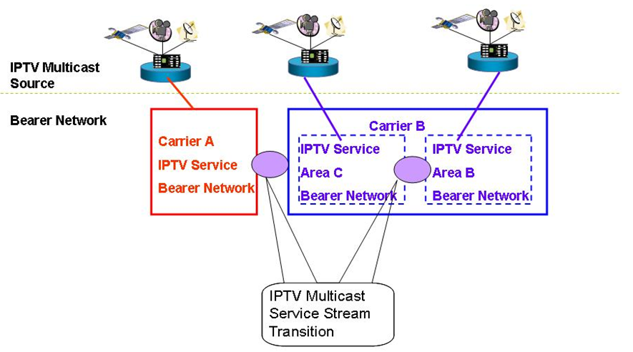

Figure 6-6: IPTV multicast address transition
- IP multicast address mapping function is recommended to support end-user’s personal broadcasting service.
- The use of Source Specific Multicast solves the problem with overlapping Multicast addresses. In case of SSM a combination of a Multicast Group address and the Source Address of the Multicast sender is used (this combination is unique and allows several senders to use the same IP Multicast address). It is recommended to deploy Source Specific Multicast.

The control of users’ multicast address
In order to control the development of multicast services on carrier’s network and avoid impact on carriers’ IPTV broadcasting services, carriers can deploy multicast service controller to manage the distribution of multicast address uniformly. However, as for the multicast application without registration, carriers will restrict the usage of these multicast addresses at the access point of IPTV network. The procedures of applying for multicast service and multicast address are as follows and shown as Figure 6-7.

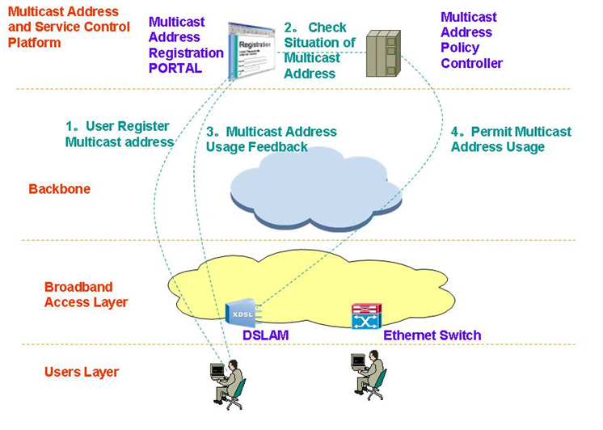

Figure 6-7: Control procedure of multicast address
1. In order to carry out services based upon multicast address users should arrange the inquiry and registration on the PORTAL of carrier-provided Multicast Address and Service Control Platform.
2. The self-service system check the situation of this multicast address from multicast address policy controller
3. If this multicast address is available, users will be told that they are allowed to use it.
4. At the same time, multicast address policy controller sends policies to the access point to allow the multicast services get access.

IPTV Multicast Address / Domain Name Management
[Editor’s note 6th meeting] In this subsection, we need more wording jobs for each sentence to be a format of requirement and generalized description.
The function of IPTV Multicast Address / Domain Name Management is an optional one for network operators, to make their management of multicast address resources more efficiently and easily. With this function, network operators do not allocate multicast IP addresses to multicast channels of IPTV service providers directly, but register domain names of these channels, and bind multicast addresses with their domain names dynamically.
- Multicast IP addresses are managed by network operators.
- Network operators can do domain name registration / deregistration on DNS servers.
- IPTV service providers negotiate domain names of their IPTV channels with network operators.
- Network operators register domain names of IPTV channels with multicast addresses dynamically assigned to these channels.
- Network operators inform IPTV service providers about the domain names registered for their IPTV channels.
- When network operators need to do multicast address management work, they just modify domain name registration on DNS servers.
    - Allocate a multicast address to an IPTV channel: register a domain name with a multicast address for the IPTV channel.
    - Revoke a multicast address from an IPTV channel: deregister the domain name of the IPTV channel.
    - Rearrange multicast addresses: modify domain name registration of IPTV channels.
- IPTV service providers get multicast address information of their IPTV channels by DNS query, and send IPTV contents to those multicast addresses.
- End users access these IPTV channels by their domain names.
- Network operators can make use of domain name information of IPTV channels to do IPTV service access control on both multicast sources (IPTV service providers) and multicast group members (end users).

IPTV multicast service management
[Editor’s note]: This subsection describes the IPTV multicast service management requirements including monitoring feature. We need many contributions to accomplish this subsection.
The packet transmission of IPTV Multicast service is usually provided based on UDP, so it can be less-reliable than TCP based delivery. Because of that reason, we absolutely need to provide the service management features including service monitoring one to guarantee the service reliability.
      - Definition of IPTV multicast service management requirements
- IPTV multicast service is recommended to provide service monitoring features for the service status management.
- IPTV multicast service is recommended to provide the statistics as the service reporting feature.
- IPTV multicast service is recommended to manage each service STBs, stream servers, management servers.
- IPTV multicast service is recommended to be capable of recovering or handling for the specific host to get the poor service quality.
      - Necessary information for IPTV multicast service management
[Editor’s note 6th meeting] In this subsection, we need to make references to WG2 working document.
- Multicast Group information
  - The multicast groups IP, port information are delivered from streaming server to clients in the live broadcasting connection time. That information is used for checking whether multicast group information is correct or not.
- Client information
  - If the clients start to receive the live broadcasting data, IPTV service management server can get the information of the each client’s IP, MAC addresses. That information is used for checking the client’s status.
- Video type information
  - When receiving live broadcasting, the clients get the video information like video size and codec type which is received from the streaming server. That information is used for video quality measurement data.
- Video Frame information
  - With checking the timestamp and sequence number of the media data header, we can get the exact time information about frame reception and remaking.
  - The Sequence number is consecutive one, so the unusual increase can be regarded as the case of IPTV service frame loss, so it can be used for service quality measurement factor.
  - From the decoding procedure of media data, we can get the I, P, B frame information which can be used as service quality measurement information.
- Bitrate information
  - The Bitrate information can be also used for IPTV service quality measurement factor
- Bitrate(bit/sec) = data size / time
      - IPTV multicast service monitoring features
- For providing IPTV multicast service monitoring, IPTV multicast service is recommended to provide the performance monitoring feature.
- And, IPTV multicast service is recommended to get the QoS performance data by manipulating of above IPTV service management information.
- And QoS performance data is recommended to include the measurement values such as fps, throughput, loss rate, delay, jitter.
- And, for the service monitoring, IPTV multicast service is also recommended to provide the measurement value of the IPTV multicast service quality, in each period such as daily, weekly, monthly basis.

IPTV Multicast Architecture
The Functional Architecture for IPTV multicast shows the principal functional groups. These functional groups provide a more detailed breakdown of the IPTV multicast functionality.

Figure 7-8 : Architecture for IPTV multicast

End-user Functions (EFs) for IPTV multicast
[Editor’s note] The function and its interfaces are required to be described only in the scope of supporting IPTV multicast service. Contributions are requested.
The multicast end-user functions include those functions normally provided by the IPTV Terminal and the end-user Network.
The multicast end-user functions are responsible for collecting control commands from the user, and interacting with the multicast application functions to join and leave from IPTV multicast groups. Multicast end-user can request the multicast service information. After receiving this information, they can join the multicast group with some QoS requirements. Then, it receives multicast data through multicast network transport functions.

IPTV Terminal Functions (ITFs) for IPTV multicast
[Editor’s note] The function and its interfaces are required to be described only in the scope of supporting IPTV multicast service. Contributions are requested.

The ITFs are responsible for something to support multicast functionality for IPTV service.[TBD]
ITF-AF is an interface between ITF and AF.
ITF-CDF is an interface between ITF and CDF.
ITF-SCF is an interface between ITF and SCF.
ITF-HNF is an interface between ITF and HNF.

Home Network Functions (HNFs) for IPTV multicast
[Editor’s note] The function and its interfaces are required to be described only in the scope of supporting IPTV multicast service. Contributions are requested.

The HNF are responsible for something to support multicast functionality for IPTV service.[TBD]
HNF-NTF is an interface between HNF and NTF.

Application Functions(AFs) for IPTV multicast
[Editor’s note] The function and its interfaces are required to be described only in the scope of supporting IPTV multicast service. Contributions are requested.

The multicast application functions provide interaction with end-user functions to join and leave of IPTV multicast services. And also this functions support basic multicast control functionality such as IPTV multicast channel change, pause, resume, etc.

AF-SCF is an interface between AF and NTF.
AF-CDF1 is one of two interfaces between AF and CDF.
AF-CDF2 is one of two interfaces between AF and CDF.
AF-MF is an interface between AF and MF.
AF-CPF is an interface between AF and CPF.

Content Delivery Functions (CDFs) for IPTV multicast
[Editor’s note] The function and its interfaces are required to be described only in the scope of supporting IPTV multicast service. Contributions are requested.

Multicast content delivery functions provide the distributed content servers for the IPTV multicast services. Multicast contents which are prepared in the application functions are delivered to the End-Users via the Network Transport Functions by the Content Delivery Functions. The contents and data are sent to the Content Delivery Functions from the Application Functions, during the multicast service. In order to support the efficient multicast services, contents may be stored/cached in the Content Delivery Functions.

CDF-MF is an interface between CDF and MF.

Service Control Functions (SCFs) for IPTV multicast
[Editor’s note] The function and its interfaces are required to be described only in the scope of supporting IPTV multicast service. Contributions are requested.

The multicast service control functions provides the functions to request and release the network and service resources required to support the IPTV multicast services.
For example, it could request the Content Delivery Functions to allocate multicast media server capacity and request the Network Transport Functions to reserve Network bandwidth for the multicast media Stream.

SCF-CDF is an interface between SCF and CDF.
SCF-MF is an interface between SCF and MF.
SCF-NTF1 is one of two interfaces between SCF and NTF.
SCF-NTF2 is one of two interfaces between SCF and NTF.

Network Transport Functions (NTFs) for IPTV multicast
[Editor’s note] The function and its interfaces are required to be described only in the scope of supporting IPTV multicast service. Contributions are requested.

These functions provide multicast connectivity with transport functions for all multicast users. The multicast transport functions can support multicast tree construction, multicast traffic replication and multicast member identification functions. Then, multicast traffic is forwarded by a multicast identifier through multicast delivery path.

Management Functions (MFs) for IPTV multicast
[Editor’s note] The function and its interfaces provide capabilities of managing multicast service are required to be described only in the scope of supporting IPTV multicast service. Contributions are requested.

The MFs are responsible for something to support multicast functionality for IPTV service. [TBD]
MF-NTF is an interface between MF and NTF.

Content Provider Functions (CPFs) for IPTV multicast
[Editor’s note] The function and its interfaces for the contents provider functions are required to be described only in the scope of supporting IPTV multicast service. Contributions are requested.

[Editor’s note] The following sentence moved from 7.2.2.
Multicast Content Server Functional Entity provides distributed storage servers (e.g. CDN) for large volumes of video and audio contents.

IPTV Multicast scenario
[Editor’s note, 6th meeting] Based on agreement of C-0983, Chapter 8 &9 are merged to one.
Editor’s Note (in 5th meeting): The descriptions in chapter 8 seem too much dependent on implementation issues of network operator; for example, access, metro, core network. Several questions have been arisen on how the following models can be mapped with IPTV architecture. Therefore, it is requested to confirm whether the context is in scope of IPTV multicast framework.

Pure IP multicast scenario

Pure IP multicast-based IPTV service delivery solution
Figure 8-1 shows the concept of pure IP multicast based IPTV service delivery solution.
In this scheme, each member registers IP multicast group by exchanging IGMPv.x messages with its access routers; and then each IP multicast router constructs IP multicast tree by exchanging multicast routing protocol messages; finally data from source flows according to the multicast tree from source to each receivers.
Because ISP owns and manages Multicast routers, ISP can tightly manage the communication.

Figure 8-1: Data distribution scheme with pure IP multicast
To provide IPTV service based on pure IP multicast, it is required for Network Provider (NP) to install multicast-capable routers; and the service solution fully depends on IP multicast network.
The pure IP multicast-based IPTV service solution has characteristics of tightly related performance to the condition of NP’s network; therefore this service solution has the merit of having full-network-speed because multicast forwarding capability is provided by each network element (i.e., multicast routers).
On the contrary, pure IP multicast-based IPTV service solution can support only bounded number IPTV service channels. Because each network element must handle each state per flow, the NP’s network may suffer from unbounded number of IPTV service channels.
Therefore, pure IP multicast-based IPTV service solution is appropriate for HDTV-quality IPTV service with bounded number of IPTV service channels.
Figure 8-2: High-level information flow for the case of IP multicast-based IPTV service
Figure 8-2 shows scenario when pure IP multicast mechanism is applied to IPTV service. To provide IPTV service, not only data delivery mechanism but such as IPTV service control, DRM management are very crucial, but this scenario will only focus on the multicast data delivery capabilities, the left are considered out of scope.
In the pure IP multicast-based IPTV service, Content Provider (CP) asks Service Provider (SP) to multicast content media (1), and then SP prepares the content media for multicasting to the announce group (2); but the way of announcing group is also considered as out of scope.
Consumer (IPTV client) exchanges signalling with SP’s IPTV control function for initiating IPTV service (3).
In pure multicast based IPTV service, NP is in charge of replicating and delivering content media to each receiver; the purpose of network transport function of NP is to configure optimized multicast tree and then forwards replicated data along the configured multicast tree. The network provided by NP consists of access, edge, and core network.
To have multicast delivery service, it is required for IPTV client to subscribe a specific multicast group. IPTV client uses network/resource management function to subscribe the multicast group (4); IPTV client can join a specific multicast group by using IGMP. IPTV client’s subscribing a group will be accomplished after following successful NP’s network authentication; then the IPTV client can be attached to the specific multicast tree. In case of NP, most optimized multicast tree from SP to consumers is configured by exchanging appropriate routing protocol.
After the successful multicast tree is configured, the content media from SP can be delivered to IPTV client with help of multicast forwarding capabilities provided by NP (5). The content media, finally reached at IPTV client’s network transport function, will be delivered to IPTV client application. To improve video quality suffered by jitter or delay, IPTV client may put appropriate size of buffer between network transport and client’s application (6).
In case when QoS monitoring is necessary, SP may gather information by asking end IPTV client of experienced QoS report or by asking NP of network statistics (7); but the details are considered as out of scope.

Alternative multicast scenario

Server-based IPTV service delivery solution
Figure 8-3 shows the concept of replicated-unicast based IPTV service delivery solution.
In this scheme, ISP puts a media server or server pool somewhere; each member connects media server or server pool; then the media server sends data to every receiver replicatively.
Because ISP or content provider (CP) owns and manages media server, ISP can tightly manage the communication; but because media server cannot support infinite number of receivers, the size of the group is tightly bounded by the performance of media server or server pool as well as server-side network bandwidth.

Figure 8-3: Data distribution scheme with replicated unicast

CDN-based IPTV service delivery solution
Figure 8-4 shows the concept of CDN-based IPTV service delivery solution.
In this scheme, ISP pre-installs CDN servers in an appropriate place; each receiver finds and then connects the nearest CDN server. Then multimedia streams from source are distributed to each receiver along the data delivery path of CDN servers.
Because ISP or content provider (CP) owns and manages CDN servers, ISP can tightly manage the communication; but because ISP cannot install CDN servers infinitely, the number of installed CDN servers bounds the size of the group tightly.

Figure 8-4: Data distribution scheme with CDN

To provide CDN-based IPTV service, it is required SP to position CDN server or server pool. CDN-based IPTV service can be easily deployed; because CDN-based IPTV service can be implemented over current unicast-based network; so, it is not required to install multicast-enabled network.
The CDN-based IPTV service solution has characteristics of tightly related performance to the power of CDN server and the number of CDN servers; because CDN server sends content media to each client repetitiously according to the each IPTV client’s connection to CDN server. The number of IPTV clients can be served at a same time totally depends on the power of CDN servers and the number of CDN servers.
However, because each client directly connects to CDN server SP can easily manage each client at any purpose; for example, SP can monitor each IPTV clients’ presence for billing in real time.
Therefore, CDN-based IPTV service solution is most suitable for IPTV service provider who does not own a network but wants to provide payable IPTV service to the bounded number of IPTV clients.

Figure 8-5: High-level information flow for the case of CDN-based IPTV service
Figure 8-5 shows the scenario when CDN mechanism is applied to IPTV service. Because this scenario only focuses on the multicast data delivery capabilities, the left are considered out of scope.
To begin with CDN-based IPTV service, CP asks SP to deliver content media; then SP convert the requested content media into suitable format for IPTV service delivery (1).
To receive IPTV service, IPTV client asks SP for specific IPTV service; and then SP gives available information about CDN servers to connect (2). IPTV client then tries to connect CDN server by using the given information from SP (3). Because unicast mechanism is applied to deliver content media to IPTV clients in CDN-based IPTV service solution (4), NP does not care about multicast delivery; NP is just for unicast data delivery capabilities (5).
The content media, finally reached at IPTV client’s network transport function, will be delivered to IPTV client application. To improve video quality suffered by jitter or delay, IPTV client may put appropriate size of buffer between network transport and client’s application (6).
In case when QoS monitoring is necessary, SP may gather information by asking end IPTV client of experienced QoS report or by asking NP of network statistics (7); but the details are considered as out of scope.

P2P-based IPTV service delivery solution
Figure 8-6 shows the concept of P2P-based IPTV service delivery solution.
In this scheme, each end-node can be both a media producer as well as a media consumer. The way of communications is as follows; each node discovers its peers and then connects them; each node can exchange media between themselves.
Because P2P model does not want to have ISP’s censorship, this model usually does not involve node of ISP’s. Although the size of group is not logically bounded, it may not be adequate to distribute contemporary media. To improve data receiving, each node tries to finds more peers as possible.

Figure 8-6: Data distribution scheme with P2P

Overlay multicast-based IPTV service delivery solution
Figure 8-7 and figure 8-8 show a brief concept of overlay multicast-based IPTV service delivery solution. In overlay multicast mechanism, special overlay nodes emulate the functions of IP multicast router’s; such as multicast data tree configuration, multicast data forwarding etc.
In this scheme, each overlay node constructs multicast data delivery path from sender to group dynamically as naïve IP multicast router does. Along the constructed path, each overlay node forwards data, which comes from its upstream node, to its downstream nodes. The size of group is not logically bounded, and it is adequate to distribute contemporary media.
The overlay node which substitutes IP multicast router may form a hardware box, a server, or an end-system; the formation is a deployment or implementation issue. Figure 8-7 shows an overlay multicast scheme without ISP’s participation.

Figure 8-7: Data distribution scheme with overlay multicast without ISP
Figure 8-8 shows an overlay multicast scheme with ISP’s participation.

Figure 8-8: Data distribution scheme with overlay multicast with ISP
To provide overlay multicast-based IPTV service, it is required for IPTV client’s network delivery function to construct overlay multicast tree and to replicate and forward content media.
Overlay multicast-based IPTV service can be easily deployed. Because overlay multicast-based IPTV service can be implemented over current unicast-based network; there is no need to change current network environment.
The noticeable feature of overlay multicast mechanism is that each client can relay received content media; i.e., each client can act like content producer as well as content consumer. Therefore the QoS of overlay multicast-based IPTV service is highly affected by the power of each IPTV client.
However, in overlay multicast-based IPTV service solution, only the participated IPTV clients to a specific IPTV channel share the burden of content media delivery; so it is not required to have centralized server nor specific network element. Therefore, overly multicast-based IPTV service does not have any limitation on the number of IPTV service channel.
On the contrary, it is difficult to manage each IPTV clients for billing and presence, because each contents media delivery elements in overlay multicast-based IPTV service are distributed.
Therefore, overlay multicast-based IPTV service solution is suitable for IPTV service of low-video-quality (low bit rate) and free IPTV service with no limitation on the number of service channel. Especially this service solution can be applied for the cyber community purpose, for personal broadcasting purpose, and for the CCTV broadcasting purpose.

Figure 8-9: High-level information flow for overlay multicast-based IPTV service

Figure 8-9 shows the scenario when overlay multicast mechanism is applied to IPTV service. Because this scenario only focuses on the multicast data delivery capabilities, the left are considered out of scope.
To begin with overlay multicast-based IPTV service, CP asks SP to delivery content media and then SP convert the requested content media into suitable format for IPTV service(1). IPTV client asks SP to provide IPTV service to receive IPTV service (2).
In overlay multicast environment, each IPTV client constructs overlay multicast tree. Along the overlay multicast tree, each IPTV client can receive content media from its parent client and can also relay the received content media to its children clients; therefore it is required for each client to know the location information of other clients participated in same IPTV channel.
To acquire information about other participated IPTV clients, IPTV client exchange signaling with SP (3). In overlay multicast-based IPTV service, unicast mechanism is applied to deliver content media; NP only needs to support unicast data delivery capabilities (4).
The content media, finally reached at IPTV client’s network transport function, will be delivered to IPTV client application. To improve video quality suffered by jitter or delay, IPTV client may put appropriate size of buffer between network transport and client’s application (5). Then IPTV client forwards the received content media to network to support its children clients (6).
In case when QoS monitoring is necessary, SP may gather information by asking end IPTV client of experienced QoS report or by asking NP of network statistics (7); but the details are considered as out of scope.

Other aspects
[Editor’s note]: This section is reserved to invite future contributions, which can address other aspects of IPTV Multicast, not a specific issue to each chapter.

Overlay multicast networking
[Editor’s note 6th meeting] WG4 decided to move the detail description of overlay multicast in Appendix as the technical information. In this chapter, as the summarization of overlay multicast technology, some essential description will be provided till next meeting.

Control framework for IPTV service level multicast
Service Level Multicast constructs and manages logical multicast path to support internet group application services over the unicast/multicast network. After exchange of control messages for service level multicast, a multicast data delivery path is constructed over physical transport network, and a logical multicast control path will be created by using multiple end hosts. Along the logical delivery path for real-time or reliable data transport, service level multicast function is performed with cooperation among upstream and downstream IMAs at service level. Only after the physical data delivery path is established via service level multicast control, IPTV applications can work as if they were in a native IPTV multicast network.
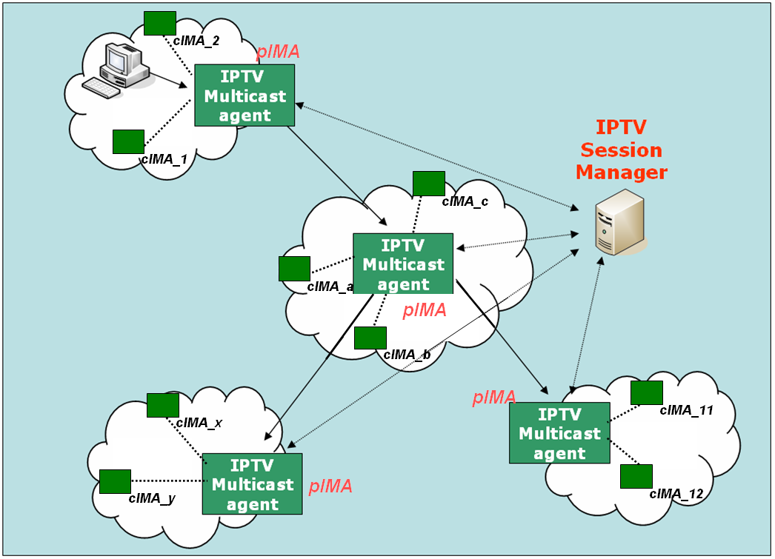
Figure 11-9 - Functional Architecture for Service Level Multicast Capabilities for IPTV

IPTV Session Manager (ISM)
ISM is involved in session configuration and maintenance for IPTV service flows. A single ISM can handle one or multiple sessions simultaneously, and it can provide the following functionalities:
- Session initialization: ISM allocates ISID (IPTV Session ID) for new session.
- Session release: Session can be released as needed.
- Session membership management
- Session status monitoring: this function enables reporting of the status of data channel, monitoring of data throughput, gathering multicast protocol topology information

IPTV Multicast Agent ( IMA )
IMA constructs overlay multicast delivery path over physical transport path, and forwards data along the constructed physical transport path. An IMA consists of two functional modules, multicast control module and multicast session control module. The main function of former is to establish multicast delivery path and that of latter to setup multicast session along the paths constructed by multicast session control module. IMA performs the control functions to exchange control messages with other entities. Its major functions are as follows.
- Session join: each IMA contacts with Session Manager.
- Session leave: when an IMA wants leave the session, it gives notice to pIMAs and cIMAs
- Session maintenance: relay request and its response will be exchanged between the two IMAs periodically.
- Loop detection & avoidance
- Partitioning detection & recovering
- Parent switching
- IPTV Session status reporting
In order to perform service level multicast of IPTV streaming applications, the functional blocks for IPTV service control are shown as Error: Reference source not found.
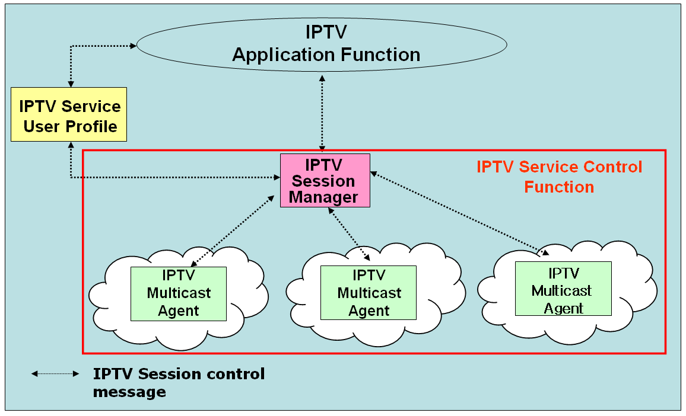

Figure 11-10 - Functional blocks of IPTV session control for IPTV application services

IMA Backup
IMA is deployed to control the construction of multicast session and deliver data among the overlay. Data stream will break if IMA goes out of work. So it is important to deploy backup function for IMA to guarantee service quality. As shown in figure11-23, nodes (IMAs or terminals) of overlay multicast will report its status to others. The report path could be different according to different IMA selection mechanism. For example, report will be transferred to the siblings if backup IMA is selected among siblings or transferred only to PIMA if backup IMA is selected by PIMA. In other scenario, IMAs may exchange data packets among their siblings to backup each other. Whatever the backup selection mechanism is, following IMA backup functions are required:
- Nodes broadcast their load status to other nodes of multicast overlay.
- Nodes responsible for backup selection select backup nodes based on the received load status.
Figure 11-11 IMA backup

Media signalling proxy
Media signalling proxy is a function to get media status in overlay multicast network by transfer media connection signalling between end hosts and obtain media session status of end hosts.
In order to get media status of overlay multicast network, media signalling proxy is recommeded to be supported by IPTV overlay multicast system. Error: Reference source not found shows how media signalling proxy operates.
Figure 11-12 - Media Signalling proxy

Overlay IPTV multicast control
Although IP multicast has not deployed globally, a lot of local networks have already been equipped with IP multicast transport. Ethernet-based LANs and private networks such as corporate and campus networks substantially provide the multicast transport capability within their local subnet or administrative domains. Recognizing these observations, there is a crucial need to use an alternative multicast delivery scheme for IPTV service. IPTV overlay networking for multicast will be an alternative solution to provide actually clinging to replicate unicast/multicast method on servers. It makes good use of existing unicast, multicast and/or multicast tunnelling schemes for diverse IPTV services (e.g., various types of group applications).
The overlay multicast control function for IPTV supports overlay session control function over physical transport network. To support the scalable session control function for overlay multicast, a hierarchical overlay multicast control will be introduced as shown in Figure 20.Error: Reference source not found
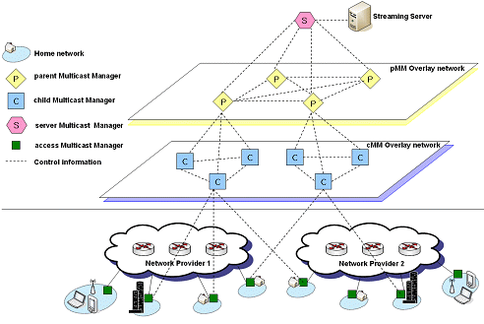

Figure 11-13 – Hierarchical structure of overlay IPTV multicast control

Control Function for IPTV overlay multicast
The control mechanism for IPTV overlay multicast creates/changes multicast session topology according to service requirements, network provider’s requirement, service provider’s requirement, user’s requirement and others. The IPTV overlay multicast requires control functions to support optimization of overlay routing, resource control and QoS support. Addition/deletion/changeof multicast session for additional IPTV service users can be controlled by modification of logical delivery path in IPTV overlay network.

Group membership management
The group membership for IPTV overlay multicast considers group size, number of group member and rate of group membership change.
- Group Membership Control: It is a function that provides mechanisms to join and leave group for IPTV overlay multicast. It may also provide the function to create or maintain the multicast groups.
- Group Partitioning: It is necessary to optimize the multicast efficiency by sub-grouping to underlying physical transport networks. Two optimization approaches to realize the group partitioning in IPTV overlay multicast will be introduced to support the following functions.
- Global group partitioning: The global group partitioning optimizes the resource usage of local network. If a multicast group in the physical transport network is experiencing serious traffic explosion temporarily, the control function of IPTV overlay multicast will be able to make a global group into multiple sub-groups to avoid the problems.
- Server group partitioning: In order to avoid performance degradation of IPTV servers, the server group partitioning will be introduced to optimize the resource usage of server network. The partitioning is performed by IPTV overlay multicast control function.

Admission control for QoS in IPTV overlay multicast network
In order to support QoS for IPTV services in overlay multicast network, resource control function for IPTV overlay network will perform resource management and admission control function in IPTV overlay multicast network.

Security for IPTV overlay multicast
IPTV overlay multicast uses shared network resource and multiple distributed overlay resources to transport data. When a user requests IPTV service, security process needs for IPTV overlay multicast function.
Overlay multicast confronts with various vulnerabilities and risks that impede from being widely deployed in mission critical business systems and applications. There are three important security challenges for the overlay network service model: Confidentiality and Integrity, Authenticity, and Availability. These three important security challenges can be classified with some properties for architectures and algorithms for building secure and scaleable information dissemination services on wide area overlay networks.

Node functions for IPTV overlay routing
An overlay multicast node function will be designated to perform overlay routing, contents location control and distribution control function for IPTV services. The designated node has full knowledge of other multicast node in the session, information on contents server and distribution control information.. In order to keep the updated information on multicast nodes, state updates occur periodically via broadcasting among all multicast nodes.

An overlay multicast node will provide few information to provide the requirements for overlay multicast resource control.
- Logical ID Assignment for overlay nodes: The overlay nodes will perform an identification function with session ID according to region or overlay IPTV service etc.
- Logical ID Assignment for contents server
- IPTV overlay multicast management function: The overlay node will collect and stores information on overlay networking management, and selects neighbour overlay nodes to exchange the information.

QoS control at overlay multicast network for IPTV services

Functional position of resource control
If the information on IPTV transport networks is directly collected and managed by IPTV overlay nodes to establish overlay transport route and configuration session topology, it will be serious burden to handle overheads in IPTV overlay networks. It is assumed that resource control functions for IPTV overlay network is located between IPTV overlay network and physical transport network, and it performs collection of information about network resource and provides QoS control to transport network.
As shown in Error: Reference source not found, it is necessary that resource control function is introduced to provide interface function for IPTV overlay multicast QoS control between physical transport and IPTV overlay network. This function performs collection and management of transport network resource (e.g., DiffServ) via specified interface (e.g. SNMP). And overlay network nodes create tree topology and optimized route to support QoS requirements of IPTV users through information collected by Resource Control function. And RCF can have the interfaces such as COPS, Diameter and H.248 to install/uninstall the policy decision for transport network The interface between overlay network and RCF will be further study. The interface may be proprietary of IPTV service providers.

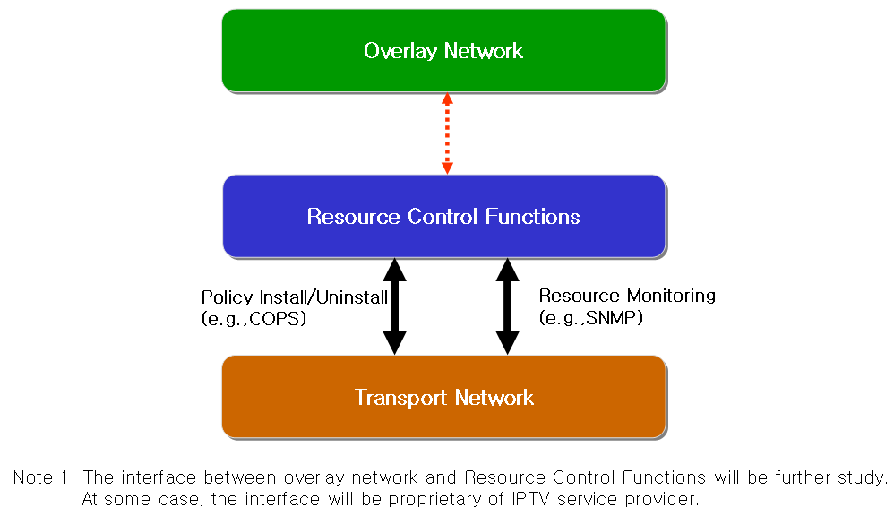

Figure 11-14 - Resource control architecture in IPTV overlay network

Resource control function
The requirements for resource control are as follows
- The Resource Control Function will collect information for resource control from transport network with periodic or a periodic. According to initiation of overlay network nodes, Resource Control function collects data for resource and QoS control.
- Resource control should be able to communicate with Resource Control Function in heterogeneous or other network.
- The following information collected is transferred to overlay network, and then overlay network creates route and optimized tree to support QoS for IPTV overlay network.
- Link State Information: it includes available bandwidth information, delay, packet loss and jitter of link.
- Routing Information: it includes routing algorithm that is used to transport network equipments and routing information of them (e.g. neighbour routing information, routing table .etc)
- Multicast Traffic Information: it includes multicast traffic parameters (e.g. channel information, type of service, user profile, source content information) per channel or session of IPTV multicast.

Resource control function for IPTV overlay multicast QoS in wired/wireless/mobile networks.
The Session Manager configures routes among IPTV overlay network nodes and optimizes tree topology for multicast sessions according to information of Resource Control Function. RCF has resource information from transport network such as link state information, routing information, multicast traffic information and so on. Session manager requests the resource information in transport network to RCF. RCF verifies the resource status based on gathered information, and makes the policy decision for the request. Session manager confirms the received message from RCF, and compares with service information. Then session manager sends the policy installing request message to RCF. After receiving the policy request message, RCF sends the policy installing request message to transport network through the configured path for overlay network. Error: Reference source not found shows the application of Resource Control Function in wired/wireless/mobile networks for IPTV overlay multicast QoS control.

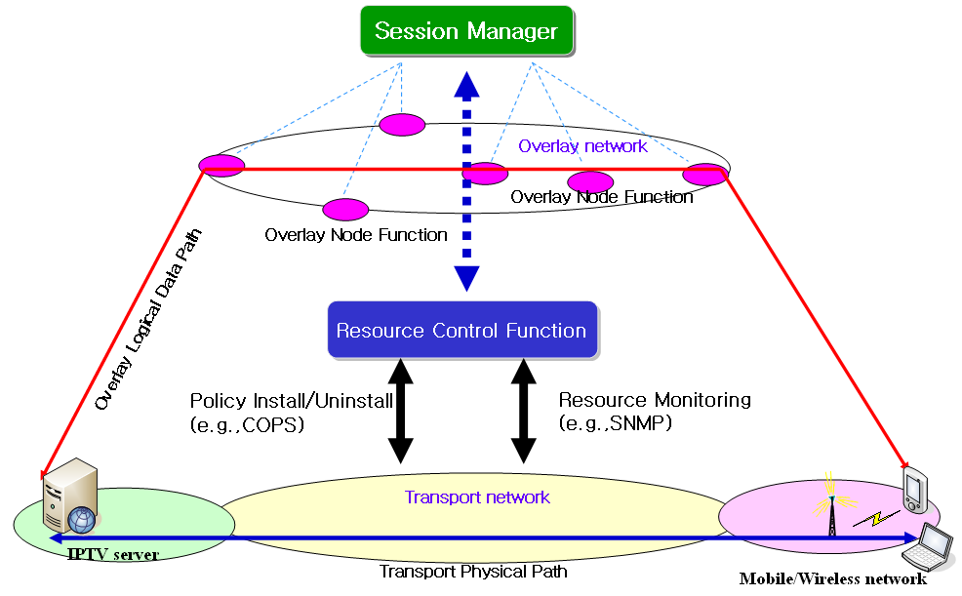

Figure 11-15 Application of resource control function in wired/wireless/mobile networks for IPTV overlay multicast QoS control

Network measurement function
In order to ensure high end-to-end service quality of the IPTV services, IPTV overlay multicast measurement system needs to be deployed to measure the IP network performance, e.g. bandwidth, packet loss between overlay nodes such that the appropriate overlay path is selected.
As part of resource control, network measurement includes receiving interface, measurement interface and forwarding interface. Receiving interface receives measurement requests from session manager and forwards them to measurement interface. Measurement interface measures the network performance between network nodes and forwards the results to forwarding interface. Forwarding interface sends the results to overlay network or other network measurement to share information.

Appendix I
Possible IPTV multicast delivery solutions
(This appendix does not form an integral part of this document)
I.1 Hybrid P2P IPTV service multicast delivery solution
Figure I.1 shows the concept of Hybrid P2P IPTV service multicast delivery solution.
In this scheme, the receivers join in multicast group as usually. Then they need to form a P2P group too. When a receiver find out that he has lost some IP packet, he can send a broadcast message to his peers to request the lost packets. Then the fast response peer can send the lost packet to it. This mechanism need the receiver caches some packet in case that it need to retransfer packet to the peer.
In this model multicast routers are control by ISP, so ISP can tightly manage the communication. P2P groups does not involve node of ISP, but it is need to limit the member in one group because too many peer will aggravate the receivers’ burden.

Figure I.1 –Hybrid P2P IPTV service multicast delivery
I.2 P2P CDN-based IPTV service multicast delivery solution
Figure I.2 shows a generalized distribution scheme with CDN that have the ability of P2P distribution.
The main problem in this architecture is how to organize CDN servers in ISP. In the traditional CDN, it is based on Client/Server technology. Upstream node (i.e. Servers) can forward data to its downstream nodes (i.e. Clients) which is not reversible. Even nodes in the same layer can not exchange data. Nowadays, for the need to improve its high reliability to serve in network, CDN servers can exchange data from each other which even have P2P abilities according to the distribution policy of CDN.

Figure I.2 – Data distribution scheme with P2P CDN
Appendix II
Procedure to provide QoS and Resource Control Functions for IPTV Overlay Multicast

When Session Manger requests information on overlay networking paths to Resource Control Function, and Resource Control Function collects the transport network information using SNMP. Resource Control provides the QoS and resource information of transport networks to Session Manager. In order to compromise the requested requirements on QoS and resource availability of IPTV overlay multicast paths, Session Manager may re-negotiate with Resource Control Function. If the provisioning of Resource Control Function is not satisfied by Session Manager, it is ignored and discarded. Figure II.1 shows procedure to create IPTV overlay multicast service to be with QoS requirements of IPTV overlay multicast paths in IPTV overlay network.

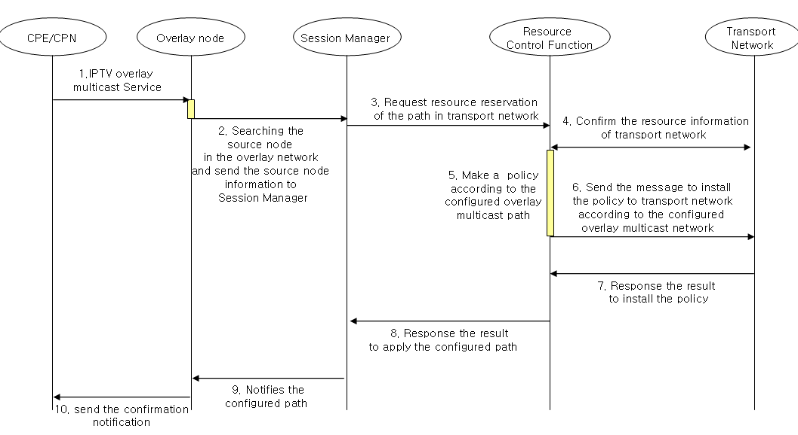
Figure II.1 - Procedure to create overlay multicast paths with Resource Reservation and Control in IPTV Overlay Network
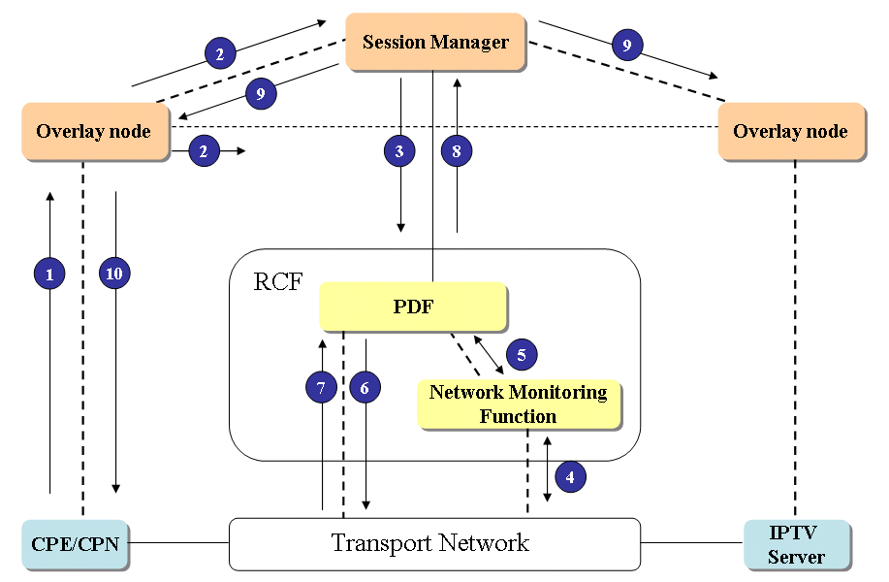
Figure II.2 – Procedure to exchange control information for provision of QoS and resource management in IPTV Overlay Network.
Figure II.2 shows an example of procedure to exchange control information for provision of QoS and resource management in IPTV Overlay Network (the same procedure of Figure II.2 is likely to Figure II.1). The RCF in IPTV Overlay Network will have similar function with Policy Decision Function. PDF performs control function based on the policies from network provider, service provider or service control function to provide QoS and resource control function to IPTV information delivery path.
The request for resource reservation and QoS control function on physical transport paths, which are mapped with logical paths in IPTV overlay network, is initiated by Session Manager, and delivered to PDF in RCF. PDF installs the policies on physical transport network, and it performs resource control function on the physical paths. The procedures in Figure II.1 and Figure II.2 are as follow.
- When IPTV overlay multicast is requested from CPE/CPN, overlay node search the originating node of contents, and forwards the information of the originating node to Session Manager. (①~②)
- Session Manager requests the Resource Control Function for the paths in accordance with IPTV session and service requirements. (③)
- If the requested requirements are met with the physical transport network, Resource Control Function confirms the resource reservation of the transport network, and applies a policy in accordance with the requests of Session Manager. (④~⑤)
- Resource Control Function sends the message to install the policy to transport network according to configured overlay multicast paths. (⑥~⑦)
- Session Manager notifies the configured path to overlay node and confirmation notification will be sent to the CPE/CPN. (⑨~⑩)

APPENDIX III

A Scenario for Service Control Function of Session Manager in IPTV Overlay Multicast Network

The service control function for IPTV in overlay multicast networking is to provide resource Request/Release function for IPTV services to Resource Control Function, IPTV service access control function to Resource Control Function, and to request content delivery control function to Content Delivery Control Function of IPTV architecture. In order to provide IPTV service control function, Session Manager in IPTV overlay network performs the following functions:
- Service Resource Request/Release: Session Manger requests resource reservation/release of transport network to create/terminate IPTV overlay session according to IPTV service requirements.
- Service Access Control: Session Manager allows IPTV service access to authenticated IPTV users according to their access rights, subscriber profiles and network policy etc.
- Request Content Delivery Control Function: Session Manager requests the location of appropriate IPTV content server which can deliver IPTV overlay multicast service to IPTV user.
Session Manager is cooperated with Content Delivery Control Functions and Resource Control Function as shown in Figure 1. Content Delivery Control Functions is used to identify appropriate IPTV content server to deliver IPTV overlay multicast service to the IPTV user. Resource Control Function provides resource reservation/release between the IPTV server and IPTV user when Session Manager requests a message to configure and optimize IPTV overlay multicast network. Each functional entity as shown in Figure 1 is corresponded with functions of IPTV architecture.
Figure III-1. Functional Entity for IPTV overlay multicast networking

Figure 2 shows procedure to perform service control function for IPTV in overlay multicast networking.
- When IPTV overlay multicast service is requested from IPTV user, Content Delivery Control Functions will search appropriate IPTV content server. It forwards IPTV user’s request which is contained the location of the IPTV content server and IPTV service requirements to Session Manager. (①)
- Session Manager in IPTV overlay multicast networking derives the IPTV service parameter from the IPTV user’s request and it performs authentication between end IPTV user and the IPTV overlay multicast service. Session Manager requests resource reservation of path between the IPTV server and IPTV user to Resource Control Function. (②)
- Resource Control Function reserves optimal delivery path according to IPTV service requirements and network policy after it observes the resource information of transport network. And it sends result of reserved path to Session Manager. (③)
- Session Manager creates/updates the IPTV overlay session according to reserved delivery path by Resource Control Function. It notifies the configured path to Content Delivery Control Functions. Content Delivery Control Functions will update managing IPTV service information according to the result of IPTV overlay session configuration. (④)

Figure III-2. Example scenario of service control in IPTV overlay multicast networking
________________

