INTERNATIONAL TELECOMMUNICATION UNION |  |  |  | Focus Group On IPTV
TELECOMMUNICATION  STANDARDIZATION SECTOR  STUDY PERIOD 2005-2008 |  |  | FG IPTV-DOC-0146
 |  |  | English only
WG(s): 6 |  | 5th FG IPTV meeting:  Geneva, 23-31 July 2007
OUTPUT DOCUMENT
Source: | Editor
Title: | Working Document: IPTV Multimedia Application Platforms

Table of Contents

1 Scope 3
2 References 3
3 Definitions 3
4 Abbreviations and Acronyms 3
5 Multimedia Application Platforms 3
5.1 ITU-R BT.1699, BT.1722 3
5.2 ITU-T J.20x Series (J.200, 201, 202, 203) 3
5.2.1 GEM 3
5.2.2 ACAP 3
5.2.2.2 Format 3
5.2.2.3 Profiles 3
5.2.3 OCAP 3
5.2.4 MHP 3
5.2.5 BML 3
5.3 ITU-T T. 17x Series (T.171, 172, 173, 174, 175, 176) 3
5.3.1 MHEG-5 3
5.4 M3W 3
5.5 BIFS 3
5.6 LASeR & SAF 3
5.7 SVG 3
6 Other Related Standards 3
6.1 ECMAScript 3
6.2 CE-HTML [CEA-2014] 3

IPTV Multimedia Application Platforms

1 Scope
This working document identifies and analyzes the relevant standards for IPTV multimedia application platforms.

2 References
The following ITU-T Recommendations and other references contain provisions, which, through reference in this text, constitute provisions of this working document. At the time of publication, the editions indicated were valid. All Recommendations and other references are subject to revision; users of this working document are therefore encouraged to investigate the possibility of applying the most recent edition of the Recommendations and other references listed below. A list of the currently valid ITU-T Recommendations is regularly published.
[A/101] ATSC Document A/101, ATSC Standard: Advanced Common Application (ACAP)
[ISO/IEC 14496-11] ISO/IEC 14496-11 (2005), Information technology — Coding of audio-visual objects —Part 11: Scene description and application engine (BIFS)
[CEA-2014] CEA-2014 (2006), Web-based Protocol and Framework for Remote User Interface on UPnPTM Networks and the Internet (Web4CE)
[GEM] ETSI TS 102 819 V1.3.1 (2005-10), Digital Video Broadcasting (DVB); Globally Executable MHP version 1.0.2 (GEM 1.0.2)
[BT.1699] ITU-R Recommendation BT.1699, Harmonization of declarative content format for interactive TV applications
[BT.1722] ITU-R Recommendation BT.1722, Harmonization of procedural content format for interactive TV applications
[J.200] ITU-T Recommendation J.200 (2001), Worldwide common core - Application environment for digital interactive television services
ITU-T Recommendation J.200 Corrigendum (2004), Worldwide common core - Application environment for digital interactive television services
[J.201] ITU-T Recommendation J.201 (2004), Harmonization of declarative content format for interactive television applications Additional media types
ITU-T Recommendation J.201 Amendment 1 (2005), Harmonization of declarative content format for interactive television applications Additional media types
[J.202] ITU-T Recommendation J.202 (2005), Harmonization of procedural content formats for interactive TV applications
[J.203] ITU-T Recommendation J.203 (2006), Common core for digital video recorder platform
[ISO/IEC 14496-20] ISO/IEC 14496-20, Information technology — Coding of audio-visual objects —Part 20: Lightweight Scene Representation (LASeR)
[ISO/IEC 23004] ISO/IEC 23004, Multimedia Middleware (M3W)
[ISO/IEC 23004-1] ISO/IEC 23004-1, Multimedia Middleware — Part 1: Architecture
[ISO/IEC 23004-2] ISO/IEC 23004-2, Multimedia Middleware — Part 2: Multimedia API
[ISO/IEC 23004-3] ISO/IEC 23004-3, Multimedia Middleware — Part 3: Component Model”
[ISO/IEC 23004-4] ISO/IEC 23004-4, Multimedia Middleware — Part 4: Resource and Quality Management
[ETSI TS 102 819] ETSI TS 102 819 V1.3.1, Digital Video Broadcasting (DVB); Globally Executable MHP version 1.0.2
[ETSI TS 102 812] ETSI TS 101 812-v1.1.1(2000), Digital Video Broadcasting (DVB) - Multimedia Home Platform (MHP) Specification 1.0 (FOREIGN STANDARD)
[ETSI TS 101 154] ETSI TS 101 154, Digital Video Broadcasting (DVB); Implementation guidelines for the use of Video and Audio Coding in Broadcasting Applications based on the MPEG 2 Transport Stream
[ISO/IEC 23000-5] ISO/IEC FCD 23000-5, Multimedia application format (MPEG-A) — Part 5: Media Streaming Player
[ANSI/SCTE 90-1] ANSI/SCTE 90-1(2004), SCTE Application Platform Specification OCAP 1.0 Profile
[ITU-T T.171] ITU-T Recommendation T.171 (1996), Protocols for interactive audiovisual services: Coded representation of multimedia and hypermedia objects
[ITU-T T.172] ITU-T Recommendation T.172 (1998), MHEG-5 support for base-level interactive applications
[ITU-T T.173] ITU-T Recommendation T.173 (1997), MHEG-3 script interchange representation
[ITU-T T.174] ITU-T Recommendation T.174 (1996), Application Programming Interface (API) for MHEG-1
[ITU-T T.175] ITU-T Recommendation T.175 (1998), Application Programming Interface (API) for MHEG-5
[ITU-T T.176] ITU-T Recommendation T.176 (1998), API for Digital Storage Media Command and Control (DSM-CC)

3 Definitions
This working document uses the following terms defined elsewhere:
TBD

4 Abbreviations and Acronyms
This working document uses the following abbreviations and acronyms.

ACAP Advanced Common Application Platform
BIFS Binary Format for Scene
BML Broadcast Markup Language
GEM Globally Executable MHP
LASeR Lightweight Application Scene Representation
MHEG Multimedia and Hypermedia information coding Experts Group
MHP Multimedia Home Platform
M3W MPEG Multimedia Middleware
OCAP Open Cable Application Platform

5 Multimedia Application Platforms

ITU-R BT.1699, BT.1722
TBD

ITU-T J.20x Series (J.200, 201, 202, 203)
This Recommendation defines APIs, semantic guarantees and system aspects of platform behaviour for harmonized procedural content formats for interactive TV applications.
Since this Recommendation was approved in 2003, several procedural content formats for interactive TV applications developed by other standardization bodies have been updated or newly developed.
Updated specifications include: DVB-GEM, DVB-MHP 1.0 and 1.1, OCAP-1.0, and ARIB STD-B23. Also ATSC has now developed ACAP.
This Recommendation has been revised to include the updated and newly developed procedural content formats. Harmonization is based on GEM 1.0.1 which has been developed with contributions from DVB, SCTE, ARIB and ATSC. Therefore, the only normative references in this Recommendation are GEM 1.0.1 and ITU-T Rec. J.200 describing the overall architecture. The other specifications listed above are included for information as well as the appendices which describe the additional APIs specific to these specifications and are therefore not included in the harmonized normative part.

GEM
TBD

ACAP

5.2.2.1 Scope
ACAP is applicable for specifications and standards based on the ACAP APIs, content formats, and semantic guarantees.
ACAP Applications are classified into two categories depending upon whether the initial application content processed is of a procedural or a declarative nature. These categories of applications are referred to as a procedural (ACAP-J) and declarative (ACAP-X) applications, respectively. An example of an ACAP-J application is a Java TVTM Xlet composed of compiled JavaTM byte code in conjunction with other multimedia content such as graphic, video, and audio. An example of an ACAP-X application is a multimedia document composed of XHTML markup, style rules, scripts, and embedded graphics, video, and audio.
Application environments are similarly classified into two categories depending upon whether they process procedural or declarative applications. These categories are referred to as ACA-J and ACAP-X environments, respectively. An example of an ACAP-J environment is a Java Virtual Machine and its associated API implementation. An example of an ACAP-X environment is an XHTML multimedia document browser, also known as a user agent.
The architecture and facilities of the ACAP standard are intended to apply to broadcast systems and receivers for terrestrial (over-the-air) broadcast and cable TV systems.

5.2.2.2 Format
ACAP is primarily based on GEM and DASE, and includes additional functionality from OCAP. The followings are the relevant specifications which ACAP includes:
- GEM: ACAP includes GEM 1.0.2 in its entirety, except as explicitly modified by the ACAP.
- OCAP: ACAP includes OCAP 1.0 in its entirety, except as explicitly modified by the ACAP for ACAP terminal operating in a terrestrial broadcast environment.
- Addition on Non-ACAP Interfaces: Terminal Specifications based on ACAP may add public interfaces, provided that they are added in a namespace that does not conflict with ACAP. ACAP terminal specifications and ACAP terminals shall not require that such extension interfaces be called by ACAP applications in order to enable behaviour that is normatively required by ACAP standard.

5.2.2.3 Profiles
ACAP defines two profiles, an ACAP-J Profile and a combined ACAP-J and ACAP-X profile. The following table shows the detailed platform profile definitions. The section and clause number in the table refers the relevant section and clause in ACAP specification [1].
Table 1: Detailed Platform Profile Definitions

OCAP
OCAP is the set of specifications for the interactive multimedia services of digital CATV that has been developed by the OpenCable project managed. OCAP 1.0 is based on MHP 1.0.2, and includes the extensions for the cable system in USA.

MHP
MHP is the set of specifications for multimedia broadcasting that has been developed by the DVB Project. MHP has two functional categories. The version 1.0 series covers the execution engine (EE) environment and the version 1.1 series covers the presentation engine (PE) environment in addition to version 1.0. The PE portion of the version 1.1 series is not standalone; it mandates the existence of the EE environment. The first release of the DVB MHP version 1.0 series was May 2000. The MHP 1.0 specification employs Java technology for an EE environment.

BML
BML (Broadcast Markup Language) is a declarative application specification for multimedia broadcasting in Japan standardized by ARIB (Association of Radio Industries and Businesses). It is defined in ARIB STD-B24 “Data coding and transmission specification for digital broadcasting”. BML consists of XHTML, CSS, DOM and ECMAScript. ARIB STD-B24 was revised to include additional functionalities for receivers with digital storage and for terrestrial digital broadcasting including mobile reception.
5.2.5.1 Scope
This specification is applied to reference model for data broadcasting service that is carried out as part of the digital broadcasting.
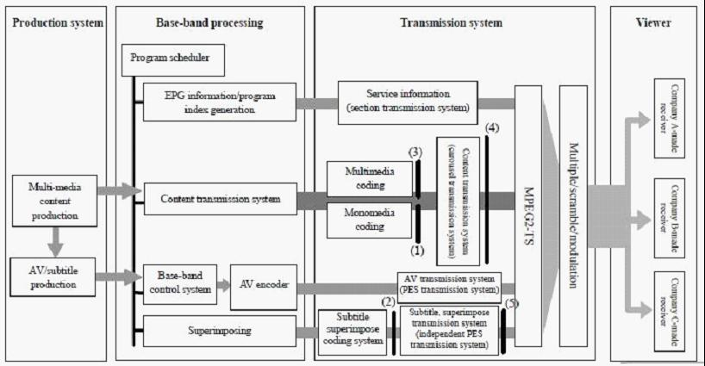
Figure 1 System Structure of BML
5.2.5.2 Data Coding
- Coding mono-media (1): Coding system for character string and bit map etc. used in multimedia is specified.
- Coding of subtitle, superimpose(2); Coding system for subtitle and superimpose is specified.
5.2.5.3 XML-based Multimedia Coding Scheme
- Multimedia Coding (3); Coding system of XML based system adopted as multimedia coding system and its profile is specified.
5.2.5.4 Data Transmission Specification
- Content transmission format (4); Content transmission format of data carousel transmission method etc. to transmit content is specified.
- Subtitle and superimpose transmission format (5); Independent PES transmission format to transmit subtitle and superimpose is specified.

ITU-T T. 17x Series (T.171, 172, 173, 174, 175, 176)
The T.170-Series of Recommendations provides Standards defining the syntax of Multimedia and Hypermedia Applications as well as it provides a Virtual Machine and a set of APIs in order to be able to build a software architecture for multimedia applications that guarantees application portability.
Applications can consist of either MHEG-1 or MHEG-5 objects. Both applications, MHEG-1 or MHEG-5 can use Virtual Machine (VM) code to enhance their functionality. However, application portability is guaranteed because the necessary interfaces for the terminal architecture are fully specified.
Recommendation T.171 and Recommendation T.173 are generic standards covering the entire domain of possible multimedia applications.
Recommendation T.172 and the DAVIC Virtual Machine can be viewed as specialisation of the above-mentioned Recommendations and are hence more suitable to be implemented in a concrete information retrieval scenario.
A typical device based on the software architecture introduced in Figure 1 would be a Set Top Unit (STU) compliant with DAVIC 1.2 specifications.
An Implementers Handbook for the T.170-Series is also available which gives guidance on how to implement Recommendation T.172 and DSM-CC.

MHEG-5
A multimedia application can be conceived as a set of self-contained objects based on synchronization and spatial-temporal relationships of multiple media formats, structural composition, event-action associations, navigation, and user interaction capabilities. Controlling the playback of time-dependent contents, like streams of multiplexed audiovisual data requires specific support. These streams demand VCR control functions (play, pause, fast forward, and so on), as well as the capability to manage events generated during their presentation. For example, rendering text subtitles can be synchronized with timecode events generated during the playback of a stream. MHEG-5 represents an application, as a set of scenes, which contain objects common to all scenes. A scene supports the spatially and temporally coordinated presentation of audiovisual content consisting of graphics, bitmaps, text, and streams (based on the multiplex of audio and video components). Interaction can be performed via graphic elements like buttons, sliders, text entry boxes, and hypertext selections. Every scene, as well as an entire application, is a self-contained entity that can represent its localized behaviour by links that are event-action associations. Events can be generated by users, expiration of timers, playback of streams, and other conditions within the RTE.
The global scope of MHEG-5 is to define the syntax and semantics of a set of object classes that can be used for interoperability of multimedia applications across minimal-resources platforms. The developed applications will reside on a server, and as portions of the application are needed, they will be downloaded to the client. In a broadcast environment, this download mechanism could rely, for instance, on cyclic rebroadcast of all portions of the application. It is the responsibility of the client to have a runtime that interprets the application parts, presents the application to the user, and handles the local interaction with the user.

M3W
ISO/IEC 23000 M3W provide two sets of APIs, Multimedia platform APIs and Support platform APIs. M3W Multimedia platform APIs defines mainly audio and video processing APIs handling front-end, decoders and post-processing of A/V and trust management APIs handling Key Management, Signature Management, License Management, and Certificate Management. The M3W Multimedia APIs offer a high-level API that is independent of the target hardware. By standardizing things that are common, the Multimedia APIs let developers focus on innovation and reduce time to market without limiting product differentiation. It simplifies the work of middleware and application developers because it is designed from what they need, rather than simply reflecting how a particular product’s hardware and software happens to be implemented.
M3W Support platform provides APIs to manage the lifetime of, and interaction with, realization entities, which enables management of extra-functional (‘support’) properties as follows;
- Resource Management: enabling the optimisation of the (perceived) Quality of Service for the user of the appliance. In practice this will usually mean the optimisation of the Quality of Service delivered by the functional part;
- Download: enabling the transfer (download as well as upload) and management of new components to permanent storage of an M3W system;
- Integrity Management: enabling the maintenance of a consistent software configuration for M3W. M3W systems have the ability to download and remove components, and also to register and un-register executable components. The Integrity Management framework enables the verification of the consistency of the current configuration, and when necessary, it can adapt the configuration in order to make the configuration consistent;
- Fault Management: enabling the transparent insertion of fault tolerance mechanisms in order to increase the dependability of an M3W system. In this context, ‘transparent’ means transparent for developers of M3W services as well as for the clients of these services

BIFS
BIFS is the scene description language standardized by ISO as a part of MPEG-4 standard, ISO/IEC 14496-11. It is designed to allow for the efficient representation of dynamic and interactive presentations, comprising 2D & 3D graphics, images, text and audiovisual material. The representation of such a presentation includes the description of the spatial and temporal organization of the different scene components as well as user-interaction and animations.
The main features of MPEG-4 BIFS are the following:
- Seamless embedding of audio/video content. MPEG-4 BIFS allows integration and control of different audio/video objects seamlessly in a scene.
- Rich set of 2D/3D graphical constructs: MPEG-4 BIFS provides a rich set of graphical constructs which enable 2D and 3D graphics. BIFS also provides tools that enable easy authoring of complex Face and Body Animation, tools for 3D mesh encoding, and representation of 2D and 3D natural and synthetic sound models.
- Local and Remote Interactivity: BIFS defines elements that can interact with the client-side scene as well as with remote servers. Interactive elements allow for text input, mouse events, and other input devices that can trigger a variety of behaviors.
- Local and Remote Animations: Scene properties, such as object positions, colors, and even shapes, etc., can be animated using either predefined scene descriptions or via streams sent from a server.
- Reuse of Content: MPEG-4 scenes can contain references to streamed sub-scenes. That means that content can easily be reused, a powerful way to create a very rich user experience from relatively simple building blocks.
- Scripted Behavior: MPEG-4 scenes can have two types of scripted behavior. A Java API can control and manipulate the scene graph, as well as built-in ECMA script (javascript) support that can be used to create complex behaviors, animations, and interactivity.
- Streamable scene-description: the spatial and temporal graphic layout is carried in a BIFS-Command stream. Such a stream operates on the scene-graph through commands which replace, delete and insert elements in the scene-graph. .
- Accurate synchronization. Audio/visual content can be tightly synchronized with other A/V content, client-side, and server-driven scene animation, thanks to the underlying MPEG-4 Systems layer.
- Compression: the scene description is binarized and compressed in an efficient way.
The diagram below summarizes the different components of BIFS.
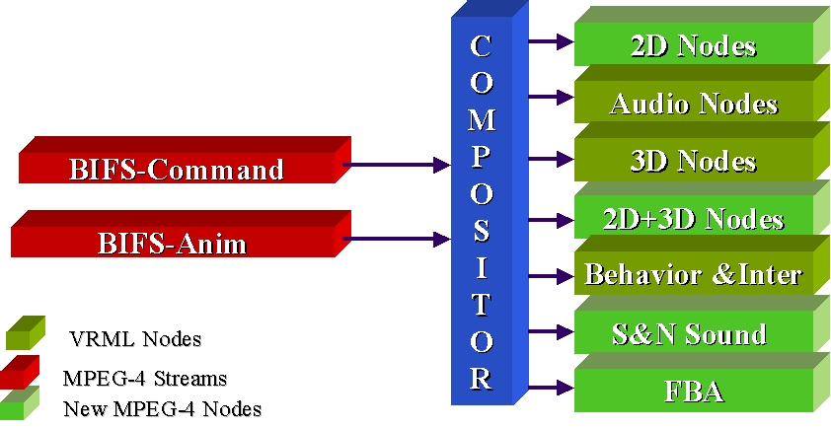
Figure 2: MPEG-4 Scene Description

LASeR & SAF
ISO/IEC 14496-20 (MPEG-4 Part 20) is a specification designed for representing and delivering rich-media services to resource-constrained devices such as mobile phones. It defines two binary formats: LASeR, Lightweight Application Scene Representation, a binary format for encoding 2D scenes, including vector graphics, and timed modifications of the scene; and SAF, Simple Aggregation Format, a binary format for aggregating in a single stream LASeR content with audio/video streams.
The LASeR specification has been designed to allow the efficient representation of 2D scenes describing rich-media services for constraint devices. A rich-media service is a dynamic and interactive presentation comprising 2D vector graphics, images, text and audiovisual material. The representation of such a presentation includes describing the spatial and temporal organization of its different elements as well as its possible interactions and animations.
The SAF specification defines tools to enable the transport of LASeR content along with its attached audiovisual material according to these requirements. The SAF specification defines a binary format for a SAF stream, made of a LASeR stream with any type of media stream. SAF streams are low overhead multiplexed streams which can be successfully delivered using any delivery mechanism: download-and-play, progressive download, streaming or broadcasting. To achieve reactivity, the SAF specification defines the concept of cache unit which allows sending in advance sub-content which will be used later on in the presentation.

SVG
SVG is a language for describing two-dimensional graphics and graphical applications in XML. SVG allows for three types of graphic objects: vector graphic shapes (e.g., paths consisting of straight lines and curves), images and text. Graphical objects can be grouped, styled, transformed and composited into previously rendered objects. The feature set includes nested transformations, clipping paths, alpha masks, filter effects and template objects.
SVG drawings can be interactive and dynamic. Animations can be defined and triggered either declaratively (i.e., by embedding SVG animation elements in SVG content) or via scripting. Sophisticated applications of SVG are possible by use of a supplemental scripting language which accesses SVG Document Object Model (DOM), which provides complete access to all elements, attributes and properties.
SVG Basic and SVG Tiny are targeted to resource-limited devices and are part of the 3GPP platform for third generation mobile phones. SVG Print is a set of guidelines to produce final-form documents in XML suitable for archiving and printing.

Other Related Standards

ECMAScript
TBD

CE-HTML [CEA-2014]
TBD

_________________

