INTERNATIONAL TELECOMMUNICATION UNION |  |  |  | Focus Group On IPTV
TELECOMMUNICATION  STANDARDIZATION SECTOR  STUDY PERIOD 2005-2008 |  |  | FG IPTV-DOC-0127
 |  |  | English only
WG(s): 6 |  | 5th FG IPTV meeting:  Geneva, 23-31 July 2007
OUTPUT DOCUMENT
Source: | Editor
Title: | Working Document: IPTV Middleware, Application and Content Platforms
CONTENTS
1 Scope 2
2 References 2
3 Definitions 3
4 Abbreviations and acronyms 3
5 Conventions 3
6 Toolbox for content coding 3
7 IPTV Middleware 3
8 Service Navigation System 3
9 IPTV Metadata 3
10 IPTV Multimedia Application Platforms 3
11 Content Provisioning 3
11.1 Introduction 3
11.2 Interface between Content/Metadata Providers and Service Providers 3
11.3 Gap Analysis for Content provisioning 3
12 Retransmission and Legacy Related Issues 3
11.2 Legacy Related Issues 3
13 Accessibility 3
14 Implementation guidelines 3
15 Scenarios 3

FIGURES
Figure 1. Functional architecture for content provision Error! Bookmark not defined.
IPTV Middleware, Application and Content Platforms

Scope
This working document identifies and defines middleware platforms, including applications, content formats, and their uses, that facilitate effective and interoperable use of an IPTV system for presenting and interacting with IPTV services.

Figure 1: Conceptual presentation of the WG activities
Editor's note: No complete agreement on the relationships between the blocks. Question about the IPTV Middleware being only on the terminal side. To be completed with the new WD on IPTV Multimedia Application Platforms

References
The following ITU-T Recommendations and other references contain provisions, which, through reference in this text, constitute provisions of this working document. At the time of publication, the editions indicated were valid. All Recommendations and other references are subject to revision; users of this working document are therefore encouraged to investigate the possibility of applying the most recent edition of the Recommendations and other references listed below. A list of the currently valid ITU-T Recommendations is regularly published.
The reference to a document within this working document does not give it, as a stand-alone document, the status of a Recommendation.
[ITU-T F.700] ITU-T Recommendation T.700 (2000), Framework Recommendation for multimedia services
[ITU-T H.222AM1] ITU-T Recommendation H.222.0 Amd 1(2002), Information technology – Generic coding of moving pictures and associated audio information: Systems Amendment 1: Carriage of metadata over ITU-T Rec. H.222.0 | ISO/IEC 13818-1 streams
[ITU-T J.90] ITU-T Recommendation J.90 (2000), Electronic programme guides for delivery by digital cable television and similar methods - Reference operating scenario and requirements
[ITU-T J.98] ITU-T Recommendation J.98 (2003), Metadata requirements for video-on-demand in cable networks
[ITU-T J.148] ITU-T Recommendation J.148 (2003), Requirements for an objective perceptual multimedia quality model
[ITU-T J.190] ITU-T Recommendation J.190 (2002), Architecture of MediaHomeNet that supports cable-based services
[ITU-T J.200] ITU-T Recommendation J.200 (2001), Worldwide common core − Application environment for digital interactive television services
[ITU-T Q.1702] ITU-T Recommendation Q.1702 (2002), Long-term vision of network aspects for systems beyond IMT-2000
[ITU-T T.171] ITU-T Recommendation T.171 (1996), Protocols for interactive audiovisual services: Coded representation of multimedia and hypermedia objects
[ITU-T T.174] ITU-T Recommendation T.174 (1996), Application programming interface (API) for MHEG-1
[ITU-T Y.101] ITU-T Recommendation Y.101 (2000), Global Information Infrastructure terminology: Terms and definitions

Definitions
3.1 This working document uses the following terms defined elsewhere:

3.1.1 Application [ITU-T Y.101]: A functional implementation realized as software running in one or spread over several interplaying hardware entities.
3.1.2 Application manager [ITU-T J.200]: The entity that is responsible for managing the lifecycle of the applications. It manages applications running in both the Presentation engine and Execution engine if both are present.
3.1.3 Application program interface (API) [ITU-T J.200]: Consists of software libraries that provide uniform access to system services.
3.1.4 Character [ITU-T J.200]: A specific "letter" or other identifiable symbol, e.g. "A".
3.1.5 Character encoding [ITU-T J.200]: Mapping between an integer input value, and the textual character that is represented by this mapping, e.g. in ASCII value 65 (decimal) is character "A", or shift-JIS for Japanese characters.
3.1.6 Content [ITU-T J.200]: A general term that refers to any of the following: application, application resource collection, or application resource.
3.1.7 Electronic program guide (EPG) [ITU-T J.200]: A Program table that is presented electronically.
3.1.8 EPG provider [ITU-T J.90]: The entity that collects, collates and assembles the elements of information that constitute the EPG database.
3.1.9 Execution engine (EE) [ITU-T J.200]: instructions and associated data and media content. An execution engine may be implemented with an operating system, computer language compilers, interpreters, and Application Interfaces (APIs), which a procedural application may use to present audiovisual content, interact with a user, or execute other tasks, which are not evident to the user. A common example of an execution engine is the JavaTV software environment, using the Java programming language and byte code interpreter, JavaTV APIs, and a Java Virtual Machine for program execution.
3.1.10 Home network (HN) [ITU-T J.190]: Short-range communications system designed for the residential environment, in which two or more devices exchange information under some sort of standard control.
3.1.11 Interactive program guide (IPG) [ATIS-0800002]: The IPG is a service facilitated by the middleware, which provides the consumer detailed information about the content available to them. (AITS, ATIS-0800002) Ability of the ITF (Terminal Function) to display and allow user selection of program, content, and service descriptions
3.1.12 Metadata format [ITU-T H.222AMD1]: Identifies the coding format of metadata.
3.1.13 Metadata service [ITU-T H.222AMD1]: Coherent set of metadata of the same format delivered to a receiver for a specific purpose.
3.1.14 Multimedia [ITU-T J.148]: The combination of multiple forms of media such as audio, video, text, graphics, fax, and telephony in the communication of information.
3.1.15 Multimedia application [ITU-T T.174]: An application which involves the presentation of multimedia information to the user.
3.1.16 Multimedia service [ITU-T Q.1702]: A service in which the interchanged information consists of more than one type, such as text, graphics, sound, image and video.
3.1.17 Multimedia representation [ITU-T T.171]: The property of handling several types of representation media.
3.1.18 Navigation [ITU-T, J.94 Amd. 1]: The process of selection and movement among IPTV services offered by the network. The service information tables defined in this protocol assist in the navigation process by providing physical service locations, channel names and numbers for user reference. Those tables supporting electronic program guides also assist the navigation process.
3.1.19 Presentation [ITU-T T.411]: The operation of rendering the content of a document in a form perceptible to a human being.
3.1.20 Presentation engine [ITU-T J.200]: A subsystem in a receiver that evaluates and presents declarative applications consisting of content, such as audio, video, graphics, and text primarily based on presentation rules defined in the presentation engine. A presentation engine also responds to formatting information, or "mark-up", associated with the content, to user inputs, and to script statements, which control presentation behaviour and initiate other processes in response to user input and other events. A common example of a presentation engine is an HTML browser, capable of displaying text and graphic content formatted in HTML, with interactive behaviour programmed in ECMA script.
3.1.21 Service [ITU-T Y.101]: A structure set of capabilities intended to support applications.
3.1.22 Stream [ITU-T J.200]: A unidirectional continuous flow of content.
3.1.23 Telecommunication service [ITU-T F.700]: Set of telecommunication capabilities that work in a complementary and cooperative way in order to let users perform applications.
3.1.24 User device [ATIS-0800002]: Also known as Home Network End-Device (HNED), Home Network Device (HND), Consumer Equipment (CE), terminal and physical device. A piece of hardware equipment running its software and attached to a Home Network and being identified by a GUID, e.g. a MAC address. A single Device can be used by one or more users.
3.2 This working document defines the following terms:
3.2.1 Application instance: An occurrence of an application
3.2.2 Broadcast TV (BTV): Same as linear TV
3.2.3 Character set: See character encoding.
3.2.4 Content protection: Act of preventing unauthorized use of any content.
3.2.5 Electronic service guide (ESG): Description for available services. Through the information in the ESG, the user can select the services and items he/she is interested in and find stored items on the terminal. (ETSI, DVB-CBMS)
3.2.6 Extended channel: Means to organise different operation content together, including live channel, TVOD, information service, EPG and so on. For each extended channel, there is a related channel number. [0062]
3.2.7 Globally executable MHP (GEM): A terminal specification based on MHP that enables applications to interoperate across OCAP, MHP and other GEM based platforms. (CableLabs, OC-SP-OCAP1.0-I16-050803, Section 3.2.1)
3.2.8 IPTV Terminal Function (ITF)*: The functionality within the home network that is responsible for terminating the IP signal, and converting the content into a renderable [i.e. enabling to be seen and/or heard] format, e.g. a STB.
*: Based on [ATIS-0800002] with modification
3.2.9 Interactive television (iTV): A service in which the user can send requests, within a browser environment, to the service provider in order to obtain additional information. This capability requires channels to have what is known as a 'return path'.
3.2.10 Lifetime/Lifecycle of an application: Characterizes the time from which the application is loaded to the time the application is destroyed. (Cable Labs, OC-SP-OCAP1.0-I16-050803, Section 3.2.1)
3.2.11 Metadata: Metadata is descriptive data associated with a content asset package or file. It may vary in depth from merely identifying the content package title or information to populate an EPG to providing a complete index of different scenes in a movie or providing business rules detailing how the content package may be displayed, copied, or sold. Separate uses for metadata have originated from the studios, distribution networks (Cable, Satellite, wireline carriers), down to the IPTV terminal device (e.g. STBs, PVRs).
Note: Based on the definition in [ITU-T J.98] with modifications.
3.2.12 Middleware: A layer of software between applications and resources, which consists of a set of service enablers that allow multiple functionalities running on one or more devices in an IPTV system to interact across a network.
3.2.13 Set-top box (STB): A device that contains demodulator, de-multiplexer, decoder, other functionalities and interfaces related to signal reception and presentation of the distributed programme at the subscriber's site.
3.2.14 Time-shifting : Act of recording of programmed content (i.e. video stream or sound) for the purpose of viewing or listening at other than original scheduled time.
3.2.15 Time-shifted TV: A TV program that has been time shifted.
3.2.16 User Interface (UI): Also known as UI, a user interface is the sensory and behavioural aspects of a program that are presented to a user. The term is generally used to denote the menuing and navigational constructs of a program. (CableLabs, OC-SP-OCAP1.0-I16-050803, Section 3.2.1)
3.2.17 Video-on-Demand (VoD): A service in which the subscriber can view video content whenever desired. The operating assumption is that the content is stored on the provider’s VoD server. Subscriber accesses the movie from a library directory which may include search engine that accesses movie description and rating. Subscribers typically have the ability to pause, play, rewind, fast forward the content, or even stop viewing it and return to it at a later time when using this service.

Abbreviations and acronyms
This working document uses the following abbreviations and acronyms.
API Application Programming Interface
AV Audio Video
DVB Digital Video Broadcasting
EPG Electronic Program Guide
ESG Electronic Service Guide
ETSI European Telecommunications Standards Institute
GEM Globally Executable MHP
GIF Graphics Interchange Format
GUI Graphical User Interface
HN Home Network
HTML Hyper Text Mark-up Language
HTTP Hyper Text Transport Protocol
I/O Input / Output
ID IDentifier
IETF Internet Engineering Task Force
IHDN In Home Digital Network
IP Internet Protocol
IPR Intellectual Property Rights
ISDN Integrated Services Digital Network
ISO International Organization for Standardization
ITU International Telecommunication Union
ITV Interactive Television
JDK Java Development Kit
JFIF JPEG File Interchange Format
JPEG Joint Picture Expert Group
LMDS Local Multipoint Distribution System
MAC Media Access Control
MHP Multimedia Home Platform
MIME multipurpose internet mail extensions
MMDS Multipoint Microwave Distribution System
MPEG Moving Picture Experts Group
NTSC National Television Systems Committee
NVOD Near-Video-On-Demand
OCAP OpenCable Application Platform
OS Operating System
OSD On Screen Display
PFR Portable Font Resource
PNG Portable Network Graphics
PSI Program Specific Information
PSIP Program and System Information Protocol
RAM Random Access Memory
ROM Read Only Memory
SI Service Information
TCP Transmission Control Protocol
TS Transport Stream
UDP User Datagram Protocol
UI User Interface
URL Uniform Resource Locator
UTF8 Universal Transformation Format 8
VM Virtual Machine
WAN Wide Area Network
XML eXtensible Markup Language

Conventions
TBD

Toolbox for content coding
See specific working document on Toolbox for content coding.

IPTV Middleware
See specific working document on IPTV Middleware

Service Navigation System
See specific working document on Service Navigation System

IPTV Metadata
See specific working document on IPTV Metadata

IPTV Multimedia Application Platforms
See specific working document on IPTV Multimedia Application Platforms
[Note: The text of the following sections is provisional, and needs to be modified, filled out, and rearranged.]

Content Provisioning

Introduction
Content provision in IPTV is the activity of providing licensed TV channels, programs, movies, music and other contents between content providers and service providers.
In this section we focus on the interface between Content/Metadata providers and Service Providers and on the content processes inside the Service Provider domain.

Interface between Content/Metadata Providers and Service Providers
Content providers can provide audiovisual channels, contents and metadata together or separately.
Pure metadata providers also exist.

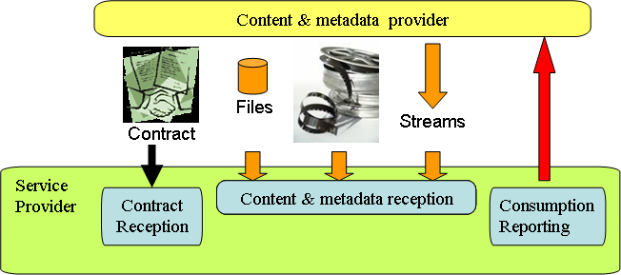
Figure 1. Interface between Content Provider & Service Provider
Editor's note: The interface needs to be harmonized with the architecture in WG1 architecture document.
For content provisioning, a set of interfaces is identified:
- Contract exchange (not to be standardised)
- Content & metadata provisioning interface
- Consumption reporting

Standards are needed for the Content & Metadata Provisioning interface.
The metadata elements for provisioning are recommended to be as common as possible with the metadata elements made available to the end-user, however with elements specific to the relation between "Content Provider" and "Service Provider" (such as distribution conditions).

Gap Analysis for Content provisioning

Content provisioning method | Identified standards
File format for content provisioning | ISO/IEC 14496-12: ISO base media file format
File format for metadata provisioning | XML file validated by metadata provisioning schema to be defined
File format for combined content & metadata provisioning | ISO/IEC 14496-12: ISO base media file format
Stream format for channel/content provisioning | MPEG-2 TS
Stream format for combined channel/content & metadata provisioning | EN 300 468: Specification for Service Information (SI) in DVB systems  TS 102 323: Carriage and signalling of TV-Anytime information in DVB transport streams

Retransmission and Legacy Related Issues
IPTV service can be combined with other platform’s services such as terrestrial (or cable, satellite) A/V channel and interactive data service. Sometimes it is necessary to re-transmit other platform’s services for the transparent service without contents processing. The integrated interactive service system may provide end-users with an easy interface to services on several platforms and allow service provider to make flexible, cost-effective, and efficient system by defining schema which is presented regardless of real time broadcasting and additional enhanced data service features.

11.1 Functional Architecture of Retransmission
Considering that there are many ways to retransmit digital broadcasting services over IPTV, it is important to define a functional architecture that enables all potential solutions. For example, figure 1 shows functional architecture for retransmission that is not only consistent with MPEG-2 transport stream (TS), but also covers direct transport of AV, metadata, and applications over IP network.

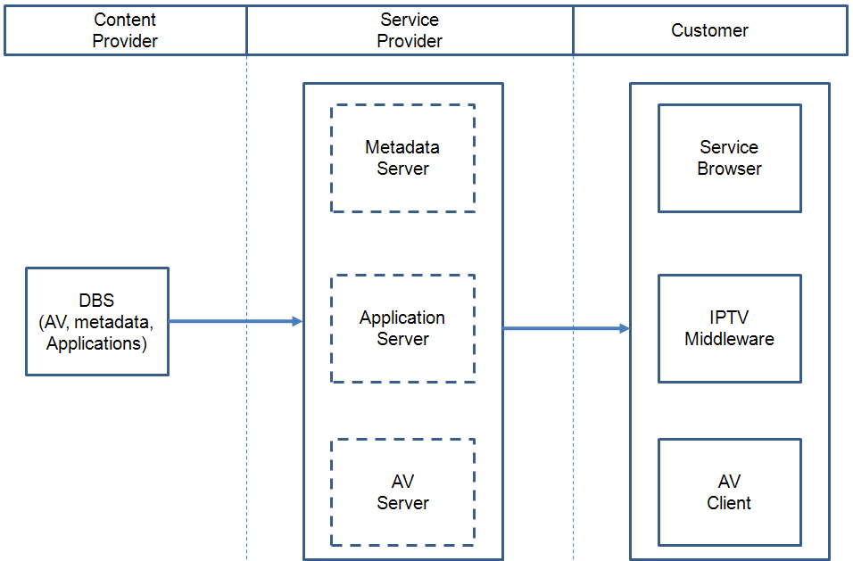
Figure 2 Functional Architecture for Retransmission

DBS: Digital Broadcast Service
Editor's note: "Service Browser" stands for "Service Navigation System"

Figure 1 shows a functional architecture for retransmission of digital broadcasting services over IPTV. Content Provider offers Digital Broadcasting Services with AV, metadata and applications. Service provider will be requested to provide three functional modules, namely Metadata Server, Application Server and AV Server for retransmission. The IPTV Terminal Device provides three functional modules: Service Browser, IPTV Middleware and AV Client to represent consumption of the retransmitted broadcasting services.
Editor's note:

11.2 Legacy Related Issues
Legacy broadcasting services provide their own services with different formats according to different standards such as ACAP, OCAP, MHP, and etc. Content formats of existing broadcasting services should be considered in the IPTV middleware to ensure identical representation of retransmitted contents over IPTV. Legacy broadcasting services provide service information and it is cost-effective to re-use their information in retransmission, and it is requested to append additional metadata to support retransmission such as channel number, multicast address, and etc.
While, legacy broadcasting services are delivered through MPEG-2 TS and the DSM-CC object carousel is often used to deliver applications over MPEG-2 TS, but makes significant processing overhead of complex tables. Therefore, it is recommended to support IP-based direct content delivery mechanism in addition to MPEG-2 TS based content delivery mechanism. An Application model and signalling should be considered to ensure interactivity of retransmitted broadcasting services over IPTV.

Accessibility
TBD

Implementation guidelines
- Electronic Programme Guide (EPG)
  - EPG supports retrieval capabilities including fast search, semantic search and quick selection.
    - EPG information should be selectable by various methods. This can be implemented by keyword-based search and/or menu-driven selection for program. In order to provide the intelligent EPG search function, semantic mechanism such as ontology-based program search or semantic tagging could be used.
  - EPG can have customized capabilities including on-demand feeding, transforming, filtering, and gathering function.
    - It allows customer to retrieve the EPG information as required at anytime. This can be implemented by using of syndication technique such as RSS based information feeding.
    - Using this kind of customized capability, it can implement distributed IPTV service for service provider which can support different content providers over the network. It can also provide personalized EPG service for end-users and flexible EPG service for various terminals. For example, EPG information might be converted to lightweight format to support the mobile terminal.
  - EPG can have layout flexibility on various devices
    - EPG information allows client to present various layouts as client’s environment. It also allows EPG server to convert or to transform the EPG information for different client environments (e.g., Mobile client).
    - This can be implemented using web-based techniques such as XML-based EPG as a data format and CSS as layout form.
  - An EPG application can support PVR applications (recording, storing).
    - Using EPG information, EPG application should support a recording operation for selected program at client side as reservation-basis and/or time-shift basis. It can also support multiple-recording operation which enables to record the multiple programs which are selected by user simultaneously unlikely with traditional PVR operation.

Scenarios
Editor’s note: The following texts and figure are also present in FG IPTV-DOC-0085. The working group should make a decision as soon as possible on where is the most proper place to locate them.
- Use case of Personal Broadcast Service

- Content Info Registration: Content provider (Customer) prepares information about content they will broadcast and registers it to metadata distribution server. This can be done by, for example, making metadata file using some authoring tools. The metadata may contain source information like client ID, content ID, and any other content-relevant information for locating it
- Content Search: Receiving client make a search with keyword
- Search Result: Metadata server responds to search request and provide search result as reply
- Session Request: Receiving client may be able to request session information with logical source information provided by content search result. In this process, session managing server may participate in session routing or charging information gathering
- Session Info: Broadcast client responds to session request and provide session info as replay. Also in this process, session managing server may be able to participate in session proxy
- Session Join: Receiving client request broadcasting client to join the session with session info (including real location)
- Receive content: Receiving client receives the content from broadcasting client

__________________

