INTERNATIONAL TELECOMMUNICATION UNION |  |  |  | Focus Group On IPTV
TELECOMMUNICATION  STANDARDIZATION SECTOR  STUDY PERIOD 2005-2008 |  |  | FG IPTV-DOC-0124
 |  |  | English only
WG(s): 4 |  | 5th FG IPTV meeting:  Geneva, 23-31 July 2007
OUTPUT DOCUMENT
Source: | Acting Editors
Title: | Working document: IPTV Multicast Frameworks
Editor’s Note:
      - IPTV service provider may implement IPTV service in two typical ways; VoD-type IPTV service and linear-type IPTV service and more. Among the two typical types of IPTV services, multicast delivery mechanism is very important to delivery liner-type IPTV service. Because multicast delivery mechanism can save network resources as well as head-end to support great number of receivers simultaneously.
      - For IPTV service based on multicast mechanism, it is quite necessary to have detailed descriptions as followings:
        - the descriptions on multicast delivery mechanism to support IPTV service
        - the descriptions on interactions between IPTV architecture to support multicast based IPTV service; and the examples are how end-user interacts with IPTV service provider, how end-user interacts with network provider, how IPTV service provider interacts with other components, and so on.
      - This document will be aligned with on-going ITU-T FGIPTV working documents; IPTV requirements, IPTV architecture, network control aspects, and so on.
      - The main contents of IPTV multicast framework will consist of the following items to provide detailed descriptions for IPTV service based on multicast delivery mechanism in non-NGN environment. However, the items listed below must align with on-going FGIPTV documents:
- Terminology for IPTV multicast service,
- Requirements for IPTV multicast service,
  - The requirement described in this WD is recommended to be described clearly but enough in detail.
  - The requirements must be practical. Because this requirement will be used by whom to prepare IPTV service promptly.
  - Each requirement is required to be able to be directly mapped into functional architecture for IPTV multicast service. (verification is necessary)
- Functional architecture for IPTV multicast service;
  - The functional architecture must align with IPTV architecture.
  - Detailed description on each functional block is required.
- IPTV service scenario based on multicast delivery,
  - This service scenario must be able to implement with verification.

Editor’s Note (in 5th meeting): During the 5th FGIPTV meeting, it is requested to contribute on “clear description on alignment between other on-going WD (“IPTV architecture”, “IPTV requirements", “IPTV network aspects” and so on) in the future meeting.

IPTV Multicast Frameworks

Summary
<Mandatory Material>
Editor’s Note: To be provided

Keywords
<Optional>
Editor’s Note: To be provided

CONTENTS
1 Scope 5
2 References 5
3 Definitions 5
3.1 Terms defined elsewhere 5
3.2 Terms defined in this Recommendation 5
4 Abbreviations and acronyms 6
5 Conventions 6
6 IPTV multicast requirements 6
6.1 IPTV multicast transport requirement 7
6.2 IPTV multicast service requirements 9
6.3 QoS requirements of IPTV multicast 10
6.4 Security requirements of IPTV multicast 12
6.5 Interoperability requirement of IPTV multicast 13
6.6 Operation and management requirement of IPTV multicast 15
7 Frameworks of IPTV Multicast 18
7.1 IPTV multicast architecture 18
7.2 Description of IPTV multicast functional entities 20
8 IPTV Multicast scenario 20
8.1 Pure IP Multicast model 21
8.2 Alternative multicast model 21
8.3 Hybrid Model 22
9 IPTV multicast solution 23
9.1 Pure IP multicast-based IPTV service delivery solution 23
9.2 Server-based IPTV service delivery solution 25
9.3 CDN-based IPTV service delivery solution 25
9.4 P2P-based IPTV service delivery solution 27
9.5 Overlay multicast-based IPTV service delivery solution 28
10 Other aspects 31
11 Overlay multicast networking 31
11.1 Control framework for IPTV service level multicast 31
11.2 Overlay IPTV multicast control 33
11.3 QoS control at overlay multicast network for IPTV services 35

IPTV Multicast Frameworks

Scope
This document on IPTV multicast frameworks describes functional requirements and frameworks of supporting multicast capabilities in terms of IPTV network control.
[Editor’s note]: This document considers multicast frameworks for non-NGN environment.

References
The following ITU-T Recommendations and other references contain provisions, which, through reference in this text, constitute provisions of this working document. At the time of publication, the editions indicated were valid. All Recommendations and other references are subject to revision; all users of this working document are therefore encouraged to investigate the possibility of applying the most recent edition of the Recommendations and other references listed below. A list of the currently valid ITU-T Recommendations is regularly published.
The reference to a document within this working document does not give it, as a stand-alone document, the status of a Recommendation.

[FGIPTV-REQ] ITU-T IPTV Focus Group, IPTV Service Requirements.

Definitions

Terms defined elsewhere
This Document uses the following terms defined elsewhere:
[TBD]

Terms defined in this Recommendation
[Editor’s note]: The alignment of terminology is needed, and related contributions are recommended to be published in this section.
This Document defines the following terms:
3.2.1 Multicast Domain Management: A multicast domain is a set of multicast routing and forwarding instances than can send multicast traffic to each other. These multicast routing and forwarding instances are referred to as IPTV multicast domain. Thus, multicast domains map all of a customer’s multicast groups that exist in particular IPTV service members to a single unique global multicast group. This is achieved by existing or specific group routing and forwarding capability in the network.
3.2.2 Multicast Access Control Functions: Multicast Access Control Functions is that control a multicast user access to IPTV multicast tree. The IPTV user can join a multicast service using these control functions with proper authentication and authorization of the user.
3.2.3 Multicast Delivery Control Functions: Multicast Delivery Control Functions is that can control IPTV multicast delivery among transport functions.
3.2.4 Overlay Network: A virtual network of nodes and logical links that is built on top of the underlying network infrastructure with the purpose of implement a network service that is not available in the underlying network infrastructure.
3.2.5 Overlay Multicast Network: One type of overlay network that provides multicast services to end users on top of the general network infrastructure.
Editor’s Note (in 5th meeting): The way of describing terminologies on “IPTV multicast interoperability” and “IPTV service exchange point” is not proper compared to other definition. Therefore, it is required to touch the following two terminologies in the next meeting.
3.2.6 IPTV multicast interoperability: IPTV multicast interoperability is the exchange of IPTV service information amongst multicast based IPTV service providers. And to make the optimal contract and to provide the stable IPTV services amongst multicast based IPTV service providers.
3.2.7 IPTV Service Exchange Point: IPTV SEP (service exchange point) is identified as a reference point for handling the service brokering function between IPTV SPs enabling the optimal contract between IPTV SPs and providing the stable IPTV services amongst IPTV service providers. IPTV SEP can be located in any peering point.
[Editor’s note]: Terms and definitions in this section should be confirmed through the meeting considering other relevant terms and definitions as appropriate for using in IPTV multicast. And special care should be taken to avoid any confusion with other terms and definitions. Especially following definitions should be confirmed.
- IPTV multicast agent
- IPTV session manager
- The definition of components in IPTV multicast functional framework picture (based on FG IPTV C-227; LL#10)

Abbreviations and acronyms
This document uses the following abbreviations and acronyms.
CAC Connection Admission Control
DRM Digital Rights Management
ECMP Equal Cost Multiple Path
IGMP Internet Group Management Protocol
IP Internet Protocol
QoE Quality of Experience
QoS Quality of Service
RP Rendezvous Point
SEP Service Exchange Point

Conventions
[TBD]

IPTV multicast requirements
[Editor’s note]: This section is also essential part of IPTV multicast frameworks WD, and describes the IPTV multicast requirements, and we have to push some of basic requirements to be included in WG1’s requirements WD. Based on many contributions in past meetings which are accepted in WG4, and living list documents, we can get the IPTV multicast requirement subsections like followings. Besides the described subsection IPTV multicast architecture, other IPTV requirement issues can be included in this section.
Editor’s Note (in 5th meeting): It is requested to the each contributor of each section to confirm whether the context is in the scope of IPTV multicast framework.

IPTV multicast transport requirement

IPTV multicast control function at the transport
[Editor’s note]: In this section, we need general definition of IPTV multicast control functions. We need appropriate contributions to accomplish the general definition of IPTV multicast control functions.
IPTV multicast control functions can be divided into two control issues. The first one is multicast access control functions relative with IPTV multicast access. The other is multicast delivery control functions relative with IPTV multicast traffic delivery.
Multicast access control functions control a multicast user access to IPTV multicast tree. The IPTV user can join a multicast service using these control functions with proper authentication and authorization of the user. These functions have the following requirements for IPTV user to access multicast tree.
- IPTV user is recommended to identify multicast tree.
- IPTV user can optionally request to join a multicast tree with authorization, authentication.
- IPTV network provider is recommended to maintain multicast information per an IPTV multicast flow.
- IPTV network provider is recommended to manage the membership of IPTV user.
- IPTV network provider is recommended to announce multicast information to users.
- IPTV network provider can optionally authorize and authorize an IPTV user.
Multicast delivery control functions control multicast delivery among transport functions. An IPTV user can receives IPTV multicast traffic after joining a multicast tree. These functions have the following requirements for IPTV user to provide IPTV multicast service.
- IPTV user can optionally receive IPTV multicast traffic with QoS guarantee.
- IPTV service provider is required to use multicast delivery of IPTV network provider.
- IPTV network provider is required to transfer IPTV traffic through multicast tree structure.
- IPTV network provider is recommended to decide a rendezvous point when a multicast tree is extended.
- IPTV network provider is recommended to manage multicast address with IPTV multicast tree.
- IPTV network provider is recommended to extend a multicast tree when an IPTV user joins.
- IPTV network provider is recommended to prune a multicast tree when an IPTV user leaves.
- IPTV network provider can optionally balance IPTV multicast traffic for load sharing.
- IPTV network provider is recommended to provide recovery mechanism for IPTV multicast traffic due to node failure and link failure.
- IPTV network provider is required to protect IPTV multicast traffic and IPTV multicast node from malicious attack.
- IPTV network provider can optionally reserve multicast resource for IPTV multicast traffic.
- IPTV network provider is recommended to provide congestion control of IPTV multicast traffic.
- IPTV network provider can optionally provide priority based transport of IPTV multicast traffic.

IPTV multicast in access node
[Editor’s note]: We need appropriate contribution to define the IPTV multicast requirement in access node.
In multi-service multi-edge architecture, the access node, which is the access point of multiple services, should be the best point to collect detail information of the multicast service instead of upper network systems.
To support multicast optimization by controlling the flooding of Ethernet multicast frames should use IGMP protocol. IGMP proxy function in access node should be supported. Access node performs the router portion of the IGMP protocol on its user interfaces and the host portion of the IGMP protocol on its network interfaces.

- The access node is recommended to reduce the number of messages from numerous users to network.
- The access node is recommended to improve bandwidth efficiency in multicast traffic.
- The access node is recommended to secure multicast delivery to undesired end users.
- The access node is recommended to ensure availability of multicast video service to end users by reduce message loss. For example, some messages are lost due to the packet loss of bearer network, or load of service router, or other possible reasons.
One of the concerns related to IGMP proxy in access node instead of IGMP snooping is that IGMP proxy solution may lead that subscriber information is terminated in access node and does not go to service edge.
As video service needs much more bandwidth and it also needs high service quality, access node should implement traffic control for high priority multicast traffic to ensure the QOS of multicast. Specifically, following functions should be supported in access node.
- The access node is recommended to control on total bandwidth of a user port that can be used for multicast service.
- The access node is recommended to aware of current available bandwidth that can be used for multicast service; the current available bandwidth can be total multicast bandwidth – consumed multicast bandwidth.
- The access node is required to support Connection Admission Control (CAC) based on available resources. When an end user subscribes to a multicast stream, access network will perform CAC: it checks if current available resources are enough for the new service subscription. The resources can be bandwidth, connection number and user service privilege profile.
- The access node is recommended to support multicast control function and multicast replication function; the multicast control function should build the privilege table for multicast users; the multicast replication function should forward multicast media content to users which have the privilege of IPTV multicast services.
The requirements of control over multicast source at IPTV multicast access point equipment are as followings.
- The access node is recommended not to respond any multicast query packet to prevent multicast user information at access point equipment from leaking. The logical ports connected to user don’t forward any ingress multicast traffic.
- The access node is recommended to enable access network equipment port to act as multicast source port. That is, multicast can be forwarded to requesting user only when they ingress through network port. Multicast ingress through other ports will be discarded to prevent illegal multicast from spreading. The ports respond to multicast query packets.
- The access node is recommended to set some special ports as both multicast receiving and sending ports.

IPTV Multicast in core node
In IPTV architecture, the core node is responsible for ensuring IPTV data transport throughout the core network. Then, it can build up a multicast tree in core network and it can extend the multicast tree to an edge node in access nodes. Therefore, the following requirements are needed to support IPTV multicast in the core node.
- IPTV network provider can optionally support the replication of IPTV traffic in a core node.
- IPTV network provider can optionally deliver the replicated IPTV traffic to multiple access nodes.
- IPTV network provider can optionally identify IPTV multicast traffic in a core node.
- IPTV network provider can optionally build up multicast tree in core network with multicast routing statically or dynamically.
- IPTV network provider is recommended to aggregate IPTV traffic in core network.
- IPTV network provider can optionally support differential service when IPTV traffic enters in core network with priority.
- IPTV network provider is recommended to allocate bandwidth for IPTV traffic in core node.
- IPTV network provider can optionally authorize and/or authenticate in a core node when an access node requests to join.
- IPTV network provider is recommended to support any source-specific multicast to provide interaction within multicast session (e.g., content feedbacks from receiving customer).

IPTV multicast service requirements
Service level IPTV multicast aims to support various kinds of group applications for IPTV service, some of which are categorized in the according to the ways of communication and the characteristics of data delivery.

Functional requirements for IPTV service level multicast
Service level IPTV multicast includes service control functions (including IPTV Session Manager and IPTV Multicast Agents) and IPTV application functions, IPTV service user Profiles.
IPTV Service control functions include session control, session membership management and service user profile management at the service level. They can also include functions for controlling media resources -- i.e., specialized resources and gateways at the service-signalling level.
IPTV application function includes a lot of functions for various IPTV multicast services. Therefore, they could be implemented specific functions dependent on the each service and could provide an interface to user to notice the IPTV service information and accept the service request of user. IPTV Application function support functions include functions such as the gateway, registration, authentication, and authorization functions at the service level. And IPTV Application Function support functions work in conjunction with the Service Control Functions to provide users with the value added services they request.
IPTV Service User Profile functions are based on the user subscription data and network data. It is a database based on a service user and shall be provided in support of:
- IPTV Multicast user authentication and authorization
- IPTV Multicast service subscription information
For IPTV service level multicast over converged network platforms (e.g., wired, wireless and broadcast networks), each multiple IMAs will handle their functionalities of multicast functions at each IMA.

QoS requirements of IPTV multicast
[Editor’s note]: This subsection describes functional requirements for supporting IPTV multicast QoS. We need explanatory text about multicast QoS in here.
Followings should be taken care as functional requirements for supporting multicast QoS:
- IPTV network is recommended to support mean(s) for multicast traffic monitoring (including performance monitoring) and for analysis for each service group.
- IPTV network is recommended to support of handling multicast traffic differently according to the requested QoS treatment.
For differentiated handling of multicast traffic, congestion avoidance and congestion management mechanism are required because network congestion may cause quality degradation of IPTV service.
- IPTV network is recommended to support congestion avoidance mechanism to prevent traffic from being dropped over other classes of traffic.
- IPTV network is recommended to support congestion management mechanism to prioritize traffic over other classes of traffic.
- IPTV network is recommended to provide a certain level of QoS when delivering IPTV service traffic to IPTV users. Resource reservation is necessary to guarantee the QoS of IPTV multicast and congestion control is necessary to maintain the QoS of IPTV multicast. Resource reservation mechanism guarantees the multicast resource on multicast distribution trees by bounding various QoS parameters such as delay, jitter, loss, etc.
- IPTV network is recommended to support resource pre-reservation mechanism. Pre-reserving mechanism is more efficient than dynamic resource reservation mechanism in that dynamic reservation mechanism needs to manage dynamic membership with many receivers. Moreover, pre-reserving mechanism is simple to control and maintain multicast resource.

High availability requirements of IPTV multicast
The quality of IPTV service is more sensitive to network stability compare to other types of data services. In that sense, IPTV multicast network is recommended to provide capabilities to ensure sufficient availability for IPTV services.
Followings should be taken care as functional requirements for multicast availability:
- Service restoration without service intervention is required in the event of multicast mechanism abnormalities.
- Multicast distribution tree is required to be restored dynamically in the event of multicast mechanism failures.
- Multicast system architecture and its components are required to be fully redundant in order to avoid a single point of failure affects the whole IPTV service.
- IPTV service content is recommended to be distributed in a load balanced manner in order to utilize multicast links efficiently.
- Multicast system architecture is required to provide an admission control mechanism to manage multicast events.
[Editor’s note]: The terminologies used in the OD were not defined by WGs, so they might be modified or changed in future meeting.
Multiple multicast trees include many multicast trees with each tree being constructed from the multicast source to the receivers and multicast data being delivered among all the multicast trees.
- In multiple multicast trees, every host is recommended to have equal or similar level of burden by handling equal or similar number of input / output data flows.
- In multiple multicast trees, each host is recommended to be placed as interior tree nodes on only small number of multicast trees, hence affect as less data flows on multicast trees as possible.
- In multiple multicast trees, node positions are recommended to consider the corresponding hosts capabilities and behaviours. The hosts with higher capabilities for multicast and elegant user behaviours are more likely to occupy important positions on the multicast trees.

QoS aware topology for IPTV multicast service
Editor’s Note (in 5th meeting): This section will describe IPTV multicast network topology design issues to guarantee the QoS, High Availability

Rendezvous Point
[Editor’s note]: Rendezvous point is specific and design issue related with PIM-SM, need to be put back to LL. We need to define the general terminology about multicast tree manager to describe the RP feature, and we need more appropriate terminology and appropriate contribution!
Location of Rendezvous Point (RP) is not only affects IPTV service delay, but also network burden. Following requirements should be taken care.
- Rendezvous point is recommended to support optimal RP positioning; optimal RP positioning depends upon Service Providers’ network topology and their multicast traffic path which taken consideration of followings:
- Loop free, Delay/Jitter independent, stability guarantee topology
- Optimal position to exchange SA information amongst multicast service provider
- Rendezvous point is recommended to support RP redundancy mechanism; IPTV network should be guaranteed optimized RP redundancy to improve IPTV service stability in case of RP failure. IPTV network should be designed their RP mechanism not only to maximize service stability, but also to minimize service recovery time during RP failure.

Load balancing of IPTV multicast
When multicast routers receive a join message, multicast routing protocol normally send its join message to one of the multicast interfaces. If some groups have the same source, among multiple multicast interfaces, only one of them is selected and sends the join. In an Equal Cost Multiple Path (ECMP) environment, all multicast interfaces cannot be used to distribute multicast traffic; instead only single interface is used. To load sharing the traffic, multicast source should be distributed for different groups, and IPTV service provider should be considered of this load sharing requirements.
- IPTV multicast source is recommended to be distributed for different groups to support load balancing.
[Editor note]: It is needed further description to clarify ECMP environment.
[Editor note]: Further clarification should be needed to clarify the relationship of this section with section for “Availability”. Next meeting should be clarified this and contributions are requested.

Security requirements of IPTV multicast
[Editor’s note]: It is required for WG4 to review of the security requirement related with IPTV multicast by WG3.
Multicast security is one of the most crucial issues in IPTV service such that it is required to provide security capabilities to protect IPTV multicast network from any malicious attempts caused by multicast security holes. Security itself is too diverse to break down to the specific multicast purpose; however functional requirements of multicast security for each network elements should be clearly defined and should provide capabilities along with the definitions.
- IPTV architecture is required to be robust against denial of service attacks targeting any multicast mechanisms.
- Multicast system architecture is required to provide a mechanism of multicast protocol adjacency authentication in order to establish a reliable peer.
- Multicast system architecture is required to provide an admission control mechanism to regulate any multicast events.
- Multicast system architecture is required to be independent of adjacent domain such that it shall not affect the adjacent multicast domain without permission.
- Multicast system architecture is required to provide a mechanism to check integrity of multicast contents before service delivery such that it prevents unauthorized contents from becoming the content source.
- IPTV network provider is recommended to secure IPTV traffic. For example, IPTV network provider can secure IPTV traffic by preventing access from unauthorized nodes.

Interoperability requirement of IPTV multicast
In IPTV markets, there will be various types of service providers; like IPTV transport provider, content provider, and contents aggregator. Each service provider need service combination of different type of service providers or need the clear contract with other service provider to get the quick service spreading. With such a clear internetworking contract amongst IPTV service providers, user can get any sources from content providers through the IPTV transport provider, and we can make IPTV service popular.
- IPTV multicast service provider is recommended to support service combination of different type of service providers.
- IPTV multicast service provider is recommended to use clear contract with other service provider to get the quick service spreading.
IPTV service provider should provide capabilities for exchanging IPTV service information between different IPTV service providers for the interoperability. Especially, for IPTV multicast interoperability, the fundamental IPTV service information for each IPTV service provider should be announced to each SP. The purpose of IPTV service information exchange is to share the IPTV source information received from all IPTV service providers in multicast based IPTV service environment.
Followings should be taken care as the IPTV service information for IPTV multicast interoperability.
- IPTV service information is recommended to provide ID of content aggregator or content provider.
- IPTV service information is recommended to provide source IP address block or some other way to approach to source.
- IPTV service information is recommended to provide multicast channel information.
- IPTV service information is recommended to provide Service Start & End time.
- IPTV service information is recommended to provide QoS, QoE information.
- IPTV service information is recommended to provide Traffic rate.
- IPTV service information is recommended to provide Video encoding rate.
- The assignment of multicast address for each IPTV service channel is recommended to be agreed between different IPTV networks for interoperability; for instance, the multicast address for each IPTV service channel could be unique between different IPTV networks, or optionally changeable when entering other IPTV network.
- IPv4 multicast addresses of RFC 3180 range (GLOP addressing in 233/8) are recommended to use to support interoperable multicast channels.
- IPv4 multicast addresses of RFC 3138 range (Extended Assignments in 233/8) or RFC 2365 range (Administratively scoped block) can be used if there is an agreement between peering IPTV SPs.
Each IPTV SP may have its own address policy and the policy of IPTV SP’s internal address may not match the inter-SP address policy. Therefore, the follow is recommended to support;
- IPTV SP is recommended to support translating addresses from other IPTV SP to its internal address; the address translation policy is up to IPTV SP.
- IPv6 multicast addresses of RFC 3307 range (Allocation Guidelines for IPv6 Multicast Addresses) are recommended to support interoperable multicast channels.
Multicast routing requirements for interoperability is following;
- Multicast BGP between different IPTV SPs is recommended to advertise multicast source routes.
Multicast BGP is used to advertise multicast source routes for RPF check. Followings should be taken care as the peering policy that MBGP is used for multicast routing protocol between IPTV SPs.
- Advertising summarized prefixes if possible
- Recommended route filtering policy
  - default information
  - private addresses(RFC 1918 range)
  - all Multicast groups(224/4)
  - ISP’s unicast prefix range from peer ISP
- AS Path filtering
- Maximum prefix limit
- Md5 authentication between MBGP peers
- MSDP source active filter is recommended to use to prevent bogus (S, G) from sending when MSDP is applied.
When the MSDP is used between IPTV SPs for their multicast service, MSDP source active filter is necessary to prevent bogus (S, G) from sending. Followings should be taken care as the MSDP filtering policy that MBGP is used for multicast routing protocol between IPTV SPs.
- Recommended MSDP SA Filter (inbound/outbound)
  - Domain-local multicast applications
  - Auto-RP groups
  - Administratively scoped groups(239/8)
  - Default SSM range(232/8)
  - Loopback addresses(127/8)
  - Private addresses(RFC1918 range)
- IPTV service provider is recommended to protect its own IPTV network and IPTV source against the malicious traffic injection from peering SPs.
IPTV service providers should protect their own IPTV network and IPTV source against the malicious traffic injection from peering SPs. This function should be implemented in IPTV multicast interoperability peering point. Followings should be taken care as the security policy for IPTV multicast interoperability.
- uRPF in peering interface
- Filtering about non-approved group range, source Block and non approved application port numbers
- PIM neighbour authentication
- TCP/ICMP message filtering for 224/4
- Protection against multicast source spoofing
- BSR message filtering
- Capability to limit the maximum number of multicast routing information
In IPTV multicast interoperability environment, IPTV service providers should provide the QoS monitoring function to handle the IPTV service quality measurement, and also IPTV service providers should provide the QoS management function to keep IPTV service in high quality.
- IPTV service provider is recommended to provide IPTV Service quality measurement and management function for interoperability.

Operation and management requirement of IPTV multicast
[Editor’s note]: This subsection describes the operation and management requirements of IPTV multicast. This subsection includes the user management, address management and service management issues

IPTV Multicast user management
[Editor’s note]: The user management is the starting point of IPTV service. This subsection describes the functional components for IPTV multicast user management issues including authentication and authorization.
As the current multicast protocol (i.e. IGMP) does not consider Multicast user authentication and authorization, it is requested a further development these issues to support IPTV services efficiently.
- IPTV multicast protocol is recommended to support multicast user authentication and authorization.
Multicast user authentication function controls the authority for users to receive multicast flows. And through authenticating multicast users, the network can distinguish legal multicast users from the illegal ones and then can distribute the multicast traffic to the reasonable receivers. Following procedures should be supported;
- When a user initiates a multicast “join” request to join a certain multicast group with an account, the duplication point should not accept the request and make him join the group at once, it should be sent the request to the authentication point.
- The authentication point inquires the account information database and returns the result to multicast duplication point. The value of the user’s multicast property in the account should be set by the service layer system.
- According to the authentication result returned from the authentication point, the Multicast duplication Point should decide whether it allow the user to join the group or not. If allow the user to join the group, the duplication will add it to distribution table. Whereas it will refuse the user to join the group.
Figure 1 - Functional components for Multicast user management

IPTV multicast address management
[Editor’s note]: To provide IPTV service be popular and interoperated with other IPTV service providers, we need to handle the IPTV multicast address management. This section describes the IPTV multicast address usage rules, the issue of multicast address transition, and the control procedure of multicast address.
According to IANA rule, several hundred millions of IPv4 and IPv6 multicast addresses can be used in the internet. As one of important resources, these multicast addresses, should be managed effectively.

IP multicast address transition
When deploying IPTV broadcasting services, carriers often use one multicast group address representing an IPTV channel. Unlike the unicast addresses, multicast addresses are not distributed depending on different countries, areas and carries all over the world. Therefore, during the operating of IPTV broadcasting service, the corresponding relationship between IPTV channel and multicast address can be overlapping or conflicting among different carriers or different service areas of one carrier. As Figure 2 shows, carrier A and carrier B want to interconnect their IPTV direct broadcasting services; or Carrier B created local IPTV broadcasting service platform in service areas C and D , where the local carriers should interconnect some broadcasting service sources. With regard to these IPTV service traffic which cross multiple multicast bearer domains, IPTV MST (multicast service stream transition) needs to be deployed at the edge of each bearer network domain to check the multicast service traffic from other domains.
- Multicast address is recommended to be changed before entering local domain when there is a multicast address conflicting.
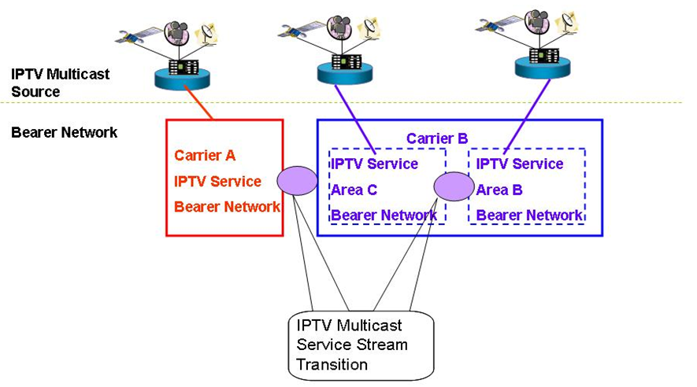

Figure 2 - IPTV multicast address transition
- IP multicast address mapping function is recommended to support customer’s personal broadcasting service.

The control of users’ multicast address
In order to control the development of multicast services on carrier’s network and avoid impact on carriers’ IPTV broadcasting services, carriers can deploy multicast service controller to manage the distribution of multicast address uniformly. However, as for the multicast application without registration, carriers will restrict the usage of these multicast addresses at the access point of IPTV network. The procedures of applying for multicast service and multicast address are as follows and shown as Figure 3.

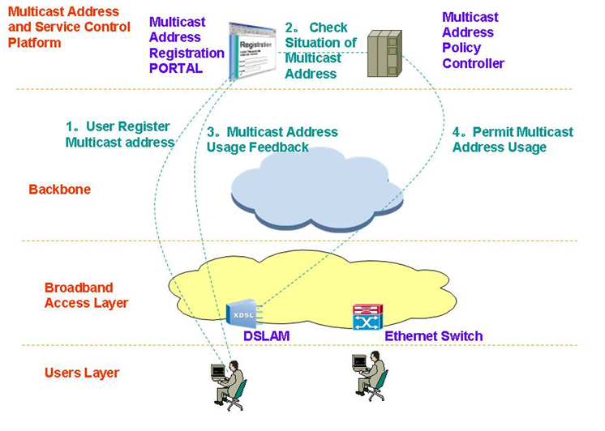

Figure 3 - Control procedure of multicast address
1. In order to carry out services based upon multicast address users should arrange the inquiry and registration on the PORTAL of carrier-provided Multicast Address and Service Control Platform.
2. The self-service system check the situation of this multicast address from multicast address policy controller
3. If this multicast address is available, users will be told that they are allowed to use it.
4. At the same time, multicast address policy controller sends policies to the access point to allow the multicast services get access.

IPTV multicast service management
[Editor’s note]: This subsection describes the IPTV multicast service management requirements including monitoring feature. We need many contributions to accomplish this subsection.

Frameworks of IPTV Multicast
[Editor’s note]: This section is the key part of IPTV multicast frameworks WD, and describes and defines the basic elements of IPTV multicast frameworks like IPTV multicast architecture. Besides IPTV multicast architecture, other framework issues can be included in this section.
Editor’s Note (in 5th meeting): It is requested to the each contributor of each section to confirm whether the context is in the scope of IPTV multicast framework.

IPTV multicast architecture
[Editor’s note]: IPTV multicast architecture is the basic frame of new WD. So this subsection describes IPTV Multicast functional framework, Physical architecture of IPTV multicast network, and logical architecture of IPTV multicast network, and so on. This section should be aligned with the architecture document of WG1.
The contexts of this chapter will be;
- IPTV multicast functional framework includes
  - the definition of IPTV multicast functional components and
  - The features of IPTV multicast functional components.
- The physical architecture of IPTV multicast network is required to describe
  - IPTV multicast network topology design issues(to guarantee the QoS, High Availability)
- The Logical architecture of IPTV multicast network describes
  - IPTV multicast routing protocol design issues and
  - IPTV multicast control protocol design issues
The Functional Architecture for IPTV multicast shows the principal functional groups. These functional groups provide a more detailed breakdown of the IPTV multicast functionality.
[Editor’s note]: This picture includes so specific functional components related with solution. In this subsection, the picture of general multicast model is needed, and this picture should be modified. This picture should be aligned with WG1’s new architecture diagram, focused on non-ngn point of view. And also this picture should be aligned with Network Control aspect WD. We need appropriate contribution!
[Editor’s note]: To clearly identify IPTV multicast frameworks, following issues could be developed. And also, related contributions are needed in this subsection.
- Definition of IPTV Multicast components: e.g., source, mediator for IPTV multicast information, receiver, etc.
- Functional components for IPTV multicast

Figure 4 - IPTV multicast function framework

Multicast end-user functions
The multicast end-user functions include those functions normally provided by the IPTV Terminal and the end-user Network.
The multicast end-user functions are responsible for collecting control commands from the user, and interacting with the multicast application functions to join and leave from IPTV multicast groups. Multicast end-user can request the multicast service information. After receiving this information, they can join the multicast group with some QoS requirements. Then, it receives multicast data through multicast network transport functions.

Multicast application functions
The multicast application functions provide interaction with end-user functions to join and leave of IPTV multicast services. And also this functions support basic multicast control functionality such as IPTV multicast channel change, pause, resume, etc.

Multicast content delivery functions
Multicast content delivery functions provide the distributed content servers for the IPTV multicast services. Multicast contents which are prepared in the application functions are delivered to the End-Users via the Network Transport Functions by the Content Delivery Functions. The contents and data are sent to the Content Delivery Functions from the Application Functions, during the multicast service. In order to support the efficient multicast services, contents may be stored/cached in the Content Delivery Functions.

Multicast service control functions
The multicast service control functions provides the functions to request and release the network and service resources required to support the IPTV multicast services.
For example, it could request the Content Delivery Functions to allocate multicast media server capacity and request the Network Transport Functions to reserve Network bandwidth for the multicast media Stream.

Multicast network transport functions
These functions provide multicast connectivity with transport functions for all multicast users. The multicast transport functions can support multicast tree construction, multicast traffic replication and multicast member identification functions. Then, multicast traffic is forwarded by a multicast identifier through multicast delivery path.

Description of IPTV multicast functional entities

Multicast group management functional entity
Multicast Group management functional entity provides various multicast information in End-User function to support IPTV multicast user’s join and leave. It can receive multicast group information request from a multicast user and send multicast group information to a multicast user. It can manage multicast group information such as multicast identifier, multicast QoS requirements, and etc.

Multicast content server functional entity
Multicast Content Server Functional Entity provides distributed storage servers (e.g. CDN) for large volumes of video and audio contents.

Multicast Path Management Functional Entity
Multicast Path Management Functional Entity configures multicast topology from source to End-user network.

IPTV Multicast scenario
Editor’s Note (in 5th meeting): The descriptions in chapter 8 seem too much dependent on implementation issues of network operator; for example, access, metro, core network. Several questions have been arisen on how the following models can be mapped with IPTV architecture. Therefore, it is requested to confirm whether the context is in scope of IPTV multicast framework.
IPTV content delivery infrastructure consists of four different layers, i.e. Content Source, Core, Metro, and Access. Content source is where IPTV service contents are originated and they can be placed in either inside or outside of delivery infrastructure. Core is service/network provider’s backbone infrastructure. Metro, in other words Aggregation or Edge, is where it connects and aggregates between core and access. Access is user’s domain that includes last mile.

Pure IP Multicast model
[Editor’s note]:In this subsection, the terminology ‘Pure IP Multicast model’ should be agreed in WG4.
In the pure IP multicast model, IP multicast mechanism is fully deployed throughout the IPTV delivery infrastructure so that IPTV content can be delivered along the multicast distribution tree. It is very efficient in that it saves network resources by avoiding duplicate identical contents for each user’s request. In addition, it dynamically builds and restores the content distribution trees when there are changes within delivery infrastructure. This model is quite adequate to provide a real time streaming service compare to other delivery models. Figure 5 shows pure IP multicast model where IPTV service contents are delivered from content sources to service users along the dynamic tree generated by IP multicast mechanism.
[Editor’s note]: In case that we put the diagram in each subsection, every diagram needs to be made in micro soft type for editing.

Figure 5 - Pure IP multicast model

Alternative multicast model
As an alternative approach, alternative multicast model can be considered for IPTV delivery infrastructure that does not have multicast capability. Unlike pure IP multicast model, this model has more freedom of design and implementation upon diverse service requirements since this model is not ruled by a single mechanism; various ways such as CDN, P2P, and overlay multicast mechanism can be applied. When designing an alternative multicast model, it is important to emphasize the way of content distribution such that it mitigates a real time streaming service delay over genuine multicast model. Figure 6 shows alternative model that delivers IPTV service purely by unicast route from content source to service users.
Figure 6 - Overlay model

Hybrid Model
Hybrid model can be a good candidate where IPTV delivery infrastructure cannot fully support pure IP multicast capabilities; from content sources to service users, some part of infrastructure can support pure IP multicast capabilities and some part cannot. Hybrid model is the most reasonable way without additional investment to enable multicast mechanism to the existing infrastructure where lack of multicast capabilities. Figure 7 shows hybrid model that combines both multicast mechanism and overlay mechanism to deliver IPTV service content to service users.
Figure 7 - Hybrid Model

IPTV multicast solution
Editor’s Note (in 5th meeting): It is requested to the each contributor of each section to confirm whether the context is in the scope of IPTV multicast framework.

Pure IP multicast-based IPTV service delivery solution
Figure 8 shows the concept of pure IP multicast based IPTV service delivery solution.
In this scheme, each member registers IP multicast group by exchanging IGMPv.x messages with its access routers; and then each IP multicast router constructs IP multicast tree by exchanging multicast routing protocol messages; finally data from source flows according to the multicast tree from source to each receivers.
Because ISP owns and manages Multicast routers, ISP can tightly manage the communication.

Figure 8 - Data distribution scheme with pure IP multicast
To provide IPTV service based on pure IP multicast, it is required for Network Provider (NP) to install multicast-capable routers; and the service solution fully depends on IP multicast network.
The pure IP multicast-based IPTV service solution has characteristics of tightly related performance to the condition of NP’s network; therefore this service solution has the merit of having full-network-speed because multicast forwarding capability is provided by each network element (i.e., multicast routers).
On the contrary, pure IP multicast-based IPTV service solution can support only bounded number IPTV service channels. Because each network element must handle each state per flow, the NP’s network may suffer from unbounded number of IPTV service channels.
Therefore, pure IP multicast-based IPTV service solution is appropriate for HDTV-quality IPTV service with bounded number of IPTV service channels.
Figure 9 – High-level information flow for the case of IP multicast-based IPTV service
Figure 9 shows scenario when pure IP multicast mechanism is applied to IPTV service. To provide IPTV service, not only data delivery mechanism but such as IPTV service control, DRM management are very crucial, but this scenario will only focus on the multicast data delivery capabilities, the left are considered out of scope.
In the pure IP multicast-based IPTV service, Content Provider (CP) asks Service Provider (SP) to multicast content media (1), and then SP prepares the content media for multicasting to the announce group (2); but the way of announcing group is also considered as out of scope.
Consumer (IPTV client) exchanges signalling with SP’s IPTV control function for initiating IPTV service (3).
In pure multicast based IPTV service, NP is in charge of replicating and delivering content media to each receiver; the purpose of network transport function of NP is to configure optimized multicast tree and then forwards replicated data along the configured multicast tree. The network provided by NP consists of access, edge, and core network.
To have multicast delivery service, it is required for IPTV client to subscribe a specific multicast group. IPTV client uses network/resource management function to subscribe the multicast group (4); IPTV client can join a specific multicast group by using IGMP. IPTV client’s subscribing a group will be accomplished after following successful NP’s network authentication; then the IPTV client can be attached to the specific multicast tree. In case of NP, most optimized multicast tree from SP to consumers is configured by exchanging appropriate routing protocol.
After the successful multicast tree is configured, the content media from SP can be delivered to IPTV client with help of multicast forwarding capabilities provided by NP (5). The content media, finally reached at IPTV client’s network transport function, will be delivered to IPTV client application. To improve video quality suffered by jitter or delay, IPTV client may put appropriate size of buffer between network transport and client’s application (6).
In case when QoS monitoring is necessary, SP may gather information by asking end IPTV client of experienced QoS report or by asking NP of network statistics (7); but the details are considered as out of scope.

Server-based IPTV service delivery solution
Figure 10 shows the concept of replicated-unicast based IPTV service delivery solution.
In this scheme, ISP puts a media server or server pool somewhere; each member connects media server or server pool; then the media server sends data to every receiver replicatively.
Because ISP or content provider (CP) owns and manages media server, ISP can tightly manage the communication; but because media server cannot support infinite number of receivers, the size of the group is tightly bounded by the performance of media server or server pool as well as server-side network bandwidth.

Figure 10 - Data distribution scheme with replicated unicast

CDN-based IPTV service delivery solution
Figure 11 shows the concept of CDN-based IPTV service delivery solution.
In this scheme, ISP pre-installs CDN servers in an appropriate place; each receiver finds and then connects the nearest CDN server. Then multimedia streams from source are distributed to each receiver along the data delivery path of CDN servers.
Because ISP or content provider (CP) owns and manages CDN servers, ISP can tightly manage the communication; but because ISP cannot install CDN servers infinitely, the number of installed CDN servers bounds the size of the group tightly.

Figure 11 - Data distribution scheme with CDN

To provide CDN-based IPTV service, it is required SP to position CDN server or server pool. CDN-based IPTV service can be easily deployed; because CDN-based IPTV service can be implemented over current unicast-based network; so, it is not required to install multicast-enabled network.
The CDN-based IPTV service solution has characteristics of tightly related performance to the power of CDN server and the number of CDN servers; because CDN server sends content media to each client repetitiously according to the each IPTV client’s connection to CDN server. The number of IPTV clients can be served at a same time totally depends on the power of CDN servers and the number of CDN servers.
However, because each client directly connects to CDN server SP can easily manage each client at any purpose; for example, SP can monitor each IPTV clients’ presence for billing in real time.
Therefore, CDN-based IPTV service solution is most suitable for IPTV service provider who does not own a network but wants to provide payable IPTV service to the bounded number of IPTV clients.

Figure 12 – High-level information flow for the case of CDN-based IPTV service
Figure 12 shows the scenario when CDN mechanism is applied to IPTV service. Because this scenario only focuses on the multicast data delivery capabilities, the left are considered out of scope.
To begin with CDN-based IPTV service, CP asks SP to deliver content media; then SP convert the requested content media into suitable format for IPTV service delivery (1).
To receive IPTV service, IPTV client asks SP for specific IPTV service; and then SP gives available information about CDN servers to connect (2). IPTV client then tries to connect CDN server by using the given information from SP (3). Because unicast mechanism is applied to deliver content media to IPTV clients in CDN-based IPTV service solution (4), NP does not care about multicast delivery; NP is just for unicast data delivery capabilities (5).
The content media, finally reached at IPTV client’s network transport function, will be delivered to IPTV client application. To improve video quality suffered by jitter or delay, IPTV client may put appropriate size of buffer between network transport and client’s application (6).
In case when QoS monitoring is necessary, SP may gather information by asking end IPTV client of experienced QoS report or by asking NP of network statistics (7); but the details are considered as out of scope.

P2P-based IPTV service delivery solution
Figure 13 shows the concept of P2P-based IPTV service delivery solution.
In this scheme, each end-node can be both a media producer as well as a media consumer. The way of communications is as follows; each node discovers its peers and then connects them; each node can exchange media between themselves.
Because P2P model does not want to have ISP’s censorship, this model usually does not involve node of ISP’s. Although the size of group is not logically bounded, it may not be adequate to distribute contemporary media. To improve data receiving, each node tries to finds more peers as possible.

Figure 13 - Data distribution scheme with P2P

Overlay multicast-based IPTV service delivery solution
Figure 14 and Figure 15 show a brief concept of overlay multicast-based IPTV service delivery solution. In overlay multicast mechanism, special overlay nodes emulate the functions of IP multicast router’s; such as multicast data tree configuration, multicast data forwarding etc.
In this scheme, each overlay node constructs multicast data delivery path from sender to group dynamically as naïve IP multicast router does. Along the constructed path, each overlay node forwards data, which comes from its upstream node, to its downstream nodes. The size of group is not logically bounded, and it is adequate to distribute contemporary media.
The overlay node which substitutes IP multicast router may form a hardware box, a server, or an end-system; the formation is a deployment or implementation issue. Figure 14 shows an overlay multicast scheme without ISP’s participation.

Figure 14 - Data distribution scheme with overlay multicast without ISP
Figure 15 shows an overlay multicast scheme with ISP’s participation.

Figure 15 - Data distribution scheme with overlay multicast with ISP
To provide overlay multicast-based IPTV service, it is required for IPTV client’s network delivery function to construct overlay multicast tree and to replicate and forward content media.
Overlay multicast-based IPTV service can be easily deployed. Because overlay multicast-based IPTV service can be implemented over current unicast-based network; there is no need to change current network environment.
The noticeable feature of overlay multicast mechanism is that each client can relay received content media; i.e., each client can act like content producer as well as content consumer. Therefore the QoS of overlay multicast-based IPTV service is highly affected by the power of each IPTV client.
However, in overlay multicast-based IPTV service solution, only the participated IPTV clients to a specific IPTV channel share the burden of content media delivery; so it is not required to have centralized server nor specific network element. Therefore, overly multicast-based IPTV service does not have any limitation on the number of IPTV service channel.
On the contrary, it is difficult to manage each IPTV clients for billing and presence, because each contents media delivery elements in overlay multicast-based IPTV service are distributed.
Therefore, overlay multicast-based IPTV service solution is suitable for IPTV service of low-video-quality (low bit rate) and free IPTV service with no limitation on the number of service channel. Especially this service solution can be applied for the cyber community purpose, for personal broadcasting purpose, and for the CCTV broadcasting purpose.

Figure 16 – High-level information flow for overlay multicast-based IPTV service

Figure 16 shows the scenario when overlay multicast mechanism is applied to IPTV service. Because this scenario only focuses on the multicast data delivery capabilities, the left are considered out of scope.
To begin with overlay multicast-based IPTV service, CP asks SP to delivery content media and then SP convert the requested content media into suitable format for IPTV service(1). IPTV client asks SP to provide IPTV service to receive IPTV service (2).
In overlay multicast environment, each IPTV client constructs overlay multicast tree. Along the overlay multicast tree, each IPTV client can receive content media from its parent client and can also relay the received content media to its children clients; therefore it is required for each client to know the location information of other clients participated in same IPTV channel.
To acquire information about other participated IPTV clients, IPTV client exchange signaling with SP (3). In overlay multicast-based IPTV service, unicast mechanism is applied to deliver content media; NP only needs to support unicast data delivery capabilities (4).
The content media, finally reached at IPTV client’s network transport function, will be delivered to IPTV client application. To improve video quality suffered by jitter or delay, IPTV client may put appropriate size of buffer between network transport and client’s application (5). Then IPTV client forwards the received content media to network to support its children clients (6).
In case when QoS monitoring is necessary, SP may gather information by asking end IPTV client of experienced QoS report or by asking NP of network statistics (7); but the details are considered as out of scope.

Other aspects
[Editor’s note]: This section is reserved to invite future contributions, which can address other aspects of IPTV Multicast, not a specific issue to each chapter.

Overlay multicast networking

Control framework for IPTV service level multicast
Service Level Multicast constructs and manages relayed multicast functions to support internet group application services over the unicast-based network. After control messages of a service level multicast are exchanged, a multicast data delivery path is constructed by using multiple end hosts even such as personal desktop computer. Along the delivery path, real-time or reliable data transport channels are inter-connected between upstream and downstream IMAs. Only after the data delivery path and data channel are established, group applications can work as if they were in a native IPTV multicast network.
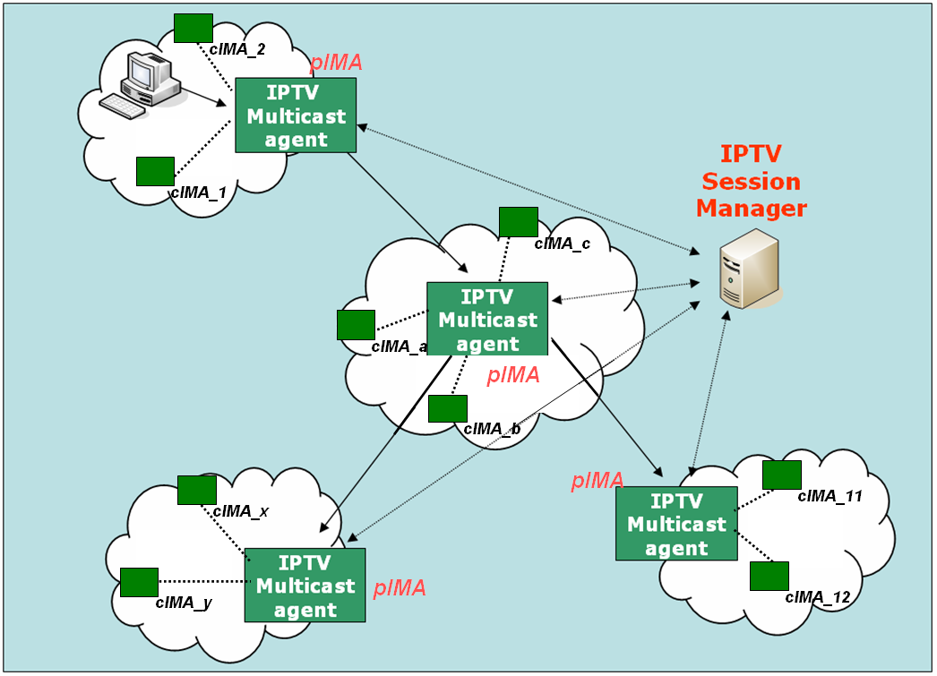
Figure 17 - Functional Architecture for Service Level Multicast Capabilities for IPTV

IPTV Session Manager (ISM)
ISM is involved in session configuration and maintenance for IPTV service flows. A single ISM can handle one or multiple sessions simultaneously, and it can provide the following functionalities:
- Session initialization: ISM allocates ISID (IPTV Session ID) for new session.
- Session release: Session can be released as needed.
- Session membership management
- Session status monitoring: this function enables reporting of the status of data channel, monitoring of data throughput, gathering multicast protocol topology information
- Membership management

IPTV Multicast Agent ( IMA )
IMA constructs relayed multicast delivery path and forwards data along the constructed path from pIMA ( parent IPTV Multicast Agent ) and to cIMA ( child IPTV Multicast Agent). An MA consists of control module and data transport module. The main function of former is to establish relayed data delivery path and that of latter to setup data channel along the path constructed by control module and relay data through the channel. IMA performs the control functions to exchange control messages with other entity. Its major functions are as follows.
- Session join: each IMA contacts with Session Manager.
- Session leave: when an IMA wants leave the session, it gives notice to pIMAs and cIMAs
- Session maintenance: relay request and its response will be exchanged between the two IMAs periodically.
- Loop detection & avoidance
- Partitioning detection & recovering
- Parent switching
- IPTV Session status reporting
In order to perform service level multicast of streaming application for IPTV service, the functional box of service control can be described into few functional blocks in detail as shown in Figure 18.
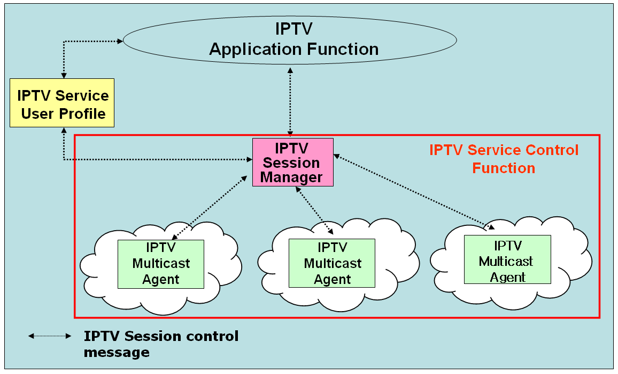

Figure 18 - Functional blocks of IPTV session control for IPTV application services

Media signalling proxy
Media signalling proxy is a function to get media status in overlay multicast network by transfer media connection signalling between end hosts and obtain media session status of end hosts.
In order to get media status of overlay multicast network, media signalling proxy is recommeded to be supported by IPTV overlay multicast system. Figure 19 shows how media signaling proxy operates.
Figure 19 - Media Signalling proxy

Overlay IPTV multicast control
Although IP multicast has not deployed globally, a lot of local networks have already been equipped with IP multicast transport. For example, Ethernet-based LANs and private networks such as corporate and campus networks substantially provide the multicast transport capability within their local subnet or administrative domains. Recognizing these observations, there is a crucial need to use an alternative multicast delivery scheme for IPTV service. service lev Overlay multicast for IPTV service will be an alternative solution to provide actually clinging to replicate unicast method on servers. It makes good use of existing unicast, multicast and/or multicast tunnelling schemes for various applications in IPTV (e.g., various types of group applications).
The overlay service multicast control function for IPTV provides a session control to multicast capability over physical transport network. To support the session control function for overlay multicast capability. shows architecture for “Overlay IPTV Service Multicast Functions” for IPTV service.
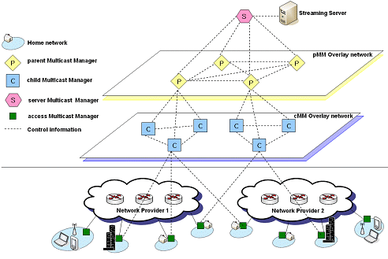

Figure 20 - Functional structure of overlay IPTV multicast control

Control in overlay IPTV multicast
The overlay IPTV multicast can use diverse control mechanisms for constructing different multicast trees depending on IPTV application parameters or application class. The control mechanism supports to change multicast tree structure depending on application requirements, different regions of network conditions, native multicast support and multicast group membership. The overlay IPTV multicast supports efficient routing and resource usage by overlay multicast control. A changing of multicast tree to deliver IPTV service may be used network resource unnecessarily. If possible, the overlay IPTV multicast use existing multicast tree and control mechanism without changing.

Group membership management
The group membership for overlay IPTV multicast considers group size, number of group’s member and rate of group membership change. It provides group membership control and group partitioning.
- Group Membership Control: This is a generic group membership control of overlay IPTV multicast. It is a function that provides mechanisms to join and leave group for overlay IPTV multicast. It may additionally provide functions to create or maintain the multicast groups.
- Group Partitioning: This is to optimize the transmission efficiency by sub-grouping the groups and mapping each sub-group to underlying networks. In the following, two optimization approaches to realize this group partitioning are differentiated and described.
- Global group partitioning: The Global group partitioning optimizes the resource usage of local network. If a multicast group in local network is crowded, the group need sub-grouping.
- Server group partitioning: The Server group partitioning optimized the resource usage of server network providing IPTV services. This partitioning is to consider the processing capacity of the server.

Admission control for QoS for overlay IPTV multicast
In order to support QoS for IPTV services in overlay multicast network, overlay multicast node will perform admission control through interaction between overlay multicast node and resource control function of physical internet transport network.

Security for overlay IPTV multicast
Overlay IPTV multicast uses shared network resource and multiple distributed overlay resources to transport data. When a user requests IPTV service, security process needs for IPTV overlay multicast function.
Overlay multicast confronts with various vulnerabilities and risks that impede from being widely deployed in mission critical business systems and applications. There are three important security challenges for the overlay network service model: Confidentiality and Integrity, Authenticity, and Availability. These three important security challenges can be classified with some properties for architectures and algorithms for building secure and scaleable information dissemination services on wide area overlay networks.

Node functions for IPTV overlay routing
An overlay multicast node function will be designated to perform routing and session control for IPTV services. The designated node has full knowledge of other multicast node in the session, and computes the multicast tree according to its current snapshot of the available bandwidth at these multicast nodes. In order to keep the updated information on multicast nodes, state updates occur periodically via broadcasting among all multicast nodes.
The overlay multicast node constructs and updates multicast tree from sender to group dynamically, and collects network information and exchange the information with neighbour overlay multicast node. Each IPTV multicast node manages some information related to network resources underlying network from resource control function.
An overlay multicast node will provide few information to provide the requirements for overlay multicast resource control.
- Session ID Assignment: The overlay nodes will perform an identification function with session ID. The session ID is unique according to region or overlay IPTV service etc.
- IPTV overlay multicast management function: The overlay node will collect and stores information on overlay networking management, and selects neighbour overlay nodes to exchange the information.

QoS control at overlay multicast network for IPTV services

Functional position of resource control
If the information on IPTV transport networks is directly collected and managed by IPTV overlay nodes to establish overlay transport route and configuration trees, it will be serious burden to handle overheads in IPTV overlay networks. It is assumed that resource control functions for IPTV overlay network is located between IPTV overlay network and physical transport network, and it performs collection of information about network resource and provides QoS control to transport network.
As shown in Figure 21, it is necessary that resource control function is introduced to provide interface function for IPTV overlay multicast QoS control between physical transport and IPTV overlay network. This function performs collection and management of transport network resource (e.g., DiffServ) via specified interface (e.g. SNMP). And overlay network nodes create tree topology and optimized route to support QoS requirements of IPTV users through information collected by Resource Control function. And RCF can have the interfaces such as COPS, Diameter and H.248 to install/uninstall the policy decision for transport network The interface between overlay network and RCF will be further study. The interface may be proprietary of IPTV service providers.

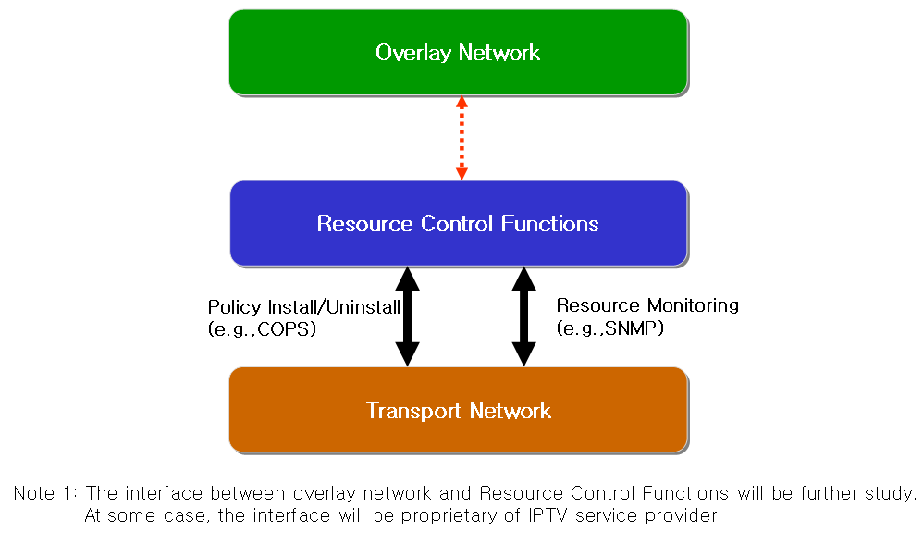

Figure 21 - Resource control architecture in IPTV overlay network

Resource control function
The requirements for resource control are as follows
- The Resource Control Function will collect information for resource control from transport network with periodic or aperiodic. According to initiation of overlay network nodes, Resource Control function collects data for resource and QoS control.
- Resource control should be able to communicate with Resource Control Function in heterogeneous or other network.
- The following information collected is transferred to overlay network, and then overlay network creates route and optimized tree to support QoS for IPTV overlay network.
- Link State Information: it includes available bandwidth information, delay, packet loss and jitter of link.
- Routing Information: it includes routing algorithm that is used to transport network equipments and routing information of them (e.g. neighbour routing information, routing table .etc)
- Multicast Traffic Information: it includes multicast traffic parameters (e.g. channel information, type of service, user profile, source content information) per channel or session of IPTV multicast.

Resource control function for overlay QoS control in heterogeneous networks.
The Session Manager configures routes among IPTV overlay network nodes and optimizes tree topology for multicast sessions according to information of Resource Control Function. RCF has resource information from transport network such as link state information, routing information, multicast traffic information and so on. Session manager requests the resource information in transport network to RCF. RCF verifies the resource status based on gathered information, and makes the policy decision for the request. Session manager confirms the received message from RCF, and compares with service information. Then session manager sends the policy installing request message to RCF. After receiving the policy request message, RCF sends the policy installing request message to transport network through the configured path for overlay network. Figure 22 shows the application of Resource Control Function in heterogeneous networks for overlay QoS control.

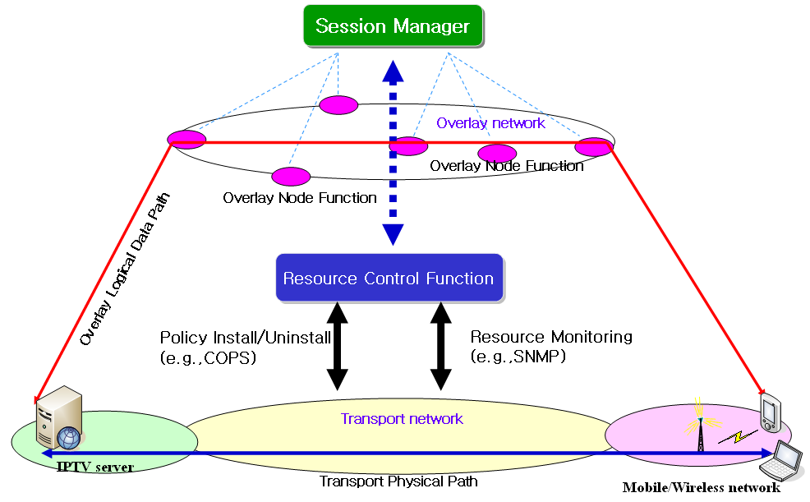

Figure 22 - Application of resource control function in heterogeneous networks for overlay QoS control

Network measurement function
In order to ensure high end-to-end service quality of the IPTV services, overlay multicast measurement system needs to be deployed to measure the IP network performance, e.g. bandwidth, packet loss between overlay nodes such that the appropriate overlay path is selected.
As part of resource control, network measurement includes receiving interface, measurement interface and forwarding interface. Receiving interface receives measurement requests from session manager and forwards them to measurement interface. Measurement interface measures the network performance between network nodes and forwards the results to forwarding interface. Forwarding interface sends the results to overlay network or other network measurement to share information.
Appendix I
Possible IPTV multicast delivery solutions
(This appendix does not form an integral part of this document)
I.1 Hybrid P2P IPTV service multicast delivery solution
Figure I.1 shows the concept of Hybrid P2P IPTV service multicast delivery solution.
In this scheme, the receivers join in multicast group as usually. Then they need to form a P2P group too. When a receiver find out that he has lost some IP packet, he can send a broadcast message to his peers to request the lost packets. Then the fast response peer can send the lost packet to it. This mechanism need the receiver caches some packet in case that it need to retransfer packet to the peer.
In this model multicast routers are control by ISP, so ISP can tightly manage the communication. P2P groups does not involve node of ISP, but it is need to limit the member in one group because too many peer will aggravate the receivers’ burden.

Figure I.1 –Hybrid P2P IPTV service multicast delivery
I.2 P2P CDN-based IPTV service multicast delivery solution
Figure I.2 shows a generalized distribution scheme with CDN that have the ability of P2P distribution.
The main problem in this architecture is how to organize CDN servers in ISP. In the traditional CDN, it is based on Client/Server technology. Upstream node (i.e. Servers) can forward data to its downstream nodes (i.e. Clients) which is not reversible. Even nodes in the same layer can not exchange data. Nowadays, for the need to improve its high reliability to serve in network, CDN servers can exchange data from each other which even have P2P abilities according to the distribution policy of CDN.

Figure I.2 – Data distribution scheme with P2P CDN
Appendix II
Procedure to provide QoS and Resource Control Functions for IPTV Overlay Multicast
(This appendix does not form an integral part of this document)

When Session Manger requests information on overlay networking paths to Resource Control Function, and Resource Control Function collects the transport network information using SNMP. Resource Control provides the QoS and resource information of transport networks to Session Manager. In order to compromise the requested requirements on QoS and resource availability of IPTV overlay multicast paths, Session Manager may re-negotiate with Resource Control Function. If the provisioning of Resource Control Function is not satisfied by Session Manager, it is ignored and discarded.
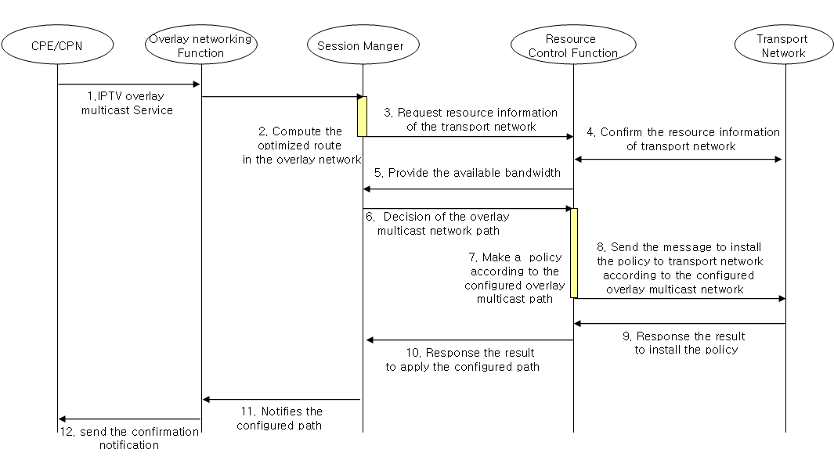
Figure II.1 - Procedure to create overlay multicast paths with QoS mapping and Resource Reservation in IPTV Overlay Network
Figure II.1 shows procedure to create IPTV overlay multicast service to be with QoS requirements of IPTV overlay multicast paths in IPTV overlay network.
- When IPTV overlay multicast is requested from CPE/CPN, overlay networking function forwards its request to Session Manager. (① ~ ②)
- Session Manager requests the current network resource status information to Resource Control Function. (③)
- Resource Control Function provides the resource information of the transport network, and waits the final decision of Session Manager. (④~⑤)
- Session Manger requests the creation of IPTV overlay multicast paths to overlay networking functions according to the IPTV multicast requirements of Session Manager. (⑥)
- Resource Control Function receives the final decision of Session Manager, and makes a policy or required bandwidth values to the transport network. (⑦)
- Resource Control Function sends the message to install the policy or bandwidth to transport network according to configured overlay multicast paths. (⑧~⑩)
- Overlay networking function will send the confirmation notification to the CPE/CPN. (⑪~⑫)

________________

