INTERNATIONAL TELECOMMUNICATION UNION |  |  |  | Focus Group On IPTV
TELECOMMUNICATION  STANDARDIZATION SECTOR  STUDY PERIOD 2005-2008 |  |  | FG IPTV-DOC-0123
 |  |  | English only
WG(s): 4 |  | 5th FG IPTV meeting:  Geneva, 23-31 July 2007
CONTRIBUTION
Source: | Editors
Title: | Working Document: IPTV Network Control Aspects
CONTENTS
1 Scope 3
2 References 3
3 Definitions 3
4 Abbreviations 4
5 Conventions 4
6 Framework of IPTV network control aspects 4
7 Control and signalling aspects 5
7.1 Network Control 5
7.1.1 Unicast Network Control 5
7.1.2 Multicast Network Control 5
7.1.2.1 Multicast IP address management 5
7.1.2.2 Connection Admission Control 5
7.1.2.3 Attachment control network 6
7.1.2.4 Multicast session identifier management 6
7.1.2.5 Source Specific Multicast 6
7.2 Multicast Availability 7
7.2.1 Multicast Service failure recovery 7
7.2.1.1 Redundant system architecture & topology 7
7.2.1.2 Robust network against Attacks 7
7.3 Multicast security Requirements 7
7.4 Broadcast TV Control 7
7.5 Session Control 7
7.6 Stream Control 8
8 Content distribution aspects 8
8.1 Content distribution network topology 8
8.1.1 CDN-based IPTV media delivery mechanism 8
8.1.2 Distributed content storage/cache and content serving 9
8.1.3 Centralized Content Location Management 9
8.1.4 Content Distribution Protocols 10
8.1.5 Statistical performance of Content Delivery Network 10
8.2 Distributed Content Distribution 10
8.3 Distributed Edge Server Networks 11
9 IPTV Consumer Domain Attachment and Initialization 11
10 Identification aspects 12
11 Home, Access and Core network aspects 12
11.1 Requirements of the IPTV network control aspect 13
12 Network control aspects for non-NGN 13
13 Network control aspects for NGN 13
14 Network control aspects for IMS-based NGN 13
15 IPTV Inter-working 13
15.1 General Inter-working requirements 13
15.1.1 End to End High Availability guarantee policy 13
15.2 Unicast Inter-working requirements 13
15.2.1 Unicast traffic policy 13
15.3 Multicast Inter-working requirements 13
15.3.1 Addressing requirements 13
15.3.2 In-service process among ISPs 13
15.3.3 Routing Policy 14
15.3.3.1 Topology requirements 14
15.3.4 Security Policy over multicast exchange peers 14
15.3.5 End to End multicast QoS guarantee policy 14
15.3.5.1 Inbound/outbound QoS policy 14
16 Overlay Network 14
16.1 Control Function in IPTV Overlay Network 15
16.2 Multicast Function in IPTV Overlay Network 15
16.3 Manageable overlay network 15
17 Other aspects 15
IPTV network control aspects

Scope
This document describes different aspects for IPTV network control. It provides a list of requirements to address control and signalling related to authentication and authorization, content delivery, quality of service (QoS), quality of experience (QoE) and security.

References
The following ITU-T Recommendations and other references contain provisions, which, through reference in this text, constitute provisions of this working document. At the time of publication, the editions indicated were valid. All Recommendations and other references are subject to revision; all users of this working document are therefore encouraged to investigate the possibility of applying the most recent edition of the Recommendations and other references listed below. A list of the currently valid ITU-T Recommendations is regularly published.
The reference to a document within this working document does not give it, as a stand-alone document, the status of a Recommendation.
[IPTV.ARC] ITU-T FG IPTV working document (xxxx), IPTV Architecture
[IPTV.REQ] ITU-T FG IPTV working document (xxxx) IPTV Services Requirements
[ITU-T Y.2111] ITU-T Recommendation Y.2111 (2006), Resource and admission control
functions in Next Generation Networks
[IETF RFC 3376] IETF RFC 3376(2002), Internet Group Management Protocol, Version 3
[IETF RFC 2236] IETF RFC 2236(1997), Internet Group Management Protocol, Version 2
[IETF RFC 2710] IETF RFC 2710 (1999), Multicast Listener Discovery (MLD) for IPv6
[IETF RFC 3810] IETF RFC 3810(2004), Multicast Listener Discovery Version 2 (MLDv2) for
IPv6
[IETF RFC 4604] IETF RFC 4604(2006), Using Internet Group Management Protocol Version 3 (IGMPv3) and Multicast Listener Discovery Protocol Version 2 (MLDv2) for Source-Specific Multicast.
[IETF RFC 4601] IETF RFC 4601(2006), Protocol Independent Multicast - Sparse Mode (PIM-SM):
[IETF RFC 4541] IETF RFC 4541(2006), Considerations for Internet Group Management Protocol (IGMP) and Multicast Listener Discovery (MLD) Snooping Switches.
[IETF RFC 4605] IETF RFC 4605(2006), Group Management Protocol (IGMP) / Multicast Listener Discovery (MLD)-Based Multicast Forwarding ("IGMP/MLD Proxying").

Definitions
This working document uses or defines the following terms:
TBD

Abbreviations
This working document uses the following abbreviations.
CAC Connection Admission Control
CDN Content delivery network
IGMP Internet Group Management Protocol
ISP Internet Service Provider
NNI Network Network Interface
QoE Quality of Experience
QoS Quality of Service
SNI Service Node Interface
UNI User Network Interface
VPN Virtual Private Network
Editor’s note: need more definition based on the current document.

Conventions
TBD

Framework of IPTV network control aspects
This section provides a general overview of IPTV network control aspects, as shown in Figure 6-1. There are many views of addressing control aspects of IPTV networks. This overall framework contained functional components related to IPTV network control aspects and aligned with IPTV Functional Architecture Framework.
Figure 6.1 Overview of IPTV network control
Editor’s note: figure 6-1 will be replaced as an Architecture diagram of WG1.

Control and signalling aspects

Network Control

Unicast Network Control
Editor’s note: need contributions

Multicast Network Control
Multicast network transport is one of the major drivers to promote IPTV service in telecommunication network. Multicast functionality is required to make efficient use of network bandwidth resources when delivering broadcast content. Therefore, multicast and its control function are important in network to deliver IPTV service content.
Because there can be various types of IP multicast schemes for efficient broadcast content delivery, it is required that each multicast scheme can be controlled.
- The equipment in transport stratum for IPTV service is recommended to support the static configuration of IP multicast distribution tree, and to support well designed dynamic IP multicast protocol to reduce influence for IPTV service.
- The IPTV network is recommended to support multicast user authentication function for multicast services of IPTV.
- The IPTV network is recommended to support alternative multicast schemes; such as CDN, overlay multicast, P2P, and so on. It is required to have a compatible capability of managing different multicast schemes.
- The IPTV network is recommended to support multicast in access network and multicast protocol proxy in access nodes or other network nodes where multicast traffic is replicated to users.
Editor’s note: need contributions to refine above

Multicast IP address management
- The multicast IP address is recommended to be manageable to ensure the deployment of IPTV service successfully.
- Multicast IP Address Transition is recommended to be supported for Cross-domain IPTV Broadcasting Service Stream.
- The IPTV network is recommended to support the Control of Users’ Multicast Address for user multicasting.

Connection Admission Control
It is required that Connection Admission Control is supported in the access network based on available resources. When the end user subscribes to a multicast stream, the access network will perform CAC: check if current available resources are enough for the new service subscription. The resources can be bandwidth, connection number and user service privilege profile.
- IPTV network is recommended to support configuring users’ corresponding multicast privileges according to the multicast group address.
- IPTV network is recommended to support configuring the relationship between users and their multicast privilege.
More specifically, IPTV network and multicast control function is recommended to support building privilege table for multicast users according to the multicast group address, so that when users receive IPTV multicast services, multicast network control deals with IPTV multicast services according to users' multicast privilege.
The multicast replication function is recommended to forward multicast media content to users which have the privilege of IPTV multicast services. That is to say, multicast network control will forward the IPTV service contents to the user only if the user has multicast privilege.
For the reason that some IPTV service traffic is mixed in the access network,
- IPTV network is recommended to support the QoS class queues for each IPTV service stream or each IPTV service stream category.
- IPTV network is recommended to support queues control function to guarantee quality for IPTV service streams in access network.
It is necessary to guarantee the quality of all using IPTV services (except Best Effort service) even if multiple services are used at a customer premise.
- IPTV network is recommended to support the Bandwidth Allocation Function (BAF) for IPTV service stream or for each IPTV service stream category in access network.
For reference, the bandwidth allocation function can be operated based on the following information.
- User ID
- Service Stream ID
- Bandwidth
    - Whole bandwidth of access line
    - Minimum guarantee bandwidth
    - Maximum guarantee bandwidth

Attachment control network
The attachment control network is required to support the multicast control function and multicast replication function which provide IPTV multicast services for users. The multicast control function is recommended to build the privilege table for multicast users, and the multicast replication function is recommended to forward multicast media content to users which have the privilege of IPTV multicast services.
Editor’s note: need contributions.

Multicast session identifier management
Because there can be various multicast schemes, it is required to describe multicast session uniquely. For example, a multicast session using pure IP multicast can be described by IP multicast address but a multicast session using CDN can be described by URL. IPTV is recommended to manage identifier to describe a specific multicast session uniquely.

Source Specific Multicast
Source Specific Multicast reduces the overall complexity within IPTV. SSM is also optimized for One-to-Many deployment scenarios which are typically used within IPTV. ASM and SSM can be used in parallel (deploying different address ranges) if necessary. The use of SSM eases the deployment of IPTV and reduces the complexity, allowing more flexible IPTV services.

Multicast Availability

Multicast Service failure recovery
IPTV System is required to provide the capability for ensuring sufficient availability of multicast network for IPTV services.
Editor’s Note: What if one party in a multicast group wants to pause and restart a video? Do you want users to be able to pause and resume communications without losing any information when they are a part of a multicast group?

Redundant system architecture & topology
The IPTV network is recommended to be fully redundant system architecture and topology such that a single point of failure is recommended to not affect the whole network.

Robust network against Attacks
The IPTV network is recommended to be designed to be robust such that it can tolerate unexpected attacks such as DOS attack.

Multicast security Requirements
This section describes general requirements for multicast security.
Security is a critical issue for multicast network deployment.
IPTV network multicast control is recommended to authenticate user for multicast service and only deliver multicast service to authenticated user.

Broadcast TV Control
Channel zapping protocol are the interactions for and between the Service Stratum and the Transport Stratum in terms of channel selection.
Multicast control of Broadcast TV is recommended to include but not limit to the followings:
- Channel Access Control: Channel Access Control of Broadcast TV is recommended to support some access right statuses of the entitlement to each of the broadcast channel for each user, such as fully allowed, preview allowed, not allowed.
- Channel Preview Capability: Channel Preview Capability of Broadcast TV is recommended to support some preview control functions of the Broadcast TV channel, such as Maximum duration for each preview, Maximum times of previews, Blackout duration after each preview, Reset period of channel preview, Recognition Time of channel preview, etc.
- Call Detail Record: Call Detail Record is recommended to report the entitlement status of the channel being access, and records the channel access activities of each customer should be generated automatically.
- Priority of BTV and other traffic
- Service Management System
Editor’s note: need contribution to describe above two items.

Session Control
Editor’s note: need contributions to complete this part.
The stream session control protocol is recommended to support carrying authentication/authorization token, carrying message signature and cross server session.

Stream Control
Editor’s note: need contributions to complete this part.
The stream transport protocol is recommended to support representation of position in frame, frame awareness, frame awareness for trick modes, physical server aware client.

Content distribution aspects
IPTV Content distribution network are required to support non-real time and real-time IPTV services such as BTV, VOD & EPG content delivery, System Information, Ad-Insertion (e.g. SCTE 35), provide Content Protection, Closed Captioning, Content Transport leveraging and Content Segmentation, define CDN components to record and provide performance statistic.
- Content Segmentation
Content Segmentation can optionally be required in some IPTV deployments. IPTV Content Segmentation functions are recommended to include:
- Generating segment at codec frame boundaries.
- Be aware of codec format, such as MPEG-2, MPEG-4, AVS, H.264 and VC-1.
- Apply to both clear-text and encrypted contents.
- Support the quick identification of any frame within the segment and the entire program file.

Content distribution network topology
The IPTV Content distribution network is recommended to be layered. Each layer may have several serving nodes which construct flexibly content distribution network. The serving node may be constructed by a node controller and several stream servers. The node controller provides the load balance among the stream servers in the serving node, and adjusts the deployment of the contents between serving nodes. Stream server is required to provide stream serving in real-time to users under the control of the node controller.
Distributed structure is recommended to be adopted in a content distribution network layer. The serving node in the content distribution network layer may communicate with each other to exchange the contents.

CDN-based IPTV media delivery mechanism
In order to ensure manageability and interoperability of CDN-based IPTV content distribution network, the CDN-based IPTV media delivery mechanism is recommended to include Media Delivery Manager, Media Delivery Agent and Stream media server.
Media Delivery Manager, which is responsible for global load balancing and interfacing with other subsystems, supports serving control function, content control function and operation maintenance function.
Media Delivery Agent, which is responsible for local load balance, is attached with every stream media nodes and supports serving control function, content control function and operation maintenance function for the corresponding node.
Stream Media Server, is responsible for storing content and streaming media, supports streaming function, content storage function, content distribution/delivery function, and operation maintenance function.

Distributed content storage/cache and content serving
  - Distributed Content Storage/Cache
Powered by content distribution protocol, content distribution network can store or cache segmented content in a distributed mechanism on servers at different level based on viewing demand patterns and operator-specified policies. The content storage/cache nodes are classified by their physical network location and their subscriber coverage in the hierarchical distributed content storage/cache architecture. The hierarchical distributed architecture enables service providers to dynamically distribute video contents according to pre-defined distribution policies based on attributes such as content classification, subscriber viewing demand, and bandwidth availability.
The distributed content distribution mechanism enables service providers to store beginning content segments directly on the storage/cache node at edge (closest to the subscribers), and store the remaining content segment on storage/cache node at the intermediate or central level. Once the viewing is started, it can ensure the end user can get and play the first content segment timely, and then the remaining segment can be dynamically delivered. This simplifies and expedites content distribution, reduces storage requirements, and minimizes network congestion.
Editor’s note: contributions are invited to generalize it.
  - Distributed Content Serving
Content serving in distributed content serving architecture is completed by several independent content serving nodes, the content delivery control node appoints an appropriate content serving node to provide streaming service for each IPTV client & terminal according to the load of each content serving node and the state of content segments distributed in each content storage/cache node. According to the distribution protocol, the remaining content segments not stored on edge servers are pushed from the upper level storage cache nodes to storage/cache node at edge level dynamically.
Editor’s note: contributions are invited to generalize it.

Centralized Content Location Management
A centralized content location management module is recommended to be responsible for keeping track of the locations of all the content in the IPTV network. It maintains a record of network topology, a content location, and a content distribution session.
The network topology describes the topology of the media servers and the network topology among them. Media content is copied from one location to another by creating content distribution sessions between two media servers in the two locations. These sessions are created and deleted as the copy process starts and finishes. This information is used by the content location management module to keep track of the bandwidth usage among the media servers and the central site.
The characteristics of the centralized content location management include as follows.
- Track each content program location in the distributed media servers.
- Keep track of the distribution sessions among media servers.
- Keep statistical and historic data of content delivery and copy sessions.

Content Distribution Protocols
The initial content distribution is typically through content pushing. The content is pushed from central media server to edge media servers according to the policy, schedule and distribution topology provided by centralized content location management.
The content delivery protocols are recommended to support flexibly as follows.
- Flexible policies for content distribution
- Scheduled pushing of content to delivery servers
- Quickly identify a source of the content and start copying
- The dynamic pulling of content by the delivery servers
- Multiple sources for content pulling.

Statistical performance of Content Delivery Network
Statistical performance of Content Delivery network mainly includes the content storage server, the content serving server and the content delivery control function.
  - The content storage server - manages content stored in both memory and persistent storage according to policy, i.e. content swapping, content deletion etc.
The content storage server records the number of requests satisfied by pushed contents, requests satisfied by pulled contents, requests satisfied by pulling remote contents, requests satisfied by local contents, requests for remote contents, content push sessions and content pull sessions. The ratio between number of requests satisfied by pushed contents and this number indicates the effectiveness of content push. The ratio between number of requests satisfied by pulled contents and this number indicates the effectiveness of content pull.
  - The content serving server - transmit requested content to end system in designated forms, or redirect request to other functionalities.
The content serving server record the number of received requests for contents, served bytes and unsatisfied requests. This number of received requests for contents indicates the amount of load on the node. This number of served bytes indicates the number of bytes actually consumed by users – the effective bytes. Sum of bytes for pushed contents and bytes for pulled contents indicates the number of bytes made available to users. The ratio between the effective bytes and the available bytes indicates effectiveness of content push and pull.
  - Content delivery control function - trigger and control content transmission among content storage server, designate content, source, destination, speed of the transmission.

Distributed Content Distribution
The IPTV network is recommended to support a distributed architecture among content edge servers.
Co-located edge media servers are recommended to have the ability to be organized in a distributed structure to share the load, to raise the reliability and to reduce the total cost of the edge servers.
According to the method of the distributed structure, original files or content can be stored evenly on the servers. User’s requests can be redirected to the most suitable edge server automatically without the help of a central device.

Distributed Edge Server Networks
Distributed architecture is applied to organize all local edge server networks to form distributed edge server networks. That is, distributed architecture among all local edge server networks is recommended to be supportable such that the burden of both serving users and content storage can be evenly distributed on all local edge server networks.
- Content Locating
Some automatic content locating approach is applied in the local edge server network to find a suitable edge server for the user. If not found, the user’s request will be routed among all local edge server networks (by using automatic content locating method again) to locate a suitable local edge server network containing edge server with desired content.
- Server functions
Each edge server in local edge server network is recommended to support automatic content locating methods for distributed structure. Each local edge server network is recommended to support automatic content locating methods for distributed structure. Automatic content locating capability is recommended to be supported by some agent server in each local edge server network, i.e. the agent server acts as the content locating agent of the corresponding local edge server network.
In DHT, edge server calculates and distributes content ID and content information to edge server in its local edge server network. Agent server calculates and distributes content ID and content information to another agent server which directly distributes content ID and content information to edge server in that edge server network. Content information is searched among edge servers in requestor’s local network. If not found, some agent server is found to be responsible for the content information. That agent server directly searches content information in that edge server network by locating some edge server storing the required content information.

IPTV Consumer Domain Attachment and Initialization
The IPTV device attachment and initialization process can be broken down into the following steps: Setup & Configuration, Network Attachment, Service Provider Discovery, and Services discovery & Service attachment.
  - Setup & Configuration
Setup & Configuration activities relate to acquiring and configuring a physical ITF device. It establishes the identity and authentication credentials for the ITF, and service provider identity and any additional information for one or more service providers.
  - Network Attachment
Network Attachment refers to the activities associated with the ITF establishing Layer-3 connectivity to an IP-network and potentially obtaining additional network configuration data. During the network attachment phase, some information, such as IPv4 address, network mask, default route, DNS, local network domain name, SIP proxies, others…, may be obtained.
  - Service Provider Discovery
Service Provider discovery is the process by which an ITF(IPTV Terminating Function) becomes aware of the available IPTV Service Providers, learns the location of their Service Discovery (SD) Servers and the means for attaching to each SD server. As a result, by contacting the discovered SD Server(s), an ITF can perform the subsequent Services Discovery and Service Attachment procedures.
  - Service Discovery & Service Attachment
Services Discovery is the process by which an ITF receives the necessary signaling information which prepares it to learn about and access the available IPTV Services. The ITF interacts with one or more Service Provider Servers (discovered earlier) in order to acquire information about specific services.
The Services Discovery function includes both the ‘services discovery authorization’ means and the ‘services description’. Having been authorized by a Service Provider SD Server, the consumer needs to be able to navigate through the variety of service offerings and then attach to a specific service.

Identification aspects
It is necessary to provide identification mechanism to identify IPTV users, customers and subscribers to support IPTV services, which could be used in various players such as customer, service providers, network providers and content providers.
The IPTV network controls, manages and makes provision to optimize the service for various types of resources. In order to realize service optimization, the IPTV network can optionally utilize six IPTV Identifiers for its Content, Content Reference, Content Provider, Service Provider, Network provider and End-User.
- Content ID (CID) - unique identifier of Individual Content.
- Content Reference ID (CRID) - unique identifier of Content Reference.
Editor’s note: contributions are necessary to clarify Content Reference.
- Content Provider ID (CPID) - unique identifier of Content Provider.
- Service Provider ID (SPID) - unique identifier of Service Provider.
- Network Provider ID (NPID) – unique identifier of Network Provider.
- User ID (UID) – unique identifier of User or Subscriber.
The IPTV network uses some locators to locate content among CDN to optimize the storage and serving. The IPTV network can optionally utilize the following three Locators to locate content..
- Logical Locator – specifies the content to be acquired, the owner of content and how to request it. It includes information about the service provider’s identification, the content provider’s identification, the content identification, the protocol to be used and other application information.
- Physical Locator – specifies the physical address of the content in the Logical locator. The content delivery translates Logical Locator into Physical Locator to assign the server to an instant of content request. It includes the protocol, IP address and port to be used. It also includes the path of the content or content’s metadata.
- Internal Physical Locator – is used in content serving for load balancing when servers share a single IP address.

Home, Access and Core network aspects
Editor’s note: need contributions to complete this part
This section will identify specific requirements on addressing functions and signalling as to home, access and core network technologies in relation to IPTV service aspects.
The access control network is recommended to support the multicast control function and multicast replication function which provide IPTV multicast services for users.

Requirements of the IPTV network control aspect
The home or access network is recommended to provide NAT traversal function where required.
Editor’s note: need contributions to complete this part
The edge devices (i.e. home gateway) are recommended to have the capability of service traffic identifying and marking.

Network control aspects for non-NGN
Editor’s note: need contributions to complete this part

Network control aspects for NGN
Editor’s note: need contributions to complete this part

Network control aspects for IMS-based NGN
Editor’s note: need contributions to complete this part

IPTV Inter-working

General Inter-working requirements

End to End High Availability guarantee policy
Multicast services are mostly affected by network link failure and/or routing protocol neighbour failure.
Graceful restart techniques to avoid temporary service disruption during link failure and neighbour failure is recommended to be supported.

Unicast Inter-working requirements

Unicast traffic policy
Editor’s note: need contributions to complete this part
ISPs can send multicast and unicast traffic simultaneously over the same links or different links.

Multicast Inter-working requirements
This section describes requirements for transportation of multicast traffic amongst service providers. Its main objective is to present a set of requirements and scenarios which would result in general requirements about service negotiation, selection and development for IPTV multicast service provider

Addressing requirements
Editor’s note: need contributions to complete this part

In-service process among ISPs
Editor’s note: need contributions to complete this part

Routing Policy

Topology requirements
Editor’s Note: It is recommended to be clearly define “Multicasts Traffic Exchange Point”
Multicast traffic exchange point could be located at any point of network. Routers could be connected directly or indirectly using tunnel mechanism.
- Topology options
Centralized Multicast Exchange Point: SPs establish multicast peering at centralized point
Distributed Multicast Exchange Point: Multicast traffic is transmitted at closest regional pops to maximize the resource utilization.
- Multi-homing vs. Single-homing
Multi-homing: In this topology, customer ISP peers with single backbone ISP or two backbone ISPs for failure redundant and traffic load balancing. One of many cautions in this topology is that customer ISP is recommended to advertise only their local AS information not to transit other ISP’s multicast traffic.
Editor’s Note: Single Homing and Multi-homing definition need to check original contributor.
- Single-homing:
Editor’s note: need contributions to describe Single-homing

Security Policy over multicast exchange peers
Editor’s note: need contributions to complete this part

End to End multicast QoS guarantee policy
IPTV network is recommended to have service quality measurement function to facilitate high quality service.
Editor’s note: need contributions to complete this part

Inbound/outbound QoS policy
Editor’s note: need contributions to complete this part
The IPTV network is recommended to provide mechanisms to support QoS/QoE parameter adjustment due to changes of content characteristics on a channel.
The stream session control protocol is recommended to support QoS/QoE adjustment procedure due to changes of content characteristics on a channel.

Overlay Network
IPTV overlay network is responsible for forwarding and handling of IPTV application data in ways that are different form. And overlay network is operated in organized and coherent way by the third party to provide IPTV services.
IPTV overlay network consists of virtual network topologies on top of the physical network, as shown in figure 16.1, which directly interfaces to users. With the rapid advancement of internet and computing technology, much more aggregate information and computing resources are available from clients or peers than from a limited number of centralized servers.
Figure 16.1 Overlay Service and Network for IPTV

Control Function in IPTV Overlay Network
In order to provide overlay session control in overlay networks for IPTV service, IPTV service control function is necessary to perform session control and management for IPTV overlay network, to establish and maintain the network and system resources.

Multicast Function in IPTV Overlay Network
The overlay IPTV multicast can use diverse mechanisms for constructing different multicast trees depending on IPTV application parameters or application classes. The overlay IPTV multicast supports efficient routing and resource usage by overlay multicast control.
In order to provide scalability for multicast function, hierarchical structure for overlay multicast will be introduced in IPTV overlay networks.

Manageable overlay network
In order to achieve manageable P2P network, ISP is recommended to involve in some management functions of P2P. With these management functions, ISP can tightly manage the P2P network.
The advantages of manageable P2P model are:
  - ISP can tightly manage content distribution network by involving in the management of P2P.
  - The size of user group is not bounded by the capability of media server.

Other aspects
Editor’s note: This section is for inviting future contributions, which could be addressed to IPTV network control aspects. Following issues are addressed for the time being:
- Multicast VPN
IPTV multicast VPN service may accelerate IPTV applications as the worldwide demand for VPN services grows. In the meantime, IPTV multicast VPN also may enrich IPTV applications, such as classified IPTV service features according to geographical groups and customers’ demand, differentiated IPTV service features in security and QoS for communities or groups, classified IPTV group service features, personalized IPTV service capabilities on IPTV service provider’s network.
- Parental controls
It is required to support mechanisms for the service provider to support the enforcement of parental controls which allow associated users to control and monitor IPTV programs including EPG/ECG from fixed or mobile terminals. The mechanism asks for network to store and forward the under-controlled TV programs to associated terminals. The mechanism is also required to be on the basis of a user profile and policies which may be changed by associated user from other terminals. The policies are varieties include time limit, the programme classes and etc.
- Various home, access and core transport scenarios for multicasting
- Any other issues related to IPTV Network control aspects
Editor’s note: need contributions to describe above two items.
Appendix I: Example of IPTV Consumer Domain Attachment and Initialization
I.1 IPTV device Initialization and Attachment flow
The following is an example flow of multicast-base push mode for IPTV device Initialization and Attachment.
Figure I.1 IPTV Device Initialization and Attachment flow
The following two sub-sections attached here only for reference purpose.
I.2 DNG Network Attachment
The most prevalent automatic method currently used to attach to the network is the DHCP protocol. Using this protocol, the DNG acquires its WAN IP address, and can also learn the address of the remote configuration server.
The figure below shows the sequence of events that take place when the DNG is powered up or initialized.
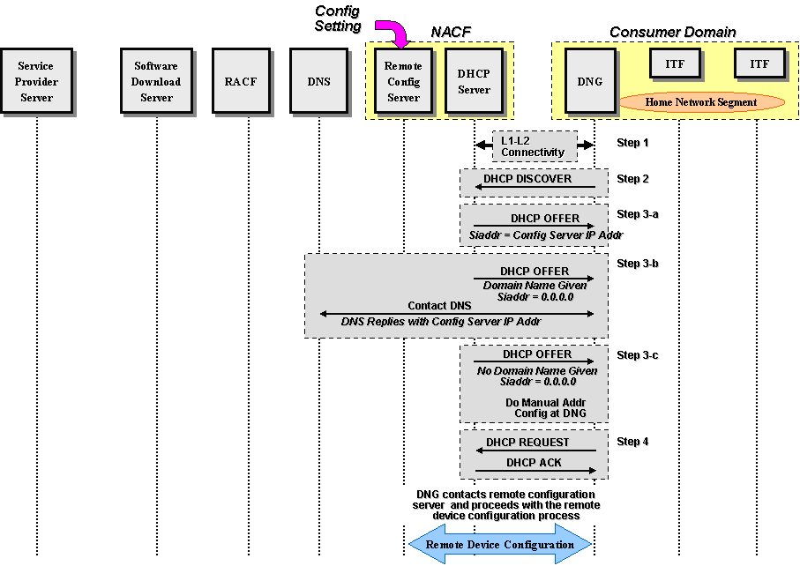
Figure I.2: DNG Network Attachment
I.3 Local DHCP Server on the DNG
In this case it is assumed that the DNG has already attached to the network and acquired its L3 networking information. The following sequence takes place when an ITF device is powered up or initialized:
The flow is shown below:
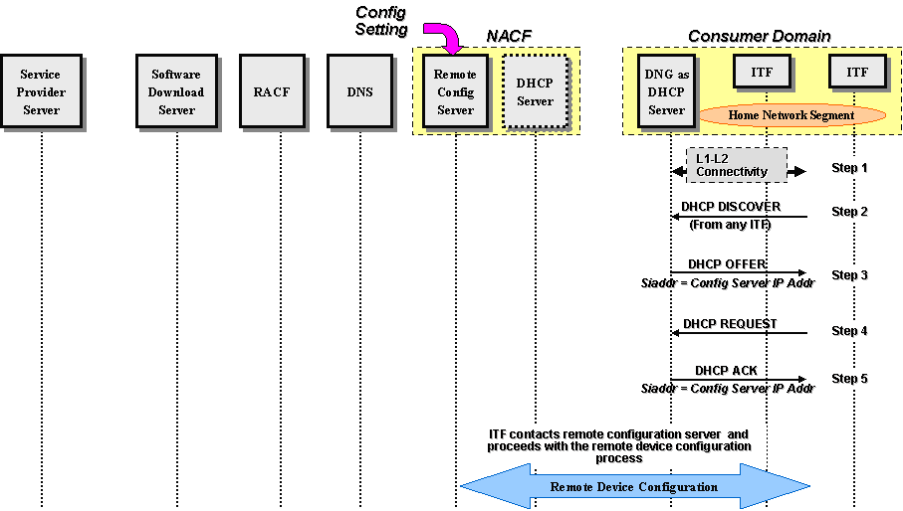
Figure I.3: ITF Device Network Attachment with a Local DHCP Server in the DNG
After acquiring the IP address of the remote configuration server, the ITF device interacts with the remote configuration server to acquire needed configuration parameters.

Appendix II: Example of Multicast VPN
II.1 Requirement on Multicast VPN in IPTV network control aspect
The IPTV multicast VPN operates with the security, management and Quality of Service (QoS) policies of a private network. Figure 1 depicts an example of basic IPTV multicast VPN services. In Figure B.1, the main office offers diverse IPTV application services which are sent from IPTV contents server, to home office, remote office and business partner with IPTV connected on VPN.
Figure II.1. Example of Basic Configuration in IPTV Multicast VPN

In order to provide IPTV multicast VPN, The IPTV access node will provide secured and encrypted multiple connections between main office and remote office. So, the IPTV multicast VPN will have multiple benefits as follows:
- Extend geographic connectivity
- Improve security
- Reduce operational costs
- Reduce transit time and transportation costs for remote users
II.2 IPTV Multicast VPN Group Management
The IPTV multicast VPN group management is to achieve privacy and integrity in IPTV network. According to features of IPTV service, geographical position of IPTV users or both, IPTV multicast VPN groups can be formed diversely into same IPTV VPN or different IPTV VPN sites. Each IPTV multicast VPN group is assigned according to different security grade and QoS.
In order to support additionally secure group management, IPTV multicast VPN group will be applied to provide the following:
- Limiting of IPTV Multicast VPN Group Member:
The member limitation of IPTV multicast VPN group needs to optimize the resource usage of IPTV network.
- User Privacy:
The identity of the IPTV multicast VPN group members is kept secret from other IPTV VPN group. If needed, it is kept secret from other members of the same IPTV group.
- Data integrity:
The data received by the IPTV multicast VPN group members is coming from an authorized sender and has not been modified during transit.
__________

