IPTV Multicast Frameworks
INTERNATIONAL TELECOMMUNICATION UNION |  |  |  | Focus Group On IPTV
TELECOMMUNICATION  STANDARDIZATION SECTOR  STUDY PERIOD 2005-2008 |  |  | FG IPTV-DOC-0092
 |  |  | English only
WG(s): 4 |  | 4th FG IPTV meeting:  Bled, Slovenia, 7-11 May 2007
OUTPUT DOCUMENT
Source: | Editor
Title: | Working Document: IPTV Multicast Frameworks

TABLE OF CONTENTS
1. Scope 4
2. References 4
3. Definitions 4
3.1. Terms defined elsewhere 4
3.2. Terms defined in this Recommendation 4
4. Abbreviations and acronyms 5
5. Conventions 5
6. IPTV Multicast scenario 6
6.1. Pure IP Multicast model 6
6.2. Alternative multicast model 7
6.3. Hybrid Model 7
7. Frameworks of IPTV Multicast 8
7.1. IPTV multicast architecture 8
7.1.1. The architecture of multicast function framework 9
7.1.2. IPTV multicast network physical architecture 9
7.1.2.1. Rendezvous Point 10
7.1.2.2. Load balancing of IPTV multicast 10
7.1.3. IPTV multicast network Logical architecture 10
7.1.4. IPTV multiple multicast path 11
8. IPTV multicast requirements 11
8.1. IPTV multicast Transport requirement 11
8.1.1. IPTV Multicast Control Function at the Transport 11
8.1.2. IPTV Multicast in Access Node 12
8.1.3. IPTV Multicast in Core Node 13
8.2. IPTV Multicast Service Requirements 14
8.2.1. Functional Requirements for IPTV Service Level Multicast 14
8.2.2. Control Framework for IPTV Service Level Multicast 14
8.2.2.1. IPTV Session Manager (ISM) 15
8.2.2.2. IPTV Multicast Agent ( IMA ) 16
8.3. High Availability requirements of IPTV multicast 16
8.4. QoS requirements of IPTV multicast 17
8.5. Security requirements of IPTV multicast 18
8.6. Interoperability requirement of IPTV multicast 18
8.6.1. Definition of IPTV multicast interoperability 19
8.6.2. Definition of IPTV multicast interoperability information 20
8.6.3. Requirements for IPTV multicast interoperability 20
8.7. Operation and management requirement of IPTV multicast 22
8.7.1. IPTV Multicast user management 22
8.7.2. IPTV multicast address management 23
8.7.2.1. IP Multicast Address Transition 23
8.7.2.2. The Control of Users’ Multicast Address 24
8.7.3. IPTV multicast service management 25
9. IPTV multicast solution 25
9.1. Pure IP multicast-based IPTV service delivery solution 25
9.2. Server-based IPTV service delivery solution 26
9.3. CDN-based IPTV service delivery solution 26
9.4. P2P-based IPTV service delivery solution 27
9.5. Overlay multicast-based IPTV service delivery solution 28
9.5.1. Overlay IPTV Multicast Control 29
9.5.1.1. Control in Overlay IPTV Multicast 30
9.5.1.2. Group Membership Management 30
9.5.1.3. Admission Control for QoS for overlay IPTV Multicast 31
9.5.1.4. Security for Overlay IPTV Multicast 31
9.5.1.5. Node functions for IPTV overlay routing 31
9.5.2. QoS Control at Overlay Multicast Network for IPTV Services 32
9.5.2.1. Functional Position of Resource Control 32
9.5.2.2. Resource Control Function 32
9.5.2.3. Resource Control Function for Overlay QoS Control in Heterogeneous Networks. 33
10. Other aspects 34

IPTV Multicast Frameworks
- Scope
This draft working document describes functional requirements and frameworks of supporting multicast capabilities in terms of IPTV network control.
[Editor’s note]: This document considers multicast frameworks for non-NGN environment.
- References
The following ITU-T Recommendations and other references contain provisions, which, through reference in this text, constitute provisions of this working document. At the time of publication, the editions indicated were valid. All Recommendations and other references are subject to revision; all users of this working document are therefore encouraged to investigate the possibility of applying the most recent edition of the Recommendations and other references listed below. A list of the currently valid ITU-T Recommendations is regularly published.
The reference to a document within this working document does not give it, as a stand-alone document, the status of a Recommendation.
TBD
[FG IPTV-DOC-0083] ITU-T IPTV Focus Group, IPTV Service Requirements

- Definitions
  - Terms defined elsewhere
This Document uses the following terms defined elsewhere:
[TBD]
  - Terms defined in this Recommendation
This Document defines the following terms:
[Editor’s note]: The alignment of terminology is needed, and related contributions are recommended to be published in this section.
IPTV Service Exchange Point (SEP)
IPTV SEP identifies as a reference point for handling the service brokering function between IPTV Service Providers enabling the optimal contract between IPTV Service Providers and providing the stable IPTV services amongst IPTV service providers.
Multicast Domain Management
A multicast domain is a set of multicast routing and forwarding instances than can send multicast traffic to each other. These multicast routing and forwarding instances are referred to as IPTV multicast domain. Thus, multicast domains map all of a customer’s multicast groups that exist in particular IPTV service members to a single unique global multicast group. This is achieved by existing or specific group routing and forwarding capability in the network.
Multicast Access Control Functions
Multicast Access Control Functions is that control a multicast user access to IPTV multicast tree. The IPTV user can join a multicast service using these control functions with proper authentication and authorization of the user.
Multicast Delivery Control Functions
Multicast Delivery Control Functions is that can control IPTV multicast delivery among transport functions.
Others: TBD
[Editor’s note]: Terms and definitions in this section should be confirmed through the meeting considering other relevant terms and definitions as appropriate for using in IPTV multicast. And special care should be taken to avoid any confusion with other terms and definitions. Especially following definitions should be confirmed.
- IPTV multicast agent
- IPTV session manager
- The definition of components in IPTV multicast functional framework picture (based on FG IPTV C-227; LL#10)
- Abbreviations and acronyms
This working document uses the following abbreviations.
CAC Connection Admission Control
DRM Digital Rights Management
ECMP Equal Cost Multiple Path
IGMP Internet Group Management Protocol
IP Internet Protocol
QoE Quality of Experience
QoS Quality of Service
RP Rendezvous Point
SEP Service Exchange Point
- Conventions
[TBD]

- IPTV Multicast scenario
[Editor’s note]: The IPTV multicast scenario depends on the status of delivery infrastructure to provide the capability of multicast. Some of the delivery infrastructure is simply not ready to enable multicast mechanism for many reasons such that either part of or none of delivery infrastructure is capable of multicast mechanism. In order to provide IPTV service in more versatile manner, various type of model can be considered, like overlay and genuine multicast model. And the functional requirements and frameworks of network control aspects for multicast depend largely on the choice of those scenarios. Without consensus on taking scenario the discussion might be confused. This section will describe multicast providing scenario including possible service models.
Following sections are based on document FGIPTV-C-497, C-530, C-531.
IPTV content delivery infrastructure consists of four different layers, i.e. Content Source, Core, Metro, and Access. Content source is where IPTV service contents are originated and they can be placed in either inside or outside of delivery infrastructure. Core is service/network provider’s backbone infrastructure. Metro, in other words Aggregation or Edge, is where it connects and aggregates between core and access. Access is user’s domain that includes last mile.

Pure IP Multicast model
[Editor’s note]:In this subsection, the terminology ‘Pure IP Multicast model’ should be agreed in WG4.
In the pure IP multicast model, IP multicast mechanism is fully deployed throughout the IPTV delivery infrastructure so that IPTV content can be delivered along the multicast distribution tree. It is very efficient in that it saves network resources by avoiding duplicate identical contents for each user’s request. In addition, it dynamically builds and restores the content distribution trees when there are changes within delivery infrastructure. This model is quite adequate to provide a real time streaming service compare to other delivery models. Figure 1 shows pure IP multicast model where IPTV service contents are delivered from content sources to service users along the dynamic tree generated by IP multicast mechanism.
[Editor’s note]: In case that we put the diagram in each subsection, every diagram needs to be made in micro soft type for editing.

[Fig. 1] Pure IP Multicast model

Alternative multicast model
As an alternative approach, alternative multicast model can be considered for IPTV delivery infrastructure that does not have multicast capability. Unlike pure IP multicast model, this model has more freedom of design and implementation upon diverse service requirements since this model is not ruled by a single mechanism; various ways such as CDN, P2P, and overlay multicast mechanism can be applied. When designing an alternative multicast model, it is important to emphasize the way of content distribution such that it mitigates a real time streaming service delay over genuine multicast model. Figure 2 shows alternative model that delivers IPTV service purely by unicast route from content source to service users.
[Fig. 2] Overlay Model

Hybrid Model
Hybrid model can be a good candidate where IPTV delivery infrastructure cannot fully support pure IP multicast capabilities; from content sources to service users, some part of infrastructure can support pure IP multicast capabilities and some part cannot. Hybrid model is the most reasonable way without additional investment to enable multicast mechanism to the existing infrastructure where lack of multicast capabilities. Figure 3 shows hybrid model that combines both multicast mechanism and overlay mechanism to deliver IPTV service content to service users.
[Fig. 3] Hybrid Model

- Frameworks of IPTV Multicast
[Editor’s note]: This section is the key part of IPTV multicast frameworks WD, and describes and defines the basic elements of IPTV multicast frameworks like IPTV multicast architecture. Besides IPTV multicast architecture, other framework issues can be included in this section.
  - IPTV multicast architecture
[Editor’s note]: IPTV multicast architecture is the basic frame of new WD. So this subsection describes IPTV Multicast functional framework, Physical architecture of IPTV multicast network, and logical architecture of IPTV multicast network, and so on. This section should be aligned with the architecture document of WG1.
IPTV multicast functional framework includes the definition of IPTV multicast functional components and features. The physical architecture of IPTV multicast network describes IPTV multicast network topology design issues to guarantee the QoS, High Availability. The Logical architecture of IPTV multicast network describes IPTV multicast routing protocol design issues and control protocol design issues.
    - The architecture of multicast function framework
Multicast functionality is required to make efficient use of network bandwidth resources when delivering broadcast content. IPTV multicast and its control function are important in network to support stable IPTV services.
Following sections are based on document FGIPTV-C-227 (LL#10).
In order to enhance and optimize service capability of IPTV, multicast function should be required to perform at transport stratum, service stratum or both.
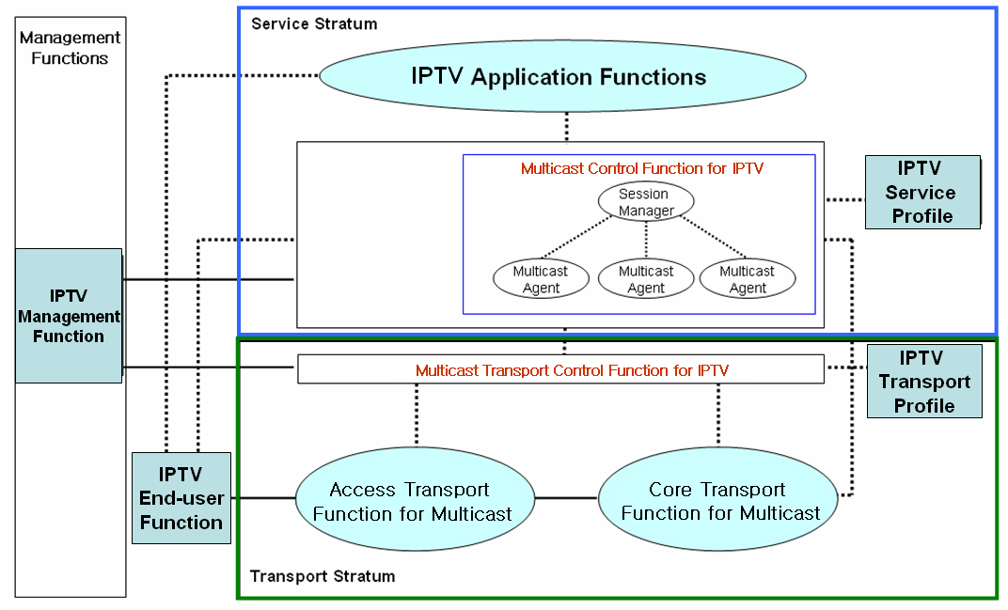
Fig. 4 IPTV Multicast Function Framework (Back to LL)

[Editor’s note]: This picture includes so specific functional components related with solution. In this subsection, the picture of general multicast model is needed, and this picture should be modified. This picture should be aligned with WG1’s new architecture diagram, focused on non-ngn point of view. And also this picture should be aligned with Network Control aspect WD. We need appropriate contribution!
[Editor’s note]: To clearly identify IPTV multicast frameworks, following issues could be developed. And also, related contributions are needed in this subsection.
- Definition of IPTV Multicast components: e.g., source, mediator for IPTV multicast information, receiver, etc.
- Functional components for IPTV multicast
    - IPTV multicast network physical architecture
[Editor’s note]: The physical architecture of IPTV multicast network describes IPTV multicast network topology design issues to guarantee the QoS, High Availability

Following sections are based on document FGIPTV-C-0137 (LL#2).
      - Rendezvous Point
[Editor’s note]: Rendezvous point is specific and design issue related with PIM-SM, need to be put back to LL. We need to define the general terminology about multicast tree manager to describe the RP feature, and we need more appropriate terminology and appropriate contribution!
Location of Rendezvous Point (RP) is not only affects IPTV service delay, but also network burden. Following requirements should be taken care.
- Optimal RP Positioning: Optimal RP positioning depends upon Service Providers’ network topology and their multicast traffic path which taken consideration of followings:
- Loop free, Delay/Jitter independent, stability guarantee topology
- Optimal position to exchange SA information amongst multicast service provider
- RP redundancy mechanism: IPTV network should be guaranteed optimized RP redundancy to improve IPTV service stability in case of RP failure. IPTV network should be designed their RP mechanism not only to maximize service stability, but also to minimize service recovery time during RP failure.
      - Load balancing of IPTV multicast
Following sections are based on document FGIPTV-C-0137 (LL#2).
When multicast routers receive a join message, multicast routing protocol normally send its join message to one of the multicast interfaces. If some groups have the same source, among multiple multicast interfaces, only one of them is selected and sends the join. In an Equal Cost Multiple Path (ECMP) environment[note], all multicast interfaces cannot be used to distribute multicast traffic; instead only single interface is used. To load sharing the traffic, multicast source should be distributed for different groups, and IPTV service provider should be considered of this load sharing requirements.
[Editor note]: Need further description to clarify ECMP environment.
[Editor note]: Further clarification should be needed to clarify the relationship of this section with section for “Availability”. Next meeting should be clarified this and contributions are requested.
    - IPTV multicast network Logical architecture
[Editor’s note]: The Logical architecture of IPTV multicast network describes IPTV multicast routing protocol requirements and design issues and control protocol requirements and design issues. We need appropriate contributions to accomplish this subsection.
    - IPTV multiple multicast path
[Editor’s note]: In this subsection, the requirements of building multiple multicast paths (e.g. trees) from the service source to the end hosts are described. Main idea is based on FG IPTV-C-492. The contribution to describe the General concept, not specific to implementation issues is needed.
Multiple multicast trees include many multicast trees with each tree being constructed from the multicast source to the receivers and multicast data being delivered among all the multicast trees.
- IPTV multicast requirements
[Editor’s note]: This section is also essential part of IPTV multicast frameworks WD, and describes the IPTV multicast requirements, and we have to push some of basic requirements to be included in WG1’s requirements WD. Based on many contributions in past meetings which are accepted in WG4, and living list documents, we can get the IPTV multicast requirement subsections like followings. Besides the described subsection IPTV multicast architecture, other IPTV requirement issues can be included in this section.
  - IPTV multicast Transport requirement
[Editor’s note]: This subsection describes the requirements of IPTV multicast delivery network as IPTV transport.
    - IPTV Multicast Control Function at the Transport
[Editor’s note]: In this section, we need general definition of IPTV multicast control functions. We need appropriate contributions to accomplish the general definition of IPTV multicast control functions.

IPTV multicast control functions can be divided into two control issues. The first one is multicast access control functions relative with IPTV multicast access. The other is multicast delivery control functions relative with IPTV multicast traffic delivery.

Multicast access control functions control a multicast user access to IPTV multicast tree. The IPTV user can join a multicast service using these control functions with proper authentication and authorization of the user. These functions have the following requirements for IPTV user to access multicast tree.
- IPTV user is recommended to identify multicast tree.
- IPTV user can optionally request to join a multicast tree with authorization, authentication.
- IPTV network provider is recommended to maintain multicast information per an IPTV multicast flow.
- IPTV network provider is recommended to manage the membership of IPTV user.
- IPTV network provider is recommended to announce multicast information to users.
- IPTV network provider can optionally authorize and authorize an IPTV user.

Multicast delivery control functions control multicast delivery among transport functions. An IPTV user can receives IPTV multicast traffic after joining a multicast tree. These functions have the following requirements for IPTV user to provide IPTV multicast service.
- IPTV user can optionally receive IPTV multicast traffic with QoS guarantee.
- IPTV service provider is required to use multicast delivery of IPTV network provider.
- IPTV network provider is required to transfer IPTV traffic through multicast tree structure.
- IPTV network provider is recommended to decide a rendezvous point when a multicast tree is extended.
- IPTV network provider is recommended to manage multicast address with IPTV multicast tree.
- IPTV network provider is recommended to extend a multicast tree when an IPTV user joins.
- IPTV network provider is recommended to prune a multicast tree when an IPTV user leaves.
- IPTV network provider can optionally balance IPTV multicast traffic for load sharing.
- IPTV network provider is recommended to provide recovery mechanism for IPTV multicast traffic due to node failure and link failure.
- IPTV network provider is required to protect IPTV multicast traffic and IPTV multicast node from malicious attack.
- IPTV network provider can optionally reserve multicast resource for IPTV multicast traffic.
- IPTV network provider is recommended to provide congestion control of IPTV multicast traffic.
- IPTV network provider can optionally provide priority based transport of IPTV multicast traffic.
    - IPTV Multicast in Access Node
[Editor’s note]: We need appropriate contribution to define the IPTV multicast requirement in access node.
Following sections are based on document FGIPTV-C-197 (LL#7)
In multi-service multi-edge architecture, the access node, which is the access point of multiple services, should be the best point to collect detail information of the multicast service instead of upper network systems.
To support multicast optimization by controlling the flooding of Ethernet multicast frames should be use of IGMP protocol.
IGMP proxy function in access node should be supported. Access node performs the router portion of the IGMP protocol on its user interfaces and the host portion of the IGMP protocol on its network interfaces. Thus, access node can:
- Reduce the number of messages from numerous users to network
- Improve bandwidth efficiency in multicast traffic
- Secure multicast delivery to undesired end users
- Ensure availability of multicast video service to end users by reduce message loss. Specifically, for example, some messages are lost due to the packet loss of bearer network, or load of service router, or other possible reasons.
One of the concerns is that doing IGMP proxy in access node instead of snooping is that IGMP proxy solution may lead to an issue that subscriber information is terminated in access node and does not go to service edge [note].
[Editor’s Note]: need further clarification what the service node means and places compare with access and core node.
As video service need much bandwidth and also should be a service with high service quality. Access node should implement traffic control for high priority multicast traffic to ensure the QOS of multicast. Specifically, following functions should be supported in access node:
- Total Multicast Bandwidth: access node should be able to control on total bandwidth of a user port that can be used for multicast service;
- Current Available Bandwidth: the access node should be able to aware of current available bandwidth that can be used for multicast service, specifically, can be total multicast bandwidth – consumed multicast bandwidth;
- Connection Admission Control (CAC): It is required that Connection Admission Control supported in Access network based on available resources. When end user subscribes to a multicast stream, access network will perform CAC: check if current available resources are enough for the new service subscription. The resources can be bandwidth, connection number and user service privilege profile.
- Network Attachment Control: The attachment control should be supported by the multicast control function and multicast replication function. The multicast control function should build the privilege table for multicast users, and the multicast replication function should forward multicast media content to users which have the privilege of IPTV multicast services.

    - IPTV Multicast in Core Node
TBD
[Editor’s note]: In this subsection, we have to define the general IPTV multicast requirements in core node perspective. We need appropriate contributions to accomplish this subsection.
  - IPTV Multicast Service Requirements
[Editor’s note]: We need appropriate contribution to define the IPTV multicast requirement in service perspective. Current description is so specific that we need general description related requirement in service perspective.
[Editor’s note]: This subsection describes functional requirements and control frameworks for IPTV service level multicast including service level functional elements
Following sections are based on document FGIPTV-C-227 (LL#10).
Service level in IPTV multicast aims to support various kinds of group applications for IPTV service, some of which are categorized in the according to the ways of communication and the characteristics of data delivery.
    - Functional Requirements for IPTV Service Level Multicast
Service level IPTV multicast includes service control functions (including IPTV Session Manager and IPTV Multicast Agents) and IPTV application functions, IPTV service user Profiles.
IPTV Service control functions include session control, session membership management and service user profile management at the service level. They can also include functions for controlling media resources -- i.e., specialized resources and gateways at the service-signalling level.
IPTV application function includes a lot of functions for various IPTV multicast services. Therefore, they could be implemented specific functions dependent on the each service and could provide an interface to user to notice the IPTV service information and accept the service request of user. IPTV Application function support functions include functions such as the gateway, registration, authentication, and authorization functions at the service level. And IPTV Application Function support functions work in conjunction with the Service Control Functions to provide users with the value added services they request.
IPTV Service User Profile functions are based on the user subscription data and network data. It is a database based on a service user and shall be provided in support of:
- IPTV Multicast user authentication and authorization
- IPTV Multicast service subscription information
For IPTV service level multicast over converged network platforms (e.g., wired, wireless and broadcast networks), each multiple IMAs will handle their functionalities of multicast functions at each IMA.

    - Control Framework for IPTV Service Level Multicast
Service Level Multicast constructs and manages relayed multicast functions to support internet group application services over the unicast-based network. After control messages of a service level multicast are exchanged, a multicast data delivery path is constructed by using multiple end hosts even such as personal desktop computer. Along the delivery path, real-time or reliable data transport channels are inter-connected between upstream and downstream IMAs. Only after the data delivery path and data channel are established, group applications can work as if they were in a native IPTV multicast network.
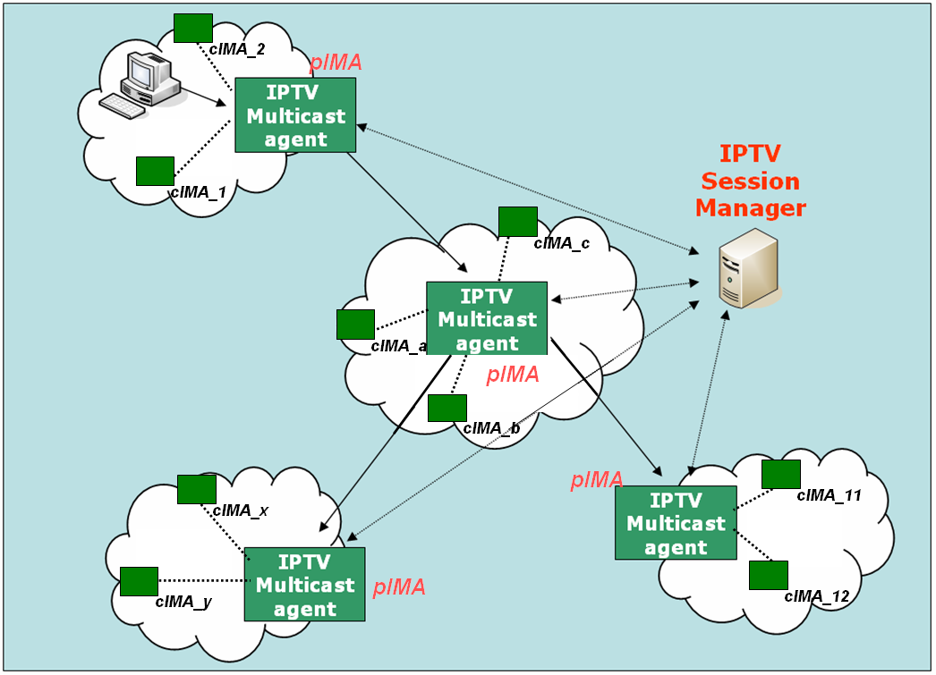
Fig. 5 Functional Architecture for Service Level Multicast Capabilities for IPTV

      - IPTV Session Manager (ISM)
ISM is involved in session configuration and maintenance for IPTV service flows. A single ISM can handle one or multiple sessions simultaneously, and it can provide the following functionalities:
- Session initialization: ISM allocates ISID (IPTV Session ID) for new session.
- Session release: Session can be released as needed.
- Session membership management
- Session status monitoring:
- report the status of data channel
- data throughput
- multicast protocol topology information gathering
- multicast protocol membership management
      - IPTV Multicast Agent ( IMA )
IMA constructs relayed multicast delivery path and forwards data along the constructed path from pIMA ( parent IPTV Multicast Agent ) and to cIMA ( child IPTV Multicast Agent). An MA consists of control module and data transport module. The main function of former is to establish relayed data delivery path and that of latter to setup data channel along the path constructed by control module and relay data through the channel. IMA performs the control functions to exchange control messages with other entity. Its major functions are as follows.
- Session join: each IMA contacts with Session Manager.
- Session leave: when an IMA wants leave the session, it gives notice to pIMAs and cIMAs
- Session maintenance: relay request and its response will be exchanged between the two IMAs periodically.
- Loop detection & avoidance
- Partitioning detection & recovering
- Parent switching
- IPTV Session status reporting
In order to perform service level multicast of streaming application for IPTV service, the functional box of service control can be described into few functional blocks in detail as shown in Fig. 8.
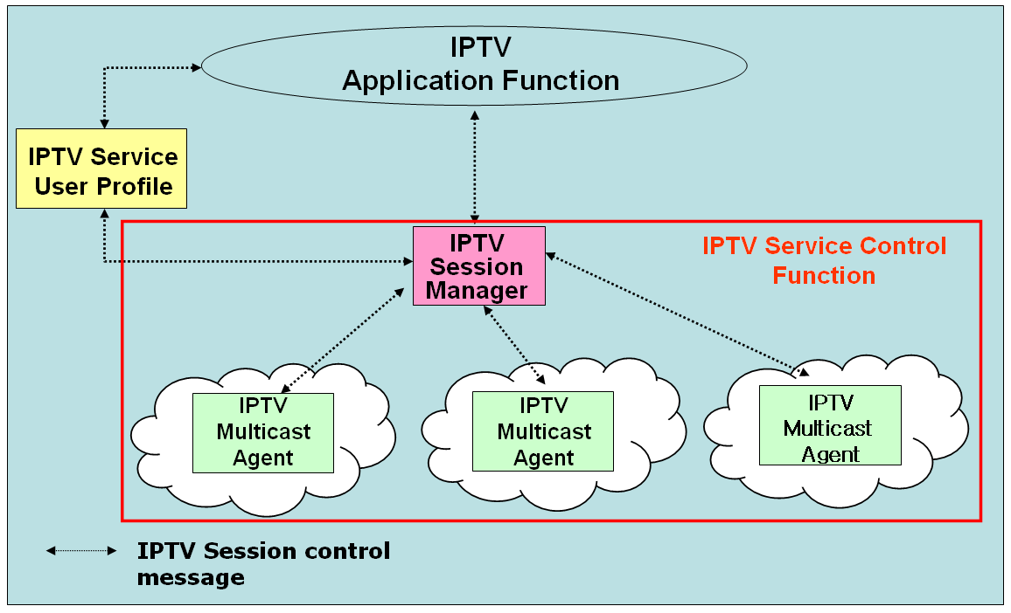
Fig. 6 Functional Blocks of IPTV Session Control for IPTV Application Services
  - High Availability requirements of IPTV multicast
[Editor’s note]: This subsection describes functional requirements for IPTV multicast High Availability issues. The result of discussion about C-498 should be included in this subsection

Following sections are based on document FGIPTV-C-0137, 401, 498 (LL#2).
The quality of IPTV service is more sensitive to network stability compare to other types of data services. In that sense, IPTV multicast network is recommended to provide capabilities to ensure sufficient availability for IPTV services.

Followings should be taken care as functional requirements for multicast availability:
- IPTV service is required to restore without service intervention in the event of multicast mechanism abnormalities.
- Multicast distribution trees are required to be restored dynamically in the event of multicast mechanism failures.
- Multicast system architecture and its components are required to be fully redundant in order to avoid a single point of failure affects the whole IPTV service.
- IPTV service contents are recommended to be distributed in a load balanced manner in order to utilize multicast links efficiently.
- Multicast system architecture is required to provide an admission control mechanism to manage multicast events.
[Editor’s note]: The terminologies used in the OD were not defined by WGs, so they might be modified or changed in future meeting.
  - QoS requirements of IPTV multicast
[Editor’s note]: This subsection describes functional requirements for supporting IPTV multicast QoS. We need explanatory text about multicast QoS in here.

Following sections are based on document FGIPTV-C-0137 (LL#2), C-534.
Followings should be taken care as functional requirements for supporting multicast QoS:
- IPTV network should support mean(s) for multicast traffic monitoring (including performance monitoring) and analysis for each service group.
- IPTV network should support differentiated handling of multicast traffic which requested QoS treatment. For differentiated handling of multicast traffic, congestion avoidance and congestion management mechanism are required because network congestion may cause quality degradation of IPTV service.
  - Congestion avoidance mechanism is recommended to prevent IPTV traffic from being dropped over other classes of traffic.
  - Congestion management mechanism is recommended to prioritize IPTV traffic over other classes of traffic.
- It is required to provide a certain level of QoS when delivering IPTV service traffic to IPTV users. Resource reservation is necessary to guarantee the QoS of IPTV multicast and congestion control is necessary to maintain the QoS of IPTV multicast. Resource reservation mechanism guarantees the multicast resource on multicast distribution trees by bounding various QoS parameters such as delay, jitter, loss, etc.
  - It is recommended to support resource pre-reservation mechanism for IPTV traffic. Pre-reserving mechanism is more efficient than dynamic resource reservation mechanism in that dynamic reservation mechanism needs to manage dynamic membership with many receivers. Moreover, pre-reserving mechanism is simple to control and maintain multicast resource.

  - Security requirements of IPTV multicast
[Editor’s note]: Multicast security is one of the most crucial issues in IPTV service. This subsection describes functional requirements for supporting IPTV multicast security. The result of discussion about C-498 should be included in this subsection.
[Editor’s note]: We need the review of the security requirement related with IPTV multicast by WG3.
[Editor’s note]: The terminologies used in the OD were not defined by WGs, so they might be modified or changed in future meeting.

Following sections are based on document FGIPTV-C-0137, 402, 498 (LL#2).
Multicast security is one of the most crucial issues in IPTV service such that it is required to provide security capabilities to protect IPTV multicast network from any malicious attempts caused by multicast security holes. Security itself is too diverse to break down to the specific multicast purpose; however functional requirements of multicast security for each network elements should be clearly defined and should provide capabilities along with the definitions.

- IPTV architecture is required to be robust against denial of service attacks targeting any multicast mechanisms.
- Multicast system architecture is required to provide a mechanism of multicast protocol adjacency authentication in order to establish a reliable peer.
- Multicast system architecture is required to provide an admission control mechanism to regulate any multicast events.
- Multicast system architecture is required to be independent of adjacent domain such that it shall not affect the adjacent multicast domain without permission.
- Multicast system architecture is required to provide a mechanism to check integrity of multicast contents before service delivery such that it prevents unauthorized contents from becoming the content source.

  - Interoperability requirement of IPTV multicast
[Editor’s note]: Internetworking is key issues for IPTV service popularity. This subsection describes functional requirements for IPTV interoperability including interoperability information, components, and features. Current description is so specific that we need general description related with interoperability requirement, appropriate contributions are needed.

Following sections are based on document FGIPTV-C-0400, FGIPTV-C-0135 (LL#5).
    - Definition of IPTV multicast interoperability
[Editor’s Note: In this section, we need to define the case and the reason that the interoperability of IPTV multicast is necessary.]
In IPTV markets, there will be various types of service providers; like IPTV transport provider, content provider, and contents aggregator. Each service provider need service combination of different type of service providers or need the clear contract with other service provider to get the quick service spreading. With such a clear internetworking contract amongst IPTV service providers, user can get any sources from content providers through the IPTV transport provider, and we can make IPTV service popular.

Definition of IPTV multicast interoperability
IPTV multicast interoperability is the exchange of IPTV service information amongst multicast based IPTV service providers. And to make the optimal contract and to provide the stable IPTV services amongst multicast based IPTV service providers, we need to define IPTV multicast interoperability functions. Detail IPTV multicast interoperability functions are described in 8.6.3. IPTV multicast interoperability point is shown in Fig. 5.

Fig. 7 IPTV multicast interoperability and IPTV service exchange point

Definition of IPTV Service Exchange Point
IPTV SEP (service exchange point) is identified as a reference point for handling the service brokering function between IPTV SPs enabling the optimal contract between IPTV SPs and providing the stable IPTV services amongst IPTV service providers. IPTV SEP can be located in any peering point, and the reference model example of IPTV SEP is shown in Fig. 5.

    - Definition of IPTV multicast interoperability information
IPTV service provider should provide capabilities for exchanging IPTV service information between different IPTV service providers for the interoperability. Especially, for IPTV multicast interoperability, the fundamental IPTV service information for each IPTV service provider should be announced to each SP. The purpose of IPTV service information exchange is to share the IPTV source information received from all IPTV service providers in multicast based IPTV service environment.
Followings should be taken care as the IPTV service information for IPTV multicast interoperability.
- ID of content aggregator or content provider
- source IP address block or some other way to approach to source
- multicast channel information
- Service Start & End time
- QoS, QoE information
- Traffic rate
- Video encoding rate
    - Requirements for IPTV multicast interoperability
[Editor’s note: Related Document: FGIPTV-C-0400, C-0136 (LL#6): Need further discussion, study and contribution.]

Multicast Addressing requirements for interoperability
The assignment of multicast address for each IPTV service channel should be agreed between different IPTV networks for interoperability. For instance, the multicast address for each IPTV service channel could be unique between different IPTV networks, or optionally changeable when entering other IPTV network.
In former case, it is recommended to use RFC 3180 range (GLOP addressing in 233/8) for interoperable multicast channels. Or IPTV SPs can use RFC 3138 range (Extended Assignments in 233/8) or RFC 2365 range (Administratively scoped block) if there is an agreement between peering IPTV SPs.
In latter case, each IPTV SP may have its own address policy and the policy of IPTV SP’s internal address may not match the inter-SP address policy. Therefore, each IPTV SP can translate the address from other IPTV SP to their internal address. The address translation is up to the IPTV SP’s policy.

Multicast Routing requirements for interoperability
It is recommended to use Multicast BGP between IPTV SPs for their multicast service. Multicast BGP is used to advertise multicast source routes for RPF check. Followings should be taken care as the peering policy that MBGP is used for multicast routing protocol between IPTV SPs.
- Advertising summarized prefixes if possible
- Recommended route filtering policy
  - default information
  - private addresses(RFC 1918 range)
  - all Multicast groups(224/4)
  - ISP’s unicast prefix range from peer ISP
- AS Path filtering
- Maximum prefix limit
- Md5 authentication between MBGP peers

When the MSDP is used between IPTV SPs for their multicast service, MSDP source active filter is necessary to prevent bogus (S, G) from sending. Followings should be taken care as the MSDP filtering policy that MBGP is used for multicast routing protocol between IPTV SPs.
- Recommended MSDP SA Filter (inbound/outbound)
  - Domain-local multicast applications
  - Auto-RP groups
  - Administratively scoped groups(239/8)
  - Default SSM range(232/8)
  - Loopback addresses(127/8)
  - Private addresses(RFC1918 range)

Security support functions for interoperability
IPTV service providers should protect their own IPTV network and IPTV source against the malicious traffic injection from peering SPs. This function should be implemented in IPTV multicast interoperability peering point. Followings should be taken care as the security policy for IPTV multicast interoperability.
- uRPF in peering interface
- Filtering about non-approved group range, source Block and non approved application port numbers
- PIM neighbour authentication
- TCP/ICMP message filtering for 224/4
- Protection against multicast source spoofing
- BSR message filtering
- Capability to limit the maximum number of multicast routing information

IPTV Service quality measurement and management functions for interoperability
[Editor’s note: Related Document: FGIPTV-C-0399 : Need further discussion, study and contribution.]
In IPTV multicast interoperability environment, IPTV service providers should provide the QoS monitoring function to handle the IPTV service quality measurement, and also IPTV service providers should provide the QoS management function to keep IPTV service in high quality.

  - Operation and management requirement of IPTV multicast
[Editor’s note]: This subsection describes the operation and management requirements of IPTV multicast. This subsection includes the user management, address management and service management issues
    - IPTV Multicast user management
[Editor’s note]: The user management is the starting point of IPTV service. This subsection describes the functional components for IPTV multicast user management issues including authentication and authorization.
Following sections are based on document FGIPTV-C-168 (LL#11).
As the current multicast protocol (i.e. IGMP) does not consider Multicast user authentication and authorization, it is requested a further development these issues to support IPTV services efficiently.
Multicast User authentication function controls the authority for users to receive multicast flows. And through authentication of multicast users, the network can distinguish legal multicast users from the illegal ones and then distribute the multicast traffic to the reasonable receivers. Following procedures should be supported.
- When a user initiates a multicast “join” request to join a certain multicast group with an account, the duplication point should not accept the request and make him join the group at once, it should be sent the request to the authentication point.
- The authentication point inquires the account information database and returns the result to multicast duplication point. The value of the user’s multicast property in the account should be set by the service layer system.
- According to the authentication result returned from the authentication point, the Multicast duplication Point should decide whether it allow the user to join the group or not. If allow the user to join the group, the duplication will add it to distribution table. Whereas it will refuse the user to join the group.
Fig. 8 Functional components for Multicast user management

    - IPTV multicast address management
[Editor’s note]: To provide IPTV service be popular and interoperated with other IPTV service providers, we need to handle the IPTV multicast address management. This section describes the IPTV multicast address usage rules, the issue of multicast address transition, and the control procedure of multicast address.
Related Following sections are based on document FGIPTV-C-157 (LL#8), C-137(LL#2)
According to IANA rule, the addresses ranging from 224.0.0.0 to 239.255.255.255 belong to IP multicast address. As the addresses from 224.0.0.1 to 224.0.1.255 are distributed to the specific protocols and implementations, the addresses from 239.0.0.0 to239.255.255.255 can only be used in the private areas. Therefore, several hundred millions of multicast addresses from 224.0.2.0 to 238.255.255.255 can be used in the internet. As one of important resources, these multicast addresses, should be managed effectively.
IPTV multicast functions should be support of interactive control aspects.
      - IP Multicast Address Transition
When deploying IPTV broadcasting services, carriers often use one multicast group address representing an IPTV channel. Unlike the unicast addresses, multicast addresses are not distributed depending on different countries, areas and carries all over the world. Therefore, during the operating of IPTV broadcasting service, the corresponding relationship between IPTV channel and multicast address can be overlapping or conflicting among different carriers or different service areas of one carrier. As Fig. 1 shows, carrier A and carrier B want to interconnect their IPTV direct broadcasting services; or Carrier B created local IPTV broadcasting service platform in service areas C and D , where the local carriers should interconnect some broadcasting service sources. With regard to these IPTV service traffic which cross multiple multicast bearer domains, IPTV MST (multicast service stream transition) needs to be deployed at the edge of each bearer network domain to check the multicast service traffic from other domains. If the multicast address of IPTV service stream is conflicting to the multicast address planning of local domain, the multicast address of IPTV stream coming from other domains should be changed before entering local domain.
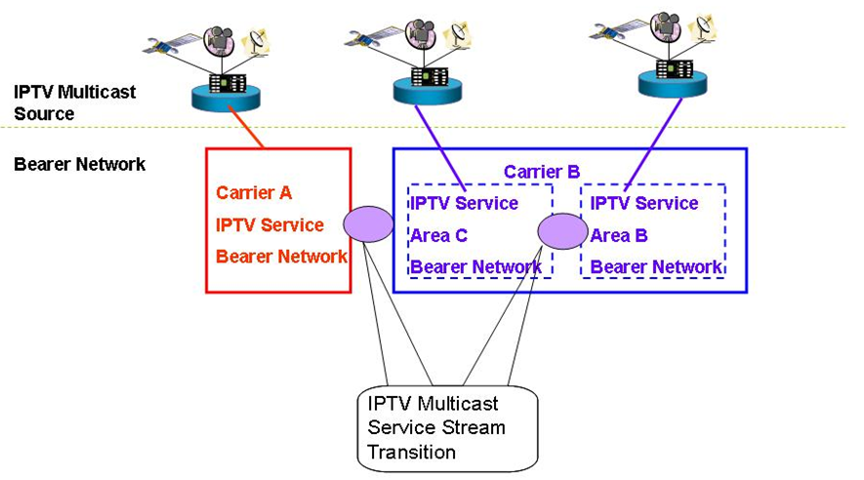
Fig. 9 IPTV Multicast Address Transition
      - The Control of Users’ Multicast Address
In order to control the development of these multicast services on carrier’s network and avoid impact on carriers’ IPTV broadcasting services, carriers can deploy multicast service controller to manage the distribution of multicast address uniformly. However, as for the multicast application without registration, carriers will restrict the usage of these multicast addresses at the access point of IPTV network. The procedures of applying for multicast service and multicast address are as follows and shown as Fig. 3.
1. In order to carry out services based upon multicast address users should arrange the inquiry and registration on the PORTAL of carrier-provided Multicast Address and Service Control Platform.
2. The self-service system check the situation of this multicast address from multicast address policy controller
3. If this multicast address is available, users will be told that they are allowed to use it.
4. At the same time, multicast address policy controller sends policies to the access point to allow the multicast services get access.
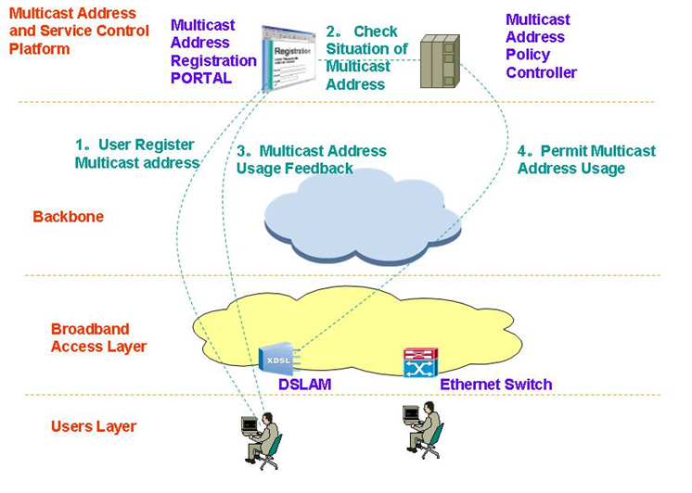
Fig. 10 Control Procedure of Multicast Address
    - IPTV multicast service management
[Editor’s note]: This subsection describes the IPTV multicast service management requirements including monitoring feature. We need many contributions to accomplish this subsection.
- IPTV multicast solution
[Editor’s note]: According to Ch. 6 ‘IPTV multicast scenario’, various IPTV multicast solutions can be described in this section including overlay multicast, and so on.
  - Pure IP multicast-based IPTV service delivery solution
Figure 11 shows the concept of pure IP multicast based IPTV service delivery solution.
In this scheme, each member registers IP multicast group by exchanging IGMPv.x messages with its access routers; and then each IP multicast router constructs IP multicast tree by exchanging multicast routing protocol messages; finally data from source flows according to the multicast tree from source to each receivers.
Because ISP owns and manages Multicast routers, ISP can tightly manage the communication.

Figure 11 – Data distribution scheme with pure IP multicast

  - Server-based IPTV service delivery solution
Figure 12 shows the concept of replicated-unicast based IPTV service delivery solution.
In this scheme, ISP puts a media server or server pool somewhere; each member connects media server or server pool; then the media server sends data to every receiver replicatively.
Because ISP or content provider (CP) owns and manages media server, ISP can tightly manage the communication; but because media server cannot support infinite number of receivers, the size of the group is tightly bounded by the performance of media server or server pool as well as server-side network bandwidth.
Figure 12 – Data distribution scheme with replicated unicast

  - CDN-based IPTV service delivery solution
Figure shows the concept of CDN-based IPTV service delivery solution.
In this scheme, ISP pre-installs CDN servers in an appropriate place; each receiver finds and then connects the nearest CDN server. Then multimedia streams from source are distributed to each receiver along the data delivery path of CDN servers.
Because ISP or content provider (CP) owns and manages CDN servers, ISP can tightly manage the communication; but because ISP cannot install CDN servers infinitely, the number of installed CDN servers bounds the size of the group tightly.

Figure 13 – Data distribution scheme with CDN

  - P2P-based IPTV service delivery solution
Figure 14 shows the concept of P2P-based IPTV service delivery solution.
In this scheme, each end-node can be both a media producer as well as a media consumer. The way of communications is as follows; each node discovers its peers and then connects them; each node can exchange media between themselves.
Because P2P model does not want to have ISP’s censorship, this model usually does not involve node of ISP’s. Although the size of group is not logically bounded, it may not be adequate to distribute contemporary media. To improve data receiving, each node tries to finds more peers as possible.

Figure 14 – Data distribution scheme with P2P

  - Overlay multicast-based IPTV service delivery solution
Figure and Figure 16show a brief concept of overlay multicast-based IPTV service delivery solution. In overlay multicast mechanism, special overlay nodes emulate the functions of IP multicast router’s; such as multicast data tree configuration, multicast data forwarding etc.
In this scheme, each overlay node constructs multicast data delivery path from sender to group dynamically as naïve IP multicast router does. Along the constructed path, each overlay node forwards data, which comes from its upstream node, to its downstream nodes. The size of group is not logically bounded, and it is adequate to distribute contemporary media.
The overlay node which substitutes IP multicast router may form a hardware box, a server, or an end-system; the formation is a deployment or implementation issue. Figure shows an overlay multicast scheme without ISP’s participation.

Figure 15 – Data distribution scheme with Overlay Multicast without ISP

Figure 16 shows an overlay multicast scheme with ISP’s participation.
Figure 16 – Data distribution scheme with Overlay Multicast with ISP

    - Overlay IPTV Multicast Control
Following sections are based on document FGIPTV-C-227 (LL#10), C-595.
Although IP multicast has not deployed globally, a lot of local networks have already been equipped with IP multicast transport. For example, Ethernet-based LANs and private networks such as corporate and campus networks substantially provide the multicast transport capability within their local subnet or administrative domains. Recognizing these observations, there is a crucial need to use an alternative multicast delivery scheme for IPTV service. service lev Overlay multicast for IPTV service will be an alternative solution to provide actually clinging to replicate unicast method on servers. It makes good use of existing unicast, multicast and/or multicast tunneling schemes for various applications in IPTV (e.g., various types of group applications).
The overlay service multicast control function for IPTV provides a session control to multicast capability over physical transport network. To support the session control function for overlay multicast capability. Fig. 9 shows architecture for “Overlay IPTV Service Multicast Functions” for IPTV service.
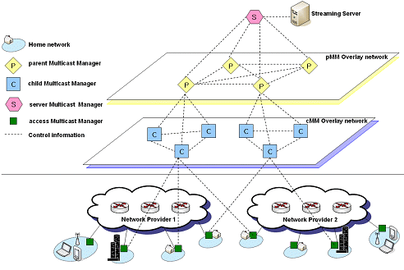
Fig. 17 Functional Structure of Overlay IPTV Multicast Control

      - Control in Overlay IPTV Multicast
The overlay IPTV multicast can use diverse control mechanisms for constructing different multicast trees depending on IPTV application parameters or application class. The control mechanism supports to change multicast tree structure depending on application requirements, different regions of network conditions, native multicast support and multicast group membership. The overlay IPTV multicast supports efficient routing and resource usage by overlay multicast control. A changing of multicast tree to deliver IPTV service may be used network resource unnecessarily. If possible, the overlay IPTV multicast use existing multicast tree and control mechanism without changing.

      - Group Membership Management
The group membership for overlay IPTV multicast considers group size, number of group’s member and rate of group membership change. It provides group membership control and group partitioning.
- Group Membership Control: This is a generic group membership control of overlay IPTV multicast. It is a function that provides mechanisms to join and leave group for overlay IPTV multicast. It may additionally provide functions to create or maintain the multicast groups.
- Group Partitioning: This is to optimize the transmission efficiency by sub-grouping the groups and mapping each sub-group to underlying networks. In the following, two optimization approaches to realize this group partitioning are differentiated and described.
- Global group partitioning: The Global group partitioning optimizes the resource usage of local network. If a multicast group in local network is crowded, the group need sub-grouping.
- Server group partitioning: The Server group partitioning optimized the resource usage of server network providing IPTV services. This partitioning is to consider the processing capacity of the server.
      - Admission Control for QoS for overlay IPTV Multicast
In order to support QoS for IPTV services in overlay multicast network, overlay multicast node will perform admission control through interaction between overlay multicast node and resource control function of physical internet transport network.
      - Security for Overlay IPTV Multicast
Overlay IPTV multicast uses shared network resource and multiple distributed overlay resources to transport data. When a user requests IPTV service, security process needs for IPTV overlay multicast function.
Overlay multicast confronts with various vulnerabilities and risks that impede from being widely deployed in mission critical business systems and applications. There are three important security challenges for the overlay network service model: Confidentiality and Integrity, Authenticity, and Availability. These three important security challenges can be classified with some properties for architectures and algorithms for building secure and scaleable information dissemination services on wide area overlay networks.

      - Node functions for IPTV overlay routing
An overlay multicast node function will be designated to perform routing and session control for IPTV services. The designated node has full knowledge of other multicast node in the session, and computes the multicast tree according to its current snapshot of the available bandwidth at these multicast nodes. In order to keep the updated information on multicast nodes, state updates occur periodically via broadcasting among all multicast nodes.
The overlay multicast node constructs and updates multicast tree from sender to group dynamically, and collects network information and exchange the information with neighbour overlay multicast node. Each IPTV multicast node manages some informations related to network resources underlying network from resource control function.
An overlay multicast node will provide few informations to provide the requirements for overlay multicast resource control.
- Session ID Assignment: The overlay nodes arewill perform a identification function with session ID. The session ID is unique according to region or overlay IPTV service etc.
- IPTV overlay multicast management function: The overlay node will collect and stores informations on overlay networking management, and selects neighbour overlay nodes to exchange the information.
    - QoS Control at Overlay Multicast Network for IPTV Services
      - Functional Position of Resource Control
If the information on IPTV transport networks is directly collected and managed by IPTV overlay nodes to establish overlay transport route and configuration trees, it will be serious burden to handle overheads in IPTV overlay networks. It is assumed that resource control functions for IPTV overlay network is located between IPTV overlay network and physical transport network, and it performs collection of information about network resource and provides QoS control to transport network.
As shown in Figure 1, it is necessary that resource control function is introduced to provide interface function for IPTV overlay multicast QoS control between physical transport and IPTV overlay network. This function performs collection and management of transport network resource (e.g., DiffServ) via specified interface (e.g. SNMP). And overlay network nodes create tree topology and optimized route to support QoS requirements of IPTV users through information collected by Resource Control function.
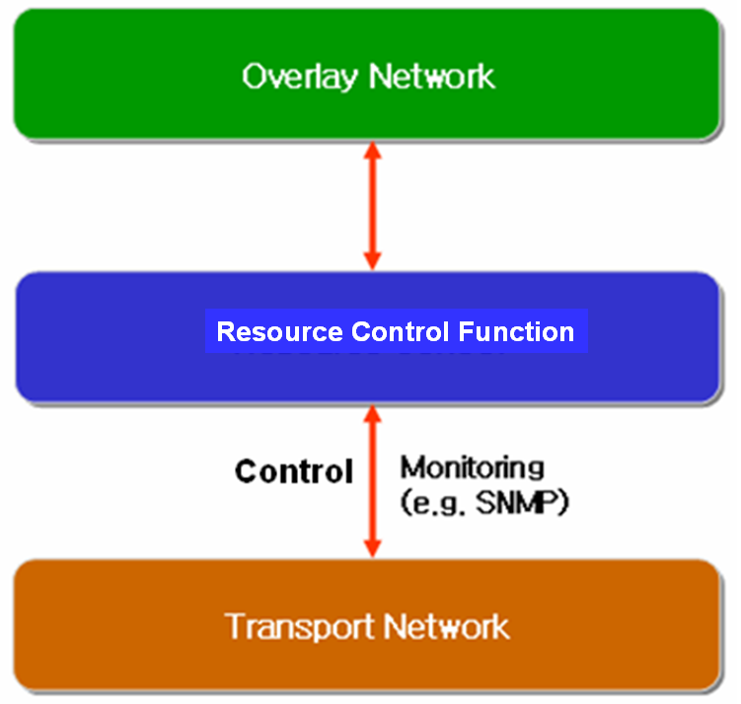
Fig. 18 Resource Control Architecture in IPTV Overlay Network

      - Resource Control Function
The requirements for resource control are as follows
- The Resource Control Function will collect information for resource control from transport network with periodic or aperiodic. According to initiation of overlay network nodes, Resource Control function collects data for resource and QoS control.
- Resource control should be able to communicate with Resource Control Function in heterogeneous or other network.
- The following information collected is transferred to overlay network, and then overlay network creates route and optimized tree to support QoS for IPTV overlay network.
- Link State Information: it includes available bandwidth information, delay, packet loss and jitter of link.
- Routing Information: it includes routing algorithm that is used to transport network equipments and routing information of them (e.g. neighbour routing information, routing table .etc)
- Multicast Traffic Information: it includes multicast traffic parameters (e.g. channel information, type of service, user profile, source content information) per channel or session of IPTV multicast.

      - Resource Control Function for Overlay QoS Control in Heterogeneous Networks.

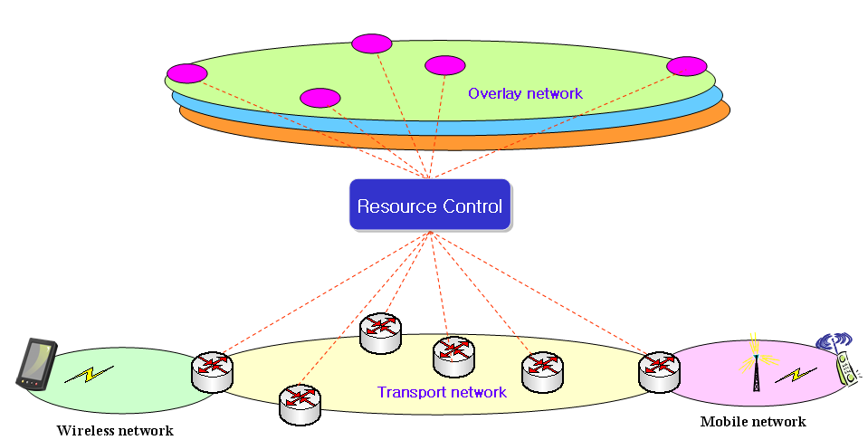

Fig. 19 Application of Resource Control Function in Heterogeneous Networks for Overlay
QoS Control

The Session Manager configure routes among IPTV overlay network nodes and optimize tree topology for multicast sessions according to information of Resource Control Function. Figure 2 shows an application of Resource Control Function for wired and wireless/mobile networks.
Figure 3 shows an example for application of Resource Control Function for different service providers. Because of sharing the related service information or network information in terms of SLA, optimal sessions for IPTV overlay multicast will be configured in accordance with the information collected by Resource Control Function, and the sessions will be optimized with QoS requirements of IPTV users.
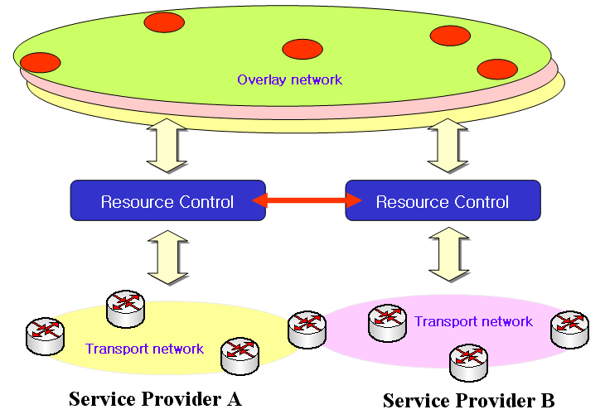
Fig. 20 Application of the Resource Control Functions in different multiple ISPs for Overlay QoS Control
- Other aspects
[Editor’s note]: This section is reserved to invite future contributions, which can address other aspects of IPTV Multicast, not a specific issue to each chapter.

________________

