INTERNATIONAL TELECOMMUNICATION UNION |  |  |  | Focus Group On IPTV
TELECOMMUNICATION  STANDARDIZATION SECTOR  STUDY PERIOD 2005-2008 |  |  | FG IPTV-DOC-0050
 |  |  | English only
WG(s): 4 |  | 2nd FG IPTV meeting:  Busan, 16 – 20 October 2006
OUTPUT DOCUMENT
Source: | WG 4 Leader
Title: | Living list: Multicasting aspect of IPTV services
This document contains living list issues following the agreement taken at the July meeting based on Terms of References and input documents.
The following living list structure are intended to progress the work on WG4 related deliverables.
A. List of Items
- Title of item
B. Description of each item
- Title
- Description of the problem and possible solutions
- List of documents addressing the issue
- Intermediate agreements
No. | Title of Living List Items
1 | Multicast Feature of IPTV Bearer Network
2 | Functional Requirements for IPTV multicast network
3 | Functional requirements for overlay multicast based IPTV media delivery system
4 | Functional requirements of Overlay Multicast Service Control Architecture
5 | Functional Requirement for interoperability amongst IPTV service Providers
6 | Functional Requirements for interoperability amongst IPTV multicast service providers
7 | Functional Requirements of Multicast Control
8 | Functional Requirements for Multicast Address Management
9 | Hierarchical Architecture for Overlay IPTV Service Multicast
10 | Requirements for IPTV Network Node
11 | Procedure of IPTV multicast user authentication and authorization

Living List #Multicast-1 of WG4

Area: Functional Requirements of Multicasting
Issues: Multicast Feature of IPTV Bearer Network
Related Document: FGIPTV-C-165
Background:
The multicast service traffic mainly comes from multicast service source deployed in backbone network area. The multicast capability which the backbone network supports has great effect to the development of IPTV services. It is requested to take into consideration that how to develop multicasting features on the bearer network with various multicast capabilities supporting IPTV services.
Study Issues:
To decrease the dependency of IPTV service with the IP bearer network, multicast feature on IPTV bearer network should be developed. Following two scenarios would be taken consideration of this study:
  - Scenario 1 (IPTV bearer network which has weak capability of supporting multicast protocol): As for the carrier whose bearer network has weak capability of supporting multicast protocol, he should construct the multicast service distribution tree in the backbone network from multicast service source to backbone network edge in order to deploy his IPTV services rapidly. Generally, the location of IPTV multicast source and the number of multicast channel are fixed, however, because the backbone network with weak multicast routing capability, the following optimization proposal can be adopted. The equipment on IPTV bearer network should support the static configuration of multicast distribution tree. The multicast distribution tree from multicast source to backbone network edge can be configured manually.
- Scenario 2 (Reduce dynamic multicast protocol effect to IPTV service): Normally, multicast distribution tree is created via multicast routing protocol, which running should be adaptive to the changes of backbone network unicast routing. However, when IPTV service is delivered by the multicast routing table which is created by dynamic multicast protocol, the multicast distribution tree will shrink to multicast source if one channel does not have audiences for a long time. In the other words, IPTV broadcasting service can not reach the subscribers when new audiences join in, because users’ IPTV channel application will be sent to IPTV broadcasting source hop-by-hop, then the IPTV broadcasting service traffic will be transferred to the edge of backbone network, which delays the IPTV channels switching time greatly. Hereby, the following optimization proposal can be used to solve this problem. To some popular channels, no matter the terminal users want to watch this channel or not, the edge node of backbone network sends IPTV service demands within a time scale, so that we can guarantee the service traffic of this channel can be delivered to the edge of backbone network and shorten the deferral of users’ channel switching.
Living List #Multicast-2 of WG4

Area: Functional Requirements of Multicast, Architecture
Issues: Functional Requirements for IPTV multicast network
Related Document: FGIPTV-C-0137
Background:
To Deploy IPTV multicast network as nation wide scale and to provide the stable IPTV services amongst multicast service providers, there are so many deployment issues. And we need the standardization activity about stable and robust multicast network architecture. To solve that issues and get the optimal multicast network architecture, in this document, we are going to propose the requirements and reference model for the IPTV multicast network architecture based on any multicast test experiences and test results.

Study Issues:
Study for functional requirements for IPTV multicast network
- Topology Requirements
  - Optimal RP Positioning
Location of RP not only affects IPTV service delay, but also network burden. Optimal RP positioning depends upon SPs’ network topology and their multicast traffic path. One of main reasons to apply multicast is to reduce backbone traffic produced by redundant customers’ request, so it is advantageous to locate RP near the source compare to locate it somewhere in middle of backbone.
    - Loop free, Delay/Jitter independent, stability guarantee topology
    - Optimal position to exchange SA information amongst multicast service provider
  - Optimal RP redundancy mechanism to consider Service recovery time in RP failure, Operation issues, and feasibility issues including Vendor status
RP redundancy should be guaranteed to improve IPTV service stability in case of RP failure. SPs need to design their RPs not only to maximize service stability, but also to minimize service recover time during RP failure.
  - Multicast Traffic Load balancing Requirements
Multicast distribution tree is always established by following the interface where the “JOIN” message received. When multicast routers receive a join message, multicast routing protocol normally send its join message to one of the multicast interfaces. If some groups have the same source, among multiple multicast interfaces, only one of them is selected and sends the join. In an ECMP environment, all multicast interfaces cannot be used to distribute multicast traffic; instead only single interface is used. To load sharing the traffic, it is best to distribute multicast source for different groups, but it should be considered with SPs’ design philosophy.
- Availability Requirements
  - Multicast Service failure recovery time: guarantee non stop forwarding for multicast traffic
  - Link/Node failure recovery time: guarantee non stop forwarding for multicast traffic
  - Guideline for High availability feature
    - Multicast Traffic ready condition for whole PIM links for IPTV service can be considered
    - Non stop forwarding features for multicast traffic; PIM, IGP, BGP Graceful restart, and No service interruption from PIM neighbor cutoff
    - Fully redundant system architecture & topology
    - Robust network against Any DoS attacks
    - In service software upgrade; By ISSU feature, multicast service should not be affected even in a maintenance period such as software upgrade.
- Multicast QoS Requirements
  - Perfect provisioning for multicast traffic
  - Differentiated service for multicast traffic
    - Stern traffic Classification & marking, PHB
  - Multicast traffic Monitoring & analysis for each service group
  - Performance monitoring for each service group
- Multicast security Requirements
  - Security is the most critical issue for multicast network deployment, so we need very stern multicast requirements. In this section, we just describe the multicast security requirements based on only network level not application level.
  - RP security
    - RP: Group range filtering
      - All multicast groups send join messages toward RP in a domain by default. When configuring RP, it is necessary to designate specific group addresses so prevent unwanted groups from sending join messages to alleviate RP overload.
      - For example, except approved GLOP address for KT IPTV service (: 233.18.158.0/24), whole other group range should be filtered in RP.
    - PIM register message filtering: only approved source can register in RP
      - Every first hop router sends source registration toward RP once they receive multicast packet from any source. RP needs to apply PIM register message filter so as to prevent unwanted sources from sending by bogus sources.
    - MSDP SA filter: Limitation for SA information per MDSP peer, per source, per instance
      - MSDP SA messages contain source and group information for RPs in PIM-SM domains, and they exchange SA messages without filtering them for specific source or group addresses by default. MSDP SA filter is necessary to prevent bogus (S, G) from sending.
  - PIM router security
    - Multicast Route limit : To protect against any kind of Worm attack via multicast routing update
    - BSR message filtering
      - If RP selection is selected by a static way, it is necessary to block bootstrap messages to prevent RP from overriding the information. Fault RP information can be inserted and spread into the network by malicious users, and results in source interception or service failure. If SP’s domain does not use bootstrap messages to select RP, it is recommended to block bootstrap messages in multicast routers.
    - PIM authentication among each neighbours
      - The definition and purpose of this feature is the same as that of IGP/BGP authentication. It is highly recommended to block PIM neighborship facing customer interfaces to prevent unwanted information from spreading out.
    - TCP/ICMP message filtering for 224/4
  - Last mile PIM router
      - Filtering all multicast traffic except approved IGMP join messages.
        - Protection against multicast source spoofing
        - In the last mile, it is necessary to apply filtering to block spoofed customer IP, multicast sources sent from customer side, and PIM neighborship with customer facing interface.

Living List #Multicast-3 of WG4

Area: Functional Requirements of Multicast
Issues: Functional Requirements for overlay multicast based IPTV media delivery system
Related Document: FGIPTV-C-0221
Background:
To deliver IPTV media, native IP multicast mechanism is the best solution. Because IP multicast router copies IPTV media data and then forwards them to destined group, native IP multicast mechanism shows high performance by reserving resources of network’s as well as media sender’s. But native IP multicast highly depends on the condition of underlying network, which means to make native IP multicast possible, all the routers must be changed into multicast-enabled; and that means ISP mush pay for the expense. Not alone the matter of cost, several problems prevent native IP multicast mechanism from being fully deployed in the Internet.
Therefore some well-known alternative multicast mechanisms are emerged; which are CDN, P2P, and overlay multicast mechanism.
In an overlay multicast mechanism, each node constructs multicast data delivery path from sender to group dynamically as native IP multicast router does. Along the constructed path, each node forwards media, which arrives from its upstream node, to its downstream nodes. The size of group is not logically bounded, and it is adequate to distribute contemporary media.
There wasn’t enough consideration on overlay multicast mechanism in the last meeting, it is necessary to consider "overlay multicast mechanism" as one of the possible IPTV media delivery mechanisms.

Study Issues:
Study for functional requirements for overlay multicast based IPTV media delivery system to develop a standard on “Overlay multicast based IPTV media delivery system,”
- Initialization
- Join
- Leave
- Release (or Termination)
- Maintenance
- Monitoring

Living List #Multicast-4 of WG4

Area: Functional Requirements of Multicasting
Title: Functional requirements of Overlay Multicast Service Control Architecture
Related Document: FGIPTV-C-228
Background:
To date the limitations of transport capability in existing networks are often blamed for poor end-to-end performance and prolonged connectivity interruptions for application services requesting higher capabilities. For well provisioning of IPTV services with higher capability, it needs another approach to lead their work focusing on the end-systems, overlooking the design and development of new solutions for IPTV service providers. Therefore, intelligent features for IPTV application services are necessarily provided in overlay IPTV service networking.
Study Issues:
Study on requirements of IPTV interactive control system needed and followings are proposed example of requirements.
Based on the consideration, it is necessary to aim at building and dynamically configuring IPTV service networking with intelligent features. At some case some adaptive configuring features will be very helpful to provide user controllable IPTV services. To provide these flexibilities and intelligent features to IPTV service users, an overlay service control networking for IPTV will have to consider the following issues:
- For each new host that joins the network, a new connection that connects it to an IPTV overlay networking control point is created, and the topology is then updated with new channel and routing tables are re-computed. For more dynamic running on IPTV service networking in transport network, some IPTV service features will be interacted with each other to be connected to the other appropriate IPTV service control point.
- the configuration of the particular (or virtual) mesh, among allowed hosts, that connects all hosts in order to satisfy the best approach in IPTV service;
- QoS-capable IPTV service is very important features to provide a tailored diverse IPTV application services that could be differentiated in terms of performance and QoS, accounting, security and privacy.
- Application-aware networking for multiple IPTV applications is requested to reflect its application service specific features.
- Provision of active and intelligent service networking features for adaptive users requirements of IPTV group users.
Living List #Multicast-5 of WG4

Area: Functional Requirements of Multicast
Issues: Functional Requirement for interoperability amongst IPTV service Providers
Related Document: FGIPTV-C-0135
Background:
To make the optimal contract amongst IPTV SPs and to provide the stable IPTV services amongst multicast service providers, we need the standardization activity defining the features of IPTV service exchange point to handle the service broking function amongst IPTV SPs. In this section, we are going to define the IPTV SEP (service exchange point) and SEP reference model as interoperability perspective and define essential requirements of IPTV SEP
Study Issues:
Study for functional requirements for interoperability amongst IPTV service Providers
- Definition of IPTV Service exchange point
  - Definition and reference model of IPTV service exchange point
    - Definition of IPTV SEP
To make the optimal contract between IPTV SPs and to provide the stable IPTV services amongst IPTV service providers, IPTV SEP is handling the service broking function between IPTV SPs.
    - Reference model example of IPTV SEP
  - Location of IPTV SEP
    - IPTV SEP can be located in any peering point, and can be implemented as router line card, like SBC (Session Border Controller) type.
  - Definition of IPTV information registry in IPTV SEP
    - For IPTV service interoperability, the fundamental information for each IPTV service provider should be announced. This information can be summarized as following information registry.
      - ID of content aggregator or video provider (BGP AS number is preferred)
      - source IP address block
      - multicast IP address block (applied for only multicast stream) block
      - Descriptor
      - Transport protocol(UDP or TCP)
      - Port number
      - Authentication key
      - URL for session announcement (https:// )
    - The purpose of the IPTV information Registry is to define the IPTV source information from all IPTV providers.
    - Additionally, the session announcement should be defined for the multicast transmission. The session announcement URL is defined in the IPTV information Registry. Each IPTV provider should announce the session announcement information for all multicast streams.
    - Session announcement information includes following fields.
- ID of the content aggregator
- Descriptor
- Start time
- End Time
- Multicast address
- Authentication key
    - IPTV Address Registry and Session Announcement Server

- Function of IPTV SEP
  - Access Privileges and authentication function
  - Resource Usage, CAC support
  - QoS and Quality monitoring function
  - Inter-domain address translation and Control of multicast injection
  - VoD Admission Control Support
  - Security Support function
  - Policing of Multicast traffic and Unicast traffic
  - Policy exchange feature
Living List #Multicast-6 of WG4

Area: Functional Requirements of Multicast
Issues: Functional Requirements for interoperability amongst IPTV multicast service providers
Related Document: FGIPTV-C-0136
Background:
To make the optimal contract amongst multicast based IPTV SPs and to provide the stable IPTV services amongst multicast service providers, we need the standardization activity defining the requirements for interoperability amongst IPTV multicast service providers. In this section, we are going to define the detailed functional interoperability requirements for inter-IPTV AS multicast transmission.
Study Issues:
Study for functional requirements for interoperability amongst IPTV multicast service Providers
- Addressing requirements
  - For interoperable multicast channels, it is recommended to use RFC 3180 range (GLOP addressing in 233/8). ISPs can use RFC 3138 range(Extended Assignments in 233/8) or RFC 2365 range(Administratively scoped block) if there is an agreement between peering ISPs
- Routing policy for interoperability
  - MBGP policy
    - Advertising summarized prefixes if possible
    - Recommended route filtering policy
- default information
- private addresses(RFC 1918 range)
- all Multicast groups(224/4)
- ISP’s unicast prefix range from peer ISP
    - AS Path filtering
    - Maximum prefix limit
    - md5 authentication between MBGP peers
  - MSDP policy
    - MSDP allows multicast sources for a group to be known to all rendezvous points (RPs) in different domains by way of MSDP SA (Source Active) messages. MSDP SA messages contain source and group information for RPs in PIM-SM domains, and they exchange SA messages without filtering them for specific source or group addresses by default. MSDP SA filter is necessary to prevent bogus (S, G) from sending.
    - Recommended MSDP SA Filter (inbound/outbound)
- Domain-local multicast applications
- Auto-RP groups
- Administratively scoped groups(239/8)
- Default SSM range(232/8)
- Loopback addresses(127/8)
- Private addresses(RFC1918 range)
- Unicast traffic policy for interoperability
  - ISPs can send multicast and unicast traffic simultaneously over the same links or different links. Unicast routing table is used for multicast RPF check. Multicast traffic should not reject due to conflict between unicast routing policy and multicast routing policy. Load-balancing mechanism is not exactly same between unicast and multicast. So SPs should establish the traffic/link policy considering these mechanisms.
- Security Policy over multicast exchange peers for interoperability
  - uRPF in exchange peer interface
  - Filtering about non-approved group range, source Block and non-approved application port numbers
  - PIM authentication
  - TCP/ICMP message filtering for 224/4
  - Protection against multicast source spoofing
  - BSR message filtering
  - Multicast Route limit
- End to End multicast QoS guarantee policy for interoperability
  - Inbound/outbound QoS policy
    - Many ISPs which provide multicast services have partial or full deployment of Diffserv implementations in their networks today, either across the entire network or minimally on the edge of the network. In inter-AS environments also, they should provide a set of QoS policy such as traffic classification, rewriting and scheduling rules for reliable reliably transport of the multicast traffic.
  - Policing of multicast & unicast traffic based on contract
    - ISPs should provide a set of policing mechanisms which could be configured on the inter-AS links to ensure that traffic routed through the links does not exceed the bandwidth negotiated among them.
- End to End High Availability guarantee policy for interoperability
- Billing considerations for interoperability
- Content protection for interoperability

Living List #Multicast-7 of WG4

Area: Functional Requirements of Multicasting
Issues: Functional Requirements of Multicast Control
Related Document: FGIPTV-C-197
Background:
Multicast functionality is required to make efficient use of network bandwidth resources when delivering broadcast content. Video traffic encapsulated in IP multicast packets will probably be flooded within VLAN in a non- optimized L2 network. The target in IPTV multicast traffic delivery is to support multicast optimization by controlling the flooding of Ethernet multicast frames by using IGMP proxy in intermediate (L2) devices especially Access Node which is the closest (First Mile) to the end user.
The desired goal is to support multicast optimization by controlling the flooding of Ethernet multicast frames by making use of IGMP protocol.
Study Issues:
A study of IGMP proxy function supported in access node (or other network node in bearer network where multicast replicated to users) could be requested. Access node performs the router portion of the IGMP protocol on its user interfaces and the host portion of the IGMP protocol on its network interfaces. Thus, access node (or other network node in bearer network where multicast replicated to users) can:
- Reduce the number of messages from numerous users to network
- Improve bandwidth efficiency in multicast traffic
- Secure multicast delivery to undesired end users
- Ensure availability of multicast video service to end users by reduce message loss. Specifically, for example, some messages are lost due to the packet loss of bearer network, or load of service router, or other possible reasons.
One of the concerns is that doing IGMP proxy in access node (or other network node in bearer network where multicast replicated to users) instead of snooping is that IGMP proxy solution may lead to an issue that subscriber information is terminated in access node and does not go to service edge. But in multi-service multi-edge architecture, the access node, which is the access point of multiple services, will be the best point to collect multicast service detail information instead of upper network devices.
As video service need much bandwidth and also should be a service with high service quality. It is proposed that access node should implement traffic control for high priority multicast traffic to ensure the QOS of multicast. Specifically, it is proposed that following functions are supported in user access line:
- Total Multicast Bandwidth: the access node should be able to control on total bandwidth of a user port that can be used for multicast service;
- Current Available Bandwidth: the access node should be able to aware of current available bandwidth that can be used for multicast service, specifically, can be total multicast bandwidth – consumed multicast bandwidth;
- Connection Admission Control: When end user subscribes to a multicast stream, access node will perform CAC based on the status of resources.
Living List #Multicast-8 of WG4

Area: Functional Requirements of Multicasting
Title: Functional Requirements for Multicast Address Management
Related Document: FGIPTV-C-157
Background:
According to IANA rule, the addresses ranging from 224.0.0.0 to 239.255.255.255 belong to IP multicast address. As the addresses from 224.0.0.1 to 224.0.1.255 are distributed to the specific protocols and implementations, the addresses from 239.0.0.0 to239.255.255.255 can only be used in the private areas. Therefore, several hundred millions of multicast addresses from 224.0.2.0 to 238.255.255.255 can be used in the internet. As one of important resources, these multicast addresses, should be managed effectively.
Study Issues:
IPTV Network requirements need study in interactive control aspects and followings are proposed example of requirements.
1. IP Multicast Address Transition for Cross- domain IPTV Broadcasting Service Stream
When deploying IPTV broadcasting services, carriers often use one multicast group address representing an IPTV channel. Unlike the unicast addresses, multicast addresses are not distributed depending on different countries, areas and carries all over the world. Therefore, during the operating of IPTV broadcasting service, the corresponding relationship between IPTV channel and multicast address can be overlapping or conflicting among different carriers or different service areas of one carrier. As figure 1 shows, carrier A and carrier B want to interconnect their IPTV direct broadcasting services; or Carrier B created local IPTV broadcasting service platform in service areas C and D , where the local carriers should interconnect some broadcasting service sources. With regard to these IPTV service traffic which cross multiple multicast bearer domains, IPTV MST (multicast service stream transition) needs to be deployed at the edge of each bearer network domain to check the multicast service traffic from other domains. If the multicast address of IPTV service stream is conflicting to the multicast address planning of local domain, the multicast address of IPTV stream coming from other domains should be changed before entering local domain.
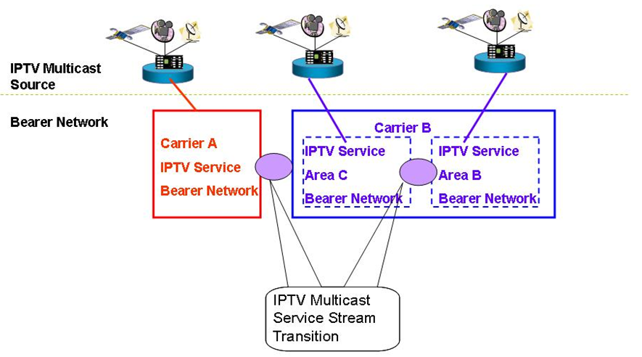
Figure 1
2． The Control of Users’ Multicast Address
In order to control the development of these multicast services on carrier’s network and avoid impact on carriers’ IPTV broadcasting services, carriers can deploy multicast service controller to manage the distribution of multicast address uniformly. However, as for the multicast application without registration, carriers will restrict the usage of these multicast addresses at the access point of IPTV network. The procedures of applying for multicast service and multicast address are as follows and shown as figure 2.
1. In order to carry out services based upon multicast address users should arrange the inquiry and registration on the PORTAL of carrier-provided Multicast Address and Service Control Platform.
2. The self-service system check the situation of this multicast address from multicast address policy controller
3. If this multicast address is available, users will be told that they are allowed to use it.
4. At the same time, multicast address policy controller sends policies to the access point to allow the multicast services get access.
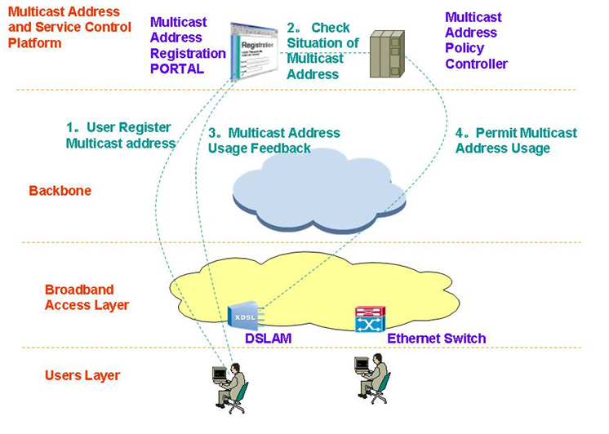
Figure 2

Living List #Multicast-9 of WG4

Area: Functional Architecture of IPTV Multicasting
Title: Hierarchical Architecture for Overlay IPTV Service Multicast
Related Document: FGIPTV-C-228
Background:
A video stream may be transmitted over an IP network in a number of ways, of which the three most popular are:
- MPEG-2 Transport Stream encapsulated in IP/UDP only.
- MPEG-2 Transport Stream encapsulated in IP/UDP and RTP as documented in “Digital Video Broadcasting (DVB); Transport of MPEG-2 TS Based DVB Services over IP Based Networks” (ETSI TS 102 034) which uses IETF RFC 2250 and 3550.
- Elemental streams encapsulated in UDP and RTP as documented in IETF RFC 3550, 3984 etc.
Study Issues:
Means of transmission for IPTV Streams need study and followings are proposed method.
As shown in Figure 1, an overlay network for IPTV service control has a feature interaction capability to analyze, tradeoff and generate option for IPTV application services. In addition, few service control nodes will perform policy management, configuration and monitoring service components. And the overlay processing entities will perform service processing for user’s requirements and information with dynamic.
Figure 1 shows an example of IPTV service control structure, overlay control framework.

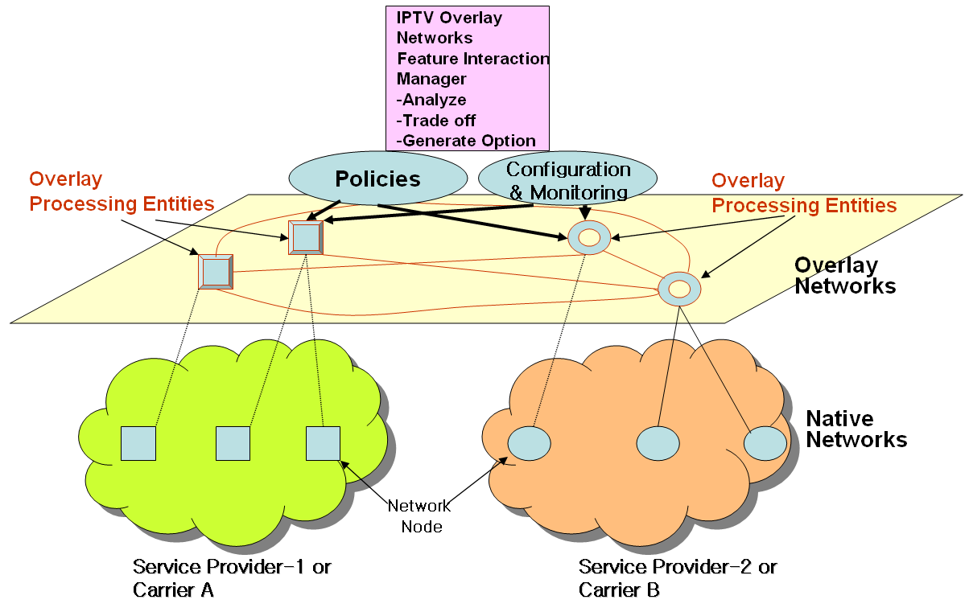
Figure 1 Overlay Network Framework for IPTV Service Controls

Case Study: Hierarchical Architecture for Overlay IPTV Service Multicast
There is a crucial need to develop an alternative multicast control scheme, overlay IPTV multicasting control approach. It makes good use of existing unicast, multicast and/or multicast tunneling schemes. In addition, service level multicast is designed as several separate forms to support any kinds of group service type well. Thus, overlay control structure of IPTV services will be a promising approach of IPV service control mechanisms, and it is expected to provide a substantial solution for group applications for IPTV services.
Figure 4 shows architecture for “Overlay Service Control Functions” for IPTV service. The overlay service control function performs an IPTV session control to provide multicast capability for diverse IPTV service capabilities.
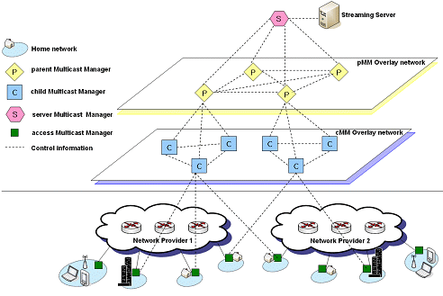
Figure 2 An Example of Overlay Control: Hierarchical Architecture for Overlay IPTV Service Multicast Control

The future work scopes on overly IPTV service control framework are needed as follows.
● define control actions (sub-goals in configuration and monitoring, etc) performed on a set of service dependent resources for different sub-goals for sub-goals of IPTV service.
● define IPTV service and network management process.
● define resource interaction models for IPTV service
● define interactions between network management system and service control options
● define security considerations for IPTV service clients in fixed and mobile environment
● define interfaces to overlay networks feature interaction manager
Living List # Multicast-10 of WG4

Area: Multicasting Control Function
Title: Functional Requirements for IPTV Network Node
Related Document: FGIPTV-C-227
Background:
In order to enable the IPTV system and achieve the interoperability, many aspects should be standardized, especially for IPTV media delivery system. Careful study is required on IPTV media delivery system and on the standard work on this domain to produce correlative standard documents.
Study Issues:
Study on functional requirements of IPTV network node to support IPTV Streams is required.

1. Multicast Control Functions for IPTV Service
Based on In order to enhance and optimize service capability in mobile VPN multicast function, its multicast function will be required to perform at transport stratum, service stratum or both.
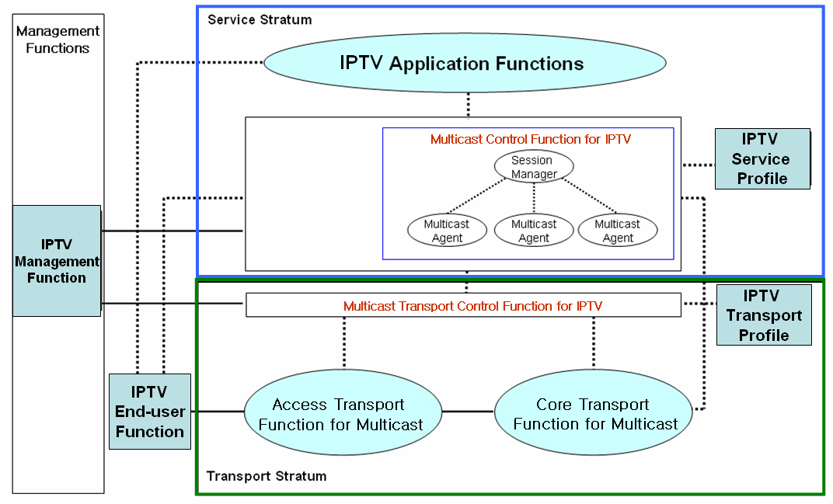
Figure 1 IPTV Multicast Function Framework

1.1 IPTV Multicast Control Function at the Transport Stratum
- Identifications of IPTV multicast group and service

An IPTV multicast group and service should be identified by the relevant mapping mechanisms with physical or logical identifiers of mobile IPTV users.
- Multicast session management for IPTV Services

The multicast transport control function for IPTV services manages the multicast session information including multicast tree information, which includes the number of multicast IPTV users, multicast domain, the QoS levels per multicast group, and accounting information per user, etc. It supports a multicast tree configuration for a specific multicast group. The multicast tree can be dynamically updated when joining and leaving IPTV customers. Depending on network topology and physical media, multicast tree path can be constructed by physical media (e.g., FTTH/PON and wireless LAN).

- Multicast Domain Management
A multicast domain is a set of multicast routing and forwarding instances than can send multicast traffic to each other. These multicast routing and forwarding instances are referred to as IPTV multicast domain. Thus, multicast domains map all of a customer’s multicast groups that exist in particular IPTV service members to a single unique global multicast group. This is achieved by existing or specific group routing and forwarding capability in the network.

1.2 IPTV Multicast Function at the Service Stratum
Service level multicasting aims to support various kinds of group applications for IPTV service, some of which are categorized in the according to the ways of communication and the characteristics of data delivery. In order to provide mobile IPTV multicast at the service stratum in the network (e.g., NGN), two major functional entities, ISM (IPTV Session Manager) and IMA (IPTV Multicast Agent) are introduced to perform multicast function at the service stratum in the network.

1.2.1 Functional Requirements for IPTV Service Level Multicast
Service level IPTV multicast includes service control functions (including IPTV Session Manager and IPTV Multicast Agents) and IPTV application functions, IPTV service user Profiles.
IPTV Service control functions include session control, session membership management and service user profile management at the service level. They can also include functions for controlling media resources -- i.e., specialized resources and gateways at the service-signaling level.
IPTV application function includes a lot of functions for various IPTV multicast services. Therefore, they could be implemented specific functions dependent on the each service and could provide an interface to user to notice the IPTV service information and accept the service request of user. IPTV Application function support functions include functions such as the gateway, registration, authentication, and authorization functions at the service level. And IPTV Application Function support functions work in conjunction with the Service Control Functions to provide users with the value added services they request.
IPTV Service User Profile functions are based on the user subscription data and network data. It is a database based on a service user and shall be provided in support of:
- IPTV Multicast user authentication and authorization
- IPTV Multicast service subscription information
For IPTV service level multicast over converged network platforms (e.g., wired, wireless and broadcast networks), each multiple IMAs will handle their functionalities of multicast functions at each IMA.

1.2.2. Control Framework for IPTV Service Level Multicast
Service Level Multicasting constructs and manages relayed multicasting functions to support internet group application services over the unicast-based network. After control messages of a service level multicasting are exchanged, a multicast data delivery path is constructed by using multiple end hosts even such as personal desktop computer. Along the delivery path, real-time or reliable data transport channels are inter-connected between upstream and downstream IMAs. Only after the data delivery path and data channel are established, group applications can work as if they were in a native IPTV multicast network.
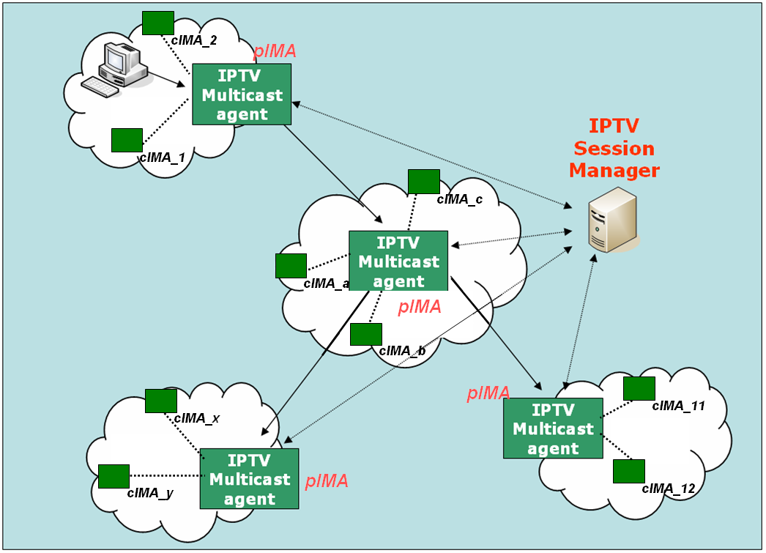
Figure 2. Functional Architecture for Service Level Multicast Capabilities for IPTV

1.2.2.1 IPTV Session Manager ( ISM)
ISM is involved in session configuration and maintenance for IPTV service flows. A single ISM can handle one or multiple sessions simultaneously, and it can provide the following functionalities:
- Session initialization: ISM allocates ISID (IPTV Session ID) for new session.
- Session release: Session can be released as needed.
- Session membership management
- Session status monitoring:
- report the status of data channel
- data throughput
- multicasting protocol topology information gathering
- multicasting protocol membership management
1.2.2.2 IPTV Multicast Agent ( IMA )
IMA constructs relayed multicast delivery path and forwards data along the constructed path from pIMA ( parent IPTV Multicast Agent ) and to cIMA ( child IPTV Multicast Agent). An MA consists of control module and data transport module. The main function of former is to establish relayed data delivery path and that of latter to setup data channel along the path constructed by control module and relay data through the channel. IMA performs the control functions to exchange control messages with other entity. Its major functions are as follows.
- Session join: each IMA contacts with Session Manager.
- Session leave: when an IMA wants leave the session, it gives notice to pIMAs and cIMAs
- Session maintenance: relay request and its response will be exchanged between the two IMAs periodically.
- Loop detection & avoidance, partitioning detection & recovering, Parent switching
- IPTV Session status reporting
In order to perform service level multicasting of streaming application for IPTV service, the functional box of service control can be described into few functional blocks in detail as shown in Figure 3.
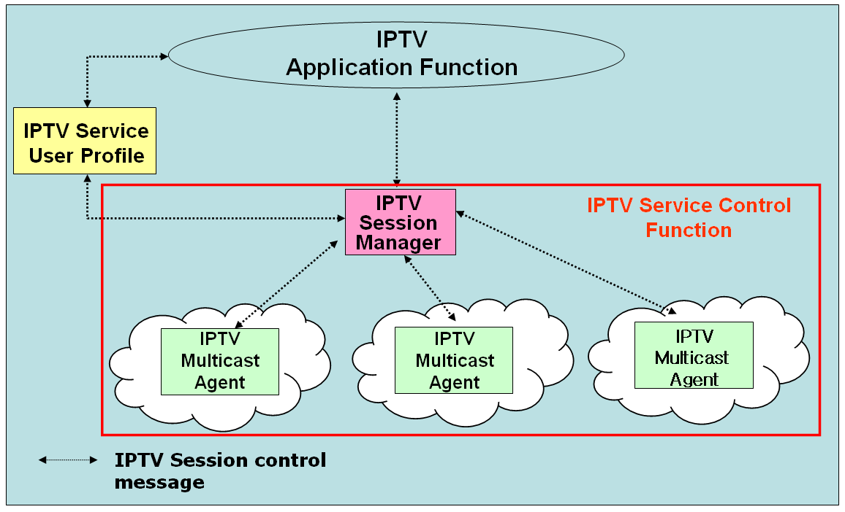
Figure 3 Functional Blocks of IPTV Session Control for IPTV Application Services

1.2.3 Overlay Multicast Control for IPTV Services
Current reliable multicast transport mechanisms have unresolved problems including scalability, flow control, congestion control and etc. Until the related reliable multicast transport mechanism settles down, group communications requiring reliable data transfer are actually clinging to replicate unicast method based on servers. Although IP multicast has not deployed globally, a lot of local networks have already been equipped with IP multicast transport. For example, Ethernet-based LANs and private networks such as corporate and campus networks substantially provide the multicast transport capability within their local subnet or administrative domains.
Recognizing these observations, there is a crucial need to develop an alternative multicast delivery scheme, service level multicasting approach. It makes good use of existing unicast, multicast and/or multicast tunneling schemes. In addition, service level multicast is designed as several separate forms to support any kinds of group service type well. Service level multicasting is expected to provide a substantial solution for group applications for IPTV service.
Figure 4 shows an architecture for “Overlay IPTV Service Multicast Functions” for IPTV service. The overlay service control function performs a IPTV session control to provide multicast capability for diverse IPTV service capabilities.
Figure 4 Overlay IPTV Service Multicast Control
Living List # Multicast-11 of WG4

Area: Multicasting User Authentication
Title: Procedure of IPTV multicast user authentication and authorization
Related Document: FGIPTV-C-168
Background:
As the current multicast protocol (i.e. IGMP) does not consider Multicast user authentication and authorization, it is a little difficult to develop the IPTV services efficiently. So it is very necessary for the IPTV bearer network to restructures the multicast and make it easy to provide authentication function for the multicast users.
Study Issues:
Multicast User authentication function controls the authority for users to receive multicast flows. And through authentication of multicast users, the network can distinguish legal multicast users from the illegal ones and then distribute the multicast traffic to the reasonable receivers. Following procedures would be considered to support this.
- When a user initiates a multicast “join” request to join a certain multicast group with an account, the duplication point will not accept the request and make him join the group at once, it will sent the request to the authentication point.
- The authentication point inquires the Account information Database and returns the result to Multicast duplication Point. The value of the user’s multicast property in the account could be set by the service layer system.
- According to the authentication result returned from the authentication point, the Multicast duplication Point will decide whether it allow the user to join the group or not. If allow the user to join the group, the duplication will add it to distribution table. Whereas it will refuse the user to join the group.
Fig. 1 Functional components for Multicast user management
___________

