INTERNATIONAL TELECOMMUNICATION UNION |  |  |  | Focus Group On IPTV
TELECOMMUNICATION  STANDARDIZATION SECTOR  STUDY PERIOD 2005-2008 |  |  | FG IPTV-C-1117
 |  |  | English only
WG(s): 2, 1 |  | 7th FG IPTV meeting:  Qawra, St Paul’s Bay, Malta, 11-18 December 2007
CONTRIBUTION
Source: | Digital Fountain
Title: | Proposed Working Document Updates to add Application Layer Error Recovery Mechanisms to IPTV Architecture
ABSTRACT
This document proposes updates to the working document on “IPTV Architecture“ and “Application Layer Error Recovery Mechanisms” to integrate Application Layer Error Recovery Mechanisms into the IPTV Architecture.

1 Introduction
The WG2 of the IPTV FG on IPTV has drafted a Working Document on “Application Layer Error Recovery Mechanisms.” The document includes different mechanisms for the recovery of lost packets, especially if the IPTV network functions cannot provide sufficient QoS. This contribution serves to clarify the usage of the application layer error recovery in the IPTV architecture. Updates to relevant working documents are proposed.

2 Proposal

2.1 Proposed Modifications to IPTV Architecture Working Document
It is proposed to add the Application Layer Error Recovery Functions to the IPTV Architecture. Relevant updates of the Working Document T05-FG.IPTV-DOC-148 “IPTV Architecture” shall be considered:
- The functional block of application layer error recovery function shall be added to the IPTV architecture as proposed in the below figure.
- In section 9.6.3.2.2, add the following sentence “The Delivery Functions may use the Application Layer Error Recovery Functions [reference to WD-ALERM]. It serves to provide reliability in case that the IPTV network functions cannot provide sufficient QoS.”
- The functional block of application layer error recovery client function shall be added to the IPTV architecture as proposed in the below figure.
- A new section 9.6.2.6 with title “Application Layer Error Recovery Client Function” and the following text shall be added “The IPTV Terminal Device may include an Application Layer Error Recovery Client Function [reference to WD-ALERM], which provides recovery of lost packets.”

2.2 Proposed Addition of new Section to Working Document on “Application Layer Error Recovery Mechanisms”
Furthermore, it is proposed to add a new section 7 to the working document on “Application Layer Error Recovery Mechanisms” on “Application Layer Error Recovery Mechanisms in IPTV Architecture”. By this addition all other section numbers shall be updated.

7 Application Layer Error Recovery Mechanism in IPTV Architecture
According to the Working Document T05-FG.IPTV-DOC-148 “IPTV Architecture”, the Functional Architectural Overview for IPTV consists of several IPTV functional architecture components, namely:
- End-User Functions performing mediation between the end-user and the IPTV infrastructure.
- Application Functions enabling the End-User Functions to select, and purchase if necessary, a content item.
- Content Delivery Functions facilitating delivery of content from the application functions to the end-user IPTV terminal functions using the capabilities of the network transport and control functions.
- Service Control Functions providing the functions to request and release the network and service resources required to support the IPTV services.
- Management Functions: The Management functions (MF) performs overall system management, status monitoring and configuration. This set of functions may be deployed in a centralized or distributed manner.
- Content Provider Functions providing by the entity that owns or is licensed to sell content or content assets (i.e. owner of the content, metadata and usage rights).
- Network Functions are the combination of network transport and network control functions. The network control functions control the network transport layer to provide the required Quality of Service (QoS) for the successful operation of IPTV. The network transport and control functions provide IP layer connectivity between the IPTV service components and the end-user functions.
Figure 1 provides an overview of the IPTV architecture with the relevant function components for this document. The application layer error recovery function and the application layer error recovery client function are added to the relevant functional components.
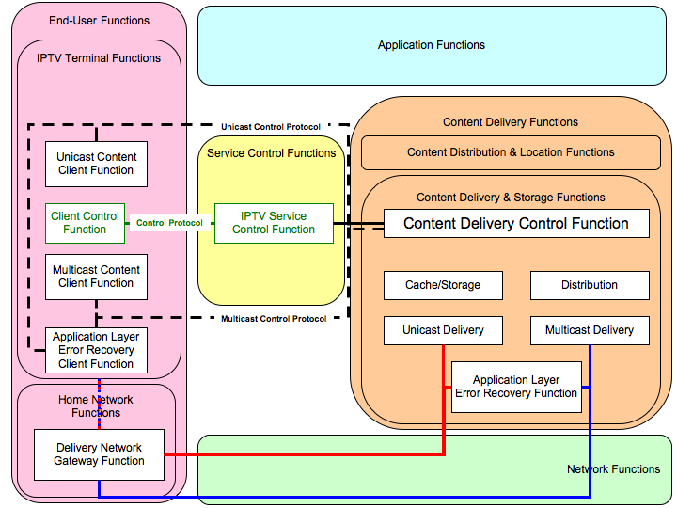
Figure 1 Application Layer Error Recovery Mechanism in IPTV Architecture
Application Layer Error Recovery Functions as addressed in this document are part of the IPTV Architecture, namely of the Content Delivery Functions and the End-User Functions. Specifically, the Application Layer Error Recovery Function is part of the Content Delivery and Storage Functions and the Application Layer Error Recovery Client Function is part of the IPTV Terminal Functions
By the use of the Application Layer Error Recovery Function the Application Layer Error Recovery Client Function may recover lost packets, especially if the IPTV network functions cannot provide sufficient QoS.
By the use of the IPTV Service Control Function and a Control Protocol the Content Delivery Control Function may transfer setup and configuration information to the Client Control Function to setup and configure the Application Layer Error Recovery Client Function.
The Application Layer Error Recovery function may be used for unicast and multicast delivery.
The Application Layer Error Recovery function may be used for different IPTV services, specifically for
- Broadcast services such as Linear TV,
- On-Demand Services such as Video-on-Demand,
- Content download service such as Push-VoD.
The Application Layer Error Recovery function may be used in combination with different IPTV related protocols. Section 8 discusses IPTV related protocols used in the context of application layer error recovery.

2.3 Proposed Modifications of Working Document on “Application Layer Error Recovery Mechanisms”
Further, if the above architectural updates are agreed, it is proposed to adapt the language in the document to consistently reflect the updates and the definition of the functions throughout the working document.

________________

