INTERNATIONAL TELECOMMUNICATION UNION |  |  |  | Focus Group On IPTV
TELECOMMUNICATION  STANDARDIZATION SECTOR  STUDY PERIOD 2005-2008 |  |  | FG IPTV-C-1114
 |  |  | English only
WG(s): 4 |  | 7th FG IPTV meeting:  Qawra, St Paul’s Bay, Malta, 11-18 December 2007
CONTRIBUTION
Source: | ETRI, Huawei
Title: | Revised Text of Section 10 for “IPTV Multicast Frameworks” Document ( FG IPTV-DOC-0157)
The revised text for “10. Overlay multicast networking” of the document “IPTV Multicast Frameworks (FG IPTV-DOC-0157)” is proposed as follows.

------------------------------------------

Overlay multicast networking

  - Control framework for IPTV overlay multicast
IPTV overlay multicast networking consists of virtual network topologies on top of the physical network, and it constructs and manages logical multicast path over the unicast/multicast physical transport network.
In order to provide IPTV multicast function in overlay networks, it is necessary to perform multicast session control and management for IPTV overlay multicast networking. The IPTV overlay multicast can use diverse mechanisms for constructing different multicast trees depending on IPTV applications or other requirements. The overlay IPTV multicast supports efficient routing and resource usage by overlay multicast control.
In overlay IPTV multicast framework, a logical multicast control path will be created along the logical delivery path, a multicast data delivery path is constructed over physical transport network, and a logical multicast, the control path will be created along the logical delivery path for reliable data transport. IPTV overlay multicast function is performed with cooperation among upstream and downstream IPTV Multicast Agents (IMAs) at service level. IPTV multicast session management (ISM) function at will be provided for multicast session configuration and maintenance at service level. IPTV logical delivery path is established via ISM and IMA at service level, and IPTV applications can work as if they were in a native IPTV multicast network.

IPTV Session Manager (ISM)
ISM is involved in session configuration and maintenance for IPTV service flows. A single ISM can handle one or multiple sessions simultaneously, and it can provide the following functionalities:
- Session initialization: ISM allocates ISID (IPTV Session ID) for new session.
- Session release: Session can be released as needed.
- Session membership management
- Session status monitoring: this function enables reporting of the status of data channel, monitoring of data throughput, gathering multicast protocol topology information

IPTV Multicast Agent ( IMA )
IMA constructs overlay multicast delivery path over physical transport path, and forwards data along the constructed physical transport path. An IMA consists of two functional modules, multicast control module and multicast session control module. The main function of former is to establish multicast delivery path and that of latter to setup multicast session along the paths constructed by multicast session control module. IMA performs the control functions to exchange control messages with other entities. Its major functions are as follows.
- Session join: each IMA contacts with Session Manager.
- Session leave: when an IMA wants leave the session, it gives notice to pIMAs and cIMAs
- Session maintenance: relay request and its response will be exchanged between the two IMAs periodically.
- Loop detection & avoidance
- Partitioning detection & recovering
- Parent switching
- IPTV Session status reporting
In order to perform service level multicast of IPTV streaming applications, the functional blocks for IPTV service control are shown as Error: Reference source not foundfigure 11-9.
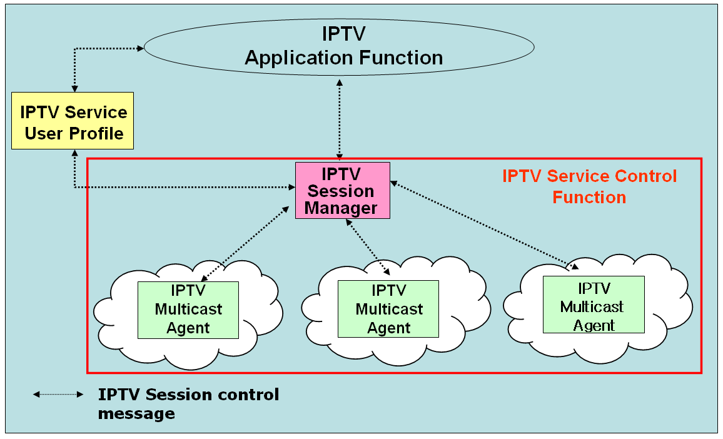

Figure 11-9 - Functional blocks of IPTV session control for IPTV application services

IMA Backup
Because data stream will break if IMA goes out of work, it is important to deploy backup function for IMA to guarantee service quality. The following IMA backup functions are required:

- Nodes broadcast their load status to other nodes of multicast overlay.
- Nodes responsible for backup selection select backup nodes based on the received load status.

Media signalling proxy
Media signalling proxy is a function to get media status in overlay multicast network by transfer media connection signalling between end hosts and obtain media session status of end hosts.
In order to get media status of overlay multicast network, media signalling proxy is may be supported by IPTV overlay multicast system.

Error: Reference source not found shows how media signalling proxy operates.

Functional Requirements for IPTV overlay multicast

    - Group membership management
The group membership for IPTV overlay multicast considers group size, number of group member and rate of group membership change. Group membership management function provides the function to create or maintain the multicast groups. If a multicast group in the physical transport network is experiencing serious traffic explosion temporarily, the control function of IPTV overlay multicast will be able to make a global group into multiple sub-groups to avoid the problems.

    - Admission control for QoS in IPTV overlay multicast network
In order to support QoS for IPTV services in overlay multicast network, resource control function for IPTV overlay network will perform resource management and admission control function in IPTV overlay multicast network.

Security for IPTV overlay multicast
IPTV overlay multicast uses shared network resource and multiple distributed overlay resources to transport data. When a user requests IPTV service, security process needs for IPTV overlay multicast function.
Overlay multicast confronts with various vulnerabilities and risks that impede from being widely deployed in mission critical business systems and applications. There are three important security challenges for the overlay network service model: Confidentiality and Integrity, Authenticity, and Availability. These three important security challenges can be classified with some properties for architectures and algorithms for building secure and scaleable information dissemination services on IPTV overlay networks.

Node functions for IPTV overlay routing
An overlay multicast node function will be designated to perform overlay routing, contents location control and distribution control function for IPTV services. The designated node has full knowledge of other multicast node in the session, information on contents server and distribution control information. In order to keep the updated information on multicast nodes, state updates occur periodically via broadcasting among all multicast nodes.

- QoS control in IPTV overlay multicast network

Resource control function for IPTV overlay multicast

provides interface function for IPTV overlay multicast QoS control between physical transport and IPTV overlay network. The function performs collection and management of transport network resource (e.g., DiffServ) via specified interface (e.g. SNMP)

QoS control function in IPTV overlay multicast
network will also provide the measurement function of overlay multicast performance to ensure high end-to-end IPTV service quality over IPTV overlay sessions on selected appropriate overlay path.
According to initiation of overlay network nodes, Resource Control function collects data for resource and QoS control.

________________

