Introduction
INTERNATIONAL TELECOMMUNICATION UNION |  |  |  | Focus Group On IPTV
TELECOMMUNICATION  STANDARDIZATION SECTOR  STUDY PERIOD 2005-2008 |  |  | FG IPTV-C-1099
 |  |  | English only
WG(s): 5 |  | 7th FG IPTV meeting:  Qawra, St Paul’s Bay, Malta, 11-18 December 2007
CONTRIBUTION
Source: | ZTE Corporation
Title: | Proposal on the software architecture of the Terminal Device
This contribution proposes a software architecture of the IPTV Terminal Device for document “FG IPTV-DOC-0159(15-19 Oct. 2007), Working Document: Aspects of IPTV End System – Terminal Device”.

Discussion

The Terminal Device is very important role when the IPTV service is consumed. And at the same time, the architecture of the Terminal Device affects the interface with the IPTV system devices and the application of service provided by the operator and the service provider. So it’s necessary to define an integrated architecture of the Terminal Device.

Fortunately, the architecture of the Terminal Device is studied in WG5 and the Software Architecture Layered Relationship is figured out in the document of “FG IPTV-DOC-0159 (15-19 Oct. 2007), Working Document: Aspects of IPTV End System – Terminal Device”. And the architecture of the middleware of the Terminal Device is constructed in the WG6’s document of “FG IPTV-DOC-0163 (15-19 Oct. 2007), Working Document: IPTV Middleware”.

The software architecture of the Terminal Device given in the last meeting is the figure 1.

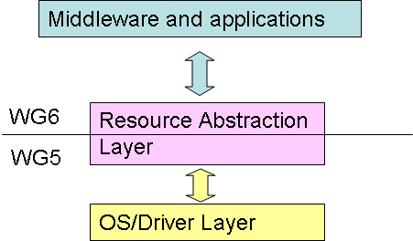

Figure 1 Software Architecture Layered Relationship

And the document 0163 of the WG6 only gives the architecture of the middleware.

So some items may be considered here:
- Where is the integrated architecture of the Terminal Device?
- The word “WG5” and “WG6” may not appear in the architecture of the Terminal Device, because not the map of Terminal Device architecture is talked about here.
- How about the architecture if there is no middleware in the Terminal Device? As we all know that the middleware is optional.

With the above considered, an software architecture of the Terminal Device is proposed as Figure 2:
Driver/OS Layer
Resource Abstract Layer

Middleware Layer

Embedded Services
Applications (VoD, PVR etc)

Figure 2 Software Architecture of the Terminal Device

Diver/OS Layer: This layer is the operation system and hard drives layer. The operations system is responsible for scheduling the task or process, controlling the signal, memory management etc other system functions. The drivers handle the operation of the hardware of the terminal device, such as Open, Close, Write, Read, Control etc.

Resource Abstract Layer: This layer is the interface of Driver/OS Layer and the Middleware or Embedded Services. And this layer abstracts the interface of the Drives/OS, then it brings the advantage that the services and the applications are independent of the Drive/OS Layer.

Embedded Services: This layer includes some base service when the terminal device is produced, such as the initialization, software upgrading . And all the services are embedded in the terminal device which has no Middleware Layer.

Middleware Layer: Middleware is defined as the layer of software between applications and resources, which consists of a set of service enablers that allow multiple functionalities running on one or more devices in an IPTV system to interact across a network. WG6 “Working Document: IPTV Middleware” should be consulted for any details regarding the Middleware and Applications Layer.

Applications Layer: This layer includes the applications of the IPTV, such as PVR, VoD etc.
Reference
[1] FG IPTV-DOC-0159 (15-19 Oct. 2007), Working Document: Aspects of IPTV End System – Terminal Device
[2] FG IPTV-DOC-0163 (15-19 Oct. 2007), Working Document: IPTV Middleware
Proposal
- Proposes to discuss about the software architecture of terminal device.
- Proposes to replace Figure 7-2 Software Architecture Layered Relationship in the document 0159 with Figure 2 given by this contribution.
3. Proposes to discuss these explaining words about every layer above and then add them to document 0159

_________________

