Introduction
INTERNATIONAL TELECOMMUNICATION UNION |  |  |  | Focus Group On IPTV
TELECOMMUNICATION  STANDARDIZATION SECTOR  STUDY PERIOD 2005-2008 |  |  | FG IPTV-C-1081
 |  |  | English only
WG(s): 4 |  | 7th FG IPTV meeting:  Qawra, St Paul’s Bay, Malta, 11-18 December 2007
CONTRIBUTION
Source: | KT
Title: | Restructured and edited version of IPTV multicast frameworks Working Document
At the last meeting in Tokyo, WG4 discussed ‘IPTV multicast frameworks WD’ in detail, however, WG4 did not fully revise whole contents of multicast WD for a lack of time. Especially, in Chapter 6, dedicated to IPTV multicast requirements, and Chapter 10, dedicated to Overlay multicast networking, we still have many issues and sub chapters to be aligned and agreed.
In order to improve the quality of the multicast WD within a limited span of time, we need to have a strong consensus to clarify and align ‘Chapter 6’ and ‘Chapter 10’ in this meeting. And, according to the last meeting’s agreement in WG4, we had email editing session to make a consensus and solve those issues. So, in this contribution, we would like to propose the restructured and edited version of IPTV multicast frameworks Working Document, based on the result of email editing session.

Discussion

We have so many implementation specific contents in Chapter 6 ‘IPTV multicast requirements’ and Chapter 10 ‘Overlay multicast networking’ in our IPTV multicast frameworks WD. Those contents are informative and valuable materials, not normative. To keep those valuable and informative contents in Ch.6, we propose new Chapter 9; ‘Ch. 9 Implementation guideline for IPTV multicast’. Actually, the original name of Ch. 9 is ‘Other aspects’, we can change the name of Ch. 9 from ‘Other aspects’ to ‘Ch.9 Implementation guideline for IPTV multicast’.

After that, we propose to classify the multicast requirements into normative part and informative part in Ch. 6. And we propose to move whole informative contents to ‘Ch. 9 Implementation guideline for IPTV multicast’.
WG4 agreed that we can have many references to DOC 147(WD: IPTV Service requirements) as IPTV multicast requirements. So, we made bunch of normative IPTV multicast requirements that can be made with combining the requirements from DOC 147(WD: IPTV Service requirements) and from Ch.6 of DOC 157(our multicast WD). And, at last meeting, we marked many multicast requirements which need further clarification to make sense, and WG4 discussed those requirements through email editing session and agreed to delete some requirements which do not make sense. Based on the result of email editing session, we revised Chapter 6, and would like to propose the revised version of Ch. 6 ‘IPTV multicast requirements’ like attached WD.

Proposal
- We would like to propose following restructured and revised version of IPTV multicast frameworks WD, based on the result of email editing session.
CONTENTS
1 Scope 2
2 References 2
3 Definitions 2
3.1 Terms defined elsewhere 2
3.2 Terms defined in this Recommendation 2
4 Abbreviations and acronyms 2
5 Conventions 2
6 IPTV multicast requirements 2
6.1 IPTV multicast transport requirement 2
6.2 QoS requirements of IPTV multicast 2
6.3 Security requirements of IPTV multicast 2
6.4 Interoperability requirement of IPTV multicast 2
6.5 Service management requirements of IPTV multicast 2
7 IPTV Multicast Architecture 2
7.1 End-user Functions (EFs) for IPTV multicast 2
7.2 Application Functions(AFs) for IPTV multicast 2
7.3 Content Delivery Functions (CDFs) for IPTV multicast 2
7.4 Service Control Functions (SCFs) for IPTV multicast 2
7.5 Management Functions (MFs) for IPTV multicast 2
7.6 Content Provider Functions (CPFs) for IPTV multicast 2
8 IPTV Multicast scenario 2
8.1 Pure IP multicast scenario 2
8.2 Alternative multicast scenario 2
9 Implementation guideline for IPTV multicast 2
9.1 IPTV multicast transport 2
9.1.1 Implementation model of IPTV Multicast transport 2
9.1.1.1 Any Source Multicast 2
9.1.1.2 Source Specific Multicast 2
9.1.2.1 Multicast Group management in access node 2
■ Internet Group Management Protocol 2
■ IGMP Transparent Snooping 2
■ IGMP Proxy 2
■ Fast Leave / Immediate Leave 2
9.2 IPTV multicast QoS 2
9.3 IPTV multicast Interoperability 2
9.4 IPTV multicast Service management 2
10 Overlay multicast networking 2
10.1 Entities for overlay multicast networking for IPTV service 2
10.2 Mission of overlay multicast networking ( TBD ) 2
I.1 Hybrid P2P IPTV service multicast delivery solution 2
I.2 P2P CDN-based IPTV service multicast delivery solution 2
II.1 Enhanced entities for overlay multicast networking 2
II.1.1 IMA Backup 2
II.1.2 Media signalling proxy 2
II.2 Detailed Control Function for IPTV overlay multicast 2
II.2.1 Group membership management 2
II.2.2 Admission control for QoS in IPTV overlay multicast network 2
II.2.3 Security for IPTV overlay multicast 2
II.2.4 Node functions for IPTV overlay routing 2
II.2.5 QoS control at overlay multicast network for IPTV services 2
II.2.5.1 Functional position of resource control 2
II.2.5.2 Resource control function 2
II.2.5.3 Resource control function for IPTV overlay multicast QoS in wired/wireless/mobile networks. 2
II.2.6 Network measurement function 2
II.3 High-level procedure of QoS and Resource Control Functions for IPTV Overlay Multicast 2
II.4 Scenario for Session manager’s Service Control Function 2

IPTV Multicast Frameworks

Scope
This document on IPTV multicast frameworks describes functional requirements and frameworks of supporting multicast capabilities in terms of IPTV network control.
[Editor’s note]: This document considers multicast frameworks for non-NGN environment.

References
The following ITU-T Recommendations and other references contain provisions, which, through reference in this text, constitute provisions of this working document. At the time of publication, the editions indicated were valid. All Recommendations and other references are subject to revision; all users of this working document are therefore encouraged to investigate the possibility of applying the most recent edition of the Recommendations and other references listed below. A list of the currently valid ITU-T Recommendations is regularly published.
The reference to a document within this working document does not give it, as a stand-alone document, the status of a Recommendation.

[FGIPTV-REQ] ITU-T IPTV Focus Group, IPTV Network Control Aspects..
[FG IPTV WD] ITU-T IPTV Focus Group, IPTV Service Requirements.
[IETF RFC 1918] IETF RFC 1918 (1996), Address Allocation for Private Internets
[IETF RFC 3180] IETF RFC 3180 (2001), GLOP Addressing in 233/8
[IETF RFC 3307] IETF RFC 3308 (2002), Allocation Guidelines for IPv6 Multicast Addresses

Definitions

Terms defined elsewhere
This Document uses the following terms defined elsewhere:
[TBD]

Terms defined in this Recommendation
This Document defines the following terms:
3.2.1 Multicast Domain Management: A multicast domain is a set of multicast routing and forwarding instances than can send multicast traffic to each other. These multicast routing and forwarding instances are referred to as IPTV multicast domain. Thus, multicast domains map all of a customer’s multicast groups that exist in particular IPTV service members to a single unique global multicast group. This is achieved by existing or specific group routing and forwarding capability in the network.
3.2.2 Multicast Access Control Functions: Multicast Access Control Functions is that control a multicast user access to IPTV multicast tree. The IPTV user can join a multicast service using these control functions with proper authentication and authorization of the user.
3.2.3 Multicast Delivery Control Functions: Multicast Delivery Control Functions is that can control IPTV multicast delivery among transport functions.
3.2.4 Overlay Network: A virtual network of nodes and logical links that is built on top of the underlying network infrastructure with the purpose of implement a network service that is not available in the underlying network infrastructure.
3.2.5 Overlay Multicast Network: One type of overlay network that provides multicast services to end users on top of the general network infrastructure.
3.2.6 IPTV multicast interoperability: IPTV multicast interoperability is the exchange of IPTV service information amongst multicast based IPTV service providers. And to make the optimal contract and to provide the stable IPTV services amongst multicast based IPTV service providers.
3.2.7 IPTV Service Exchange Point: IPTV SEP (service exchange point) is identified as a reference point for handling the service brokering function between IPTV SPs enabling the optimal contract between IPTV SPs and providing the stable IPTV services amongst IPTV service providers. IPTV SEP can be located in any peering point.

Abbreviations and acronyms
This document uses the following abbreviations and acronyms.
CAC Connection Admission Control
CCTV Closed-Circuit TV
cIMA child IMA
CP Content Provider
DRM Digital Rights Management
ECMP Equal Cost Multiple Path
IGMP Internet Group Management Protocol
IMA IPTV Multicast Agent
IP Internet Protocol
ISP Internet Service Provider
QoE Quality of Experience
QoS Quality of Service
pIMA parent IMA
RP Rendezvous Point
SEP Service Exchange Point
SP Service Provider

Conventions
In this document:
The keywords “is required to” indicate a requirement which must be strictly followed and from which no deviation is permitted if conformance to this document is to be claimed.
The keywords “is prohibited from” indicate a requirement which must be strictly followed and from which no deviation is permitted if conformance to this document is to be claimed.
The keywords “is recommended” indicate a requirement which is recommended but which is not absolutely required. Thus this requirement need not be present to claim conformance.
The keywords “is not recommended” indicate a requirement which is not recommended but which is not specifically prohibited. Thus, conformance with this specification can still be claimed even if this requirement is present.
The keywords “can optionally” indicate an optional requirement which is permissible, without implying any sense of being recommended. This term is not intended to imply that the vendor’s implementation must provide the option and the feature can be optionally enabled by the network operator/service provider. Rather, it means the vendor may optionally provide the feature and still claim conformance with the specification.

IPTV multicast requirements

IPTV multicast transport requirement
• The IPTV architecture is required to allow for two-ways communication between End-user Network and the Service Provider [ATIS-0800002].
• The IPTV architecture is required to support the addressability of particular device such as ITFs within the end-user Network [ATIS-0800002].
• The IPTV architecture is required to allow for the utilization of Internet protocols and standards related with multicast transmission[ATIS-0800002].
• The IPTV architecture is recommended to allow the delivery of IPTV services over different access networks (e.g. cable, optical, xDSL, wireless)
• The IPTV architecture is recommended to adapt dynamically to change in wireless networks characteristics when the service is delivered over a mobile network (e.g. bandwidth, packet loss rate, etc.
• The IPTV architecture can optionally support a replacement algorithm for content caching and distribution.
• The IPTV architecture is required to support a mechanism for NAT traversal [ATIS-0800002].
• The IPTV architecture is recommended to support mechanisms for the receipt of content from different sources, e.g., satellite, dedicated IP connections.
• The IPTV architecture is recommended to support the ability of both multicasting and unicasting transmission schemes.
• The IPTV architecture is required to support the management and enforcement of the service providers' transport policies by the network provider [ATIS-0800002].
• The IPTV architecture is required to support access networks in case of NGN-based IPTV as defined in NGN architecture.
• The IPTV architecture is required to support multicast means of communication to all end-users [ATIS-0800002].
• The IPTV architecture is required to allow the service provider to utilize the network providers' multicast delivery capabilities [ATIS-0800002].
• The IPTV architecture is recommended to support mechanisms that allow IPTV services to be distributed to specific group of end-users.
• The IPTV architecture is recommended to support mechanisms for transmitting identification information related to end-users who want to receive or are selected to receive IPTV services
• The IPTV architecture is required to support IP filtering functions in the DNGF in order to prevent selected local multicast traffic on the HNS from appearing on the DN [ATIS-0800002].
• The IPTV architecture is recommended to support the ability for the DNGF to implement standard IP routing functions, per established IETF specifications. [ATIS-0800002]
• The IPTV architecture is recommended to support the ability for the DNGF to support routing functions per IPv4 specifications. [ATIS-0800002]
• The IPTV architecture is recommended to support both IPV 6 and IPV4. [ATIS-0800002]
• The IPTV architecture is recommended to support static and dynamic address allocation schemes for both IPV4 and IPV6 [ATIS-0800002]
• The IPTV architecture is recommended to support the ability for the DNGF to support the routing of IP packets between all interfaces toward the access/core network (WAN side of the HN), and toward the ITF (LAN side of the HN). Specifically, this means: [ATIS-0800002]
- Routing is recommended to be supported from DN to HNS (downstream flow).
- Routing is recommended to be supported from HNS to DN (upstream flow).
- Routing is recommended to be supported from any HNS to any other HNS (bidirectional flows).
• The IPTV architecture is recommended to support the ability for the DNGF to support multiple logical IP interfaces (multiple attachment points at the IP layer) on any particular physical DN interface [ATIS-0800002].
• The IPTV architecture is recommended to support the ability for the DNGF to assign IP addresses to devices in the Home Network [ATIS-0800002].
• The IPTV architecture is recommended to support automated configuration capabilities for the IPTV devices [ATIS-0800002].
• The DNGF is recommended to support NAT/NAPT capability mapping IP address and port numbers between the public WAN and the LAN(s) [ATIS-0800002].
• The IPTV multicast network is recommended to provide identification of multicast group to the ITF.
• The IPTV multicast network is recommended to maintain multicast session information for each multicast group, and announce them to the ITFs.
• IPTV service provider is required to use multicast delivery provided by the IPTV network provider.
• IPTV network provider can use multicast tree structure to deliver IPTV multicast traffic.
• IPTV network provider is recommended to optionally authenticate and authorize an IPTV multicast source.
• IPTV network provider is recommended to optionally manage the identification of IPTV Multicast tree, to decide to which IPTV Multicast tree a multicast source can send a multicast service.
• IPTV network provider is required to provide the stable multicast tree management when the IPTV end-users join and leave.

QoS requirements of IPTV multicast
• The IPTV architecture is required to support a framework that identifies the key components and measurement points for Quality of Service Measurement (QoSM) [ATIS-0800002].
• The IPTV architecture is recommended to support a mechanism for obtaining information pertaining to terminal device capabilities.
• The IPTV terminal device is recommended to be able to declare Media-providing entities their usage environments description - e.g. Type of service, Type of Terminal, Type of transmission medium, User Preferences, Available QoS Level [ATIS-0800002].
• The IPTV architecture, if re-transmission broadcast service is supported, is recommended to provide comparable Quality of Experience to the end-user as the direct reception.
• The IPTV architecture is required to support the service provider to be able to get QoS information from the end-user device.
• The IPTV architecture is required to allow the delivery of IPTV services with a defined Quality of Experience (QoE) for the IPTV end-user [ATIS-0800002].
• The IPTV architecture is recommended to support consistent QoS for the duration of the service.
• The IPTV architecture is recommended to support a mechanism by which network operators can integrate IPTV QoS management functions into a common framework with other services and applications [ATIS-0800002].
• The IPTV architecture is recommended to rely upon any relevant QoS capabilities (e.g. RACF [ITU-T Y.2111] and DiffServ [IETF RFC 2475]) when integrating IPTV services into NGN-based environments.
• The IPTV architecture can optionally support the delivery of multiple services over the common IP transport with a manageable IP Quality of Service (QoS); services can optionally be delivered from multiple service providers or from a single provider [ATIS-0800002].
• The IPTV architecture is required to support mechanisms for supporting appropriate resiliency in the service provider infrastructure to maintain a high QoE [ATIS-0800002].
• The IPTV architecture is recommended to support an appropriate QoE for end-users eligible for uploading content to the service provider’s network [ATIS-0800002].
• The IPTV architecture is recommended to support means to provide channel changing times with sufficient QoE.
• Networks that support IPTV are required to support the IP QoS class and associated performance requirements specified in Y.1541 [ITU-T Y.1541], which recommends the selection of relevant specific QoS classes based on application requirements.
• The IPTV architecture is required to support a mechanism for assigning traffic priorities [ATIS-0800002].
• The IPTV architecture is required to support the relevant mechanisms for IPTV traffic identification, classification and marking, policing and conditioning, scheduling and discarding.
• The IPTV architecture is recommended to support mechanisms for dynamic IPTV traffic load balancing so as to dynamically accommodate with the network load and congestion conditions at any given time, so as to deliver the set of IPTV services to the end-users with the relevant level of quality.
• The IPTV architecture is recommended to offer an admission control solution for admission of IPTV services over the access and core network resources from the home network to the service source.
• The IPTV architecture is required to support the capability for management of capacity on the services and network elements [ATIS-0800002].
• The IPTV architecture can optionally support mechanisms to support QoS/QoE parameter adjustment due to changes of content characteristics on a channel.
• The IPTV architecture is recommended to support an application layer error recovery mechanism to support sufficient QoE/QoS for unicast distribution of any IPTV service.
• The IPTV architecture is recommended to support an application layer error recovery mechanism to support sufficient QoE/QoS for multicast distribution of any IPTV service.
• Any application layer error recovery mechanism integrated in the IPTV architecture is recommended to be bandwidth efficient.
• Any application layer error recovery mechanism integrated in the IPTV architecture is recommended to be flexible to cover a range of networks conditions and IPTV services.
• The IPTV architecture is required to define mechanism to appropriately distinguish different forms of traffic -- e.g. data and voice [ATIS-0800002].
• The IPTV architecture is recommended to support redundancy and failover mechanisms for infrastructure components. [ATIS-0800002].
• The IPTV architecture is recommended not to put any constraint on latency sensitive services. [ATIS-0800002]
• The IPTV architecture is required to define traffic management mechanisms for the differential treatment of IPTV traffic [ATIS-0800002].
• The IPTV architecture is required to support the ability to configure QoS rules at the DNGF that govern traffic mapping (upstream or downstream) for the different services [ATIS-0800002].
• The IPTV architecture (including DNGF) is recommended to support the ability to perform the bandwidth management of all HNS networks attached to the DNG [ATIS-0800002].
• The IPTV architecture (including DNGF) is recommended to support performing call admission functions to protect the home network from excessive and harmful traffic on any HNS, between two HNSs attached to the DNG, and between any HNS and any DN [ATIS-0800002].
• The IPTV architecture (including DNGF) is recommended to support the ability for the DNGF to perform policing functions on incoming traffic and drop offending traffic to protect the home network [ATIS-0800002].
• The IPTV architecture (including DNGF) is recommended to support routing IP traffic based on provision-able/manageable mechanisms to guarantee QoS for different service classes [ATIS-0800002].
• The IPTV architecture (including DNGF) is recommended to support mapping downstream traffic to corresponding local flows to provide QoS for the different services. This includes L3 to L2 mapping, based on the local HNS [ATIS-0800002].
• The IPTV architecture (including DNGF) is recommended to support mapping upstream traffic generated by the end-devices to corresponding outgoing flows to provide QoS for the different services. This includes L2 to L3 mapping [ATIS-0800002].
• Where the Home Network transports multiple latency sensitive traffic types (e.g., the IPTV services and frequency distribution protocols, or time distribution protocols), these protocols and the Home Network infrastructure is recommended to be configured such that they do not impact the latency requirements of each service [ATIS-0800002].
• IPTV service provider is recommended to guarantee the QoS of IPTV multicast traffic.
• IPTV network provider is recommended to provide recovery mechanism for IPTV multicast traffic due to node failure and link failure.
• IPTV network provider can optionally reserve multicast resource for IPTV multicast traffic.
• IPTV network provider is recommended to provide congestion control for the IPTV multicast traffic.
• IPTV network provider can optionally provide priority based transport for IPTV multicast traffic.

Security requirements of IPTV multicast
Multicast security is one of the most crucial issues in IPTV service such that it is required to provide security capabilities to protect IPTV multicast network from any malicious attempts caused by multicast security holes. Security itself is too diverse to break down to the specific multicast purpose; however functional requirements of multicast security for each network elements should be clearly defined and should provide capabilities along with the definitions.
• The IPTV architecture is recommended to have a means to allow content to be seen only by the appropriate audience. This means it may be triggered by the service provider and/or the user).
• The IPTV architecture is required to support the ability for the service provider to prevent the sending of bulk unsolicited contents to the end-users.
• The IPTV architecture is required to support the service provider to be able to authenticate, authorize and charge the subscriber.
• The IPTV architecture is required to support the service provider to be able to authenticate the end-user to authorize purchase of products, ordering VoD, or watching particular programs by using the appropriate controls – e.g. PIN number, login.
• The IPTV architecture is recommended to take into account the influence/impact on performance, quality of service, usability, scalability and cost constraints on deployment of security.
• The IPTV architecture is required to support protection of content that is transferred over multicast and/or over unicast streams.
• The IPTV architecture is required to support Service Protection, as defined in Clause 3.
• The IPTV architecture is required to support authorization and authentication capabilities for the end-user.
• The IPTV architecture is recommended to support the capability for authenticating and authorizing end-users for content sharing services (e.g. content export and content redistribution).
• The IPTV architecture is required to support the capability of preventing the DoS attack to network.
• The IPTV architecture is required to support the provision of security measures to block illegal or unwanted traffic.
• The IPTV architecture is required to support network operators to prevent that the network topology and its resources are visible to unauthorized entities.
• The IPTV architecture is required to be capable of supporting a network which uses content label information in order to control access to content.
• The IPTV architecture is required to be hardened against attacks on multicast capabilities.
• The multicast architecture is required to support the capability of multicast protocol adjacency authentication in order to establish a reliable peer.
• To protect the home network from malicious or unauthorized access, the IPTV architecture is recommended to support the ability for the DNGF to establish a firewall, with multiple levels of security and appropriate application level gateways [ATIS-0800002].
• The IPTV architecture is required to support a method to authenticate IPTV terminal devices.
• The home network elements supporting IPTV services are recommended to support the authentication procedures required by the network and service providers [ATIS-0800002].
• IPTV network provider is required to protect IPTV multicast traffic and IPTV multicast node from malicious attack.
• IPTV architecture is required to be robust against denial of service attacks targeting any multicast mechanisms.
• The multicast architecture is required to support the capability of multicast protocol adjacency authentication in order to establish a reliable peer.
• The multicast architecture is required to support the capability of admission control to regulate any multicast events.
• The multicast architecture is required to provide the capability of authenticating multicast contents before delivery such that it prevents unauthorized multicast from becoming the multicast source.
• IPTV network provider is recommended to secure IPTV traffic. For example, IPTV network provider can secure IPTV traffic by preventing access from unauthorized nodes.
• IPTV network provider is recommended to support authentication and authorization for both multicast user as source and multicast user as receiver.

Interoperability requirement of IPTV multicast
• The IPTV architecture is required to define the key service delivery components of IPTV services and their interfaces into the other domains [ATIS-0800002].
• The IPTV architecture is recommended to support a functional component that presents an open interface for the 3rd party applications to use the capabilities and resources of the IPTV network.
• The IPTV architecture is required to include capabilities for transferring settlement information between service providers [ATIS-0800002].
• The IPTV architecture is required to support a mechanism that allows for service-based transport QoS to be managed across multiple network domains [ATIS-0800002].
• The IPTV architecture is recommended to support capabilities for the interoperability and user mobility between different IPTV networks allowing access to IPTV services by the customer either in motion or not.
• The IPTV architecture is recommended to support means by which service/network providers can integrate IPTV subscriber management functions with a subscriber management system that can be used across multiple NGN services, including IMS-based services [ATIS-0800002].
• The IPTV architecture is recommended to support capabilities for exchange of IPTV services information between different IPTV services providers. For instance, the service information can optionally include the source information, channel information, service start/end time, and QoS information.
• The IPTV architecture is recommended to allow service continuity over different networks.
• The IPTV architecture is recommended to support nomadism of end systems.
• The IPTV architecture is recommended to support device mobility that allows a mobile device to maintain its ongoing IPTV services while freely moving around.
• The IPTV architecture (including DNGF) is recommended to support being the arbitrator for local traffic traversing from one HNS network to another HNS network, attached to the DNG [ATIS-0800002].
• The IPTV architecture is recommended to support an IPTV services for the whole end-user domain, which can optionally consist of multiple home networks and stationary or mobile end-devices with direct wireless interfaces with the network provider domain – i.e., the IPTV architecture must allow for the whole end-user domain to belong to the same service domain [ATIS-0800002].
• The IPTV architecture is recommended to allow multiple network providers for a single home network – i.e., the IPTV architecture is recommended to allow a single home network to connect to more than one transport domain [ATIS-0800002].
• The IPTV architecture is recommended to allow different providers for the transport and these service strata – i.e., the IPTV architecture must allow a single home network to belong to separate transport and service domains [ATIS-0800002].
• The IPTV architecture is recommended to allow for multiple providers for different or similar services – i.e., the IPTV architecture must allow a single home network to belong to multiple service domains [ATIS-0800002].

Service management requirements of IPTV multicast
• The IPTV architecture can optionally support usage environments description.
• The IPTV architecture is required to support mechanisms for the collection of data for accounting and reporting purposes, partner settlements, and reconciliation of end-user usage -- such as service subscriptions, purchases, and transactions [ATIS-0800002].
• The IPTV architecture is recommended to support the ability to remotely configure and administer Network and Service elements [ATIS-0800002].
• The IPTV architecture is required to support the ability to trace the source of incoming content (e.g. messages that has been a cause for complaint by an end-user).
• The IPTV architecture is recommended to allow content usage statistics to be collected.
• The IPTV architecture is required to support mechanisms for the IPTV services Provider to Operate, Administer, Maintain, and Provision (OAMP) IPTV equipments [ATIS-0800002].
• The IPTV architecture is required to facilitate the ability of the Service Provider to manage the IPTV services with regards to Fault, Configuration, Accounting, Performance, and Security (FCAPS) [ATIS-0800002].
• The IPTV architecture is required to support the capability of monitoring the network elements (e.g. routers) and service elements (e.g. ITF) that report alarms in the event of faults.
• The IPTV architecture is recommended to support mechanisms for the service provider perform subscriber management functions such as opening or cancelling or activating or freezing an account, searching user account’s balance, searching user’s consumption detail record, modifying user’s information (e.g. accounts, login name, payment type), grouping users etc.
• The IPTV architecture is required to support the service provider be able to upgrade the end-user device remotely.
• The IPTV architecture is required to support the service provider to be able to capture the end-user IPTV Terminal capabilities (e.g.: codecs, access limitations, etc).
• The IPTV architecture is recommended to support the service provider to be able to update the end-user device remotely, e.g. update software, firmware and virus list.
• The IPTV architecture is recommended to support the capability to monitor video quality.
• If the IPTV architecture is recommended to support mechanisms for accessing end-user location information in case of NGN-based IPTV, if the IPTV architecture includes them, which are compliant with emerging standards for such information -- e.g. emerging ITU-T NGN standards for Network Attachment Control Function (NACF) interfaces [ATIS-0800002].
• The IPTV architecture is required to support a mechanism for assigning IP-addresses and subnet masks to an attaching DNG [ATIS-0800002].
• The IPTV architecture is recommended to support both static and dynamic address allocation schemes, numbering and naming schemes.
• The DNG and ITF are recommended to support the status information report to the service provider. [ATIS-0800002].
• The IPTV architecture can optionally support signalling capabilities for transmitting bandwidth related information.
• The IPTV architecture can optionally use the bandwidth related information to determine the appropriate content coding means to deliver the content.
• The IPTV architecture is recommended to support a mechanism through which end-users can make content they produced/created available to other end-users [ATIS-0800002].
• The IPTV architecture is recommended to support mechanisms for end-users to control who is able to view end-user originated content; everyone versus a specific subset of people [ATIS-0800002].
• The IPTV architecture is recommended to allow the service provider to be able to access device, network and content metrics important for QoS, e.g. dropped packet rates, jitter, integrity of transport streams, etc.
• IPTV network provider is recommended to manage multicast address in IPTV multicast tree.
• IPTV network is recommended to support mean(s) for multicast traffic monitoring (including performance monitoring) and for analysis for each service group.
• The IPTV architecture is required to support mechanisms for exchanging subscriber-related information between the visited service provider (where the end-user accesses the IPTV services) and the home IPTV service provider (where the end-user has its subscription to the IPTV services) in case mobility is supported.

IPTV Multicast Architecture
The Functional Architecture for IPTV multicast shows the principal functional groups. These functional groups provide a more detailed breakdown of the IPTV multicast functionality.

Figure 7-1 : Architecture for IPTV multicast

End-user Functions (EFs) for IPTV multicast
[Editor’s note] The function and its interfaces are required to be described only in the scope of supporting IPTV multicast service. Contributions are requested.
The multicast end-user functions include those functions normally provided by the IPTV Terminal and the end-user Network.
The multicast end-user functions are responsible for collecting control commands from the user, and interacting with the multicast application functions to join and leave from IPTV multicast groups. Multicast end-user can request the multicast service information. After receiving this information, they can join the multicast group with some QoS requirements. Then, it receives multicast data through multicast network transport functions.

IPTV Terminal Functions (ITFs) for IPTV multicast
[Editor’s note] The function and its interfaces are required to be described only in the scope of supporting IPTV multicast service. Contributions are requested.

The ITFs are responsible for something to support multicast functionality for IPTV service.[TBD]
ITF-AF is an interface between ITF and AF.
ITF-CDF is an interface between ITF and CDF.
ITF-SCF is an interface between ITF and SCF.
ITF-HNF is an interface between ITF and HNF.

Home Network Functions (HNFs) for IPTV multicast
[Editor’s note] The function and its interfaces are required to be described only in the scope of supporting IPTV multicast service. Contributions are requested.

The HNF are responsible for something to support multicast functionality for IPTV service.[TBD]
HNF-NTF is an interface between HNF and NTF.

Application Functions(AFs) for IPTV multicast
[Editor’s note] The function and its interfaces are required to be described only in the scope of supporting IPTV multicast service. Contributions are requested.

The multicast application functions provide interaction with end-user functions to join and leave of IPTV multicast services. And also this functions support basic multicast control functionality such as IPTV multicast channel change, pause, resume, etc.

AF-SCF is an interface between AF and NTF.
AF-CDF1 is one of two interfaces between AF and CDF.
AF-CDF2 is one of two interfaces between AF and CDF.
AF-MF is an interface between AF and MF.
AF-CPF is an interface between AF and CPF.

Content Delivery Functions (CDFs) for IPTV multicast
[Editor’s note] The function and its interfaces are required to be described only in the scope of supporting IPTV multicast service. Contributions are requested.

Multicast content delivery functions provide the distributed content servers for the IPTV multicast services. Multicast contents which are prepared in the application functions are delivered to the End-Users via the Network Transport Functions by the Content Delivery Functions. The contents and data are sent to the Content Delivery Functions from the Application Functions, during the multicast service. In order to support the efficient multicast services, contents may be stored/cached in the Content Delivery Functions.

CDF-MF is an interface between CDF and MF.

Service Control Functions (SCFs) for IPTV multicast
[Editor’s note] The function and its interfaces are required to be described only in the scope of supporting IPTV multicast service. Contributions are requested.

The multicast service control functions provides the functions to request and release the network and service resources required to support the IPTV multicast services.
For example, it could request the Content Delivery Functions to allocate multicast media server capacity and request the Network Transport Functions to reserve Network bandwidth for the multicast media Stream.

SCF-CDF is an interface between SCF and CDF.
SCF-MF is an interface between SCF and MF.
SCF-NTF1 is one of two interfaces between SCF and NTF.
SCF-NTF2 is one of two interfaces between SCF and NTF.

Network Transport Functions (NTFs) for IPTV multicast
[Editor’s note] The function and its interfaces are required to be described only in the scope of supporting IPTV multicast service. Contributions are requested.

These functions provide multicast connectivity with transport functions for all multicast users. The multicast transport functions can support multicast tree construction, multicast traffic replication and multicast member identification functions. Then, multicast traffic is forwarded by a multicast identifier through multicast delivery path.

Management Functions (MFs) for IPTV multicast
[Editor’s note] The function and its interfaces provide capabilities of managing multicast service are required to be described only in the scope of supporting IPTV multicast service. Contributions are requested.

The MFs are responsible for something to support multicast functionality for IPTV service. [TBD]
MF-NTF is an interface between MF and NTF.

Content Provider Functions (CPFs) for IPTV multicast
[Editor’s note] The function and its interfaces for the contents provider functions are required to be described only in the scope of supporting IPTV multicast service. Contributions are requested.

[Editor’s note] The following sentence moved from 7.2.2.
Multicast Content Server Functional Entity provides distributed storage servers (e.g. CDN) for large volumes of video and audio contents.

IPTV Multicast scenario
[Editor’s note, 6th meeting] Based on agreement of C-0983, Chapter 8 &9 are merged to one.
Editor’s Note (in 5th meeting): The descriptions in chapter 8 seem too much dependent on implementation issues of network operator; for example, access, metro, core network. Several questions have been arisen on how the following models can be mapped with IPTV architecture. Therefore, it is requested to confirm whether the context is in scope of IPTV multicast framework.

Pure IP multicast scenario

Pure IP multicast-based IPTV service delivery solution
Figure 8-1 shows the concept of pure IP multicast based IPTV service delivery solution.
In this scheme, each member registers IP multicast group by exchanging IGMPv.x messages with its access routers; and then each IP multicast router constructs IP multicast tree by exchanging multicast routing protocol messages; finally data from source flows according to the multicast tree from source to each receivers.
Because ISP owns and manages Multicast routers, ISP can tightly manage the communication.

Figure 8-1: Data distribution scheme with pure IP multicast
To provide IPTV service based on pure IP multicast, it is required for Network Provider (NP) to install multicast-capable routers; and the service solution fully depends on IP multicast network.
The pure IP multicast-based IPTV service solution has characteristics of tightly related performance to the condition of NP’s network; therefore this service solution has the merit of having full-network-speed because multicast forwarding capability is provided by each network element (i.e., multicast routers).
On the contrary, pure IP multicast-based IPTV service solution can support only bounded number IPTV service channels. Because each network element must handle each state per flow, the NP’s network may suffer from unbounded number of IPTV service channels.
Therefore, pure IP multicast-based IPTV service solution is appropriate for HDTV-quality IPTV service with bounded number of IPTV service channels.
Figure 8-2: High-level information flow for the case of IP multicast-based IPTV service
Figure 8-2 shows scenario when pure IP multicast mechanism is applied to IPTV service. To provide IPTV service, not only data delivery mechanism but such as IPTV service control, DRM management are very crucial, but this scenario will only focus on the multicast data delivery capabilities, the left are considered out of scope.
In the pure IP multicast-based IPTV service, Content Provider (CP) asks Service Provider (SP) to multicast content media (1), and then SP prepares the content media for multicasting to the announce group (2); but the way of announcing group is also considered as out of scope.
Consumer (IPTV client) exchanges signalling with SP’s IPTV control function for initiating IPTV service (3).
In pure multicast based IPTV service, NP is in charge of replicating and delivering content media to each receiver; the purpose of network transport function of NP is to configure optimized multicast tree and then forwards replicated data along the configured multicast tree. The network provided by NP consists of access, edge, and core network.
To have multicast delivery service, it is required for IPTV client to subscribe a specific multicast group. IPTV client uses network/resource management function to subscribe the multicast group (4); IPTV client can join a specific multicast group by using IGMP. IPTV client’s subscribing a group will be accomplished after following successful NP’s network authentication; then the IPTV client can be attached to the specific multicast tree. In case of NP, most optimized multicast tree from SP to consumers is configured by exchanging appropriate routing protocol.
After the successful multicast tree is configured, the content media from SP can be delivered to IPTV client with help of multicast forwarding capabilities provided by NP (5). The content media, finally reached at IPTV client’s network transport function, will be delivered to IPTV client application. To improve video quality suffered by jitter or delay, IPTV client may put appropriate size of buffer between network transport and client’s application (6).
In case when QoS monitoring is necessary, SP may gather information by asking end IPTV client of experienced QoS report or by asking NP of network statistics (7); but the details are considered as out of scope.

Alternative multicast scenario

Server-based IPTV service delivery solution
Figure 8-3 shows the concept of replicated-unicast based IPTV service delivery solution.
In this scheme, ISP puts a media server or server pool somewhere; each member connects media server or server pool; then the media server sends data to every receiver replicatively.
Because ISP or content provider (CP) owns and manages media server, ISP can tightly manage the communication; but because media server cannot support infinite number of receivers, the size of the group is tightly bounded by the performance of media server or server pool as well as server-side network bandwidth.

Figure 8-3: Data distribution scheme with replicated unicast

CDN-based IPTV service delivery solution
Figure 8-4 shows the concept of CDN-based IPTV service delivery solution.
In this scheme, ISP pre-installs CDN servers in an appropriate place; each receiver finds and then connects the nearest CDN server. Then multimedia streams from source are distributed to each receiver along the data delivery path of CDN servers.
Because ISP or content provider (CP) owns and manages CDN servers, ISP can tightly manage the communication; but because ISP cannot install CDN servers infinitely, the number of installed CDN servers bounds the size of the group tightly.

Figure 8-4: Data distribution scheme with CDN

To provide CDN-based IPTV service, it is required SP to position CDN server or server pool. CDN-based IPTV service can be easily deployed; because CDN-based IPTV service can be implemented over current unicast-based network; so, it is not required to install multicast-enabled network.
The CDN-based IPTV service solution has characteristics of tightly related performance to the power of CDN server and the number of CDN servers; because CDN server sends content media to each client repetitiously according to the each IPTV client’s connection to CDN server. The number of IPTV clients can be served at a same time totally depends on the power of CDN servers and the number of CDN servers.
However, because each client directly connects to CDN server SP can easily manage each client at any purpose; for example, SP can monitor each IPTV clients’ presence for billing in real time.
Therefore, CDN-based IPTV service solution is most suitable for IPTV service provider who does not own a network but wants to provide payable IPTV service to the bounded number of IPTV clients.

Figure 8-5: High-level information flow for the case of CDN-based IPTV service
Figure 8-5 shows the scenario when CDN mechanism is applied to IPTV service. Because this scenario only focuses on the multicast data delivery capabilities, the left are considered out of scope.
To begin with CDN-based IPTV service, CP asks SP to deliver content media; then SP convert the requested content media into suitable format for IPTV service delivery (1).
To receive IPTV service, IPTV client asks SP for specific IPTV service; and then SP gives available information about CDN servers to connect (2). IPTV client then tries to connect CDN server by using the given information from SP (3). Because unicast mechanism is applied to deliver content media to IPTV clients in CDN-based IPTV service solution (4), NP does not care about multicast delivery; NP is just for unicast data delivery capabilities (5).
The content media, finally reached at IPTV client’s network transport function, will be delivered to IPTV client application. To improve video quality suffered by jitter or delay, IPTV client may put appropriate size of buffer between network transport and client’s application (6).
In case when QoS monitoring is necessary, SP may gather information by asking end IPTV client of experienced QoS report or by asking NP of network statistics (7); but the details are considered as out of scope.

P2P-based IPTV service delivery solution
Figure 8-6 shows the concept of P2P-based IPTV service delivery solution.
In this scheme, each end-node can be both a media producer as well as a media consumer. The way of communications is as follows; each node discovers its peers and then connects them; each node can exchange media between themselves.
Because P2P model does not want to have ISP’s censorship, this model usually does not involve node of ISP’s. Although the size of group is not logically bounded, it may not be adequate to distribute contemporary media. To improve data receiving, each node tries to finds more peers as possible.

Figure 8-6: Data distribution scheme with P2P

Overlay multicast-based IPTV service delivery solution
Figure 8-7 and figure 8-8 show a brief concept of overlay multicast-based IPTV service delivery solution. In overlay multicast mechanism, special overlay nodes emulate the functions of IP multicast router’s; such as multicast data tree configuration, multicast data forwarding etc.
In this scheme, each overlay node constructs multicast data delivery path from sender to group dynamically as naïve IP multicast router does. Along the constructed path, each overlay node forwards data, which comes from its upstream node, to its downstream nodes. The size of group is not logically bounded, and it is adequate to distribute contemporary media.
The overlay node which substitutes IP multicast router may form a hardware box, a server, or an end-system; the formation is a deployment or implementation issue. Figure 8-7 shows an overlay multicast scheme without ISP’s participation.

Figure 8-7: Data distribution scheme with overlay multicast without ISP
Figure 8-8 shows an overlay multicast scheme with ISP’s participation.

Figure 8-8: Data distribution scheme with overlay multicast with ISP
To provide overlay multicast-based IPTV service, it is required for IPTV client’s network delivery function to construct overlay multicast tree and to replicate and forward content media.
Overlay multicast-based IPTV service can be easily deployed. Because overlay multicast-based IPTV service can be implemented over current unicast-based network; there is no need to change current network environment.
The noticeable feature of overlay multicast mechanism is that each client can relay received content media; i.e., each client can act like content producer as well as content consumer. Therefore the QoS of overlay multicast-based IPTV service is highly affected by the power of each IPTV client.
However, in overlay multicast-based IPTV service solution, only the participated IPTV clients to a specific IPTV channel share the burden of content media delivery; so it is not required to have centralized server nor specific network element. Therefore, overly multicast-based IPTV service does not have any limitation on the number of IPTV service channel.
On the contrary, it is difficult to manage each IPTV clients for billing and presence, because each contents media delivery elements in overlay multicast-based IPTV service are distributed.
Therefore, overlay multicast-based IPTV service solution is suitable for IPTV service of low-video-quality (low bit rate) and free IPTV service with no limitation on the number of service channel. Especially this service solution can be applied for the cyber community purpose, for personal broadcasting purpose, and for the CCTV broadcasting purpose.

Figure 8-9: High-level information flow for overlay multicast-based IPTV service

Figure 8-9 shows the scenario when overlay multicast mechanism is applied to IPTV service. Because this scenario only focuses on the multicast data delivery capabilities, the left are considered out of scope.
To begin with overlay multicast-based IPTV service, CP asks SP to delivery content media and then SP convert the requested content media into suitable format for IPTV service(1). IPTV client asks SP to provide IPTV service to receive IPTV service (2).
In overlay multicast environment, each IPTV client constructs overlay multicast tree. Along the overlay multicast tree, each IPTV client can receive content media from its parent client and can also relay the received content media to its children clients; therefore it is required for each client to know the location information of other clients participated in same IPTV channel.
To acquire information about other participated IPTV clients, IPTV client exchange signaling with SP (3). In overlay multicast-based IPTV service, unicast mechanism is applied to deliver content media; NP only needs to support unicast data delivery capabilities (4).
The content media, finally reached at IPTV client’s network transport function, will be delivered to IPTV client application. To improve video quality suffered by jitter or delay, IPTV client may put appropriate size of buffer between network transport and client’s application (5). Then IPTV client forwards the received content media to network to support its children clients (6).
In case when QoS monitoring is necessary, SP may gather information by asking end IPTV client of experienced QoS report or by asking NP of network statistics (7); but the details are considered as out of scope.

Implementation guideline for IPTV multicast
[Editor’s note]: This section is reserved to invite future contributions, which can address other aspects of IPTV Multicast, not a specific issue to each chapter.

IPTV multicast transport

Implementation model of IPTV Multicast transport
Two different service models for IP-Multicast are currently supported: Any Source Multicast (ASM) and Source Specific Multicast (SSM). Within an IPTV Multicast Framework both service models can be used and also deployed in parallel because ASM and SSM are running in different address spaces.
ASM generally deploys IGMPv2 or IGMPv3 (MLDv1/MLDv2) without source information and PIM-Sparse Mode in combination with the Multicast Source Discovery Protocol (MSDP) whereas SSM deploys IGMPv3/MLDv2 with source information and PIM-Source Specific Multicast as a routing protocol.
The following section describes Any Source Multicast, Source Specific Multicast, related protocols and general mechanisms to be deployed within an IP-Multicast enabled IPTV network.

Any Source Multicast
Any Source Multicast (ASM) is the classical variant and uses a model where all decisions are made based on the multicast group address (G) only. Devices are able to join and leave multicast groups in order to receive IPTV streams. The receivers do not have knowledge about the Multicast senders within the network. When two IP Multicast senders are sending to the same IP Multicast group address (G) and a client joins (G), the client receives traffic from both IP Multicast senders.
Receiver
Join (*, G)
Sender S1
Sender S2
Sender S3
G
G
Any Source Multicast
enabled IPTV Network
G
Figure 6-2: Any Source Multicast
This model has some significant drawbacks for IPTV deployment:
    - Addressing: Due to the fact that only the IP Multicast address is used it is not possible to distinguish different senders on the network level. Therefore it is necessary to implement an entity which manages the use of IP Multicast addresses. This slows the deployment down because to setup new IPTV channels or change existing IPTV channels it is necessary to obtain a free (unused) IP Multicast address.
    - Security: In a group based model it is easy to disturb existing IPTV channels by simply sending traffic to the same group address. To avoid those attacks complex filter mechanisms are needed at the ingress and/or egress points of the network (and potentially at customer’s premises to avoid unwanted and disturbing IP Multicast traffic).
    - Redundancy: On the network level Any Source Multicast usually deploys PIM-SM (Protocol Independent Multicast – Sparse Mode) a central Rendezvous Point (RP) which represents a single point of failure. To overcome this problem redundant RPs and additional protocols are necessary.
    - Complexity: Taking 1-3 into account (as well as some other drawbacks) the use of Any Source Multicast adds complexity. To reduce the complexity and to overcome the problems with ASM a new model “Source Specific Multicast” was developed.

Source Specific Multicast
Source Specific was developed to overcome the problems encountered by Any Source Multicast. The main difference between the two models is the use of the source address of the multicast sender. In contrast to ASM with SSM it is possible to distinguish between a sender (S1) and a sender (S2) sending to the same IP Multicast address (G). Receivers not only specify the group address G but also the address of the sender (S), resulting in an IP Multicast channel (S,G). Because the Unicast address within a network uniquely identifies an end system, the combination of (S,G) is unique as well. A receiver joining (S1,G) does not receive the traffic from another system sending to the same IP Multicast address.
Receiver
Join (S1, G)
Sender S1
Sender S2
Sender S3
G
G
Source Specific Multicast
enabled IPTV Network
G
Figure 6-3: Source Specific Multicast
Source Specific Multicast solves the following problems:
    - Addressing: It is no longer necessary to centrally coordinate the use of IP Multicast addresses. Any sender can send to any existing IP Multicast group. The network and the receivers are able to specify a particular sender using an IP Multicast group. IP Multicast channels (S,G) are handled and routed individually by the network and the clients as well.
    - Security: Denial of Service (DoS, DDoS) attacks by simply sending to a Multicast group which is already in use are not longer possible because individual senders can be distinguished.
    - Complexity: Source Specific Multicast reduces the overall complexity within IPTV. It solves several issues related to security and addressing and also removes the need for centralized Rendezvous Points.
SSM is also optimized for One-to-Many deployment scenarios which are typically used within IPTV. In addition ASM and SSM can be used in parallel (deploying different address ranges) if necessary. The use of SSM eases the deployment of IPTV and reduces the complexity, allowing more flexible IPTV services. The IETF has assigned the default address space 232/8 for the use with Source Specific Multicast.

IPTV multicast in access node

In multi-service multi-edge architecture, the access node, which is the access point of multiple services, should be the best point to collect detail information of the multicast service instead of upper network systems.

It is necessary to control the flooding of multicast frames in Ethernet environment. In IPv4 case, in access node, IGMP transparent snooping or IGMP snooping with proxy reporting function can be used for that control function.

In principle,
- The access node is recommended to reduce the number of messages from numerous end-users to network.
- The access node is recommended to improve bandwidth efficiency in multicast traffic.
- The access node is recommended to secure multicast delivery to undesired end-users.
- The access node is recommended to ensure availability of multicast video service to end-users by reduce message loss. For example, some messages are lost due to the packet loss of bearer network, or load of service router, or other possible reasons.
One of the concerns related to IGMP proxy in access node instead of IGMP snooping is that IGMP proxy solution may lead that subscriber information is terminated in access node and does not go to service edge.

As video service needs much more bandwidth high service quality, access node should implement traffic control for high priority multicast traffic to ensure the multicast QoS. Specifically, following functions should be supported in access node.
- The access node is recommended to control on total bandwidth of a user port that can be used for multicast service.
- The access node is recommended to be aware of the current available bandwidth that can be used for multicast service; the current available bandwidth can be total multicast bandwidth – consumed multicast bandwidth.
- The access node is required to support Connection Admission Control (CAC) based on available resources. When an end-user subscribes to a multicast stream, access network will perform CAC: it checks if available resources are enough for the new service subscription. The resources can be bandwidth, connection number and user service privilege profile.
- The access node is recommended to support multicast control function and multicast replication function; the multicast control function should build the privilege table for multicast users; the multicast replication function should forward multicast media content to the end-users which have the privilege of IPTV multicast services.
The requirements of control over multicast source at IPTV multicast access point equipment are as followings.
- The access node is recommended not to respond to any multicast query packet to protect multicast user information at access point equipment. The logical ports connected to user don’t forward any ingress multicast traffic.
- The access node is recommended to enable access network equipment port to act as multicast source port. That is, multicast can be forwarded to requesting end-user only when accessing through network port. To avoid illegal access, multicast access through other ports will be discarded.. The ports respond to multicast query packets.
- The access node is recommended to set some special ports as both multicast receiving and sending ports.
- The access node is recommended to support L3 based mechanisms for Multicast instead of L2 mechanisms.
- The access node is recommended to provide sufficient security mechanisms to protect the network against multicast based attacks by the end users, e.g.:
  - IGMP rate limit
  - IGMP filter mechanisms (control of group ranges, maximal number of subscriptions, etc.)

Multicast Group management in access node

Internet Group Management Protocol
The Internet Group Management Protocol (IGMP, MLD for IPv6) is used between an IP-Multicast capable end system (e.g. IPTV Terminal Device) and a IP-Multicast capable router. IGMP is available in different versions: IGMPv1, IGMPv2 and IGMPv3. IGMP is used by end systems to join and leave IP-Multicast groups or channels (depending on the IGMP version).
- IGMPv1 (RFC1112): IGMPv1 is the oldest version of IGMPv1. Due to the fact that IGMPv1 does not support a “Leave Message”, IGMPv1 in not widely implemented and was replaced by IGMPv2/IGMPv3. IGMPv1 supports only the ASM model.
- IGMPv2 (RFC2236)/MLDv1 (RFC2710): IGMPv2 added the capability of end system to leave a Multicast group by sending a “Leave Messages” to the next node. IGMPv2/MLDv1 supports only the ASM model; both protocols are widely deployed today.
- IGMPv3 (RFC3376)/MLDv2 (RFC3810): The main difference is the support of filter mechanisms (exclude/include filter) to support Source Specific Multicast. IGMPv3/MLDv2 supports the ASM and the SSM service model.

IGMP Transparent Snooping
IGMP snooping optimizes the distribution of multicast within an IEEE 802.1 bridging domain so multicast traffic is only sent on bridge ports where there are known to be active receivers and/or multicast routers. IGMP snooping functionality resides on IEEE bridging devices that connect IGMP hosts to IGMP routers and consists of two main components. The first function is the IGMP snooping control section which:
1) Monitors IGMP messages (and optionally other multicast router messages, such as PIM or DVMRP hello packets), to determine the port location of the multicast routers and active receivers within an IEEE bridged domain.
2) Builds per port, per VLAN multicast forwarding tables
3) Maintains basic IGMP membership state on non-router ports to determine when a forwarding entry should be removed.
The second function is the data forwarding section which:
1) Forwards packets in the 224.0.0.0/24 range which are not IGMP messages on all ports.
2) Forwards multicast packets with a destination IP address outside 224.0.0.0/24, which are not IGMP according to per VLAN, per port multicast forwarding tables.
This basic mode of operation is often referred to as “transparent IGMP snooping” and does not absorb, nor alter, nor generate IGMP messages when performing the above functions.

IGMP Proxy
IGMP proxy is a function to reduce the number of IGMP/MLD messages in a network and to enable a device to communicate with a Multicast enabled router without using a IP-Multicast routing protocol.
Figure 6-4: IGMP Proxy functional description
If more than one upstream interface is available (e.g. different VLANs) the following rules apply:
- “Simple Mode”, only one Upstream Interface for IGMP/Multicast”: If only one upstream interface needs to support Multicast/IGMP it should be possible to select the proxy interface by static configuration or a dynamic mechanism like a Multicast default route using the DHCP option 121 (Classless Static Route Option).
- “Extended Mode”, different Upstream Interfaces for IGMP/Multicast: More than one upstream interface needs to support Multicast/IGMP (e.g. different service VLANs). In this scenario the Multicast groups/Multicast channels need to be configured on the corresponding interfaces; e.g. 239/8 on interface #1 and 232/8 on interface #2. The proxy needs to separate the address spaces, e.g. an IGMP report on interface #1 must not include information about multicast groups/channels on interface #2. The device must support a mechanism to configure (assign) the multicast groups/channels to the corresponding upstream interfaces. This can be done by using static configuration (pre configured device, using a GUI, etc.) or a dynamic mechanism.
- “Forking Mode”: In this mode IGMP reports are sent to more than one upstream interface. Queries will be answered on all upstream interfaces which are configured for “Forking Mode”; reports include information about all Multicast groups/channels the CPE is subscribed to. It is within the responsibility of the receivers of the membership reports to take action on the received reports. In a standard scenario only one of the receivers will forward multicast traffic to avoid duplicate traffic. Other network components can act on the membership reports (e.g. change filters or QoS settings) without forwarding the traffic (see Error: Reference source not found).
Figure 6-5: IGMP Proxy in Forking Mode

This macro-function can be decomposed in 3 elementary sub-functions:

Fast Leave / Immediate Leave
A function associated with IGMP snooping or IGMP routing whereby the switch or router stops sending immediately the multicast stream when receiving an IGMP leave for the last member on this requesting interface, i.e. without sending one or more group specific queries and waiting for its timeout.

IPTV multicast QoS

Narrow sense of IPTV multicast QoS
Followings should be taken care as functional requirements for supporting multicast QoS:
- IPTV network is recommended to support of handling multicast traffic differently according to the requested QoS treatment.
- For differentiated handling of multicast traffic, congestion avoidance and congestion management mechanism are required because network congestion may cause quality degradation of IPTV service.
  - IPTV network is recommended to support congestion avoidance mechanism to prevent multicast traffic from being dropped over other classes of traffic.
  - IPTV network is recommended to support congestion management mechanism to prioritize multicast traffic over other classes of traffic.
- IPTV network is recommended to provide a certain level of QoS when delivering IPTV service traffic to IPTV end-users. Resource reservation is necessary to guarantee the QoS of IPTV multicast and congestion control is necessary to maintain the QoS of IPTV multicast. Resource reservation mechanism guarantees the multicast resource on multicast distribution trees by bounding various QoS parameters such as delay, jitter, loss, etc.
- IPTV network is recommended to support resource pre-reservation mechanism. Pre-reserving mechanism is more efficient than dynamic resource reservation mechanism in that dynamic reservation mechanism needs to manage dynamic membership with many receivers. Moreover, pre-reserving mechanism is simple to control and maintain multicast resources

Wide sense of IPTV multicast QoS : High availability
The quality of IPTV service is more sensitive to network stability compare to other types of data services. In that sense, IPTV multicast network is recommended to provide capabilities to ensure sufficient availability for IPTV services.
Followings should be considered for multicast availability:
- Service restoration without service intervention is required in the event of multicast mechanism abnormalities.
- Multicast distribution tree is required to be restored dynamically in the event of multicast mechanism failures.
- Multicast system architecture and its components are required to be fully redundant in order to avoid a single point of failure affecting the whole IPTV service.
- IPTV service content is recommended to be distributed in a load balanced manner in order to utilize multicast links efficiently.
- Multicast system architecture is required to provide an admission control mechanism to manage multicast events.
Multiple multicast trees include many multicast trees with each tree being constructed from the multicast source to the receivers and multicast data being delivered among all the multicast trees.
- In multiple multicast trees, every host is recommended to have equal or similar level of burden by handling equal or similar number of input / output data flows.
- In multiple multicast trees, each host is recommended to be placed as interior tree nodes on only small number of multicast trees, hence affecting fewer data flows on multicast trees as possible.
- In multiple multicast trees, node positions are recommended to consider the corresponding hosts capabilities and behaviours. The hosts with higher capabilities for multicast and elegant user behaviours are more likely to occupy important positions on the multicast trees.

QoS aware topology for IPTV multicast service

Rendezvous Point
Location of Rendezvous Point (RP) is not only affects IPTV service delay, but also network burden. Following requirements should be taken care.
- Rendezvous point is recommended to support optimal RP positioning; optimal RP positioning depends upon Service Providers’ network topology and their multicast traffic path which taken consideration of followings:
- Loop free, Delay/Jitter independent, stability guarantee topology
- Optimal position to exchange SA information amongst multicast service provider
- Rendezvous point is recommended to support RP redundancy mechanism; IPTV network should be guaranteed optimized RP redundancy to improve IPTV service stability in case of RP failure. IPTV network should be designed their RP mechanism not only to maximize service stability, but also to minimize service recovery time during RP failure.

Load balancing of IPTV multicast
When multicast routers receive a join message, multicast routing protocol normally send its join message to one of the multicast interfaces. If some groups have the same source, among multiple multicast interfaces, only one of them is selected and sends the join. In an Equal Cost Multiple Path (ECMP) environment, all multicast interfaces cannot be used to distribute multicast traffic; instead only single interface is used. To load share the traffic, multicast source should be distributed for different groups, and IPTV service provider should be considered for this load sharing requirements.
- IPTV multicast source is recommended to be distributed to different groups to support load balancing.

IPTV multicast Interoperability
In IPTV markets, there will be various types of service providers; like IPTV transport provider, content provider, and contents aggregator. Each service provider need service combination of different type of service providers or need the clear contract with other service provider to get the quick service spreading. With such a clear internetworking contract amongst IPTV service providers, user can get any sources from content providers through the IPTV transport provider, and we can make IPTV service popular.
- IPTV multicast service provider is recommended to support service combination of different type of service providers.
- IPTV multicast service provider is recommended to use clear contract with other service provider to get the quick service spreading.
IPTV service provider should provide capabilities for exchanging IPTV service information between different IPTV service providers for the interoperability. Especially, for IPTV multicast interoperability, the fundamental IPTV service information for each IPTV service provider should be announced to each SP. The purpose of IPTV service information exchange is to share the IPTV source information received from all IPTV service providers in multicast based IPTV service environment.
Followings should be taken care as the IPTV service information for IPTV multicast interoperability.

- IPTV service information is recommended to provide ID of content aggregator or content provider.
- IPTV service information is recommended to provide source IP address block or some other way to approach to source.
- IPTV service information is recommended to provide multicast channel information.
- IPTV service information is recommended to provide Service Start & End time.
- IPTV service information is recommended to provide QoS, QoE information.
- IPTV service information is recommended to provide Traffic rate.
- IPTV service information is recommended to provide Video encoding rate.
- The assignment of multicast address for each IPTV service channel is recommended to be agreed between different IPTV networks for interoperability; for instance, the multicast address for each IPTV service channel could be unique between different IPTV networks, or optionally changeable when entering other IPTV network.
- IPv4 multicast addresses of [IETF RFC 3180] range (GLOP addressing in 233/8) are recommended to use to support interoperable multicast channels.
- IPv4 multicast addresses of [IETF RFC 3138] range (Extended Assignments in 233/8) or [IETF RFC 2365] range (Administratively scoped block) can be used if there is an agreement between peering IPTV SPs.
- IP multicast address ranges of [IETF RFC 4607 : Source-Specific Multicast for IP] is recommended to be supported to use Source Specific Multicast.
Each IPTV SP may have its own address policy and the policy of IPTV SP’s internal address may not match the inter-SP address policy. Therefore, the follow is recommended to support;
- IPTV SP is recommended to support translating addresses from other IPTV SP to its internal address; the address translation policy is up to IPTV SP.
- IPv6 multicast addresses of [IETF RFC 3307] range (Allocation Guidelines for IPv6 Multicast Addresses) are recommended to support interoperable multicast channels.
Multicast routing requirements for interoperability is following;
- Multicast BGP between different IPTV service providers is recommended to advertise multicast source routes.
Multicast border gateway protocol (MBGP) is used to advertise multicast source routes for RPF check. Followings should be considered as the peering policy that MBGP is using for multicast routing protocol between IPTV service providers.
- Advertising summarized prefixes if possible
- Recommended route filtering policy
  - default information
  - private addresses defined by [IETF RFC 1918]
  - all Multicast groups(224/4)
  - ISP’s unicast prefix range from peer ISP
- AS Path filtering
- Maximum prefix limit
- Md5 authentication between MBGP peers
- Source active filtering of MSDP(Multicast Source Discovery protocol)is recommended to use to prevent bogus (S, G) from sending when MSDP is applied.
When the MSDP is used between IPTV SPs for their multicast service, MSDP source active filter is necessary to prevent bogus (S, G) from sending. Followings should be taken care as the MSDP filtering policy that MBGP is used for multicast routing protocol between IPTV SPs.
- Recommended MSDP SA Filter (inbound/outbound)
  - Domain-local multicast applications
  - Auto-RP groups
  - Administratively scoped groups(239/8)
  - Default SSM range(232/8)
  - Loopback addresses(127/8)
  - Private addresses(RFC1918 range)
- IPTV service provider is recommended to protect its own IPTV network and IPTV source against the malicious traffic injection from peering service providers (SPs).
IPTV service providers should protect their own IPTV network and IPTV source against the malicious traffic injection from peering SPs. This function should be implemented in IPTV multicast interoperability peering point. Followings should be considered as the security policy for IPTV multicast interoperability.
- uRPF (unicast Reverse Path Forwarding) in peering interface
- Filtering about non-approved group range, source Block and non approved application port numbers
- PIM (Protocol Independent Multicast) neighbour authentication
- TCP/ICMP message filtering for 224/4
- Protection against multicast source spoofing
- BSR (Bootstrap router) message filtering
- Capability to limit the maximum number of multicast routing information
In IPTV multicast interoperability environment, IPTV service providers should provide the QoS monitoring function to handle the IPTV service quality measurement, and also IPTV service providers should provide the QoS management function to keep IPTV service in high quality.
- IPTV service provider is recommended to provide IPTV Service quality measurement and management function for interoperability.

IPTV multicast Service management

IPTV Multicast user management
As the current multicast protocol (i.e. IGMP) does not consider Multicast user authentication and authorization, it is requested a further development of those functions to support IPTV services efficiently.
Multicast user authentication function controls the authority for users to receive multicast flows. And through authenticating multicast users, the network can distinguish legal multicast users from the illegal ones and then can distribute the multicast traffic to the reasonable receivers. Following procedures should be supported;
- When a user initiates a multicast “join” request to join a certain multicast group with an account, the duplication point should not accept the request and make him join the group at once, it should be sent the request to the authentication point.
- The authentication point inquires the account information database and returns the result to multicast duplication point. The value of the user’s multicast property in the account should be set by the service layer system.
- According to the authentication result returned from the authentication point, the Multicast duplication Point should decide whether it allow the user to join the group or not. If allow the user to join the group, the duplication will add it to distribution table. Whereas it will refuse the user to join the group.
Figure 6-6: Functional components for Multicast user management

IPTV multicast address management
According to IANA rule, several hundred millions of IPv4 and IPv6 multicast addresses can be used in the internet. As one of important resources, these multicast addresses, should be managed effectively.

IP multicast address transition
When deploying IPTV broadcasting services, carriers often use one multicast group address representing an IPTV channel. Unlike the unicast addresses, multicast addresses are not distributed depending on different countries, areas and carries all over the world. Therefore, during the operating of IPTV broadcasting service, the corresponding relationship between IPTV channel and multicast address can be overlapping or conflicting among different carriers or different service areas of one carrier. As Error: Reference source not found shows, carrier A and carrier B want to interconnect their IPTV direct broadcasting services; or Carrier B created local IPTV broadcasting service platform in service areas C and D , where the local carriers should interconnect some broadcasting service sources. With regard to these IPTV service traffic which cross multiple multicast bearer domains, IPTV MST (multicast service stream transition) needs to be deployed at the edge of each bearer network domain to check the multicast service traffic from other domains.
- Multicast address is recommended to be changed before entering local domain when there is a multicast address conflicting.
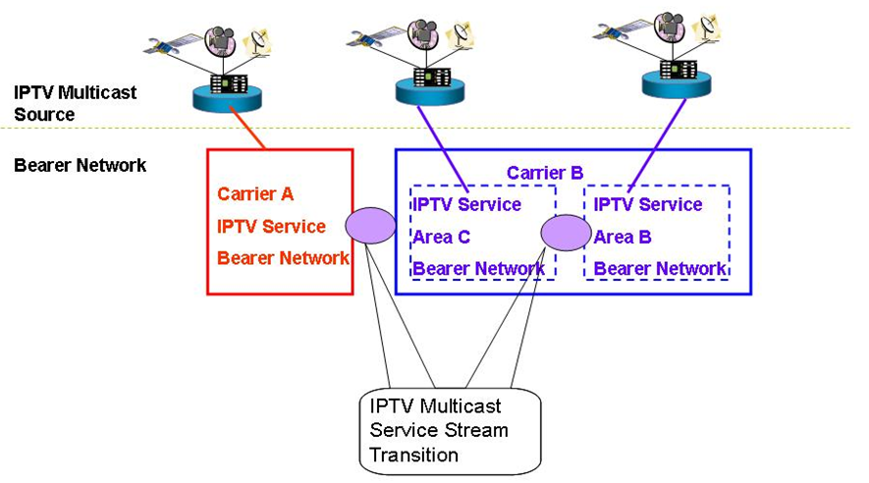

Figure 6-7: IPTV multicast address transition
- IP multicast address mapping function is recommended to support end-user’s personal broadcasting service.
- The use of Source Specific Multicast solves the problem with overlapping Multicast addresses. In case of SSM a combination of a Multicast Group address and the Source Address of the Multicast sender is used (this combination is unique and allows several senders to use the same IP Multicast address). It is recommended to deploy Source Specific Multicast.

The control of users’ multicast address
In order to control the development of multicast services on carrier’s network and avoid impact on carriers’ IPTV broadcasting services, carriers can deploy multicast service controller to manage the distribution of multicast address uniformly. However, as for the multicast application without registration, carriers will restrict the usage of these multicast addresses at the access point of IPTV network. The procedures of applying for multicast service and multicast address are as follows and shown as Error: Reference source not found.

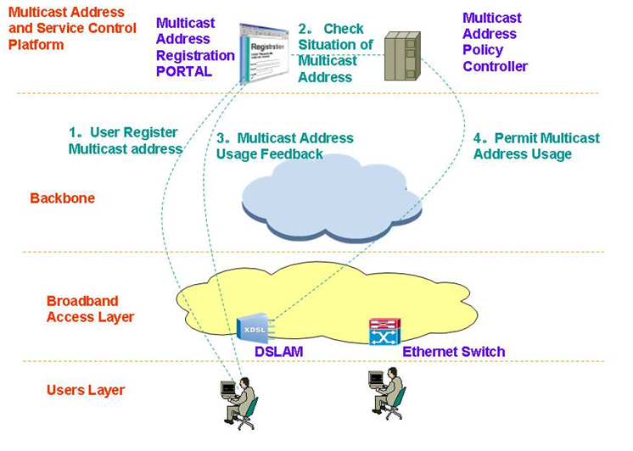

Figure 6-8: Control procedure of multicast address
1. In order to carry out services based upon multicast address users should arrange the inquiry and registration on the PORTAL of carrier-provided Multicast Address and Service Control Platform.
2. The self-service system check the situation of this multicast address from multicast address policy controller
3. If this multicast address is available, users will be told that they are allowed to use it.
4. At the same time, multicast address policy controller sends policies to the access point to allow the multicast services get access.

IPTV Multicast Address / Domain Name Management
The function of IPTV Multicast Address / Domain Name Management is an optional one for network operators, to make their management of multicast address resources more efficiently and easily. With this function, network operators do not allocate multicast IP addresses to multicast channels of IPTV service providers directly, but register domain names of these channels, and bind multicast addresses with their domain names dynamically.
- Multicast IP addresses are managed by network operators.
- Network operators can do domain name registration / deregistration on DNS servers.
- IPTV service providers negotiate domain names of their IPTV channels with network operators.
- Network operators register domain names of IPTV channels with multicast addresses dynamically assigned to these channels.
- Network operators inform IPTV service providers about the domain names registered for their IPTV channels.
- When network operators need to do multicast address management work, they just modify domain name registration on DNS servers.
    - Allocate a multicast address to an IPTV channel: register a domain name with a multicast address for the IPTV channel.
    - Revoke a multicast address from an IPTV channel: deregister the domain name of the IPTV channel.
    - Rearrange multicast addresses: modify domain name registration of IPTV channels.
- IPTV service providers get multicast address information of their IPTV channels by DNS query, and send IPTV contents to those multicast addresses.
- End users access these IPTV channels by their domain names.
- Network operators can make use of domain name information of IPTV channels to do IPTV service access control on both multicast sources (IPTV service providers) and multicast group members (end users).

IPTV multicast service management
The packet transmission of IPTV Multicast service is usually provided based on UDP, so it can be less-reliable than TCP based delivery. Because of that reason, we absolutely need to provide the service management features including service monitoring one to guarantee the service reliability.

Definition of IPTV multicast service management requirements
- IPTV multicast service is recommended to provide service monitoring features for the service status management.
- IPTV multicast service is recommended to provide the statistics as the service reporting feature.
- IPTV multicast service is recommended to manage each service STBs, stream servers, management servers.
- IPTV multicast service is recommended to be capable of recovering or handling for the specific host to get the poor service quality.

Necessary information for IPTV multicast service management
- Multicast Group information
  - The multicast groups IP, port information are delivered from streaming server to clients in the live broadcasting connection time. That information is used for checking whether multicast group information is correct or not.
- Client information
  - If the clients start to receive the live broadcasting data, IPTV service management server can get the information of the each client’s IP, MAC addresses. That information is used for checking the client’s status.
- Video type information
  - When receiving live broadcasting, the clients get the video information like video size and codec type which is received from the streaming server. That information is used for video quality measurement data.
- Video Frame information
  - With checking the timestamp and sequence number of the media data header, we can get the exact time information about frame reception and remaking.
  - The Sequence number is consecutive one, so the unusual increase can be regarded as the case of IPTV service frame loss, so it can be used for service quality measurement factor.
  - From the decoding procedure of media data, we can get the I, P, B frame information which can be used as service quality measurement information.
- Bitrate information
  - The Bitrate information can be also used for IPTV service quality measurement factor
- Bitrate(bit/sec) = data size / time

IPTV multicast service monitoring features
- For providing IPTV multicast service monitoring, IPTV multicast service is recommended to provide the performance monitoring feature.
- And, IPTV multicast service is recommended to get the QoS performance data by manipulating of above IPTV service management information.
- And QoS performance data is recommended to include the measurement values such as fps, throughput, loss rate, delay, jitter.
- And, for the service monitoring, IPTV multicast service is also recommended to provide the measurement value of the IPTV multicast service quality, in each period such as daily, weekly, monthly basis.

Overlay multicast networking
[Editor’s note 6th meeting] WG4 decided to move the detail description of overlay multicast in Appendix as the technical information. In this chapter, as the summarization of overlay multicast technology, some essential description will be provided till next meeting.
Overlay multicast networking constructs and manages logical multicast path to support internet group application services over the unicast/multicast network. After exchange of control messages for service level multicast, a multicast data delivery path is constructed over physical transport network, and a logical multicast control path will be created by using multiple end hosts. Along the logical delivery path for real-time or reliable data transport, service level multicast function is performed with cooperation among upstream and downstream IMAs at service level. Only after the physical data delivery path is established via service level multicast control, IPTV applications can work as if they were in a native IPTV multicast network.
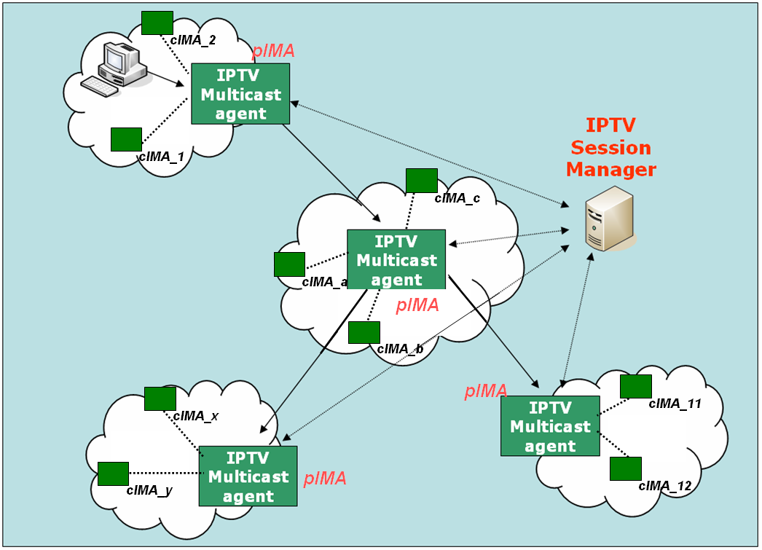
Figure 11-9 - Functional Architecture for Service Level Multicast Capabilities for IPTV

Entities for overlay multicast networking for IPTV service

IPTV Session Manager (ISM)
ISM is involved in session configuration and maintenance for IPTV service flows. A single ISM can handle one or multiple sessions simultaneously, and it can provide the following functionalities:
- Session initialization: ISM allocates ISID (IPTV Session ID) for new session.
- Session release: Session can be released as needed.
- Session membership management
- Session status monitoring: this function enables reporting of the status of data channel, monitoring of data throughput, gathering multicast protocol topology information

IPTV Multicast Agent ( IMA )
IMA constructs overlay multicast delivery path over physical transport path, and forwards data along the constructed physical transport path. An IMA consists of two functional modules, multicast control module and multicast session control module. The main function of former is to establish multicast delivery path and that of latter to setup multicast session along the paths constructed by multicast session control module. IMA performs the control functions to exchange control messages with other entities. Its major functions are as follows.
- Session join: each IMA contacts with Session Manager.
- Session leave: when an IMA wants leave the session, it gives notice to pIMAs and cIMAs
- Session maintenance: relay request and its response will be exchanged between the two IMAs periodically.
- Loop detection & avoidance
- Partitioning detection & recovering
- Parent switching
- IPTV Session status reporting

Mission of overlay multicast networking ( TBD )

Although IP multicast has not deployed globally, a lot of local networks have already been equipped with IP multicast transport. Ethernet-based LANs and private networks such as corporate and campus networks substantially provide the multicast transport capability within their local subnet or administrative domains. Recognizing these observations, there is a crucial need to use an alternative multicast delivery scheme for IPTV service. IPTV overlay networking for multicast will be an alternative solution to provide actually clinging to replicate unicast/multicast method on servers. It makes good use of existing unicast, multicast and/or multicast tunnelling schemes for diverse IPTV services (e.g., various types of group applications).

IPTV overlay network performs the followings:
- IPTV overlay network performs control function for IPTV overlay multicast
- IPTV overlay network performs Group membership management
- IPTV overlay network performs Admission control for QoS in IPTV overlay multicast network
- IPTV overlay network performs Security for IPTV overlay multicast
- IPTV overlay network performs network measurement for IPTV multicast service

Detail descriptions on overlay multicast networking will be provided in Appendix.
Appendix I
Possible IPTV multicast delivery solutions
(This appendix does not form an integral part of this document)

Hybrid P2P IPTV service multicast delivery solution
Figure I.1 shows the concept of Hybrid P2P IPTV service multicast delivery solution.
In this scheme, the receivers join in multicast group as usually. Then they need to form a P2P group too. When a receiver find out that he has lost some IP packet, he can send a broadcast message to his peers to request the lost packets. Then the fast response peer can send the lost packet to it. This mechanism need the receiver caches some packet in case that it need to retransfer packet to the peer.
In this model multicast routers are control by ISP, so ISP can tightly manage the communication. P2P groups does not involve node of ISP, but it is need to limit the member in one group because too many peer will aggravate the receivers’ burden.

Figure I.1 –Hybrid P2P IPTV service multicast delivery

P2P CDN-based IPTV service multicast delivery solution
Figure I.2 shows a generalized distribution scheme with CDN that have the ability of P2P distribution.
The main problem in this architecture is how to organize CDN servers in ISP. In the traditional CDN, it is based on Client/Server technology. Upstream node (i.e. Servers) can forward data to its downstream nodes (i.e. Clients) which is not reversible. Even nodes in the same layer can not exchange data. Nowadays, for the need to improve its high reliability to serve in network, CDN servers can exchange data from each other which even have P2P abilities according to the distribution policy of CDN.

Figure I.2 – Data distribution scheme with P2P CDN

APPENDIX II
Details of IPTV Overlay Multicast Networking

Enhanced entities for overlay multicast networking

IMA Backup
IMA is deployed to control the construction of multicast session and deliver data among the overlay. Data stream will break if IMA goes out of work. So it is important to deploy backup function for IMA to guarantee service quality. As shown in figure11-23, nodes (IMAs or terminals) of overlay multicast will report its status to others. The report path could be different according to different IMA selection mechanism. For example, report will be transferred to the siblings if backup IMA is selected among siblings or transferred only to PIMA if backup IMA is selected by PIMA. In other scenario, IMAs may exchange data packets among their siblings to backup each other. Whatever the backup selection mechanism is, following IMA backup functions are required:
- Nodes broadcast their load status to other nodes of multicast overlay.
- Nodes responsible for backup selection select backup nodes based on the received load status.
Figure 11-10 IMA backup

Media signalling proxy
Media signalling proxy is a function to get media status in overlay multicast network by transfer media connection signalling between end hosts and obtain media session status of end hosts.
In order to get media status of overlay multicast network, media signalling proxy is recommeded to be supported by IPTV overlay multicast system. Error: Reference source not found shows how media signalling proxy operates.
Figure 11-11 - Media Signalling proxy

Detailed Control Function for IPTV overlay multicast
The overlay multicast control function for IPTV supports overlay session control function over physical transport network. To support the scalable session control function for overlay multicast, a hierarchical overlay multicast control will be introduced as shown in Figure 20.Error: Reference source not found
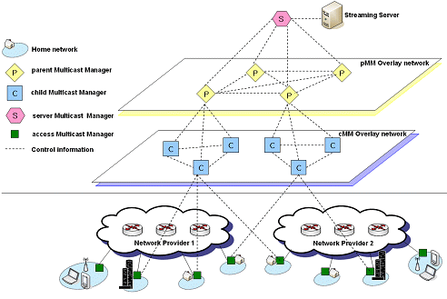

Figure 11-12 – Hierarchical structure of overlay IPTV multicast control

The control mechanism for IPTV overlay multicast creates/changes multicast session topology according to service requirements, network provider’s requirement, service provider’s requirement, user’s requirement and others. The IPTV overlay multicast requires control functions to support optimization of overlay routing, resource control and QoS support. Addition/deletion/changeof multicast session for additional IPTV service users can be controlled by modification of logical delivery path in IPTV overlay network.

Group membership management
The group membership for IPTV overlay multicast considers group size, number of group member and rate of group membership change.
- Group Membership Control: It is a function that provides mechanisms to join and leave group for IPTV overlay multicast. It may also provide the function to create or maintain the multicast groups.
- Group Partitioning: It is necessary to optimize the multicast efficiency by sub-grouping to underlying physical transport networks. Two optimization approaches to realize the group partitioning in IPTV overlay multicast will be introduced to support the following functions.
- Global group partitioning: The global group partitioning optimizes the resource usage of local network. If a multicast group in the physical transport network is experiencing serious traffic explosion temporarily, the control function of IPTV overlay multicast will be able to make a global group into multiple sub-groups to avoid the problems.
- Server group partitioning: In order to avoid performance degradation of IPTV servers, the server group partitioning will be introduced to optimize the resource usage of server network. The partitioning is performed by IPTV overlay multicast control function.

Admission control for QoS in IPTV overlay multicast network
In order to support QoS for IPTV services in overlay multicast network, resource control function for IPTV overlay network will perform resource management and admission control function in IPTV overlay multicast network.

Security for IPTV overlay multicast
IPTV overlay multicast uses shared network resource and multiple distributed overlay resources to transport data. When a user requests IPTV service, security process needs for IPTV overlay multicast function.
Overlay multicast confronts with various vulnerabilities and risks that impede from being widely deployed in mission critical business systems and applications. There are three important security challenges for the overlay network service model: Confidentiality and Integrity, Authenticity, and Availability. These three important security challenges can be classified with some properties for architectures and algorithms for building secure and scaleable information dissemination services on wide area overlay networks.

Node functions for IPTV overlay routing
An overlay multicast node function will be designated to perform overlay routing, contents location control and distribution control function for IPTV services. The designated node has full knowledge of other multicast node in the session, information on contents server and distribution control information.. In order to keep the updated information on multicast nodes, state updates occur periodically via broadcasting among all multicast nodes.

An overlay multicast node will provide few information to provide the requirements for overlay multicast resource control.
- Logical ID Assignment for overlay nodes: The overlay nodes will perform an identification function with session ID according to region or overlay IPTV service etc.
- Logical ID Assignment for contents server
- IPTV overlay multicast management function: The overlay node will collect and stores information on overlay networking management, and selects neighbour overlay nodes to exchange the information.

QoS control at overlay multicast network for IPTV services

Functional position of resource control
If the information on IPTV transport networks is directly collected and managed by IPTV overlay nodes to establish overlay transport route and configuration session topology, it will be serious burden to handle overheads in IPTV overlay networks. It is assumed that resource control functions for IPTV overlay network is located between IPTV overlay network and physical transport network, and it performs collection of information about network resource and provides QoS control to transport network.
As shown in Error: Reference source not found, it is necessary that resource control function is introduced to provide interface function for IPTV overlay multicast QoS control between physical transport and IPTV overlay network. This function performs collection and management of transport network resource (e.g., DiffServ) via specified interface (e.g. SNMP). And overlay network nodes create tree topology and optimized route to support QoS requirements of IPTV users through information collected by Resource Control function. And RCF can have the interfaces such as COPS, Diameter and H.248 to install/uninstall the policy decision for transport network The interface between overlay network and RCF will be further study. The interface may be proprietary of IPTV service providers.

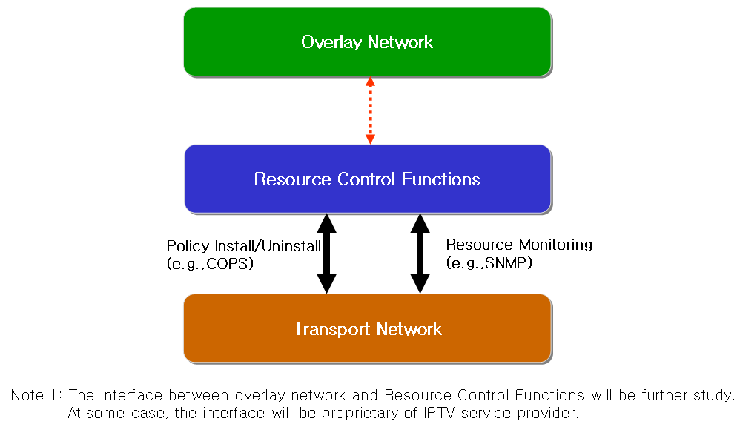

Figure 11-13 - Resource control architecture in IPTV overlay network

Resource control function
The requirements for resource control are as follows
- The Resource Control Function will collect information for resource control from transport network with periodic or a periodic. According to initiation of overlay network nodes, Resource Control function collects data for resource and QoS control.
- Resource control should be able to communicate with Resource Control Function in heterogeneous or other network.
- The following information collected is transferred to overlay network, and then overlay network creates route and optimized tree to support QoS for IPTV overlay network.
- Link State Information: it includes available bandwidth information, delay, packet loss and jitter of link.
- Routing Information: it includes routing algorithm that is used to transport network equipments and routing information of them (e.g. neighbour routing information, routing table .etc)
- Multicast Traffic Information: it includes multicast traffic parameters (e.g. channel information, type of service, user profile, source content information) per channel or session of IPTV multicast.

Resource control function for IPTV overlay multicast QoS in wired/wireless/mobile networks.
The Session Manager configures routes among IPTV overlay network nodes and optimizes tree topology for multicast sessions according to information of Resource Control Function. RCF has resource information from transport network such as link state information, routing information, multicast traffic information and so on. Session manager requests the resource information in transport network to RCF. RCF verifies the resource status based on gathered information, and makes the policy decision for the request. Session manager confirms the received message from RCF, and compares with service information. Then session manager sends the policy installing request message to RCF. After receiving the policy request message, RCF sends the policy installing request message to transport network through the configured path for overlay network. Error: Reference source not found shows the application of Resource Control Function in wired/wireless/mobile networks for IPTV overlay multicast QoS control.

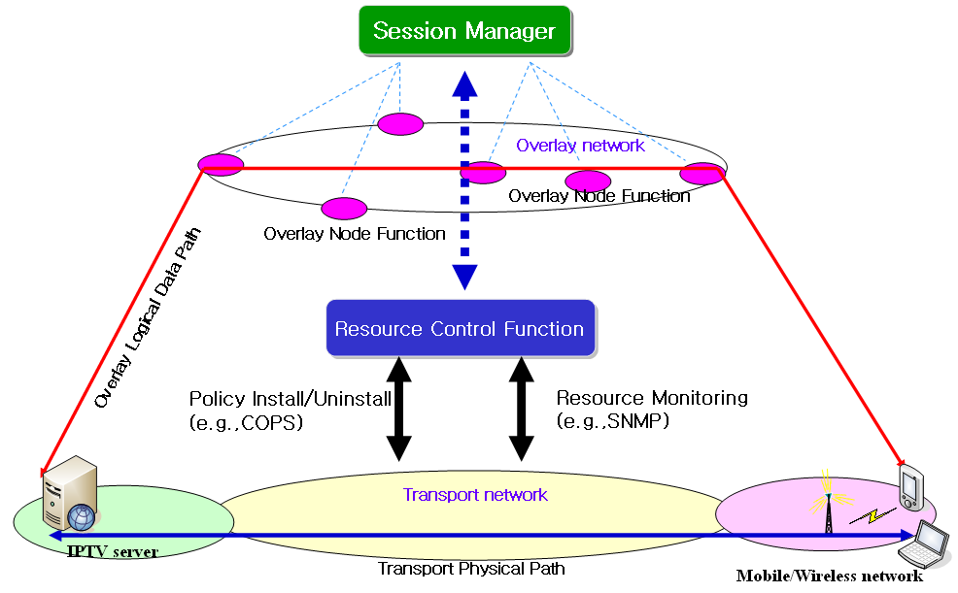

Figure 11-14 Application of resource control function in wired/wireless/mobile networks for IPTV overlay multicast QoS control

Network measurement function
In order to ensure high end-to-end service quality of the IPTV services, IPTV overlay multicast measurement system needs to be deployed to measure the IP network performance, e.g. bandwidth, packet loss between overlay nodes such that the appropriate overlay path is selected.
As part of resource control, network measurement includes receiving interface, measurement interface and forwarding interface. Receiving interface receives measurement requests from session manager and forwards them to measurement interface. Measurement interface measures the network performance between network nodes and forwards the results to forwarding interface. Forwarding interface sends the results to overlay network or other network measurement to share information.

High-level procedure of QoS and Resource Control Functions for IPTV Overlay Multicast
When Session Manger requests information on overlay networking paths to Resource Control Function, and Resource Control Function collects the transport network information using SNMP. Resource Control provides the QoS and resource information of transport networks to Session Manager. In order to compromise the requested requirements on QoS and resource availability of IPTV overlay multicast paths, Session Manager may re-negotiate with Resource Control Function. If the provisioning of Resource Control Function is not satisfied by Session Manager, it is ignored and discarded. Figure II.1 shows procedure to create IPTV overlay multicast service to be with QoS requirements of IPTV overlay multicast paths in IPTV overlay network.

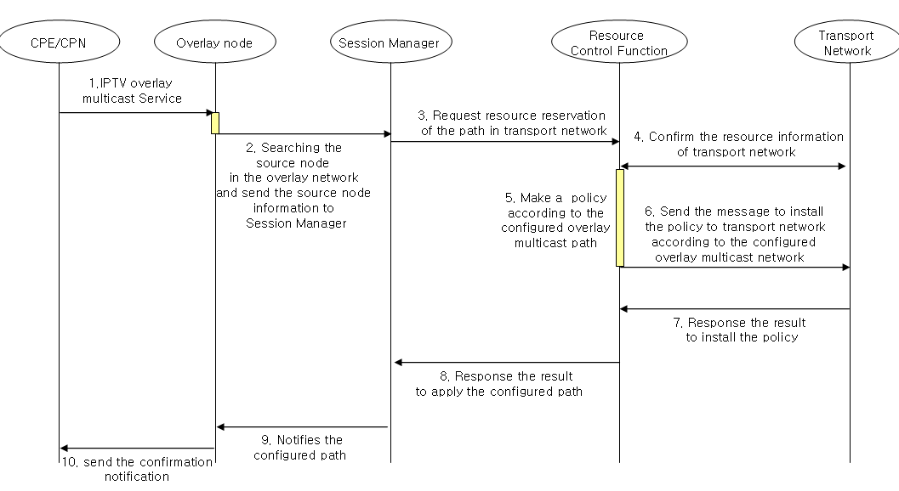
Figure II.1 - Procedure to create overlay multicast paths with Resource Reservation and Control in IPTV Overlay Network
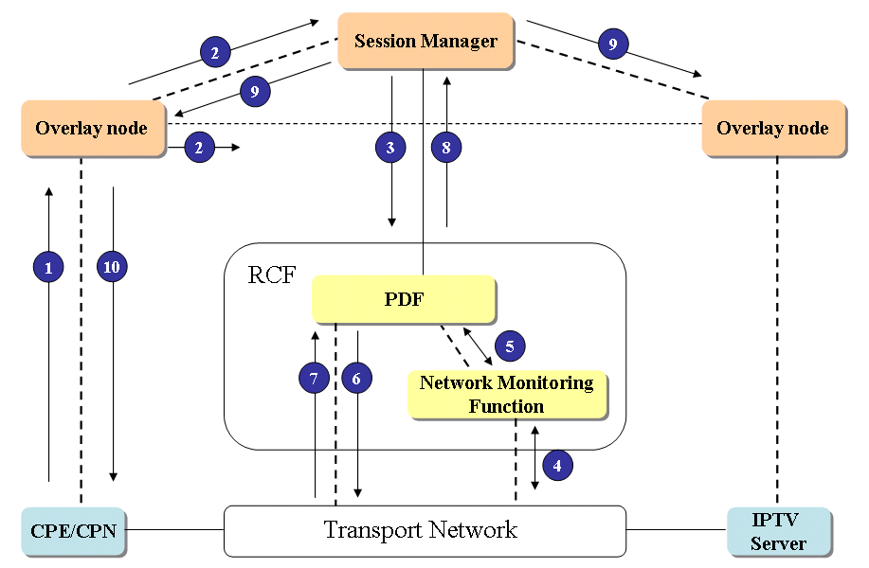
Figure II.2 – Procedure to exchange control information for provision of QoS and resource management in IPTV Overlay Network.
Figure II.2 shows an example of procedure to exchange control information for provision of QoS and resource management in IPTV Overlay Network (the same procedure of Figure II.2 is likely to Figure II.1). The RCF in IPTV Overlay Network will have similar function with Policy Decision Function. PDF performs control function based on the policies from network provider, service provider or service control function to provide QoS and resource control function to IPTV information delivery path.
The request for resource reservation and QoS control function on physical transport paths, which are mapped with logical paths in IPTV overlay network, is initiated by Session Manager, and delivered to PDF in RCF. PDF installs the policies on physical transport network, and it performs resource control function on the physical paths. The procedures in Figure II.1 and Figure II.2 are as follow.
- When IPTV overlay multicast is requested from CPE/CPN, overlay node search the originating node of contents, and forwards the information of the originating node to Session Manager. (①~②)
- Session Manager requests the Resource Control Function for the paths in accordance with IPTV session and service requirements. (③)
- If the requested requirements are met with the physical transport network, Resource Control Function confirms the resource reservation of the transport network, and applies a policy in accordance with the requests of Session Manager. (④~⑤)
- Resource Control Function sends the message to install the policy to transport network according to configured overlay multicast paths. (⑥~⑦)
- Session Manager notifies the configured path to overlay node and confirmation notification will be sent to the CPE/CPN. (⑨~⑩)

Scenario for Session manager’s Service Control Function
The service control function for IPTV in overlay multicast networking is to provide resource Request/Release function for IPTV services to Resource Control Function, IPTV service access control function to Resource Control Function, and to request content delivery control function to Content Delivery Control Function of IPTV architecture. In order to provide IPTV service control function, Session Manager in IPTV overlay network performs the following functions:
- Service Resource Request/Release: Session Manger requests resource reservation/release of transport network to create/terminate IPTV overlay session according to IPTV service requirements.
- Service Access Control: Session Manager allows IPTV service access to authenticated IPTV users according to their access rights, subscriber profiles and network policy etc.
- Request Content Delivery Control Function: Session Manager requests the location of appropriate IPTV content server which can deliver IPTV overlay multicast service to IPTV user.
Session Manager is cooperated with Content Delivery Control Functions and Resource Control Function as shown in Figure 1. Content Delivery Control Functions is used to identify appropriate IPTV content server to deliver IPTV overlay multicast service to the IPTV user. Resource Control Function provides resource reservation/release between the IPTV server and IPTV user when Session Manager requests a message to configure and optimize IPTV overlay multicast network. Each functional entity as shown in Figure 1 is corresponded with functions of IPTV architecture.
Figure III-1. Functional Entity for IPTV overlay multicast networking

Figure 2 shows procedure to perform service control function for IPTV in overlay multicast networking.
- When IPTV overlay multicast service is requested from IPTV user, Content Delivery Control Functions will search appropriate IPTV content server. It forwards IPTV user’s request which is contained the location of the IPTV content server and IPTV service requirements to Session Manager. (①)
- Session Manager in IPTV overlay multicast networking derives the IPTV service parameter from the IPTV user’s request and it performs authentication between end IPTV user and the IPTV overlay multicast service. Session Manager requests resource reservation of path between the IPTV server and IPTV user to Resource Control Function. (②)
- Resource Control Function reserves optimal delivery path according to IPTV service requirements and network policy after it observes the resource information of transport network. And it sends result of reserved path to Session Manager. (③)
- Session Manager creates/updates the IPTV overlay session according to reserved delivery path by Resource Control Function. It notifies the configured path to Content Delivery Control Functions. Content Delivery Control Functions will update managing IPTV service information according to the result of IPTV overlay session configuration. (④)

Figure III-2. Example scenario of service control in IPTV overlay multicast networking
________________

