INTERNATIONAL TELECOMMUNICATION UNION |  |  |  | Focus Group On IPTV
TELECOMMUNICATION  STANDARDIZATION SECTOR  STUDY PERIOD 2005-2008 |  |  | FG IPTV-C-1033
 |  |  | English only
WG(s): 6 |  | 7th FG IPTV meeting:  Qawra, St Paul’s Bay, Malta, 11–18 December 2007
CONTRIBUTION
Source: | China Telecom
Title: | Proposal on improvement for content provisioning in DOC-161 of WG6

Discussion
For the IPTV architecture has been defined more clearly, it is need to harmonize and fill out the relevant text about content provisioning. This contribution proposes some improvement for content provisioning in working document of WG6 and adds some notes for making the future work more clear.
For making it more obvious, the 11th section about is edited by revised edition and is shown as below.

Content Provisioning

Introduction
Content Provisioning in IPTV is the activity of providing licensed TV channels, programs, movies, music and other contents between content providers and service providers. Content Provision may sign contracts with source content provider, import raw audiovisual contents and metadata from source content provider and convert them into the required delivery format in any way. It also may be necessary to edit the programme related metadata. In some scenario，it is also necessary for content provisioning to do packaging, ad-insertion into streams, format conversion, resolution conversion, editing, etc. For protecting content right, content provisioning may encrypt the content before delivering content to service provier.

In this section we focus on the interface between Content/Metadata providers and Service Providers and on the content processes inside the content provisioning.

Interface between Content/Metadata Providers and Service Providers
Content providers can provide audiovisual channels, contents and metadata together or separately.
Pure metadata providers also exist.
In the case of broadcast retransmission, broadcast service platforms such as terrestrial, cable, or satellite digital broadcasting can provide audiovisual channels, metadata and contents for interactive services to IPTV Service platforms for retransmission.
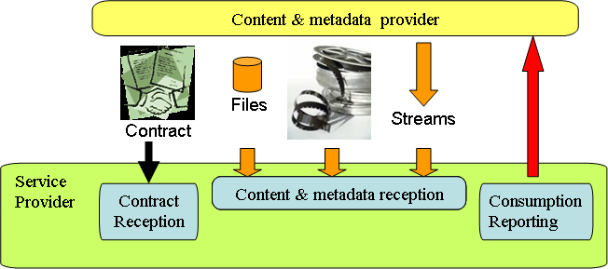
Content Provisioning
Figure 1. Relations between Content Provider & Service Provider
"Streams" stands for single programme streams and for multiple programme streams.

For content provisioning, a set of interfaces is needed and identified:
- Contract exchange (not to be standardised)
- Content & metadata provisioning interface
- Consumption reporting
Standards are needed for the Content & Metadata Provisioning interface.
The metadata elements for provisioning are recommended to be as common as possible with the metadata elements made available to the end-user, however with elements specific to the relation between "Content Provider" and "Service Provider" (such as distribution conditions).

Gap Analysis for Content and metadata provisioning
Content provisioning method | Identified standards
File format for content provisioning | Any format ,but ISO/IEC 14496-12: ISO base media file format is recommanded
File format for metadata provisioning | XML file validated by metadata provisioning schema to be defined
File format for combined content & metadata provisioning | ISO/IEC 14496-12: ISO base media file format is one of choices
Stream format for channel/content provisioning | MPEG-2 TS or RTP
Stream format for combined channel/content & metadata provisioning | EN 300 468: Specification for Service Information (SI) in DVB systems  TS 102 323: Carriage and signalling of TV-Anytime information in DVB transport streams

Proposal

It is proposed that the above revised edition about content provisioning would be discussed in WG6 and would be accepted.

Contributor List
Name | Company | Tel. | Email
Siqing Luo | China Telecom | +86 21 58755452 | luosq@sttri.com.cn
Jianting Meng | China Telecom | +86 21 58755057 | mengjt@sttri.com.cn

____________

