INTERNATIONAL TELECOMMUNICATION UNION |  |  |  | Focus Group On IPTV
TELECOMMUNICATION  STANDARDIZATION SECTOR  STUDY PERIOD 2005-2008 |  |  | FG IPTV-C-0985
 |  |  | English only
WG(s): 4 |  | 6th FG IPTV meeting:  Tokyo, Japan, 15-19 October 2007
CONTRIBUTION
Source: | ETRI
Title: | New Consideration of DSL Technology for IPTV Network Control Aspect and Control
- Introduction
Networking aspect over DSL technology will not be trivial to discuss about the networking capability for IPTV services. The DSL technology itself is assumed as the underlying transport network to support IPTV. The DSL technology is concerned with the networking architecture(s) superimposed over DSL transport to provide IP-based services and related applications, e.g., IPTV.

It is proposed that the DSL technology be considered in network control aspect for IPTV services and the part of the document will be necessary to be included in main text and Appendix of FG IPTV-DOC-0123.
- Reference Point Configuration Architecture in DSLF
The reference points identified in the DSLF in TR-144 (Broadband Multi-service Architecture & Framework Requirements.) are shown in the figure below.
The W, V, U and T reference points correspond to their traditional ITU-T usage. The A10 reference correspond to their usage.
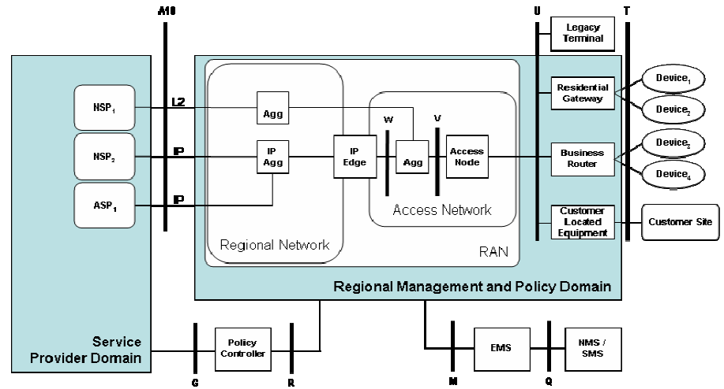
Legend:
BRAS Broadband Remote Access Server
EMS Element Management System
NMS Network Management System
RG Routing Gateway
SMS Subscriber Management System
Figure 1 - Reference Point Model
- Multi-service, multi-provider, multi-user, multi-device operation
The reference model shown above allows each instance of the service invocation to be individually distinguished by the controller and to be allocated with a distinct session and bearer. This capability will allow several real time multimedia services to operate simultaneously, each controlled separately. This shown in the figure below.

Figure 2 - Simultaneous access to many service providers

The TR-144 architecture increases the types and number of access sessions that a subscriber would typically establish to a service provider. Whereas previously there had been just one access session to an ISP, the The TR-144 architecture identifies multiple access sessions with three basic types as shown in figure 3.
Community NSP – Shown in the figure below as the solid line between the RG and NSP₁, this type of access session is established between an RG and an NSP. It is called the Community NSP connection because all the devices within the Customer Premises Network share the connection to the NSP using the NAPT feature of the RG. Because the Community NSP connection is given the Default Route at the RG there can be only one. This connection is typically set up to an ISP in order to provide Internet access to all the devices in the Customer Premises Network.

Personal NSP – Shown in the figure below as the dashed line between User₁ and NSP₂, this type of access session is established between a device within the Customer Premises Network and an NSP. It passes through the RG at the Ethernet (PPPoE) level. It is called the Personal NSP connection because only the device within the Customer Premises Network from which the connection was established can access the NSP. This avoids using the NAPT feature of the RG. This connection is typically set up to an ISP or a corporation in order to provide private or personalized access, or any access that cannot traverse the NAPT sharing mechanism at the RG.

ASP – Shown in the figure below as the dotted line between the RG and ASP₁, this type of access session is established between an RG and the ASP network. It is always a single connection and is always shared by all the ASPs. Because the Community NSP connection is given the Default Route at the RG, the ASP connection must provide the RG with a list of routes to the ASP network. Also because there is not a default route to the ASP network, it is not possible to provide typical Internet access through the ASP connection. This connection is typically set up to the ASP network in order to provide application-specific and QoS-enabled access among all the applications in the ASP network and all the devices in the Customer Premises Network.
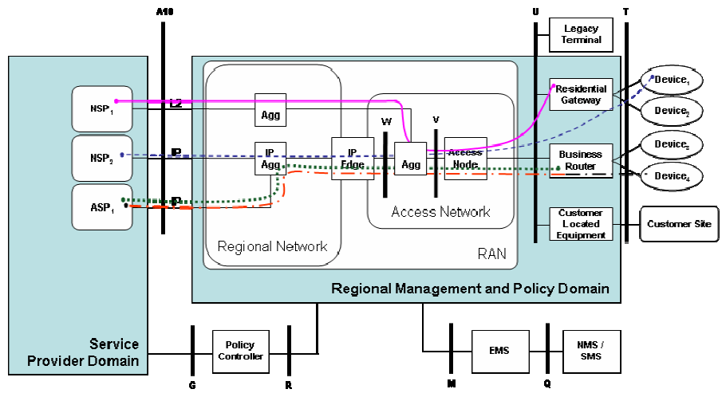
Legend:
EMS Element Management System
NMS Network Management System
RG Routing Gateway
SMS Subscriber Management System
RAN Regional/Access Network

Figure 3 - Access Session types

Requirements for the BRAS are contained in TR-092 (Broadband Remote Access Server Requirements). The BRAS can perform several logical functions (e.g. LAC, IP router, or a MPLS PE router) as it aggregates user sessions from the access network. The requirements included in this document should be applied broadly across all of these logical functions unless where explicitly stated. In addition to providing basic aggregation capabilities, the BRAS is also the injection point for providing policy management and IP QoS in the Regional and Access Networks.
The BRAS is the last IP aware device between service providers (ASPs and NSPs) and the customer network, and as such is leveraged to manage the IP traffic through the layer 2 Access Network. To accomplish this, the BRAS will need to provide a congestion management function that will allow the synthesis of IP QoS through downstream elements that are not QoS aware, which enables DSL providers to support enhanced IP applications.

- Multi-Service Delivery Framework using DSL Technology for IPTV Services
TR-094 specifies the Multi-Service Delivery Framework, providing:
- the ability to support multiple logical data connections on the same physical access technology; and,
- the ability to tailor those connections with different qualities of transmission characteristics (i.e., quality of service (QoS)).
The Broadband Access Server (BRAS) is a key network-side component.
The BRAS performs multiple functions in the network. Its most basic function is to provide aggregation capabilities between the Regional/Access Network and the NSP/ASP. For the aggregation Internet traffic, the BRAS serves as a L2TP Access Concentrator (LAC) tunneling multiple subscriber PPP sessions directly to an NSP or switched through a L2TS. It also performs aggregation for terminated PPP sessions or routed IP session by placing them into IP VPNs or 802.1Q VLANs. The BRAS also supports ATM termination and aggregation functions.
Beyond aggregation, the BRAS is also the injection point for providing policy management and IP QoS in the Regional and Access Networks. The BRAS is fundamental to supporting the concept of many-to-many access sessions.
Policy information can be applied to terminated and non-terminated sessions. For example, a bandwidth policy may be applied to a subscriber whose PPP session is aggregated into an L2TP tunnel and is not terminated by the BRAS. However, sessions that terminate on (or are routed through) the BRAS can receive per flow treatment because the BRAS has IP level awareness of the session. In this model, not only can the aggregate bandwidth for a customer be controlled but also the bandwidth and treatment of traffic on a per application basis.

TR-094 identifies a number of applications that the home network will be expected to support, the functionality that a home network must deliver to meet the application requirements, and the reference architecture for a home network that will deliver such functionality.
TR-094 covers the three primary service areas associated with the“Triple Play” of voice, video, and data services. In particular, the following areas are addressed:
- Best effort Internet access (Simple Web Surfing)
- Derived voice lines (VoIP based)
- Near Video on Demand - VoD (store and forward)
- Video on Demand - VoD (streaming video)
- Audio, image and video distribution
- Bandwidth on Demand (Turbo Button)
- Multiplayer gaming using either PCs or console devices
- Home automation (Telemetry and control)
- Remote Education

- Roadmap summary
The figure below provides a pictorial illustration of key DSL Forum documents and their relationship to architectural distribution of components.

Figure 4 - Roadmap for relevant DSL Forum Technical Reports

This figure is not exhaustive in identifying all the relevant Technical Reports. Some of the TRs shown make reference to other applicable TRs..

6. NGN generalised architecture
This section provides the mappings/equivalences between the DSL Forum architecture and the functional entities specified in ITU-T Recommendation ITU-T Y.2012Y.5
The generalised functional architectures specified in Y.2012 [ITU-T Y.2012] is shown in figure 12.

Figure 5: NGN generalized functional architecture (from ITU-T Recommendation Y.2012)

- DSL Forum architecture

Figure 3 shows the DSL Forum architecture, redrawn to provide the same orientation to that of figure 5. There are three different protocol architectures and session types illustrated in this figure. Thus, the mapping to the ITU-T Y.2012 components will vary according the architectural instance under consideration. For example the BRAS may act as an AN-FE, EN-FE or ABG-FE depending on:
a) the session type under consideration
b) the physical distribution of network elements
c) number of organizations involved/supplying network segments

7.1 Community NSP
The pink solid line shows a path between the RG and NSP₁, This type of access session is established between an RG and an NSP. It is called the Community NSP connection because all the devices within the Customer Premises Network share the connection to the NSP using the NAPT feature of the RG. Because the Community NSP connection is given the Default Route at the RG there can be only one. This connection is typically set up to an ISP in order to provide Internet access to all the devices in the Customer Premises Network.
In this case layer 2 access is extended to the NSP. Thus, EN-FE functionality would reside within the NSP provider domain. However, AN-FE and AR-FE functionality would be present in the path of the red line.

  - Personal NSP
This case assumes the use of a PPP session from a device at the customer premise to a terminating BRAS. There may be several sub-cases within this one case. Several possibilities are in fact described in Recommendation ITU-T Y.2012 in Appendix II, Scenario 2.
In the case of scenario 2, of Recommendation ITU-T Y.2012 Appendix II, three BRAS’s are shown in tandem.
In this scenario the first BRAS act only a layer 2 device, i.e. AN-FE and AR-FE.
In the scenario depicted the PPP protocol is terminated at the third BRAS, and is responsible for user authentication to establish a PPP session, and for routing encapsulated packets to the corresponding NSP. In this case a BRAS may act as an ABG-FE, as well as EN-FE.
As indicated in the scenario there may be intermediate BRAS, which would act as L2TP device to tunnel aggregated PPP streams to the third BRAS. In this situation the BRAS corresponds to the AN-FE in Recommendation ITU-T Y.2012. Additionally, it may include some AR-FE functionality.
In a more simple case, there might be only one BRAS (with no intermediates), which would terminate PPP and perform the functions of an EN-FE and ABG-FE.
This type of session is called the Personal NSP connection because only the device within the Customer Premises Network from which the session was established can access the NSP. This avoids using the NAPT feature of the RG. This connection is typically set up to an ISP or a corporation in order to provide private or personalized access, or any access that cannot traverse the NAPT sharing mechanism at the RG. A particular NSP may be identified for a given PPP session, and multiple sessions may be established.

7.3 ASP
The ASP access is shown by the blue dotted line between the RG and ASP₁. this type of access session is established between an RG and the ASP network. It is always a single connection and is always shared by all the ASPs.
Because the Community NSP connection is given the Default Route at the RG, the ASP connection must provide the RG with a list of routes to the ASP network. Also because there is no default route to the ASP network, it is not possible to provide typical Internet access through the ASP connection. This connection is typically set up to the ASP network in order to provide application-specific and QoS-enabled access among all the applications in the ASP network and all the devices in the Customer Premises Network.

- References
The following ITU-T Recommendations and other references contain provisions that, through references in this text, constitute provisions of this Recommendation.
[1] DSL Forum TR-058, Multi-Service Architecture and Framework Requirements.
[2] DSL Forum TR-059, DSL Evolution – Architecture Requirements for Support of QoS-enabled IP Services.
[3] DSL Forum TR-064, LAN-Side DSL CPE Configuration.
[4] DSL Forum TR-069, CPE WAN Management Protocol.
[5] DSL Forum TR-092, Broadband Remote Access Server Requirements .
[6] DSL Forum TR-094, Multi-Service Delivery Framework for Home Networks.
[7] DSL Forum TR-098, Gateway Device Version 1.1 Data Model for TR-069.
[8] DSL Forum TR-101, Migration to Ethernet-Based DSL Aggregation
[9] DSL Forum TR-102, Service Interface Requirements for TR-058 Architectures.
[10] DSL Forum TR-111, Applying TR-069 to Remote Management of Home Networking Devices
[11] DSL Forum TR-124, Functional Requirements for Broadband Residential Gateway Devices.
[12] DSL Forum TR-133, TR-064 Extensions for Service Differentiation
[13] DSL Forum TR-144, Broadband Multi-service Architecture & Framework Requirements.
_________________

