INTERNATIONAL TELECOMMUNICATION UNION |  |  |  | Focus Group On IPTV
TELECOMMUNICATION  STANDARDIZATION SECTOR  STUDY PERIOD 2005-2008 |  |  | FG IPTV-C-0981
 |  |  | English only
WG(s): 4 |  | 6th FG IPTV meeting:  Tokyo, Japan, 15-19 October 2007
CONTRIBUTION
Source: | ETRI
Title: | Revision of Appendix II of Working Documents (FGIPTV-DOC-0124): Procedure to provide QoS and Resource Control Functions for IPTV Overlay Multicast
This contribution proposes editorial change and new addition on procedure to create overlay multicast paths accordance with resource reservation and control in IPTV overlay network in Appendix II. The procedure to exchange control information for provision of QoS and resource management is explained in the figures.

Appendix II
Procedure to provide QoS and Resource Control Functions for IPTV Overlay Multicast

When Session Manger requests information on overlay networking paths to Resource Control Function, and Resource Control Function collects the transport network information using SNMP. Resource Control provides the QoS and resource information of transport networks to Session Manager. In order to compromise the requested requirements on QoS and resource availability of IPTV overlay multicast paths, Session Manager may re-negotiate with Resource Control Function. If the provisioning of Resource Control Function is not satisfied by Session Manager, it is ignored and discarded. Figure II.1 shows procedure to create IPTV overlay multicast service to be with QoS requirements of IPTV overlay multicast paths in IPTV overlay network.

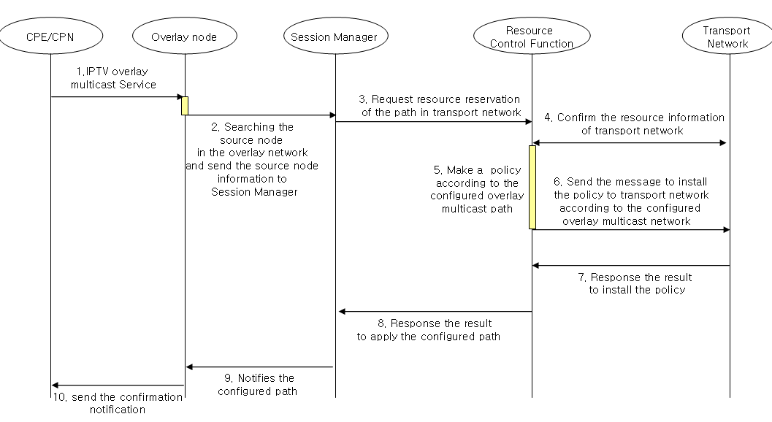
Figure II.1 - Procedure to create overlay multicast paths with Resource Reservation and Control in IPTV Overlay Network

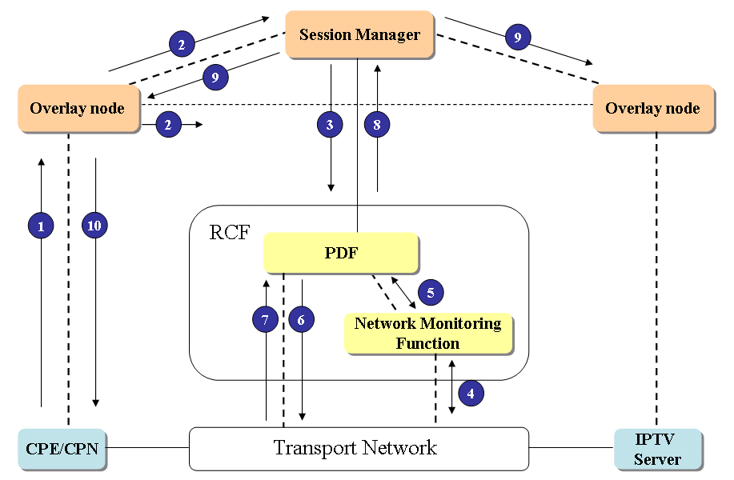
Figure II.2 – Procedure to exchange control information for provision of QoS and resource management in IPTV Overlay Network.
Figure II.2 shows an example of procedure to exchange control information for provision of QoS and resource management in IPTV Overlay Network (the same procedure of Figure II.2 is likely to Figure II.1). The RCF in IPTV Overlay Network will have similar function with Policy Decision Function. PDF performs control function based on the policies from network provider, service provider or service control function to provide QoS and resource control function to IPTV information delivery path.
The request for resource reservation and QoS control function on physical transport paths, which are mapped with logical paths in IPTV overlay network, is initiated by Session Manager, and delivered to PDF in RCF. PDF installs the policies on physical transport network, and it performs resource control function on the physical paths. The procedures in Figure II.1 and Figure II.2 are as follow.
- When IPTV overlay multicast is requested from CPE/CPN, overlay node search the originating node of contents, and forwards the information of the originating node to Session Manager. (①~②)
- Session Manager requests the Resource Control Function for the paths in accordance with IPTV session and service requirements. (③)
- If the requested requirements are met with the physical transport network, Resource Control Function confirms the resource reservation of the transport network, and applies a policy in accordance with the requests of Session Manager. (④~⑤)

- Resource Control Function sends the message to install the policy to transport network according to configured overlay multicast paths. (⑥~⑦)

- Session Manager notifies the configured path to overlay node and confirmation notification will be sent to the CPE/CPN. (⑨~⑩)

__________________

