Abstract
INTERNATIONAL TELECOMMUNICATION UNION |  |  |  | Focus Group On IPTV
TELECOMMUNICATION  STANDARDIZATION SECTOR  STUDY PERIOD 2005-2008 |  |  | FG IPTV-C-0974
 |  |  | English only
WG(s): 6 |  | 6th FG IPTV meeting:  Tokyo, Japan, 15-19 October 2007
CONTRIBUTION
Source: | France Telecom (France)
Title: | Comments on WG6 Working Document DOC-0130 on Service Navigation System
It is proposed:
- to simplify the Service Navigation System generic Architecture to focus on the navigation issue.
- to split the web-based Service Navigation System into two versions: one without "metadata API" and the other with it.

Proposal
DOC-0130 includes the following figure on the left-hand side. It introduces an interface A which is not address further in the document, so it should be removed.
In addition the "Service Provider" provides also the service/application management and the metadata data base so it can not be considered as only located on one side of the interface, this is why it is proposed to remove the "Content provision and service Provider(s)" block as follows on the figure on the right hand-side.
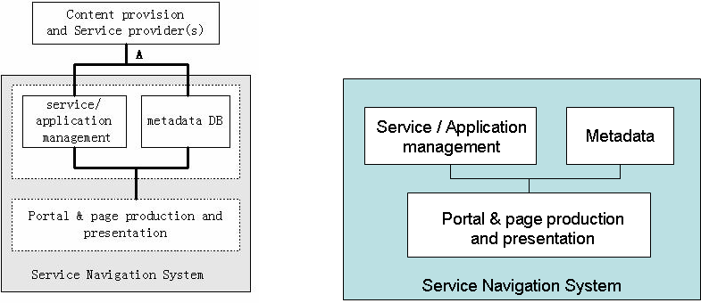
Figure 1. Present and proposed figures for Service navigation System
It is difficult to draw a line around the "Service provider" because on this figure it could go through the page production. Page production can be located in a server on the Service Provider platform or on the end-user device.
On figure 5.2. Is User-self service really a part of the EPG?
In section 5.2, the name of the functional entities should be reflected on the figures.
Section 5.2.1 although titled "requirements" does not include requirements but just a repetition of the names of modules, which is not sufficient.
What about the following simple browser-based architecture:
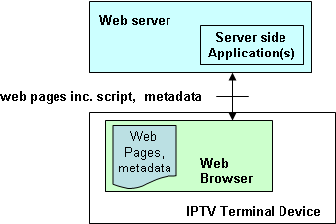
A more sophisticated browser-based architecture may make use of the metadata API to get metadata also included in AV streams coming from head-ends as follows:
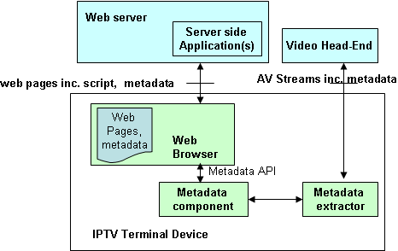

Reference to old input documents should be removed from the document or replaced by a part of these documents to have a stand-alone document.

______________

